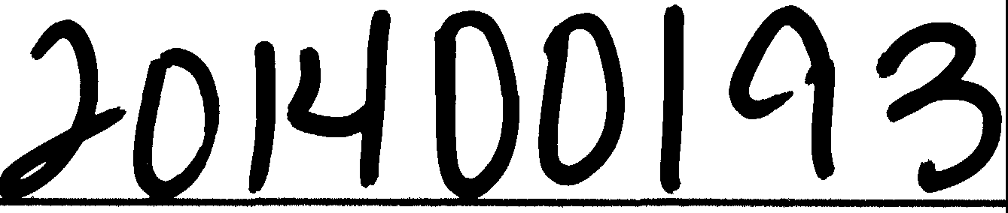

|  |  |
| --- | --- |
|  | **LOTS 31 AND 32, BLOCK E, GRAND MESA AT CRYSTAL FALLS, AMENDED**  **N**  **w E**  **s**  1"=100'  .!,  0 50 100 200 400  BEARING BASIS: TEXAS CENTRAL ZONE, |
| STATE PLANE COORDINATES (NAO 83)  LOC/\TION MAP  N.T.S.  1·.•LEGEND: ••• "'· 1RoN Ror:i w1rn c:HAPARRA1=--c,;,,·P-rouNo-1  8... COTTON SPINDLE FOUND *I*  ·- 'K NAIL FOUND LOT 104 x,0 .506:527044  ··ycc 10170694 54  PU[ - PUBLIC UTILITY EASEMENT  B.L - BUILDING SETBACK LINE  LOT 33  T.C. TRAVIS COUNTY RLOCK C  w.c. --H WILLIAMSON COUNTY  11040171 LOT AREA IN SQUARE FEET  LOT 103  STATE OF TEXAS: ·,  GRAND MF SA Af CRYS !'AL FAI LS  COUNTY OF TRAVIS: / (DOC. 200000019-T,C,)  DEDICA noN STATEMENT: (CAB. S, SL 8.i 102·-W,C.)  THAT DEAN AND MICHELL[ BUSCHICK, liEING THE OWNER OF Ll84 ACRES OF LAND ODT OF THE C.H. HEART SURVEY 704 IN TRAVIS COUNTY, IEXAS, BEING ALL. OF LOTS 3i AND 32, BLOCK E. GRAND MESA A1 CRYSTAL f'ALLS, A SUBDIVISION OF RECORD IN DOCUMENT  NO. 2000000'19, OFFICIAL PUBLIC RECORDS OF TRAVIS COUNTY, TEXAS AND IN CABINET S, SLIDES 63-102, Pl.Ar RECORDS OF )(, :30651 GL6i3  'MLUAMSON COLIN TY, TEXAS, SAID LOT .51, HAVING BEEN CONVEYfJJ *TO* US BY GIFT DEED IN DOCUMENT NO. 2012022991 AND SAID :(:c 101"/(fj§-;i,-)(f\  LOT 32, HAVING BEEN CONVEYED TO US BY GENERAL WARRANTY DEED WITH VENDOR'S LIEN IN DOCUMENT NO. 2003073955, BOTH 32A  RECORDED IN THE OFFICIAL PUBLIC RECORDS OF TRAVIS COUNTY, TEXAS, DO HEREBY PL.AT SAID 2.384 ACRES OF LAND IN \ liii _!l:5?J LOT 10  ACCORDANCE TH APPLICABLE ORDINANCES OF THE CITY OF LEANDER, AND TRAVIS, COUNTY, TEXAS, THE HEREIN DESCRIBED PLAT TO LOT 102  BE KNOWN AS "LOTS .31 AND 32, BLOCK E. GRANO MESA AT CRYSTAL FALLS, AMENDED", AND DO HEREBY DEDICATE TO THE PUBLIC THE USE BLOCK E  OF ALL RIGHI, OF··WAYS, STREUS, ALLEYS, U<5EMENTS, PARKS AND OTHrn OPEN SPACES AS SHOWN HEREON, SUBJt.CI 10 ANY  EASEMENTS AND/OR RESTRICTIONS HrnErornRE GRAN rrn AND NOT REI EASED  1N MY HAND;i THE ***_****i****"ft::*** JJAY OF **-·-"l''** -·20,: -\A.D.  D *'ii,* ***1it -*** MCHELLE-·B}! : -- · , ,.  2010 . YGLASS HILL 2010 SPYGL,>,s;; HILL Lffl 1 i  I.EAND , TEXAS 7864i LEANDER, 1[XAS 78641  STA TE Of' TEXAS: LOT 12  COUNfY OF THAWi:    STA TE' OI TEXAS:  COUNTY OF TRAVIS:  BEFORE ME, H1E UNDERSIGNED AUTHORITY, ON THIS DAY i0ERSONALl Y APPE .RED MICHELLE BUSCHICK, KNOWN TO ME TO BE THE PERSON WHOSE NAM[ IS SUBSCRIBED TO THE FOREGOING INSTRUMENT AND ACKNOWLEDGED TO ME 11-IAT HE EXECUTED THE SAME IN THE CAPACITY THEREIN STATF:D FOR TH[ PURPOSES AND CONSIDERATION THEREIN EXPRESSED,  GIVEN UNDER MY HAND AND SEAL OF Of rn;[, THIS lHE1 A Y OF :::, 2ollf. A.O. STATE OF TEXAS:  **.ltr ::f** COUNTY OF fRAVIS:  b!JJL;_- -·--- - .. . . _ -_· _ 1 " ,, ••,,,,..,- c, ,"'"-A '"',°K''P"',v·"","',\'"'N P:,1· -,,':"'o""N'';\ NO STRUCTURE IN THIS SUBDIVISION SHALL. BE OCCUPIED UNTIL CONNECTED TO A PUBLIC SEWER SYSTEM OR A  \· i-'-.)Lll:c :i1'atr: ,1' lr.:,,;-J:·  NOTARY PUBUC, STA TE OF TEXAS PRIVATE ON--SITE WASTEWATER (SEPTIC) SYSTEM THAT HAS BEEN APPROVED AND LICENSED FOR OPERATION BY THE  TRAVIS COUNTY ON -SITE WASTEWATER PROGRAM.  PLAT NOTES: NO CONSTRUCTION MAY BEGIN ON ANY LOT IN THIS SUBDIVISION UNTIL PLANS FOR THE PRIVATE ON-S\Tf: SEWAGE   1. THIS AMENDED PLAT DOES NOT REMOVE ANY RESTRICTIONS. THIS SUBDIVISION IS SUBJECT TO ALL GENERAL NOTES AND DISPOSAL SYSTEM ARE APPROVED BY THE TRAVIS COUNTY ON-SITE WASTEWATER PROGRAM.   RESTRICTIONS APPEARING ON THE PLAT OF GRAND MESA AT CRYSTAL FALLS, RECORDED IN DOCUMENT NO. 200000019, OFFICIAL DEVELOPMENT ON EACH LOT IN THIS SUBDIVISION SHALL BE IN COMPLIANCE WITH THE MINIMUM REQUIREMENTS OF PUBLIC RECORDS OF TRAVIS COUNTY, TEXAS AND IN CABINET S, SUDES 63-102, PLAT RECORDS OF 'MLUAMSON COUNTY, TEXAS, THE TITLE 30 OF THE TEXAS ADMINISTRATIVE CODE CHAPTER 285 AND TRAVIS COUNTY CODE CHAPTER 46 THAT ARE   1. ALL BUILDING SF TBACK LINES NOT SHOWN HEREON SHALL BE IN ACCORDANCE WITH THE CITY OF LEANDER'S CURRENT ZONING IN EFFECT AT THE TIME OF CONSTRUCTION.   ORDINANCE. THESE RESTRICTIONS ARE ENFORCEABLE BY THE TRAVIS COUNTY ON-Silt WASTEWATER PROGRAM.  ;;, NO DRIVEWAY SHALL BE CONSTRUCTED CLOSER THAN 50' OR 60% OF i0ARCEL FRONTAGE, WHICHEVER IS I.ESS, TO THE ROW OF AN ALL LOTS IN THIS SUBDIVISION ARE RFSTRICTED TO ONE SINGLE FAMILY DWE1UNG AND APPURTENANT STRUCTURES INTERSECTING LOCAL OR COi. LECTOfi STRFEY OR 10L1' OR 60% Of" PARCEi.. FRONTAGE.. WHICHEVER IS LESS, TO THE ROW OF AN PER ACRE.  INTrnSECTING ARTERIAf. STRffT.   1. THIS SUBDIVISION IS WHOLLY CONTAINED 'MTHIN THE CURRENT CORPORATE LIMITS OF THE CITY OF LEANDER, TEXAS NO STRUCTURE IN THIS SUBDIVISION SHALL BE OCCUPIED UNTIL CONNECTED TO A POTABLE WATER SUPPLY FROM   AN APPROVED WATER SYSTEM 0I A PRIVATE WELL   1. THE fOLLO'MNG VARIANCES WERE GRANTED PER A DEVELOPMENT AGREEMENT WITH THE CITY OF LEANDER AND APPROVAL OF THE **Ne ¥J/\:f6R WELL 11• tlll& Sl:JBDl1,ttGION MAY Bli bQQ·4;t:f;Q ljlrfllltJ 1.:i6 FEB' 01" !HE S08DIVISIOl4 BOUMQAR¥ \Afl:fliQ!..JT**   CRYSTAL FAILS II CONCEPT PLAN ON MAY 1, 200.3. **THE SOPJGEftff QF Tl IE ,l\9tlQIMli>IQ LM¢0" OWNER .**   * 1. PRIVATE STREETS WlTH ROADSIDE DR/\INAGE.   El. NO SIDEWALKS.  C, NO STREET LIGHTS. n. -.' l<'o0uV\ s\j.U 11.>-_,y.t:.IO.i?..W:o:,04'41'7 *1(1,b:t.,*   1. THIS SUBDIVISION IS SUBJECT TO A BlANKE:T TYPE UTILITY EASEMENT TO PEDERNAL.ES ELECTRIC:: COOPERATIVE, INC. AS DESCRIBED STACEY SCHEFFEL D, R., PROGRAM MANAGER, DATE IN DOCUMENT NO. 200008945:l, OfflCIAL PUBLIC RECORDS OF !RA\IIS COUNTY, TEXAS AND IN DOCUMENT NO, 2000012247, ON--SITE WASTEWATER, TRAVIS COUNTY TNR   OFFICIAL F'LIBUC RECORDS Of' 'MLLIAMSON COUNTY, TEXAS  STAfE OF ll:XAS: THE STATE OF TEXAS:  COUNTY Of TRAVIS: COUNTY OF' TRAVIS:  I, PHILLIP I.. McLAUGHLIN, AM AUTHORIZED UNDER THE LAWS OF THE STATE OF TEXAS TO PRACTICE THE PROFESSION Of" LAND I, l)ANA DFBFAUVOIR, CLERK OF rRAVIS COUNTY, TEXAS DO HEREBY CER11f"Y ·rnAT THE FOREGOING INSTRUMENT OF SURVEYIN(;, AND HEREBY STATE THAT THIS PLAT CONFORMS WITH APPLICABLE ORDINANCES OF THE CITY OF LEANDER, TEXAS AND  TRAVIS COUNTY, TEXAS AND THAT ALL EXISTING EASEMENTS OF RECORD AS FOUND ON THE TITLE POLICY PROVIDED BY INDEPENDENCE WRITING AND IT:f)CERnFICAlE OF AIITllENTICATION WAS FILED FOR RECORD IN MY OFFICE ON IH ,DAY OF  **.§Jj**A.D. Ac-4-LO.Qo·cLocKA., ANO DULY RECORDED ON rH1s THE -- DAY or  rtTLE COMPANY, GF NO. 1411028-TOH, ISSUED MAY 8, 2014, HAVE BEEN SHOWN OR NOTED HEREON.  0 ::;- -- 20J A.D. r .OQo'ClOCK **A.** OFFICIAi. PUBLIC RECORDS OF SAID COUNfY AND STATE  s:2014- ,_ IN DOCUMFNf NO•• _ **j_'::f-00_ , *f*t .v-..**• ***,I***  REGISTERED PROFESSIO fl EYOR NO. 5.100  STATE. OF TEXAS TNESS MY HAND AND SEAL OF OFFIGE OF ·n,F. COUNTY CLERK, THEt:::_,,.. l_ DAY OF *201::J* A.D,  DANA I OU -- **C RKiPJ *rffem***&  STATE OF TEXAS:  COUNTY OF TR AVIS:  APPROVED THIS THE **$!-t** DAY OF . **--- 4 +_. 201':t** A.D. **AjJN**A**D**UTHORJ.ZE'D ro BE FILED RECORD BY THE COUNTY CLERK OF TRAVIS COUNTY, A S.,  **L'-$...d** ATTES1: _ --· _,  ***1t»Jb,_***  **WAYN** WAT , E HAILE  CITY NGINEER Cl TY SECRET ARY  CITY OF LEANDER, TE:XAS CITY OF LEANDER, TEXAS  SUBMITTAL DATE: MAY 2, 2014 OWNER: SURVEYOR: ·' - TOTAL AREA OF n11s PLAT: 2.364 ACRES DEAN AND MICHELLE BUSCHICK G&R SURVEYING, I.LC ***SURVEYING, LLC*** TOTAL NUMBER OF LOTS: 2010 SPYGLASS HILL 1805 OUIDA DRIVE  RESIDENTIAL: 1 LEANDER, TEXAS 78641 AUSTIN, TEXAS 78728 *1805 OUIDA DR.*  NEW STREETS: NONE *AUSTIN, TEXAS 78728*  *PHONE: (512) 267-7430*  *FAX· (512) 836-8385*  *FIRM NO. 10032000* SHEET 1 OF 1 | |

L:\14190-GRAND MESA RE-PLAT LOTS :31 & :32 BLOCK E dwg\14190_GR-PLALdwg 6/6/2014 2:59:29 PM CDT

1111111111111111111111111111111111111111111111111111111

**TRV 200000019 20 pgs**

**PLAT DOCUMENT#**

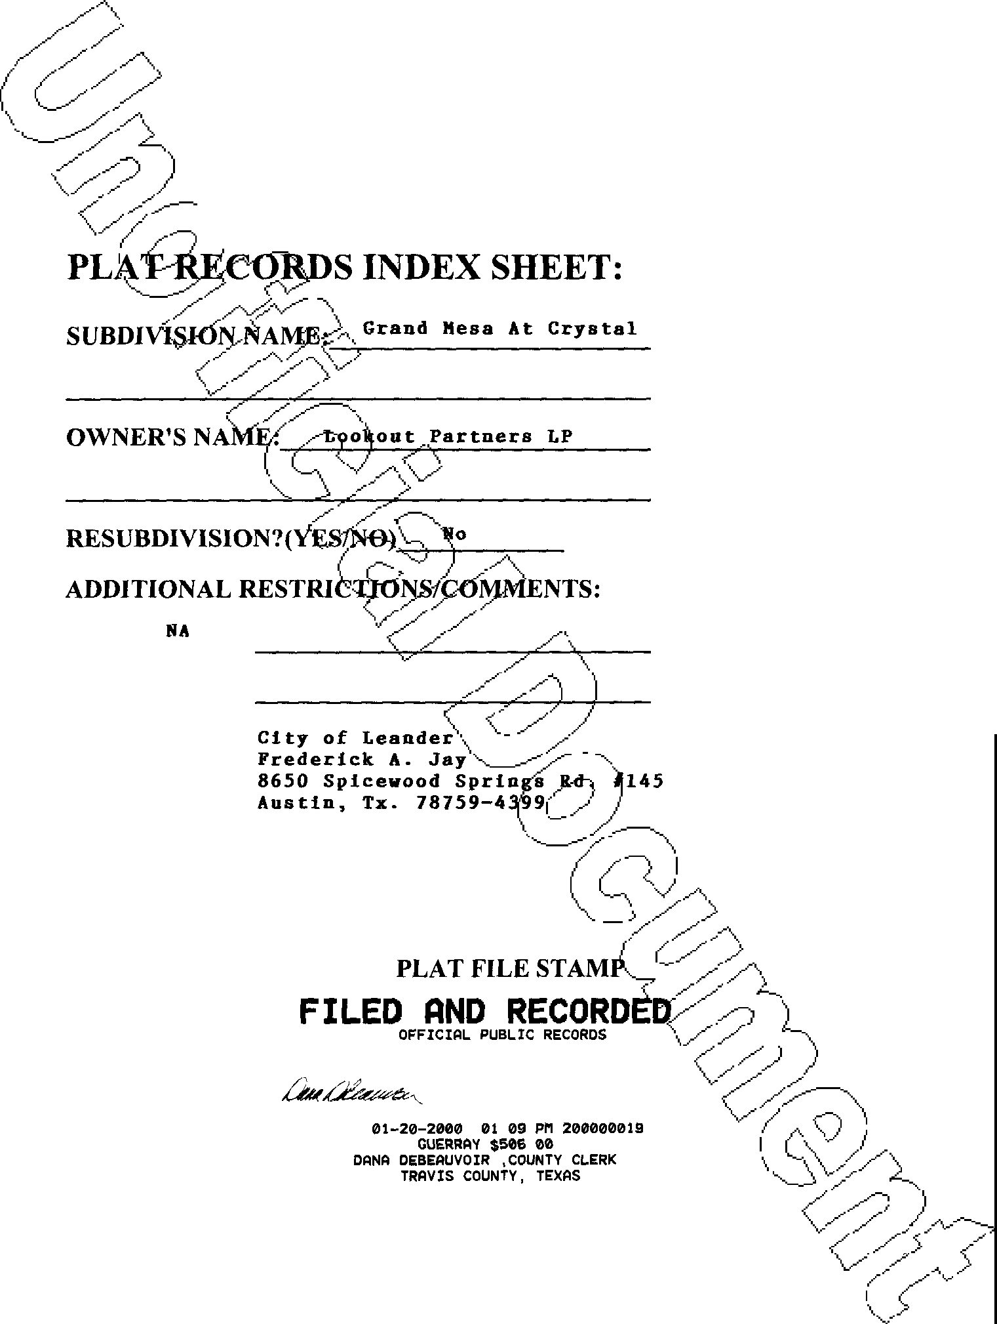

**PLAT**

**Palls**

**RETURN:**



PHOTOGRAPHIC MYLAR ***(J()o/9***

|  |  |  |
| --- | --- | --- |
| GRAND MESA  AT CRYSTAL FALLS  **TRAVIS AND WILLIAMSON COUNTIES**  **N**  16 1  **MIRA** SCALE IN FEET  **VISTA**  600 300 0 600  B L O C K 5  26 A  36 25  K C  24  35  *I* B  *I* 45 34 **TIMARRON**  /*I* 6 **MISSION**  **HILLS**  //  //  // **CRYSTAL FALLS**  *I;* **8 PARKWAY**  *)fl I,_* i  *I* \ I  *I* c *I I* \  *I*  54 ...- I  LEGEND I  **RANCHO** • 1/2" REBAR FOUND I  61  **MIRAGE** 0 1/2" REBAR WITH CAP SET  <2' 62 --.... **0** 3/4" IRON PIPE FOUND  -....._ ---- ...,..-\ ... I  - --.,,  NAIL FOUND (SIZE NOTED)  1 06: */':,* PUNCH-MARK IN ROCK FOUND  ® PK NAIL FOUND   * 2" ALUM CAP FOUND   © BLOCK DESIGNATION  73 \ \  21 \  '\ ''' **VENTANA** \ \  ''' 0 **ANYO** I \  89  B L 0 C LOCATION **MAP**  88 74 1 4 *)!* (NOT TO SCALE)  I 81  87 I *I I*  86 **CAMELBACK** \ *I I*  12 \ \ *I I*  I I ---  85 I I i I \ \ *I I*  *),* ' 82 \ I I \  I I  ' ' \--- -\ \ \ \ *I I I I*  8 \ \ '/;/  )  83 *I v*  *I*  *I I I*  1 5 \ *II*  \;  / ***/.r*** | |  |
| GRAND MESA /. *5*, | | |
| SUBDIVISION  CorutUDOR JENGKNlEJERTING CoMrPANY **8**  **307 SUNSET DRIVE ROUND ROCK, TEXAS 78664** Professional Land Surv ng,  **(512) 244-4279 FAX: (512) 244-0504** Surveying and Mappm-g_.  **CRYSTALFALlS** Austin, Texas 78704  510 South Congress Ave., Suite B-1 **00**  512-476-7103 | DRAW#G NO.:  ...6..2-05 1  pl':0,- DATE: 01/12/00  PLOT SCALE:  1 "= 600'  DRAWN BY:  LEA, COD  **1 i**  **COVER SHEET** | |

PHOTOGRAPHIC MYLAR ***.2(J(J()tJOO /9***

GRAND MESA AT CRYSTAL FALLS

SUBDIVISION IN TRAVIS **AND WILLIAMSON COUNTIES**

_,,,,. _,,,,. _,,,,.

_,,,,. _,,,,. _,,,,.

_,,,,. _,,,,.

_,,,,.

_,,,,.

_,,,,.

_,,,,.

_,,,,. _,,,,. _,,,,.

\ ._

_,,,,.

_,,,,. _,,,,. _,,,,.

_,,,,. _,,,,.

**N** SCALE 1"= 100'

MASON

2653/412

FAMILY PARTNERSHIP,

192.46 ACRES W.C.D.R.

LTD.

SCALE IN FEET

100 50 0 100

*MOSES HORNSBY ABSTRACT 292*

11937/558

HEIERMAN 146.625 ACRES (TRAVIS) 93052111 (WILLIAMSON)

C. *H. HEART SURVEY 704*

**w**

I

(/)

**w w**

(/)

**w** '--....

I

18" CED MK. W/NAIL

(/)

**w w**

(/)

•35"E 241.61

N54"1235'25"E 242.18')

(N84"

SEE SHEET 3

GRAND

MESA

SEE SHEET

P JECT N 62-9800?

DRAWi NO.:

CoruuooR lENGJINEJERJING Cow ANY

307 SUNSET DRIVE

(512) 244-4279

**ROUND ROCK, TEXAS 78664**

**FAX: (512) 244-0504**

SUBDIVISION

# 8

62-oy1

***1*** DATE:

01,/13/00

Professional Land Surv ng, Surve ng and Mappih-g_.

**CRYSTALFALlS**

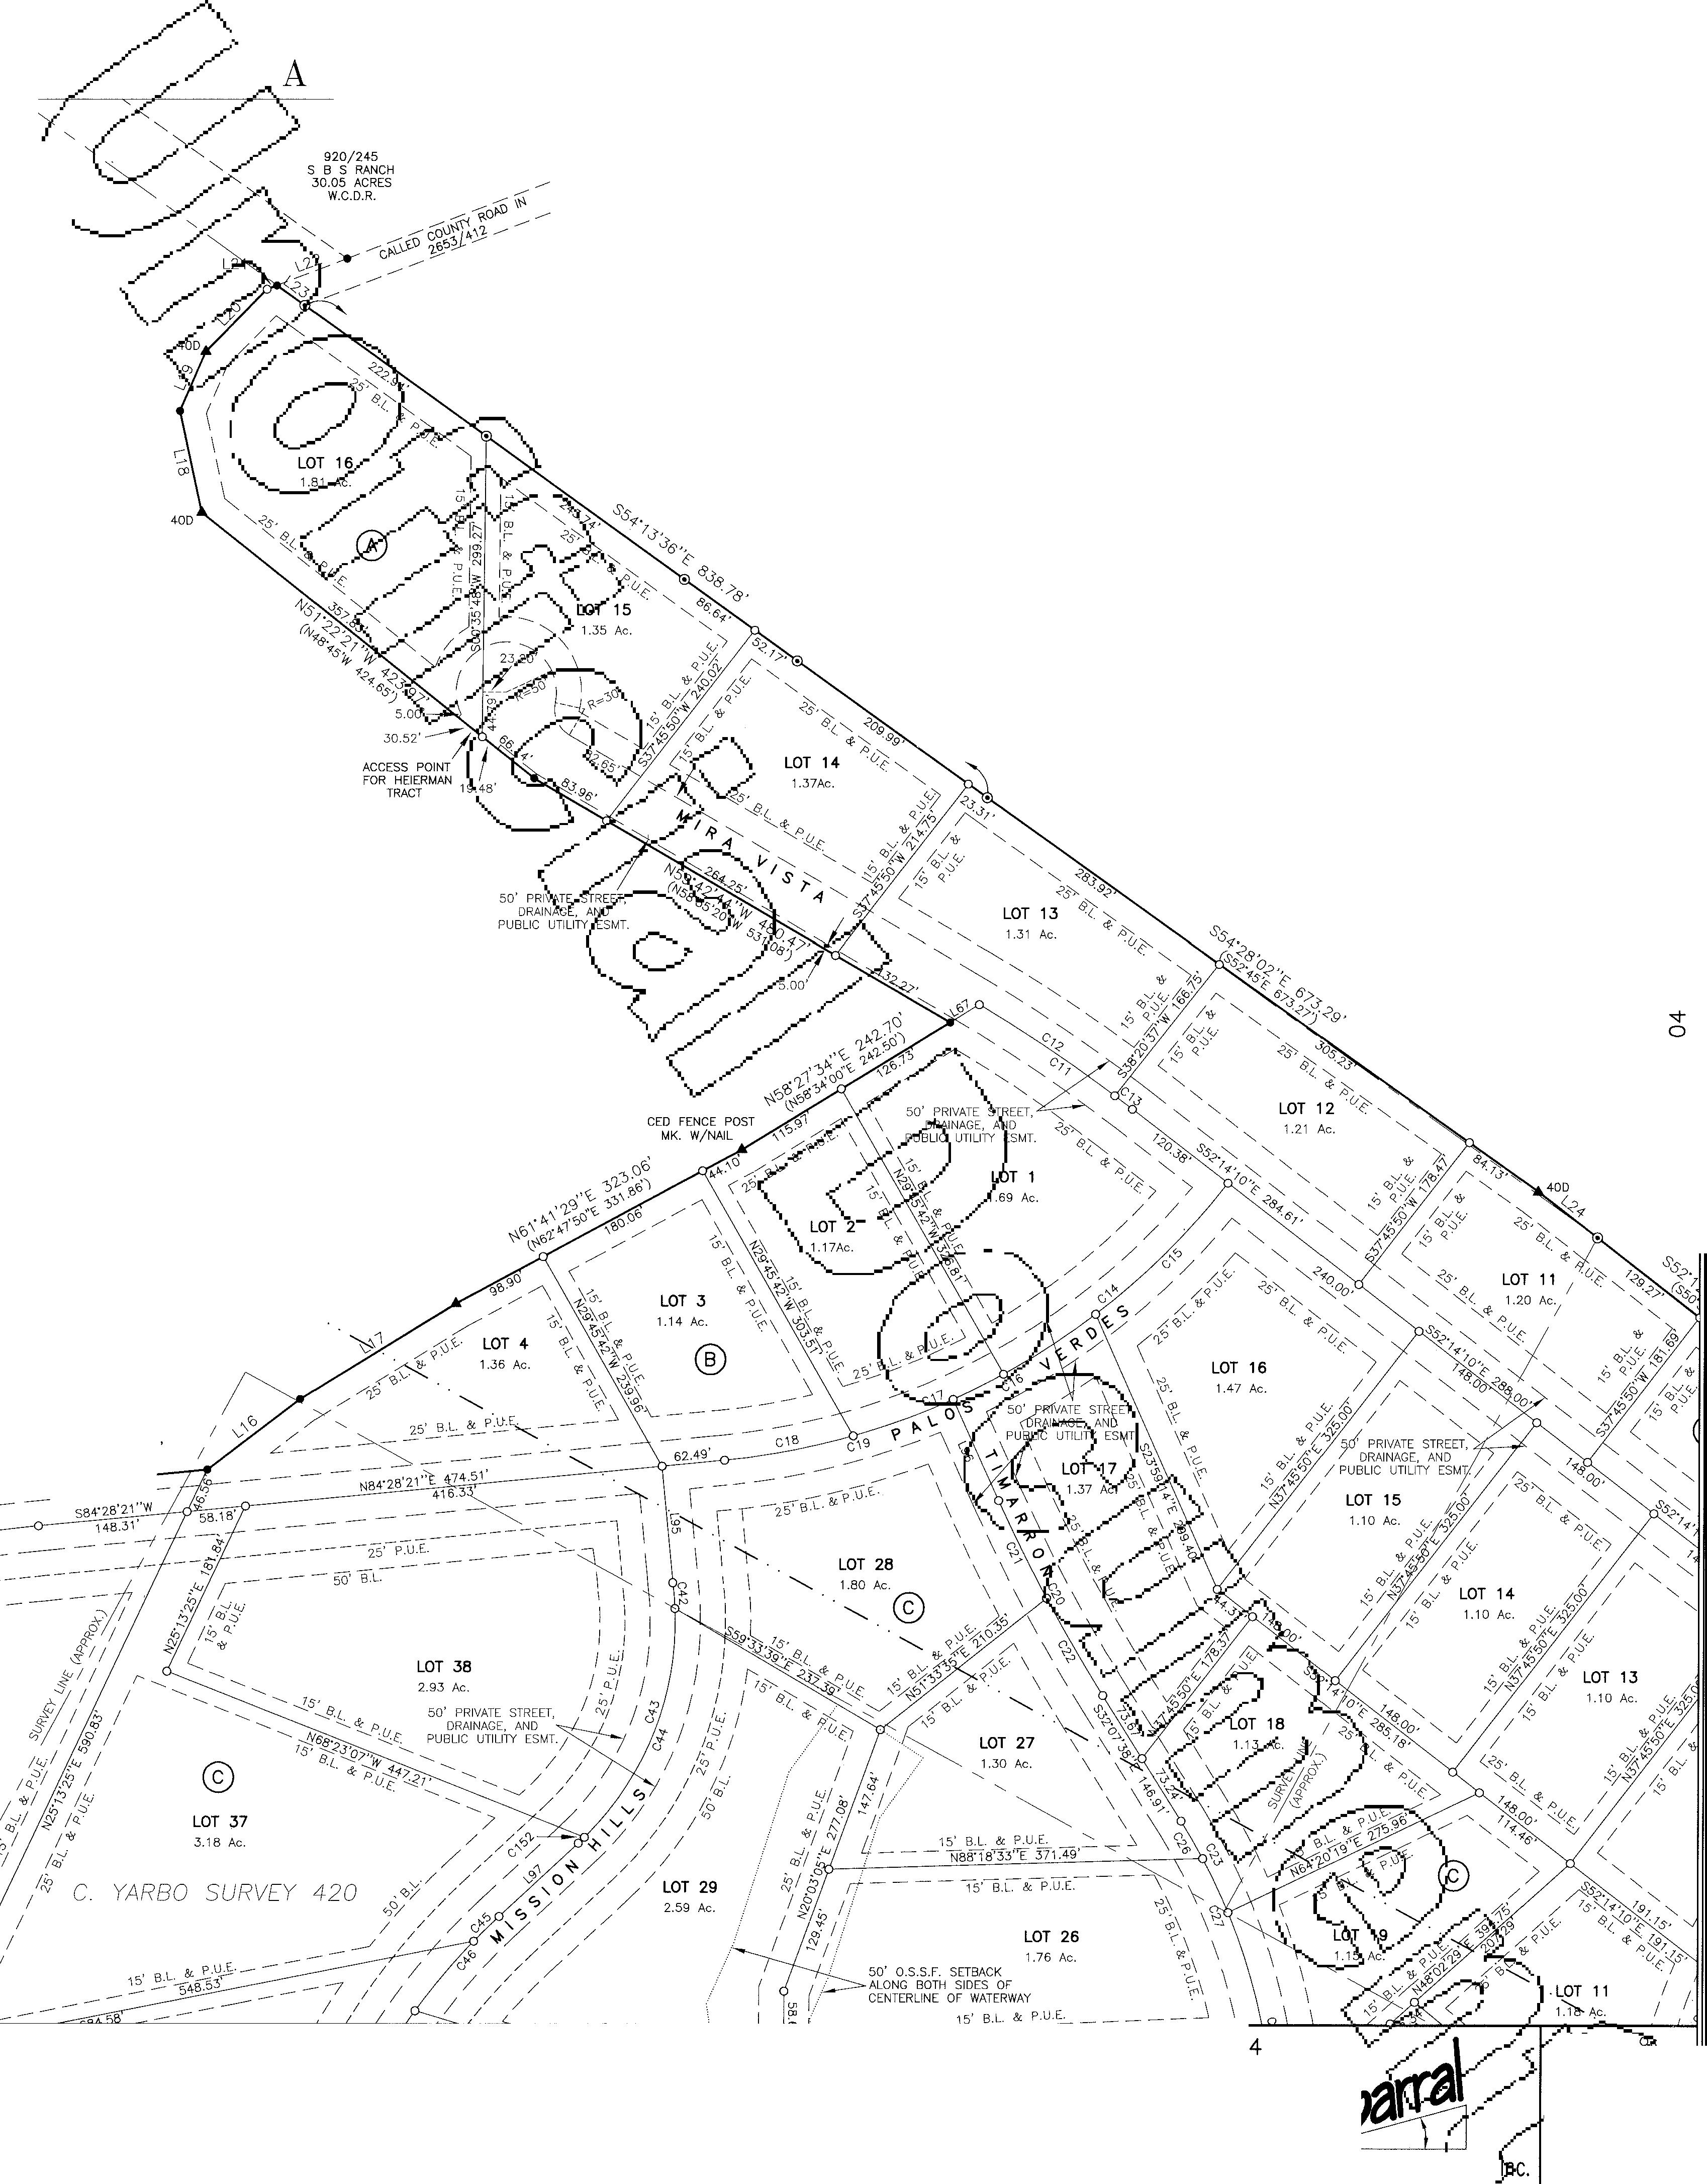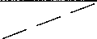

510

South Congress Ave., Suite B-1001 t

Austin, Texas 78704 SHEET

PLOT SCALE: 1"=100'

DRAWN BY: LEA, COD

512-476-7103 01 OF 19

PHOTOGRAPHIC MYLAR ***J«JO ()()(J Ip***

GRAND MESA **AT** CRYSTAL FALLS

**SUBDIVISION** IN **TRAVIS**

S ALE 1"= 100'

**AND WILLIAMSON COUNTIES**

7309/269

TOMLINSON

6.075 ACRES (TRAVIS)

1O" CED STUMP MK. W/NAIL

\

100

11937/558

HEIERMAN 146.625 ACRES (TRAVIS) 93052111 (WILLIAMSON)

LOT **42**

3.27 Ac.

*H[ART SURV[Y 704*

(0

0

w

:r:

(/)

w w

(/)

LOT 5

3.74 Ac.

SEE SHEET 06

GRAND

MESA

SEE SHEET 07

P JECT

62-980

LOT

3.89

CollmIDoR JENGJINJEIERIN"G CoMDPANY

SUBDIVISION

## I

DRA G NO.:

62-0 11

**-1,i,_q** DATE:

01713/00

307 SUNSET DRIVE

(512) 244-4279

ROUND ROCK, TEXAS 78664 FAX: (512) 244-0504

Professional Land Surv ·ng, Surve ng and Mapp1fl.g"

PLOT SCALE:

1"=100'

DRAWN sY,

LEA, COD

**CRYSTAL FALLS**

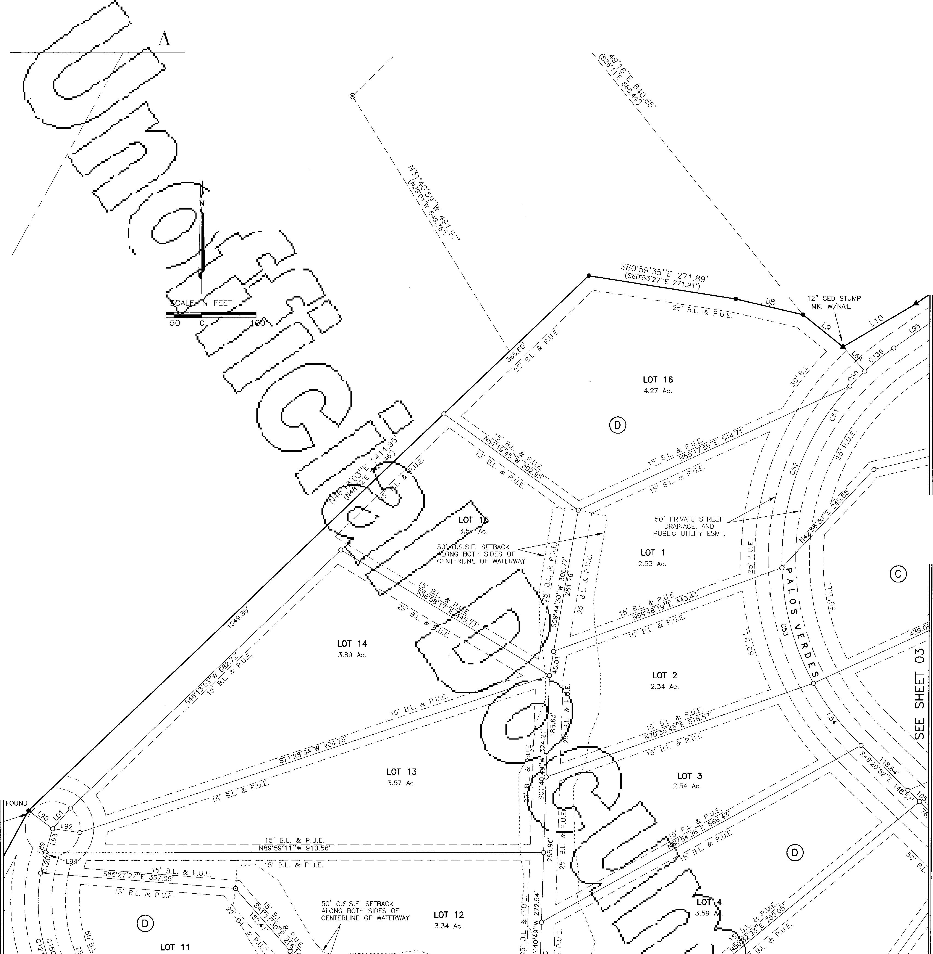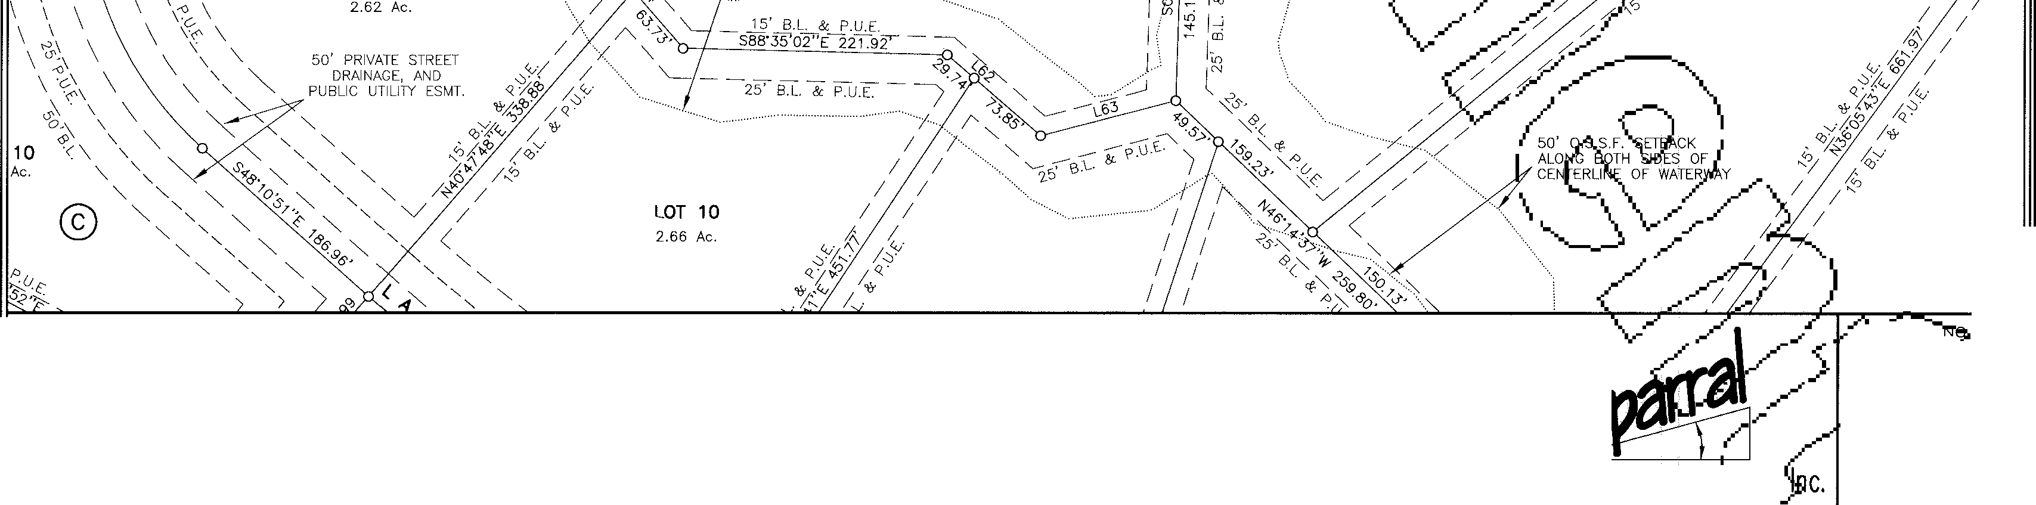

510 South Congress Ave., Suite B-1001 t

Austin, Texas 78704 **SHEET**

512-476-7103 **02 OF 19**

PHOTOGRAPHIC MYLAR

LOT 42

3.27 Ac.

@)

LOT 32

2.20 Ac.

L35

SEE SHEET 07

CoRRIDOJR. JENGI[N]EEIDNG CoMJPANY

MESA

SUBDIVISION

GRAND

# 8

SEE

RAWlef NO.:

2-0

L&'P DATE:

1 /13/00

307 SUNSET DRIVE

(512) 244-4279

ROUND ROCK, TEXAS 78664 FAX: (512) 244-0504

Professional Land SurveJi.ng, I Surve ng and Mappiri'g"_.

PLOT SCALE:

1"=100'

DRAWN BY: LEA, COD

**CRYSTAL FALLS**

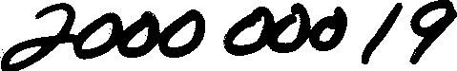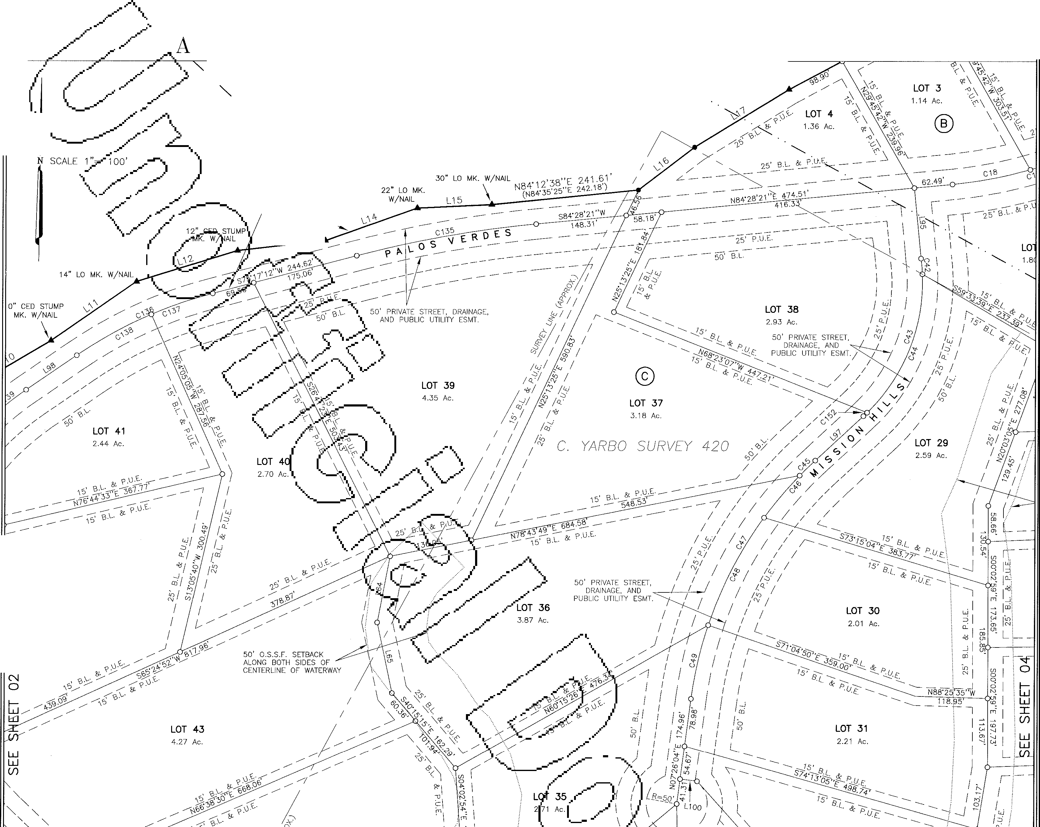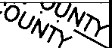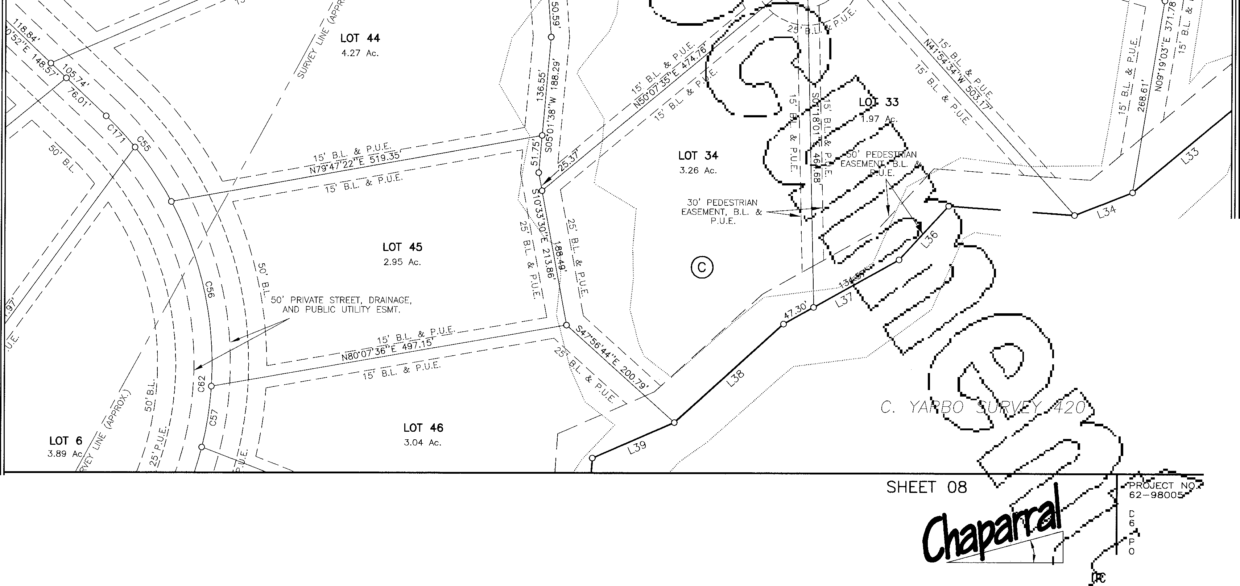

SUBDIVISION IN TRAVIS

/

/

GRAND

MESA AT

CRYSTAL FALLS

AND WILLIAMSON COUNTIES

18" CED MK. W/NAIL

SEE SHEET 01

SCALE IN FEET

'---..

._

/

100 50

0

100

'y·

/

LANDSCAPE LOT

1.230 Ac.

14" LO MK. MK. W/NAIL

L~~13~~

510 South Congress Ave., Suite B-1001 1

Austin, Texas 78704 **SHEET**

512-476-7103 **03 OF 19**

PHOTOGRAPHIC MYLAR ***J t,t1tJ t!)(}(J IP***

**LOT 23**

1.94 Ac.

50' O.S.S.F. SETBACK ALONG BOTH SIDES OF CENTERLINE OF WATERWAY

***co***

0

twi

:r:

(f)

w

w

(f)

13085/1927

LOOKOUT PARTNERS, 1708.59 ACRES

(TRAVIS)

9758695 (WILLIAMSON)

L.P.

L[)

0

twi

:r:

(f)

w

w

(f)

SEE SHEET 08

GRAND MESA

-"F't.oJECT 62-980

DRAW,: NO.:

CORRIDOR 1ENGJINJEERJING CoMJPANY

SUBDIVISION

# 8

62-0 11

-1,,I-QT- DATE:

0 '1'713/00

307 SUNSET DRIVE

(512) 244-4279

ROUND ROCK, TEXAS 78664 FAX: (512) 244-0504

Professional Land Surv ·ng, Surveying and Map

PLOT SCALE:

1"=100'

DRAWN sY,

LEA, COD

**CRYSTALFALLS**

510 South Congress Ave., Suite B-1001 S-H_E_ET

Austin, Texas 78704

--1

512-476-7103 **04 OF 19**

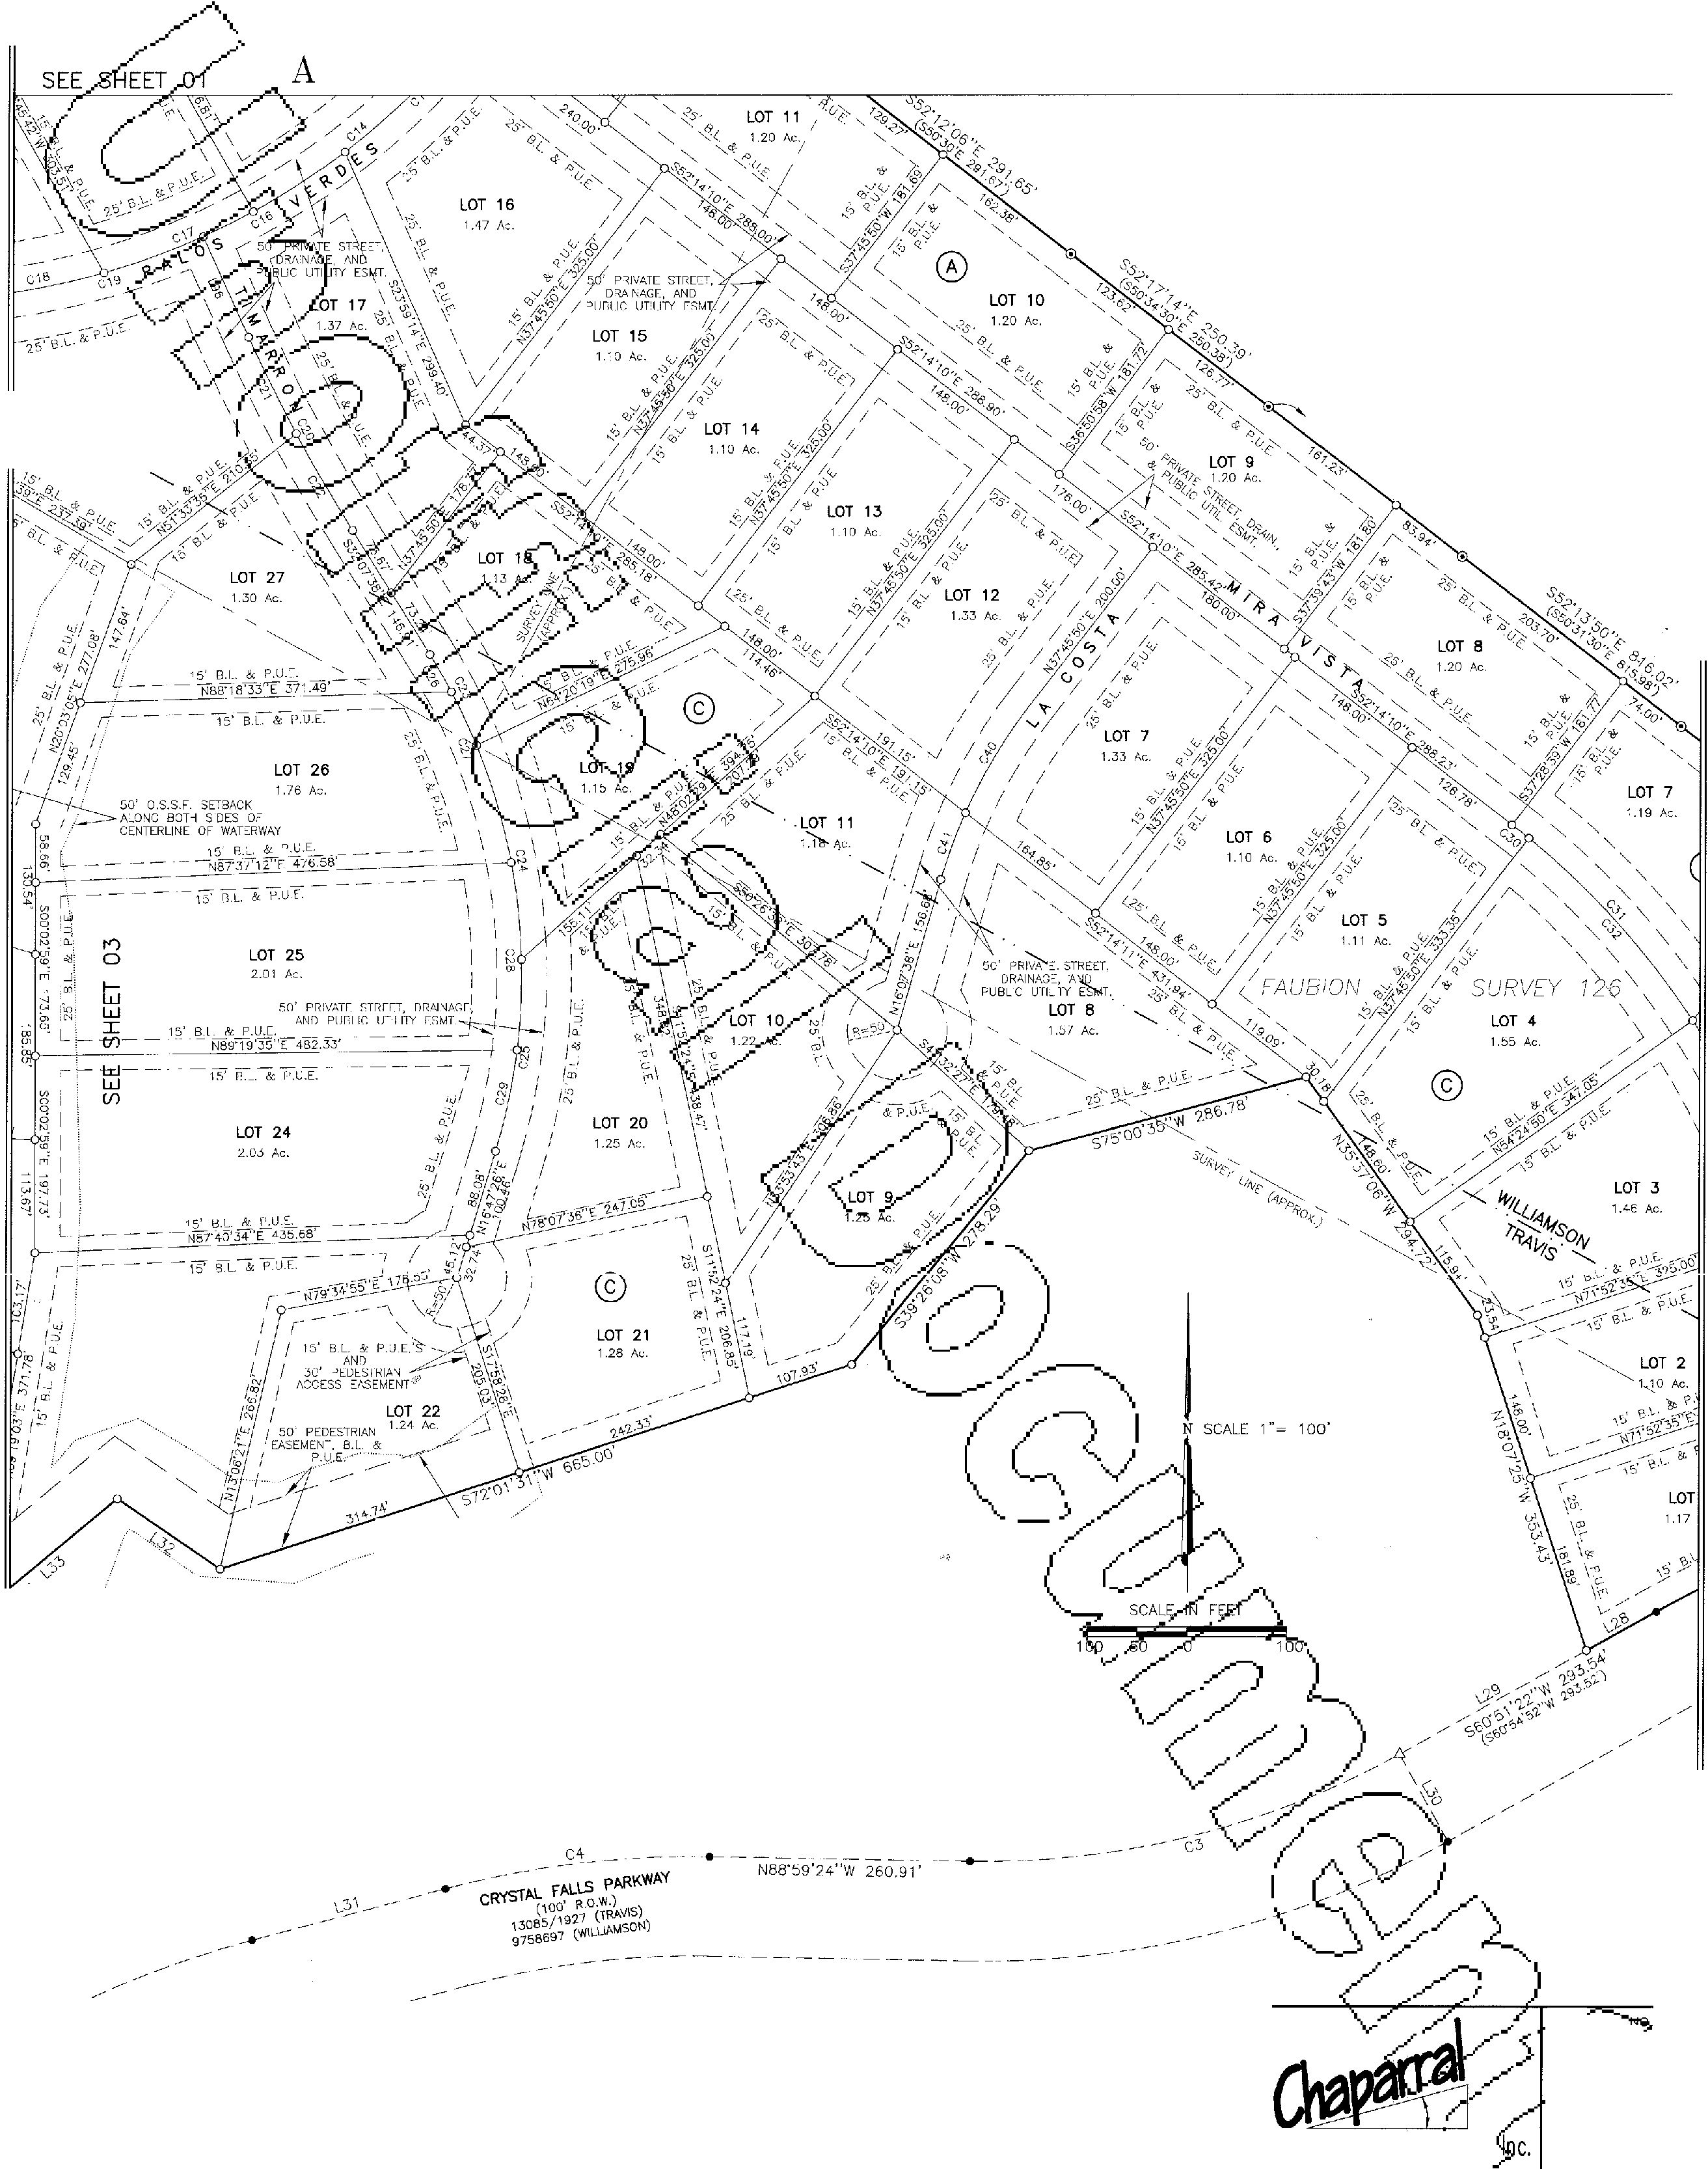

GRAND

MESA

**AT**

**SUBDIVISION IN TRAVIS**

CRYSTAL FALLS

**AND WILLIAMSON COUNTIES**

**SEE SHEET 01**

**LOT 28**

1.80 Ac.

"- ©

**L[)**

**0**

**:r:**

**(f)**

t**w**i

**w**

**(f)**

**w**

PHOTOGRAPHIC MYLAR

GRAND MESA **AT**

CRYSTAL FALLS

w

:r:

*Cf)*

w

w

*Cf)*

**SUBDIVISION**

IN **TRAVIS**

**AND WILLIAMSON**

**COUNTIES**

**N** SCALE 1 "= 100'

SCALE IN FEET

100 50 0 100

LOT 3

1.46 Ac.

NOTE: LOTS 3, BLOCK "A", AND LANDSCAPE LOTS WILL BE MAINTAINED BY THE GRAND MESA AT CRYSTAL FALLS PROPERTY OWNER'S ASSOCIATION.

**LANDSCAPE** LOT

0.081 Ac.

9758695

(WILLIAMSON)

s;j-

0

w

:r:

*Cf)*

w w

*Cf)*

GRAND MESA

CoJRruDOOR JENGl!NEEJIUNG CoMIPANY

SUBDIVISION

# 8

307 SUNSET DRIVE

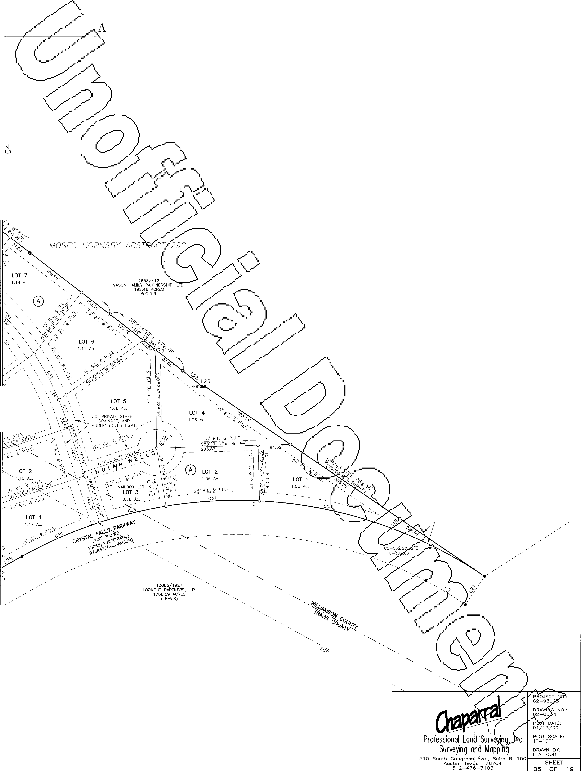

(512) 244-4279

ROUND ROCK, TEXAS 78664 FAX: (512) 244-0504

**CRYSTALFALlS**

PHOTOGRAPHIC MYLAR ***I?***

GRAND MESA **AT**

CRYSTAL

A SUBDIVISION **IN TRAVIS**

**AND WILLIAMSON COUNTIES**

SEE SHEET 02

5.63' TO ACCESS EASEMENT.

NO ACCESS FROM HEIERMAN TRACT.

**N** SCALE 1"= 1oo'

50' O.S.S.F. SETBACK ALONG BOTH SIDES OF CENTERLINE OF WATERWAY

**LOT 12**

3.34 Ac.

*I*

*I*

#### *I*

*I* 100

*I*

**LOT 9**

3.14 Ac.

r---

**0**

w

:r:

(/)

SEE SHEET 09 GRAND

MESA SEE

CORRIDOR JENGJINJEERJING CoMJPANY

SUBDIVISION

# 8

307 SUNSET DRIVE

ROUND ROCK, TEXAS 78664

Professional Land Sur ng,

PLOT SCALE:

1"=100'

(512) 244-4279

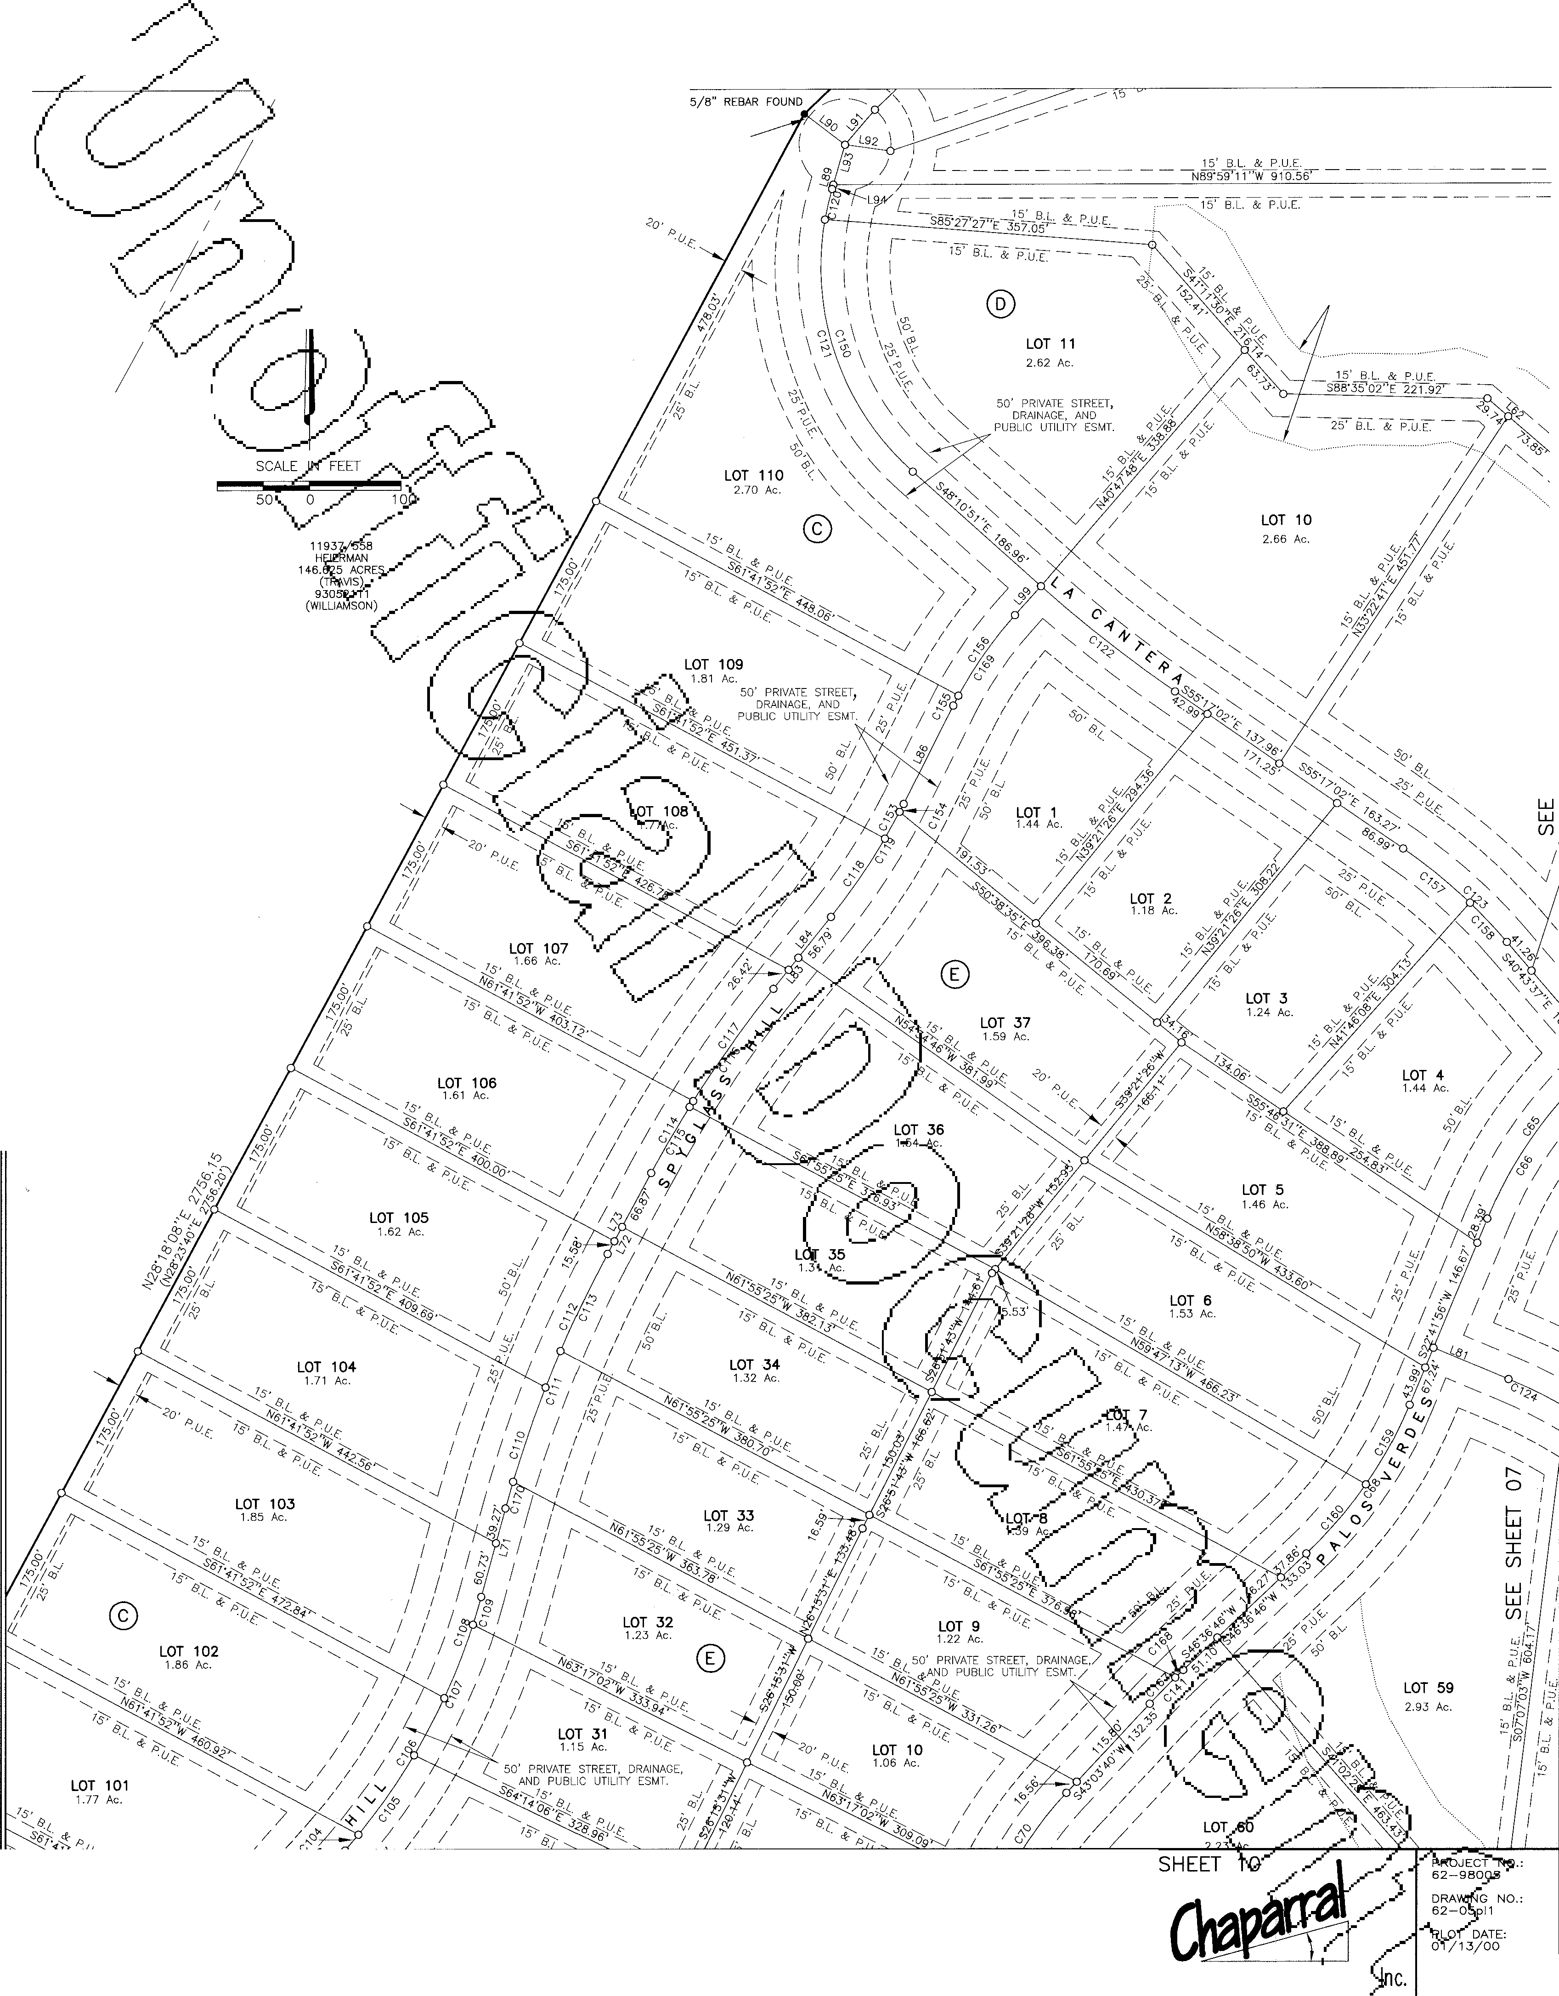

FAX: (512) 244-0504

**CRYSTALFALlS**

Surve ng and Mapp,iA DRAWN sY,

LEA, COD

510 South Congress Ave., Suite B-1 **QQl,... 1**

Austin, Texas 78704 **SHEET**

512-476-7103 **06 OF 19**

PHOTOGRAPHIC MYLAR



GRAND MESA AT CRYSTAL FALLS

A SUBDIVISION IN TRAVIS AND WILLIAMSON COUNTIES SEE SHEET 03

LOT 12

3.34 Ac.

LOT 9

3.14 Ac.

<n

*U)*

LwJ

I

(/)

w

w

(/)

N SCALE 1"= 100'

SCALE IN FEET

50 0 100

ro

0

LwJ

I

(/)

w w

(/)

*I*

*I*

*I*

*I*

*I*

*I*

*I*

*I*

*( I*

*I*

SEE SHEET 10

CoJRRIDoR ENGJINEERJING CoMJ?ANY

GRAND MESA

SUBDIVISION

## I

SEE SHEET 1

Professional Land Surv ng,

P JECT 62-980o/

DRAW, NO.: 62-05 11

-1, Q.T DATE: 01;13/00

1"=100'

307 SUNSET DRIVE

(512) 244-4279

ROUND ROCK, TEXAS 78664

FAX: (512) 244-0504

Surve ng and Mapp

PLOT SCALE:

DRAWN BY: LEA, COD

**CRYSTALFALLS**

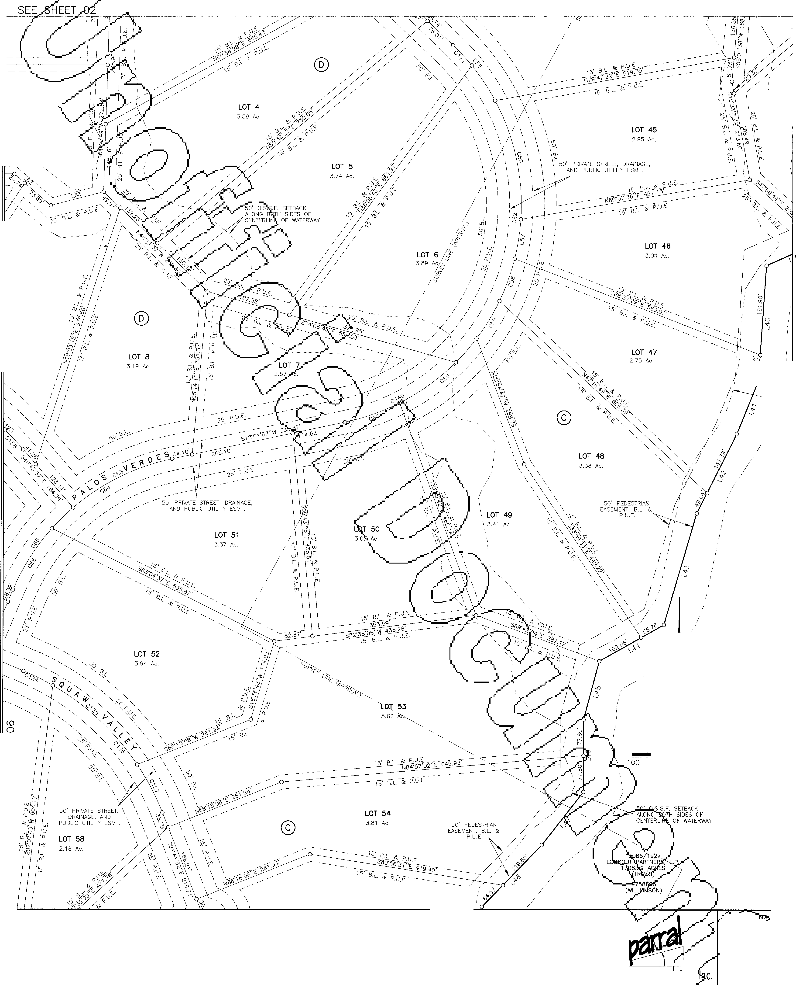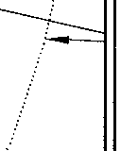

510 South Congress Ave., Suite 8-1001 1

Austin, Texas 78704 SHEET

512-476-7103 07 OF 19

PHOTOGRAPHIC MYLAR

GRAND MESA **AT** CRYSTAL FALLS

**SE SUBDIVISION IN TRAVIS AND WILLIAMSON COUNTIES SEE SHEET 04**

J (o/)I

**LOT 33**

°'-\

::::I'"°'

-s;f-

I coo,_l

"'I I

1.97 Ac.

0

w

I °*.P*'*.*c\ <l w

r" \ :m'".I Cl

OJ

50' O.S.S.F. SETBACK

ALONG BOTH SIDES OF I

I -1

I I

L35

CENTERLINE OF WATERWAY

13085/1927

LOOKOUT PARTNERS, L.P.

1708.59 ACRES (TRAVIS)

9758695

(WILLIAMSON)

(f)

w w

(f)

0

*a,*

*a,*

0

"-1-

J

N SCALE 1"= 100'

50' O.S.S.F. SETBACK

.'--''=-- ALONG BOTH SIDES OF CENTERLINE OF WATERWAY

|  |  |  |  |  |
| --- | --- | --- | --- | --- |
|  | SCALE | IN | FEET |  |
| 100 | 50 | 0 |  | 100 |

**r---**

**0**

**w**w

I

**(f)**

**w w**

**(f)**

SEE SHEET 11

CoJRRIDOR JENGrnEEllUNli Co:MlPANY

GRAND MESA

SUBDIVISION

# 8

DR NO.:

..{2

pb,c5T DATE:

01/13/00

307 SUNSET DRIVE

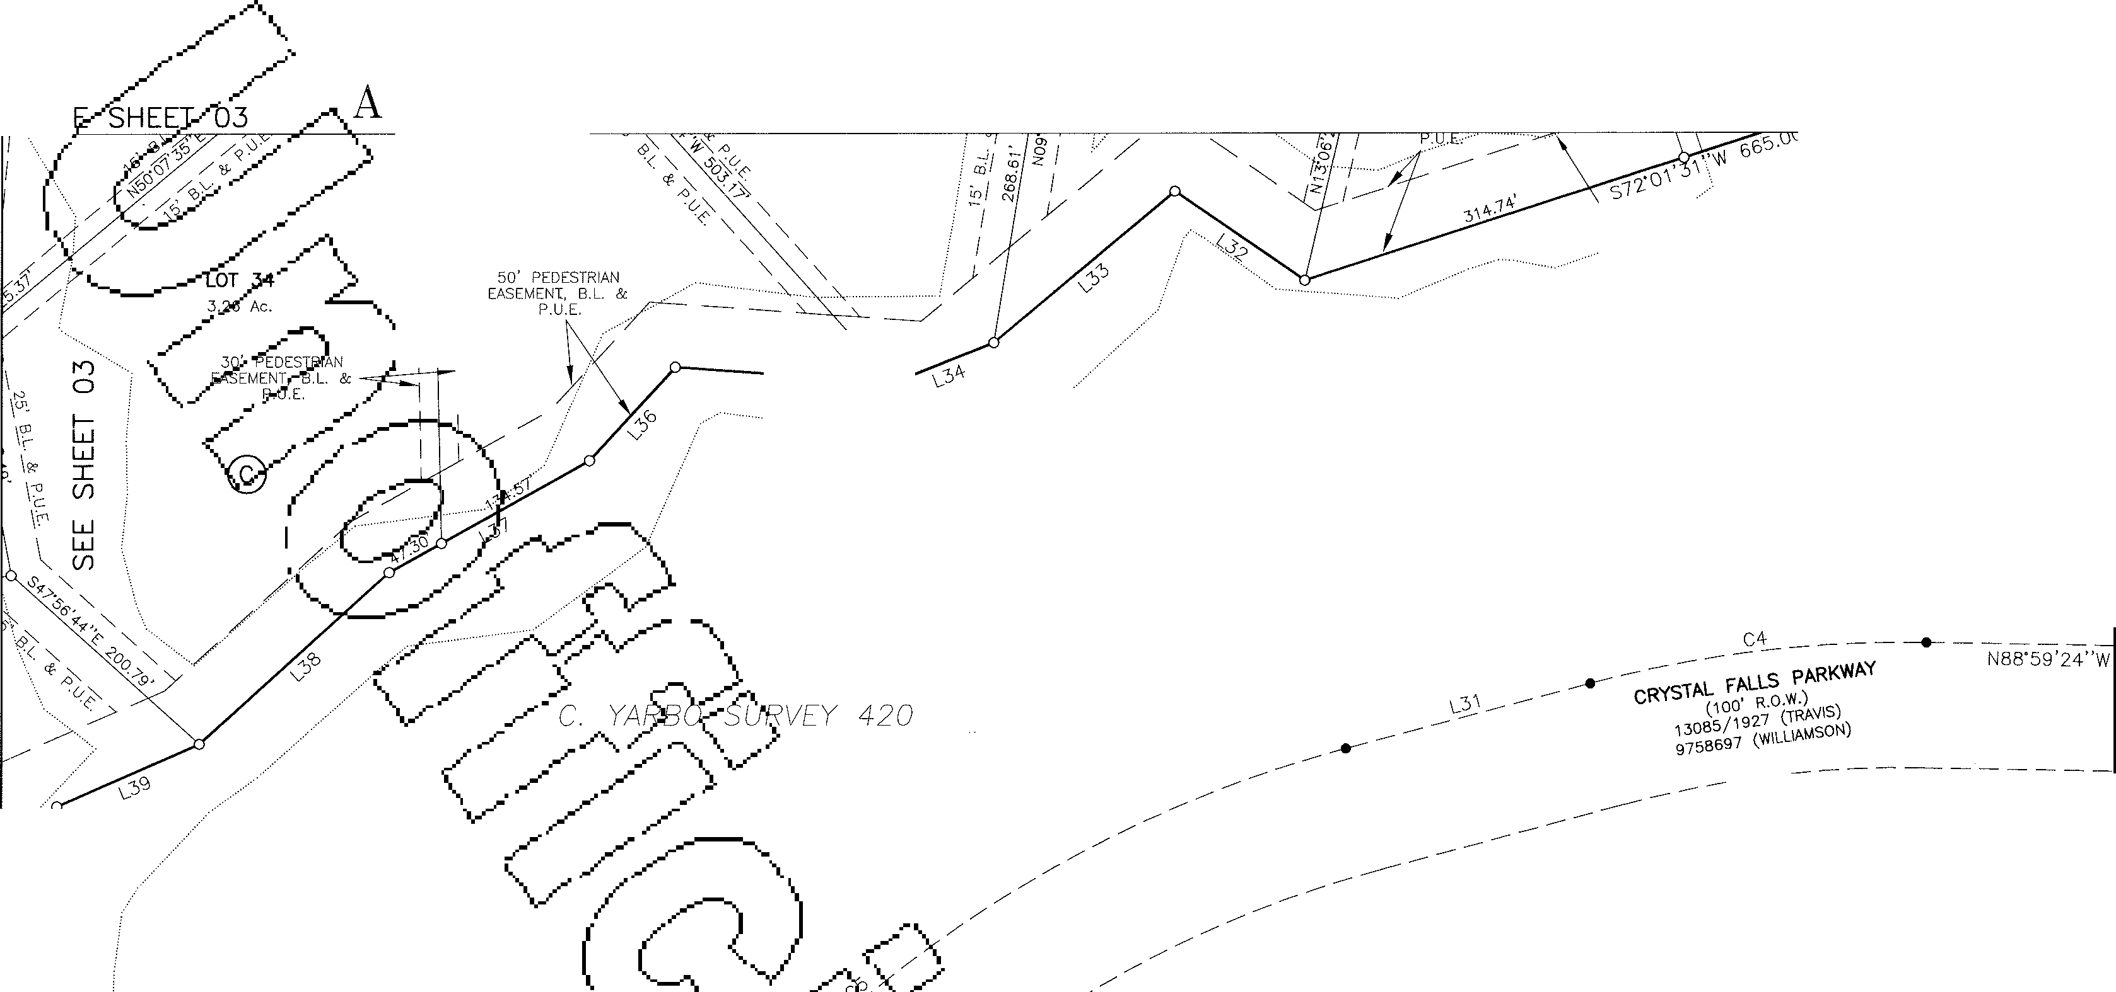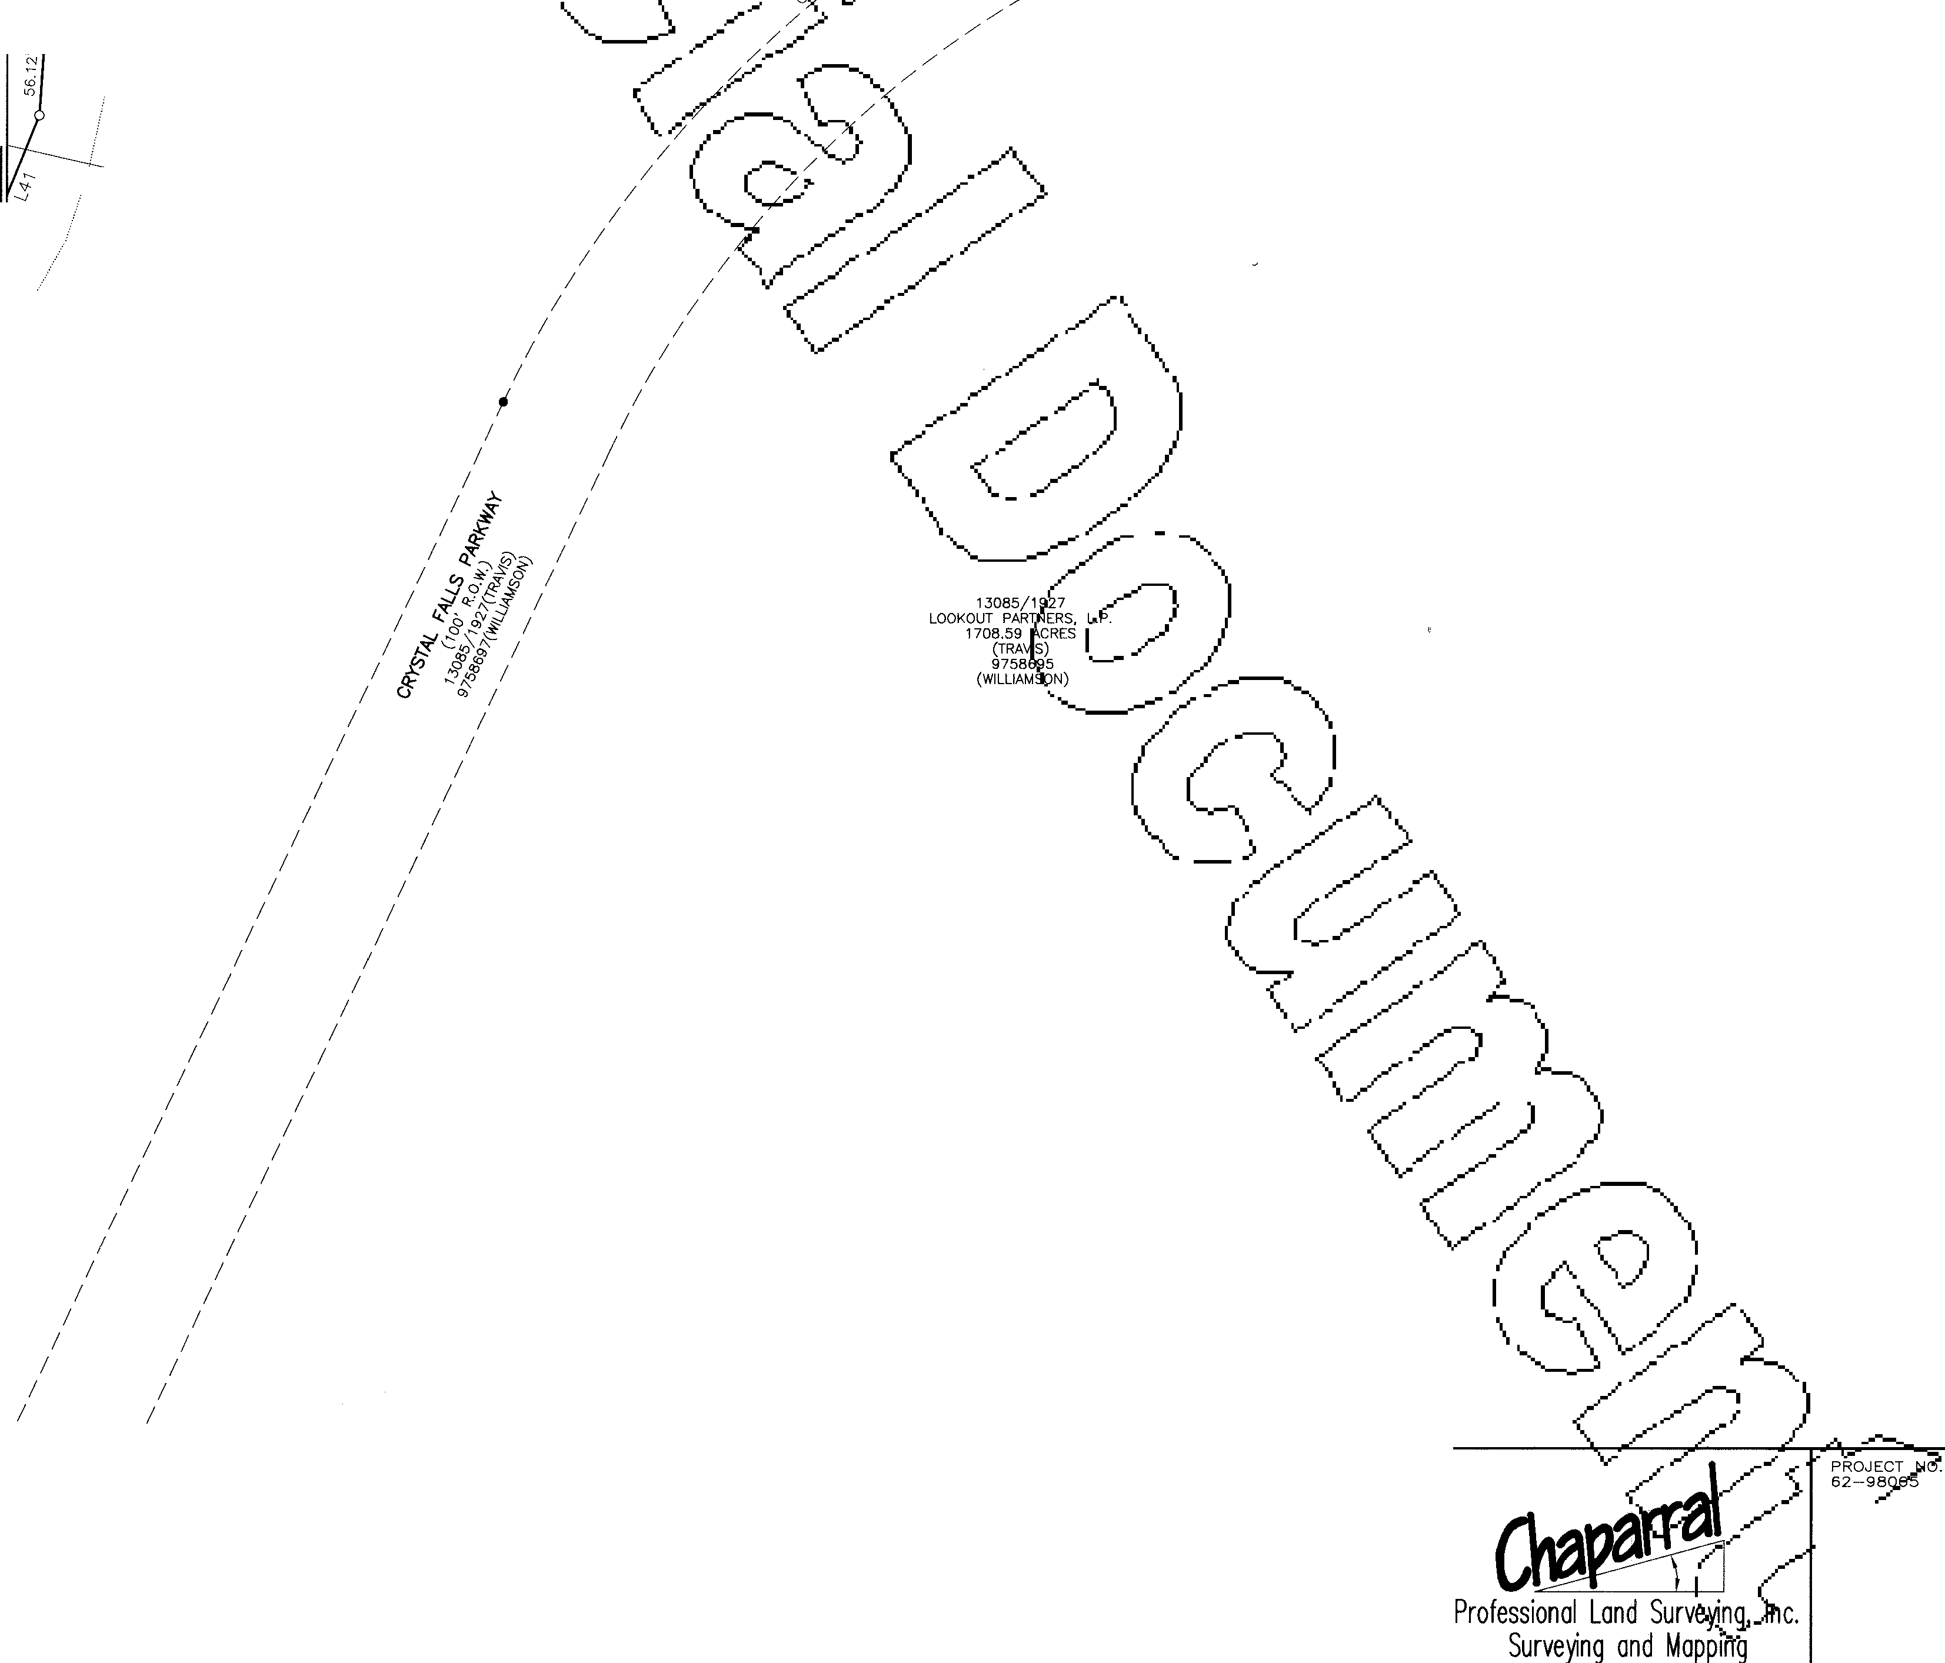

(512) 244-4279

ROUND ROCK, TEXAS 78664

FAX: (512) 244-0504

**CRYSTALFALlS**

PLOT SCALE:

1"-100'

DRAWN BY: LEA, COD

510 South Congress Ave., Suite B-1001 l

Austin, Texas 78704 SHEET

512-476-7103 08 OF 19

PHOTOGRAPHIC MYLAR

GRAND MESA AT CRYSTAL

FALLS

SUBDIVISION IN TRAVIS AND

WILLIAMSON COUNTIES SEE SHEET 06

11961/1892

LOWELL C. REED 1013.55 ACRES (TRAVIS)

LOT 1

.

3.07 Ac.

LOT 19

3.10 Ac.

SEE SHEET 12 GRAND

MESA

:JECT

_.- 62-9800§-'

CoRRIIDOR JENGJINEERJING CoMJPANY

SUBDIVISION

## I

DRAWZ NO.:

62-05 1

,OT ATE: 61)'13/00

307 SUNSET DRIVE

(512) 244-4279

ROUND ROCK, TEXAS 78664 FAX: (512) 244-0504

Professional Land Surv ·ng, Surve ng and Mapp1nq--

PLOT SCALE:

1"=100'

DRAWN BY:

LEA, COD

**CRYSTALFALLS**

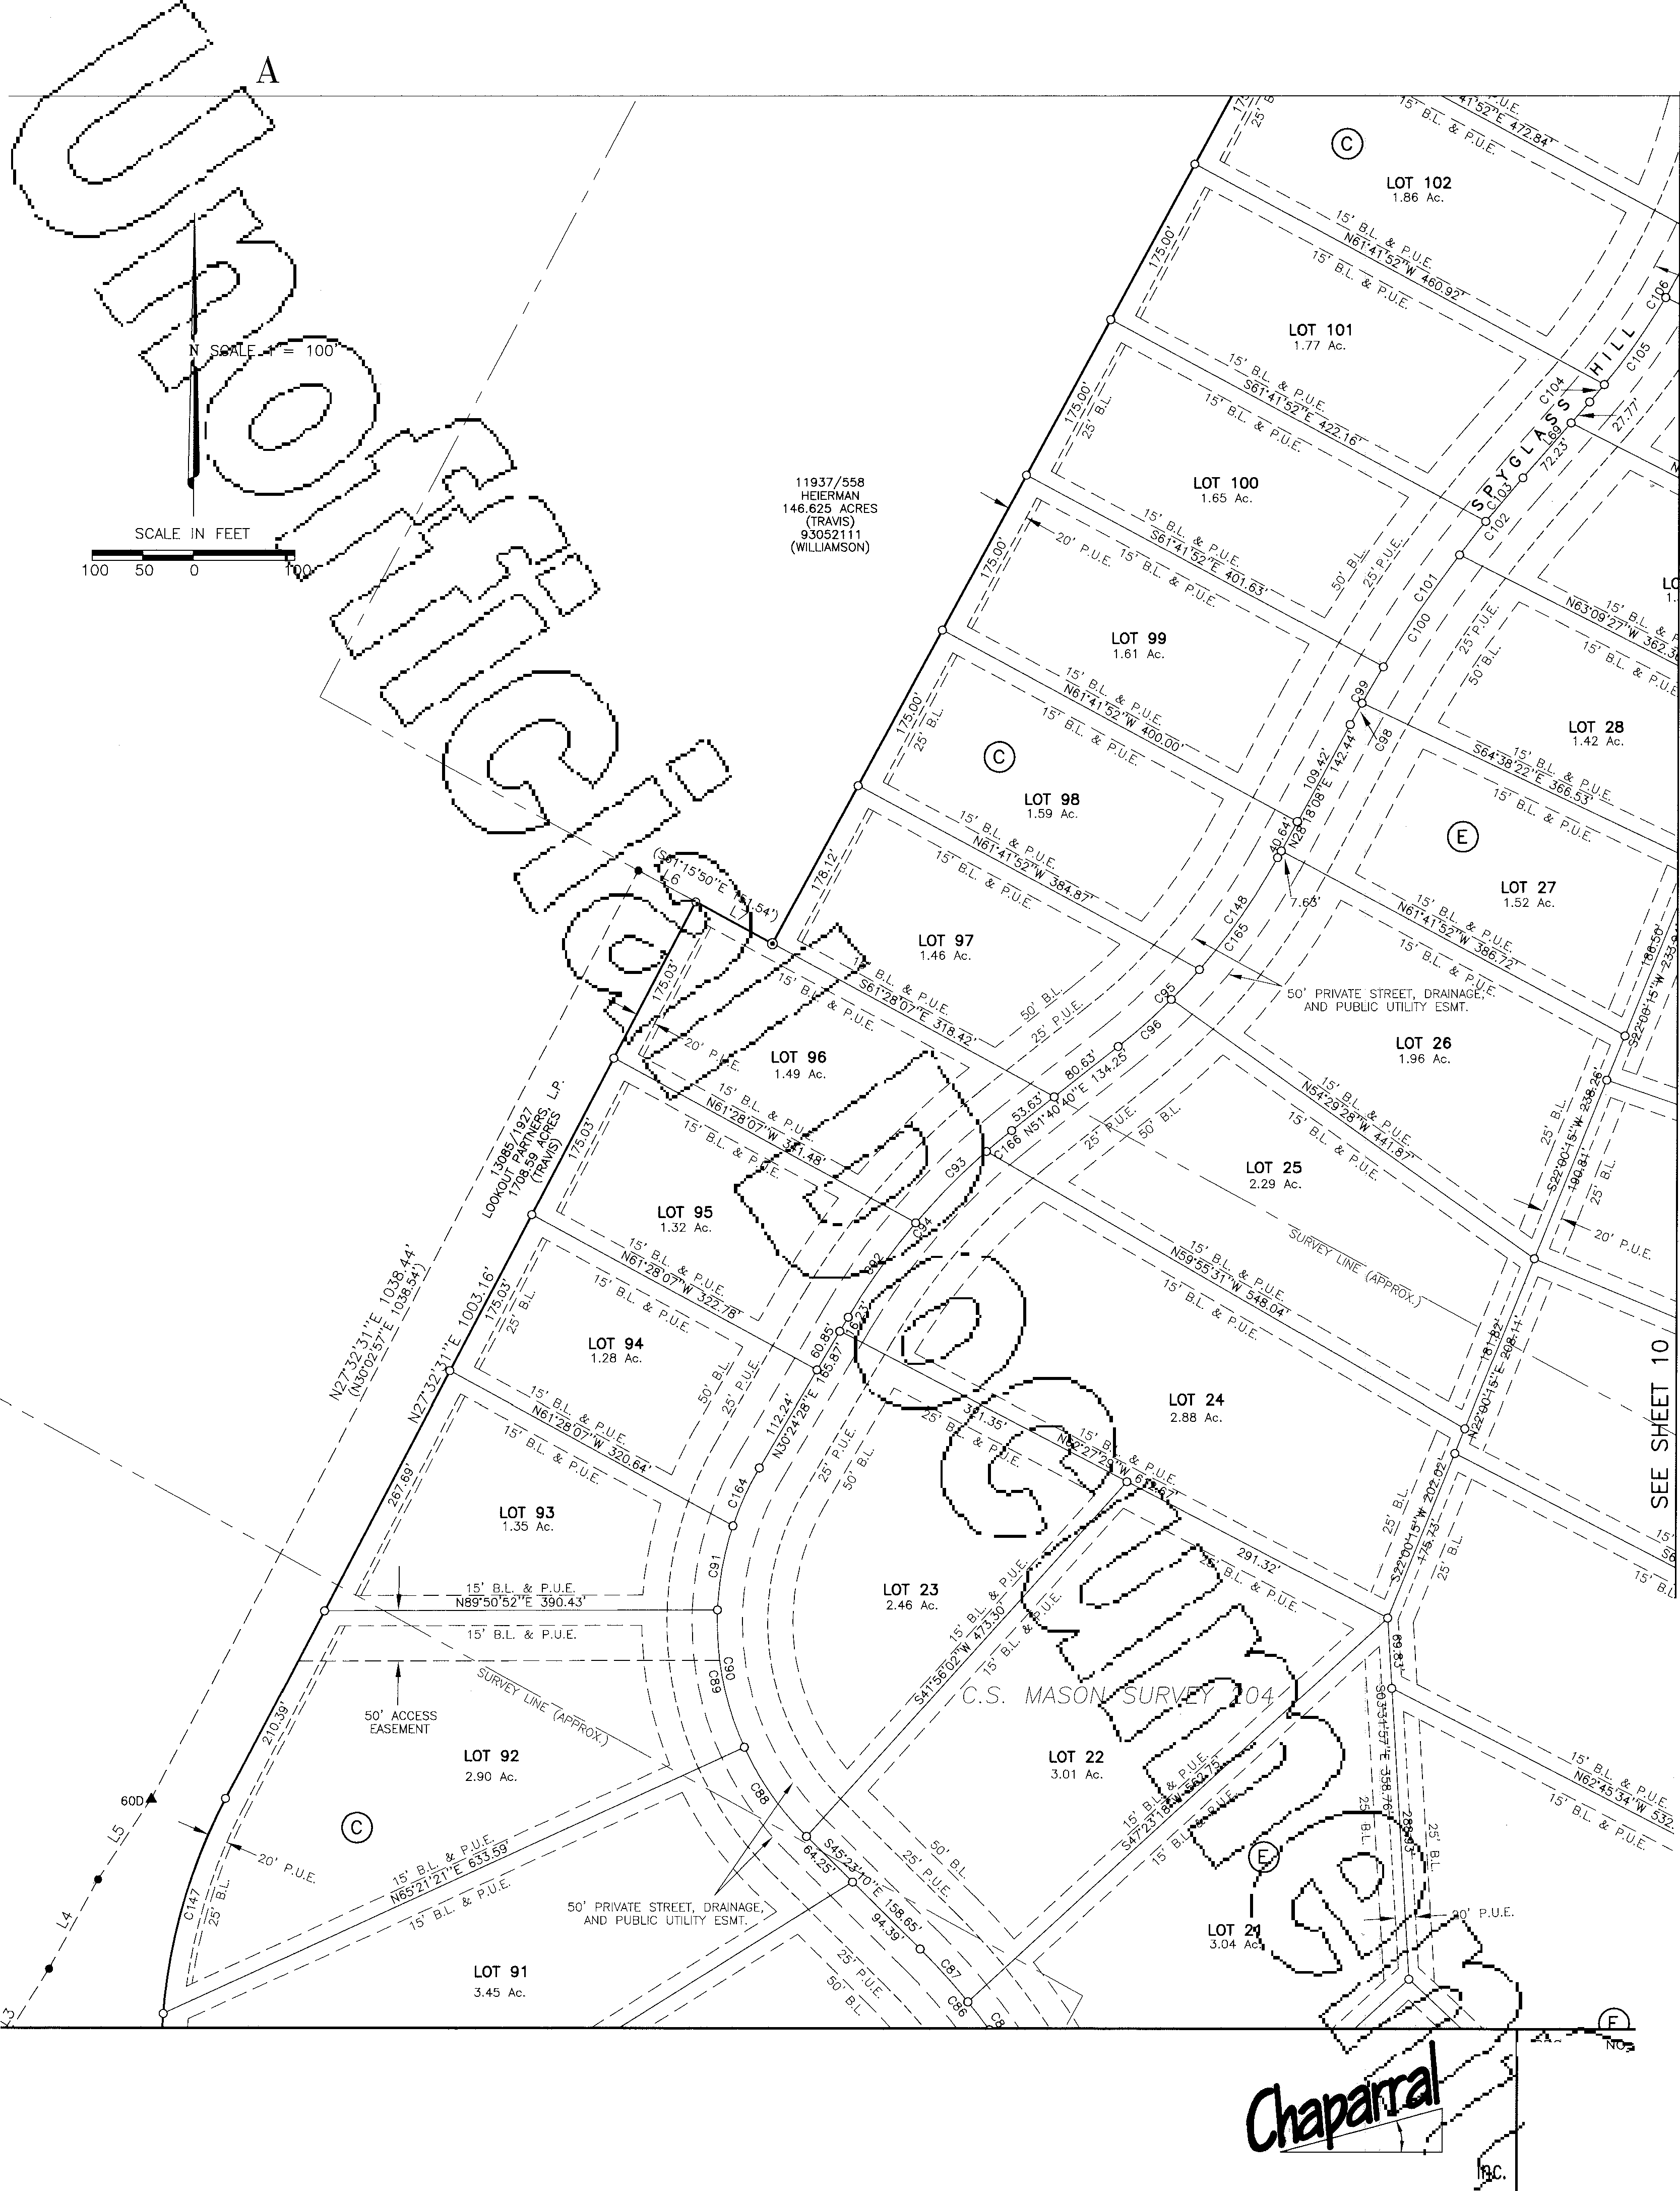

51 0 South Congress Ave., Suite B-1 ooi 4

Austin, Texas 78704 **SHEET**

512-476-7103 **09 OF 19**

PHOTOGRAPHIC MYLAR ***/P***

GRAND MESA AT CRYSTAL FALLS

SUBDIVISION IN TRAVIS AND WILLIAMSON COUNTIES SEE SHEET 07

T 28

.42 Ac.

LOT 63.

5.33 Ac. •

----.. ----.. ----..

----.. ----..

----.. ----..

----.. ----..

---*S*-*;,7c5f';*

----.. *75*

*15,----..*

*8.l.*

N SCALE 1"= 1oo·

SCALE IN FEET

LOT **64**

5.81 Ac.

..­

..-

w

w

w

(/)

0 100 I(/)

LOT 18

3.07 Ac.

OT 19

.10 Ac.

SEE SHEET 13 GRAND

MESA

**-jE?--•m.:**

62-'-gsa ,...,

CoJRRIDOR lENG][N]EERING CoMDPANY

SUBDIVISION

## I

DRA G NO.:

62-0 11

**-1P1;-g** DATE: 0 ,; 13/00

307 SUNSET DRIVE

**ROUND ROCK, TEXAS 78664**

Professional Land Sur

PLOT SCALE:

1"=100'

(512) 244-4279

**FAX: (512) 244-0504**

**CRYSTALFALLS**

Surve ng and Map DRAWN aY,

LEA, COD

51 O South Congress Ave., Suite 8-1001 1

Austin, Texas 78704 SHEET

512-476-7103 10 OF 19

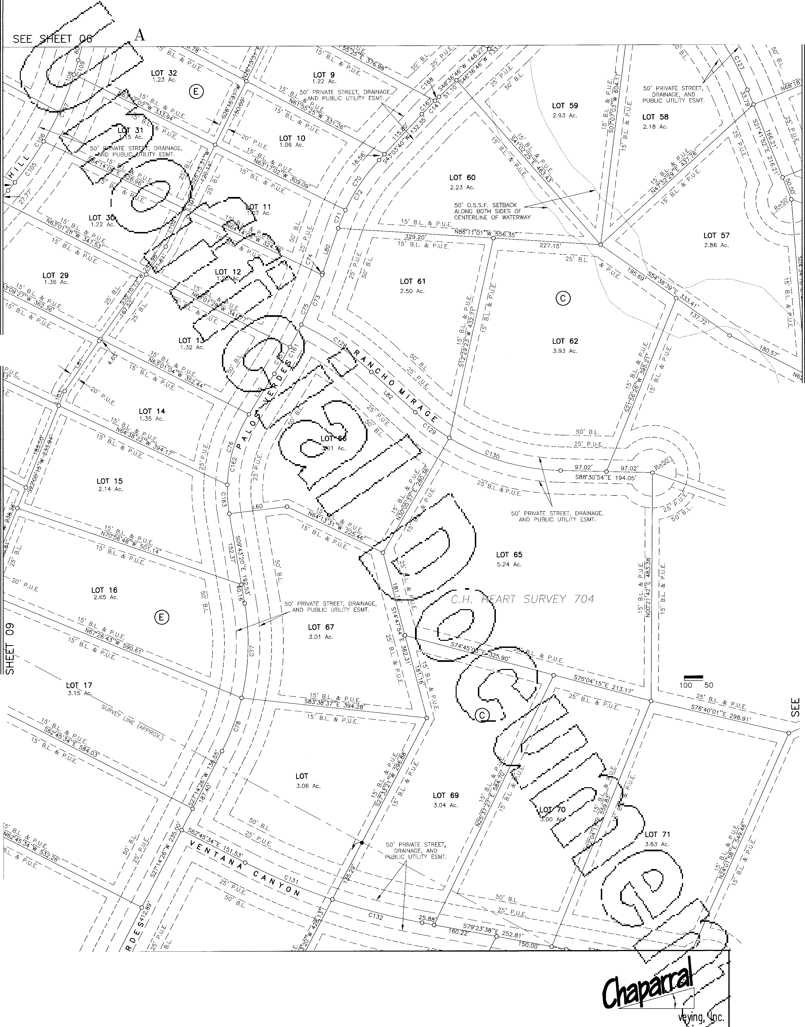

PHOTOGRAPHIC MYLAR

MESA **AT** CRYSTAL

FALLS

**SUBDIVISION IN TRAVIS AND**

*)*

**WILLIAMSON COUNTIES**

*I*

**LOT 54**

3.81 Ac.

50' O.S.S,F. SETBACK ALONG BOTH SIDES OF CENTERLINE OF WATERWAY

*(*

\

\ CsaJ>­

J

13085"/1

LOOKOUT PARTNERS, .P.

1708.59 ACRES (TRAVIS)

9758695

(WILLIAMSON)

*I*

*I*

###### *I*

50' 0.S.S.F. SETBACK / c----=-ALONG BOTH SIDES OF

CENTERLINE OF WATERWAY /

###### *I*

100

**N** SCALE 1"= 100'

SCALE IN FEET

50 0 100

**LOT 63.**

5.33 Ac.• •.

* -.._ 50' PEDESTRIAN ' */_./*
  + ... EASEMENT, B.L. & *i*

-.._, PUE *{*

.. •·.., :

···-••••........ *I i*

.. ..

30' PEDESTRIAN EASEMENT, B.L. & P.U.E.

**LOT 64**

5.81 Ac.

###### *I*

*I*

*I*

*I*

*I*

**LOT 72**

5.93 Ac.

**0** @)

t**w**:J

I

***(J)***

**w w**

***(J)***

I I I I

**LOT 73** I

*I*

4.88 Ac. I

*)*

*TO CATER SURVEY* 206

*I*

*I*

*I*

*I*

50' O.S.S.F. SETBACK

**,.-_cc** ALONG BOTH SIDES OF *I*

CENTERLINE OF WATERWAY

SEE SHEET **14**

<CORRIDOR ENGINJEERJING <COMJP'ANY

GRAND MESA

SUBDIVISION

## I

JECT 62-980ga;-

DRA NO.: 62-0 11

-'\,, *n* DATE:

oY/13/oo

307 SUNSET DRIVE

(512) 244-4279

ROUND ROCK, TEXAS 78664 FAX: (512) 244-0504

Professional Land Sur ving, Surve ng and Mapp"iflg

PLOT SCALE: 1"=100'

DRAWN BY: LEA, COD

**CRYSTALFALIS**

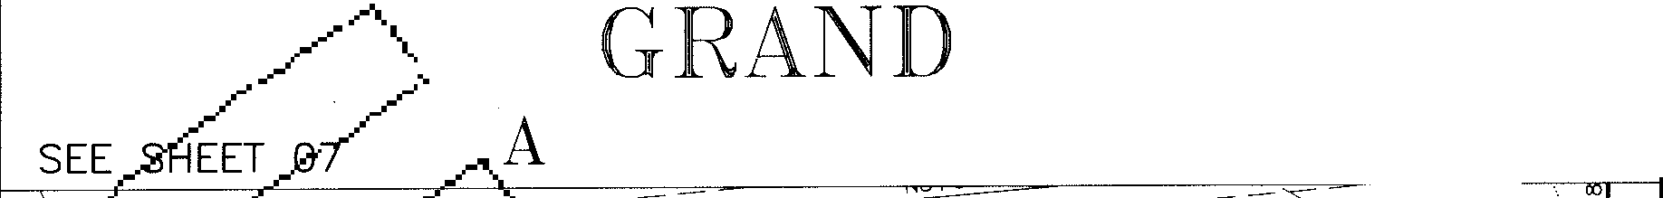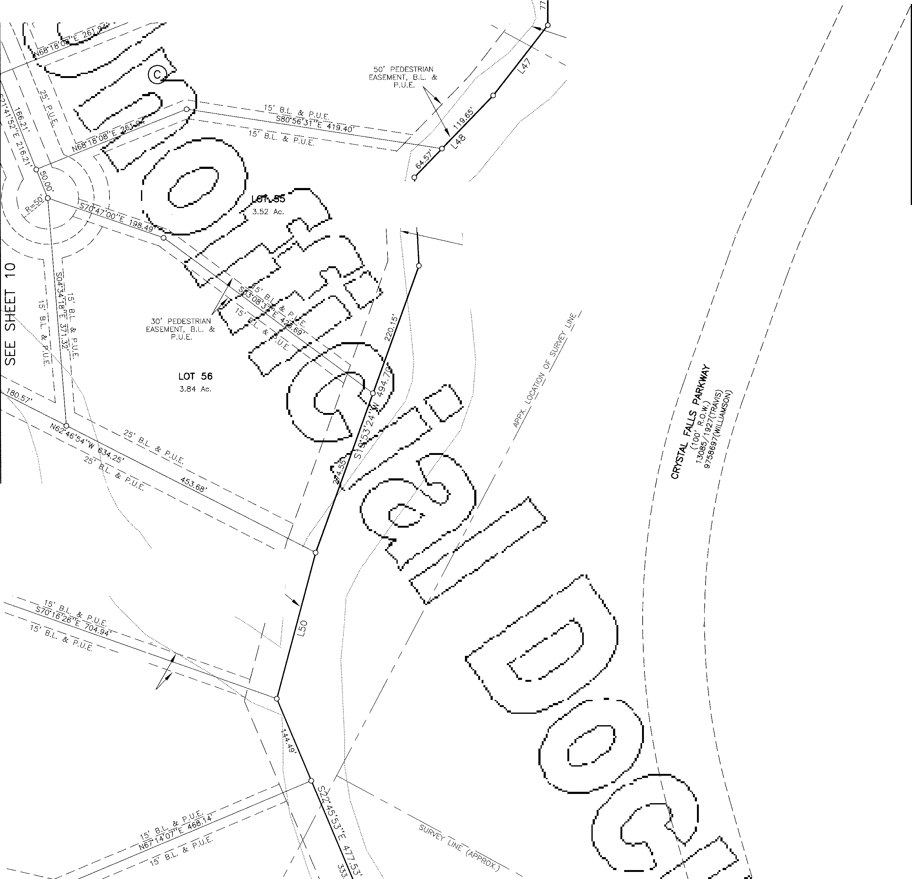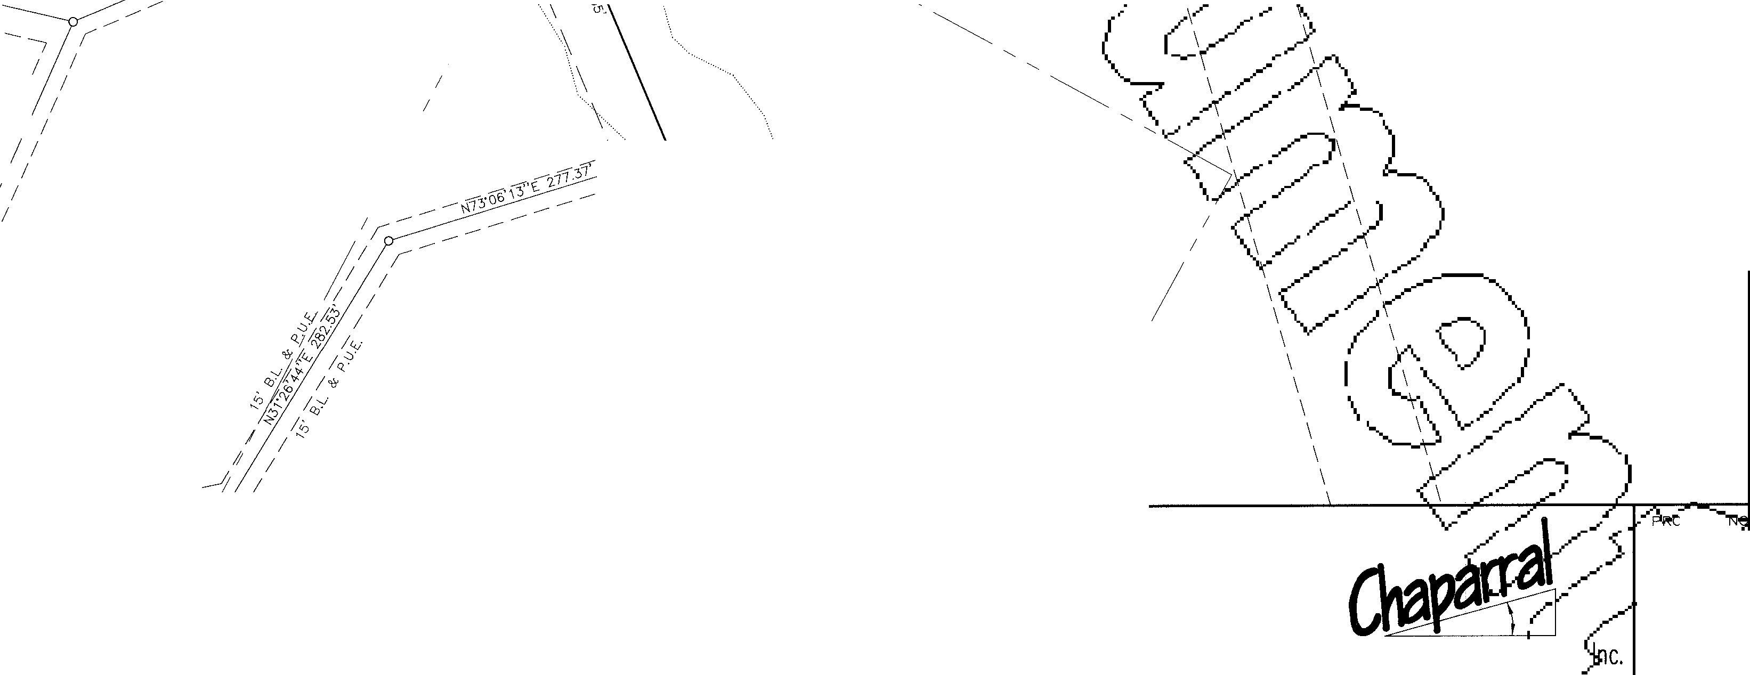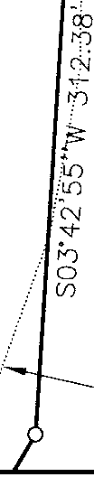

51 0 South Congress Ave., Suite 8-1 001 ,

Austin, Texas 78704 **SHEET**

512-476-7103 **11 OF 19**

PHOTOGRAPHIC MYLAR ***�19***

***/A\*** GRAND MESA **AT** CRYSTAL FALLS

*{..* **SUBDIVISION IN TRAVIS AND WILLIAMSON COUNTIES** SEE SHEET 09

**LOT 20**

3.57 Ac.

**N** SCALE 1"= 100'

SCALE IN FEET

100 50 0 100

C. *w*

*I*

*I*

*I*

*I*

*I*

*I*

*I*

*I*

*I*

*I*

GRAND MESA

**SUBDIVISION**

CORRIDOR ENGINIBEIUN"G Co:MIPANY I

**307 SUNSET DRIVE**

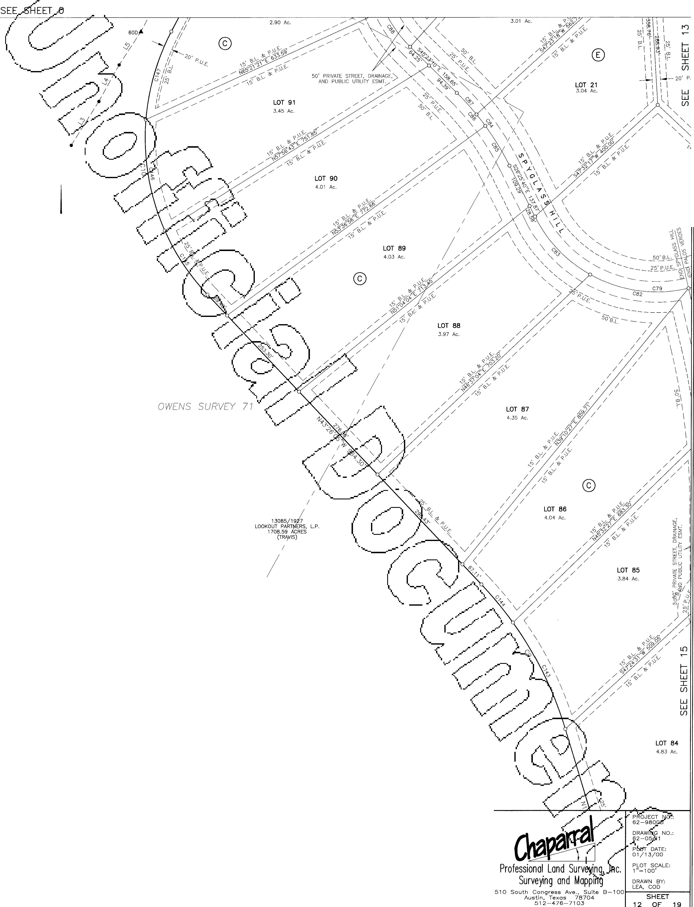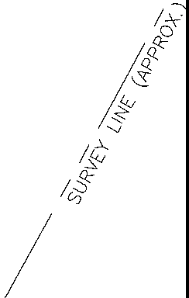

**(512) 244-4279**

**ROUND ROCK, TEXAS 78664 FAX: (512) 244-0504**

**CRYSTAL FALLS**

PHOTOGRAPHIC MYLAR

GRAND MESA AT CRYSTAL FALLS

SUBDIVISION IN TRAVIS AND WILLIAMSON COUNTIES SEE SHEET 10

LOT 71

3.63 Ac.

*I*

*I*

*I*

*I*

-

; *L*

_,,..

T 20

7 Ac.

LOT 7

5.07 Ac

..----

twi

I

(/)

w w

(/)

LOT **84**

4.83 Ac.

SEE SHEET 15

GRAND MESA

SUBDIVISION

.-***t***

OJECT

62-98

G NO.:

pl 1

CORRIDOR ENG][N]EEJlUNG COMPANY **8**

*i" I*

D/oAToE:

307 SUNSET DRIVE

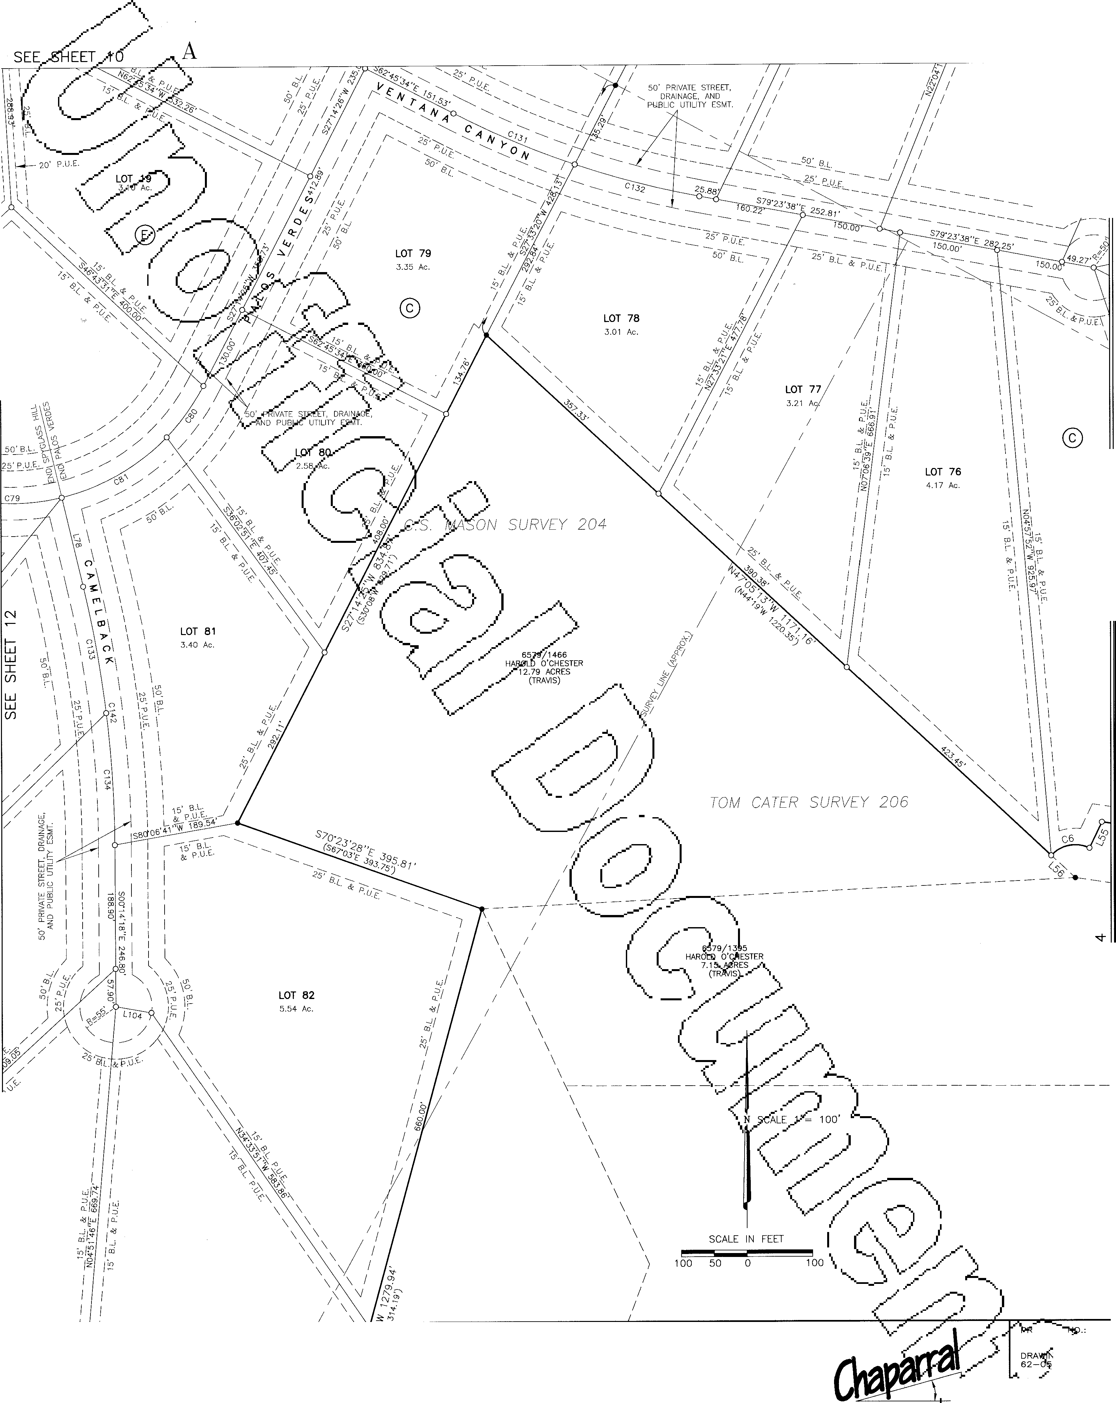

(512) 244-4279

ROUND ROCK, TEXAS 78664 FAX: (512) 244-0504

CRYSTAL FALLS

Professional Land Sur ng, nc. ioiyALE,

Surve ng and Mapp.mg DRAWN sY, LEA, COD

510 South Congress Ave., Suite 8-1001 11

Austin, Texas 78704 **SHEET**

512-476-7103 1.3 OF 19

PHOTOGRAPHIC MYLAR

GRAND MESA **AT** CRYSTAL FALLS

**SUBDIVISION IN TRAVIS AND WILLIAMSON COUNTIES SEE SHEET 11**

I

( ©

**LOT 73**

4.88 Ac.

q::,

".)

61

<'-

*ri,*

*I ?*

I

*y*,'1*,*)

'(',J

I

*"<t-*

r<)

0

I

(/)

*)*

*I*

*I*

*I*

*I*

50' O.S.S.F. SETBACK *I*

ALONG BOTH SIDES OF *I*

CENTERLINE OF WATERWAY *I*

*I*

*I*

*I*

*I*

©

**LOT 75**

5.07 Ac.

*I*

13085/1927

*I*

LOOKOUT PARTNERS, L.P.

1708.59 ACRES (TRAVIS)

9758695 (WILLIAMSON)

*I*

*I*

*I*

**N** SCALE 1"= 1 oo'

**LOT 74**

6.15 Ac.

L**w**J

I

(/)

\

\

\

\

\

\

\

I \\

-,

I \

I \

I I \

I I \

I I \

10833/1355

CITY OF LEANDER 7.0107 ACRES (TRAVIS)

I 13085/1927 \

I

I

LOOKOUT PARTNERS, L.P. \

I

1708.59 ACRES \

I I

I

I

\

I I

I I

I 13085/1974

(TRAVIS)

\

\

\

\

\

\

I

- \

\

LOOKOUT PARTNERS, LP.

375.785 ACRES

(TRAVIS) \

\

9758695 (WILLIAMSON)

\ \

\ \

\ \

\ \

I \

\

\

\

\

\

\

\

\

\

CoruuooR ENGJINJEERING CoMDPANY

GRAND MESA

SUBDIVISION

# 8

OJECT

62-980.¢

DRA G NO.:

62-0 11

.....

fl-1.©T DATE: 01/13/00

PLOT SCALE:

**307 SUNSET DRIVE**

**ROUND ROCK, TEXAS 78664**

Professional Land Surveyin

1"=100'

**(512) 244-4279**

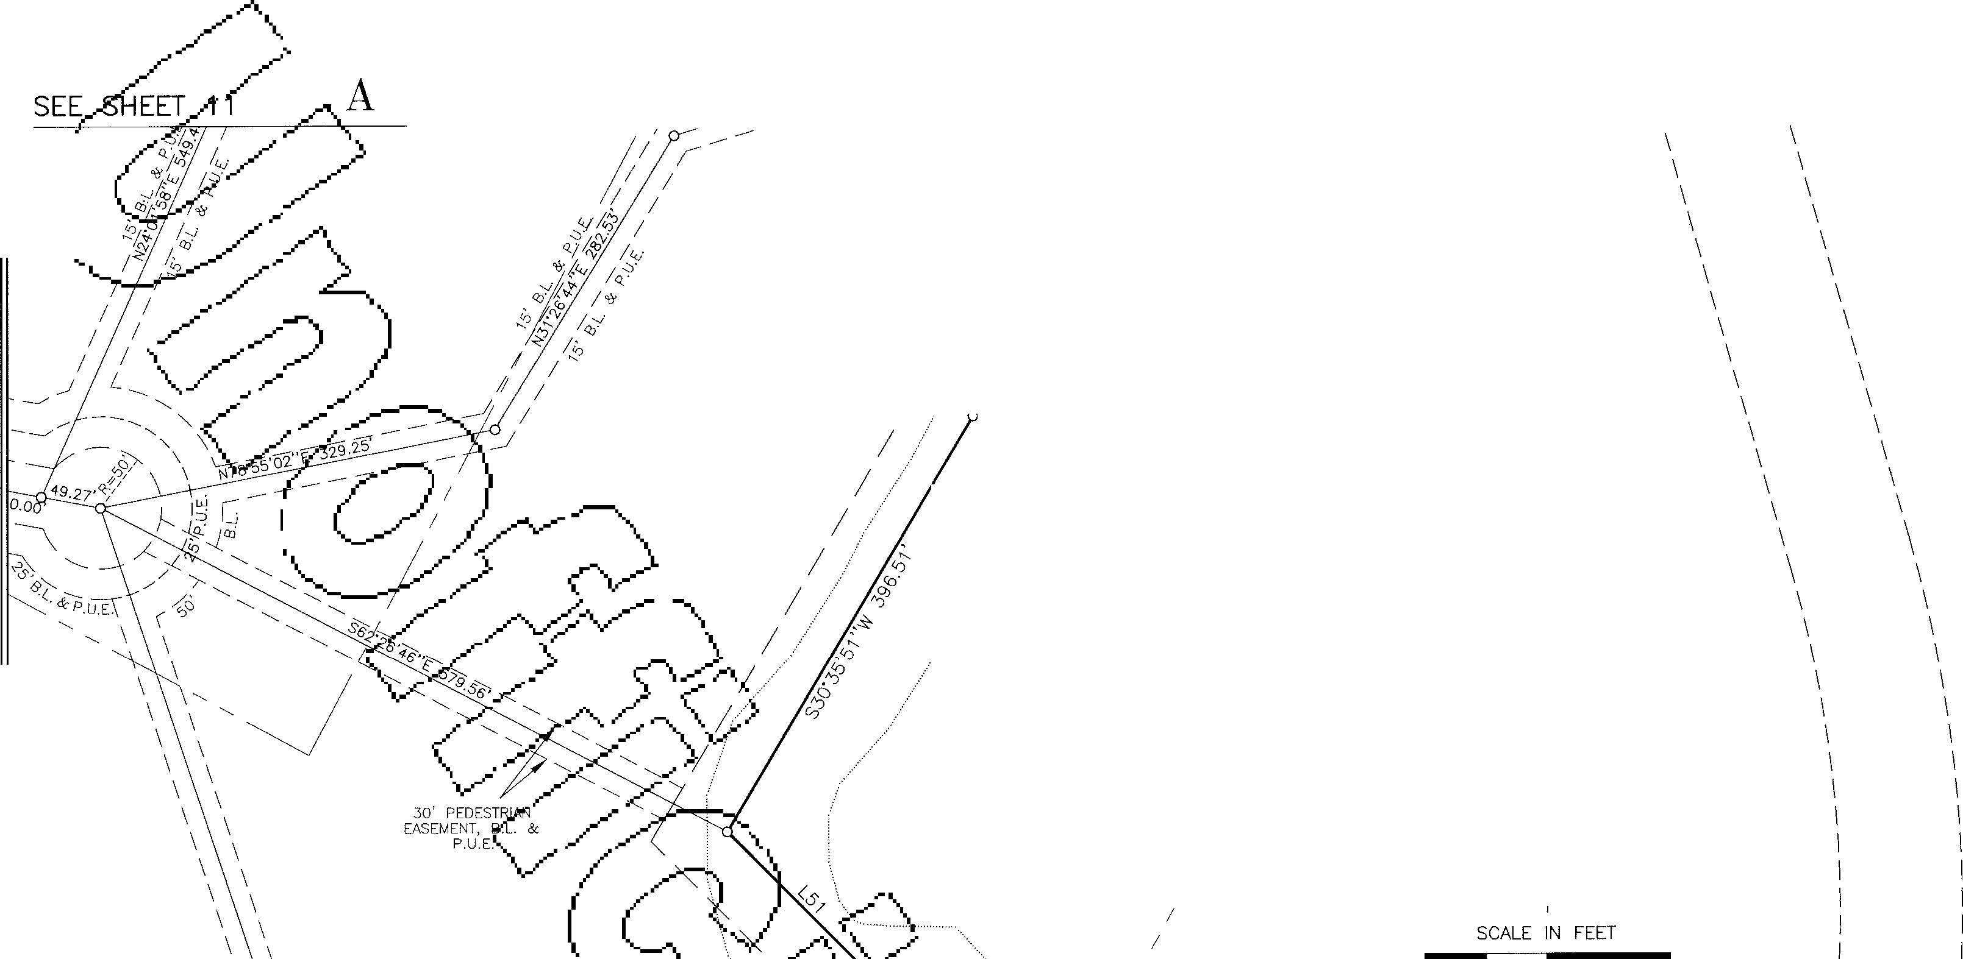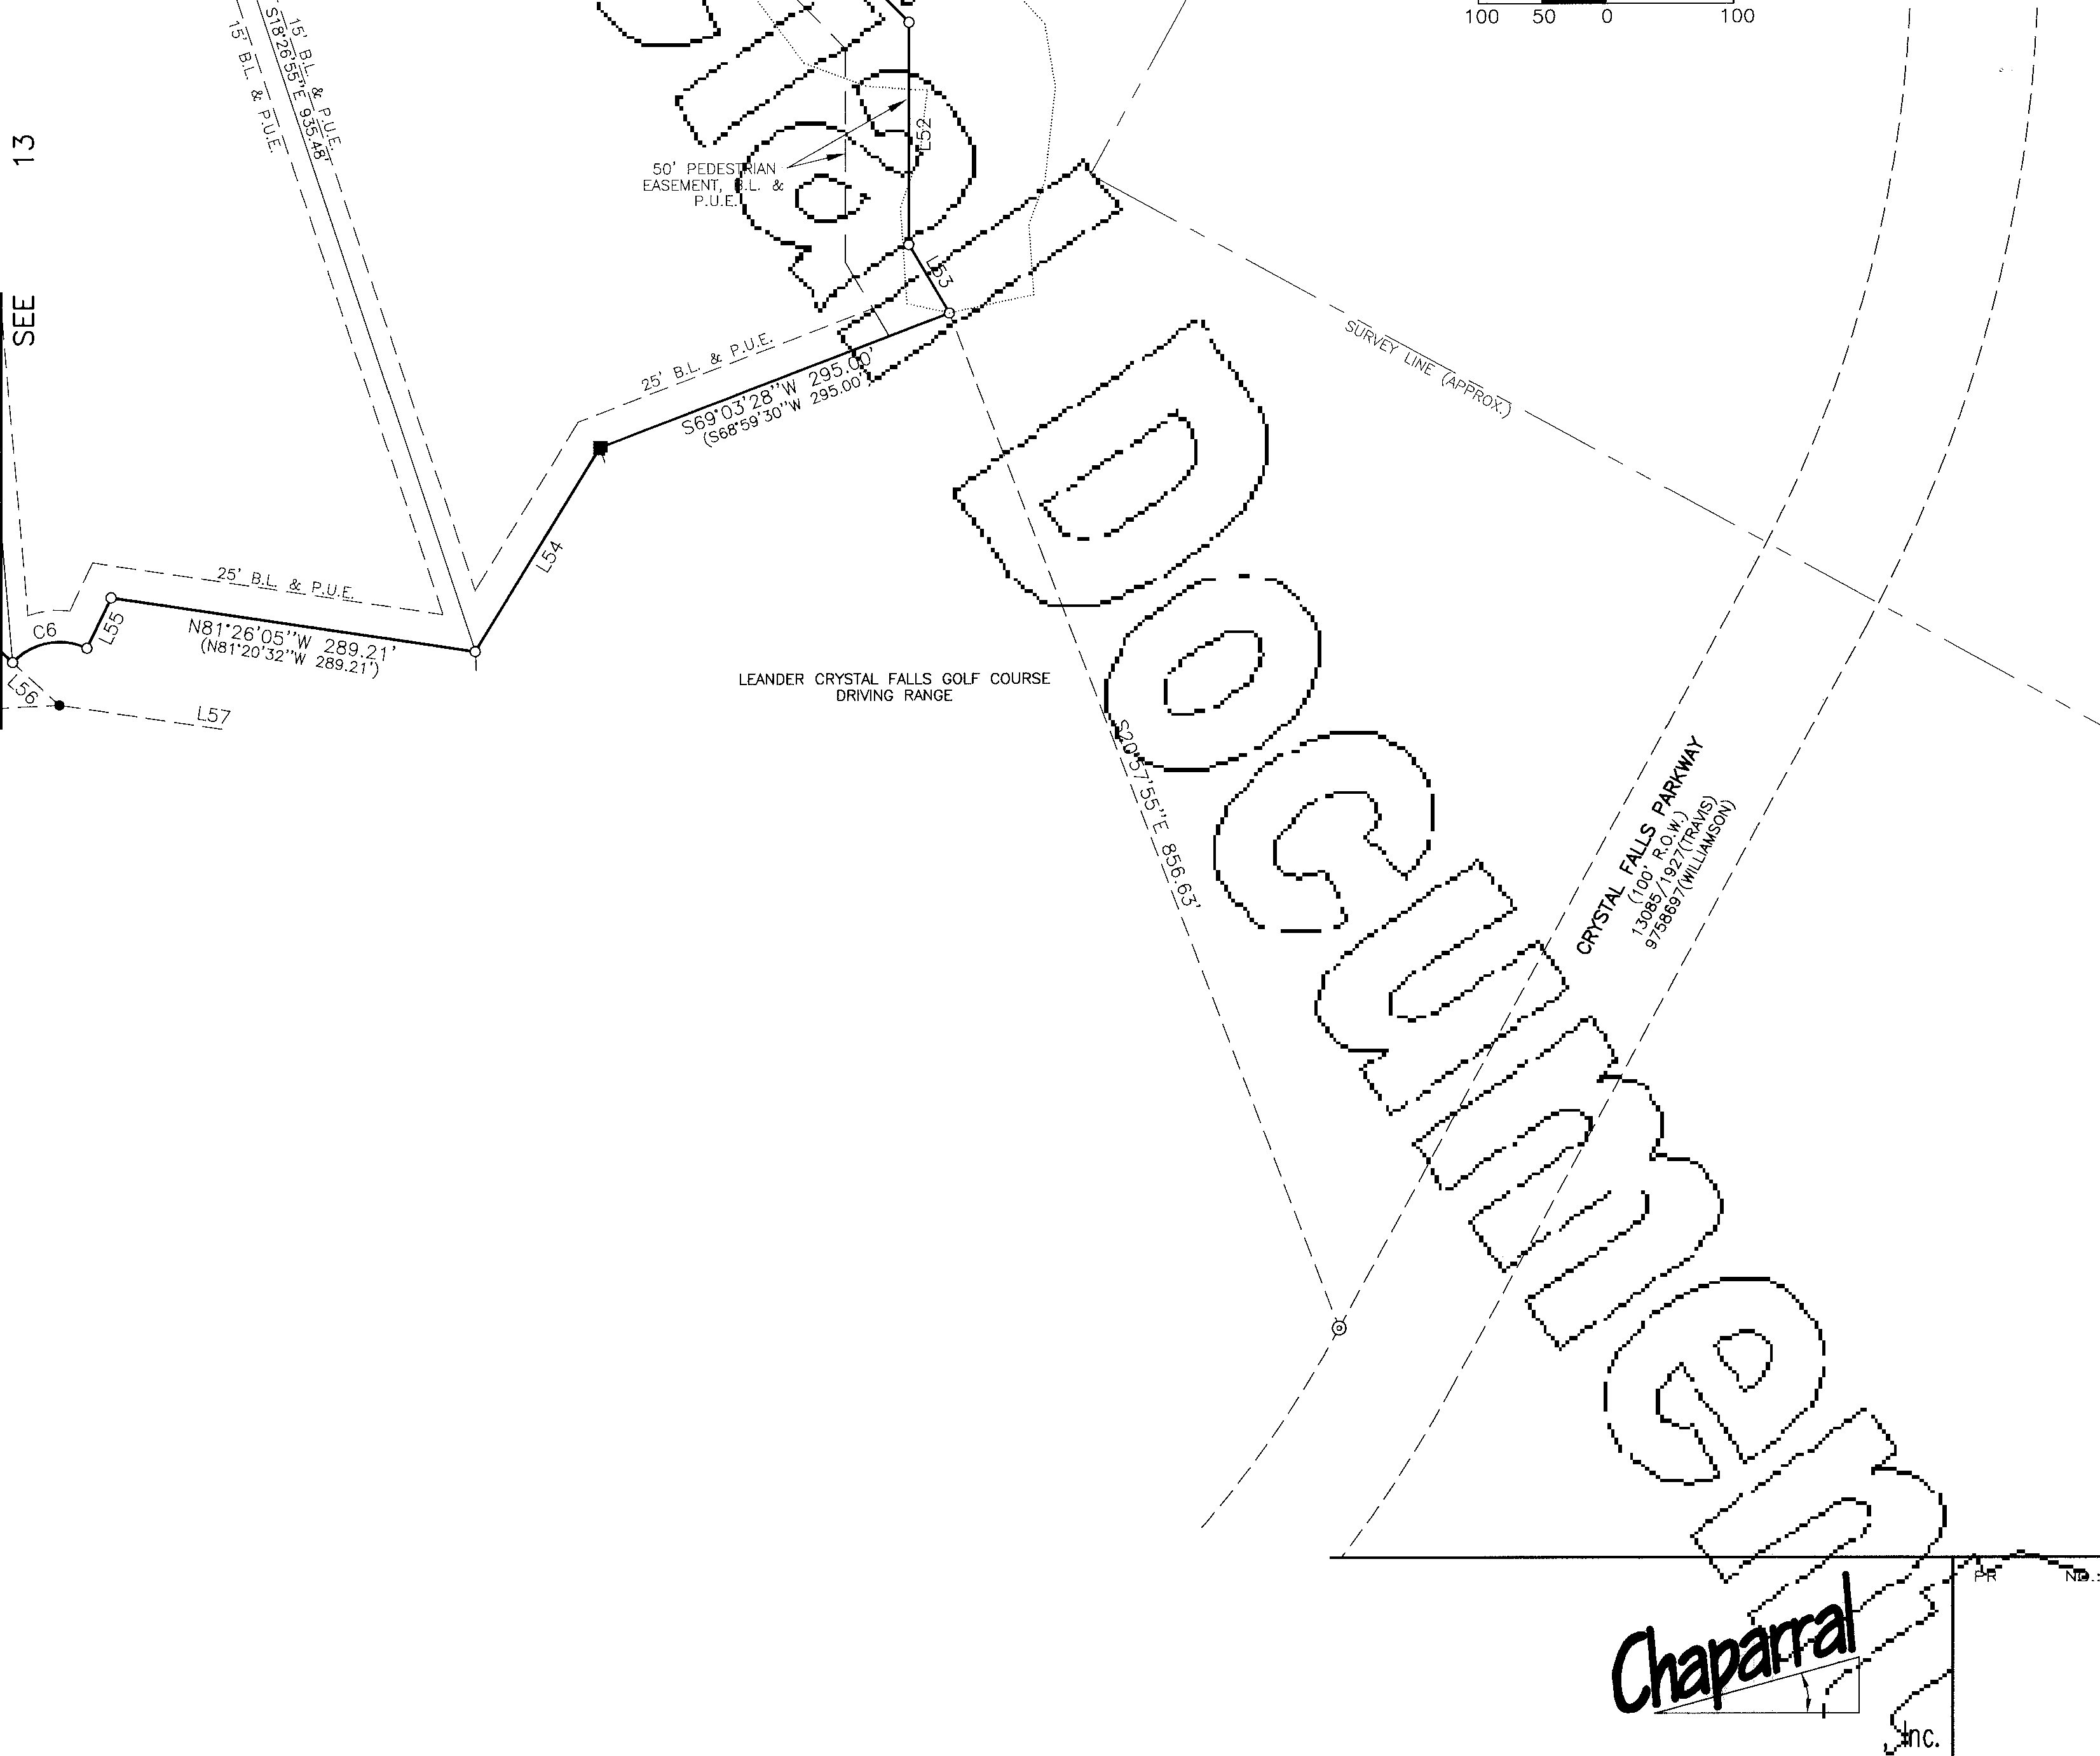

**FAX: (512) 244-0504**

**CRYSTALFALLS**

Surve ng and Mappifrg DRAWN aY,

LEA, COD

51 0 South Congress Ave., Suite B-1001 11

Austin, Texas 78704 **SHEET**

512-476-7103 **14 OF 19**

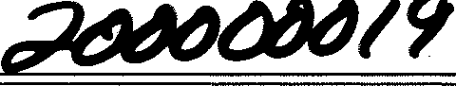PHOTOGRAPHIC MYLAR

|  |  |
| --- | --- |
| GRAND MESA **AT** CRYSTAL FALLS  **SUBDIVISION IN TRAVIS AND WILLIAMSON COUNTIES** SEE SHEET 13 | |
| *I*  *I*  6579/1395  HAROLD O'CHESTER  7.15 ACRES (TRAVIS)  LOT 82  5.54 Ac. *I*  *I*  *I*  *I*  **N** SCALE 1"= 1 oo'  SCALE IN FEET  100  12022/82  CHARLES D. BLAKE  9.64 ACRES (TRAVIS)  *I*  13085/1927  LOOKOUT PARTNERS, L.P.  1708.59 ACRES (TRAVIS)  *I*  *I*  *I*  *I*  *I*  *I*  *I*  *I*  *I*  *I*  *I*  *I*  *I*  *I*  P JECT  GRAND MESA 62-9800)-""  DRAw15f NO.:  **SUBDIVISION**  */.,* 62-oy_1  CoJRRIDoR ENGl!NEERJ[NG COMPANY **8** DATE:  01;13/00  **307 SUNSET DRIVE ROUND ROCK, TEXAS 78664** Professional Land Surv ·ng, PLOT SCALE:  1"=100'  **(512) 244-4279 FAX: (512) 244-0504** | |
| Surveying and Mappjf-ef  **CRYSTAL FALLS** 51 0 Austin, Texas 78704 B-1 **00**  South Congress Ave., Suite  512-476-7103 | DRAWN BY:  LEA, COD  **1 l**  **SHEET**  **15 OF 19** |

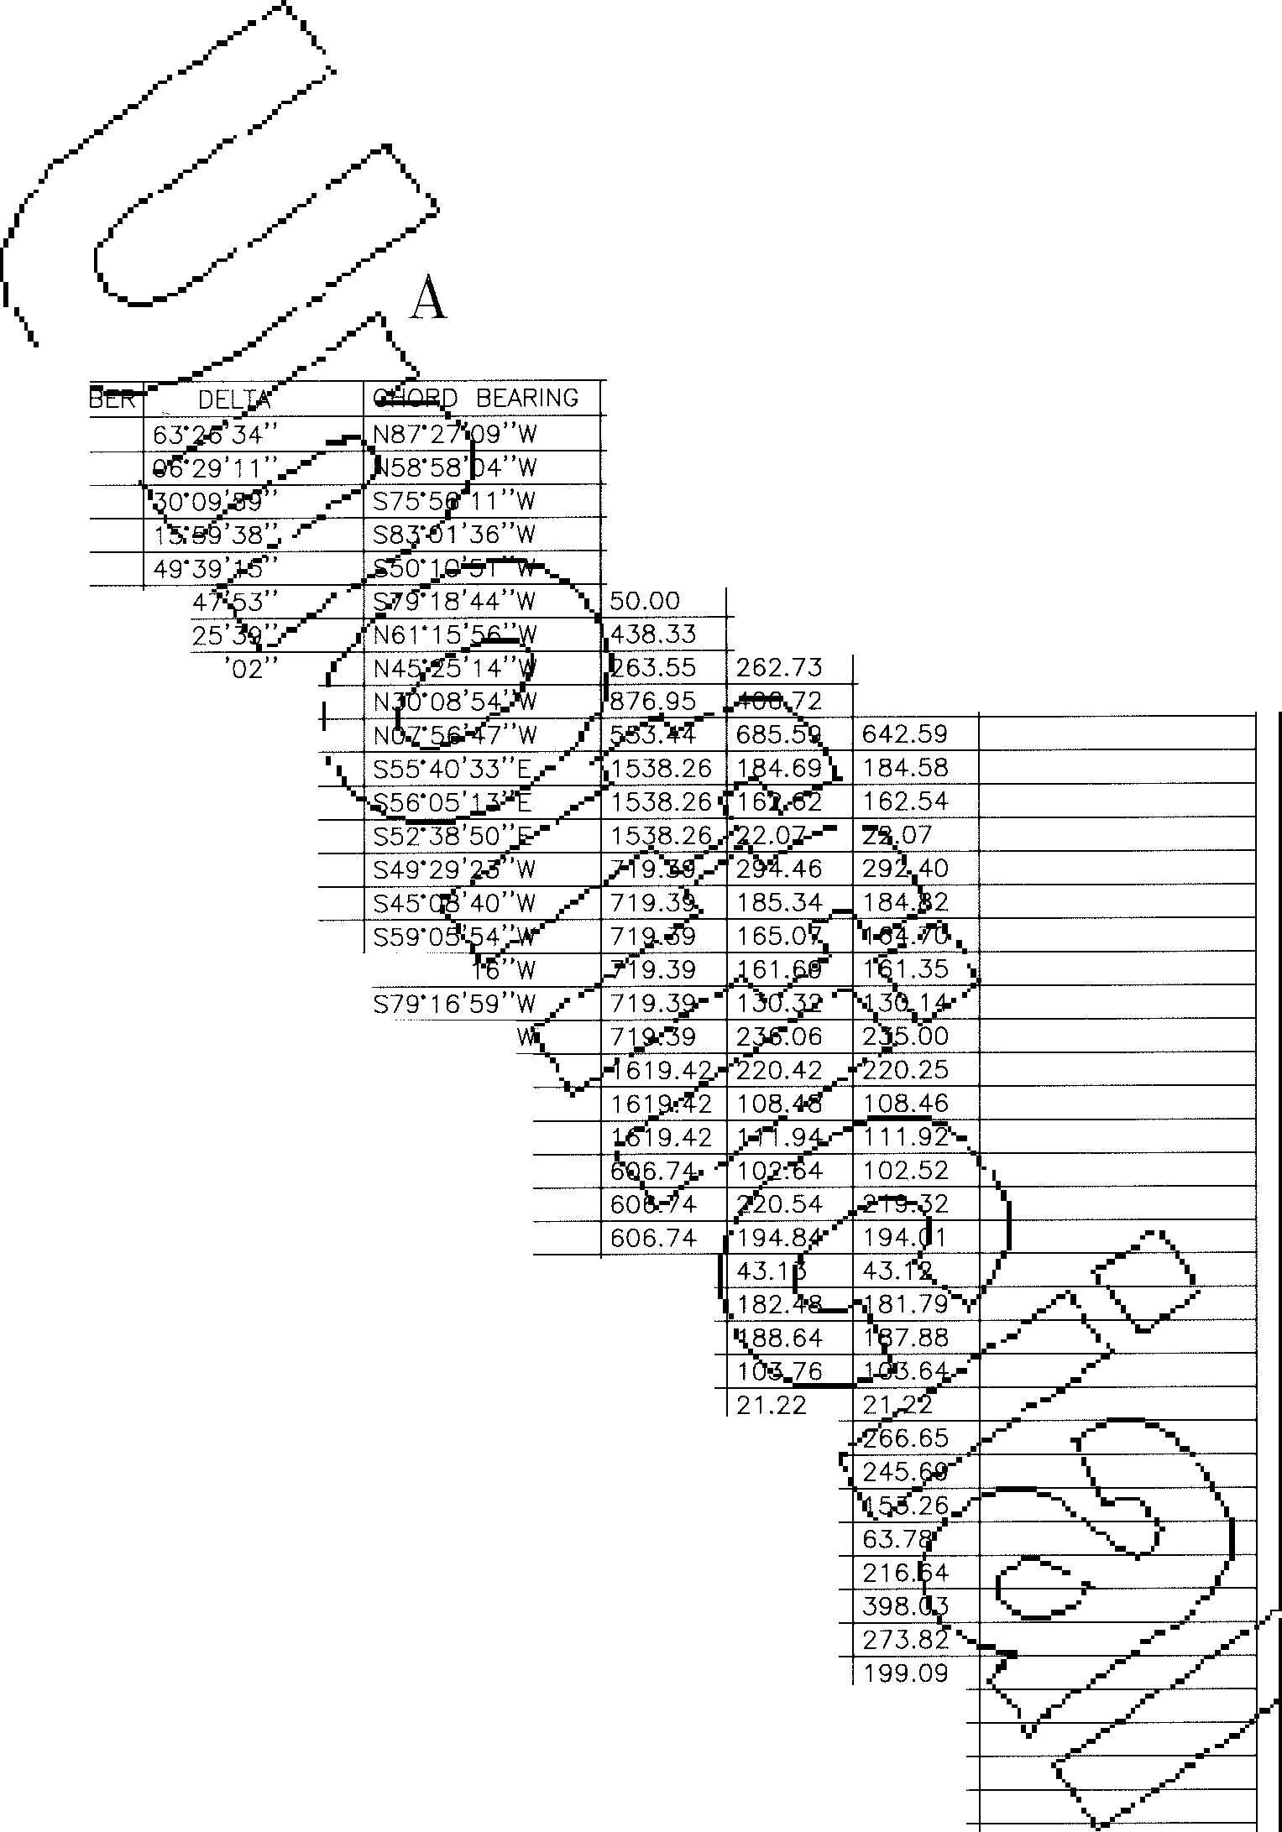PHOTOGRAPHIC MYLAR

._

GRAND MESA

**AT**

CRYSTAL FALLS

**SUBDIVISION** IN **TRAVIS AND WILLIAMSON**

COUNTIES

NUMBER C86 C87 C88 C89 C90 C91 C92 C93 C94 C95 C96 C98 C99 C100 C101 C102 C103 C104 C105 C106 C107 C108 C109 C110 C111 C112 C113 C114 C115 C116 C117 C118 C119

|  |  |  |  |  |  |  |  |  |  |
| --- | --- | --- | --- | --- | --- | --- | --- | --- | --- |
| NUM |  |  |  | |  | RADIUS | ARC | CHORD | (RECORD) |
| C1 |  |  |  | |  | 1286.12 | 1424.10 | 1352.45 | (N87'22'20"W 1352.15') |
| C2 |  |  |  | |  | 1186.12 | 134.28 | 134.20 |  |
| C3 |  |  |  | |  | 850.00 | 447.53 | 442.38 |  |
| C4 |  |  |  | |  | 960.00 | 267.98 | 267.11 |  |
| C5 |  |  |  | |  | 998.63 | 865.44 | 838.61 |  |
| C6 | 72" |  |  | |  |  | 63.53 | 59.34 |  |
| C7 | 25' |  |  | |  |  | 194.53 | 192.94 |  |
| C8 | 57'07 |  |  | |  |  |  | 251.99 |  |
| C9 | 26"34'22" | |  | | 403.08 | | | | |
| C10 | 70"58'36" | |  | | | | |
| C11 | 06"52' 45" | |  | | | | |
| C12 | 06"03'25" | |  | | | | |
| C13 | oo·49'20" | |  | | | | |
| C14 | 23"27'07" | |  | | | | |
| C15 | 1 4·45' 40" | |  | | | | |
| C16 | 13'08' 48" | |  | | | | |
| C17 | 12"52' 40" | | | S6T39' |
| C18 | 10·22·45" | | |  |  | | | | |
| C19 | 18" 48'04" | | | S75"04' 19" |  | | | | |
| C20 | 07"47'55" | | | S28" 13' 40"E | | | | | |
| C21 | 03'50'17" | | | S26"14'51 "E | | | | | |
| C22 | 03"57'38" | | | S30"08' 49"E | | | | | |
| C23 | 09·41 '33" | | | S2T16'51"E | | | | | |
| C24 | 20·49' 33" | | | S12'01'18"E | | | | | |
| C25 | 18"23'58" | | | NOT 35'27"E | | | | | |
| C26 | 04·04'23" | | | S30'05'26"E | | 606.74 |  |  |  |
| C27 | 17"13'56" | | | S19'26'17"E | | 606.74 |  |  |  |
| C28 | 17"48'50" | | | S01'54'55"E | | 606.74 |  |  |  |
| C29 | 09'47'56" | | | S11'53'28"W | | 606.74 |  |  |  |
| C30 | 01·29•32" | | | S51'29'24"E | | 814.85 |  |  |  |
| C31 | 18'50'03" | | | S42'49'09"E | | 814.85 | 267.85 |  |  |
| C32 | 17"20'30" | | | S42'04'23"E | | 814.85 | 246.63 |  |  |
| C33 | 10·47'33" | | | S28'00'21 "E | | 814.85 | 153.49 |  |  |
| C34 | 04·29• 1 o" | | | s20·22·oo"E | | 814.85 | 63.80 |  |  |
| C35 | 15'16'42" | | | S25' 45' 46"E | | 814.85 | 217.29 |  |  |
| C36 | 17"48'13" | | | N78'07' 19"W | | 1286.12 | 399.64 |  |  |
| C37 | 12"13'18" | | | S86'51 '56"W | | 1286.12 | 274.34 |  |  |
| C38 | 08"52' 41" | | | S76'18'56"W | | 1286.12 | 199.29 |  |  |
| C39 | 11·03'01" | | | S66"21 '04"W | | 1286.12 | 248.04 | 247.66 |  |
| C40 | 13"49'10" | | | S30"51 '15"W | | 523.31 | 126.22 | 125.91 |  |
| C41 | 07"49'01" | | | s20·02•09"w | | 523.31 | 71.40 | 71.34 |  |
| C42 | 04·55' 13" | | | S05"01 '23"E | | 300.00 | 25.76 | 25.75 |  |
| C43 | 52"59'40" | | | s19·00·48"w | | 299.98 | 277.46 | 267.68 |  |
| C44 | 49·40' 1 2" | | | S22"16'20"W | | 300.00 | 260.07 | 252.00 |  |
| C45 | 03'06'51" | | | S45"33'01 "W | | 650.00 | 35.33 | 35.32 |  |
| C46 | 11"06'26" | | | S41" 33' 13"W | | 650.00 | 126.01 | 125.81 |  |
| C47 | 25·34'57" | | | S31'12'07"W | | 650.00 | 290.22 | 287.82 |  |
| C48 | 17"35'21" | | | S2T 12' 19"W | | 650.00 | 199.54 | 198.76 |  |
| C49 | 10"58'35" | | | S12"55'22"W | | 650.00 | 124.52 | 124.33 |  |
| C50 | 04·42'07" | | | S44"48'28"W | | 470.00 | 38.57 | 38.56 |  |
| C51 | 57"18'52" | | | N26'47'49"E | | 470.00 | 470.16 | 450.80 |  |
| C52 | 44·19'02" | | | S20"17'54"W | | 470.00 | 363.54 | 354.54 |  |
| C53 | 26"58'04" | | | S15"20'39"E | | 470.00 | 221.22 | 219.18 |  |
| C54 | 17"31'12" | | | S3T35'17"E | | 470.00 | 143.72 | 143.16 |  |
| C55 | 18"00' 48" | | | S3T20'28"E | | 475.00 | 149.34 | 148.72 |  |
| C56 | 31·53'55" | | | S12'23'06"E | | 475.00 | 264.45 | 261.05 |  |
| C57 | 1 o·18'06" | | | S08"42'55"W | | 475.00 | 85.40 | 85.29 |  |
| C58 | 11"38'01" | | | S19"40'59"W | | 475.00 | 96.45 | 96.28 |  |
| C59 | 11·21 •35" | | | N31'10'47"E | | 475.00 | 94.18 | 94.02 |  |
| C60 | 25·10•19" | | | N49"56' 44"E | | 475.00 | 216.97 | 215.09 |  |
| C61 | 15'00'03" | | | S70"31 '56"W | | 475.00 | 124.36 | 124.01 |  |
| C62 | 84"18'11" | | | S02"53'57"W | | 475.00 | 698.90 | 637.54 |  |
| C63 | 28"45'34" | | | S63" 39' 1o"w | | 475.00 | 238.43 | 235.93 |  |
| C64 | 35·25'55" | | | S59" 49'00"W | | 475.00 | 302.03 | 296.97 |  |
| C65 | 26"34'27" | | | S35"59'09"W | | 475.00 | 220.31 | 218.34 |  |
| C66 | 18"54'07" | | | S32'08'59"W | | 475.00 | 156.70 | 155.99 |  |
| C68 | 23"54'51" | | | S34"39'21 "W | | 475.00 | 198.25 | 196.82 |  |
| C70 | 18"02'38" | | | s34·02·21 "w | | 405.85 | 127.81 | 127.29 |  |
| C71 | 05'53'03" | | | S22"04'31 "W | | 405.85 | 41.68 | 41.66 |  |
| C72 | 23'55' 41" | | | s31·05'5o"w | | 405.85 | 169.49 | 1 68.26 |  |
| C73 | 06"32' | 47" |  | S22"24'23"W | | 1035.68 | 118.33 | 118.27 |  |
| C74 | 00·12•57" | | | S19"14'28"W | | 1035.68 | 3.90 | 3.90 |  |
| C75 | 09·15•39" | | | S23"58' 46"W | | 1035.68 | 167.40 | 167.22 |  |
| C76 | 30·10'27" | | | S17"09' 19"W | | 300.00 | 157.99 | 156.17 |  |
| C77 | 23"10'15" | | | so1·51 '47"w | | 498.88 | 201.75 | 200.38 |  |
| C78 | 13"47'31" | | | S20'20' 40"W | | 498.88 | 120.09 | 119.80 |  |
| C79 | 126"21 '58" | | | N89'35'37"W | | 328.50 | 724.50 | 586.34 |  |
| C80 | 16"46'54" | | | S35'36'51 "W | | 328.50 | 96.22 | 95.87 |  |
| C81 | 32"35' | 46" |  | S60'18'11"W | | 328.50 | 186.88 | 184.37 |  |
| C82 | 42"45'18" | | | N82'01'17"W | | 328.50 | 245.13 | 239.48 |  |
| C83 | 34·14'00" | | | N43'31'38"W | | 328.50 | 196.27 | 193.36 |  |
| C84 | 12"49'16" | | | N32'50' 18"W | | 659.10 | 147.49 | 147.18 |  |
| C85 | 09·47' 18" | | | N31'19'19"W | | 659.10 | 112.60 | 112.46 |  |

_/'-, C120

C121

1 122

DELTA 09'10'12"

06"08' 1 4"

20·44'31"

26" 48' 19"

75'47'38"

16"11'43"

09·54'37"

11·21'35"

18"29'09"

10'31'42"

06'39'48"

01'02'58"

02'51'14"

07"38'33"

07"40'15"

04'18'10"

02'28'12"

01'51'05"

10'32'51"

14'29'15"

12'50'37"

09' 39'01"

02·35'53"

06'02'32"

06'35' 45"

06'57'08"

05'05'23"

03'56'36"

03·37' 1o"

06'51'43"

06' 32' 16"

08'30' 49"

11·14'55"

06'31'25"

54·32' 40"

07'06' 11"

CHORD BEARING N40" 48'04"W N42" 19'03"W N35'00'54"W N11'14'29"W NOT29'21 "W N10"15'33"E N35"21 '46"E S45"59'53"W N39"39'02"E N46"24' 49"E N48"20' 46"E N28" 49' 37"E N29"43'45"E N33"10'22"E N34"59'29"E N39"08' 44"E N40"03' 43"E N40"22' 16"E N36"01 '23"E N32" 12'06"E N24"19'39"E N20"07'58"E N16"36'24"E N18"19'44"E N19"54'52"E N24" 49' 34"E N25"45'26"E N30" 16'26"E N30"06' 43"E N35"21 '09"E N35"30'52"E N34"31 '36"E N33"09'33"E S13'06'07"W S15'54'31 "E

S51'43'57"E

RADIUS 659.10

659.10

300.00

300.00

300.00

300.00

665.68

665.68

665.68

604.25

604.25

1317.08

1317.08

1317.08

1317.08

1317.08

1317.08

695.56

695.56

695.56

695.56

695.56

695.56

1317.08

1317.08

1317.08

1317.08

1317.08

1317.08

1317.08

1317.08

695.56

695.56

300.00

300.00

1498.96

ARC 105.49

70.60

108.60

140.35

396.86

84.80

115.14

131.98

214.77

111.03

70.27

24.12

65.60

175.68

176.33

98.91

56.78

22.48

128.04

175.87

155.92

117.15

31.54

138.90

151.62

159.81

117.00

90.65

83.20

157.74

150.29

103.35

136.56

34.16

337.95

185.83

CHORD 105.37

70.57

108.01

139.08

368.55

84.52

115.00

131.77

213.84

110.88

70.23

24.12

65.60

175.55

176.20

98.89

56.77

22.48

127.86

175.41

155.59

117.01

31.54

138.83

151.53

159.72

116.96

90.63

83.19

157.64

150.21

103.26

136.34

34.14

320.37

185.71

(RECORD)

/"

,............

|  |  |  |  |  |  |
| --- | --- | --- | --- | --- | --- |
| r 1vi | 1 ti·,53'39" | S55"48'49"E | 608.70 | 179.48 | 178.83 |
| -c129 | 1o- ·22" | S52"51 '41 "E | 471.54 | 90.44 | 90.31 |

...-

|  |  |  |  |  |  |  |
| --- | --- | --- | --- | --- | --- | --- |
| c130.. 30"091 | 2" | S73"26'08"E | 471.54 | 248.21 | 245.35 |  |
| * cJ.51 08"24' | 5" | S66"57'52"E | 1368.09 | 200.80 | 200.62 |  |
| ...-C132 08" 13' | 9" | S75"16'53"E | 1368.09 | 196.39 | 196.22 |  |

C123 C124 C125 C126 C127/

14·33'25"

07' 19' 33"

33·25'54"

38" 16' 40"

\zo9•19"

S48'00'20"E S63"38' 18"E S50"34'37"E S40"50'12"E S27"46'31 "E

600.00

549.50

549.50

549.50

549.50

152.44

70.26

320.78

367.10

1.16.57

152.03

70.21

316.25

360.31

116.36

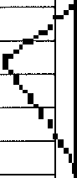-

(

c133,/

G..1-,'.'14

- --c135

05·2w J4"

0 5·;1-tl' 18"

O!'J"11'10"

s 1 0·09'07"E S03"34'27"E S79"52' 46"W

1734.40

1734.40

1867.18

196.29

201.95

299.36

196.18

201.84

299.04

C136 _.,, 19"46'11" C-..Jr-37 _.. 08"3 3'6'i-'-'.,

S65'24'06"W

s71 ·oo·41"w

712.12

712.12

245.71

106.27

244.50

106.17

C1 a'139

it: 140,.• C1411

11'13'09"\

**·1,-31"**

32"58156"

03 '06" ***j***

S61"07'36"W S51"18'18"W S61"32'30"W S44"50' 13"W

712.12

470.00

475.00

833.46

139.44

68.02

273.43

51.66

139.22

67.96

269.67

51.66

,C14i"- '.'3·09•21·-·.1

N06"48'59"W

1734.40

398.24

397.37

**'f:**143 C1 C145 C146 C147 C148 C150 C151

18' 45.'.fn" .-

"'-, "t9 "

19')-5'13" **J.**

28'29'34}'

21'5'05' **4j'i"**

112'50'5'1"

58"11'15" **-i,**

03'3 0"

**""..fi.**14' 14"W N39' 1 '25"W

\133"4 '29"W 9·4, '05"W

>J.15"5i'37"E N 3'3.3..'-'l: N19"1 13"W..._ S3'f25'21 "W/

876.95

876.95

553.44

553.44

553.44

604.25

300.00

- 1031.44

286.99

119.73

187.27

275.23

223.10

135.49

303.80

65.66

285.71

119.63

186.38

272.40

221.59

135.21

290.98

65.65

C152 C153 C154

01·47'45"

03'32'09''

00'48'02"

....

' 'S46"16'4YW N28:;3d'07"E. .-"

N**37·** 08 **'Or'**E

267.09

005.56

fill5.56

8.37

42.92

9.72

8.37

42.92

9.72

C155 C156 C157 C158 C159

01·32•02" \.

13'33'04" -..._

08' 12'22"

04' 17' 40"

11'57'03"

NL **r'-iRJ** 04"E _.-• **453,15**

""5"02'37" 3.1!,

-

;s51·00';..-f''E _. 655.3.;

:'.•1-3:***Yr' 59':.f'.'*** 781.88

st8·41ro"w **A"'t7 4-:68**

12.13

107.18

93.86

8.60

9 .99

12.13

106.93

93.78

58.59

98.81

C160 C161 C162

11'58'58"

06'33'46"

41·57'53"

**S40"."i**7'24"W.-- ■-

S28"5 **X4o.;;w**

,..

S11"15'36"W--"

**4H.65**

"1035.68

300.00

**9** .27

118.6 i19.73

99.09

118.56

214.85

C170 C171

01'18'33"

07'05'44"

N15·57' 44"E S42"47'60"E

1317.I 8

475.0(l,

3 .09\_

5 !:8.3.

30.09 ***l***

58.79'

|  |  |  |  |  |  |  |  |  |
| --- | --- | --- | --- | --- | --- | --- | --- | --- |
| C163  C164 | 11'47'26"  12'03'04" | so3·49'37' F  N24"22'56"f'a | _.,, | 300.00  300.00' | | I '61.73  63.1()'" | , | 61.63  62.98 |
| C165 | 16' 42' 44" | N36"39'30"E **y** |  | 60"4.25 | | 1.}1).25 |  | " .63  1 7 |
| C166 | 02'47'04" | N50"17'08"E | *(* | 665.68 *..I* •32..-0'5 | | | 32 _3t;,. | |
| C167 | 02'43'58" | S44"25'39"W | **833Afl°** | | | 9.75 | iq_75 '\ | |
| C168 | 00'49'08" | S46"12'12"W | 8:)3.4 6,.-- | | | 11.91 | '[ | 111l1 |
| C169 | 15'05'06" | N34"16'36"E | 453.1*f* | | 1101 | | 1 W.96 **1** | |

-

I.-'"\.

*w*

GRAND MESA

\ -- _,..-/

/

-

/,,./;

<

***..5.****)****.***  *··*

6 -980

CORRIDOR ENGINEERING COMPANY

SUBDIVISION

# 8

DRA3: NO.:

/ 62- PL1

_.lpLQ ATE: 1'2-;r14/99

PLOT SCALE:

307 SUNSET DRIVE

(512) 244-4279

ROUND ROCK, TEXAS 78664 FAX: (512) 244-0504

Professional Land Sur ng Surve ng and Ma

1"=100'

DRAWN BY: LEA, COD

**CRYSTALFALLS**

510 South Congress Ave., Suite B-1001 <

Austin, Texas 78704 **SHEET**

512-476-7103 **16 OF** 19

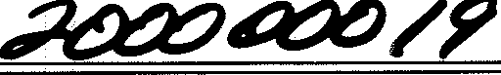

PHOTOGRAPHIC MYLAR

GRAND MESA

AT CRYSTAL FALLS

SUBDIVISION

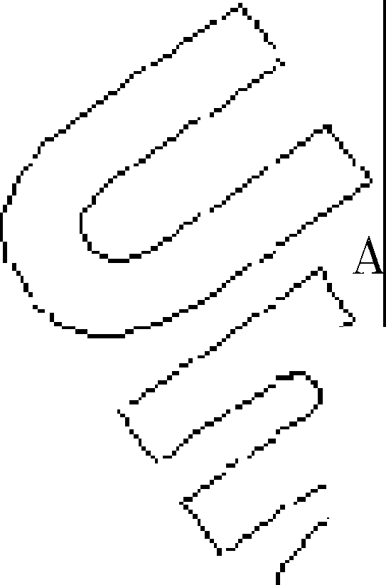

-

- ***J***

IN TRAVIS

**AND WILLIAMSON**

COUNTIES

|  |  |  |  |
| --- | --- | --- | --- |
| NUMBER | DIRECTION | DISTANCE | (RECORD) |
| L80 | s19·07•5o"w | 100.09' |  |
| L81 | S67'18'04"E | 88.55' |  |
| L82 | S47'21 '59"E | 126.21' |  |
| L83 | N38"47'01 "E | 43.21' |  |
| L84 | N38"47'01 "E | 73.58' |  |
| L86 | S26" 44'03"W | 120.00' |  |
| L89 | N16"21 '49"E | 50.00' |  |
| L90 | N52"56'17"W | 55.63' |  |
| L91 | N40"34'09"E | 50.00' |  |
| L92 | S82"08'06"E | 50.00' |  |
| L93 | S16"18'44"W | 45.08' |  |
| L94 | S16"50'02"W | 4.93' |  |
| L95 | S05"26'30"E | 116.79' |  |
| L96 | S24"19'42"E | 110.50' |  |
| L97 | S47'06'26"W | 107.47' |  |
| L98 | S55"31 '01 "W | 100.52' |  |
| L99 | S41"49'09"W | 42.30' |  |
| L100 | S82"33'56"E | 28.17' |  |
| L101 | S25"45'18"W | 29.86' |  |
| L102 | S25"45'18"W | 89.07' |  |
| L103 | s22·00•15"w | 33.22' |  |
| L104 | S79"59'1O"E | 55.00' |  |

1. Total Acres: 445.429

|  |  |  |  |  |  |  |  |  |  |  |  |  |
| --- | --- | --- | --- | --- | --- | --- | --- | --- | --- | --- | --- | --- |
| ••• "'BER | | DIRECTION | | | | DISTANCE | | | (RECORD) | | |  |
| L1 |  | S15"12'32"W | | | | 33.75' | | |  | | |
| L2 | I | N73"58' 45"W | | | | 100.00' | | |  | | |
| **L.V** | | N32"00'25"E | | | | 125.20' | | | (N34"30'27"E 125.48') | | |
| **_..t"4** | | N28"38'50"E | | | | 100.76' | | | (N31"02'28"E 100.85') | | |
| I .:.-- | | ·14'56"E | | | | 95.84' | | | (N35"38'00"E 95.82') | | |
| L6 | | N61"48'02"W | | | | 65.01' | | | (N61"28'02"W) | | |
| L7 | | '°61"2' | '02"E | | | 86.71' | | | (S61'28'02"E) | | |
| **rll** | | J::,75·4 | '18"E | | | 125.90' | | | (S76"39'25"E 125.83') | | |
| L9 | | S51"0 '59'.'E _. | | | | ::J::!1,65' | | | (S50"58'00"E 94.20') | | |
|  | | N59'2 6'C: | | | | 15 | 3' |  | (N59"08' 40"E 155.23') | | |
| L11 | | 5"' '6 | '23"E _. | | | 170.Elfi' | | | (N55"40'25"E 170.40') | | |
| L1? .- | | **N7:-'l** 9'59"E | | \ |  | l?'2.95' | | | (N72"34'50"E 173.01 ') | | |
| L13 | .,f,J83"32'16"E /_. | | | |  | 1,%19' | | ; | (N83"36'45"E 143.61') | | |
| L147 | | N70"2:,,"49·'(,....- | | | | 1"160.23' | | | l",N71"00'06 "E 160.66') | | |
| L'l.'i | | Nlff 13'20"F'.,. | | | | 122.31.' | | |  | 11186"23'35'E 121.33') | |
| L1**b'-i** ,- | | 1j52·37' 1.:1-"E | | | | 11 0·•- | | | i.(N 43'05"E 115.66') | | |
| L17 • | | N58"2,i""11 "E | | **.A** |  | 11}1".11'1., | | | (N56':!6'45"E 172.93') | | |
| L18 | | N,t'.h 5'22"y | | | | 1·1QY.21.... | | | "-lN.l'l''06'16"W 103.27') | | |
| L19 | | **ms23'd** E | | | _i-"64.38' | | | J | (N23"19'14"E 64.41') | | |
| L20 | | N4.4.-..vr '02"E/ | | | | 87.oq.:_• | | | (N43'49'05"E 86.95') | | |
| L21 | | N68"55' 4Q!!c: | | | | 1.04'0' | | | !N72'25'00"E 10.68') | | |
| L22 | | N68"5 40"E | | / |  | 74 | | | --- | | |
| L23 | | S54" 19'°1l,5"F.-' | | | | 4.17' | | | - | | |
| L24 | | S52" 15'2Y'E *I* | | | | 74.66'_.- | | | , 50"32'E | | 74.70') |
| L25 | | S50"46'35"E | |  | | 71 Z1' | | |  |  | .-" I |
| L26 | | N83'29' 44"E | |  | | **8.1'2'** | | |  | ffl5'01,)t: 8.21') **"i.** | |  |
| L27 | | S34"08'53"W | | • | | 99 | | | *"{'* _.--...',\_. | | |
| L28 | | S60"51 '22"W \ | | | | 79.97' | | \ | **_...J** _.. | | |
| L29 | | S60"51 '22"W | | | | < | <s7' | J  , | .. ---- | | |
| L30 | | S29"07'36"E | | | | 99.98' | | J | ---- - | | |
| L31 | | S75"03'06"W | | | | 200.1Ll-'" | | | _..-' *-(* | | |
| L32 | | N55"28' 37"W | | | | 125.0CJ' | | | / -...\ .... | | |
| L33 | | s50·04•oo"w | | | | 187.00'\. **a** | | | ***_.I*** _., | | |
| L34 | | S68"19'25"W | | | | 85.55' | | |  | *I* -. *I* | |
| L35 | | N85"55'01 "W | | | | 173.69' | | | ' ..._ _... | | |
| L36 | | S42" 31'43"W | | | | 100.69' | | |  | ... ...... , _.- | |
| L37 | | S60"50'05"W | | | | 181.87' | | |  | | | _. |
| L38 | | S47'40'57"W | | | | 202.83' | | | _.-' | | |
| L39 | | S66"17'26"W | | | | 123.21' | | | ... *r'* _/,,  .. ..... | | |
| L40 | | S03' 49' 11"W | | | | 248.02' | | |  | | |
| L41 | | S22"00'06"W | | | | 122.66' | | | ...._ _, | | |  |
| L42 | | S26"39'18"W | | | | 190.43' | | |  | | |
| L43 | | S16"07' 17"W | | | | 249.86' | | |  | | |
| L44 | | S60"33'56"W | | | | 157.86' | | |  | | |
| L45 | | S14"52'31 "W | | | | 129.37' | | |  | | |
| L46 | | S00'02'16"E | | | | 155.60' | | |  | | |
| L47 | | S37'55' 42"W | | | | 144.30' | | |  | | |
| L48 | | S44"00' 44"W | | | | 184.22' | | |  | | |
| L49 | | S02"51 '11 "E | | | | 1 43.46' | | |  | | |
| L50 | | s14·55•22"w | | | | 245.58' | | |  | | |
| L51 | | S44"50'56"E | | | | 176.31' | | |  | | |
| L52 | | s00·05•34"w | | | | 174.83' | | |  | | |
| L53 | | S30" 33' 47"E | | | | 62.67' | | |  | | |
| L54 | | S31"30'58"W | | | | 187.76' | | |  | | |
| L55 | | S25" 42' 40"W | | | | 43.90' | | |  | | |
| L56 | | S47'05'13"E | | | | 50.00' | | |  | | |
| L57 | | S81"26'05"E | | | | 243.08' | | |  | | |
| L60 | | N83"1O'17"E | | | | 123.15' | | |  | | |
| L61 | | N34"38' 42"E | | | | 128.48' | | |  | | |
| L62 | | S49" 12' 12"E | | | | 103.59' | | |  | | |
| L63 | | N75"25'51 "E | | | | 116.95' | | |  | | |
| L64 | | S10·55' 47"W | | | | 110.62' | | |  | | |
| L65 | | S12"02'17"E | | | | 118.85' | | |  | | |
| L66 | | S42'06'29"E | | | | 59.95' | | |  | | |
| L67 | | S58"28' 1 o"w | | | | 33.94' | | |  | | |
| L68 | | S34" 16' 13"W | | | | 35.48' | | |  | | |
| L69 | | S41.17' 49 **"W** | | | | 100.00' | | |  | | |
| L71 | | N15"18'27"E | | | | 100.00' | | |  | | |
| L72 | | N28"18'08"E | | | | 33.13' | | |  | | |
| L73 | | N28"18'08"E | | | | 84.42' | | |  | | |
| L78 | | N13'23'39"W | | | | 139.59' | | |  | | |
| L79 | | N32"14' 33"E | | | | 100.75' | | |  | | |

PLAT NOTES

1. Number of Lots:

Residential Lots

182

Community Lots

2 Landscape Lots & 1 Mail Lot

1. Number of Blocks: 5
2. Proposed Use: Residential
3. Owner: The Lookout Partners, LLP
4. Construction of improvements within this subdivision shall not commence .until all application permits and/or Construction Plans have been approved by the City of Leander, Texas. All public improvements shall conform to the current Zoning Ordinance of the City of Leander,

Texas.

1. Building setbacks not shown hereon shall conform to the current Zoning Ordinance of the City of Leander, Texas.
2. No lot in this subdivision shall be occupied until connected to the water distribution system

***_.s,L***,_the City of Leander, Texas.

The \{;:ity of Leander, Texas has granted variances to permit the omission of sidewalks, allow

/ all lot\ o front on private streets, and waive all city requirements regarding geometric and

/ pavem design criteria for the private streets shown hereon.

/ 10.)e City Leander, Texas has accepted payment of fees in-lieu of pClrk.land dedication for

_.- / t is subdi sion.

/ / 11t.3B,l k A (Mail Box Lot), all landscape Lots, and Pedestrian Easements shall be owned

.- nd mai ained by the established homeowner's association of this Subdivision.

*< 4*1

...._ _ /

All e streets shown hereon and any security gates or devices controlling access to the

*L.* SOrYJ, private streets shall be owned an_d maintained by the established homeowner's associa-

< 1\ ***7"*** of this subdivision.

-.. .l-. tre'ffl.s, edestrian Easements, Landscape Lots, and Mail Box Lot within the Grand Mesa

-.. -- subdivision **a?e.** private and shall be maintained in perpetuity by the GRAND MESA AT CRYSTAL FALLS PROPER OWNERS ASSOCIATION.

1. T com ned "p ivate Access, Drainage & PUE Easement" shown hereon -is for the sole use all Gr d Mes at Crystal Falls property owners and all utility provid_ers having utilities

---

_.constr d with' this easement only, except that all emergency services (fire, police, medical,

I

etc) _.snail also e granted access at any time these agencies deem appropriate.

( 15. Restrictive vena • the form of a "DECLARATION OF COVENANTS, CONDITIONS AND RES- ' TRICTION Oil,. GRA MESA AT CRYSTAL FALLS SUBDIVISION" are recorded in the deed

0J-'5oth Travis and illiamson Counties.

16.

BASED UPON THE ABOVE REPRESENTATIONS OF THE ENGINEER OR SURVEYOR WHOSE SEAL IS AFFIXED HERETO AND AFTER A REVIEW OF THE BLUELINE AS REPRESENTED BY THE SAID ENGINEER OR SURVEYOR, I FIND THAT ' THIS BLUELINE (SURVEY) COMPLIES WITH THE REQUIREMENTS OF EDWARDS AQUIFER REGULATIONS FOR WILLIAMSON COUNTY, WILLIAMSON COUNTY FLOOD PLAIN REGULATIONS AND WILLIAMSON COUNTY ON-SITE SEWERAGE FACILITY REGULATIONS. THIS CERTIFICATION IS MADE SOLELY UPON SUCH REPRESENTATIONS AND SHOULD NOT BE RELIED

UPON FOR VERIFICATIONS OF THE FACTS ALLEGED. THE WILLIAMSON COUNTY &: CITIES HEALTH DISTRICT AND WILLIAMSON COUNTY DISCLAIMS ANY RESPONSIBILITY TO ANY MEMBER OF THE PUBLIC FOR INDEPENDENT VERIFICATION OF THE REPRESENTATIONS, FACTUAL OR OTHERWISE CONTAINED IN THIS BLUELINE (SURVEY) AND THE

* -•.i.;:D_O_C_UME-,NTS ASSOCIATED WITH IT.

**'t-.....** - .. ***l'Ylll!J_"l***

PAULO DATE

DIRECTOR OF ENVIRONMENTAL SERVICES

CORRIDOR ENGINEERING COMPANY

GRAND

SUBDIVISION

## I

are greater than

PLOT SCALE:

307 SUNSET DRIVE

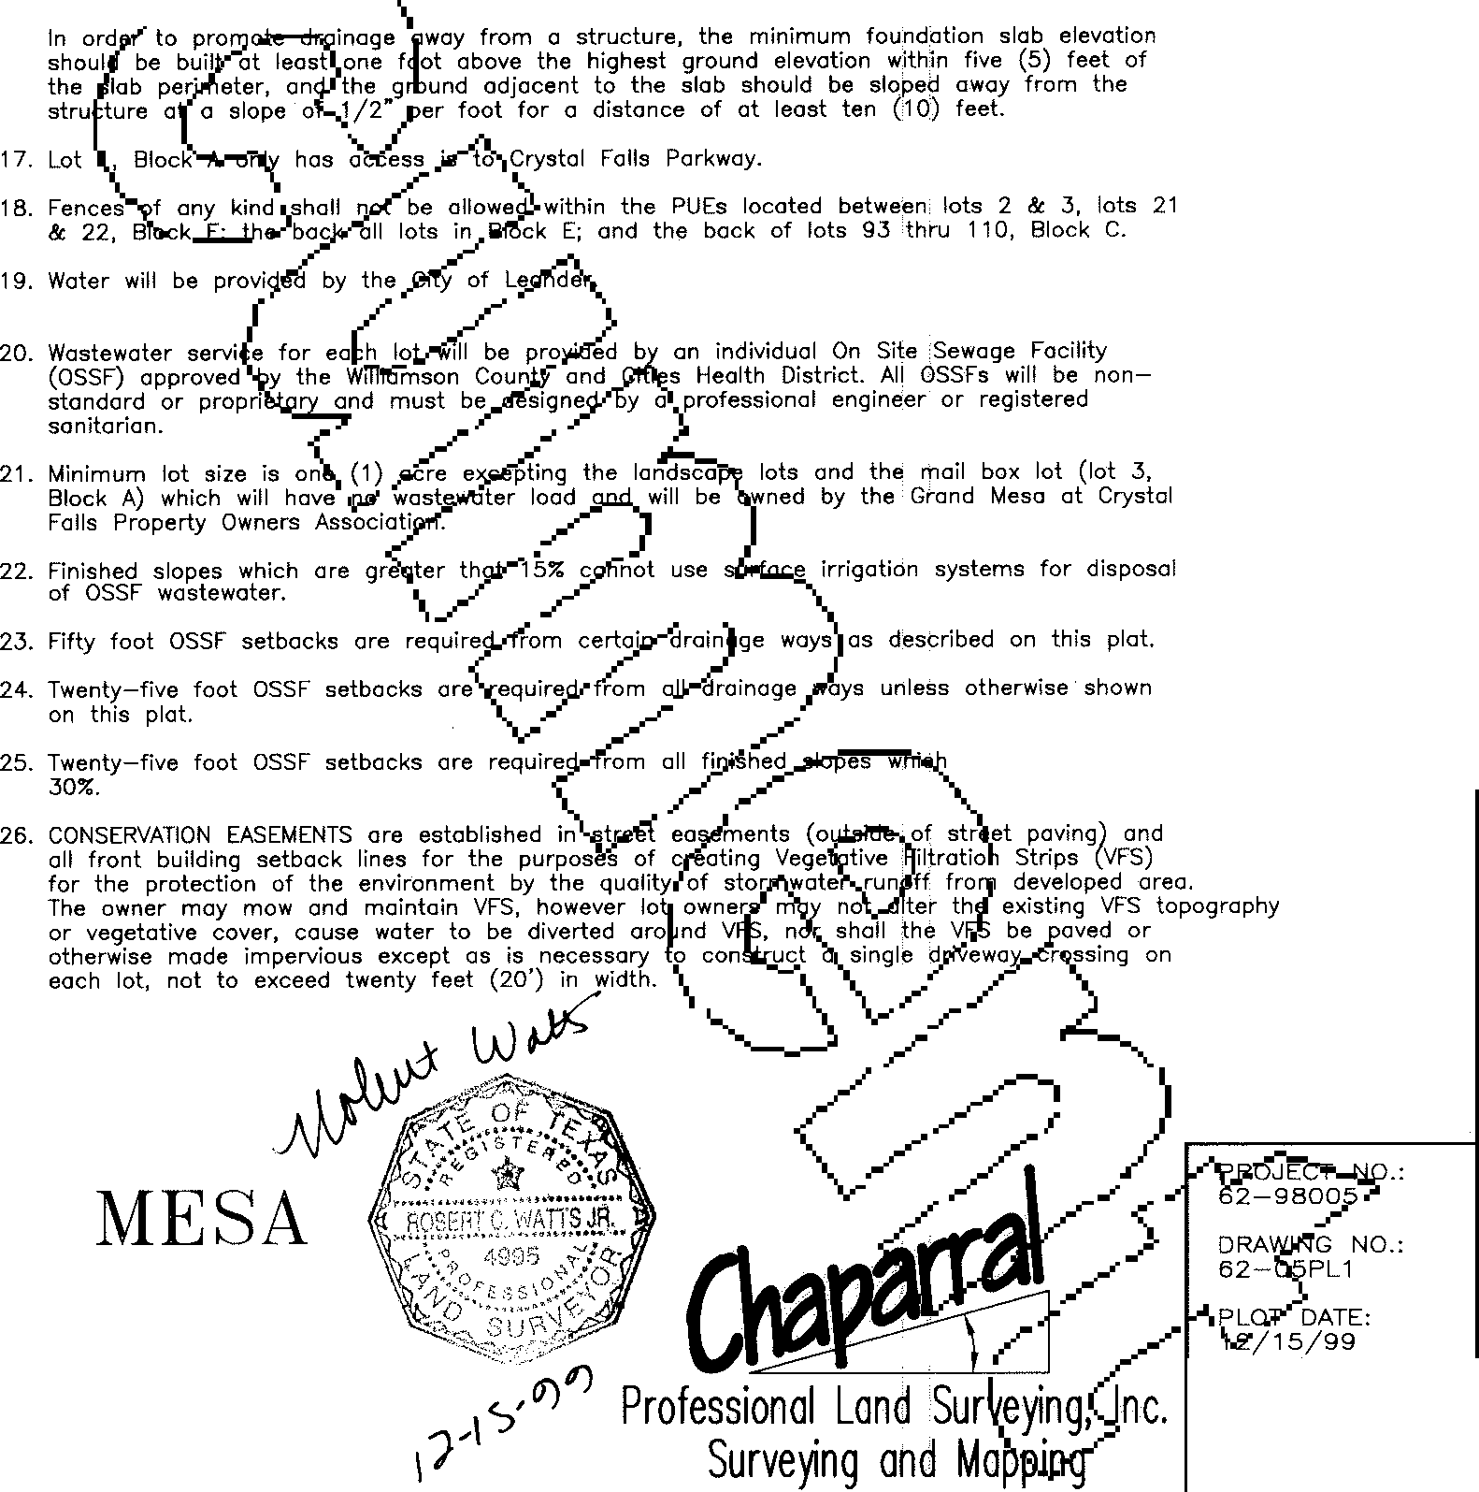

(512) 244-4279

ROUND ROCK, TEXAS 78664 FAX: (512) 244-0504

**CRYSTALF**ALLS

510 South Congress Ave., Suite Austin, Texas 78704

512-476-7103

1"=100'

DRAWN BY:

LEA, COD

8-1001 ,

SHEET

1. OF 19

PHOTOGRAPHIC MYLAR

/ *A\._*

//A

GRAND MESA AT CRYSTAL FALLS

SUBDIVISION IN TRAVIS AND WILLIAMSON COUNTIES

*( C/_>*

!:I.\JBDIVISION BOU A \

._ ------- /,. *.L..*

BEGINNING at :ebar e so tehst line o.fa 1 2.46 acre tract described in Vol'.lme 65age 4 the D Records of Wilhamson County, Texas, also beina,.,, p• -of-cur'l,ltllre in then t right-of-way line of Crystal

*Ji-of*

Falls Parkway, as1t cribed-iri'Volume 1a0 *5:* Page 1_927 of the Real_ Property

Records of Travis Co:;:nexas, a Tso b a p m the north hne of the said 1708.590 acre tr • / ***.t ***

THENCE crossing the sai d-?ll8.594cres **lhl!mlll** ht-of-way of the said Crystal Falls Parkway along **{c ;:;,e** t e left h ving a dius of 1286.12 feet, an arc length of 1424.10 feet 1md a rd which ars No 87'27'09"

a distance of 1352.45 feet to a 1'1" reba a point na

THENCE with the said 12.79 acre tract, South 70'23'28" East, a distance of

395.81 feet to a 1/2" rebar found for an angle point in this tract and an angle point in the aforementioned 12.79 acre tract, and also being the northwest comer of a

9.64 acre tract described in Volume 12022, Page 82 of the Real Property Records of Travis County, Texas;

THENCE departing the aforementioned 12.79 acre tract, along with the said 9.64 acre tract, South 15'12'32" West, a distance of 1279.94 feet to a 1/2" rebar with cap set for the beginning of curve to the left in this tract, and the north side of a sixty (60) foot roadway easement called for in Volume 12022, Page 82 of the Real Property Records of Travis County, Texas, from which a 1/2" rebar found for the southwest comer of the said 9.64 acre tract and the centerline of the said sixty

(60) foot roadway easement, bears South 15'12'39" West, a distance of 33.75 feet;

THENCE departing the said 9.64 acre tract and the north side of the sixty (60) foot roadway easement, and crossing the aforementioned 1708.590 acre tract with the northeast line of a proposed sixty (60) foot right-of-way the following eight (8) courses and distances:

1. North 58'27'11" East, a distance of 181.11 feet to the center of an 18" cedar marked with a 60d nail found;
2. North 61'41'29" East, a distance of 323.06 feetto the center ofa 4" cedar post marked with a 60d nail found;
3. North 58'27'34" East, a distance of 242.70 feet to a 1/2" rebar found for an angle point in this tract, and the aforemem1ioned 1708.590 acre tract, the northeast comer of the said 146.625 acre tract, and a point of tangency m the south line of a proposed sixty (60) foot right-of-way;

THENCE continuing with the common line of the said.146.625 acre tract, tfie aforementioned 1708.590 acre tract, and the south line of the proposed sixty (60) foot right-of-way the following two (2) courses and distances:

1. North 59'42'44" West, a distance of 480.47 feet to a 1/2" rebar found;
2. North 51'22'21" West, passing the end of the proposed sixty (60) foot right-of­ way at 127.43 feet and continuing for a total distance of 423.97 feet in all to a 40d

nail found;

/ . 1. Along said curve having a radius of 438.33 feet, an arc length of 194.53 feet THENCE South 60'51'22" West, a' ·stance of 79.97*i a"* rebarwit and a chord which bears North 61'15'56" West, a distance of 192.94 feet toa 1/2" set from which a punch-hole in ro ound, be out '51'22" t, rebarwithcapsetforapointoftangency;

distance of 213.57 feet for the beginning o 710 t eft on the north 1:!: o, ./ --._

Crystal Falls Parkway; ***1/-V*** 2 orth 73'58'45" West, a distance of 100.00 feet to a 1/2" rebar with cap set for he eginning of a curve to the right;

j

THENCE departing Crystal Falls Parkway So ndcontil'ltling over across;;:

the aforementioned 1708.590 acre tract the fol ·ng tt\irti-one (31J.- rses and . 0 said curve having a radius of 263.55 feet, an arc length of 262.73 feet distances: *.r* nd a chQ(d which bears North 45'25'14" West, a distance of 251.99 feet to a 1/2"

THENCE continuing with the common line of the said 146.625 acre tract an )he. ' aforementioned 1708.590 acre tract, the following four (4) courses and distances:

1. North 12'16'22" West, a distance of 103.21 feet to a 1/2" rebarfound;
2. North 23'23'49" East,.a <!istance of 64.38 feet to **a** 40d nail found;
3. North 44'11'02" East, a distance of 87.09 feet to a 1/2" rebar with cap set;
4. North 18'07'25" West, a distance of 353.43 feet to a,• rebar

_.A._ wit!JAip set /

) ,ar Ill"cap set for a point of tangency;

-, .--

1. North 68'55'40" East, a distance of 10.40 feet to a 1/2" rebar found for the

" *...t:* •North 16'51'43" West, a distance of 527.44 feet to a 1/2" rebar with cap set for

1. North 35'37'06" West, a distance of 294.72 feet to a3'with ca I; .-" the beginning ofa curve to the left;
2. South 75'00'35" West, a distance of 286.78 feet to a 1/2" rebar,»1· ca/s4pet· /.said curve having a radius of 876.95 feet, an arc length of 406.72 feet

/ and a cli which bears North 30'08'54" West, a distance of 403.08 feet to a 1/2"

1. South 39'26'08" West, a distance of 278.29 feet to a 1/2" re wit s rebar with p set for a point of tangency;
2. South 72'01'31" West, a distance of 665.00 feet to a 1/2" reba cap,,iet; · N h 43° '05" West, a;f ance of 964.30 feet to a 1/2" rebar with cap set for

northwest corner of this tract and the aforementioned 1708.590 acre tract, also being an area referred to as a county road in a description of **a** 192.46 acre tract of land described in Volume 2653, Page 412 of the Deed Records of Williamson

* + County,.Jexas;

THENCE departing the said 146.625 acre tract, continuing with the aforementioned 1708.590 acre tract, and crossing said county road, South '54•19'(!)5:' East a distance of 34.17 feet to a .3/4" iron pipe found for an angle

1. North 55'28'37" West, a distance of 125.00 feet to a 1/2" rebar

. {

with ca

set;

the eginnin of a curv!,1-lll th right;

-,

1. Alon id c a g a i:a!lius of 553.44 feet, an arc length of 685.59 feet nd a chord h be'ajs 07'56'47" West, a distance of 642.59 feet to a 1/2"

point in'this and the 1708.590.acre trafis,. \he. sou.thwest corner of a 192.46 acre tract described in Volume 2653, Page 112 of.the Deed Records of WIlhamson County, Texas, and the east side of said i:ouhfy road;

1. South 50'04'00" West, a distance of 187.00 feet to a 1/2" rebar with cap

bar wit ap set fo oint of tangency;

THENCE continuing with the common line of the aforementioned 1708.590.acre

-.. ,..-- /

_../

tract and the said 192.46 acre tract the following ten (10) courses and distances:

1. South 68'19'25" West, a distance of 85.55 feet to a 1/2" rebar with cap set; / / **-r----..._**
2. North 85'55'01" West,a distance of 173.69 feet to 1/2" rebar with cap set; i: 8. N 27'32'31" \\(est,a dist ce of 1003.16 feet toa 1/2" rebar with cap set

**iti,ffie** a- 5 acr tract described in Volume 11937, Page 558 of

1. South 54'13'36" East, a distance of 838.78 feet to a 3/4" iron pipe found;
2. South 42'31'43" West,a distance of 100.69 feet toa 1/2" rebar with cap set;

\ !he d Records oqraviS:,C.ou.n Texas, also beinga point in the west line of

the ore•medn1 0 acre ract, for an point m this tract, and being

1. South 54'28'02" East, a distance of 673.29 feet to a 40d nail found;
2. South 60'50'05" West,a distance of 181.87 feet to a 1/2" rebar with cap set; the nd of ea re of the pro se?ssi OJ fo right-of-way, from whicha
3. South 47'40'57" West, a distance of 202.83 feet to a 1/2" rebar with cap set;

1/2' ebar ars h 61"28*_*'0*.I'*

West istance of .01 feet;

1. South 52'15'28" East, a distance of74.66 feet to a 3/4" iron pipe found;
2. South 66'17'26" West, a distance of 123.21 feet to a 1/2" rebar with cap set;
3. South 03'49'11" West, a distance of 248.02 feet to a 1/2" rebar with cap set;
4. South 22'00'06" West, a distance of 122.66 feet to a 1/2" rebar with cap set;
5. South 26'39'18" West, a distance of 190.43 feet to a 1/2" rebar with cap set;
6. South 16'07'17'' West, a distance of 249.86 feet to a 1/2" rebar with cap set;
7. South 60'33'56"West, a distance of 157.86 feetto a 1/2" rebarwith cap set;
8. South 14'52'31" West, a distance of 129.37 feet to a 1/2" rebar with cap set;
9. South 00'02'16" East, a distance of 155.60 feet to a 1/2" rebarwith cap set;
10. South 37'55'42" West, a distance of 144.30 feet to a 1/2" rebar with cap set;
11. South 44'00'44" West, a distance of 184.22 feet to a 1/2" rebat with cap set;

THENC the comf!JP'i'line *ou,(e*aforemellli6ned 1708.590 acre tract and the said 146.acres t._m!" folio e enteell'(17) courses and distances:

1. South 61'2 E ,a distan .71 feet to a 3/4" iron pipe found;
2. North 28'18'0 ast,a ce of 2756.15 feet to a 5 "1und;
3. North 46'13'03" *M.a* distance of 1414.95 f 1/2" rebar fo ;
4. South 80'59'35" East, a distance of 27 twf"eet to.a 1:Y-"8 found;
5. South 76'45'18" East, a distance 125.90 fee 1/2" reb found;

,.

1. South 51'07'59" East, a dist ce of 93. Met to the;a,{nter of a 1 'cedar stump marked with a 60d nail foun • \_ /

I - •

1. North 59"22'26" East, a distance o\155.23 feet to the ce f a 10" cedar

stump marked with a 60d nail found; .... , u -..._

---

1. South 52'12'06" East, a distance of 291.65 feet to a 3/4" iron pipe found;
2. South 52'17'14" East, a distance of 250.39 feet to a 3/4" iron pipe found;
3. South 52'13'50" East, a distance of 816.02 feet to a 3/4" iron pipe found;
4. South 52'14'29" East, a distance of 272.76 feet to a 3/4" iron pipe found;
5. South 50'46'35" East, a distance of 71.21 feet to a 40d nail found;
6. North 83'29'44" East, a distance of 8.22 feet to a 112" rebar found;
7. South 55'43'47" East, a distance of 989.38 feetto the POINT OF BEGINNING and containing 445.429 acres of land more or less.

Surveyed on the ground December, 1998. Bearing basis is Grid Azimuth for Texas Central Zone, 1983/93 HARN values from LCRA network. Attachments: Survey drawing numb'lr 62-05BN0.

1. South 02'51'11" East, a distance of 143.46 feet to a 1/2" rebar with cap set;
2. South 19'53'24" West, a distance of 494.70 feet to a 1/2" rebarwith cap set;
3. South 14'58'22" West, a distance of 245.58 feet to a 1/2" rebar with cap set;
4. South 22'45'53" East, a distance of 477.53 feet to **a** 1/2" rebar with cap set;
5. South 03'42'55" West, a distance of 312.38 feet to a 1/2" rebarwith cap set; 28, South 30'35'51" West, a distance of 396.51 feet to a 1/2" rebar with cap set;
6. North 55'16'23" East, a distance of 170.66 feet to the ter of a 14" live oa marked with a 60d nail found;
7. North 72'49'59" East, a distance of 172.95 i.eet **!the** ceri\er of a cedar

stump marked with a 60d nail found; I /

1. North 83'32'16" East, a distance of 145.19 feet to center of a 14" r oa

marked with a 60d nail found; ' ---------/ - \

I

1. North 70'22'49" East, a distance of 160.23 feet to the center of a 2 live oak marked with a 60d nail found; (.

**V** .....-..

1. North 87"13'20" East, a distance of 122.36 feet to the center of 30" liv oak
2. South 44'50'56" East, a distance of 176.31 **feet** to a 1/2" rebar with cap set;
3. South 00'06'34" West, a distance of 174.83 feet to a 1/2" rebarwith cap set;
4. South 30'33'47" East, a distance of 62.67 feet to a 1/2" r'ebar with cap set for

marked with a 60d nail found;

1. North 84'12'38" East, a distance of 241.61 feet to a 1/2" rebar foun
2. North 52'37'12" East, a distance of 115.70 feet to a 1/2" rebar found;

*)*/ ,,.,- *>*-.,

/ /  ***.A***

*r ( /)*

an angle point in this tract and the northeast comer. of. a 7.0107 acre tract described in Volume 10833, Page 1355 of the Real Property Records of Travis County, Texas, from which a PK nail in a guard rail bollard found for the southeast corner of the said 7.0107 acre tract bears, South 20'57'55" East, a distance of

856.63 feet;

***;Nr, EN•-'•£ SU/J --; XJ*** *,µ:'*

***w¥-rtlEflf ,11£ (OR'" r-t,p*** ,,

***>dE ,rry CF LF,.,,p*** <-, _ _,/")

THENCE South 69°03'28" West with the common line of this tract and the said 7.0107 acre tract, a distance of 295.00 feet to a 1/2" rebar with a 2" aluminum cap marked CUNNINGAM-GRAVES found;

THENCE departing the said 7.0107 acre tract and continuing over and across the said 1708.590 acre tract the following four (4) courses and distances:

1. South 31°30'58" West, a distance of 187.76 feet to a 1/2" rebar with cap set;
2. North 81'26'05" West, a distance of 289.21 feet to a 1/2" rebar with cap set;
3. South 25'42'40" West, a distance of 43,90 feet to a 1/2" rebar with cap set for a point on a curve to the left;
4. Along said curve having a radius of 50.00 feet; an arc length of 63.53 feet and a chord which bears South 79°18'44" West for a distance of 59.34 feet to a 1/2" rebar with cap set for an angle point in this tract and a point in the northeast line of a 12.79 acre tract described in Volume 6579, Page 1466 of the Deed Records of Travis County, Texas, from which .a 1/2" rebar found for the easternmost comer of the aforementioned 12.79 acre tract and also being an angle point in the north line of a 7.15 acre tract described in Volume 6579, Page 1395 of the Deed Records of Travis County, Texas, bears, South 47' 05'13" East, a distance of 50.00 feet;

THENCE with the northeast line of the said 12.79 acre tract North 47°05'13" West, a distance of 1171.16 feet to a 1/2" rebar found for an angle point in this tract and

kEGAL DESCRIPTION: \/ /

445.429ACRESOFLANDINWILLIA<o· - sco TIES,LOCATEDINTHE

C.H. HEART SURVEY 704, THE c. 'Uo RVEY ,9-20, THE T. CATER SURVEY 206, AND THE C.S. MASON SURVEY 20,.. =,i::::ING A,..Pb 1142.168 ACRE TRACT DESCRIBED IN VOLUME 1308 PAGE.--192'1' OF THE RE PROPERTY

RECORDS OF TRAVIS COUNTY, TEXAS, *OY* RECO DO UMENT NO. 9758697 OF THE OFFICIAL RECORDS OF WILLjr,li.MSO C UN , T XAS, BEING ALSOAPORTIONOFA375.785ACRETRACTD CRI E IN ·• UM 13085,PAGE 1974 OF THE REi\1.. PROPERTY RECORDS OF TRA IS UNTY, rE)5eJS BEING ALSO OF RECORD IN DOCUMENT NO. 975869 OF T O IC L ,!}E"CO S OF WILLIAMSON COUNTY, TEXAS. ./"

/

GRAND MESA

P62R-O9J8Er,::T .: DRAWi NO.:

the northwest comer of the said 12.79 acre tract;

THENCE with the west line of the said 12.79 acre tract, South 27'14'25" West, a distance of 834.87 feet to a 1/2" rebar found for an angle point in this tract and the southwest comer of the said 12.79 acre tract;

SUBDIVISION

# 8

Professional Land Surve)i.. **C.**

Surve ng and Mapping

**jj,2-0** 1

PL'-cir DATE: 06/25/99

PLOT SCALE:

1"=100'

DRAWN BY: LA, COD

CRYSTALFALLS

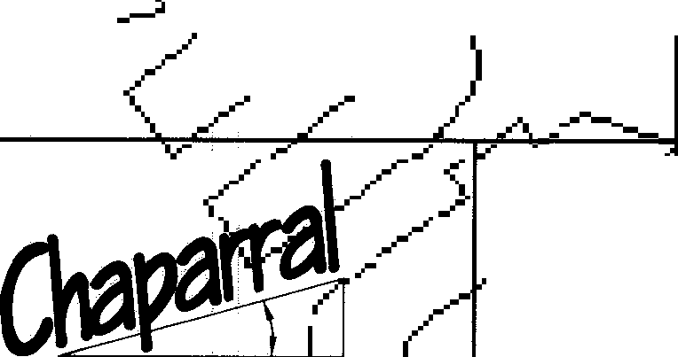

510 South Congress Ave., Suite Austin, Texas 78704

512-476-7103

s-100,1 I

SHEET

1. **OF 19**

PHOTOGRAPHIC MYLAR

**GRAND**

**AT CRYSTAL**

**MESA**

**FALLS**

**SUBDIVISION IN TRAVIS**

**AND**

**WILLIAMSON**

**COUNTIES**

THE STATE OF TEXAS COUNTY OF TRAVIS

I, DANA DEBEAUVOIR, CLERK OF TRAVIS COUNTY, TEXAS, DO HEREBY CERTIFY THAT

THE FOREGOING INSTRUMENT OF WRITING, WITH ITS CEf}fFICATE OFJ THENTICAJJ9 /.

WAS FILED. FOR. ECORD IN MY OF .;f ON TH "OAY OF *1,ltl?/lt,.,_ 7F.7c =-*

l T/ t' O'CLOCK *L;* M... AND DULY RECORDED 0 TH E Sf.;,;c,.

*u ----·* A.O. :'. AT *L-_'t!.:t* O'CLOCK LM., IN THE OFFICIAL REc'ciRos

/ *f J* • *?) /1"':J!*

bF SAID COU TY AND STATE, IN DOCUMENT NUMBER *--,.'&') d)eJ_O_, 7 _*

WITNaS. MY HAND AND SEAL OF OFFICE OF THE COU CLERK, THE y

,,,,"'*#.n-4 _;:::}do a*

OF *f /C:, f:§"* A.O.

STATE OF TEXAS COUNTY OF TRAVIS

I, ROBERT C. WATTS, JR. AM AUTHORIZED UNDER THET LAWS OF THE STATE OF TEXAS TO PRACTICE THE PROFESSION OF LAND SURVEYING, AND HEREBY STATE THAT THIS PLAT CONFORMS WITH APPLICABLE ORDINANCES OF THE CITY OF LEANDER, TEXAS AND WILLIAMSON COUNTY, TEXAS, AND THAT ALL EXISTING EASEMENTS OF RECORD OF WHICH I AM AWARE HAVE BEEN SHOWN OR NOTED HEREON.

ROBERT C. WATTS, JR.

REGISTERED PROFESSIONAL LAND SURVEYOR STATE OF TEXAS NO. 4995

*c:LCOO*

**WENDY L DAVIS**

**NOTARY PUllllC**

**State of THU**

**Comn. E,cp, 10-1 2003**

**hl£D<Li_J ,_J2a_\J_L ,_ _**

PRINT NAME

NOTARY PUBLIC IN AND FOR THE COUNTY OF ..W..1fliam.Jat--TEXAS. MY COMMISSION EXPIRES ***Ll2...::-_f...2.. ::_,:l. _{)- .***

STATE OF TEXAS COUNTY OF WILLIAMSON

,+ **L**

APPROVED THIS THE ***J.l*** DAY OF **fu .P!£... 19 *q_q*** A.O. AT A PUBLIC MEETING OF THE PLANNING AND ZONING COMMISSION OF THE CITY OF LEANDER, TEXAS AND AUTHORIZED TO BE FILED FOR RECORD BY THE COUNTY CLERK OF WILLIAMSON COUNTY, TEXAS.

CITY OF LEANDER, TEXAS

CITY OF LEANDER, TEXAS

STATE OF TEXAS COUNTY OF WILLIAMSON

I, NANCY RISTER, CLERK OF THE COUNTY COURT OF SAID C TY, DO HEREBY CERTIFY THAT THE FOREGOING INSTRUMENT IN WRITING, ITS CERTIFICATE OF AUTHENTICATION WAS FILED FOR RECORD IN MY OFFI ON THE DAY OF

, 1999 A.O., AT .M., AND DULY RECORDED THIS THE DAY OF **----2''---•** 1999 A.O., AT O'CLOCK, .M., IN THE PLAT RECORDS OE AID COUNTY IN CABINET SLIDE

TO CERTIFY WHICH, WITNESS MY COUNTY, AT MY OFFICE IN GE WRITTEN.

D AND SEAL AT THE COUNTY COURT OF SAID ETOWN, TEXAS, THE DATE LAST SHOWN ABOVE

NANCY RISTER, CLER OUNTY COURT OF WILLIAMSON TY, TEXAS

**GRAND MESA**

**307 SUNSET DRIVE**

DEPUTY

**ROUND ROCK, TEXAS 786§4**

**SUBDIVISION**

# 8

PLOT SCALE:

LEA, COD

**CORRIDOR ENGINEERING COMPANY**

**1"=100'**

DRAWN BY:

**(512) 244-4279**

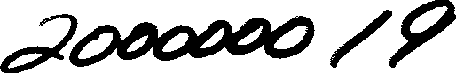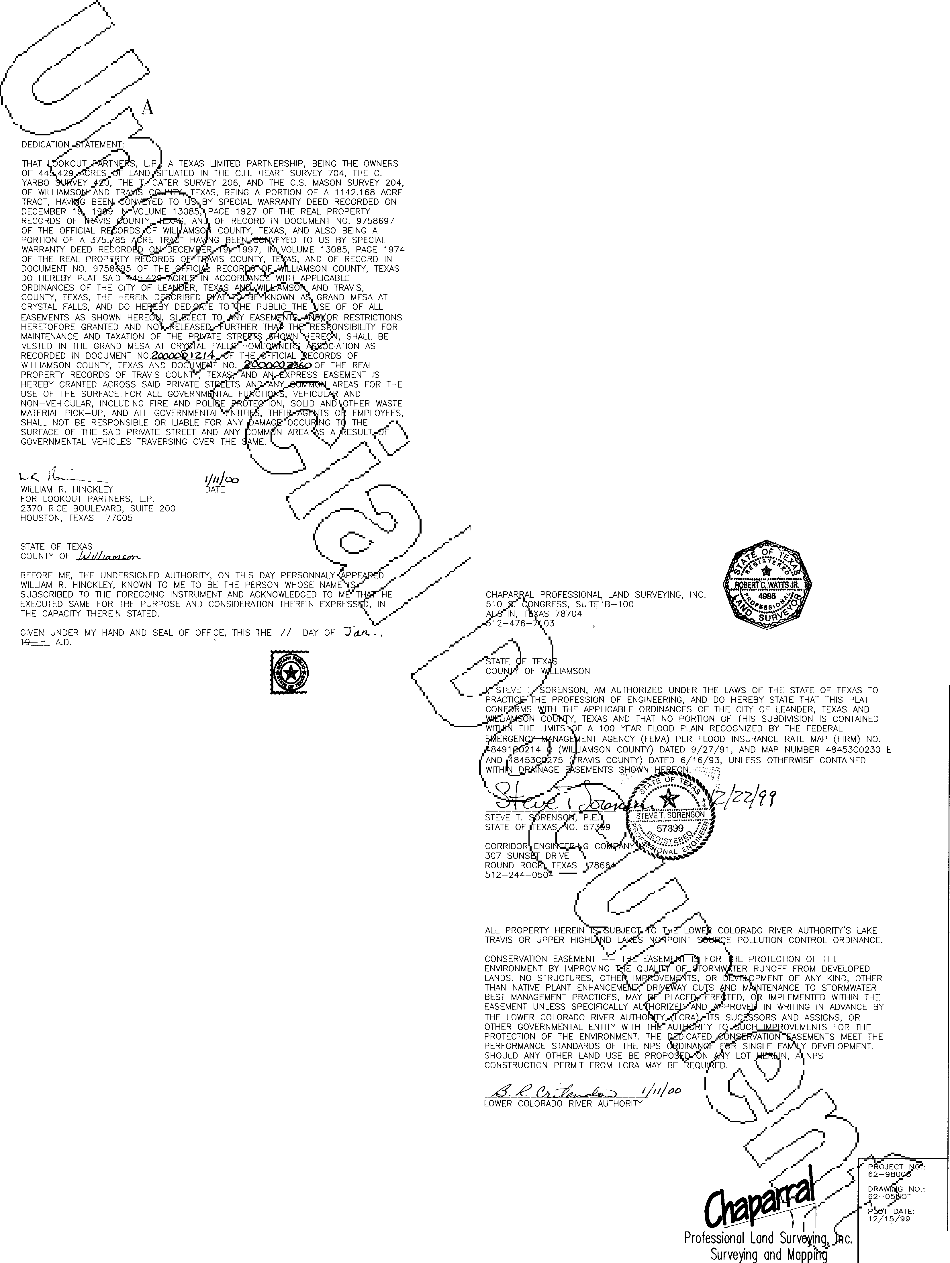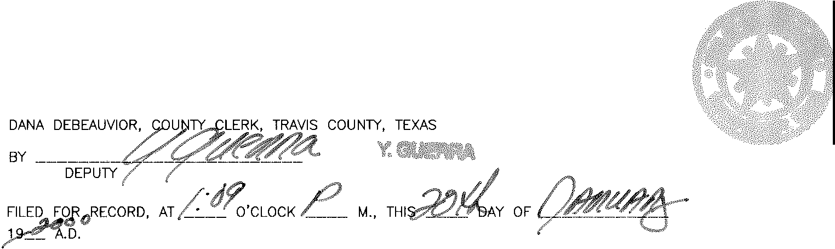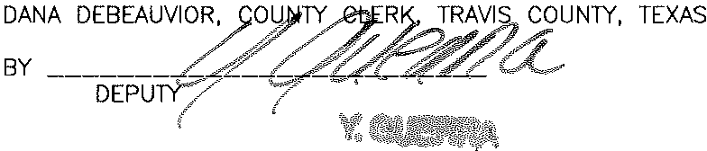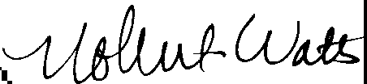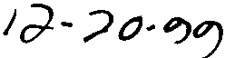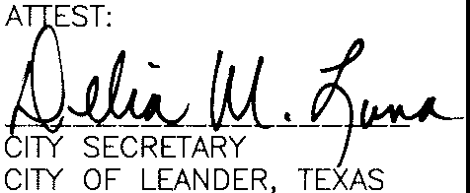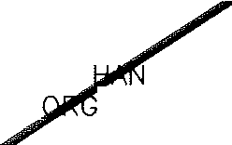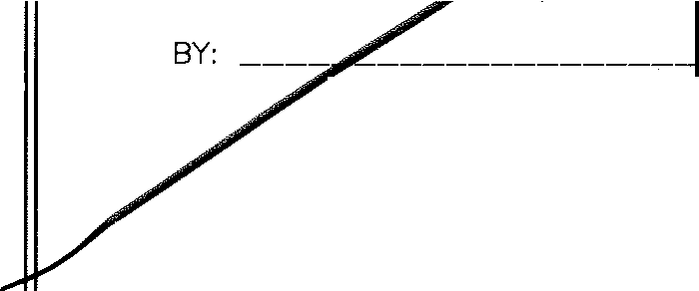

**FAX: (512) 244-0564**

**CRYSTALFALlS**

510 South Congress Ave., Suite **B-1001 tl**

Austin, Texas 78704 **SHEET**

512-476-7103 **19 OF 19**

*A*

**ELl§.G-TR})N1cALLY RECORDED**

/ / /\ TRV

**2018085720**

**6** PGS

*(* 0/ /....

\ /\

_./

/ */)* )

**\1i'AT&6J EXAS**

***a***

**OF VIS**

1, **UNN°EXATION AND AMENDMENT, CRYSTAL FALLS**

\.... -/ *r,_?-*- **GRAND MESA SECTION V;**

_/.. **/ E OF RESTRICTIVE COVENANTS**

V _..,...- *<"\--A,* . I. -

*(* / /_..,..,_ ,. \ J O l ·d'4se,-v\l

....-

_.....-

)

**THIS NOT.J(;E ,.oF ANNEXATION AND AMENDMENT, CRYSTAL FALLS**

**GRAND MES '110Nv., AND NOTICE RESTRICTIVE COVENANTS** (this

***"Restriction")*** is madtr e 1into f the y of May, 2018, by Travisso, Ltd., a Texas limited partnership ***( 'Tr*** so"t_...-mlq.\buokout Development Group LP, a Texas Limited Partnership, as Declaran ;, for the Crystal Falls Home Owner's Association, Inc. ***"Association",*** as those thei and Association) are further defined in the Original

Declaration. ( C _... ,.-------

?_ /. SSETH:

T-favisso Res-µic"tions \

WHEREAS, Travisso is the owne f *i:µ{* pr e situated in the City of Leander, located in Travis County, Texas described as"lldw l _o, Block E of Travisso Section One, Phase Two, a subdivision in Travis County, Texas,..act_pram9the map or plat recorded under Document Number 201400105, in the Official Pu lic,Record of Travis County, Texas (the

--- /

***"Property").*** \ 1 /

- ,....-

WHEREAS, Travisso desires to impose the thre/co. e" d restrictions set forth below (the ***"Travisso Restrictions")*** on the Property. \ *//\)*

-,.....-- /

*/'\.*

,

The Property is and shall be, held transferred, sold, conkeyei.dveJ ed and occupied subject to the covenants, conditions, and restrictions set forth belo ryn tl_and.

1. **Masonry Construction. Any residential home co C--- t e roperty shall be constructed with an exterior fa de on the first story of only\ ne r other mas?nry of a kind and quality similar to that permitted for residenc wi o, Section One, Phase Two.** / ()

c,· //

I

1. **Roof. Any residence constructed on the Property shall not hav t,.ifade**

**of composite shingles.** ( /; *)*

1 //_.._< ?

*5*

v· ,

20748078v.1

*(..-* ,,.-------·\_...

*\..._,)=-.*

*/A*

///

*(* 0/ /

\ /\

/

*;:/---: )* **3) Fences. Any fencing constructed on the Property must be of non-solid, see­ Jl(ro ckets, ornamental wrought iron, or other material of a kind and quality**

***U***

*Iii ¥;*

**tted for residences within Travisso, Section One, Phase Two.**

**Va es to Covenants Conditions and Restrictions for the Grand Mesa at C sta *,h* sion Section Five.** The Property will not be granted variances to the Crystal F&- e ·guid ess such guidelines conflict with items 1 -3, above.

*<*

/A_....--. ,·..,_..-­

./ / _..)

1. ***K e*** Travisso Restrictions may be amended or terminated as to any

portion of the u i • approval and execution of an amending or terminating instrument approved sseb$ f qire ors of the home owners association referenced in the

Travisso Master Co enan ("***'[PtivisyVMaster Covenanf'),*** recorded as Document No.

2013223985 in the Offic1 71.1.b R s of Travis County. The amendment or termination shall be effective upon th :(:ilifi. g--e;( strument in the Official Public Records of Travis County, Texas. ( C,. *_......J* ,.......--

1. E**n1orcement;**

**bi)n-).l**/**my**/ **na .**/T

rav1. sso,

the property owners assoc1.a. t10n

identified in the Master Covenant, arld-.J.n{owner of :µiy°iw'ithin Travisso Section One, Phase Two shall each have standing to enforce the/Tua o strictions by any lawful means, including filing an action in a court of COJll:pete uri c• n against the person violating or attempting to violate the Declaration, eithef-..t;o pteyerr{th iolation or to require its correction. The Travisso Restrictions are hereby declared' cov IlllIDjng with the land and are wholly binding on all owners of the Property and their succe o as)igns.

The Covenants, Conditions, and Restrictions fo t sa at Crystal Falls Subdivision, Section Five, are filed of record in document no. ¢9JJ-'7?J1he Official Public Records of Travis County, Texas (together with all amenclments/ctndrsupp(e ts, the **"Original Declaration").** // /\



I //

'</ /} *,*

The Declaration authorizes Declarant to annex additional land\ijlfo _the Asso• tion and Declarant wishes to do so and hereby does so in this ***"Annexation and Am'f!;f!rn(.n.t***>***A***

**Toe Property** is **hereby annexed into the Association pursuant** to **D ty**

under Section 3.36 of the Original Declaration. Such annexation and this xa,_tion/lhld

'0 ;

/

2

20748078v.1

(/1/ *....J....*

/ v·/ / *5 5*./

*Cr< v*

-.....

*/A*

///

*(* 0/ /

\ /'

en t shall become effective immediately upon recordation of a deed or other instrument

?rr tle transfer of the Property from Travisso to the Association. The Property shall at

<811ch ·... tomatically subject to the Original Declaration, Bylaws of the Association, Rules *'oy--'¥* "}S809a n, landscape guidelines of the Association, Articles of Incorporation of the Associan pplicable dedicatory instruments governing Grand Mesa Section V.

- / *r....-->*

11J0'1)e_gl Msh by amended to authorize Declarant, or after the Declarant Control Period, t:lil1/_,G;-ociationrt; :f jhrough its board, to grant in its discretion vehicular access easement(s) t( g<? t en.tities or other entities reasonably needing access in order to serve

the water quality d located on LOT 13, BLOCK D, TRAVISSO SECTION ONE, PHASE TWO, a\wbdjifisi in;ravis County, Texas, according to the map or plat recorded under Document Nwrtb;s O 5, *µ{fh.e* Official Public Records of Travis County, Texas.

_....--,.\V

---- _. ,.

**Binding Effect.** _;xa d Amendment is hereby declared a covenant running

with the land and is whofiy..-.bi'Jldiu.g l owners of the Property and their successors and assigns. ( c" *_,._.*.*..)*.. ----

IN **WITNESS WHE.,/** AND DECLARANT have executed this document as of the dates below.

*\L/;..-* /\

V / \

*/ _. /))*

\ \_/ .

*\...... ..---?* - ........

( ,-'?j

---------- .•• -

( 7_ 1/\

*>*

*>* /

*-(/ ( )*

½ .......--- /\

\ /

*'"'< /j*

\/(/

3

//

*I*

11S\,l/

(/1/ *_,)_,*

20748078v.1

/ v·

*/*/*5*

*(..- < v*

-.....

*5*_,..­

*/A*

/ /'

// /\

*(* 0/ /

\ /\

/

/ *_......-) )*

-....../ ....- _....

( ?o)/"

- /;)

_,// )

**TRAVISSO:**

**TRAVISSO, LTD.,** a Texas limited partnership

By: TMC Travisso GP, LLC, a Texas limited liability company, its

V */*_....---*/ .,0 <A.'*

*< .-->*

/

., ...-· /_,

/ '<

*(c J/';0*

STATE OF TEXAS 0 / %

COUNTY OF //2.J}VtS ,/ */./* r-......

\

\ *,./"* ., ;\.,

gBey:n "".\'2 -...

B. Mark Berman, Vice President Date: lz -*........1..-._..,. l-=-g _*

This instrument was ac4io d.We 3/ ay of *Ha.1J* , 2018, by B. Mark Berman, the Vice President-:9Tr v GP, LLC, a Texas limit; liability company, the General Partner of **TRAVISSO.X,** ., 0xas limited partnership, on behalf of said entities therein stated. _...---- /\

V /,_ \

--- *y-*

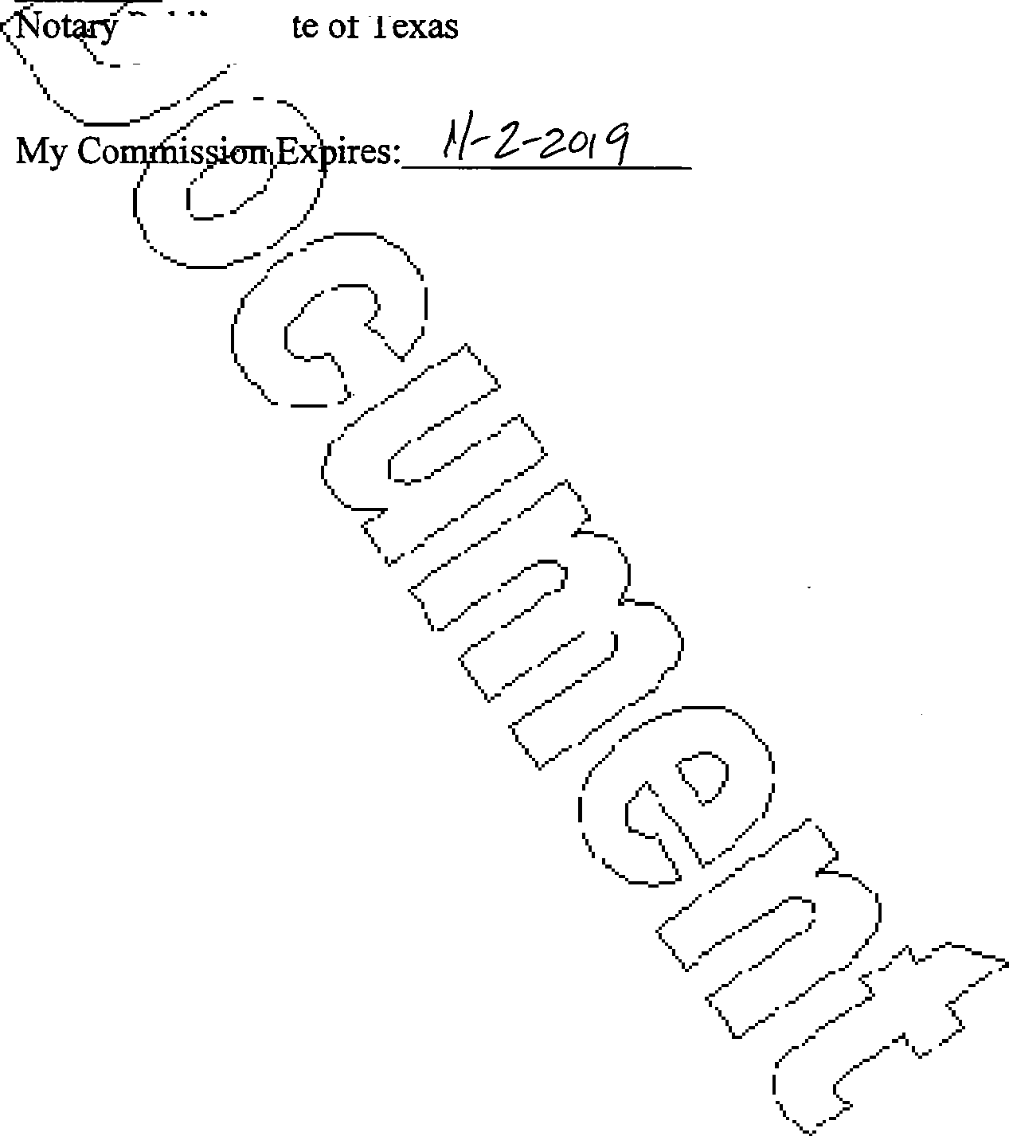

/

4

20748078v.1

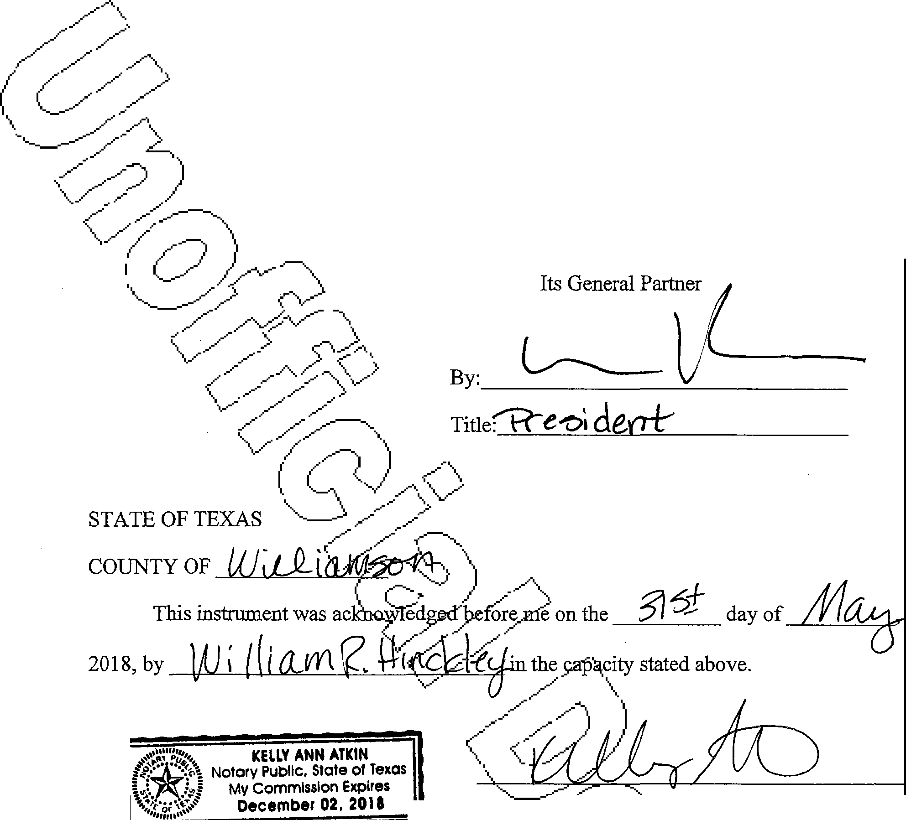

LOOKOUT DEVELOPMENT GROUP, L.P. A

TEXAS LIMITED PARTNERSHIP

By:

The Lookout Group, Inc.

NOTAJ}'\:r,Ic)IN AND FOR

THESi'

/7I _

/\

My commission *XJ'i# () --- L--* ( <?

PrintedName: **j(***<***J**,.....----,**\**... **\f**---.

**l**

File Server:CLIENTS:Crysta!Falls:Travis's6G#tPor

18:NoticeOfDeedRestrictionsTravisso.docx'\/ '/ *)*

(;;//

v;

11S\,l/

5 (/1/ *_,)_,*

20748078v.1

/ v·,/,......*5 5*/

*(,- < v*

-.....

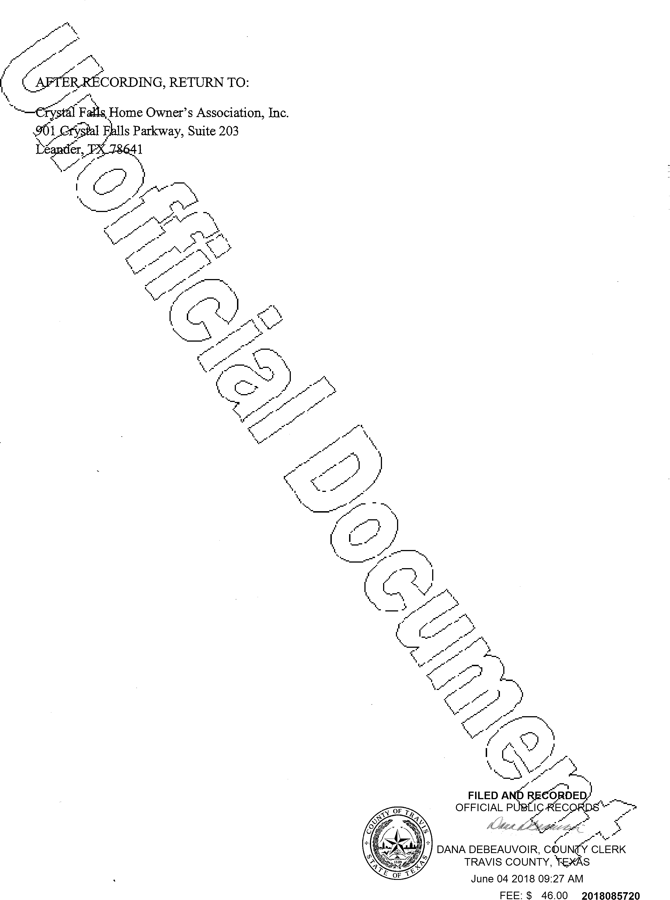

  

**TRAVISSO SECTION**



**ONE, PHASE TWO**

**LOT 170, BLOCK**

**E REPLAT**

N

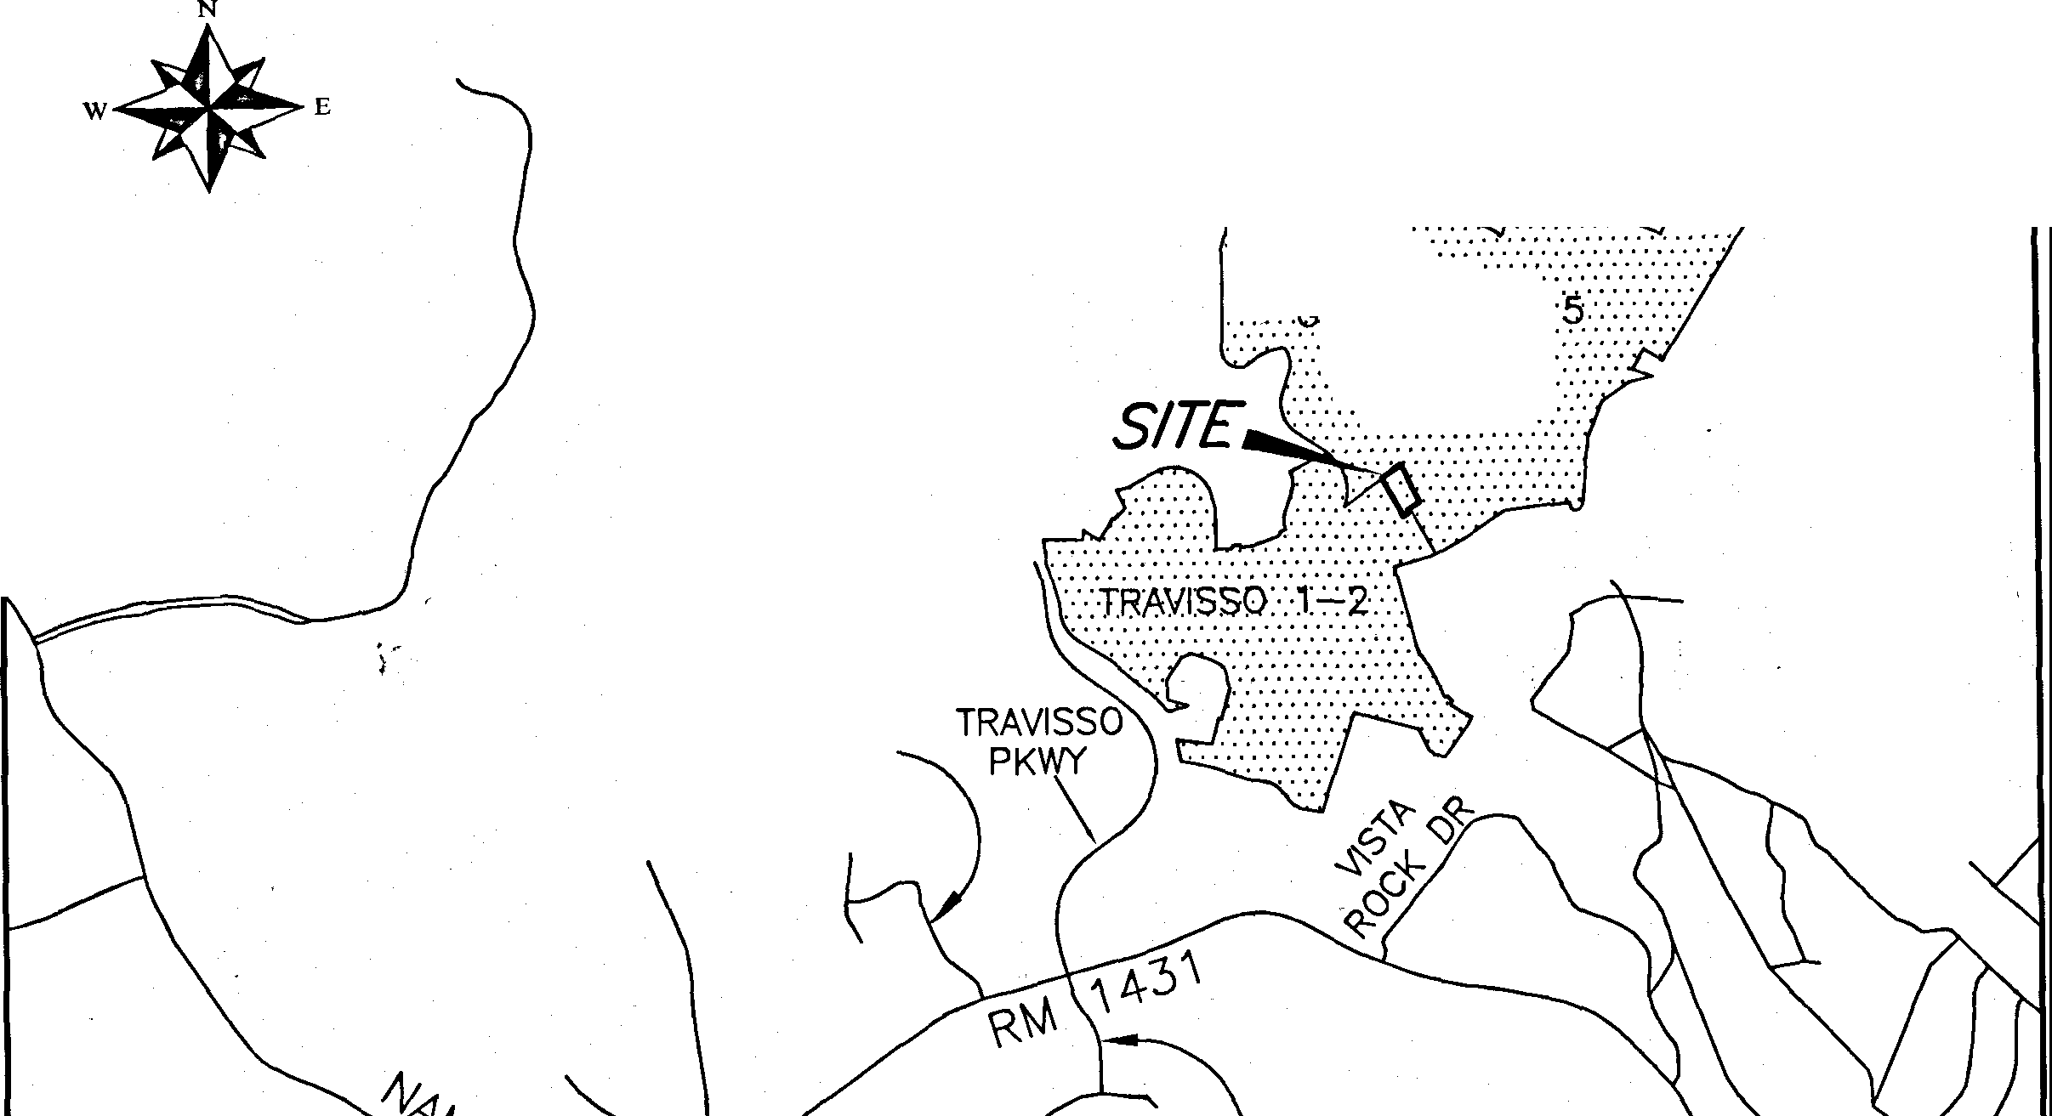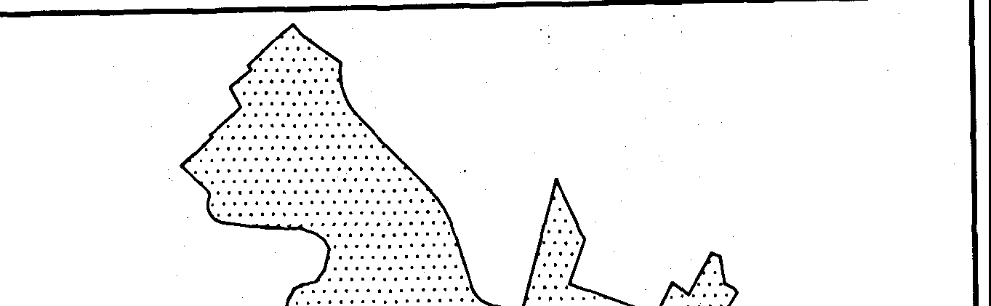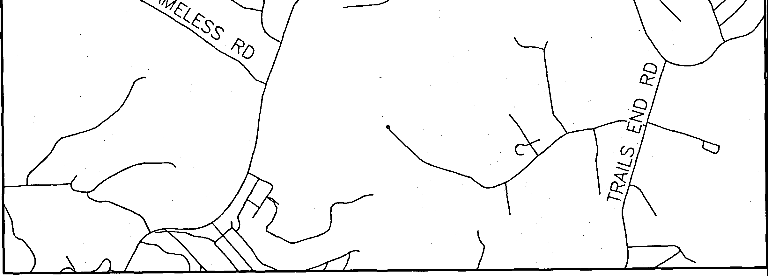

s

*·:::::::::::::..*

•::::::::::--:• i:Ni:{))tiA::

,. ......········

*·*'*:*·*:*·*:*·*:*·.·'*:*·*:*·*:*·*:*·*:*·*:*·*:*·*:*·*:*·*:*·*:*·*:*·*.*

*·:::::::::::.':.' ::.*

.·.•·•·•·•·•·•·•·•·•·•·•·•••

ANGELSIDE DR

LONESOME CREEK TR

SUBMITTAL DATE: OCTOBER 8, 2019 TOTAL AREA OF THIS PLAT: 1.308 ACRES TOTAL NUMBER OF LOTS: 1

RESIDENTIAL: 1

NEW STREETS: NONE OWNER:

CRYSTAL FALLS HOME OWNER'S ASSOCIATION, INC. 901 CRYSTAL FALLS PARKWAY, SUITE 203 \ LEANDER, TEXAS 78641

(512) 986-7444

AGENT:

BARBARA SMITH

901 CRYSTAL FALLS PARKWAY, SUITE 203

LEANDER, TEXAS 78641

(512) 986-7444

**i 1-f.#ki--RI**

a 50 100

s

1''=100'

200

400

DEVELOPER:

LOOKOUT DEVELOPMENT GROUP, LP 1789 SOUTH BAGDAD ROAD, SUITE 104

LEANDER, TEXAS 78641

(512) 690-4322

ENGINEER:

JAY ENGINEERING COMPANY INC. 1500 COUNTY ROAD 269

LEANDER, TEXAS 78641

(512) 259-3882

SURVEYOR:

G&R SURVEYING, LLC 1805 OUIDA DRIVE

AUSTIN, TEXAS 78728

(512) 267-7430

SHEE'T INDEX

SHEET **1:** COVER SHEET SHEET **2:** FINAL PLAT SHEET

SHEET 3: PLAT NOTES AND SIGNATURE BLOCKS



LOCATION MAP

SCALE: 1 "=2000'

DESCRIPTION OF 1.308 ACRES OF LAND SITUATED IN TRAVIS COUNTY, TEXAS, OUT OF THE J.M. FRAME SURVEY 656, ABSTRACT 303, BEING ALL OF LOT 170, BLOCK E, TRAVISSO SECTION ONE, PHASE TWO, A SUBDIVISION OF RECORD IN DOCUMENT NO. 201400105, ALL OF THAT CERTAIN 0.131 ACRE TRACT DESCRIBED IN DOCUMENT NO. 2019052359 AND ALL OF THAT CERTAIN PORTION OF ROARING FORK (60' PRIVATE STREET, DRAINAGE AND PUBLIC UTILITY EASEMENT), AS SHOWN ON PLAT OF GRAND MESA AT CRYSTAL

FALLS II, SECTION 5, A SUBDIVISION OF RECORD IN DOCUMENT NO. 200600041, AND DESCRIBED IN DOCUMENT NO. 2019055194, ALL OF RECORD IN THE OFFICIAL PUBLIC RECORDS OF TRAVIS COUNTY, TEXAS; SAID 1.308 ACRE TRACT BEING MORE PARTICULARLY DESCRIBED BY METES AND BOUNDS AS FOLLOWS:

BEGINNING AT AN IRON ROD WITH G&R CAP FOUND IN THE SOUTHERLY LINE OF LOT 169, BLOCK E, OF SAID GRAND MESA AT CRYSTAL FALLS 11, SECTION 5, FOR THE NORTHWESTERLY CORNER OF SAID LOT 170 AND THE HEREIN DESCRIBED TRACT;

THENCE N54"28'48nE, WITH THE SOUTHERLY LINE OF SAID LOT 169 AND THE NORTHERLY LINE OF SAID LOT 170, PASSING AT A

DISTANCE OF 156.73 FEET, A 1 /2" IRON ROD FOUND IN THE WESTERLY LINE OF SAID ROARING FORK AT THE COMMON EASTERLY CORNER OF SAID LOT 169 AND 170 AND CONTINUING INTO ROARING FORK, FOR A TOTAL DISTANCE OF 187.36 FEET 10 A CALCULATED POINT IN THE CENTER OF SAID ROARING FORK, SAME BEING THE WESTERLY LINE OF LOT 140, BLOCK E, OF SAID GRAND MESA AT CRYSTAL FALLS 11, SECTION 5, FOR THE NORTHEASTERLY CORNER OF THE HEREIN DESCRIBED TRACT;

THENCE WITH THE CENTER OF ROARING FORK, BEING IN PART, THE WESTERLY LINES OF SAID LOT 140 AND LOT 139 OF SAID BLOCK E, THE FOLLOWING THREE (3) COURSES:

1. S23"49'12"E, A DISTANCE OF 148.41 FEET TO A CALCULATED POINT OF CURVATURE OF A CURVE TO THE LEFT;
2. ALONG SAID CURVE TO THE LEFT HAVING A RADIUS OF 495.00 FEET, AN ARC LENGTH OF 41.71 FEET, AND A CHORD WHICH BEARS S26"35'21 "E, A DISTANCE OF 41.69 FEET TO A CALCULATED POINT AT THE END OF SAID CURVE;
3. S28"44'27"E, A DISTANCE OF 140.97 FEET TO A CALCULATED POINT IN THE NORTHERLY LINE OF LOT 9, BLOCK D, OF SAID GRAND MESA AT CRYSTAL FALLS 11, SECTION 5, AT THE CENTERLINE INTERSECTION OF SAID ROARING FORK AND GOOD NIGHT TRAIL (60' PRIVATE STREET, DRAINAGE AND PUBLIC UTILITY EASEMENT), AS SHOWN ON SAID PLAT OF GRAND MESA AT CRYSTAL FALLS II, SECTION 5, FOR THE SOUTHEASTERLY CORNER OF THE HEREIN DESCRIBED TRACT;

THENCE S60"24'06"W, WITH THE CENTERLINE OF SAID GOOD NIGHT TRAIL AND THE NORTHERLY LINE OF SAID LOT 9, PASSING AT A DISTANCE OF 30.00 FEET, A MAG NAIL FOUND AT THE SOUTHEASTERLY CORNER OF SAID 0.131 ACRE TRACT, AND CONTINUING FOR A TOTAL DISTANCE OF 119.37 FEET TO A MAG NAIL FOUND AT AN EL CORNER OF SAID 0.131 ACRE TRACT, SAME BEING THE NORTHWESTERLY CORNER OF SAID LOT 9;

THENCE S28"54'45"E, WITH THE WESTERLY LINE OF SAID LOT 9 AND THE SOUTHERLY LINE OF SAID 0.131 ACRE TRACT, A DISTANCE OF 30.00 FEET TO AN IRON ROD WITH G& R CAP FOUND IN THE SOUTHERLY LINE OF GOOD NIGHT TRAIL, (60' R.O.W.). AT THE NORTHEASTERLY CORNER OF LOT 10, BLOCK D, OF SAID TRAVISSO SECTION ONE, PHASE TWO;

THENCE S60"24'06"W, WITH THE SOUTHERLY LIN!:: OF GOOD NIGHT TRAIL, (60' R.O.W.) AND SAID 0.131 ACRE TRACT, SAME BEING THE NORTHERLY LINE OF SAID LOT 10, A DISTANCE OF 52.72 FEET TO A CALCULATED POINT, FOR THE SOUTHWESTERLY CORNER OF SAID 0. 131 ACRE TRACT AND THE HEREIN DESCRIBED TRACT;

THENCE WITH THE WESTERLY LINE OF SAID 0.131 ACRE TRACT AND IN PART WITH THE WESTERLY LINE OF SAID LOT 170, THE FOLLOWING THREE (3) COURSES:

1. N28"54' 45"W, A DISTANCE OF 30.00 FEET TO A CALCULATED POINT;
2. N60"24'06"E, A DISTANCE OF 4.96 FEET TO A CALCULATED POINT;
3. N29"35'42"W, PASSING AT A DISTANCE OF 30.00 FEET, AN IRON ROD WITH G& R CAP FOUND IN THE NORTHERLY LINE OF SAID GOOD NIGHT TRAIL, AT THE SOUTHWESTERLY CORNER Of: SAID LOT 170, AND CONTINUING FOR A TOTAL DISTANCE OF 310.92 FEET TO THE POINT OF BEGINNING, CONTAINING AN AREA OF 1.308 ACRES OF LAND, MORE OR LESS.

**SURVEYING, LLC**

*1805 OUIDA DR.*

*AUSTIN, TEXAS 78728*

*PHONE: (512) 267-7430*

*FAX: (512) 836-8385*

*FIRM NO. 10032000*

SHEET **1** OF **3**

**TRAVISSO SECTION ONE, PHASE TWO, LOT 170, BLOCK E REPLAT**

•

*INSIGNIA*.*•*..

0

®

PUE

PSE DE BL

LEGEND

1/2" IRON ROD FOUND

IRON ROD WITH CAP FOUND (INSIGNIA NOTED) MAG NAIL FOUND

CHISELED "x'' IN CONCRETE FOUND CALCULATED POINT

BLOCK NAME

PUBLIC UTILITY EASEMENT PUBLIC SAFETY EASEMENT DRAINAGE EASEMENT BUILDING SETBACK LINE

**-I I;·** :,:-

**Cf1**

N



s

1"=1 oo·

**1::: @t:t,tiNf.·hU**

.**;I** *i* : -I,,

**i!!fadM?}!-!d&·**'.-:,

**i-J:O**

:id

0 50 100 200 400

BEARING BASIS: TEXAS CENTRAL ZONE, STATE PLANE COORDINATES (NAO 83)

140

'\/

/

*A*

168

®

® /

*'b* /\

f, <§l r

"'-,*4*,*.F*3/'o f/j \

* / \ 137

\

\

\

/ GRAND MESA AT

/ CRYSTAL FALLS II, SECTION 5

/ DOC. 200600041

GRAND MESA AT

*)--'* CRYSTAL FALLS II, SECTION 5

DOC. 2 0600041 \

138

/ 169

/

*POB*

TRAVISSO SECTION ONE, PHASE TWO

DOC. 201400105

172 *J.M.*

\ 7

\

\ ·\

*FRAM[\SURV[Y 656,* \

*ABS. f03*

\ 8 \

9 \ \

-

GRAND MESA AT

CRYSTAL FALLS II, SECTION 5

DOC. 20060\041

- --- \

\ \

\ \

\ @

\ ....- \ \

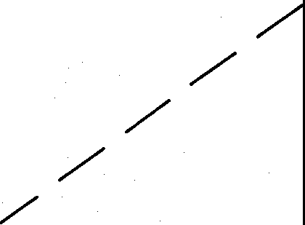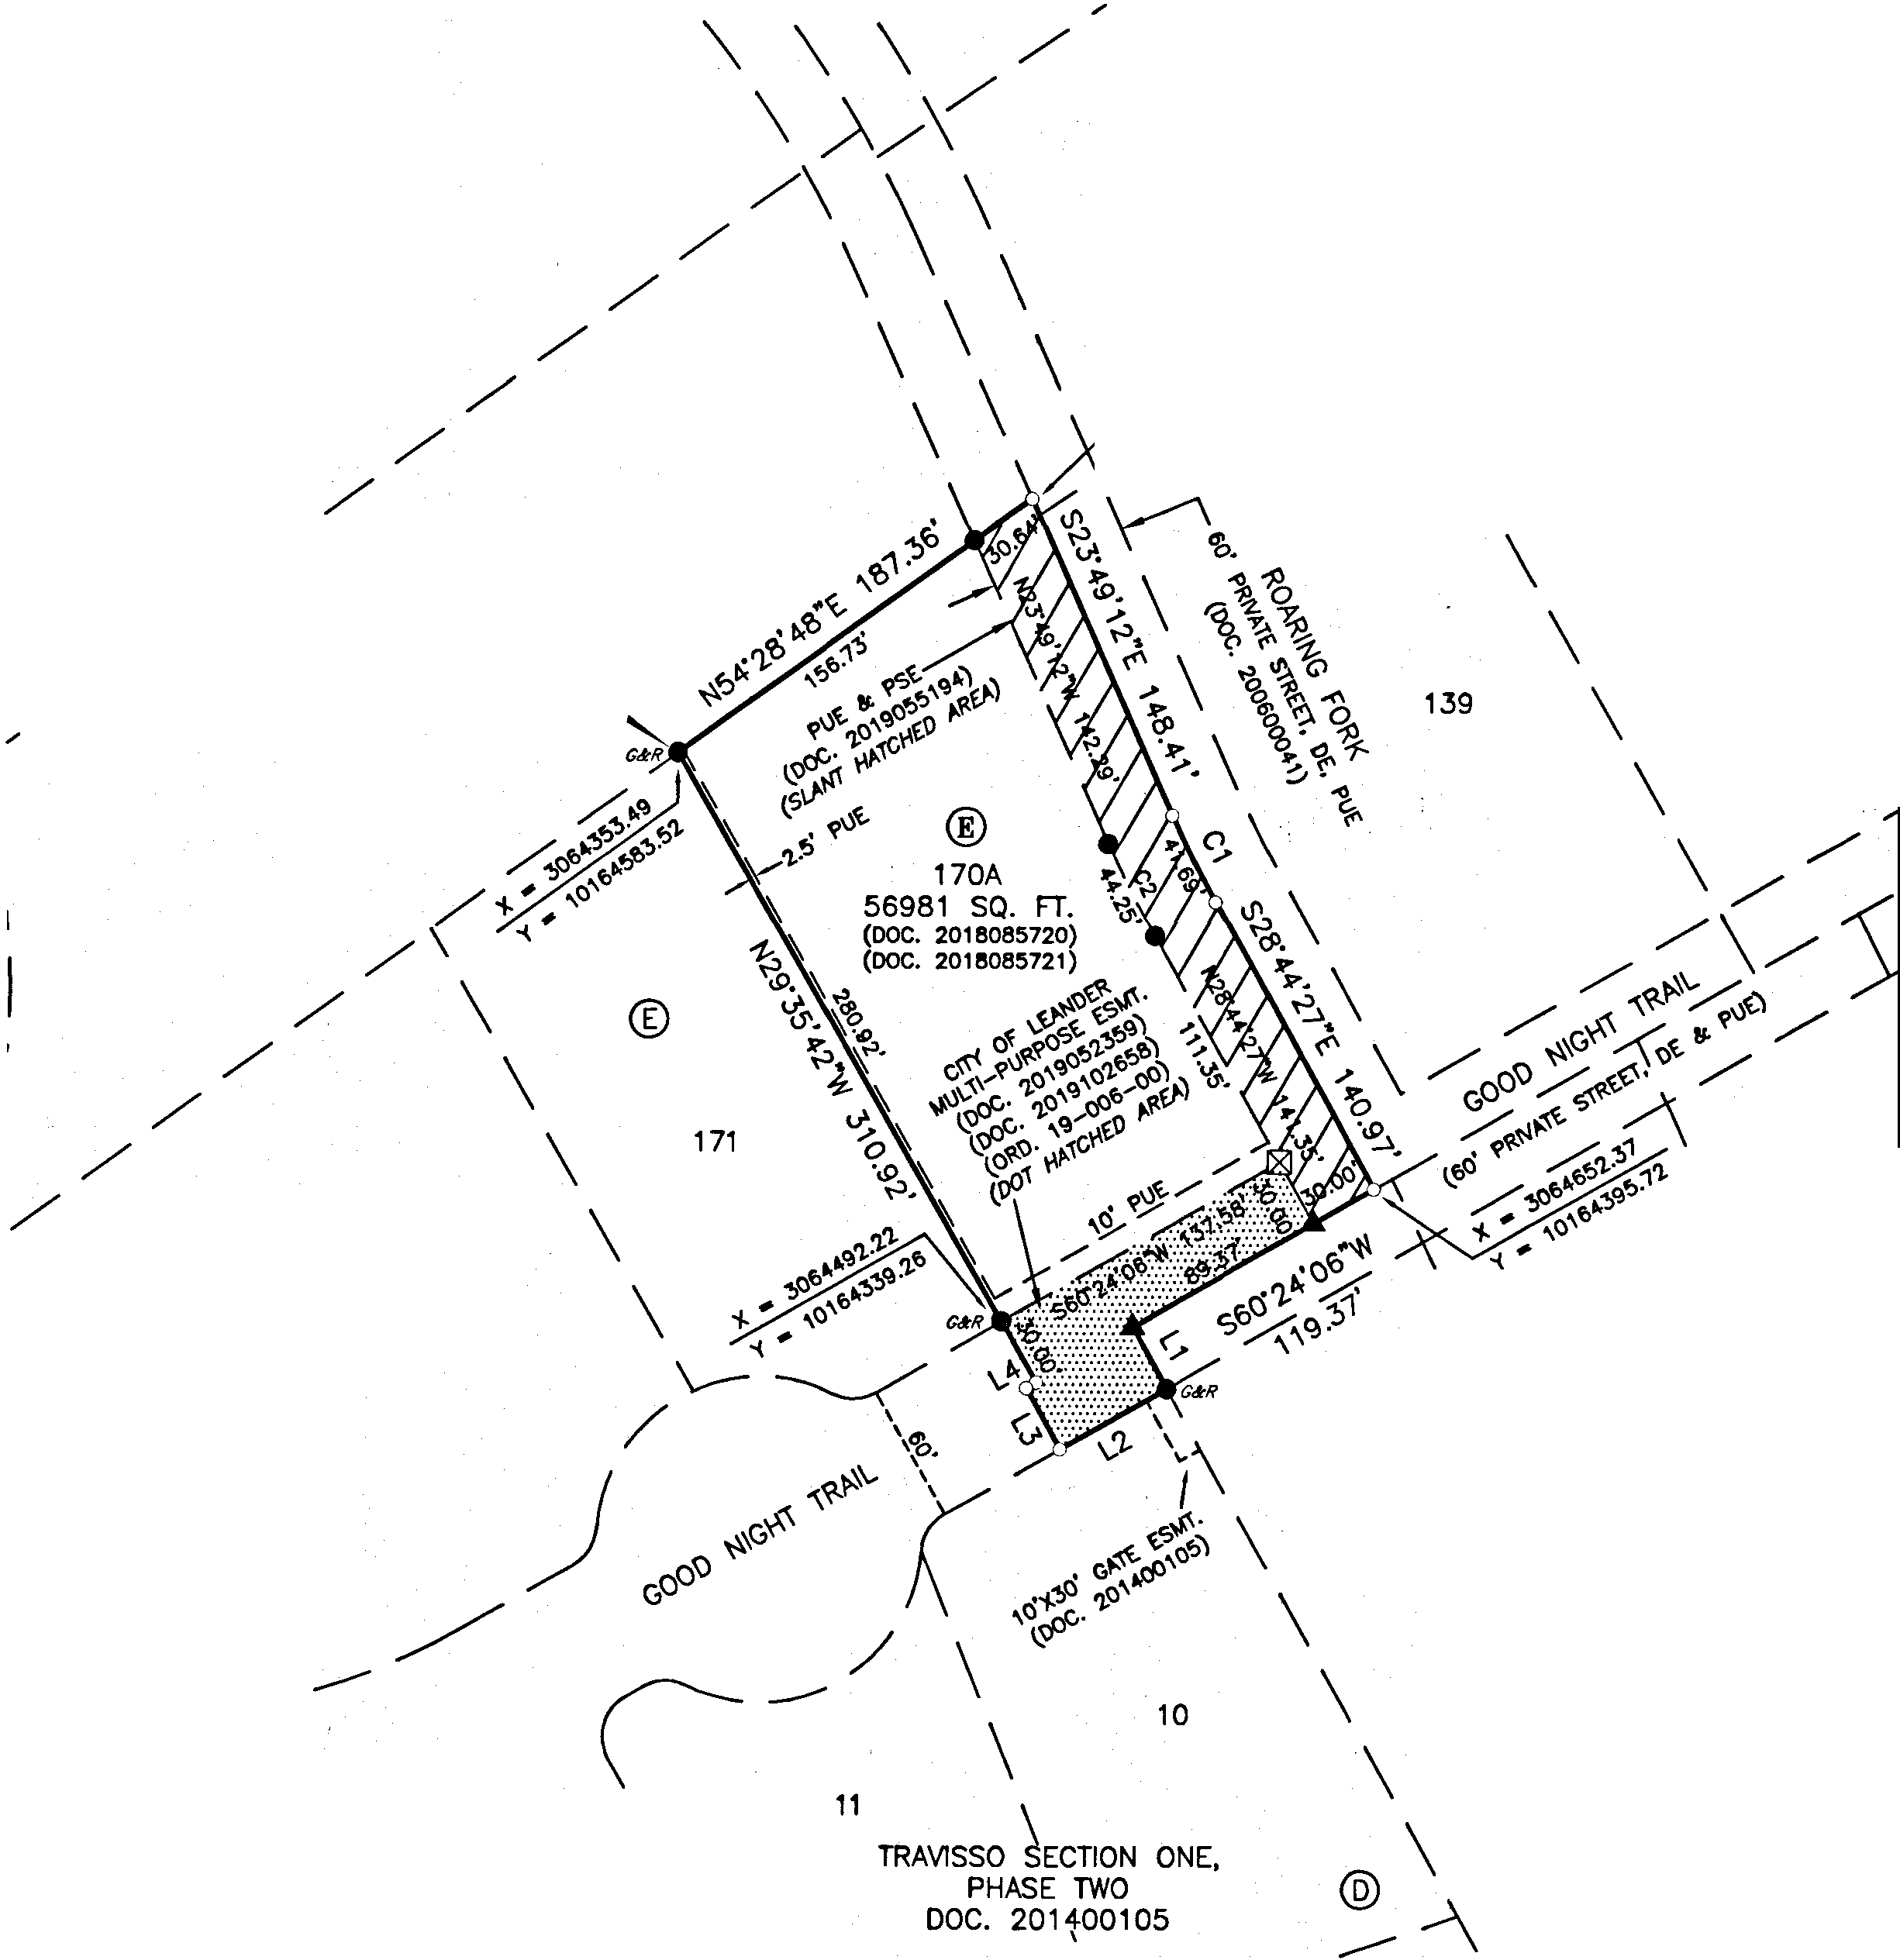

CURVE TABLE

|  |  |  |  |  |  |  |
| --- | --- | --- | --- | --- | --- | --- |
| NO. | DELTA | RADIUS | ARC | CHORD BEARING | CHORD LENGTH | TANGENT |
| C1 | 4·49•39• | 495.00' | 41.71' | S26'35'21 "E | 41.69' | 20.87' |
| C2 | 4·49'49" | 525.00' | 44.26' | N26'34' 48"W | 44.25' | 22.14' |

LINE TABLE

|  |  |  |
| --- | --- | --- |
| LINE | BEARING | DISTANCE |
| L1 | S28"54'45"E | 30.00' |
| L2 | S60'24'06"W | 52.72' |
| L3 | N28'54'45"W | 30.00' |
| L4 | N60'24'06"E | 4.96' |



**SURVEYING, LLC**

*1805 OUIDA DR.*

*AUSTIN, TEXAS 78728*

*PHONt: (512) 267-7430*

*FAX: (512) 836-8385*

*FIRM NO. 10032000*

SHEET 2 OF 3

**TRAVISSO SECTION**

**ONE, PHASE TWO,**

**ZCT?-I0013**

**LOT 170,**

STATE OF TEXAS:

COUNTY OF TRAVIS:

DEDICATION STATEMENT:

THAT CRYSTAL FALLS HOME OWNER'S ASSOCIATION, INC., A TEXAS CORPORATION, AS THE OWNER OF LOT 170, BLOCK E, OF TRAVISSO SECTION ONE, PHASE TWO, RECORDED IN DOCUMENT NO. 2018085721, THAT CERTAIN 30 FOOT PORTION OF ROARING FORK, A 60 FOOT PRIVATE STREET, DRAINAGE AND PUBLIC UTILITY El\SEMENT, RECORDED IN DOCUMENT NO.

2019055194 AND THAT CERTAIN 0.131 ACRE TRACT OF LAND RECORDED IN DOCUMENT NO. 2019102658, ALL OF THE OFFICIAL PUBLIC RECORDS OF TRAVIS COUNTY, TEXAS, DOES HEREBY CERTIFY THAT THERE ARE NO LIEN HOLDERS AND DEDICATES TO THE PUBLIC FOREVER USE OF ALL ADDITIONAL ROW, STREETS, ALLEYS, EASEMENTS, PARKS, AND ALL OTHER LANDS INTENDF'[) FOR PUBLIC DEDICATION, OR WHEN THE SUBDIVIDER HAS MADE PROVISION FOR PERPETUAL MAINTENANCE THEREOF, TO THE INHABiTANTS OF THE SUBDIVISION AS SHOWN HEREON TO BE KNOWN AS TRAVISSO SECTION ONE, PHASE

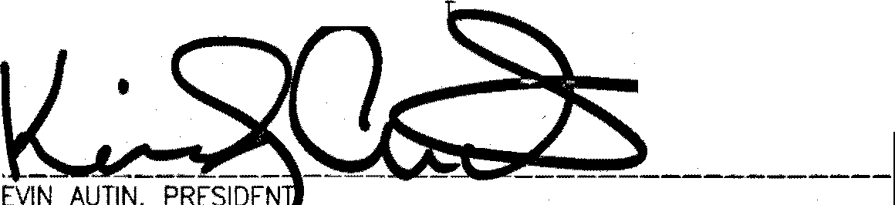

TWO, LOT 170, BLOCK

EPLA

•

K

**BLOCK E REPLAT**

STATE OF TEXAS:

COUNTY OF TRAVIS:

THAT I, PHILLIP L. McLAUGHL!N, AM AUTHORIZED UNDER THE LAWS OF THE STATE OF TEXAS TO PRACTICE THE PROFESSION OF LAND SURVEYING AND HEREBY STATE THAT I PREPARED THIS PLAT FROM AN ACTUAL AND ACCURATE ON-THE-GROUND SURVEY OF THE LAND AND THAT THE CORNER MONUMENTS SHOWN THEREON WERE PROPERLY PLACED UNDER MY PERSONAL SUPERVISION, IN ACCORDANCE WITH ALL CITY OF LEANDER ORDINANCE AND CODES, AND THAT ALL EXISTING EASEMENTS OF RECORD AS FOUND ON THE TITLE POLICY

PROVIDED BY INDEPENDENCE TITLE COMPANY, GF NO. 1909144-LND, ISSUED APRIL 17, 2019 HAVE BEEN SHOWN OR NOTED HERON.

10-01-2020

SURVEYOR NO. 5300

CRYSTAL • ••R'S ASSOCIATION, INC.

901 CRYS WAY, SUITE 203 LEANDER, 

STATE OF TEXAS:

COUNTY OF TRAVIS:

' .

STATE OF TEXAS:

COUNTY OF TRAVIS:

BEFORE ME, THE UNDERSIGNED AUTHORITY, ON THIS DAY PERSONALLY APPEARED KEVIN AUT!N, KNOWN TO ME TO BE THE PERSON WHOSE NAME IS SUBSCRIBED TO THE FOREGOING INSTRUMENT AND ACKNOWLEDGED TO ME THAT HE EXECUTED SAME FOR THE PURPOSE AND CONSIDERATION THEREIN EXPRESSED, IN THE CAPACITY THEREIN STATED.

GIVEN UNDER MY HAND AND SEAL OF OFFICE, THIS THE\'.!. DAY **o4doh!'2o_l0A.D.**

THAT I, SAMUEL D. KIGER, AM AUTHORIZED UNDER THE LAWS OF THE STATE OF TEXAS TO PRACTICE THE PROFESSION OF

**AND** STATE THAT THIS PlAT CONFORMS ¼1TH THE APPLICABLE ORDINANCES Of THE CITY OF LEANDER,

SAMUEL D. KIGER, P.E. -------------------- • STATE OF TEXAS NO. 89353

P.O. BOX 1220

LEANDER, TEXAS 78646-1220 • **0.**

,,.

512-259-3882

NOTARY PUBLIC IN AND FOR THE COUNTY OF **\Ji\\i Px'1.**

**KEU.YAMI**

**My Nolmy I>1130040859**

**E,q,lres December2,20Zl**

STATE OF TEXAS: COUNTY OF TRAVIS:

**·1'\•1.•**

MY COMMISSION EXPIRES ***-' - - -'LO'&*1..**

PLAT NOTES

1. THIS SUBDIVISION IS WHOLLY CONTAINED WITHIN THE CURRENT CORPORATE LIMITS OF THE CITY OF LEANDER, TEXAS.

2, THIS PLAT IS SUBJECT TO THE COVENANTS, CONDITIONS AND RESTRICTIONS FOR THE GRAND MESA AT CRYSTAL FALLS SUBDIVISION SECTION FIVE, RECORDED IN DOCUMENT NO. 2006029777 AS AMENDED IN DOCUMENT NO. 2019093433, OFFICIAL PUBLIC RECORDS OF TRAVIS COUNTY, TEXAS.

1. A BUILDING PERMIT IS REQUIRED FROM THE CITY OF LEANDER PRIOR TO CONSTRUCTION OF ANY BUILDING OR SITE

;MPROVEMENTS ON ANY LOT IN THIS SUBDIVISION.

1. NO BUILDINGS, FENCES, LANDSCAPING OR OTHER STRUCTURES ARE PERMITTED WITHIN DRAINAGE EASEMENTS SHOWN, EXCEPT AS APPROVED BY THE CITY OF LEANDER PUBLIC WORKS DEPARTMENT.
2. NO STRUCTURE lN THIS SUBDIVISION SHALL BE OCCUPIED UNTIL CONNECTED TO A PUBLIC SEWER SYSTEM OR A PRIVATE ON-SITE WASTEWATER (SEPTIC). SYSTEM THAT HAS BEEN APPROVED AND LICENSED FOR OPERATION BY THE TRAVIS COUNTY ON-SITE WASTEWATER PROGR.l>.M.
3. NO CONSTRUCTION MAY BEGIN ON ANY LOT IN THIS SUBDIVISION UNTIL PLANS FOR THE PRIVATE ON-SITE SEWAGE DISPOSAL SYSTEM ARE APPROVED BY THE TRAVIS COUNTY ON-SITE WASTEWATER PROGRAM.
4. DEVELOPMENT ON EACH LOT IN THIS SUBDIVISION SHALL BE IN COMPLIANCE WITH THE MINIMUM REQU!REMENTS OF THE TITLE

30 OF THE TEXAS ADMINISTRATIVE CODE CHAPTER 285 AND TRAVIS COUNTY CODE CHAPTER 48 THAT ARE IN EFFECT AT THE TIME OF CONSTRUCTION.

1. THESE RESTRICTIONS ARE ENFORCEABLE BY THE TRAVIS COUNTY ON-SITE WASTEWATER PROGRAM,
2. ALL LOTS IN THIS SUBDIVISION ARE RESTRICTED TO ONE SINGLE FAMILY DWELLING AND APPURTENANT STRUCTURES PER ACRE.
3. NO STRUCTURE IN THIS SUBDIVISION SHALL BE OCCUPIED UNTIL CONNECTED TO **A** POTABLE WATER SUPPLY FROM AN APPROVED WATER SYSTEM OR **A** PRIVATE WELL.
4. PROPERTY OWNER SHALL PROVIDE FOR ACCESS TO DRAINAGE EASEMENTS AS MAY BE NECESSARY AND SHALL NOT PROHIBIT ACCESS BY THE CITY OF LEANDER.
5. ALL EASEMENTS ON PRIVATE PROPERTY SHALL BE MAINTAINED BY THE PROPERTY OWNER OR HIS OR HER ASSIGNS.

7, IN ADDITION TO THE EASEMENTS SHOWN HEREON, A TEN (10')FOOT WlDE PUBLIC UTILITY EASEMENT IS DEDICATED ALONG AND ADJACENT TO ALL RIGHT-OF-WAY AND A TWO AND A HALF (2.5') FOOT WIDE PUBLIC UTILITY EASEMENT IS DEDICATED ALONG ALL SIDE LOT LINES (SEE TYPICAL EASEMENT DETAIL).

1. NO PORTION OF THIS TRACT IS WITHIN A FLOOD HAZARD AREA AS SHOWN ON THE FLOOD INSURANCE RATE MAPS PANEL NOS. 484530 0095H FOR TRAVIS COUNTY, EFFECTIVE SEPT. 26, 2008, UNLESS CONTAINED ¼1THIN DRAINAGE EASEMENTS SHOVJN HEREON.
2. BUILDING SETBACKS NOT SHOWN HEREON SHALL COMPLY WITH THE MOST CURRENT ZONING ORDINANCE OF THE CITY OF LEANDER. ADDITIONAL RESIDENTIAL GARAGE SETBACKS MAY BE REQUIRED AS LISTED IN THE CURRENT ZONING ORD:NANCE.
3. NO WATER WELL IN THIS SUBDIVISION MAY BE LOCATED WITHIN CONSENT OF THE ADJOINING LAND OWNER(S).

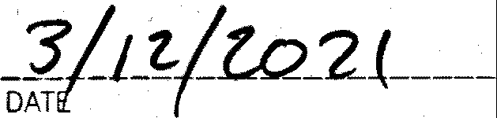., - / **.::foNJ.TH1'rJ *ffPr'lr'A***



*-*

*--* _·• **_j?.6_tlosoo1z.1;7**

ACEY SCHEFFEL D... , ROGRAM MANAGER, ' N-SITE WASTEWATER, TRAVIS COUNTY TNR

STATE OF TEXAS: COUNTY OF TRAVIS:

150 FEET OF THE SUBDIVISION BOUNDARY WITHOUT THE

1. ALL UTILITY LINES MUST BE LOCATED UNDERGROUND. THIS SUBDIVISION WAS APPROVED WITH A PUBLIC HEARING HELD IN ACCORDANCE WITH TEXAS LOCAL GOVERNMENT CODE.
2. THIS PROPERTY IS SUBJECT TO BLANKET TYPE UTILITY EASEMENTS GRANTED TO PEDERNALES ELECTRIC COOPERATIVE, APPROVED THIS THE **_J_ ----** DAY OF **_ _Q_:e.t, _m_».et** 20J}Jj A.O. AT PUBLIC MEETING OF THE PLANNING AND ZON!NG INC. IN DOCUMENT NOS. 2014090540 AND 2014129650, OFFICIAL PUBLIC RECORDS OF TRAVlS COUNTY, TEXAS. COMMISSION OF THE CITY OF LEANDER. TEXAS AND AUTHORIZED TO BC FILED FOR RECORD BY THE COUNTY CLERK OF TRAVIS

***ffJ1_***

CO TEXAS. _

***fJJ*** - (

1. NO DRIVEWAY SHALL BE CONSTRUCTE:D CLOSER THAN 50' OR 60% OF PARCEL FRONTAGE, WHICHEVER IS LESS, TO THE ***,,I I}***

ROW OF AN·. INTERSECTING LOCAL OR COLLECTOR STREET OR 100' OR 60% OF PARCEL FRONTAGE, WHICHEVER IS LESS, TO -- -- · •• ATTEST.·

THE ROW OF AN INTERSECTING ARTERIAL STREET. **r,,.** --- - :-..:::---- ------ -- -- --- -----

**II\ BEGGh#.R03S,** IRlvl N ELLEN COUFAL, SEC TARY

1. THE HOA BYLAWS ARE RECORDED IN THE OFFICIAL PUBLIC RECORDS OF TRAVIS COUNTY, TEXAS UNDER DOCUMENT NO. PLANNING AND ZONING COMMISSION PLANNING AND ZONI G COMMISSION

2012206635. CITY OF LEANDER, TEXAS CITY OF LEANDER, TEXAS

1. NO LOT IN THIS SUBDIVISION SHALL BE OCCUPIED UNTIL CONNECTED TO THE CITY OF LEANDER WATER DISTRIBUTION FACILITIES.
2. ALL PROPERTY HEREIN IS SUBJECT TO THE LOWER COLORADO RIVER AUTHORITY'S HIGHLAND. LAKES WATERSHED ORDINANCE. WRITTEN

NOTIFICATION AND/OR PERMITS ARE REQUIRED PRIOR TO COMMENCING ANY DEVELOPMENT ACTIVITIES. CONTACT LCRA WATERSHED MANAGEMENT AT 1-800-776-5272, EXTENSION 2.3?4 FOR MORF INFORMATION.

1. APPROVAL OF THIS FINAL PLAT DOES NOT CONSTITUTE THE APPROW•L OF VARIANCES OR WAIVERS TO ORDINANCE REQUIREMENTS.
2. A PERPETUAL PUBLIC SAFETY AND PUBLIC SERVICE EASEMENT IS HEREBY DEDICATED FOR THE PURPOSE OF PROVIDING PUBLIC SAFETY SERVICES, POLICE, FIRE AND MEDICAL SERVICES, UTILITY METER READING, CODE ENFORCEMENT, BUILDING

THE STATE OF TEXAS:

COUNTY OF TRAVIS:

I, DANA DEBEAUVOIR, CLERK OF TRAVIS COUNTY, TEXAS DO HEREBY CERTIFY THAT THE FOREGOING INSTRUMENT OF WRITING AND ITS CERTIFICATE OF AUTHENTICATION WAS FILED FOR RECORD IN MY

JJl_

orncE ON THE DAY *2[* **::::fvV\ C:..** . 202-J A.D. ATJQ o'CLOcK& .• AND

INSPECTIONS, SOLID WASTE COLLECTION, PUBLIC SCHOOL TRANSPORTATION, ANY OTHER PUBLIC SERVICES AND ENFORCING THE CITY ORDINANCES; ANO GIVING THE CITY AND ITS AUTHORIZED OFFICERS AND DESIGNEES UNINHIBITED INGRESS AND

DULY RECOR, D D ON THE \

DAY OF

***'***-***J***=***U***-***V***-***\***-***e***-***_***

--· 20 **1J-1**, A.O. AT '(); $*,*<*_J_*'*O*'

CLOCK

EGRESS OVER, ACROSS AND THROUGH SUCH STREETS, ROADWAYS, AND RIGHTS-OF-WAY FOR THE PURPOSE OF PROVIDING PUBLIC SAFETY SERVICES, POLICE, FIRE AND MEDICAL SERVICES, AND ENFORCING THE PENAL CODE AND CITY

ORDINANCES. WITH THE EXCEPTION OF THE GATE LOCATED ON GOODNIGHT TRAIL WHICH SHALL BE ACCESSED USltlG THE DISPATCH SYSTEM DESCRIBED IN THAT CERTAIN GATE OPERATION AND USAGE AGREEMENT (THE "GATE AGREEMENT") BETWEEN THE CITY OF LEANDER AND THE CRYSTAL FALLS HOMEOWNER'S ASSOCIATION, INC., DATED JULY 21, 2017

RECORDED AS DOCUMENT NO. 2017128115, OFFICIAL PUBLIC RECORDS OF TRAVIS COUNTY, TEXAS (THE "OPRTCT") WHILE THAT AGREEMENT IS IN EFFECT, THE HOA SHALL MAINTAIN AT ALL TIMES WITH THE CITY SECRETARY THE CURRENT GATE CODE OR KEY FOR ALL GATES REGULATING .ACCESS TO AND FROM THE SUBDIVISION, OR OTHERWISE PROVIDE A

MUTUALLY-ACCEPTABLE METHOD OF ACCESS FOR THE CITY AND ITS AGENTS. THE FOREGOING PROVISIONS ARE NOT INTENDED TO MODIFY OR EXPAND THE USES, TERMS, OR ANY RIGHTS GRANTED TO THE CITY IN THE GATE AGREEMENT OR THE DEED WITHOUT W..I\RRANTY RECORDED AS DOCUMENT NO, 2019052359 OF THE OPRTCT OR THE RELEASE AND

ASS GNMENT OF INTEREST IN PROPERTY PUBLIC UTILITY, DRAINAGE AND GOVERNMENTAL USE EASEMENT RECORDED W!TH DOCUMENT N0.2019052359 OF THE OPRTCT.

1. THIS SUBDIVISION IS SUBJECT TO ALL GENERAi. NOTES AND RESTRICTIONS APPEARING ON THE PLAT OF GRAND MESA AT CRYSTAL FALLS II, SECTION FIVE, RECORDED IN DOCUMENT NO. 200600041, OFFICIAL PUBLIC RECORDS OF TRAVIS COUNTY, TEXAS,
2. THIS PLAT CONFORMS TO THE FINAL PLAT FOR GRAND MESA AT CRYSTAL FALLS II, SECTION FIVE, APPROVED BY THE PLANNING & ZON,NG COMMISSION ON FEBRUARY 9, 2006.

M., OFFICIAL PUBLIC RECORDS OF SAID COUNTY AND STATE IN DOCUMENT NO. '} **\C.Ol 3 *1***

WITNESS MY HAND AND SE.AL OF OFFICE OF THE COUNTY CLERK, THE - - DAY OF ..Y- {.. , 202:l. A.D.

DANA DEBEAUVOIR, COUNTY CLERK, TRAVIS COUNTY, TEXAS



.

BY-- --D L -.

**E. t;ED!r,J..**

*·***··(,=!=3***:***)**



**SURVEYING, LLC**

*1805 OUIDA DR.*

*AUSTIN, TEXAS 78728*

*PHONE: {512) 267-7430*

*FAX: {512) 836-8385*

*FIRM NO. 10032000*

SHEET 3 OF 3

III llllllllll1111111111111113pgs 202100131

**PLAT**

PLAT RECORDS INDEX SHEET

SUBDIVISION NAME TRAVISSO SECTION ONE, PHASE TWO, LOT 170, BLOCK E REPLAT

**OWNERS NAME** CRYSTAL FALLS HOME OWNER'S ASSOCIATION, INC

RESUBDIVISION? YES □  ADDITIONAL RESTRICTIONS / COMMENTS

TAX CERTIFICATE 2021121636

RETURN

JAMES BROWDER - P/UP

FILED AND RECORDED

**OFFICIAL PUBLIC RECORDS**



Dana DeBeauvoIr, County Clerk Travis County, Texas

**202100131** Jun01,20211035AM

Fee $102 00 MEDINAE

**202100131 Page 2 of 4**





**TRAVISSO SECTION ONE, PHASE TWO LOT 170, BLOCK E REPLAT**

**N**

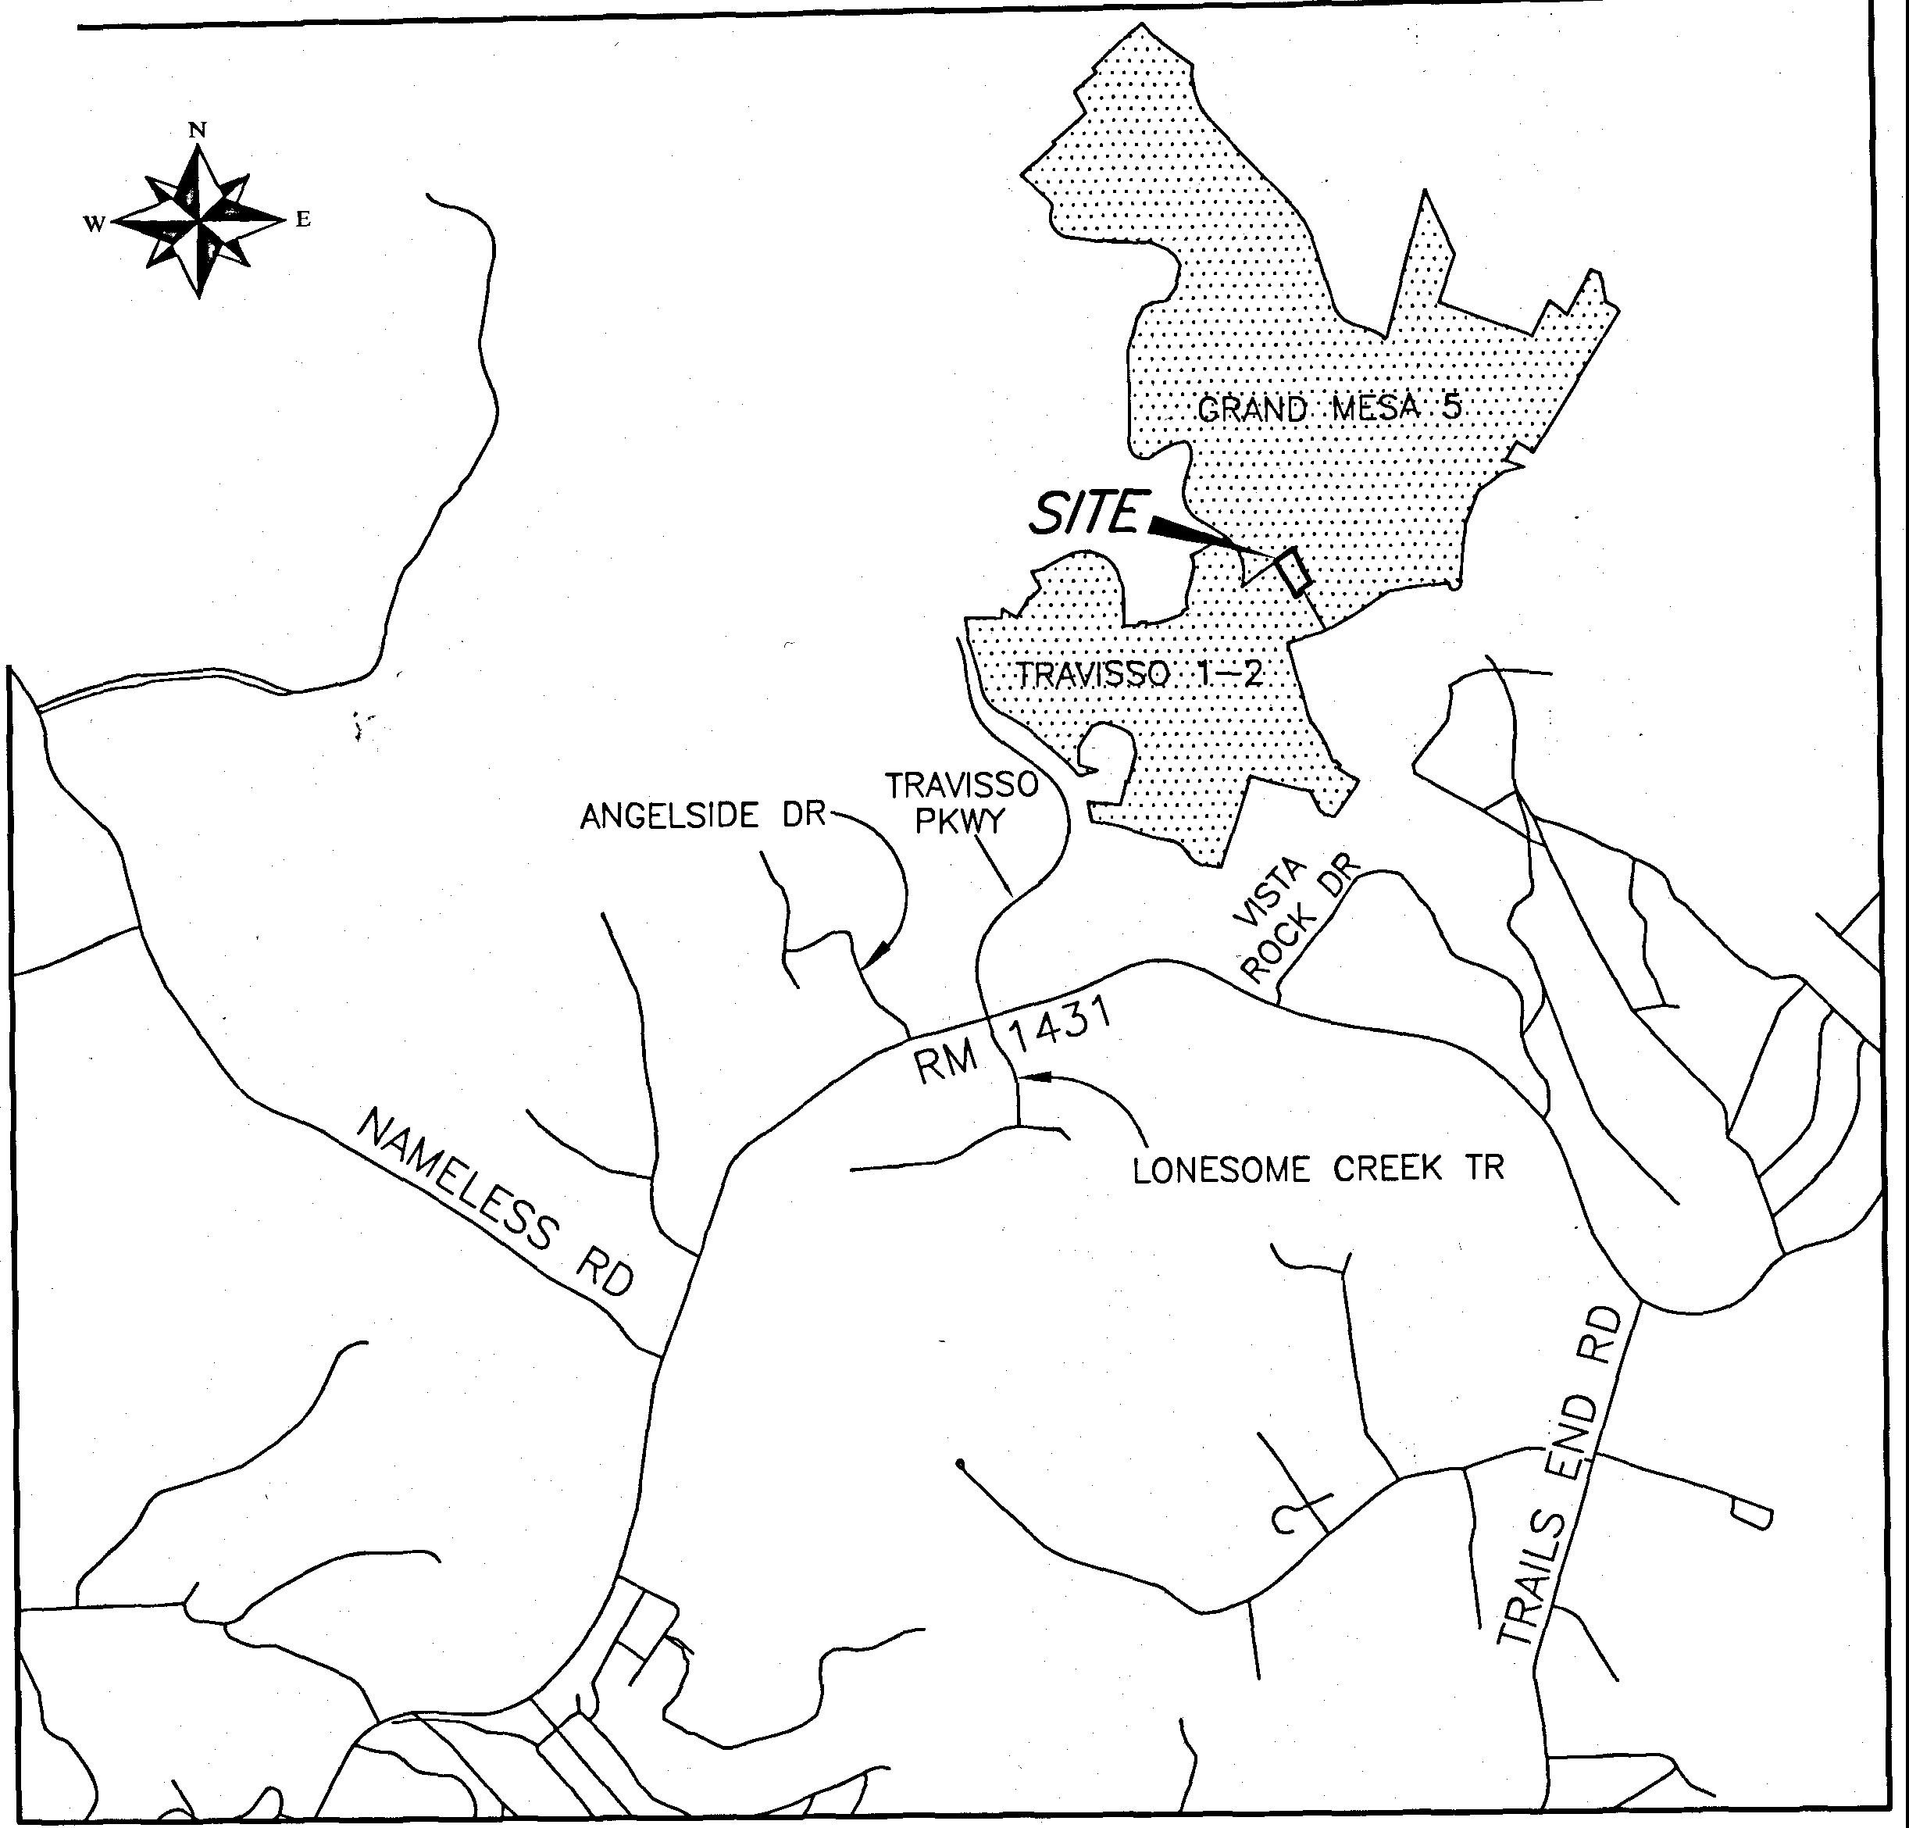

s

SUBMITTAL DATE: OCTOBER **B,** 2019 TOTAL AREA OF THIS PLAT: 1.308 ACRES TOTAL NUMBER OF LOTS: **1**

RESIDENTIAL: 1

NEW STREETS: NONE OWNER:

CRYSTAL FALLS HOME OWNER'S ASSOCIATION, INC.

901 CRYSTAL FALLS PARKWAY, SUITE 203

LEANDER, TEXAS 78641

(512) 986-7444

AGENT:

BARBARA SMITH

901 CRYSTAL FALLS PARKWAY, SUITE 203

LEANDER, TEXAS 78641

(512) 986-7444

0 50 100

**s**

1"=100'

200



400

DEVELOPER:

LOOKOUT DEVELOPMENT GROUP, LP 1789 SOUTH BAGDAD ROAD, SUITE 104

LEANDER, TEXAS 78641

(512) 690-4322

ENGINEER:

JAY ENGINEERING COMPANY INC. 1500 COUNTY ROAD 269

LEANDER, TEXAS 78641

(512) 259-3882

SURVEYOR:

G&R SURVEYING, LLC 1805 OUIDA DRIVE

AUSTIN, TEXAS 78728

(512) 267-7430

SHEET INDEX

SHEET **1:** COVER SHEET SHEET **2:** FINAL PLAT SHEET

SHEET **3:** PLAT NOTES AND SIGNATURE BLOCKS

LOCATION MAP

SCALE: 1"=2000'

DESCRIPTION OF 1.308 ACRES OF LAND SITUATED IN TRAVIS COUNTY, TEXAS, OUT OF THE J.M. FRAME SURVEY 656, ABSTRACT 303, BEING ALL OF LOT 170, BLOCK E, TRAVISSO SECTION ONE, PHASE TWO, A SUBDIVISION OF RECORD **IN** DOCUMENT NO. 201400105, ALL OF THAT CERTAIN 0.131 ACRE TRACT DESCRIBED IN DOCUMENT NO. 2019052359 AND ALL OF THAT CERTAIN PORTION OF ROARING FORK (60' PRIVATE STREET, DRAINAGE AND PUBLIC UTILITY EASEMENT), AS SHOWN ON PLAT OF GRAND MESA AT CRYSTAL FALLS 11, SECTION 5, A SUBDIVISION OF RECORD IN DOCUMENT NO. 200600041, AND DESCRIBED IN DOCUMENT NO. 2019055194, ALL OF RECORD IN THE OFFICIAL PUBLIC RECORDS OF TRAVIS COUNTY, TEXAS; SAID 1.308 ACRE TRACT BEING MORE PARTICULARLY DESCRIBED BY METES AND BOUNDS AS FOLLOWS:

BEGINNING AT AN IRON ROD WITH G&R CAP FOUND IN THE SOUTHERLY LINE OF LOT 169, BLOCK E, OF SAID GRAND MESA AT CRYSTAL FALLS II, SECTION 5, FOR THE NORTHWESTERLY CORNER OF SAID LOT 170 AND THE HEREIN DESCRIBED TRACT;

THENCE N54"28'48"E, WITH THE SOUTHERLY LINE OF SAID LOT 169 AND THE NORTHERLY LINE OF SAID LOT 170, PASSING AT A

DISTANCE OF 156.73 FEET, A 1/2" IRON ROD FOUND IN THE WESTERLY LINE OF SAID ROARING FORK AT THE COMMON EASTERLY CORNER OF SAID LOT 169 AND 170 AND CONTINUING INTO ROARING FORK, FOR A TOTAL DISTANCE OF 187.36 FEET 10 A CALCULATED POINT IN THE CENTER OF SAID ROARING FORK, SAME BEING THE WESTERLY LINE OF LOT 140, BLOCK E, OF SAID GRAND MESA AT CRYSTAL FALLS II, SECTION 5, FOR THE NORTHEASTERLY CORNER OF THE HEREIN DESCRIBED TRACT;

THENCE WITH THE CENTER OF ROARING FORK, BEING IN PART, THE WESTERLY LINES OF SAID LOT 140 AND LOT 139 OF SAID BLOCK E, THE FOLLOWING THREE (3) COURSES:

1. S23'49' 12"E, A DISTANCE OF 148.41 FEET TO A CALCULATED POINT OF CURVATURE OF A CURVE TO THE LEFT;
2. ALONG SAID CURVE TO THE LEFT HAVING A RADIUS OF 495.00 FEET, AN ARC LENGTH OF 41.71 FEET, AND A CHORD WHICH BEARS S26'35'21"E, A DISTANCE OF 41.69 FEET TO A CALCULATED POINT AT THE END OF SAID CURVE;
3. S28'44'27"E, A DISTANCE OF 140.97 FEET TO A CALCULATED POINT IN THE NORTHERLY LINE OF LOT 9, BLOCK D, OF SAID GRAND MESA AT CRYSTAL FALLS II, SECTION 5, AT THE CENTERLINE INTERSECTION OF SAID ROARING FORK AND GOOD NIGHT TRAIL {60' PRIVATE STREET, DRAINAGE AND PUBLIC UTILITY EASEMENT), AS SHOWN ON SAID PLAT OF GRAND MESA AT CRYSTAL FALLS 11, SECTION 5, FOR THE SOUTHEASTERLY CORNER OF THE HEREIN DESCRIBED TRACT;

THENCE S60'24'06"W, WITH THE CENTERLINE OF SAID GOOD NIGHT TRAIL AND THE NORTHERLY LINE OF SAID LOT 9, PASSING AT A DISTANCE OF 30.00 FEET, A MAG NAIL FOUND AT THE SOUTHEASTERLY CORNER OF SAID 0.131 ACRE TRACT, AND CONTINUING FOR A TOTAL DISTANCE OF 119.37 FEET TO A MAG NAIL FOUND *AT* AN EL CORNER OF SAID 0.131 ACRE TRACT, SAME BEING THE NORTHWESTERLY CORNER OF SAID LOT 9;

THENCE S28'54'45"E, WITH THE WESTERLY LINE OF SAID LOT 9 AND THE SOUTHERLY LINE OF SAID 0.131 ACRE TRACT, A DISTANCE OF 30.00 FEET TO AN IRON ROD WITH G& R CAP FOUND IN THE SOUTHERLY LINE OF GOOD NIGHT TRAIL, (60' R.0.W.), AT THE NORTHEASTERLY CORNER OF LOT 10, BLOCK D, OF SAID TRAVISSO SECTION ONE, PHASE TWO;

THENCE S60'24'06"W, WITH THE SOUTHERLY LINE: OF GOOD NIGHT TRAIL, (60' R.O.W.) AND SAID 0.131 ACRE TRACT, SAME BEING THE NORTHERLY LINE OF SAID LOT 10, A DISTANCE OF 52.72 FEET TO A CALCULATED POINT, FOR THE SOUTHWESTERLY CORNER OF SAID 0.131 ACRE TRACT AND THE HEREIN DESCRIBED TRACT;

THENCE WITH THE WESTERLY LINE OF SAID 0.131 ACRE TRACT AND IN PART WITH THE WESTERLY LINE OF SAID LOT 170, THE FOLLOWING THREE (3) COURSES:

1. N28'54' 45"W, A DISTANCE OF 30.00 FEET TO A CALCULATED POINT;
2. N60'24'06"E, A DISTANCE OF 4.96 FEET TO A CALCULATED POINT;
3. N29'35'42"W, PASSING AT A DISTANCE OF 30.00 FEET, AN IRON ROD WITH G& R CAP FOUND IN THE NORTHERLY LINE OF SAID GOOD NIGHT TRAIL, AT THE SOUTHWESTERLY CORNER 01=' SAID LOT 170, AND CONTINUING FOR A TOTAL DISTANCE OF 310.92 FEET TO THE POINT OF BEGINNING, CONTAINING AN AREA OF 1.308 ACRES OF LAND, MORE OR LESS.

**SURVEYING, LLC**

*1805 OUIDA DR.*

*AUSTIN, TEXAS 78728*

*PHONE: (512) 267-7430*

*FAX: (512) 836-8385*

*FIRM NO. 10032000*

SHEET 1 OF **3**



**TRAVISSO SECTION ONE, PHASE TWO, LOT 170, BLOCK E REPLAT**

*INS/CNIA •*

•

•

t'i<l

0

®

PUE

PSE DE BL

**LEGEND**

1/2" IRON ROD FOUND

IRON ROD WITH CAP FOUND (INSIGNIA NOTED) MAG NAIL FOUND

CHISELED **"X" IN** CONCRETE FOUND CALCULATED POINT

BLOCK NAME

PUBLIC UTILITY EASEMENT PUBLIC SAFETY EASEMENT DRAINAGE EASEMENT BUILDING SETBACK LINE

**N**



s

1"=100'

nd

0 50 100 200 400

BEARING BASIS: TEXAS CENTRAL ZONE, STATE PLANE COORDINATES (NAD 83)

**168**

®

140

®

/

,,/

/ **GRAND MESA AT**

/ CRYSTAL FALLS II, SECTION 5

/ DOC. 200600041

138

\ 7

TRAVlSSO SECTION ONE,

\

PHASE TWO DOC. 201400105

·\

172

*J.M.*

*FRAM[\SURV[Y 656,* \

*ABS. '(03*

- ---

--

\ 8 \

9 \ \

GRAND MESA **AT**

CRYSTAL FALLS II, SECTION 5

DOC. 20060\041

- \

\ \

\ \ \ --- \

\ @

\ ,,.

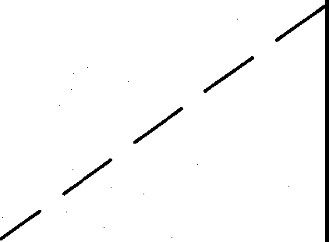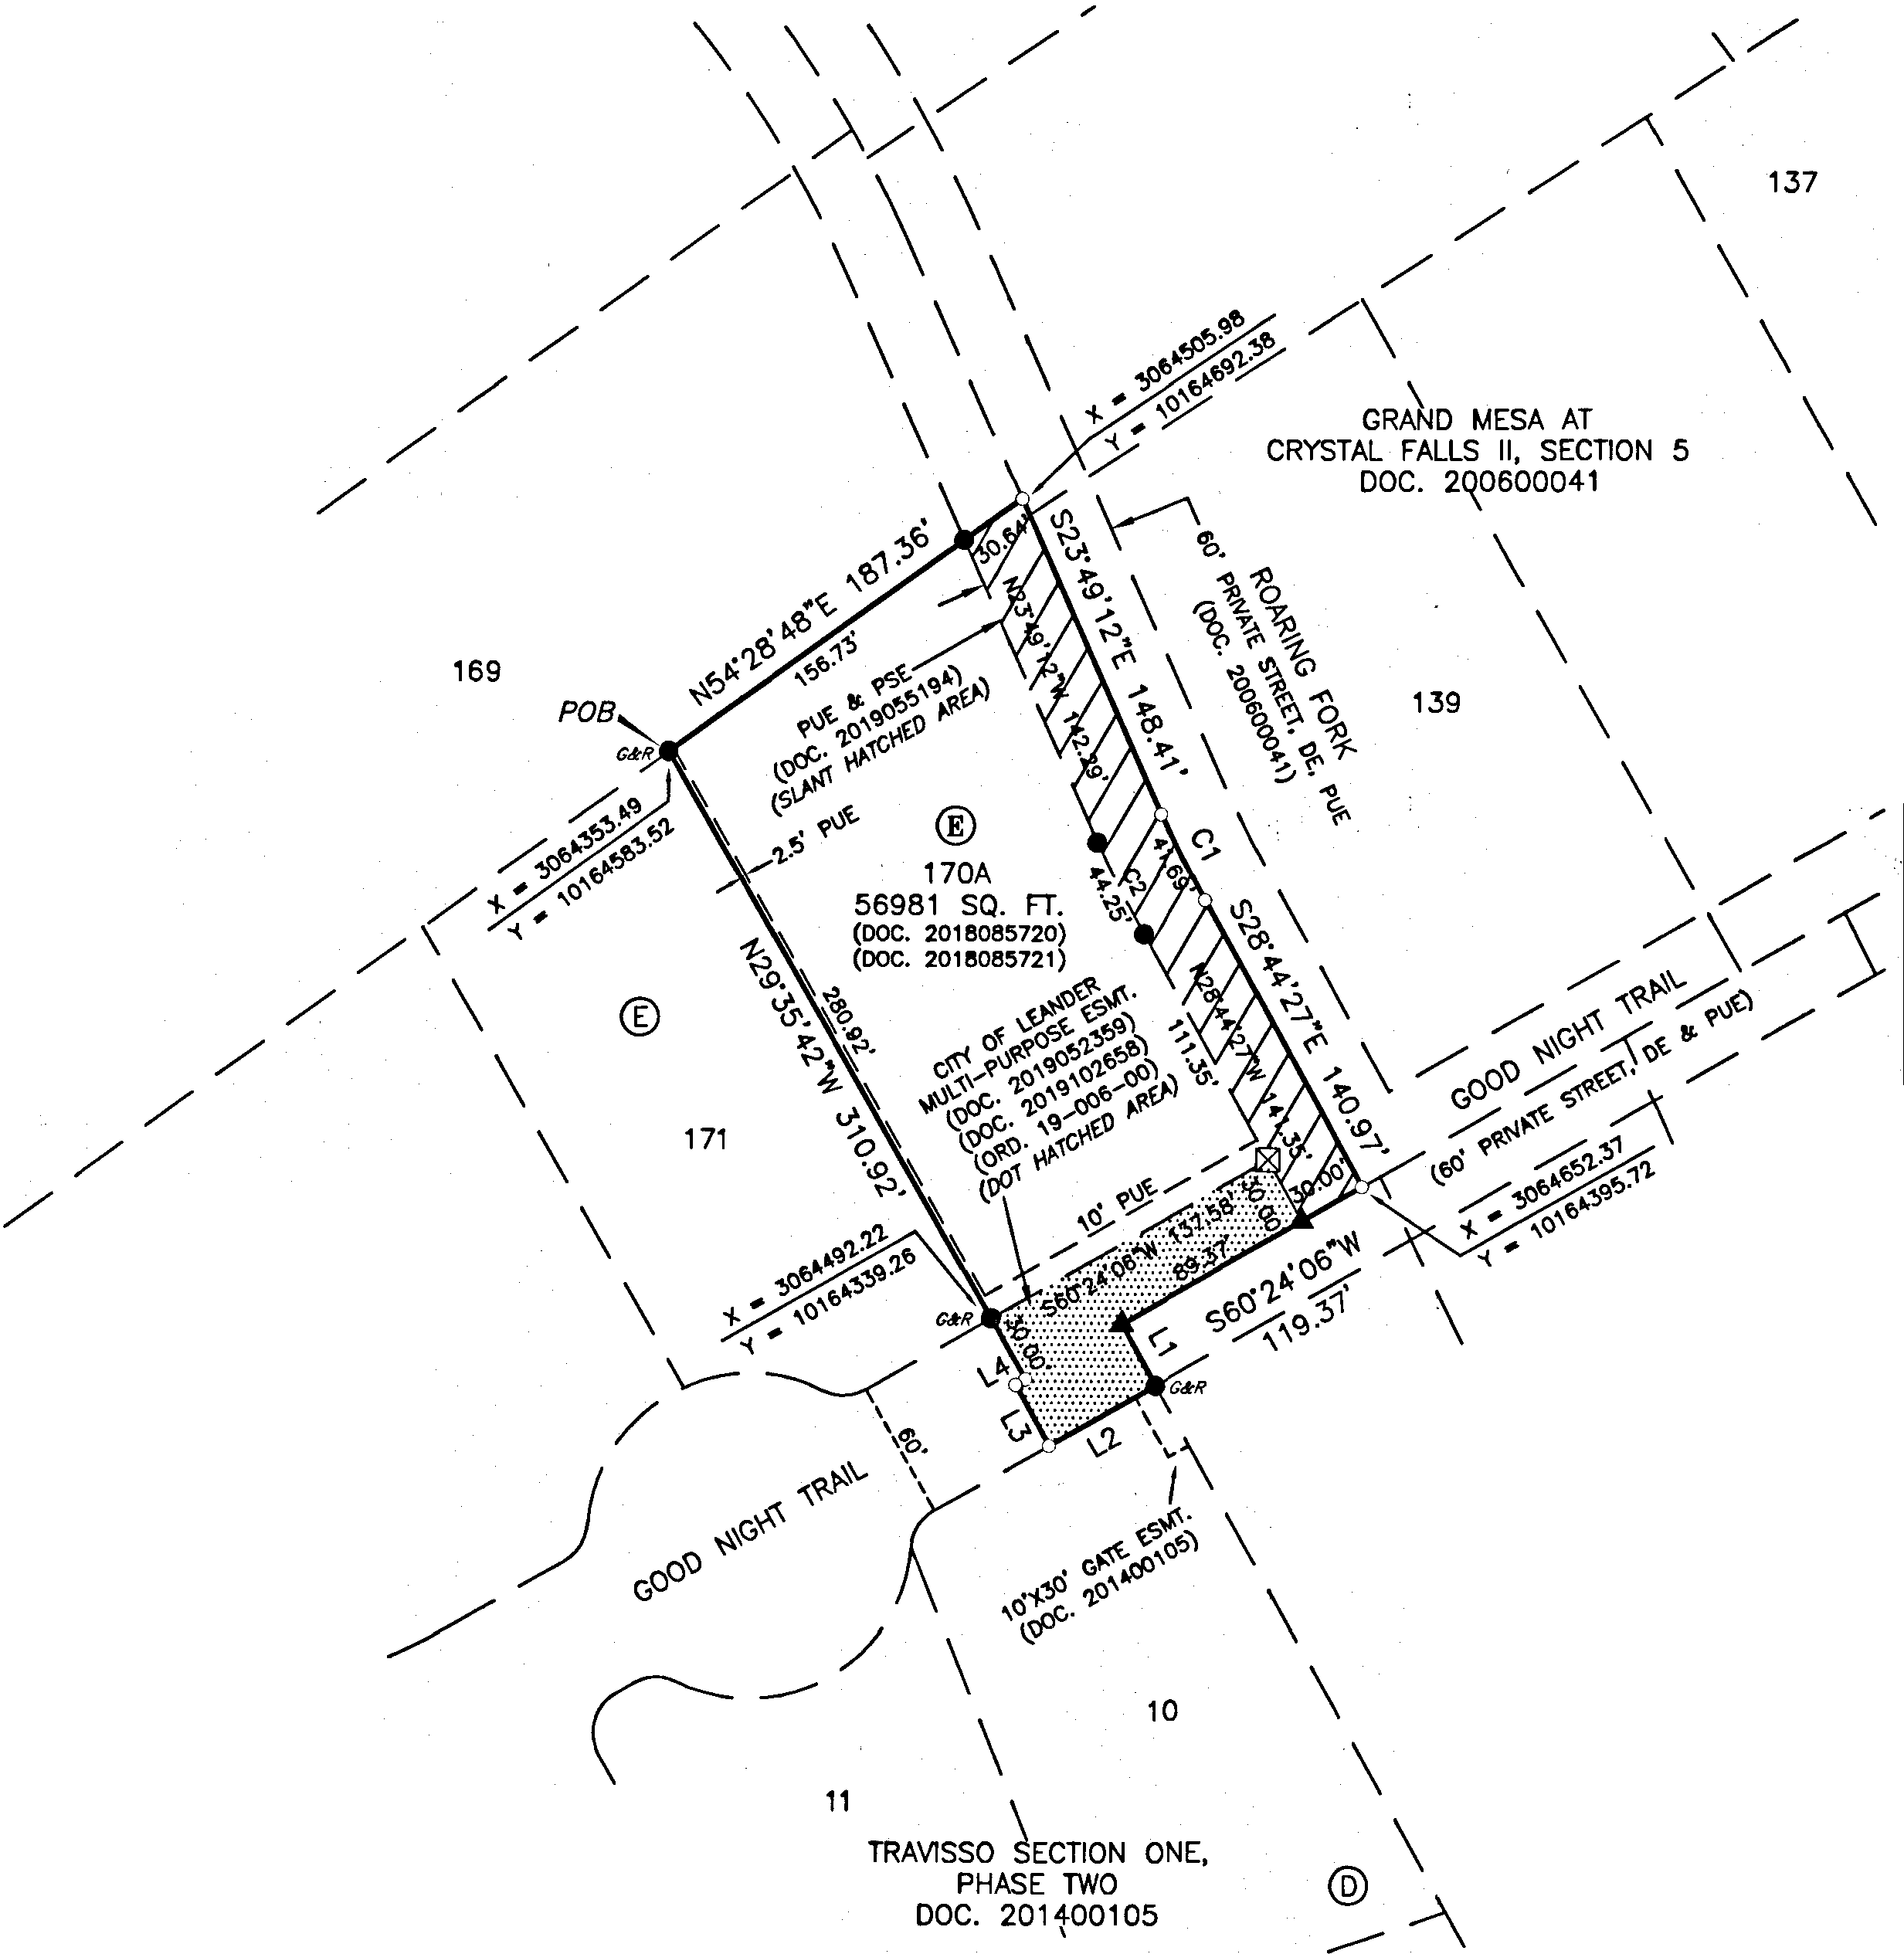

CURVE TABLE

|  |  |  |  |  |  |  |
| --- | --- | --- | --- | --- | --- | --- |
| NO. | DELTA | RADIUS | ARC | CHORD BEARING | CHORD . LENGTH | TANGENT |
| C1 | 4·49•39• | 495.00' | 41.71' | S26'35'21"E | 41.69' | 20.87' |
| C2 | 4·49'49" | 525.00' | 44.26' | N26'34'48·w | **44.25'** | 22.14' |

LINE TABLE

|  |  |  |
| --- | --- | --- |
| LINE | BEARING | DISTANCE |
| L1 | S28'54'45"E | 30.00' |
| L2 | S60"24'06"W | 52.72' |
| L3 | N28'54'45"W | 30.00' |
| L4 | N60"24'06"E | 4.96' |

**SURVEYING, LLC**

*1805 OUIDA DR.*

*AUSTIN, TEXAS 78728*

*PHONt: (572) 267-7430*

*FAX: (512) 836-8385*

*FIRM NO. 10032000*

SHEET 2 OF 3



**TRAVISSO SECTION ONE, LOT 170, BLOCK E**

**PHASE TWO, REPLAT**

**Z<n-10013**

STATE OF TEXAS:

COUNTY OF TRAVIS:

DEDICATION STATEMENT:

THAT CRYSTAL FALLS HOME OWNER'S ASSOCIATION, INC., A TEXAS CORPORATION, AS THE OWNER OF LOT 170, BLOCK E, OF TRAVISSO SECTION ONE, PHASE TWO, RECORDED IN DOCUMENT NO. 2018085721, THAT CERTAIN 30 FOOT PORTION OF ROARING FORK, A 60 FOOT PRIVATE STREET, DRAINAGE AND PUBLIC UTILITY EASEMENT, RECORDED IN DOCUMENT NO.

2019055194 AND THAT CERTAIN 0.131 ACRE TRACT OF LAND RECORDED IN DOCUMENT NO. 2019102658, ALL OF THE OFFICIAL PUBLIC RECORDS OF TRAVIS COUNTY, TEXAS, DOES HEREBY CERTIFY THAT THERE ARE NO LIEN HOLDERS AND DEDICATES TO THE PUBLIC FOREVER USE OF ALL ADDITIONAL ROW, STREETS, ALLEYS, EASEMENTS, PARKS, AND ALL OTHER LANDS INTENDED FOR PUBLIC DEDICATION, OR WHEN THE SUBDIVIDER HAS MADE PROVISION FOR PERPETUAL MAINTENANCE THEREOF, TO THE INHABITANTS OF THE SUBDIVISION AS SHOWN HEREON TO BE KNOWN AS TRAVISSO SECTION ONE, PHASE TWO, LOT 170, BLOCK EPLA

•

K

CRYSTAL R'S ASSOCIATION, INC. 901 CRYS """',_. WAY, SUITE 203 LEANDER, 

STATE OF TEXAS:

COUNTY OF TRAVIS:

BEFORE ME, THE UNDERSIGNED AUTHORITY, ON THIS DAY PERSONALLY APPEARED KEVIN AUTIN, KNOWN TO ME TO BE THE PERSON WHOSE NAME IS SUBSCRIBED TO THE FOREGOING INSTRUMENT AND ACKNOWLEDGED TO ME THAT HE EXECUTED SAME FOR THE PURPOSE AND CONSIDERATION THEREIN EXPRESSED, IN THE CAPACITY THEREIN STATED.

GIVEN UNDER MY HAND AND SEAL OF OFFICE, THIS THE **l.l.** DAY **o4dob.!.'2a_Z0A.D.**

STATE OF TEXAS:

COUNTY OF TRAVIS:

THAT I, PHILLIP L. McLAUGHLIN, AM AUTHORIZED UNDER THE LAWS OF THE STATE OF TEXAS TO PRACTICE THE PROFESSION OF LAND SURVEYING AND HEREBY STATE THAT I PREPARED THIS PLAT FROM AN ACTUAL AND ACCURATE ON-THE-GROUND SURVEY OF THE LAND AND THAT THE CORNER MONUMENTS SHOWN THEREON WERE PROPERLY PLACED UNDER MY PERSONAL SUPERVISION, IN ACCORDANCE WITH ALL CITY OF LEANDER ORDINANCE AND CODES, AND THAT ALL EXISTING· EASEMENTS OF RECORD AS FOUND ON THE TITLE POLICY

PROVIDED BY INDEPENDENCE TITLE COMPANY, GF NO. 1909144-LND, ISSUED APRIL 17, 2019 HAVE BEEN SHOWN OR NOTED HERON.

PH-ILL-IP -L.- c- - H 10-01-2020

REGISTERED PROFES ND SURVEYOR NO. 5300 STATE OF TEXAS

STATE OF TEXAS:

COUNTY OF TRAVIS:

THAT I, SAMUEL D. KIGER, AM AUTHORIZED UNDER THE LAWS OF THE STATE OF TEXAS TO PRACTICE THE PROFESSION OF

ENGIN E.RA·NID **K'.'EREBY** STATE THAT THIS PLAT CONFORMS WTH THE APPLICABLE ORDINANCES OF THE CTY OF LFANOER, TEXAS. •



**OFt**

,,.

**iS',o;;**

**.**

--- --

SAMUEL D. KIGER, P.E.

STATE OF TEXAS NO. 89353

P.0. BOX 1220

LEANDER, TEXAS 78646-1220

512-259-3882

NOTARY PUBLIC IN AND FOR THE COUNTY OF **\)_i}li Px'1.**

**KEU.YATKJN**

**MyNofaly I>1130040659**

**Expires December 2,2022**

STATE OF TEXAS: COUNTY OF TRAVIS:

**t'\ . *i*** •

MY COMMISSION EXPIRES **-' - - -i.02.'L**

PLAT NOTES

1. THIS SUBDIVISION IS WHOLLY CONTAINED WITHIN THE CURRENT CORPORATE LIMITS OF THE CITY OF LEANDER, TEXAS.

2, THIS PLAT IS SUBJECT TO THE COVENANTS, CONDITIONS AND RESTRICTIONS FOR THE GRAND MESA AT CRYSTAL FALLS SUBDIVISION SECTION FIVE, RECORDED IN DOCUMENT NO. 2006029777 AS AMENDED IN DOCUMENT NO. 2019093433, OFFICIAL PUBLIC RECORDS OF TRAVIS COUNTY, TEXAS.

1. A BUILDING PERMIT IS REQUIRED FROM THE CITY OF LEANDER PRIOR TO CONSTRUCTION OF ANY BUILDING OR SITE IMPROVEMENTS ON ANY LOT IN THIS SUBDIVISION.
2. NO BUILDINGS, FENCES, LANDSCAPING OR OTHER STRUCTURES ARE PERMITTED WITHIN DRAINAGE EASEMENTS SHOWN, EXCEPT AS APPROVED BY THE CITY OF LEANDER PUBLIC WORKS DEPARTMENT.
3. NO STRUCTURE IN THIS SUBDIVISION SHALL BE OCCUPIED UNTIL CONNECTED TO A PUBLIC SEWER SYSTEM OR A PRIVATE ON-SITE WASTEWATER (SEPTIC). SYSTEM THAT HAS BEEN APPROVED AND LICENSED FOR OPERATION BY THE TRAVIS COUNTY ON-SITE WASTEWATER PROGRAM.
4. NO CONSTRUCTION MAY BEGIN ON ANY LOT IN THIS SUBDIVISION UNTIL PLANS FOR THE PRIVATE ON-SITE SEWAGE DISPOSAL SYSTEM ARE APPROVED BY THE TRAVIS COUNTY ON-SITE WASTEWATER PROGRAM.
5. DEVELOPMENT ON EACH LOT IN THIS SUBDIVISION SHALL BE IN COMPLIANCE WITH THE MINIMUM REQUIREMENTS OF THE TITLE

30 OF THE TEXAS ADMINISTRATIVE CODE CHAPTER 285 AND TRAVIS COUNTY CODE CHAPTER 48 THAT ARE IN EFFECT AT THE TIME OF CONSTRUCTION.

1. THESE RESTRICTIONS ARE ENFORCEABLE BY THE TRAVIS COUNTY ON-SITE WASTEWATER PROGRAM.
2. ALL LOTS IN THIS SUBDIVISION ARE RESTRICTED TO ONE SINGLE FAMILY DWELLING AND APPURTENANT STRUCTURES PER ACRE.
3. NO STRUCTURE IN THIS SUBDIVISION SHALL BE OCCUPIED UNTIL CONNECTED TO A POTABLE WATER SUPPLY FROM AN APPROVED WATER SYSTEM OR A PRIVATE WELL.
4. PROPERTY OWNER SHALL PROVIDE FOR ACCESS TO DRAINAGE EASEMENTS AS MAY BE NECESSARY AND SHALL NOT PROHIBIT ACCESS BY THE CITY OF LEANDER.
5. ALL EASEMENTS ON PRIVATE PROPERTY SHALL BE MAINTAINED BY THE PROPERTY OWNER OR HIS OR HER ASSIGNS.
6. IN ADDITION TO THE EASEMENTS SHOWN HEREON, A TEN (1 O') FOOT WIDE PUBLIC UTILITY EASEMENT IS DEDICATED ALONG AND ADJACENT TO ALL RIGHT-OF-WAY AND A TWO AND A HALF (2.5') FOOT WIDE PUBLIC UTILITY EASEMENT IS DEDICATED ALONG ALL SIDE LOT LINES (SEE TYPICAL EASEMENT DETAIL).
7. NO PORTION OF THIS TRACT IS WITHIN A FLOOD HAZARD AREA AS SHOWN ON THE FLOOD INSURANCE RATE MAPS PANEL NOS. 48453C 0095H FOR TRAVIS COUNTY, EFFECTIVE SEPT. 26, 2008, UNLESS CONTAINED WITHIN DRAINAGE EASEMENTS SHOWN HEREON.
8. BUILDING SETBACKS NOT SHOWN HEREON SHALL COMPLY WITH THE MOST CURRENT ZONING ORDINANCE OF THE CITY OF LEANDER. ADDITIONAL RESIDENTIAL GARAGE SETBACKS MAY BE REQUIRED AS LISTED IN THE CURRENT ZONING ORDINANCE.
9. NO WATER WELL IN THIS SUBDIVISION MAY BE LOCATED WITHIN CONSENT OF THE ADJOINING LAND OWNER(S).

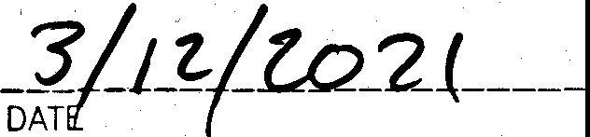., ***/:Jor-J,.TH,tpJffPr'I***

*--* _ • • **l'b_tJoSoo Z,1 7**

ACEY SCHEFFEL D. ., ROGRAM MANAGER, ' N-SITE WASTEWATER, TRAVIS COUNTY TNR

STATE OF TEXAS: COUNTY OF TRAVIS:

150 FEET OF THE SUBDIVISION BOUNDARY WITHOUT THE

1. ALL UTILITY LINES MUST BE LOCATED UNDERGROUND. THIS SUBDIVISION WAS APPROVED WITH A PUBLIC HEARING HELD IN ACCORDANCE WITH TEXAS LOCAL GOVERNMENT CODE.

= £

1. THIS PROPERTY IS SUBJECT TO BLANKET TYPE UTILITY EASEMENTS GRANTED TO PEDERNALES ELECTRIC COOPERATIVE, APPROVED THIS THE **_J_ ----** DAY OF **_ _Q_:ec., _ _b_er 20.J)J::j** A.O. AT PUBLIC MEETING OF THE PLANNING AND ZONING INC. IN DOCUMENT NOS. 2014090540 AND 2014129650, OFFICIAL PUBLIC RECORDS OF TRAVIS COUNTY, TEXAS. COMMISSION OF THE CITY OF LEANDER. TEXAS AND AUTHORIZED TO BE FILED FOR RECORD BY THE COUNTY CLERK OF TRAVIS
2. NO DRIVEWAY SHALL BE CONSTRUCTED CLOSER THAN 50' OR 60% OF PARCEL FRONTAGE, WHICHEVER IS LESS, TO THE >

O TEXAS. _

* + **-;....t)** ---.. .

ROW OF AN INTERSECTING LOCAL OR COLLECTOR STREET OR 100' OR 60% OF PARCEL FRONTAGE, WHICHEVER IS LESS, TO • ***J=***

THE ROW OF AN INTERSECTING ARTERIAL STREET. ***n..*** ,._, ---------- -.:;-:;;;:;:;:;:;;:;;:;;::-- "----- ATTEST: -- -- --- ------ "' **-itt:BEGG1,4kf!MS,** AIKM N ELLEN COUFAL, SEC TARY

1. THE HOA BYLAWS ARE RECORDED IN THE OFFICIAL PUBLIC RECORDS OF TRAVIS COUNTY, TEXAS UNDER DOCUMENT NO. PLANNING AND ZONING COMMISSION PLANNING AND ZONI G COMMISSION

2012206635. CITY OF LEANDER, TEXAS CITY OF LEANDER, TEXAS

1. NO LOT IN THIS SUBDIVISION SHALL BE OCCUPIED UNTIL CONNECTED TO THE CITY OF LEANDER WATER DISTRIBUTION FACILITIES.
2. ALL PROPERTY HEREIN IS SUBJECT TO THE LOWER COLORADO RIVER AUTHORITYS HIGHLAND' LAKES WATERSHED ORDINANCE. WRITTEN

NOTIFICATION AND/OR PERMITS ARE REQUIRED PRIOR TO COMMENCING ANY DEVELOPMENT ACTIVITIES. CONTACT LCRA WATERSHED MANAGEMENT AT 1 -800- 776-5272, EXTENSION 2324 FOR MORE INFORMATION.

1. APPROVAL OF THIS FINAL PLAT DOES NOT CONSTITUTE THE APPROVAL OF VARIANCES OR WAIVERS TO ORDINANCE REQUIREMENTS.
2. A PERPETUAL PUBLIC SAFETY AND PUBLIC SERVICE EASEMENT IS HEREBY DEDICATED FOR THE PURPOSE OF PROVIDING PUBLIC SAFETY SERVICES, POLICE, FIRE AND MEDICAL SERVICES, UTILITY METER READING, CODE ENFORCEMENT, BUILDING INSPECTIONS, SOLID WASTE COLLECTION, PUBLIC SCHOOL TRANSPORTATION, ANY OTHER PUBLIC SERVICES AND ENFORCING THE CITY ORDINANCES; AND GIVING THE CITY AND ITS AUTHORIZED OFFICERS AND DESIGNEES UNINHIBITED INGRESS AND EGRESS OVER, ACROSS AND THROUGH SUCH STREETS, ROADWAYS, AND RIGHTS-OF-WAY FOR THE PURPOSE OF PROVIDING PUBLIC SAFETY SERVICES, POLICE, FIRE AND MEDICAL SERVICES, AND ENFORCING THE PENAL CODE AND CITY

ORDINANCES. WITH TH.E EXCEPTION OF THE GATE LOCATED ON GOODNIGHT TRAIL WHICH SHALL BE ACCESSED USING THE

DISPATCH SYSTEM DESCRIBED IN THAT CERTAIN GATE OPERATION AND USAGE AGREEMENT (THE "GATE AGREEMENT") BETWEEN THE CITY OF LEANDER AND THE CRYSTAL FALLS HOMEOWNER'S ASSOCIATION, INC., DATED JULY 21, 2017 RECORDED AS DOCUMENT NO. 2017128115, OFFICIAL PUBLIC RECORDS OF TRAVIS COUNTY, TEXAS (THE "OPRTCT") WHILE THAT AGREEMENT IS IN EFFECT, THE HOA SHALL MAINTAIN AT ALL TIMES WITH THE CITY SECRETARY THE CURRENT GATE CODE OR KEY FOR ALL GATES REGULATING ACCESS TO AND FROM THE SUBDIVISION, OR OTHERWISE PROVIDE A

MUTUALLY-ACCEPTABLE METHOD OF ACCESS FOR THE CITY AND ITS AGENTS. THE FOREGOING PROVISIONS ARE NOT

INTENDED TO MODIFY OR EXPAND THE USES, TERMS, OR ANY RIGHTS GRANTED TO THE CITY IN THE GATE AGREEMENT OR THE DEED WITHOUT WARRANTY RECORDED AS DOCUMENT NO. 2019052359 OF THE OPRTCT OR THE RELEASE AND ASSIGNMENT OF INTEREST IN PROPERTY PUBLIC UTILITY, DRAINAGE AND GOVERNMENTAL USE EASEMENT RECORDED WITH DOCUMENT N0.2019052359 OF THE OPRTCT.

1. THIS SUBDIVISION IS SUBJECT TO ALL GENERAL NOTES AND RESTRICTIONS APPEARING ON THE PLAT **OF** GRAND MESA AT CRYSTAL FALLS II, SECTION FIVE, RECORDED IN DOCUMENT NO. 200600041, OFFICIAL PUBLIC RECORDS OF TRAVIS COUNTY, TEXAS.
2. THIS PLAT CONFORMS TO THE FINAL PLAT FOR GRAND MESA AT CRYSTAL FALLS II, SECTION FIVE, APPROVED BY THE PLANNING & ZONING COMMISSION ON FEBRUARY 9, 2006.

THE STATE OF TEXAS:

COUNTY OF TRAVIS:

I, DANA DEBEAUVOIR, CLERK OF TRAVIS COUNTY, TEXAS DO HEREBY CERTIFY THAT THE FOREGOING INSTRUMENT OF .WRITING AND ITS CERTIFICATE OF AUTHENTICATION WAS FILED FOR RECORD IN MY

OFFICE ON THE **J.!5.t_** DAY *9[* **:::fv"V\** *(_* . *202-l* A.O. ATJQ -35:' 0'CLOCK .. AND DULY RECORDED ON THE I DAY OF ***-;S"u\'\.*** (:, . 202J A.D. AT - i:o'CLOCK **er.M.,** OFFICIAL PUBLIC RECORDS OF SAID COUNTY AND STATE IN DOCUMENT NO.  **')-ICC,\ 3*1***

**\ 'r**

WITNESS MY HAND AND SEAL OF OFFICE OF THE COUNTY CLERK, THE DAY

OF **;J (. ,** 20J.:l. A.D.

DANA DEBEAUVOIR, COUNTY CLERK, TRAVIS COUNTY, TEXAS



.

BY •

-·

**SURVEYING, LLC**

*1805 OUIDA DR.*

*AUSTIN, TEXAS 78728*

*PHONE: (512) 267-7430*

*FAX: {512) 836-8385*

*FIRM NO. 10032000*

SHEET 3 OF 3

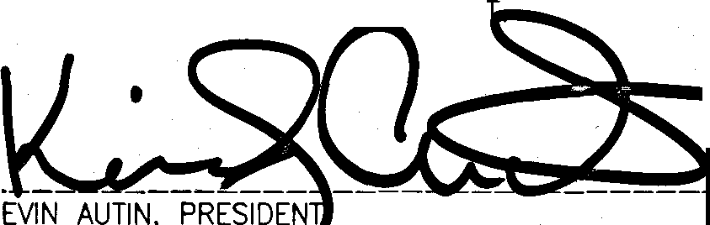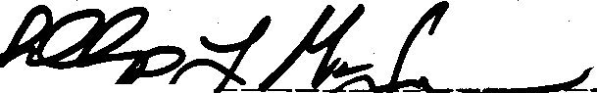

(Page 1 of 2)

*11111111111111111*/llll*lllll*llllllllll*lllll*lllll*llllllll*

TRV

1 PG

201400231

**PLAT**

PLAT RECORDS INDEX SHEET:

**SUBDIVISION NAME:** LOT45 J\:ND LOT 46, BLOCK H, GRAND MESA AT CRYSTAL FALLS II SECTION 6, AMENDED

**OWNERS NAME:** LOOKOUT DEVELOPMENT GROUP LP., LOOKOUT GROUP INC

RESUBDIVISION? YES O NO

ADDITIONAL RESTRICTIONS / COMMENTS:

2014153565-. Tax Certificate

RETURN:

**MIKE SIEFERT**

**1001 CRYSTALS FALLS PKWY**

**LEANDER TX 78641**

FILED **AND RECORDED**

**OFFICIAL PUBLIC RECORDS**

Oct 13, 2014 02:25 PM 201400231

CLINTONB: **$48.00**

Dana DeBeauvoir, County Clerk Travis County TEXAS

(Page 2 of 2)

LOT 45 AND LOT 46, BLOCK H, GRAND MESA AT CRYSTAL FALLS II SECTION 6, AMENDED

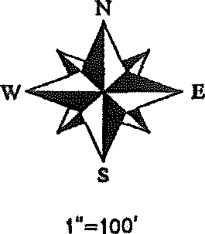

0 50 100 200

B£AAIIIO BASIS: W(AS OOllRAL ZOHE. STATE PIJJlE OOOROINATES (HAD 83)

400

LOCATION MAP

11.T.S.

STATE Of' TEXAS:

COUNTY Of' TRA\IS,

DEDICATION STATEMENT:

lHAT LOOKOUT DEV£LOPMENT CROUP, LP., A TE)(AS LitJmo PARlNERSHJP, 8EINO 1HE Oll!IERS Of' 2.289 ACRES Of' LANO SITUATED IN lRAVIS COUNTY, TEl<AS OUT Of' lHE P.A. OLOSSIJN SUR\f:Y, ABSlRACT NO. 2609, lHE MCKINNEY AND \\IWAtJS SURVEY, ABSTRACT HO. 2199, ANO lHE C.S. MASON SUR\f:Y, ABSlRACT NO. 2551, BEING ALL OF Lots 45 AND 48, ElOCK H, GRANO MESA AT CRYSTAL rALLS 11, SECTION 8, A SUBOI\ISlOH or RECORD IN DOCUMENT 200800122, OFFICIAL PUBLIC RECORDS, 1RA"1S COUNTY, TEXAS, CON\f:YEO TO US BY DEED Of' RECORD IN DOCUMENT HO. 2008041128, OfFICIAL PUBLIC RECORDS Of lRA\IS, COUNTY, TEXAS, 00 HEREBY PLAT SAID 2.289 ACRES Of LAND IN ACCORDANCE \\llH APPLICASLE ORDINANCES Of' lHE CITY Of' LEANDER, AHO lRAVIS, COUNTY, TEXAS, lHE HEREIN DESCRIBED PLAT TO 8E l<N0\\11 AS "LOT 45 AND LOT 48, BLoa< H, !JlAND MESA AT CR11HAL fNJ,.S I SECTION

**f,** NIEIIOED", AND DO HEREBY DEDICATE TO lHE PUBLIC THE USE Of' ALL RIGHT-Of'-WAYS, SlREETS, ALLEYS, EASEMENTS, !'ARKS AND OTHER OPEN SPACES AS SH0\\11 HEREON, OR \\ttEN THE SUBDI\IDER HAS MADE PRO\ISlOH fOR PERPETUAL MAINTENANCE .lltliREOf',

TD THE INHABITANTS TOHE SIJBOI\IfSIOH', SUBJECT TO ANY EASELIEHTS ANO/OR RESTRICTIONS HERETOrORE GRANTED.· AHO tlO.T RELEASED.

=,,...----- *10/ },*

\\ILUAtJ R. HINCKLEY, PRESIDENT DATE

LOOKOUT CROUP, INC

GENERAL PARTNER LOOl<OUT DEl'EI.OPMENT GROUP, l.P, V.,WAtJ R. HINCKLEY, OPERATING MANACER

237D RICE BOULEVARD, SUITE 200 HOUSTON, TEXAS *noo!*

STATE or TEXAS:

COUNTY or fflA\1S:

CUIM: TA8LE

=g; o EN ?ii' tru°a J'iii°t,:io& i

E=o - N11C:WAr1<NJ

*i:\.m:*

Ill

NO. DELTA

Cl 4'J8'3J"

IIAOIUS

. o•

ARC CHORD BEARING CHORD

0 34' OO'JJ'58"W 60 J '

TANOEtlT

. 6'

1HE CAPACITY THEREJN STATED FOR THE PURPOSES ANO CONSIDERATION THEREIN /l£SSED, UNDER MY HAN ANO SEAL or Of'FICE, llllS THE IOAY OF 201:!. A.O.

*cewa*

PLAT NOTES:

1. THIS AMENDED PLAT DOES HOT REMO\f: ANY RltsmiCTIONS. THIS SUBOI\ISlON IS SUBJECT TD ALL GENERAL NOTES ANO RESTRICTIONS APPEARING ON THE PLAT or GRANO ll[SA AT CRYSTAL rALLS M SECTION 6, RECORDED IN DOCUMENT HO. 200800122, Of'FICIAL PUBLIC RECORDS, TRA\IS COUNTY, TEXAS.
2. ALL BUILDING SETBACK LINES HOT SH0\\11 HEREON SHALL BE IN ACCORDANCE 111TH THE CITY OF LEANDER'S CURRENT ZONING ORDINANCE,

J, NO DAll/!WAY S>lALL BE CONSTRUCTED CLOSER THAil 50' OR GO>I OF PARCEL FRONTAGE, \\HICH£'-"R IS LESS, TO THE ROW OF AN INTERSECTING LOCAL **OR** COLLECTOR SfflEET OR 100' OR 80:C Of PARCEL fRONTAG£, \\ttlCHE\f:R IS LESS, TO THE ROW or AN INTERSECTING ARTERIAL STREET.

1. THIS SUBDI\ISIOH IS \\ttOllY CONTAINED \\ITHIH THE CURRENT CORPORATE LIi.HTS Of' THE CITY Of' LEANDER, TEXAS
2. **A** 10-FOOT PUBLIC UTILITY EASEMENT ADJACENT TD ALL RIGHTS-OF-WAY IS HEREBY DEDICATED 111TH THIS PLAT.
   1. THE rOLLOVilNO VARIANCES WERE GRANTED PER **A** DE',f;LOPIJENT AGREEMENT \lilTH THE CITY Of' LEANDER ANO APPROVAL Of' THE CRYSTAL FALLS II CONCEPT PLAN ON MAY 1, 2003,
      1. PRIVATE SlREETS VilTH ROADSIDE DRAINAGE.

**8.** HO SIDEWALKS.

C. HO SlREET LIGHTS.

STATE Of TEXAS:

COUHTY or TRA'IIS:

I, PHIWP l, Mol.J.UOHUN, At.I AIJIHORJZED UNGER THE LAWS OF THE STATE OF TEXAS TO PRACTICE THE PROF£SSION Of LANO SUR'lf:IIHG, ANO HEREBY STATE THAT l'ttlS PLAT CONf'OfllJS WllH APPUCAIILE ORDINANCES Of 1HE CITY Of' LEANDER, TEXAS AND TRA\IS CO\JHTY, TEXAS HID THAT ALL t)(ISTING EASEMENTS *OF* RECORD AS rO\JND ON THE TITLE POLICY RECEMD fROIJ INOEl'ENDENCE TITLE COMPANY ON DECEMBER 08, 2013, HA\f: BEEN SHOWN OR NoTE0 HEREON,

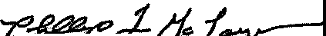

PHIWPl..c oifuifEPTEMBER JO, 2014

STATE Of TEXAS:

COUHTY OF TRAVIS:

NO STRUCTUR;; IN THIS SUSDMS!ON SHAU. SE OCCUPIED UNTIL CONNECTED TD A PUBUc SEWER SYSTEIJ OR A E THAT HAS SEEN APPRO\f:O HID LICENSED roR OPERATION BY THE

Wt"% X ic ;:,

NO CONSTRUCTION MAY BEGIN OH ANY LoT IN THIS SUBOMslON UNTIL PLAHS f'Ofl THE PRNATE ON-SITE SEWAGE DISPOSAL SYSTEM ARE APPRO'IEO BY THE lRAVIS COUNTY ON-SITE WASTEWATER PROGRAM,

OE\f:LOPMEHT ON EACH LOT Ill THIS SUSOI\ISION SHALL SE: IN COMPLIANCE WITH THE LUNJMUM REQUIREMENT$ OF THE TITLE JO or THE TEXAS AOMINISlRATM: CODE CHAPTER 285 AND TRA'IIS COUHTY COOE CHAPTER **46** THAT Al<E IN E1fECT AT THE TIME OF CONSTRIJCTJON,

THESE RESTRICTIONS ARE ENFORCEABLE BY THE TRA'IIS COUNTY Oil-SITE WASIEWATER PROGRAtJ,

ALL LoTS IN THIS SUBOMSION ARE RESlRKlTED TO ONE SINGLE FAMILY DWELLING ANO APPURTENANT STRUCTURES PER N:RE,

NO STRUCTURE *IN* THIS SUBOl',ISION SHALL BE OCCUPIED UNTIL CONNECTED TD A POTABLE WATER SUPPLY fROIJ AN APPRO'IEO WATER SYSTEM OR **A** PRNATE 'IIElL

110 WATER WELL IN THIS SUBDMSIOH MAY SE LOCATED WITHIN 150 fEET or THE SUBOMS!ON BOUNDARY WITHOUT THE CONSENT OF THE AOJOININO LAND OWNER{S),

fl 1 ***eoo#P)* $1!ut1 ,P. .,D. .il-r>SC.:>4'1l7** *Jo(* 7/,4

*(o4..* S .RrrJ: t if'• DATE

THE STATE Of TEXAS:

COUNTY Of' TRAVIS:

I, DANA DEBEAUVOIR, CLERK OF COUNTY COURT, \11TH AND FOR THE COUNTY ANO STATE AfORESAlO, 00 HEREBY CERTIFY THAT THE f'OflECOINO IN\TRUMENT OF IIIIITING, AND ITS CERTIFICATE Of' AUTIJENTICATION, WAS FILED FOR

RECORD 1N t.lY OFFICE ON THE oAY or OCl'Tltar 20J1. A.a. AT *i:1!5* O'CUJCK3.i.• ANO ouLv

a ..

RtGISTEREO PROfESS LANO SURVtYOR NO. ilJOO STATE TEXAS

or

RECORDED ON THIS THE \:;in OAY Of' OC-tW: 1014 A.O. AT *'/.'J!ij* n'N0CK

OFFICIAi.

STATE OF TEXAS:

COUNTY or fflA\IS: ti,,.

APPRO\'EO THIS THE- DAY or Oc.+o ber 2o rl_ A.O. AND AIJTHOR!ZED TO BE FILED .

*.<f[J*

lRA',1S COUNTY, TEXAS. *.(* • *I I u*

*NllilL>*

*'1&2/._* ATTEST: ,:q-)·•- A ...:.i ·'.\

PUBLIC RECORDS Of SAID COUNTY AND STATE IN DOCUMENT NO. 1-()\,4 *0()'],31* 111TNESS MY HANO ANO SEAL

Of THE COUNTY COURT Of' SAID COUNTY, AT LIY Of'Flc:E IN AUSTIN, TEXAS 1HE LAST DATE \\ruTTEN ABOVE.

c

UY

DANA OEl)EAUvooi

CLERK, COUNTY COUR lRA\IS COUNTY, TEXAS

CITY ENGINEER & ati: t' Y 1'· ','•: ....;.l, •,

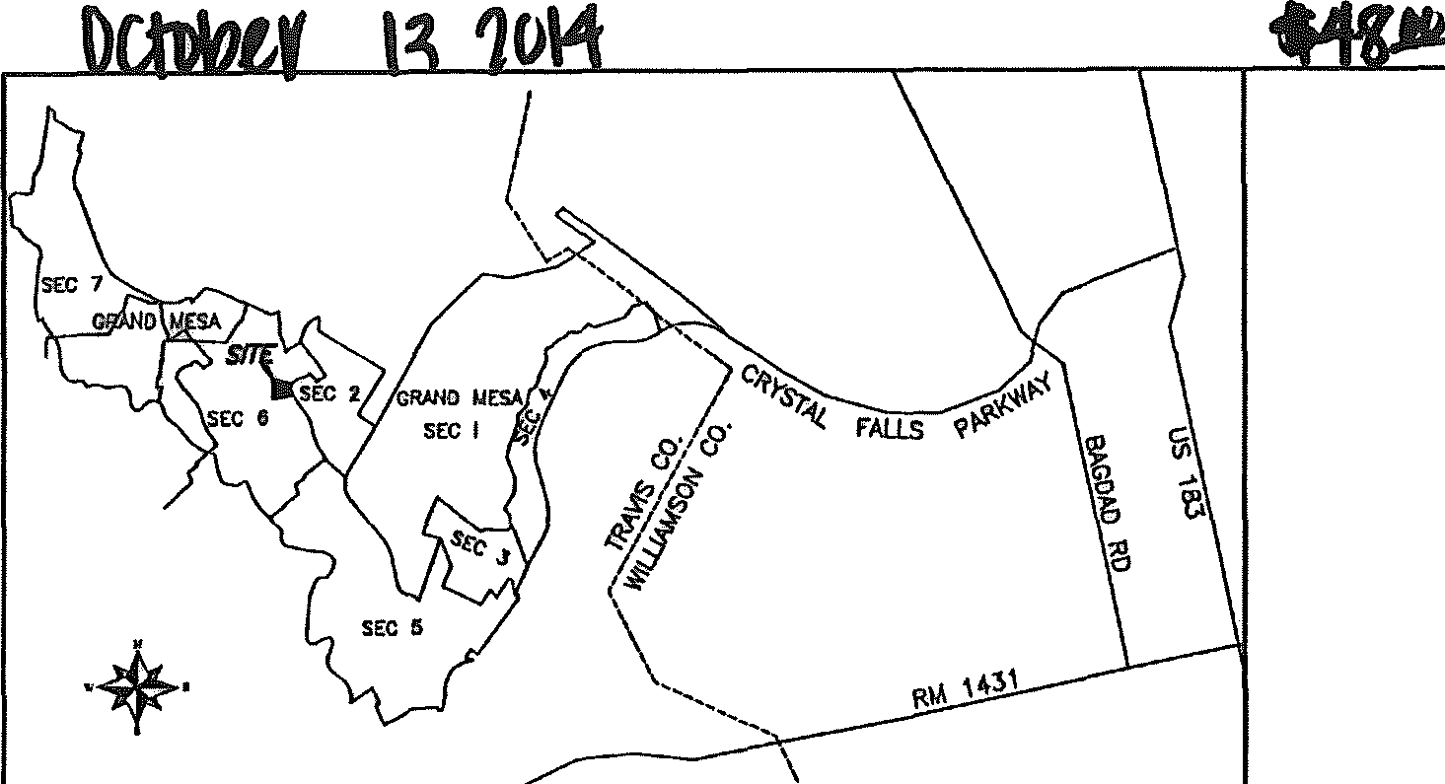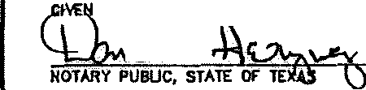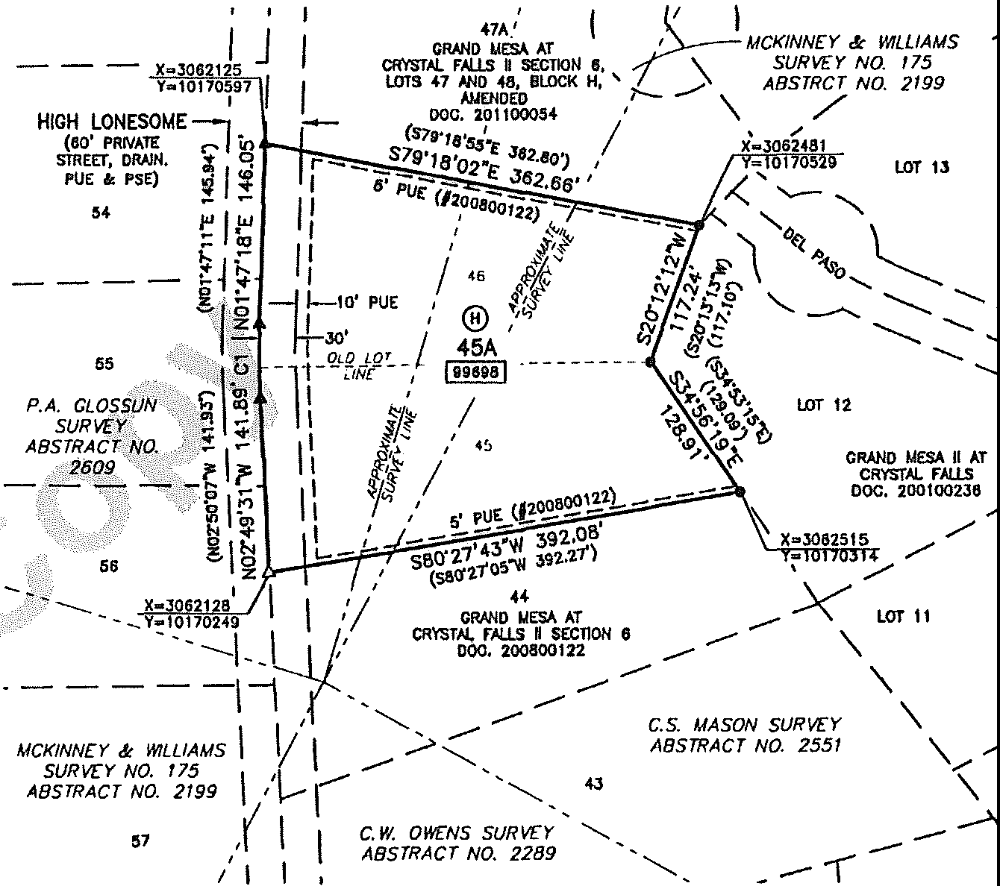

• A 6

®

PUE PSE

[!ill!]

,. IRON ROO v.11H CAP FOUND

,. PK NAIL FOUND

= PK NAIL SET

"' BLOCK NAME

= PUBLIC UTILITY EASEMENT

= PUBLIC SAFETY EASEMENT

= LOT AREA IN SQUARE FEET

CITY OF LEANDER, TEXAS CITY Of' LEANDER. TE)(AS :'· \, *di}*

::rr!!-: 6

:s c:T: : !3,.CllfS =T DE',£1,0PLIEIIT CROUP, lP 18&RO OURVEIO : TOTAL NUMBER or LOTS: 1 2370 RICE BOULEVAIID, STE 200 • =•

RESlOEHTIAIJt HOUSTON, TEXA9 *n00$* AUSTIN, TEXAS *1a12a* SURVEYING, LLC

NEW STREETS: NONE *1805 OUIDA DR.*

*AUsnN, Tl;XAS 78728*

*PHONF: (512) 267-74JO*

*FAX: (512) 8J6-8J85* SHEET 1 OF I

Cit,'? *of* :.\ City of Leander Planning Department 104 North Brushy Street

PO Box 319

Leander, Texas 78646-0319

Fax (512) 528-2729

[www.leandertx.org](http://www.leandertx.org/)

RA \csAI Ssc:.no,-J *lo*

Subdivision: A-ME/\/{>11\.\C:, kits *lS-to.£*

Submittal Date: 7-2.9- 09

File#:

(City will assign File #)

**AMENDED PLAT**

***APPLICATION*** & ***CHECKLIST***

*This application and checklist is provided as a service of the City of Leander. Its purpose* is *to assist the applicant in preparing a proposal that meets City standards so it can be expedited through the review process.*

Prior to submission of an Amended Plat, we recommend that the applicant meet with a representative of the Planning Department to determine if the application is complete prior to printing the required number of plat copies:

Ellen Pizalate (528-2750), Robin Griffin (528-2763), or David Hutton (528-2732)

**AN AMENDED PLAT DOES NOT REQUIRE A CONCEPT PLAN, PRELIMINARY PLAT OR CONSTRUCTION PLANS. AS PRESCRIBED BY STATE STATUTE,** IT **MAY BE UTILIZED TO AMEND EXISTING PLATTED LOTS WITHOUT VACATION OF THE PRECEDING PLAT, WITHOUT A PUBLIC HEARING AND WITHOUT APPROVAL OF OTHER LOT OWNERS WITHIN THE PLATTED SUBDIVISION IF** IT **IS UTILIZED SOLELY FOR ONE OR MORE OF THE FOLLOWING PURPOSES (CHECK ONE OR MORE AS APPLICABLE):**

**0** To correct an error in a course or distance shown on the preceding plat.

**0** To add a course or distance that was omitted on the preceding plat.

□ To correct an error in a real property description shown on the preceding plat.

**0** To indicate monuments set after the death, disability, or retirement from practice of the engineer or surveyor responsible for setting monuments.

**0** To show the location or character of a monument that has been changed in location or character or that is shown incotTectly as to location or character on the preceding plat.

**ii** To correct any other type of scrivener or clerical error or omission previously approved by the City, including lot numbers,

acreage, street names, and identification of adjacent recorded plats.

**0** To correct an error in courses and distances of lot lines between two adjacent lots if:

1. Both lot owners join in the application for amending the plat,
2. Neither lot is abolished,

r=======h:e a:m:e:n:dm en -t d o e s n o:tatt e m.:;p t-t-=o-r'-e1m,ho,voeror epc o,,f-frfdc-et do-nct-hoev pernoiap_enrftysi_riogrhirt_seosftrtih_iec toit-hoienrsoi,_wan[nedrjs i;n_th;e;::p;;l;a;t•.':_';_':_:!!1!

ri

-- - **J,.._+ 1;no. nr P. sement.**

_ .._. -_--_-- _*.::.*.*.*....-_ -_ **..,;.;.,,.,i;..., J-**

PAYTOTHE

**LOST COVE CORPORATION OBA CRYSTAL FALLS REALTY CONSTRUCTION ACCOUNT**

1001 CRYSTAL FALLS PARKWAY

LEANDER, TX 78641

FIRST TEXAS **BANK**

ROUNDROCK, Tl( 78664

7/29/2009

1646

88-474/1149

04

ORDER OF City ofLeander



SevenHundredand 00/JOO****************

$ **700.00

. ******************************************************************************

City of Leander

DOLLARS

MEMO G_M_6_c_or_re_c_ti o_n

11•2

5 2 :l 111 211•

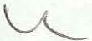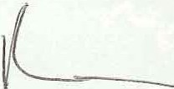

**INSTRUCTIONS:**

* Fill out the following application and checklist completely prior to submission.
* Use the most current application from the City's website ([www.leandertx.org)](http://www.leandertx.org/) or from the Plarming Department.

Place a check mark on each line if you have complied with that item. Indicate with N/A if the item does not apply to your plat. *This cltecklist is 011/y a guide. All stale (IJU/ local subdivision requirements C(IJIIIOI be reflected 011 this cltecklist.* If there are any questions regarding subdivision regulations, the applicant should consult the source law. City ordinances can be obtained from the City of Leander at our website or at city hall.

REQUIRED ITEMS FOR SUBMITTAL PACKAGE:

Submit the following items to the Planning Department or include on the Amended Plat:

I. Completed and signed application/checklist.

*--::;,*2. Seven (7) sets of the amended plat - **18" X 24" in size and collated and folded into fourths (9" x 12") with the name of the subdivision showing.** (The original mylar is not submitted until all comments have been addressed. If located within

the ETJ, one additional set of the plat is required ifin Williamson County and two additional sets of the plat are required ifin Travis County.)

3. Copy of deed showing current ownership.

*_::L._* 4. Copy of existing deed restrictions or covenants.

5. Filing Fee: $500.00 + $200 Professional Recovery Fee= $700 Total Fee

**THE FOLLOWING INFORMATION IS REQUIRED TO BE SHOWN ON THE PLAT AND/OR SUBMITTED WITH THE PLAT:**

***General lllformatiou:***

*_:L_* I. The proposed name of the subdivision. The name should be the subdivision, lot(s) and block being replatted and followed by the word:

***Amended***

*_L* 2. The date, scale, no11h point, names and addresses of the owner of record, developer, registered public surveyor, and licensed professional engineer (if applicable).

1. A location map. (Reconunend USGS 7.5 minute quadrangle map.)
2. Identification and location of proposed uses and reservations for all lots within the subdivision.
3. The following note is shown: *-:tt.';'*

***This amended plat does 1101 remo11e any restrictions.***

*:L_* 6. Plat or deed references for adjacent properiy as determined by the most recent tax rolls for all properties located within two hundred (200) feet of the subdivision boundary.

1. Plat note stating as follows: *1*

***B11ildi11g setbacks 1101 sltowu hereon sitall comply with Ille most current za11i11g ordi11a11ce of Ille City of Leander.***

1. Plat note for single family plats as follows: 1:17,i..{

***No driveway shall be constructed closer titan 50' or 60% of parcel frontage, wltichever is less, to the ROW of au i11lersecli11g local or collector street. No driveway slta/1 be constructed closer titan 100 feet or 60% of parcel frontage, wlticltever is less, lo the ROW of an i11tersecti11g arterial street.***

*.,L* 9. Certification, signature and revision blocks as required by the City and County, including the following:

* 1. A ce11ified statement by the surveyor is provided indicating that all easements of record are shown or noted on the plat (as found on the title policy or discovered with a title search prepared in conjunction with the most recent purchase) and the plat is in conformance with the Leander Subdivision Ordinance.
  2. Owner's dedication statement signed and acknowledged by owners dedicating all additional ROW, streets, alleys, easements, parks, and other open spaces to public use, or, when the subdivider has made provision for perpetual maintenance thereof, to the inhabitants of the subdivision. All signatures are with permanent/waterproof ink and notary seals are legible.
  3. If subdivision is not to be served by the City water system, provide a ceriification from a licensed professional engineer and approval by the Texas Commission on Environmental Quality (if applicable) that water satisfactory for human consumption is available in adequate supply at the time of submission.

2 *Revised 07/08/2009*

* 1. If the subdivision is not to be served by an organized wastewater collection system, provide this note with the engineer's seal stating whether the tract is or is not located in the Edwards Aquifer Recharge Zone and a signature block certified by Paulo Pinto, Williamson Co. Director of Environmental Services:

***Based upo11 tJ,e above represe11tatio11s of the e11gineer or surveyor wJ,ose seal is affixed l,ereto, mu/ after a review of tJ,e survey as represented by the said engineer or surveyor,*** *I* ***find that tl,is plat complies wit!, the requirements of tile Edwards Aquifer Regulatio11sfor Williamso11 County, Williamson County Flood Plain Regulations, mu/ the Williamson County On-Site Sewerage Facility Regulations. This certification is made solely upo11 such representations mu/ should not be relied upon for verifications of tl,e facts alleged. The Williamso11 County*** & ***Cities Health District mu/ Williamson County disclaims any respo11sibility to any member of tl,e public for i11depe11dent verification of the representations, factual or otl,erwise, contained in tJ,e plat and the docume11ts associated wit!,*** *it.*

***Paulo Pinto***

***Director of Environmental Services***

***Date***

* 1. Lot area, width and depth, public utility and drainage easements, and setbacks conform to the requirements as established for the designated land use as set forth in the Zoning Ordinance.
  2. The County recording statement is located in the lower right hand corner of the signature page.

STATE OF TEXAS COUNTY OF WILLIAMSON

I, NANCY E., RISTER, CLERK OF COUNTY COURT, WITH AND FOR THE COUNTY AND STATE AFORESAID, DO HEREBY CERTIFY THAT THE FOREGOING INSTRUMENT OF WRITING, AND ITS CERTIFICATE OF AUTHENTICATION, WAS FILED FOR RECORD IN MY OFFICE ON THE_ DAY OF , 20_, A.O. AT_ O'CLOCK_.M., AND WAS DULY RECORDED ON THIS THE_DAY OF J 20_, A.O. AT O'CLOCK_.M, PLAT RECORDS OF SAID COUNTY AND STATE IN CABINET , SLIDES_ WITNESS MY HAND AND SEAL OF THE COUNTY COURT OF SAID COUNTY, AT MY OFFICE IN GEORGETOWN, TEXAS THE LAST DATE WRITTEN ABOVE.

BY: _ NANCY E. RISTER

CLERK, COUNTY COURT WILLIAMSON COUNTY, TEXAS

Or

STATE OF TEXAS COUNTY OF TRAVIS

I, DANA DEBEAUVOIR, CLERK OF COUNTY COURT, WITH AND FOR THE COUNTY AND STATE AFORESAID, DO HEREBY CERTIFY THAT THE FOREGOING INSTRUMENT OF WRITING, AND ITS CERTIFICATE OF

AUTHENTICATION, WAS FILED FOR RECORD IN MY OFFICE ON THE_DAY OF J 20_, A.O. AT_

O'CLOCK_.M., AND WAS DULY RECORDED ON THIS THE_DAY OF J 20 , A.O. AT_ O'CLOCK_.M, PLAT RECORDS OF SAID COUNTY AND STATE IN CABINET_, SLIDES_WITNESS MY HAND AND SEAL OF THE COUNTY COURT OF SAID COUNTY, AT MY OFFICE IN AUSTIN, TEXAS THE LAST DATE WRITTEN ABOVE.

BY: _ DANA DEBEAUBOVOIR

CLERK, COUNTY COURT TRAVIS COUNTY, TEXAS

* 1. If the property is in Travis County and within the City ETJ, provide a Travis County Commissioner's Court approval note.
  2. City approval statement as follows:

*Approved tJ,is the day of , 20_ A.D. mu/ autltorized to be filed for record by tJ,e County Clerk of _*

***County.***

*Wayne S. Watts, PE, City E11gi11eer City of Leander, Texas*

*ATTEST:*

*Debbie Haile, City Secretary City of Lea11der, Texas*

3 *Revised 07/08/2009*

***ExisJj.11g Co11ditio11s:***

_ _ I. The existing property lines of the land being subdivided, including bearings and distances, of the land being subdivided.

Property lines shall be drawn sufficiently wide to provide easy identification.

1. Areas delineating the regulatory one hundred (100) year floodplain, if applicable. This information must be certified by a licensed professional engineer.
2. Location, dimensions, names and descriptions of all existing or recorded streets, alleys, reservations, railroads, easements or other public rights-of-way within the subdivision, intersecting or contiguous with its boundaries or forming such boundaries, as determined from existing deed and plat records.

/ 4. Survey ties locating adjacent intersecting streets/driveways and median breaks to determine compliance with alignment or off-set requirements on a boundary street within a distance of 1,000 feet of the subdivision boundaty.

/ 5. Survey ties at no less than three hundred (300) foot intervals across boundary streets indicating existing ROW width/location (unless such ROW was dedicated by plat).

/ 6. The location of City limit lines and/or extra-territorial jurisdiction, as depicted on the City's most recent base map, if either traverses the subdivision or is contiguous to the subdivision boundary.

.,_,/' 7. The location of the County line if it traverses the subdivision or is contiguous to the subdivision boundary.

***Survey Co11trol l11formatio11:***

./ I. True bearings and distances to the nearest established street lines, official monuments, or existing subdivision corner, accurately described and rotated to the state plane coordinate system. Using said system, X and Y coordinates shall be identified for four (4) property corners.

/ 2. The description and location of all permanent monuments or benchmarks, standard monuments, survey control points and lot pins.

3. Sufficient data for each lot to prove mathematical closure.

4. AutoCAD or GIS digital file on a CD as follows: Any graphics files in electronic format shall be in ESRl shape file format or Autodesk native file format, using the Datum, Projection, and Units listed below. The zoom settings, views, pen tables, and layers for each file shall be set to display the drawing as a complete plat sheet. Symbol files, font files, external reference files and other files required to correctly display the drawings shall be included in the same directmy as the graphics files. A key of all CAD layers, with a description of the information on each layer, shall be provided to assist city

staff in extracting the required information. For submittals in Shape file format, all metadata as listed above shall ·be included.

Datum: North American Datum 1983 (NAD 83) Units: US Survey Feet

Projection: Texas State Plane - Central Zone (4203)

***b11pr!J)•eme11ts:***

_ _ l. The location, bearings, distances, and widths of proposed easements to be dedicated to public use.

2. A ten foot wide public utility, landscape and pedestrian access easement is dedicated and shown graphically adjacent to all street ROW. (Note: ifuse is single family or duplex, only dedicate a ten foot public utility easement).

3. Water Courses and Easements: Distances along the side lot lines from the right-of-way line or the high bank of a stream. Traverse line along the edge of all major waterways in a convenient location, preferably along a utility easement if paralleling the drainage easement or stream.

4_ The property lines and number designations of all proposed lots and blocks, with complete bearings, distances and dimensions for front, rear and side lot lines. If inside the City, lots are in conformance with the Leander Composite Zoning Ordinance. If outside the City, lots served by a central sewage system have a minimum area as provided in the Composite Zoning Ordinance in the zoning district appropriate for the proposed land use. Lots to be served by septic systems shall be a minimum of20,000 square feet in area and conform to the County regulations based on percolation tests.

*V-* 5. The use, property dimensions, names and boundary lines of all reservations to be dedicated for public use, including schools, churches, parks and open spaces; common ownership; or subsequent development.

4 *Revised 07/08/2009*

1lJ...fl_ 6. The proposed location of sidewalks for each street shown as a dotted line inside the proposed right-of-way and the following sidewalk note:

*Sidewalks shall be i11stalled 011 tlte s11btlivisio11 side of [i11sert street 11a111e(s)j. Those side,valks not abutting a reside11tial, commercial or i11t/11strial lot (i11cludi11g sidewalks a/011g street fro11tages of lots proposed for scltools, clturches, park lots, dete11tio11 lots, drai11age lots, lam/scape lots, or similar lots), sidewalks 011 arterial streets to which access is proltibited, sidewalks 011 doub/efro11tage lots 011 lite side to which access is prohibited, a11d all sidewalks 011 safe school routes shall be installed wlte11 lite adjoining street is constructed.*

*L* 7. If inside the City limits, subdivision complies with the Composite Zoning Ordinance. If plat does not comply with existing zoning, a re-zoning application is enclosed.

**Current zoning** (if inside Leander), (Do not show on plat)

8. No lot has a lot line intersection of less than forty-five (45) degrees.

*V----* 9. All lots front on a public roadway.

/ I0. Wherever feasible, single family and two family residential lots are oriented so that the rear line of a lot is not the side lot line of another lot.

1. There are no single family or two family double frontage lots except where one of the frontages is to an arterial street.
2. Single family and two family residential lots adjacent to an arterial street have access on a residential street only and a note is shown on the plat prohibiting access to the other street.
3. Single family and two family residential corner lots on unequal class streets have access only to the street with the lower classification and a note is shown on the plat prohibiting access to the other street.
4. "Flag" lots are not proposed unless there are no other reasonable alternatives and they meet the following conditions: Driveways would be located no closer than permitted by the Transportation Criteria Manual.

The minimum width of the flag Jot is no less than twenty five (25) feet.

The narrow po11ion of the lot is dedicated as a common driveway access easement. No more than two "flag" lots are located side by side,

The Fire Chief has no objection to the lot layout.

The narrow "flag pole" portion of the lot is not considered when calculating lot width, depth or area requirements, or in establishing setback requirements.

/ 15. For residential plats, the following note is provided if applicable:

*For lots less tlta11 sixty feet wide am/ za11ed SFC, SFL or SFT, reside11tial street faci11g garages shall be located 110 closer to the street than five feet i11 front of lite d111el/i11g or roof covered porch, with such d111el/i11g or porclt structure being 1101 less titan seve11 feet wide for all portio11s of the structure adjacent to the garage. For all other lots, reside11tial street facing garages shall be located 110 closer to tlte street titan tlte d111elli11g.*

1. A note is provided limiting access to a specified roadway if required.

/ 17. Is this plat subject to an approved PUD, PDD or developer agreement? (YIN) If yes, provide a copy.

_.,,,- 18. Is applicant proposing a development agreement? (YIN) If yes, provide a letter explaining proposal.

1ll_&: 19. For multi-lot non-residential plats, the following note is provided:

*All lots contained i11 this subdivision mu/ users thereof shall have reciprocal access for i11gress mu/ egress titrough*

***all drive /a11es,jire la11es a11d driveways.***

,.,......----20. Certification from a licensed professional engineer and approval by the Texas Conunission on Environmental Quality (TCEQ) (when community well serving more than 25 people for over 60 days a year or when connecting a private well to a public city system) that water satisfactory for human consumption is available in adequate supply at the time of submission, except that such certification is not required if the property will be served by the City water system.

***Support Doc11111e11ts:***

I. Copy of approved application for flood plain map amendment or revision by FEMA (if applicable).

1. Note: Original tax certificates from the Williamson County tax office (includes County, City, and ACC) and LISD tax office are required prior to recording.

*rJlK* 3. If the plat is in Williamson County, provide the owner's affidavit for recording.

*5 Revised 07/08/2009*

*Ann/icaut J11formatio11:*

Please Note: The signature of owner authorizes City of Leander staff to visit and inspect the property for which this application is being submitted. The signature also indicates that the applicant or his agent has reviewed the requirements of this checklist and all items on this checklist have been addressed and complied with.

**The agent is the official contact person for this project and the single point of contact. All correspondence and communication will be conducted with the agent. If no agent is listed, the owner will be considered the agent.**

**(Check One):**

/, *the owner, will represent this application with the City of Leander.*

v *I, the owner, hereby authorize the person named below to act as my agent in processing this application with the City of Leander.* **Property Owner:** *L*Dt:>1-, o v I J')E\1 £LD?M \;;NT Phone: '2...£,,0 -20 *lolo* Fax: 2. &l 9 *0* 43 Address: )oo\ "<l',,l h;....\\s \,1u..; City: Le.. State:Ti_Zip: T(J ,,4 I Mobile: _

1

Signature: \.,I\.. T *\1'-*

W\L.\..\(!\1--\ \ H,NC..\ L>:.'-/

\"12-JZS.\ \>S t,j .,-

Email: _

**Project Agent:** Als,lc..L\ IV\ St\,,\-\

Address: *I* 0 *o* \ e\'-f-\-a._ \ re \\s \:)\._*'-\J[*

Phone: 2..l.o c9-'2 *O(.., (r*

City: *kcx.vJQ_s*

Fax: *2./oo* -'1O'-j 3

State: Zip: 9 *8(0* lf I

Email:_----==bQ.-=-t'--\.::..;)..:c.:'"'"'-=-0>-=-_@..---=e:..!.,_,-,--==--'-'o""L"""'A'----'--'o.."-=--'\\'-"-'=c<...9,, '\...,_C'-_,_e ..=-:-\.. Mobile: Pager:

*I* ***hereby attest that*** *I* ***prepared this application*** *I* ***checklist mu/ tltat all i11formatio11 shown hereon is correct am! complete to the best ofmy knot lge.*** \/

v'--- \L--- w)Ll-\f\M R,\-\,NcKL Y '1-2-9-o9

Signature Name (printed) Date

6 *Revised 07/08/2009*

**ELECTRONICALLY RECORDED**

TRV **5**

**2009161177**

PGS



**STATEOFTEXAS**

**COUNTY OF WILLIAMSON**

**CORRECTION AJIFIDAVlT**

Crichton and Associates, did heretofure provide surveying services in conjunction with prepau;tion of 1he Grand Mesa at Crystal Falls n, Section 6 Amending Lots *65,* 66, 67 and 68 Block E, A subdivision in Travis County, Texas according to the map or plat thereof recorded in Document Number 200900128 of Travis County, Texas Real Property Records:

Due to a scrivener's error1he owner's dedication on the face of the plat reads as follows:

THAT LOOKOUT DEVELOPMENT GROUP, L.P., A TEXAS LIMITED PARTNERSHJP, BEING THE OWNER OF THAT 6.8992 ACRE BEING LOTS 65, 66, 67 AND 68 BLOCK EOFGRAND MESA AT CRYSTAL FALLS II, SECTION 6, A SUBDNISION RECORDED IN DOCUMENT NUMBER 20080041128 OF

nm

TR.AVIS COUNTY, TEXAS OFFICIAL RECORDS DO HEREBY AMEND SAID LOTS *65, 66,* 67 AND 68, BLOCK.!! IN ACCORDANCE WIT!:{ APPUCABLE ORDINANCES OF THE CITY OF LEANDER, TEXAS AND TRAVIS COUNTY, TEXAS, TO BE KNOWN AS GRAND MESA AT CRYSTAL FALLS, AMENDJNG

LOTS *65,* 66, 67 AND *58* BLOCK1!AND DO HEREBY DEDICATE TO nm PUBLlC THE USE OF ALL

STREETS AND EASEMENTS AS SHOWN HEREON, SUBJECT TO ANY EASEMENTS AND/OR RESTRICTIONS HERETOFORE GRANTED AND NOT RELEASED.

**"'™"'MY""'"''/"nra""14,AY *.,cl'fw***

*\.A._..* If.. =

WILLIAM R. HINCKLEY, PRESIDENT LOOKOUT GROUP, INC.

GENERAL PARTNER, LOOKOUT DEVELOPMENT GROUP, L.P. 2370 RlCE BOULEVARD, SUITE 200

HOUSTON, TEXAS 77005

The owner dedication ls corrected toread as follows:

TI!AT LOOKOUT DEVELOPMENT GROUP, L.P,, A TEXAS LIMITED PARTNERSHIP, BEING THE OWNER OF ruAT 6,8992 ACRE BEING LOTS 65, 66, 67 AND 68 BLOCK.E OF GRAND MESA AT CRYSTAL FALLS II, SECTION 6, A SUBDNISION RECORDED IN DOCUMENT NUMBER 200800122 OF TI!E TR.AVIS COUNTY, TEXAS OFFICIAL RECORDS DO HEREBY AMEND SAID LOTS *65,*66, 67 AND 68, BLOCK JJ,, lN ACCORDANCE WITH APPLICABLE ORDINANCES OF TI!E CITY OF LEANDER, TEXAS AND TRAVIS COUNTY, TEXAS, TO BEKNOWN AS GRAND MESA AT CRYSTAL FALLS II, SECTION 6 AMENDING LOTS 65, 66, 67 AND 68 BLOCKE AND DO HEREBY DEDICATE *TO* THE PUBLIC THE USE OF ALL STREETS AND EASEMENTS AS SHOWN HEREON;SUBJECT *TO* ANY EASEMENTS AND/OR RESTRICTl:ONS HERETOFORE GRANTED AND NOT RELEASED.

STATE OF TEXA

COUNTY OF Wi!!iamsoft

This instrument was acknowledged before me on September 22, 2009 by Lookout Development Group LP, The Lookout Group, Tnc., its General Partner by William R. Hinckley President.



"'-

;SHAREE S. ROBERTSON

*f.<'T.A;; i"* NOTARYPUBUCSTATEOf Tl:XAS

\.. /. **COMMJSSION EXPIRES:**

.' DECEMBER 15, 2009

DAY OF 20_A.D.

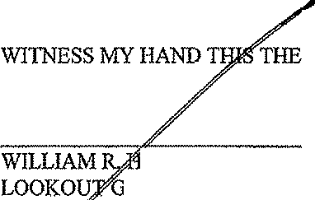

INCKLEY, PRESIDENT

RO\Jl',INC.

GENE PARTNER, LOOKOUT DEVELOPMENT GROUP, L.P. 2370 ICE BOULEVARD, SUITE 200

H STON, TEXAS 77005

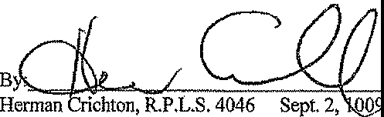

**STATE OF TEXAS**

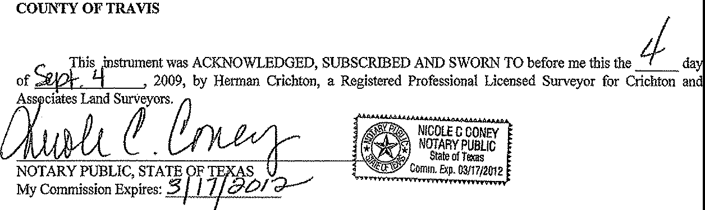

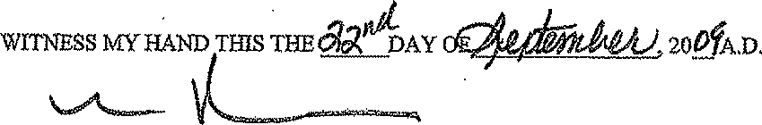

WILLIAM R. HINCKLEY, PRESIDENT

LOOKOUT GROUP, INC.

GENERAL PAR1NER, LOOKOUT DEVELOPMENT GROUP, L.P. 2370 RICE BOULEVARD, SUITE 200

HOUSTON, TEXAS 77005

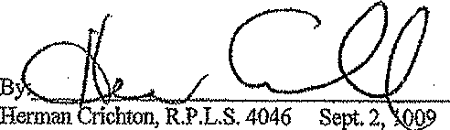

**STATE OF TEXAS**



STATEOFTEXAS ***AALI***

COUNTY OFMlHaw o.i

This instrument was acknowledged before me on September 22, 2009 by Looko:ut Development Group LP, The Lookout Group, Inc., its General Partner by William R. Hinckley President.

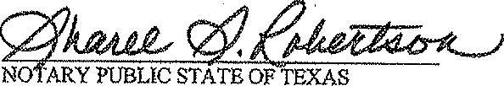



SHAREE 8. ROBERTSON

NO!AftYPUSUC STATEOFTEKAS

**COPlMISSION EXPIR S;**

DECEMBER 15, 2009

FILED AND RECORDED OFFICIAL PUBLIC RECORDS

Lhst..1.::;.2::t .12 -•- /1.,•.'"(_··

DANA DEBEAUVOIR, COUNTY CLERK TRAVIS COUNTY, TEXAS

September 24 2009 08:17 AM

FEE:$ 32.00 2009161177

I I I

\

C, 'I,,

**GRAND MESA%**

**(Sec. 8)**

,.,.

\ \

.# **GRAND MESA**

**{Sec.6)**

. .._

l

-I r- I

/,

*J*

\.

....

,.,.....

*I*

I ...

..

'

....

...

...

'I-,

*I*

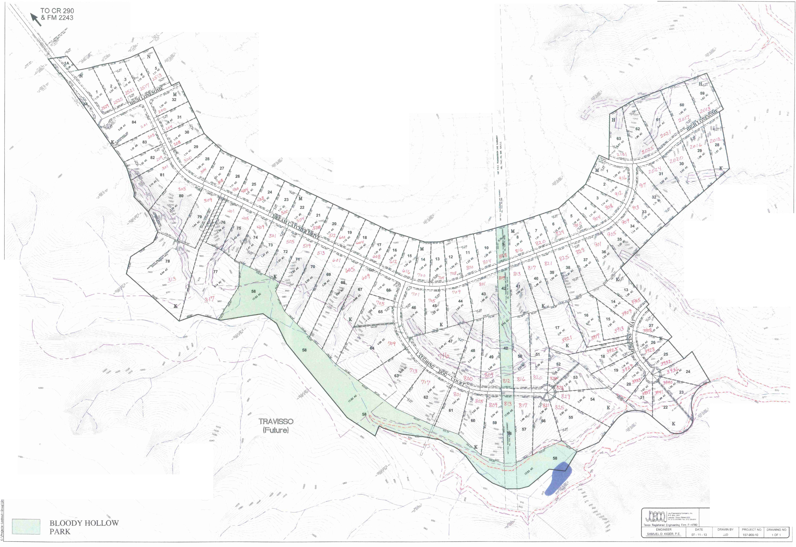

l

*(* 119<'

*I* ,IP'

*I* ,o,o

...

*J* ***,ii*** scale: 1" = 200'

10,l0 5' Contours

**GRAND MESA 7**

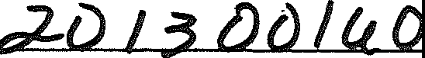

**LOT 66, BLOCK K, GRAND MESA AT CRYSTAL FALLS 11, SECTION 7, REPLAT**

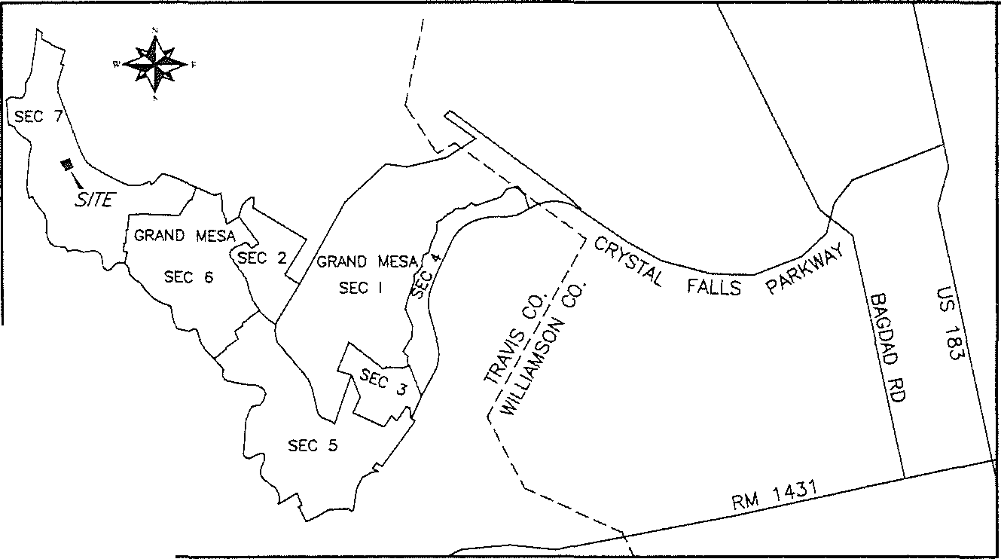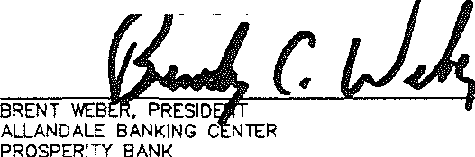

*0*

6

®

PUE

PSE

I 48128I

IRON ROD WITH G&R CAP SET MAG NAIL SET

BLOCK NAME

PUBLIC UTILITY EASEMENT PUBLIC SAFETY EASEMENT LOT AREA IN SQUARE FEET

SUBMITTAL OATE: MAY 30, 2013.

TOTAL AREA OF THIS PLAT: 1.105 ACRES TOTAL NUMBER OF LOTS: 1

RESIDENTIAL: 1 **s**

NEW STREETS: NONE

LOCATION MAP

N.T.S.

SURVEYOR:

G&R SURVE'!1NG, LLC 1B05 OUIDA DRIVE

AUSTIN, TEXAS 78728

OWNER AND DEVELOPER:

LOOKOUT DEVELOPMENT GROUP, L.P. 2370 RICE BOULEVARD, SUITE 200

HOUSTON, TEXAS 77005

1"=100'

0 50 100 200 400

BEARING BASIS: TEXAS CENTRAL ZONE, STATE PLANE COOROINATES (NAO 83)

STATE OF TEXAS: COUNTY OF TRAVlS:

DEDICATION STATEMENT:

LEGEND:

68

_,,,,/'

67

_,,,,/'

X=3056178 1'=101 ,2417

_,,,,/'

"*·o*'"'-

*'o*

"'

*>* \

X=.3058380 Y=101 2 09

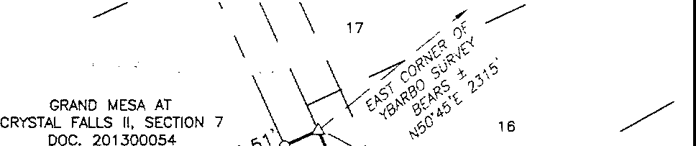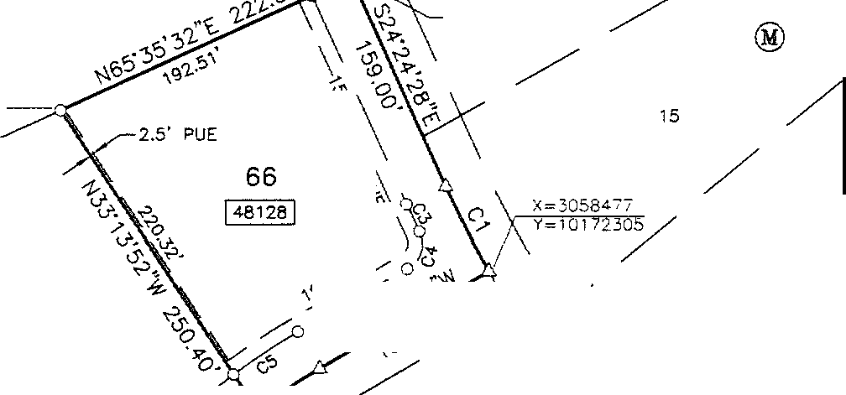

THAT LOOKOUT DEVELOPMENT GROUP, LP., A TEXAS LIMITED PARTNERSHIP, BEING THE OWNER OF 1.105 ACRES OF LAND SITUATED IN TRAVlS COUNTY, TEXAS OUT OF THE C. '!1BARBO SURVEY 422, BEING ALL OF LOT 66, BLOCK K, GRAND MESA AT CRYSTAL FALLS II, SECTION 7, A SUBDIVlSION OF RECORD IN DOCUMENT NUMBER 201300054, OFFICIAL PUBLIC RECORDS, TRAVlS COUNTY, TEXAS AND ALSO BEING A PORTION OF A 219.70 ACRE TRACT OF LANO CONVEYED TO LOOKOUT DEVELOPMENT GROUP, L.P. BY DEED OF RECORD IN DOCUMENT NUMBER 2012064164, OFFICIAL PUBLIC RECORDS OF TRAVlS COUNTY, TEXAS, DO HEREBY PLAT SAID 1.105 ACRES OF LAND IN ACCORDANCE 'MTH APPLICABLE ORDINANCES OF THE CITY OF LEANDER, TEXAS AND TRAVlS, COUNTY. TEXAS, THE HEREIN DESCRIBED PLAT TO BE KNOWN AS "LOT 66, BLOCK K,

GRAND MESA AT CRYSTAL FALLS II, SECTION 7, REPLAT", AND 00 HEREBY DEDICATE ALL ADDITIONAL ROW, STREETS, ALLEYS. EASEMENTS, PARKS, ANO OTHER OPEN SPACES TO PUBLIC USE. OR, WHEN THE SUBDIVlDER HAS MADE PROVlSION FOR PERPETUAL MAINTENANCE THEREOF, TO THE INHABITANTS OF THE SUBOIVlSION AS SHOWN HEREON, SUBJECT TO ANY EASEMENTS AND/0 STRICTIONS HERETOFORE GRANTED AND NOT RELEASED.

**7-Jo_-13**

_,,,,/'

65

""

®

LAUGHING DOG COURT

(60' PRIVATE c,1.-

STREET. DRAIN.. -/

P.S.E. & P.U.E.)-- /

. ,/i

14

/

DREAM-\" /

CADTRCIVHEER \ " 13

STREET. DRAIN., A

'MLLIAM R. HINCKLEY. PRESIDENT LOOKOUT GROUP, INC.

GENERAL PARTNER LOOKOUT DEVELOPMENT GROUP, L.P. 'MLLIAM R. HINCKLEY, OPERATING MANAGER MORNINGSIDE LAND AND CATILE CO., LL. C.

GENERAL PARTNER KEY-DEER HOLDINGS, LP. 2370 RICE BOULEVARD, SUITE 200

HOUSTON, TEXAS 77005

DATE

x 3oss315

/ / / Y 10172Z07

64

*N1* ®

(60' PRIVATE (:

P.S.E. & P.U.E.)

46 /45

STATE OF TEXAS:

|  |  |  |  |  |  |  |
| --- | --- | --- | --- | --- | --- | --- |
| CURVE TABLE | | | | | | |
| NO. | DELTA | RADIUS | ARC | CHORD BEARING | CHORD | TANGENT |
| C1 | 5·31•40• | 690.00' | 66.57' | S2710'18"E | 66.54' | 33.31' |
| C2 | 7·27•45• | 400.00' | 52.10' | sss-12·os-w | 52.06' | 26.09' |
| CJ | 1·39•44• | 720.00' | 20.89' | s25·14•2o"E | 20.89' | 10.44' |
| C4 | 8000·10· | 20.00· | 30.02' | S1o55'53"W | 27.28' | 18.65' |
| C5 | 709'45" | 430.00' | 53.75' | S5o21'06"W | 53.72' | 26.91' |

COUNTY OF TRAVlS:

BEFORE ME, THE UNDERSIGNED AUTHORITY, ON THIS DAY PERSONALLY APPEARED 'MLLIAM R. HINCKLEY, KNOWN TO ME TO BE THE PERSON WHOSE NAME IS SUBSCRIBED TO THE FOREGOING INSTRUMENT AND ACKNO'MLEDGED TO ME THAT HE EXECUTED SAME FOR THE PURPOSE ANO CONS10ERATION THEREIN EXPRESSED, IN THE CAPACITY THEREIN STATED.

GIVEN UNDER MY HAND AND SEAL OF OFFICE, THIS THE **Jo** DAY OF . **201.l_** A.O.

PRINT NAME

**J**

NOTARY PUBLIC IN AND FOR THE COUNTY OF TEXAS. MY COMMISSION EXPIRES **J'.Z.**

STATE OF TEXAS; COUNTY OF TRAVlS:

**&AR'SARA A, SMITH**

N•nllrv P1JMl1c, State of Texas My Cnmm1ss18n Expires Oecttmbe119, 2016

STATE OF TEXAS:

COUNTY OF TRAVJS:

APPROVED THIS THE *D*,.*\*,**6** i\.. DAY OF _- **,..J**U..".'.--'-j-, 20_!_ A.O. AT PUBLIC MEETING OF THE

BY SIGNING THIS PLAT, THE LIENHOLDER HEREBY SUBORDINATES ANY DEED OF TRUST, VENDOR'S LIEN. OR OTHER TYPE OF LIEN OWNED BY THE LIENHOLDER 'MTH RESPECT TO THE PROPERTY TO THE EASEMENTS CONVEYED TO THE CITY OR THE PUBLIC UNOE S PLAT.

PLANNING AND ZONING COMMISSION OF THE CITY OF LEANDER. TEXAS ANO AUTHORIZED TO BE FILED FOR RECORD BY THE COUNTY CLERK OF **'Tro...viS** COUNTY, TEXAS.

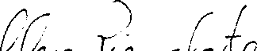

CITY OF LEANDER, TEXAS

ATTEST: :::':-e=:- =2-=c.c1:.' :'=:'.:::!:'.....:: --- ELLEN PIZALATE, SECR *Y*

PLANNING AND ZONIN OMMISSION CrTY OF LEANDER, TEXAS

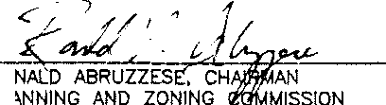

RO

p

STATE OF TEXAS; COUNTY OF TRAVlS:

I, PHILLIP L. McLAUGHLIN, AM AUTHORIZED UNDER THE LAWS OF THE STATE OF TEXAS TO PRACTICE THE PROFESSION OF LAND SURVEYING, AND HEREBY STATE THAT THIS PLAT CONFORMS 'MTH APPLICABLE ORDINANCES OF THE CITY OF LEANDER, TEXAS AND TRAVlS COUNTY, TEXAS AND THAT ALL EXISTING EASEMENTS OF RECORD AS FOUND ON THE PROPERTY REPORT RECEIVED FROM INDEPENDENCE TITLE COMPANY ON JANUARY 18, 2013, HAVE SEEN SHOWN OR NOTED HEREON.

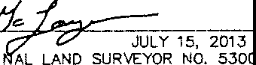*_7° d=*

PHILLIP L. McLAUGHLIN REGISTERED PROFESSIO STATE OF TEXAS

STATE OF TEXAS:

COUNTY OF TRAVlS:

I, DANA OEBEAUVOIR. CLERK OF TRAVlS COUNTY, TEXAS 00 HEREBY CERTIFY THAT THE FOREGOING INSTRUMENT WRITING AND 11 CERTIFICATE OF AUTHENTICATION WAS FILED FOR RECORD IN **MY** OFFICE ON THE ***r-r*** DAY

OF

***.S,:..!.....*** 20_D.o. **A'r)'•.S&** O'CLOCK.. ANO DULY RECORDED ON THIS THE _J DAY

L)

**M'J** 20b A.a. 'fr1_:,_S1l'._o·cLocK.. OFFICIAL PUBLIC RECORDS OF SAID couNTY AND STATE

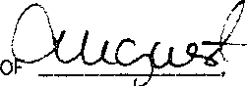IN DOCUMENT N:C::o 13J]o*(Leu*

*'M* MY HANO ANQ_ SEAL OF OFFICE OF THE COUNTY CLERK. THE*2* DAY

::, **•):f¥1r. ""'-"'/"N** = !

BY • *t* /, *r* i \ *1* -..QJ"G-V\.t Ck' 43

0

0 PUTY



**SURVEYING,** LLC

*1805 OUIDA DR.*

*AUSTIN, TEXAS 78728*

*PHONE: (572} 267-7430*

L:\ 11232-GRAND MESA SECTION 7\dwg\11232-GR-PLAT-LOT 66 K-AME'IDED.dwg 7/15/2013 8:39.33 AM CDT *FAX: (512) 836-8385*

SHEET 1 OF 2



LOT 66, BLOCK K. GRANO MESA AT CRYSTAL FALLS II, SECTION *1,* REPLAT

Pl.AT NOTES

1. THIS SHORT FORM FINAL Pl.AT DOES NOT REMOIIE ANY RESlRICllONS. RESlRICTION Of ACCESS FROM LOT 86, BU<. "K" TO DREAM

CATCHER 0111\IE AS STATED IN PLAT NOTE 315 Of ORANO MESA AT CR'l'STAL FALLS U, SECTION 7, IS HEREBY REMOIIEO. THIS SUBOl'l!SION

IS SUBJECT TO AU. OTHflt GENERAL NOTES ANO APPEARING ON THE PLAT Of ORANO MESA AT CR'ISTAL FAU..S U, SECTION 7,

RECORDED IN DOCUMENT NUMBER 201300054, OFFICIAL PUIIUC RECORDS, lRA'IIS COUNTY, TEXAS.

1. THIS SUBDMSION IS WHOLLY CONTAINED WITHIN THE CURRENT CORPORATE UMrTS OF THE CITY OF I.EANOER, TEXAS.
2. CONSTRUCTION OF IMPROVEMENTS WITHIN THIS SUIIOMSION SHAU. NOT COMMENCE UNTlt. Al.I. APPLICATION PERMrTS AND/OR CONSlRUCTION PLANS HAIIE BEEN APPR= BY THE CITY OF LEANDER, TEXAS. *AU.* PUBUC IMPROVEMENTS SHALL CONFORM TO THE CURRENT ZONING ORDINANCE OF THE CITY OF LEANDER, TEXAS.

- NO LOT IN THIS SUBDMSION SHALL BE OCCUPIED UNTIL CONNECTED TO THE WATER DISTRIBUTION S'l'STEM OF THE CITY OF LEANDER, TEXAS.

5. RESlRICTM: CO\IENANTS FOR THIS Pl.AT ARE RECORDED IN THE OFFICIAL PUBUC RECORDS OF TRAVIS COUNTY, TEXAS UNDER DOCUMENT NUMBER 2013050108.

e. IN ORDER TO PROMOTE DIWNAGE AWAY FROM A STRUCTURE, THE MINIMUM FOUNOATION SLAB ELEVATION SHOULD BE BUILT lo.T LElo.5T ONE FOOT >l!YJ,/E THE HIGHEST GROUNO ELEVATION WITHIN FI\IE (5) FEET OF THE SLAB PEl!IMETER, AND THE GROUND AllJloCENT TO THE SLAB SHOULO BE SLOPED AWAY FROM THE STRUCTURE AT A SLOPE OF 1/2" PER FOOT FOR A DISTANCE OF AT LElo.5T TEN (10) FEET.

1. WATER WILL BE PIICMDED BY THE CITY OF LEANDER.
2. PROPERTY OWNERS SHALL F'A(Ml)E FOR ACCESS TO DMHAGE EASEMENTS AS MAY 111E NECESSARY AND SHALL NOT Pll0HaT ACCESS BY THE CITY OF LEAIUII.

II. *AU.* EASElolENTS ON P'IWATE l'A0PEIITY SHAU. 11£ -- BY THE OWNEJI 011 HIS 011 HER ASlllGHS.

1. AU. SU8IDl'4SION CONSmUC'llCN SHALL CONFOIIM TO THE CIIY *OF* LENaJII coot: *OF .* CONSffllJCTION STAlolDMDS, ANO G£NERAI..LY

ACCEPTED l'll.<oC11C£S.

1. NO l!llUllOIHGS, FDICES, I.N«JSCAPING OR OTl£lt SIIWCTUll£S l#t£ -,-J"ED WITHIN - EA5ElolENTS SHOWN, EXCEPT AS Al"PIIIMro BY THE CITY OF l.EAND£R PVIIUC 'IIOAl<S 00'AlmlEHT.
2. WASTEWATER AND WATER SYSTEMS SHALL C0NFOIIM TO TCEQ (TEXAS ON ENIMIONMEHTAL QIJM.ITY) ANO STATE ll0illAO OF INSOl'iANCE REQUIIIE,l[NlS. THE 0IIINER UN0Elt5T#lll5 ANO JOINOIUDGOI TIHAT Pl.AT VAClillON 011 l'IE-PLATflNcl M,jl.y IIIE REQUIIIED, AT THE OIIINEJl!'S SOI.E EXP01SE. If P!.AHS TO DEVELOP THI$ **S>..-i!ll0N DO** NOT COMPLY wmt SUCII coot:s ANO REQUll'l£MOfrS,

1 J. DE\IE..0PER SHAU. 1!E -.E FOR *AU.* RELOCATION *Nl,f)* IIIOCJIFICATIONS TO EXISTING I.ITIUllES.

14. '!HE 0111ND1 Of lHIS SUIEIMSl0N, AND HIS 011 HER Slia:DIIOIII l"IO -.S, ilSSUIIIES ll£SPONillllllJ FOIi l'UIICS FOIi CQ8ftllUCT10N Of SUIIDMSION - OOMPLY 11111N -""l'I.JCMIU: CCIDl!S MO Of THE CIIY OF I.Ulllllf:R. lHE OIIIMDI UNIIEIIISTNIDS MlJ THAT PLAT 'W>CA1l0N OR ll£JII\AT1'lN; W/1' Ill[ **RBIUIPIED,** AT THE OIIIER'S SOLE EXPEIGE, IF Pl.ANS TO lNIS llUICMSIOH DO NOT COMl'LY 11111N SUCH CODES *#llJ*

15. - SU11E1Y **l'tlR** SIJlllllMSl0N CONSmUCTION, IN F0lld ACCll'TAIIU 1'0 THE CITY OF L£#1C£11, S1W.1. !IE Pll0'IIDED PIIIOII TO l'UIT

BY THE l'I.NolNINC AND ZOHING CCYifiSSOI.

1'. COlillillJfflY IMPACT FEES FOR INDMOU,ll L1m1 TO IIE PND PIIIOR 1'0 ISSl.WU OF *Nf'f* IIUILlllNG P£1111111TS.

17. SlTE 0EVEL.ClPMENT CONSmUC110N l'VNS Si/lU. IIE ll£IAElllED */111,f)* Al'F'l'IOIIED *I/It'* THE CITY OF L£fllCl£R l"AICIR TO ANY CONSTIIUCllCN.

11. TDIPQIIMY AHO P£IUIIAHENT EAtOIENIS 1'0 IIIE l'RICM0El) M RllQUND FOR OFF-SITE •TER. Al'ID DIWIWlE

11. l'NSlifD SUll'D WHICH *IJlf/lE.* IIIIEA'IIR Tl-WI 15!11 CNIIIOT USE SISl'EMII.

20. l'IIDITY--fll/E FOOT OS5f *1#1£.* R£QUlllflEI> ,_ ALL -- WAlll.

21. lllEMY-fM *RIOT* Ol!IIIF *JJRE.* REOUIIIC l'1ll0U ALL F-.i) SLGfl£S - *NIE.* 8IIISAD THAN 30II[

U. ALL l"IIII/A1I: _,. ll40illlll- - *Mr* smRl'f IIA1D IIR DNCD CONfflllWIIG A0CDII 1'0 lM£ **Sillli1II'.** l'l8VII.TE 9'Mml SHN.l. lit

Ollllml MO IT' M *OF* 11-111 11W.

23A. 10 RIOT PUE ADJACENT 1'0 ALL l'IQliOlafA'IS *#llJ* ALL IIIIIHT...Qf"-•'IS AHil A 2.5 FOOT PU£ .ALJ:IHG ALL SIDE LOT UNO IS HE11U1Y

DEDll:A'IED.

1. *AU.* IIUII.DGNC SETalCI< LINES NOT SHOIIH ON StW.I.. IIIE IN ACC0l'IIW4CE WITH THE CIIY OF I.EANDEll'S CUM£NT 0IIIDll6tNCE.
2. THE F0U..OIIIING - llEIE QIIIIINTEI) l'Ot A _,- llllTH THE CIIY 01' lENCIEJII AND OF THE

Cl!'ISm. FAUS ft <XlNCG'1" ON i4flY 1, llOOJ.

* 1. -1E SfflEIS llllTH

ll-NO

C. NO SmE£l' UQHIS.

2G. mE Df:l>UOl'Ellt, IIIJll.llfll. SEi..LDI. **OR**- StW.I.. INfl3IIIII, IN -- EliCH IU'IO OF SUIIIIMll0lll U1TS OR t.0CA"IEJ) W11H1N l'UlOD ,_,. SUCH l'IIIOl'l:fflY IS IN *NI ICOITlfll'D* **l'ID00** lif//£A #ID MIT A f'UXID PIJIIN PDMT 1111.L IIE IIErAJIIIEil tllEl'09IE A Sllll.lCIUIIE 0#1 llE l'UICID ON THE l'IIIGl'Elll'Y. M NallCE: IDWJ. llE F1UiO Rlll ReXIPID IN M lll'l'ICIIII.

l'UIILJC IIECOll'IC *OF* 1'li'<\IIS CCIUlll'IY. A *Ct1F1* OF lHlS NOIICE lll-WJ.. llE 1111b Al'l'IJCA'llllMS Al'IIE W4lE P'llll FLOOD l'VIIN

PDIIIITS.

1. PIIIIOII l0 #fr ALTlliW10N5, - l'U. -. CIWGCL . OR ST0IWlE *OF* -.S

IIR */1#1* 0110 OWIQI£ l1ITHlil lHE 100 '!£M Fl.llOO l'Uel LIIClll8 - 1l-llS l'UIT, NI Ml.ltA1ION 1'011 FLOOD JIIUIIN

PIMIIT - A DOCNl"IION *(IF* THE l'RGIIECI" - OODIT OF **CHillllllES,** IF *//Hf,* T0 lHE 'IM1IIICOURS[ Clllt NIIW. _.,. ,aA IIDULT

*0/F* '!HE pflOl'09EI) litUST Ill[ SUlllllffl:D 1'0 .olflll It'!' '!HE CITY OF Lu.tall Fl.llOO l'I.AIN -. ALL

llP£Cll'lCA1l0N - llETAU All! CQIPln[ ll£Whl illlUl1" llE l'lllO\IIIIED.

1. - TO *//Hf* Al.'J'EIIATION 011 - C0MlfflllJCllCN INCH 'lllLL Clwa: EXIITNI: Fl..000 IWIUNS 0lt El.£V,tITTONS, A LEmJII OF

- litUST II[ SIJIIIMITTED TO- Al"l'lll:M1) lt'I' M l'UIOW. £MEIIIIEtlC'I' AODICY.

211. NO- IIHIIU. llE CClllllPIIUClm CLOIIIPI- 90' 011- *OF* ,, l'll0lfTAII£.- IS I.Dlli, ro TH£- *OF* Al!!

... w,ION LOCAL Qlt CCU£CtOfl ffllfET OR 100' 011 - *OF* IWICIJ. ,-rAII[. 'IIMIQe8 IS USS. 1'0 THE - *OF AH* lill!IIIIIIECII

S'IIIEET.

JO. ,_,- BUILDING LINES N'lf. ldflillUMD FROM THE EDGE OF 1HE SlllEET EASEMENT.

1. GlliAAGES FACING A SIOE STllfZT ON A CORNER LOT ARE - lO BE SET IW:K 20'.
2. A PIJIIUC SAFETY EI\SEMENT IS HEIIOY GRANTED FOR ALL PlllMIJE SfflEETS, DRAINAGE NC> PUii.iC UTlU1Y E"AS£MENTS WITHIN THIS SUIIIOMSION.
3. *Al.* ClAIIISOH DISPOSAi... INC. -.&.. 11£ THE SOLE PRCMOER Of IIIIIIITE H11UUHG FOR THIS SlTE llOTH DURING AND AFTER CONS11IUCTION.
4. ALL HE11E1N IS IUlloll!CT 10 THE LOWEii C0t.O!W)0 IINIII NJTH0IIITYS lllGHUND LMQ 'llllll!MtEl OIIDINAHCE. lllll!TlEN

NOllFICATlON NC/all PElllll'II MIIE IIEQJll'l£I) Pllt(lfi TO COMNDICl'III /IMY ACffil1ml. CGNTACT l.CRA \l!Al'EIUIHED

IIANAGDIEPIT AT 1-II00-77S-5Z72, D1DiSKlN 2.324 FOIi YCIII[ IIIIFOIUdA11011.

36. lHE HOMEOWNER ASSOCIA'IICIN llln..AIIIS */JII/E.* RECORDED IN 1HE Ol'l'laAL PUIIUC ll£CORDII Of' lMolS CIMIIY, TEXAS UNlER 00CUIIIPIT NIIIIIIIEPt 20122011G35.

JS. ALL l.1llUTY LINES- lHE SUIIDMSl0N *1#1£.* IIEQUIMD TO II[ UNDEllOROUND.



**SURVEYING,** LLC

*1805 OUIDA DR.*

*AUSTTH, TEXAS 78728*

*PHONE: (512) 267-7430*

L:\11232-GRANO ESA SECTION 7\dwg\11232-GR-Pllo.T-LOT 66 K-AMENOED.dwg 7/15/2013 8:39:33 AM CDT *FAX: (512)* ***836-8385*** SHEET 2 OF 2

**GRAND**

**FINAL MESA AT SECTION**

**PLAT OF CRYSTAL 8, PHASE**

**FALLS**

**1**

**11,**

FIELD NOTES:

DESCRIPTION OF 96.278 ACRES OF LAND SITUATED IN TRAVIS COUNlY, TEXAS, OUT OF THE PA GLOSSOM SURVEY, THE TEXAS MEXICO RAILROAD CO. SURVEY 203, THE **MCKINNEY** &: WILLIAMS SURVEY 175, AND THE CANDELARIA YBARBO SURVEY 422, BEING A PORTION OF A 1,013.55 ACRE TRACT OF LAND DESCRIBED IN A DEED OF RECORD *TO* LOOKOUT PARTNERS, L.P. IN DOCUMENT NUMBER 2000162836, OFFICIAL PUBLIC RECORDS OF TRAVIS COUNTY, TEXAS; SAID 96.278 ACRE TRACT BEING MORE PARTICULARLY DESCRIBED BY METES AND BOUNDS AS FOLLOWS:

BEGINNING AT A AN IRON ROD WITH CAP FOUND IN THE SOUTHERLY LINE OF A 127.030 ACRE TRACT OF LAND DESCRIBED IN A DEED OF RECORD TO DOUGLAS D. HOOD IN VOLUME 12189, PAGE 1339, REAL PROPERTY RECORDS OF TRAVIS COUNTY, TEXAS, SAME BEING THE NORTHERLY LINE. OF SAID 1,013.55 ACRE TRACT, BEING THE MOST NORTHERLY NORTHEAST CORNER OF GRAND MESA AT CRYSTAL FALLS II, SECTION 7, A SUBDIVISION OF RECORD IN DOCUMENT NUMBER 201300054, OFFICIAL PUBLIC RECORDS OF TRAVIS COUNTY, TEXAS, FOR THE NORTHWESTERLY CORNER OF THE HEREIN DESCRIBED TRACT;

*I*

*I*

LEGEND: *I*

*I*

\

*CAP* **e** = IRON ROD WITH CAP FOUND

0 = IRON ROD WITH G&R CAP SET

@ STEEL FENCE POST

@

THENCE CONTINUING WITH THE NORTHERLY LINE OF SAIO 1,013.55 ACRE TRACT, AND THE SOUTHERLY LINE OF SAID 127.030 ACRE TRACT, AND GENERALLY ALONG THE LINE OF A W!RE GAME FENCE, THE FOLLOWING TWO (2) COURSES:

...

= COTTON SPINDLE FOUND

= MAG NAIL FOUND

1. 575•33•18•E, A DISTANCE OF 337.99 FEET TO A 3" IRON FENCE POST;
2. s75·45'41•E, A DISTANCE OF 198.88 FEET TO **AN** IRON ROD WITH G&:R CAP SET, FOR THE NORTHEASTERLY CORNER OF THE HEREIN DESCRIBED TRACT;

THENCE OVER AND ACROSS SAID 1,013.55 ACRE TRACT, THE FOLLOWING TWENlY-FOUR (24) COURSES:

1. S13"58'08-W, **A** DISTANCE OF 354.86 FEET TO AN IRON ROD WITH G&:R CAP SET;
2. S76"01'52"E, **A** DISTANCE OF 15.37 FEET TO **AN** IRON ROD **WITH** G&:R CAP SET;
3. S13"21'02-W, A DISTANCE OF 359.80 FEET TO AN IRON ROD WITH G&:R CAP SET;
4. S76'01'52"E, **A** DISTANCE OF 270.40 FEET TO AN IRON ROD WITH G&:R CAP SET;

0 = CALCULATED POINT

® = BLOCK NAME

PUE = PUBLIC UTILITY EASEMENT

PSE = PUBLIC SAFETY EASEMENT DE = DRAINAGE EASEMENT

WBZE = WATER BUFFER ZONE EASEMENT RCS = RIPARIAN CORRIDOR SETBACK

♦•

11156971 = LOT AREA IN SQUARE FEET

N

**p-':"".:-:-:-.;-;-:-**

FALLS

1. S12"44'45-W, A DISTANCE OF 116.39 FEET TO AN IRON ROD WITH G&:R CAP SET;
2. S2747'13•E, **A** DISTANCE OF 1156.40 FEET TO AN IRON ROD WITH G&:R CAP SET;
3. S4711'05-W, A DISTANCE OF 66.66 FEET TO AN IRON ROD WITH G&:R CAP SET;

t:-::::.:::-:::.:::-J =

LIMITS OF WBZE/RCS

w

s

1. S52'18'35"E, A DISTANCE OF 673.41 FEET TO AN IRON ROD WITH G&:R CAP SET;
2. N3741'25"E, A DISTANCE OF 1200.00 FEET TO AN IRON ROD WITH G&:R CAP SET;
3. S52'18'35"E, **A** DISTANCE OF 100.00 FEET TO AN IRON ROD WITH G&:R CAP SET;
4. S3741'25-W, **A** DISTANCE OF 497.46 FEET TO AN IRON ROD WITH G&:R CAP SET;
5. S52'18'35"E, **A** DISTANCE OF 280.00 FEET TO AN IRON ROD WITH G&:R CAP SET;
6. S3741'25"W, **A** DISTANCE OF 17.19 FEET TO AN \RON ROD WITH G&:R CAP SET;
7. S52'18'35"E, A DISTANCE OF 306.74 FEET TO AN IRON ROD WITH G&:R CAP SET;
8. N52'07'11"E, **A** DISTANCE OF 225.17 FEET TO AN IRON ROD WITH G&:R CAP SET;
9. S56"27' 46"E, A DISTANCE OF 112.56 FEET TO AN IRON ROD WITH G&:R CAP SET;
10. N23"57'26•E, A DISTANCE OF 122.88 FEET TO AN IRON ROD WITH G&:R CAP SET;
11. S73"28'16"E, **A** DISTANCE OF 634.10 FEET TO AN IRON ROD WITH G&R CAP SET;
12. S88'08'23"E, A DISTANCE OF 320.33 FEET TO AN IRON ROD WITH G&:R CAP SET;
13. S3720'47-W, A DISTANCE OF 234.63 FEET TO AN IRON ROD WITH G&:R CAP SET;
14. sso·53'13"E, A DISTANCE OF 228.08 FEET TO AN IRON ROD WITH G&:R CAP SET;
15. S42'07'38"E, A DISTANCE OF 358.38 FEET TO AN JRON ROD WITH G&:R CAP SET;
16. S38'21'40"W, A DISTANCE OF 187.07 FEET TO **AN** IRON ROD WITH G&:R CAP SET;
17. S11'36'02•E, **A** DISTANCE OF 146.06 FEET TO AN IRON ROD **WITH** CAP FOUND IN THE NORTHERLY LINE OF GRAND MESA AT CRYSTAL FALLS II, SECTION 6, **A** SUBDIVISION OF RECORD IN DOCUMENT NUMBER 200800122, OFFICIAL PUBLIC RECORDS OF TRAVIS COUNTY, TEXAS, FOR THE SOUTHEASTERLY CORNER OF THE HEREIN DESCRIBED TRACT;

THENCE CONTINUING OVER ANO ACROSS THE 1,013.55 ACRE TRACT, WITH THE NORTHERLY LINE OF SAID GRAND MESA AT CRYSTAL FALLS II, SECTION **6,**

THE FOLLOWING TWO (2) COURSES:

1. S70'13'39"W, A DISTANCE OF 160.07 FEET TO **AN** IRON ROD WITH CAP FOUND;
2. N70'24'17''W, A DISTANCE OF 500.09 FEET TO **AN** IRON ROD **WITH** CAP FOUND AT THE NORTHWESTERLY CORNER OF SAID GRAND MESA AT CRYSTAL FALLS II, SECTION 6, SAME BEING THE MOST EASTERLY NORTHEAST CORNER OF SAID GRAND MESA AT CRYSTAL FALLS II, SECTION 7;

THENCE CONTINUING OVER AND ACROSS THE 1,013.55 ACRE TRACT, **WITH** THE NORTHEASTERLY LINE OF SAID GRAND MESA AT CRYSTAL FALl.iS II, SECTION 7, THE FOLLOWING SEVENTEEN (17} COURSES:

1. N70'21'37''W, A DISTANCE OF 654.85 FEET TO **A** COTTON SPINDLE FOUND;
2. N80'17'58"'W, **A** DISTANCE OF 224.84 FEET TO **A** COTTON SPINDLE FOUND;
3. S40'38'26''W, A DISTANCE OF 380.30 FEET TO A t.4AG NAIL FOUND AT THE POINT OF CURVATURE OF A CURVE TO THE RIGHT;
4. ALONG SAID CURVE TO THE RIGHT, AN ARC LENGTH OF 7.60, WITH **A** RADIUS OF 430.00 FEET, AND A CHORD WHICH BEARS N26"11'50''W, **A**

DISTANCE OF 7.60 FEET TO A MAG NAIL FOUND;

1. N25'41'26''W, A DISTANCE OF 83.98 FEET TO A COTTON SPINDLE FOUND;
2. S64'30'44"'W, A DISTANCE OF 266.66 FEET TO AN IRON ROD WITH CAP FOUND;
3. S88'17'57''W, A DISTANCE OF 302.18 FEET TO AN IRON ROD WITH CAP FOUND;

,--

1

I I I I I I I I I I

HEET 2

SHEET INDEX

(NOT TO SCALE) 7

I I I I I I

'

I

I I

I I

I I

L

|  |  |  |
| --- | --- | --- |
| I |  | I |
| I |  | I |
| I |  | |
| I |
| I |
| I |

7

I 7

-I

I I

I I

I r +­

I I

I

I

LOCATION MAP

(NOT TO SCALE)

OWNER AND DEVELOPER:

LOOKOUT DEVELOPMENT GROUP, L.P.

2370 RICE BOULEVARD, SUITE 200

HOUSTON, TEXAS 77005

SURVEYOR:

G&R SURVEYING, LLC

1805 OUIDA DRIVE

AUSTIN, TEXAS 78728

ENGINEER:

JAY ENGINEERING CO., INC.

P. 0. BOX 1220

LEANDER, TEXAS 78646

- 7

I I I I I

I I

SUBMITTAL DATE: JANUARY 21, 2015 TOTAL AREA OF THIS PLA.T: 96.278 ACRES TOTAL NUMBER OF LOTS: 75

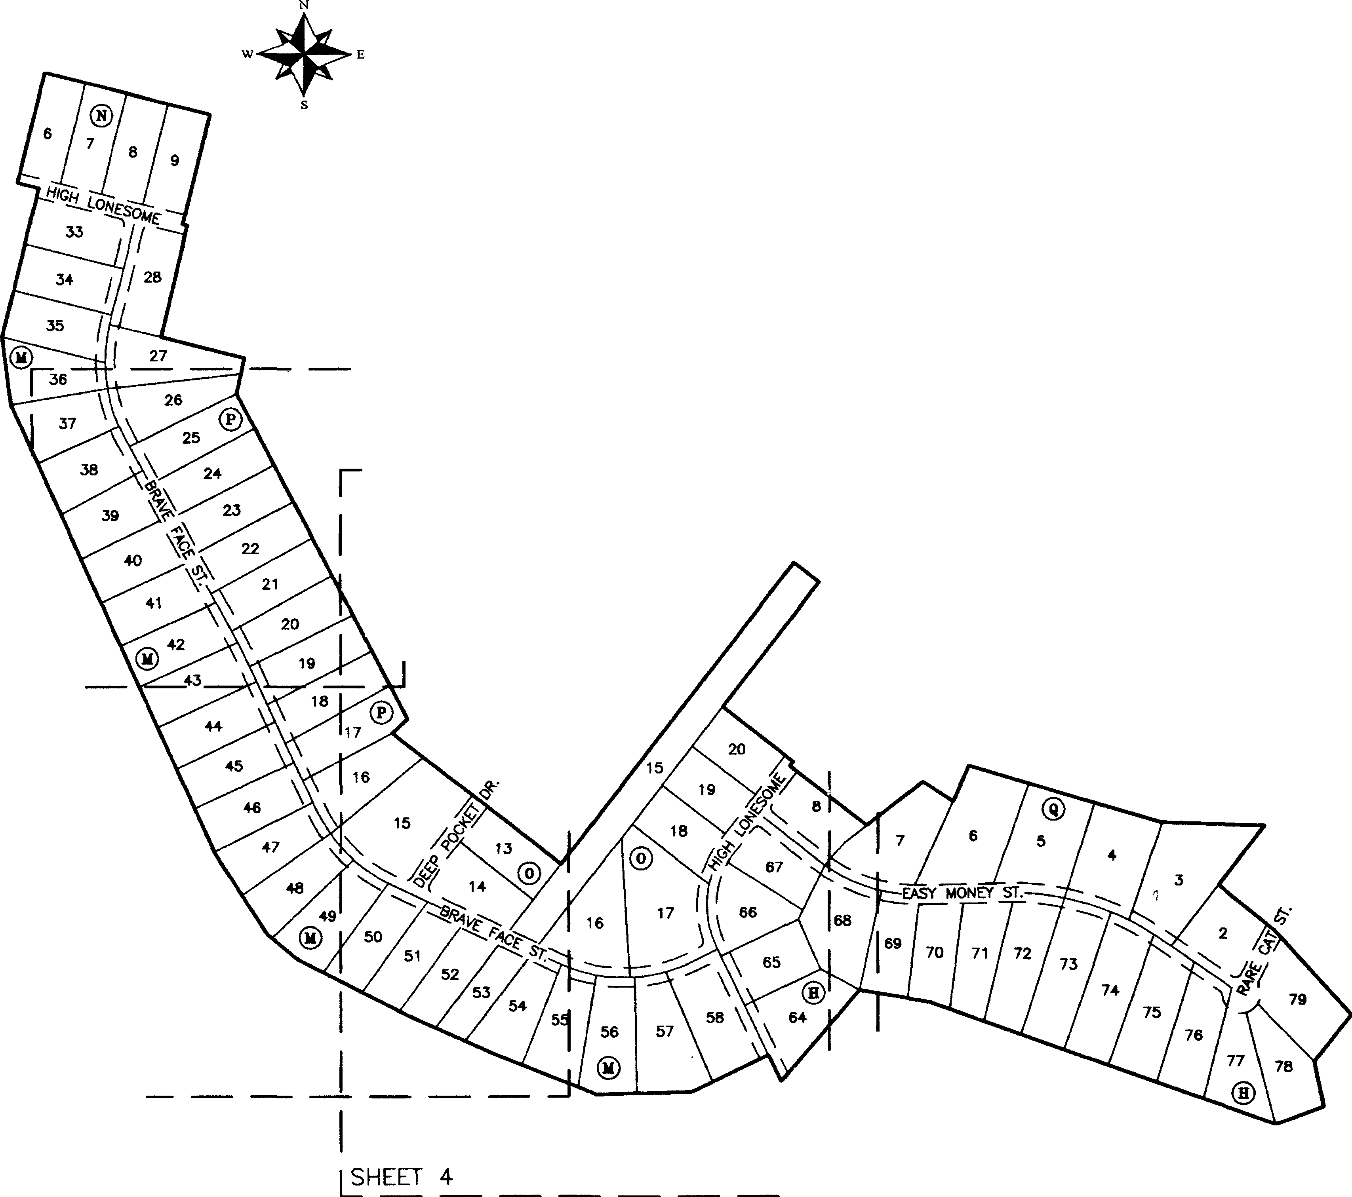RESIDENTIAL: 73

PARK: 2

LINEAR FEET OF NEW STREETS (PRIVATE): HIGH LONESOME: 1,534

BRAVE FACE STREET: 3,493

DEEP POCKET DRIVE: 364 EASY MONEY STREET: 1,693 RARE CAT STREET: 227 TOTAL: 7,311

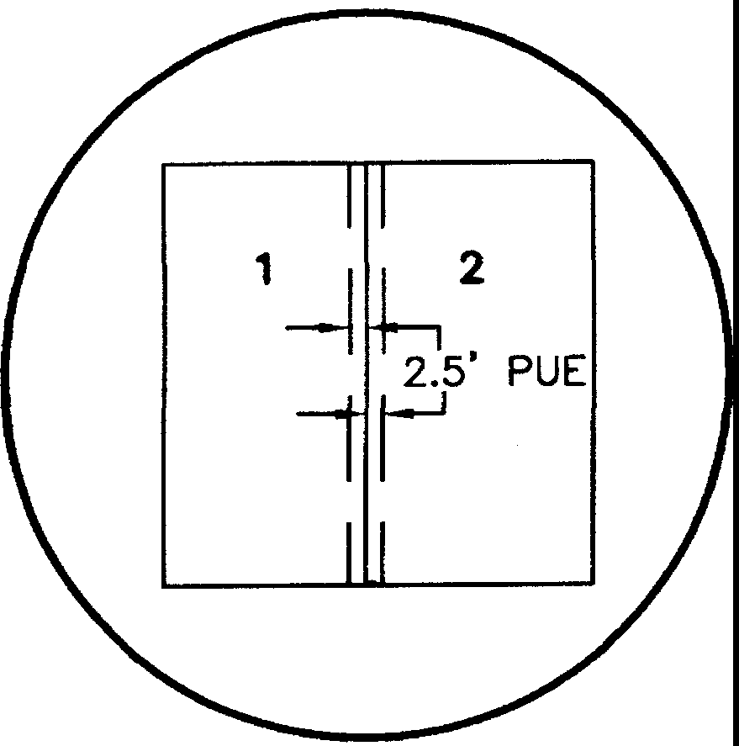

TYPICAL EASEMENT DETAIL (SIDE LOT LINES)

1. N68'26'49"W, A DISTANCE OF 341.63 FEET TO A MAG NAIL FOUND;

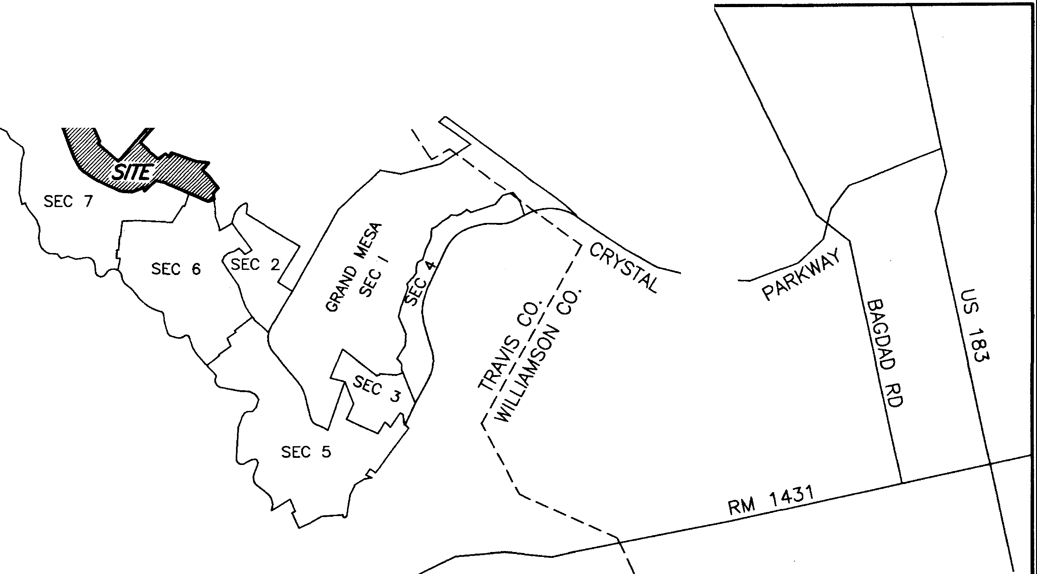

1. N66'01'56"W, A DISTANCE OF 308.81 FEET TO A COTTON SPINDLE FOUND;
2. N62"58'48"W, A DISTANCE OF 385.06 FEET TO AN IRON ROD WITH CAP FOUND;
3. N50' 43'12"'W, A DISTANCE OF 120.19 FEET TO A COTTON SPINDLE FOUND;
4. N32'53'11**"'W, A** DISTANCE OF 309.38 FEET TO AN IRON ROD WITH CAP FOUND;
5. N24'25'52''W, A DISTANCE OF 1546.68 FEET TO AN IRON ROD WITH CAP FOUND;
6. N0715'55"'W, A DISTANCE OF 215.60 FEET TO AN IRON ROD WITH CAP FOUND;
7. N13"58'08"'E, A DISTANCE OF 480.00 FEET TO AN IRON ROD WITH CAP FOUND;
8. N76"01'52"W, A DISTANCE OF 69.51 FEET TO AN IRON ROD **WITH** CAP FOUND;
9. Nl 3'58'08"E, A DISTANCE OF 358.60 FEET TO THE POINT OF BEGINNING, CONTAINING AN AREA OF 96.278 ACRES OF LAND, MORE OR LESS.

L:\13152-GRAND MESA SECTION 8\dwg\13152_GR-PLAT-8-1.dwg 3/19/2015 8:13:22 AM CDT

HEET 3

I I

'_J

I

I

I I I I

SHEET 1 OF 7

N.T.S.

***&;=t***

***SURVEYING, LLC***

*1805 OUIDA DR*

*AUSTIN, TEXAS 78728*

*PHONE: (512) 267-7430*

*FAX: (512) 836-8385*

**1,01€>ooon**

**FINAL PLAT OF**

**37**

i 47214 I

**GRAND**

**MESA AT CRYSTAL SECTION 8, PHASE**

N

s

1''=100'

**FALLS**

**1**

**11,**

0 50

100

200

400

BEARING BASIS:TEXAS CENTRAL ZONE, STATE PLANE COORDINATES (NAO 83)

I 48479 I

**40**

I 48150I

**22**

I 48226I

23

'-"·

**42**

j 47695 J

22

()

b,\

REMAINDER OF 1013.55 AC. (TRACT **1)**

'G •-,ti

,._6':> *b. G*9J'o

*'!)\.*

LOOKOUT PARTNERS, L.P. DOC. 2000162836

*p*

*CANDELARIA YBARBO SURVEY 422*

21

\

*I*

®

/

*I*

*\>* / *I*

\ \ **20** /

\ *\>//*

/ \)\ \ 19 /

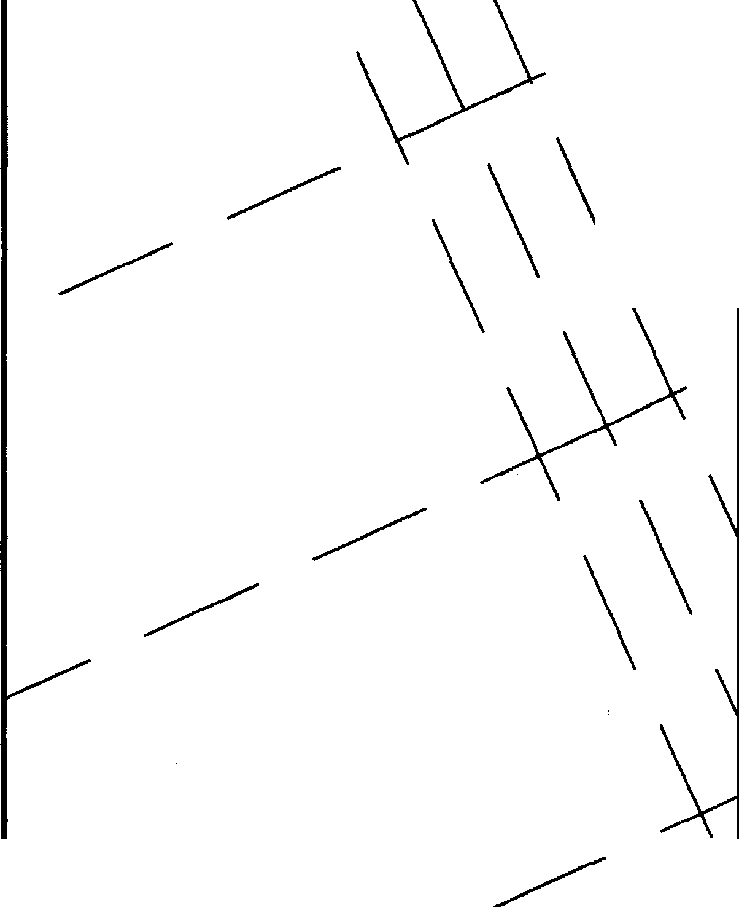

\

//

/

**15**

11031301

18

*N=10172711.3•>_.-:-:*

/

*£=3058643.0*

17

\\ \

16

/.RAND MESA AT CRYSTAL FALLS II SECTION 7

DOC. 20130001/

15

/



\ **66** \ \

14

65 \ %*//\x/* / *I*

*A*/ \\\ / " *I I*

/,// ;< *I* 12 *I I*

& / **11**

*I*

*I*

/

*s :a E'/:; ,0 LC I* y " '--.

*I*

/

*AUSTIN, TEXAS 78728* "---- 9

*PHONE: (512) 267-7430* /

**54**

j49668 I

**55**

*FAX· (512) 836-8385* SHEET 3 OF 7 45

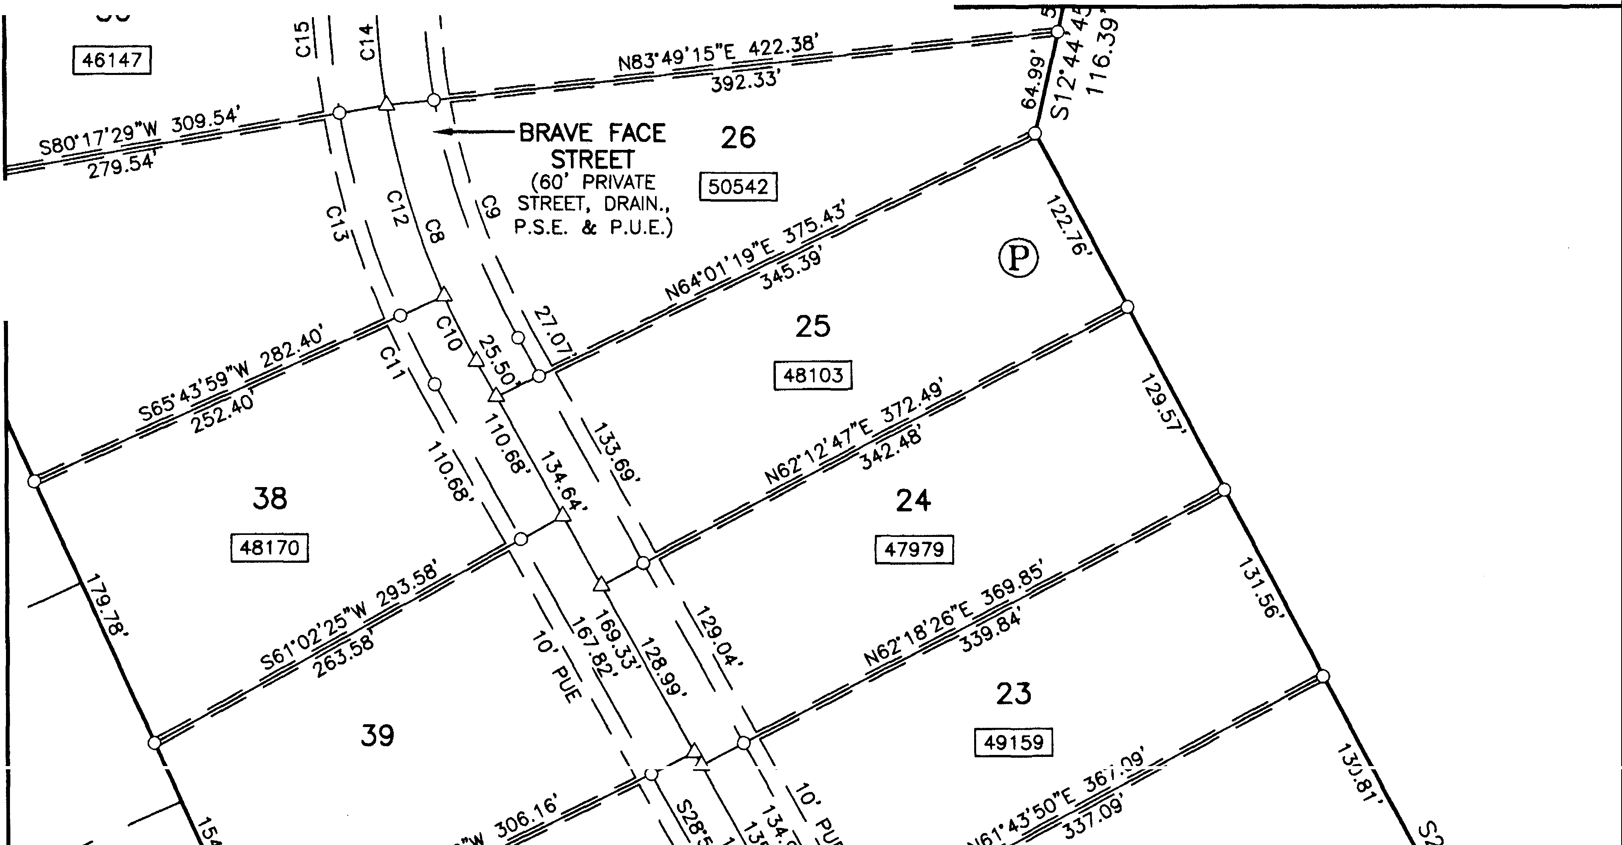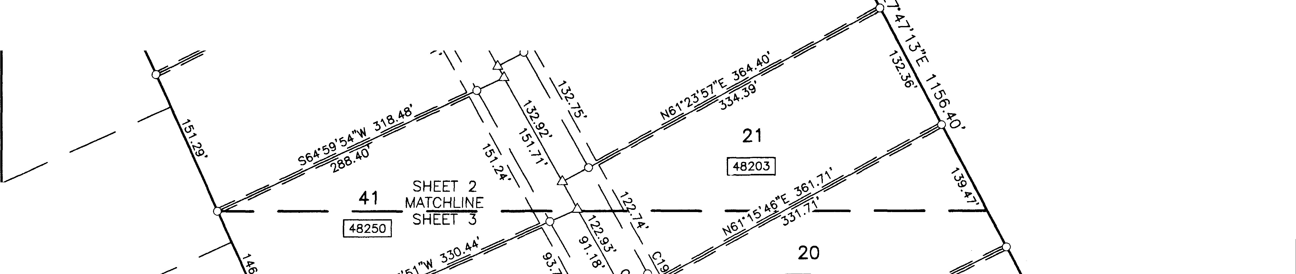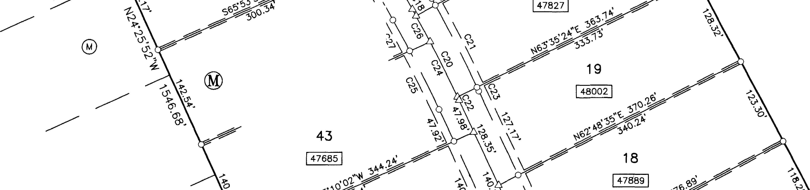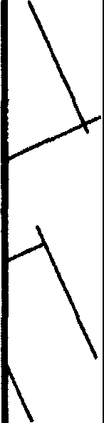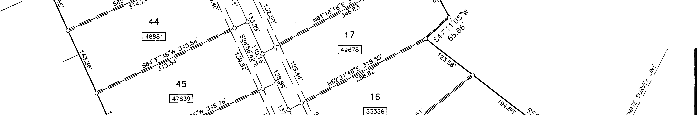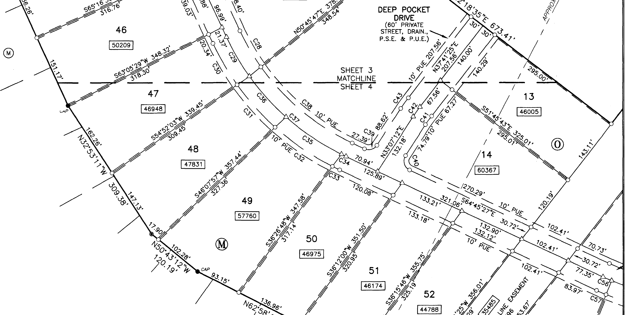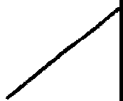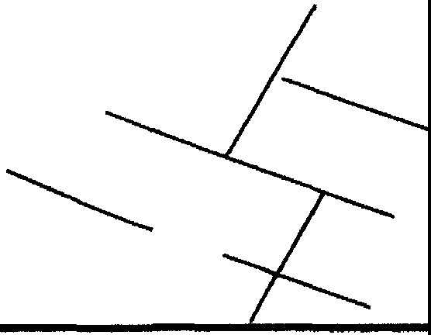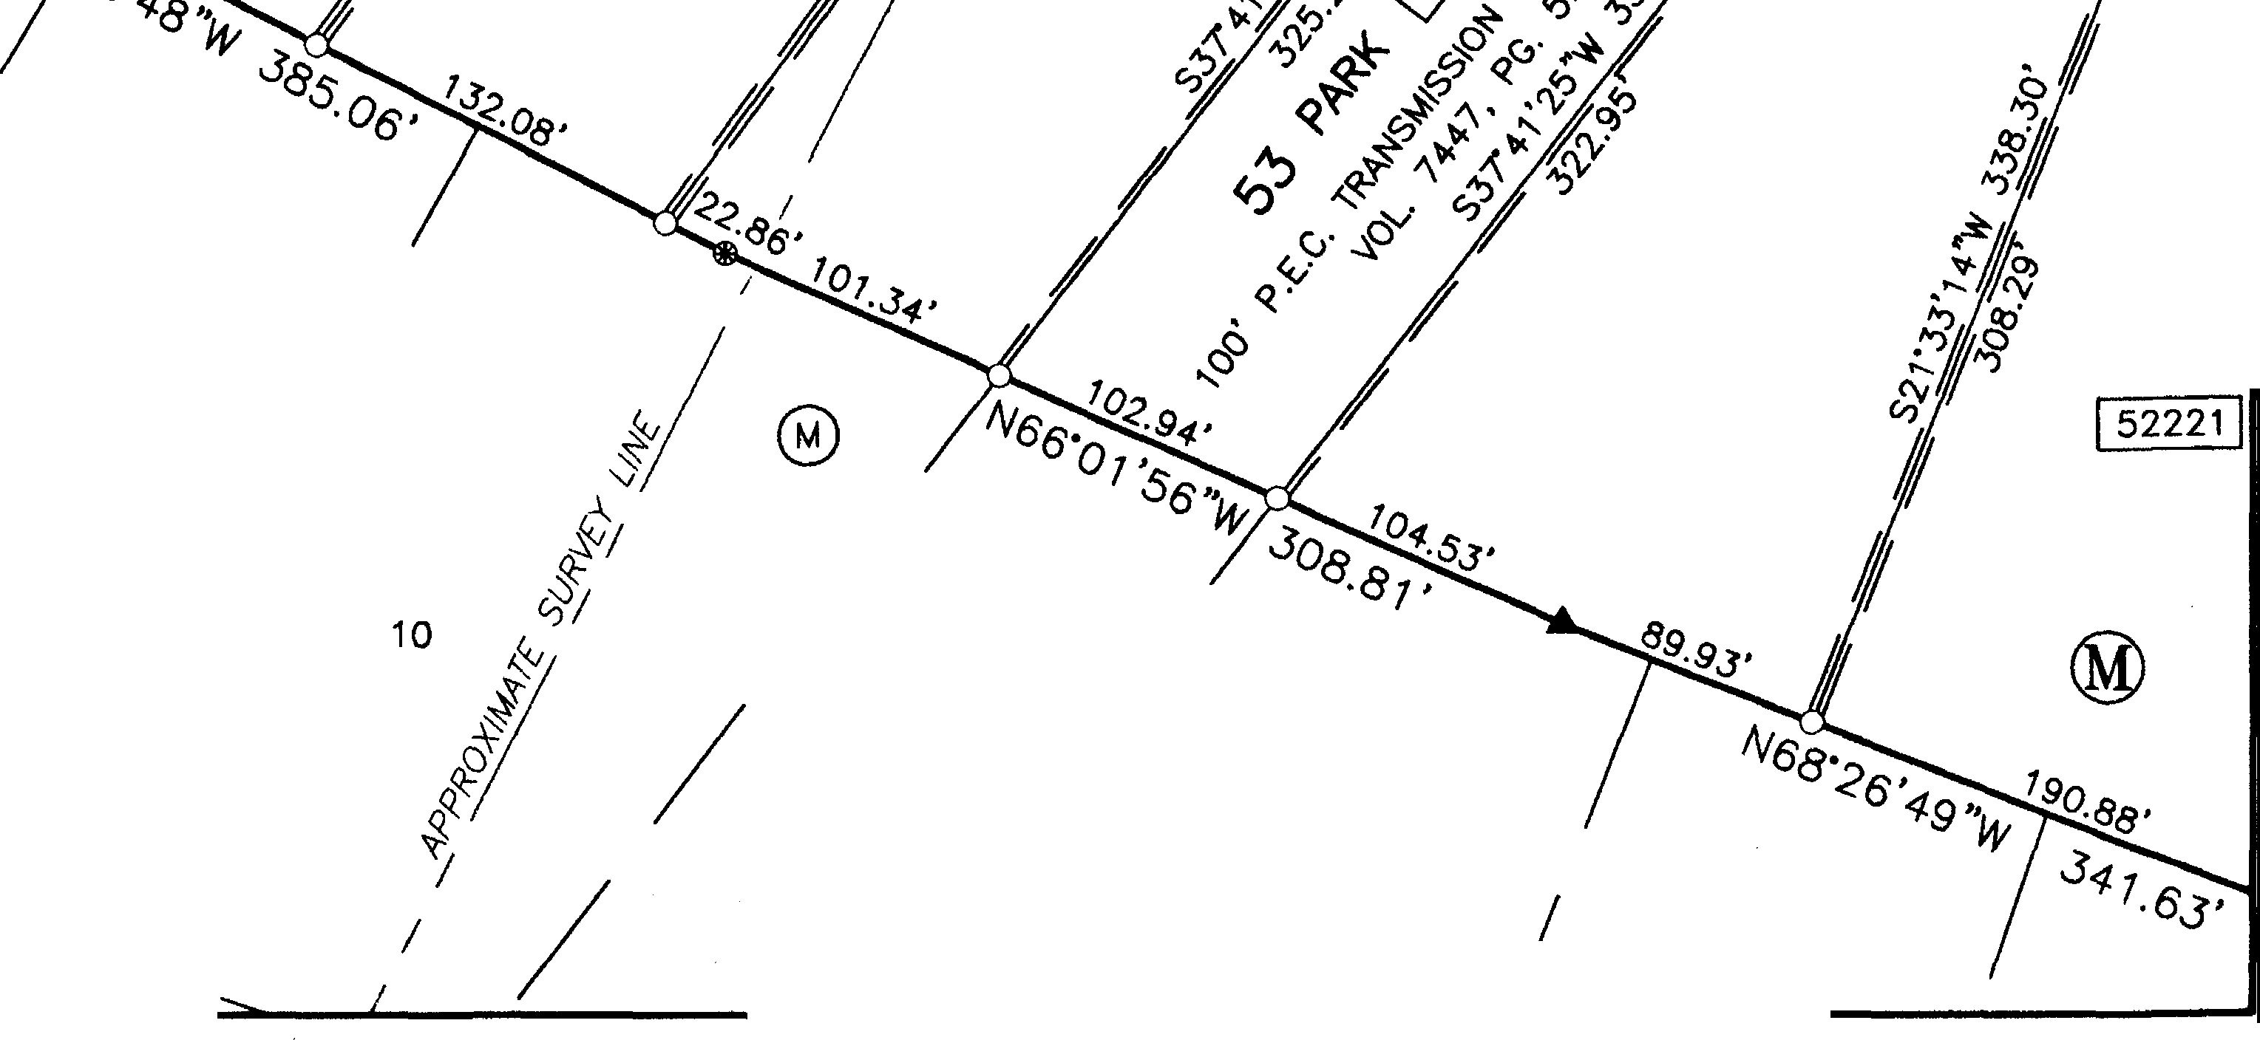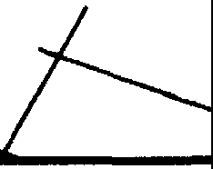

L,\13152-GRAND MESA SECTION 8\dwg\13152_GR-PLAT-8-1.dwg 3/19/2015 B,13,22 AM CDT

-------

-------

/ 8

*MCKINNEY* & *WILLIAMS SURVEY 175*

S.S. *[VANS SURVEY 501*

*I*

**GRAND**

**FINAL**

**MESA AT**

**PLAT OF**

**CRYSTAL**

**FALLS**

**11,**

12.346 AC.

*I*

, PHILIP R. HAMILTON

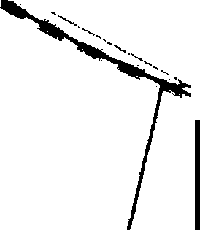' . DOC. 2001060263

""''°'°

*I*

, *-?o--t*

/,.i,,...,

*--,;-c'*

*I* **SECTION**

*I*

*I*

**8, PHASE 1**

**N**

*Su;;,*

*vcr*

*I*

*I I*

*I*

*I*

*<'1)/c'*

®

2.60 AC. RIDGE CONSTRUCTION

& DEVELOPMENT, LLC DOC. 2004204049

*I*

*TEXAS MEXICO RAILROAD* CO. *SURVEY 203*

0 50

E

s

1"=100'

100 200

400

*I* 2 *I*

*I*

3 *I*

**4**

*I*

*I*

*I*

5

### --- *I*

*I* BEARING BASIS:TEXAS CENTRAL ZONE,

STATE PLANE COORDINATES (NAO 83)

127.030 AC. (TRACT 2) DOUGLAS D. HOOD

VOL. 12189, PG. 1339

,_ --..........,_- *l*

*c.'i'*•*c*• ..,*1n,,u llS* -

... - -

-----

----------

*--f* ---

-----

-

*MCKINNEY* & *WILLIAMS SURVEY 175*

-----

----- " '

32

31

®

-----

**34**

I 480601

0co

·

C) ***.s***

**(I:)**

•

*::*0)*;* .0

*C*• *\/*

REMAINDER OF 1013.55 AC. (TRACT 1)

,._

*.C\/*

30 I'<)

LOOKOUT PARTNERS, L.P. DOC. 2000162836

-----

-----

**35**

I 48706 j

*CANDELARIA YBARBO SURVEY 422*

29

*I*

GRAND MESA AT CRYSTAL FALLS II SECTION 7

DOC. 201300054

28

t_v.

(J1

*CAP*

**37**

1472141

76

1481501

75

***SURVEYING, LLC***

*1805 OUIDA DR*

*AUSTIN, TEXAS 78728*

*PHONE: (512) 267-7430*

*FAX: (512) 836-8385*

@

22

SHEET 2 OF 7

L,\13152-GRAND MESA SECTION 8\dwg\13152-GR-PLAT-8-1.dwg 3/19/2015 8,13,22 AM CDT **43**

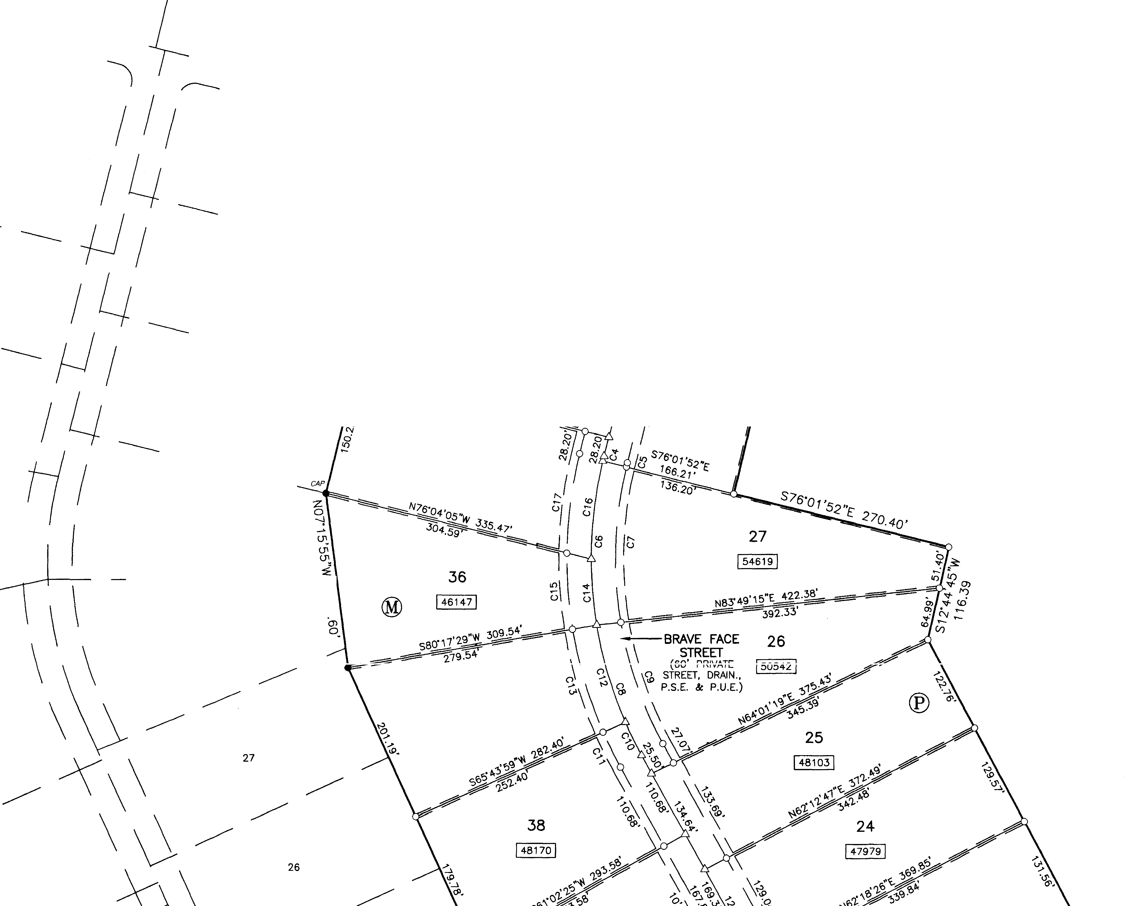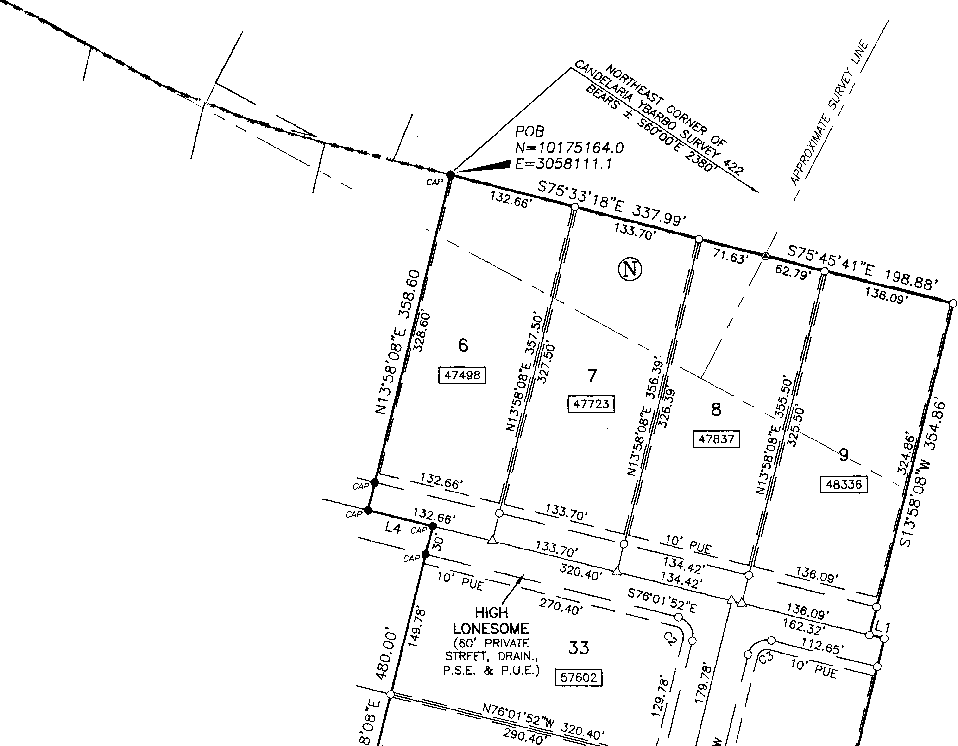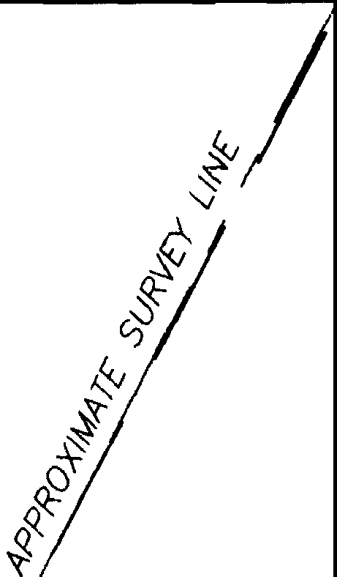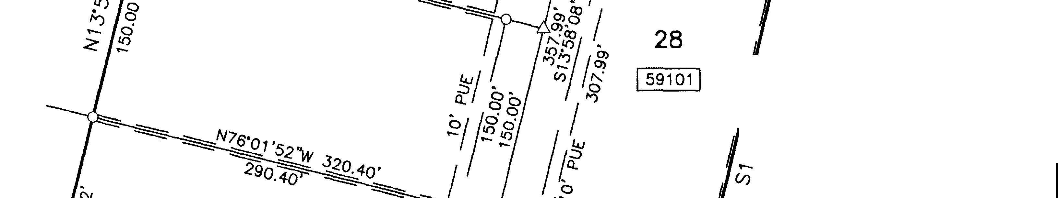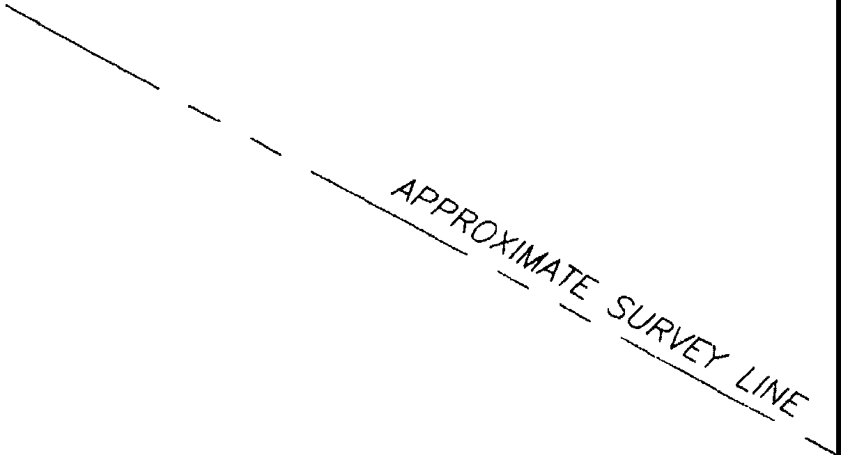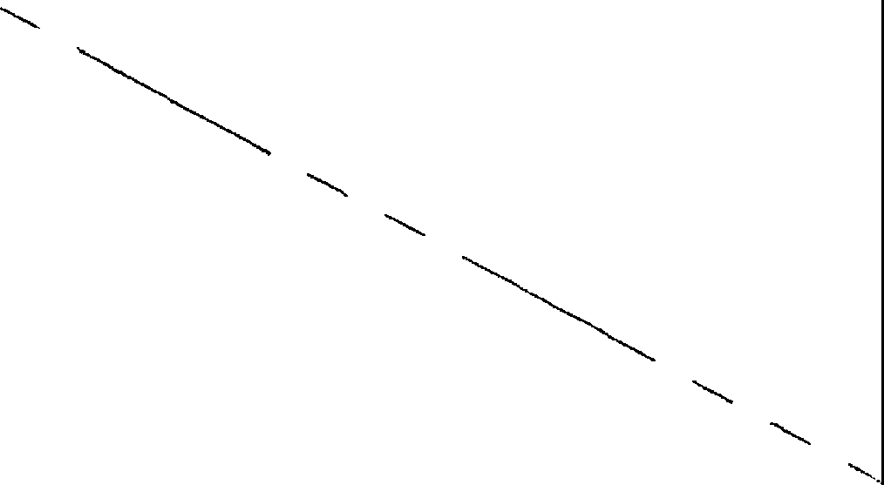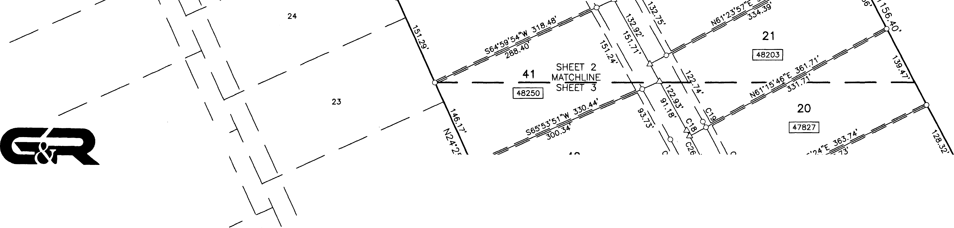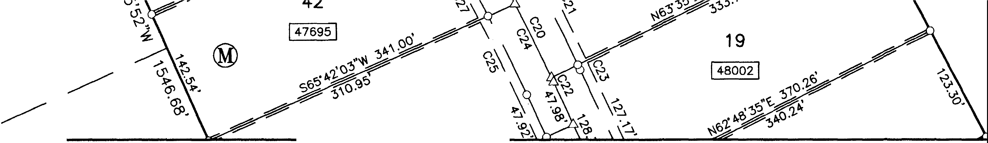

**FINAL PLAT OF**

**GRAND MESA AT CRYSTAL SECTION 8, PHASE**

N



s

1"=100'

**FALLS**

**1**

**11,**

*I*

*I*

*I*

*I*

REMAINDER OF 1013.55 AC. (TRACT 1) LOOKOUT PARTNERS, L.P.

*I* DOC. 2000162836

*I*

*I*

*MCKINNEY* & *WIL.L/AMS SURVEY 175*

*I*

*I*

*N=10173623.3 ­*

*I*

E=3060470.8

0 50 100

200

*I*

400 *I*

*I*

BEARING BASIS:TEXAS CENTRAL ZONE, STATE PLANE COORDINATES (NAD 83)

*I*

*I*

*I*

REMAINDER OF 1013.55 AC. (TRACT 1)

*I*

LOOKOUT PARTNERS, L.P. *I*

*I*

DOC. 2000162836

*CANOELAf?IA YBARBO SURVEY 422*

*I*

*I*

® *I*

7 *I*

*I*

**16**

I 53356 I

15

11037301

**PARK**

I1483ooj

*PA* GL.OSSOM *SURVEY*

8

1519971

*I*

*I*

*I*

*I*

**54**

I 49668 I

*I*

*I*

*I*

9

*I*

56

I56609 J

**64**

I 60762 I

*I*

63

*I*

***SURVEYING, LLC***

*MCKINN[* Y: *WILLIAMs/suRV£Y* 175

*I* 7 *I*

*I*

------ *I* 6

--------------

\

*I*

128.47'

*CAP*

*I*

*I*

173.70' \ *I*

\

\

**4** \ 3 \

2

*1805 OUIDA DR*

-------

--------------

*--i_ I I*

*AUSTIN, TEXAS 78728*

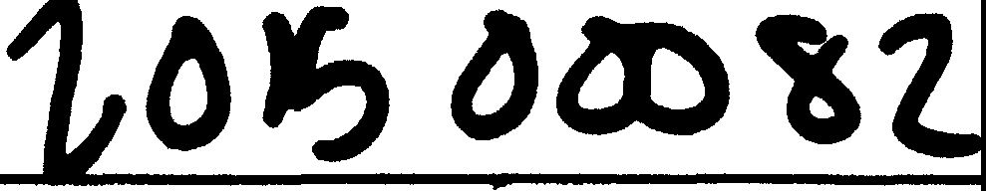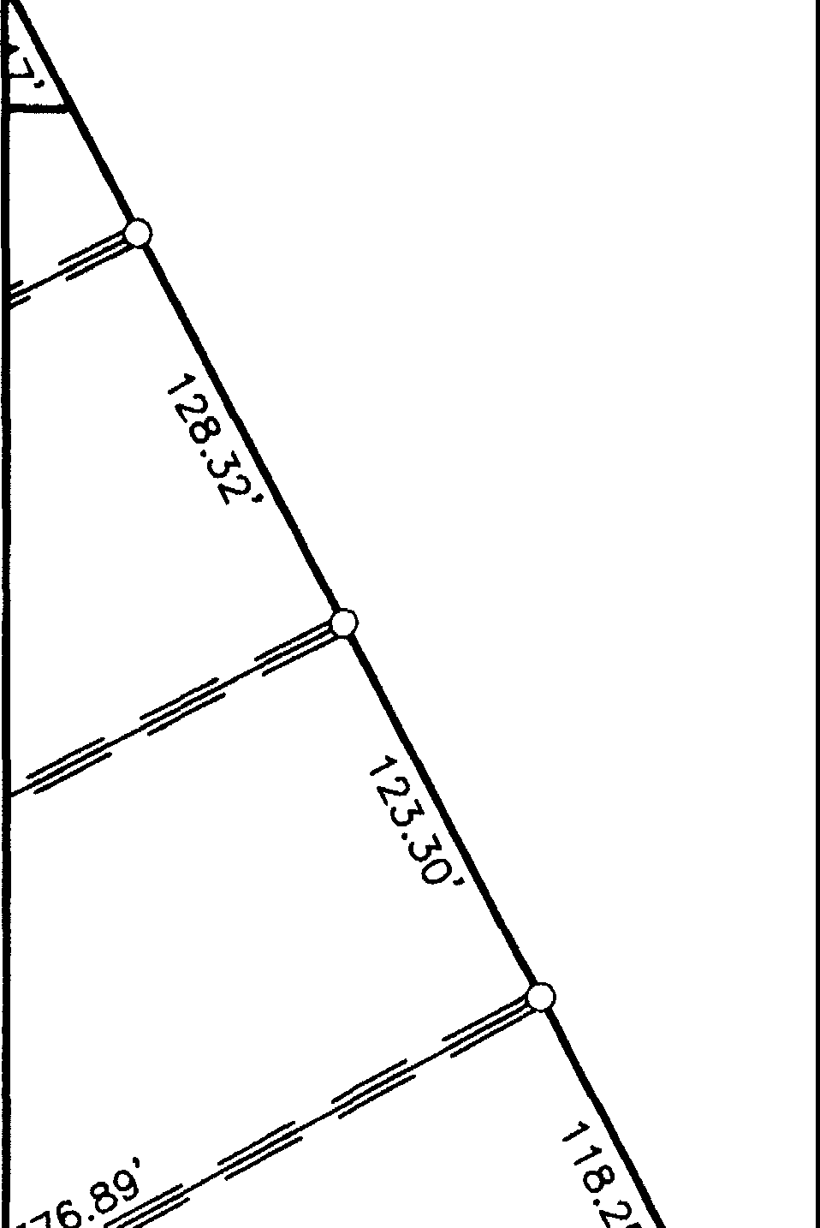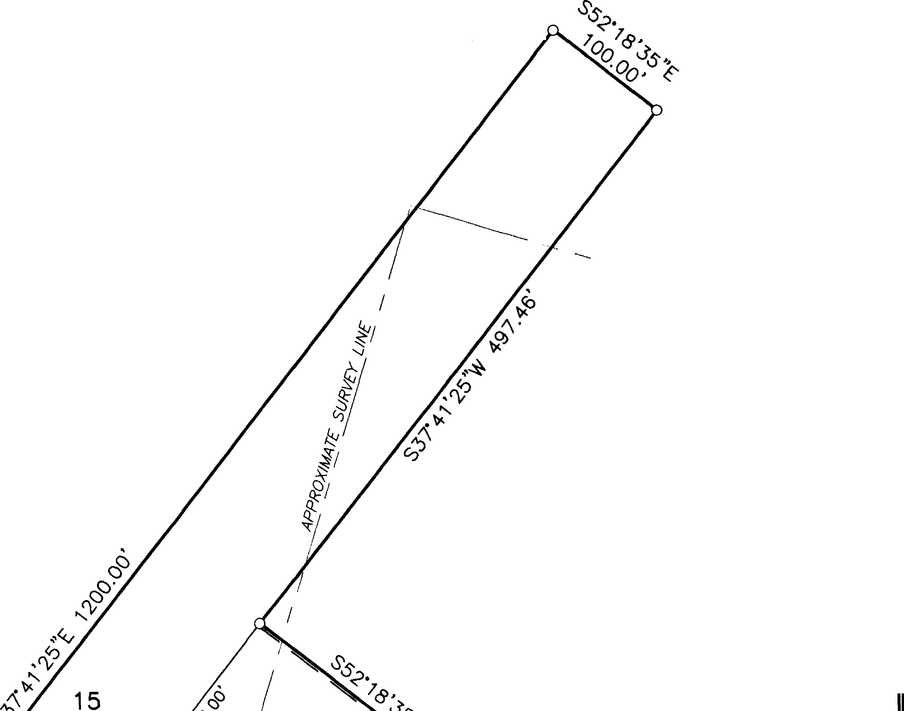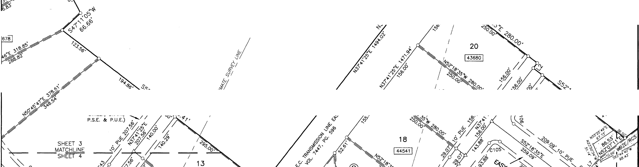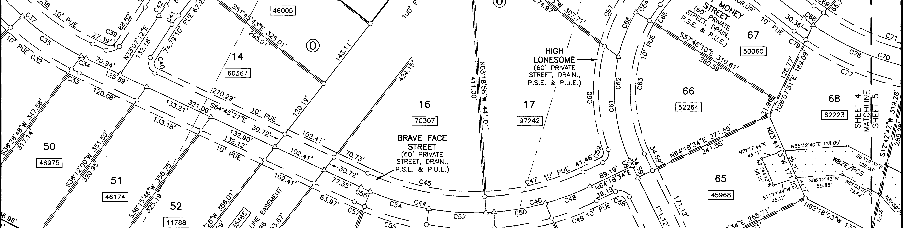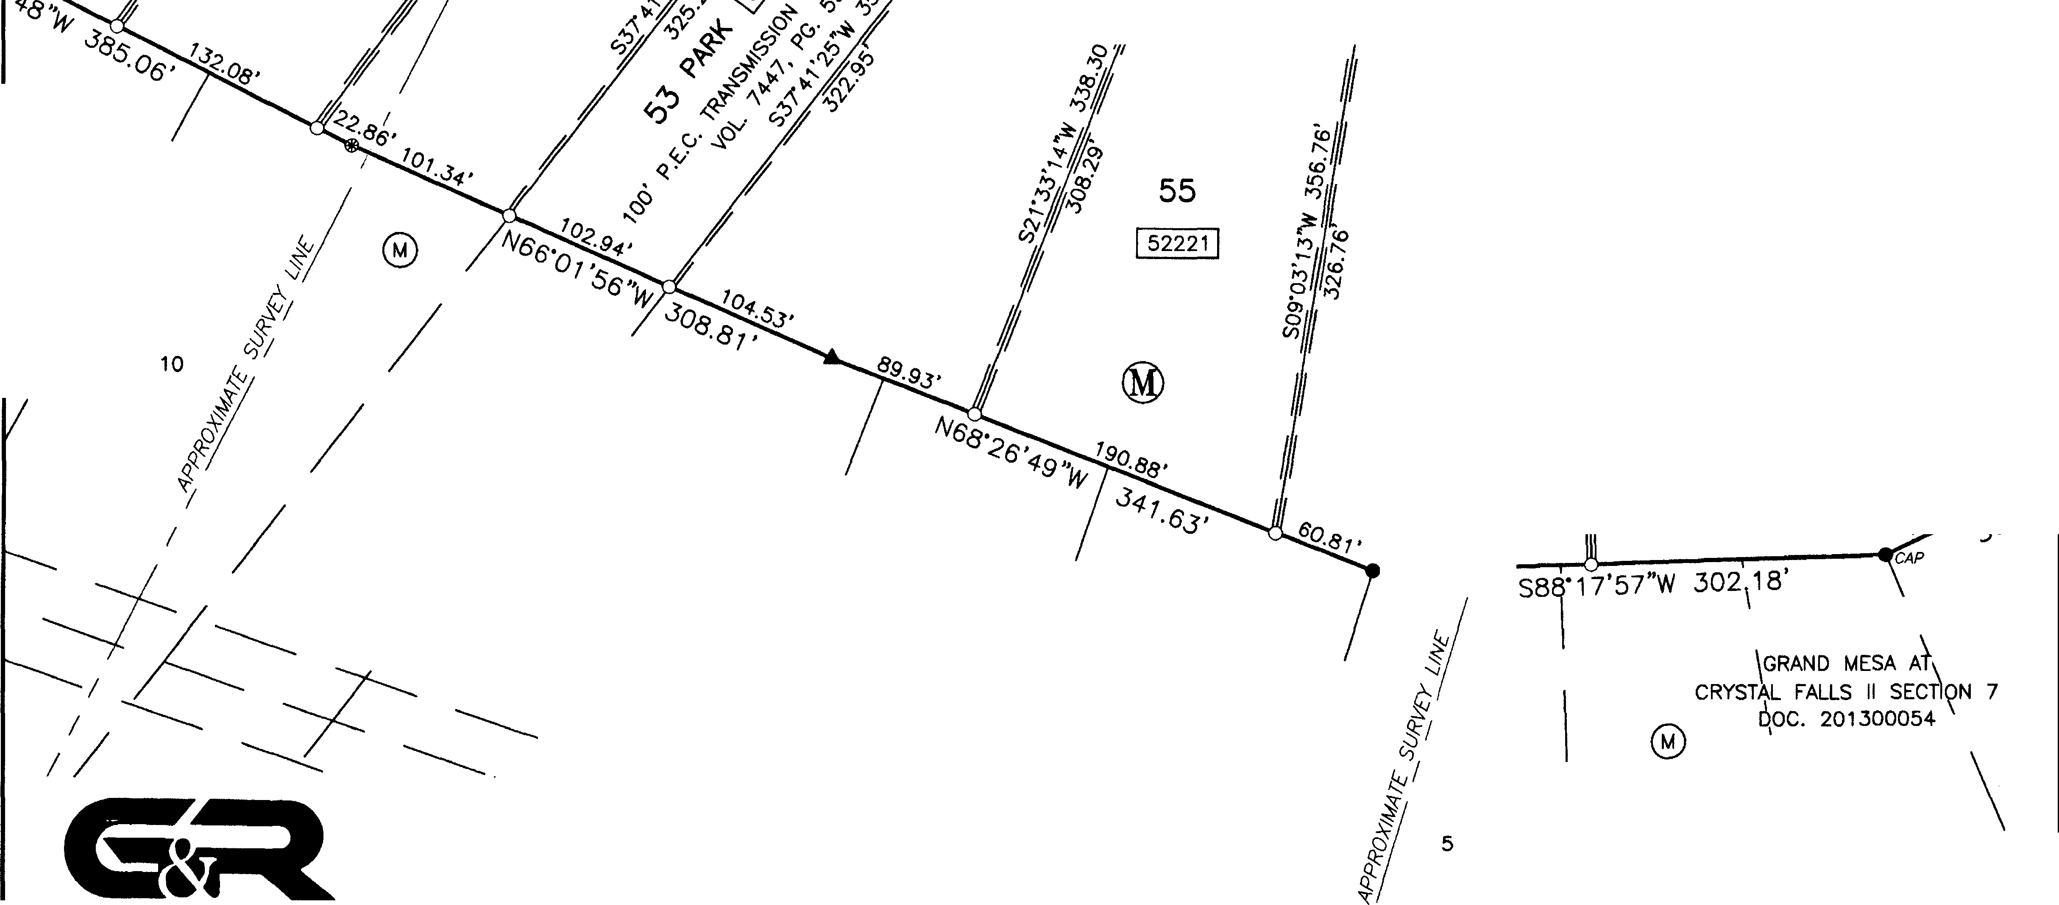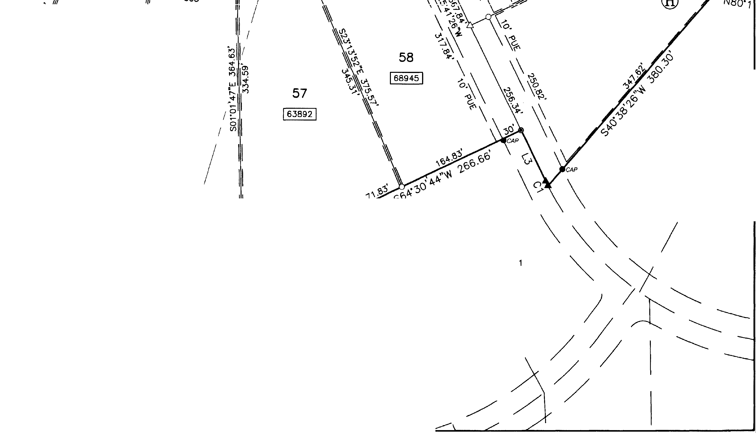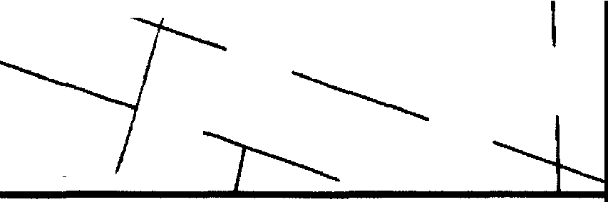

*PHONE: (512) 267-7430*

*FAX: (512) 836-8385* SHEET 4 OF 7

L\13152-GRAND MESA SECTION 8\dwg\13152-GR-PLAT-6-1.dwg 3/19/2015 6:13:22 **AM** CDT

------- *---:J---*-*I* ,

*I* ------- \

.. •"'"'

**N**

**GRAND**

**FINAL PLAT OF MESA AT CRYSTAL SECTION 8, PHASE**

- ­

**FALLS**

**1**

*MCKINNEY* & *WILLIAMS SURVEY 175*

--...

, --...----

I

' ·--------------

REMAINDER OF 1013.55 AC. (TRACT **1)** LOOKOUT PARTNERS, L.P.

DOC. 2000162836

s

1"=100'

400

*PA* GLOSSOM *SURVEY*

REMAINDER OF 1013.55 AC. (TRACT 1) LOOKOUT PARTNERS, L.P.

DOC. 2000162836

*I I I*

***o*** ..".) *:.._* . l • • *1****ff****5****o*** *'1:*

*'-r-* 0, "v "' *1.*

" ,., ••• •O,• •••• *·"?.*

*I* ***}11"6' V-l>***

*.****:J****.* ***60***

***Cl)"* ...._**

*·fY* .. .. .. *.. ·Oo..*

63 GRAND MESA AT / . . ' . . ' . ' ' .

CRYSTAL FALLS II SECTION 7 DOC. 201300054

• .• .• .•

.•

.• •.•.• .• .• .•

..• •.*s>*.*.1'4*

*I*

*I* 62 *I*

• • • • •. •. • •. • • . •. •. • •.*•'.7 0-82.'*

....... ' ...

*I I*

. *'#BZ[/RCS.* . . . . ·*ss,..;*

* . . • • . ' • • • • • ..J>... J.'..

. . . . . .

61

·@. . . ... ''*<!'*

. . '

***6'>****·O*

*I I I*

*I*

60 *I*

59 *I I*

*I*

*I I*

. ..

' . . ' . . .

\

.. ' *'i.*

co-01 1

---

*I I*

---

58

57

GRAND MESA AT '\ i

DOC. 200800122 *[=3062137.4*

\

---

31

*I I*

30

*I I*

*I I* 29

------------

*I*

*I*

*I*

------

*I* 56

*I* /i

*I* 55

/

/

54

28

® *I I I*

*I I I*

\

\

\

\

53 \

*-{*

J

/

& 52

***SURVEYING, LLC***

*1805 OUIDA DR*

*AUSTIN, TEXAS 78728*

*PHONE: (512) 267-7430*

*FAX: (512) 836-8385*

6

SHEET 5 OF 7

-----

49

©

*I*

t.,\13152-GRANO MES• SECTION 8\dwg\13152-GR-PLAT-8-1.dwg 3/19/2015 8:13:22 AA! CDT

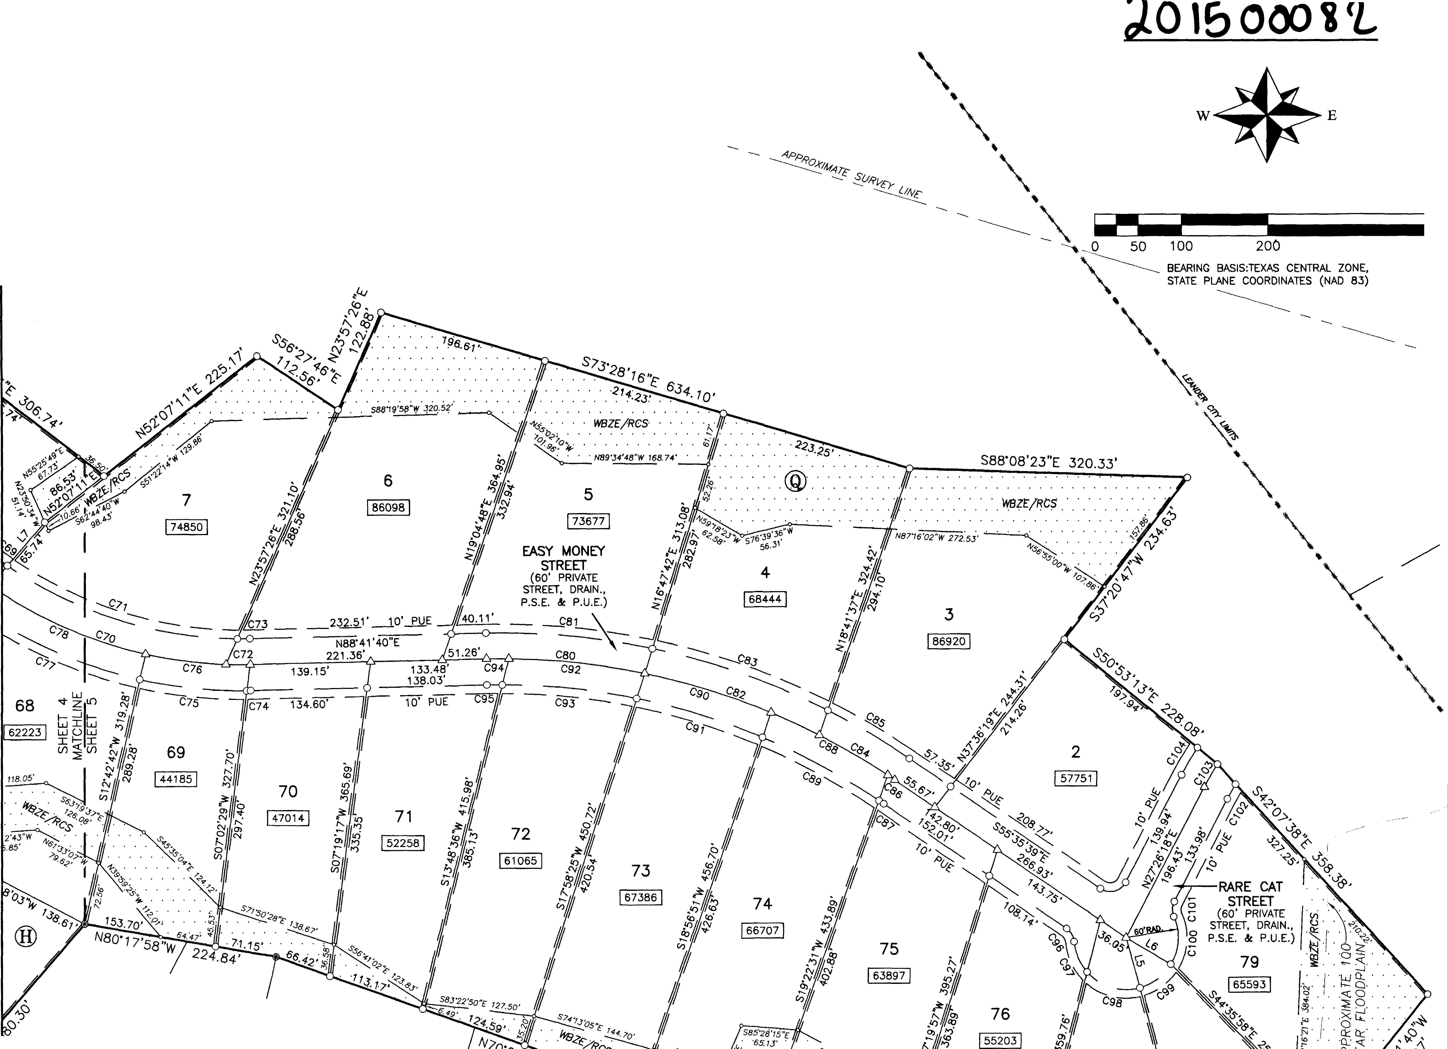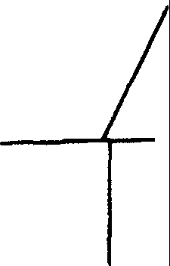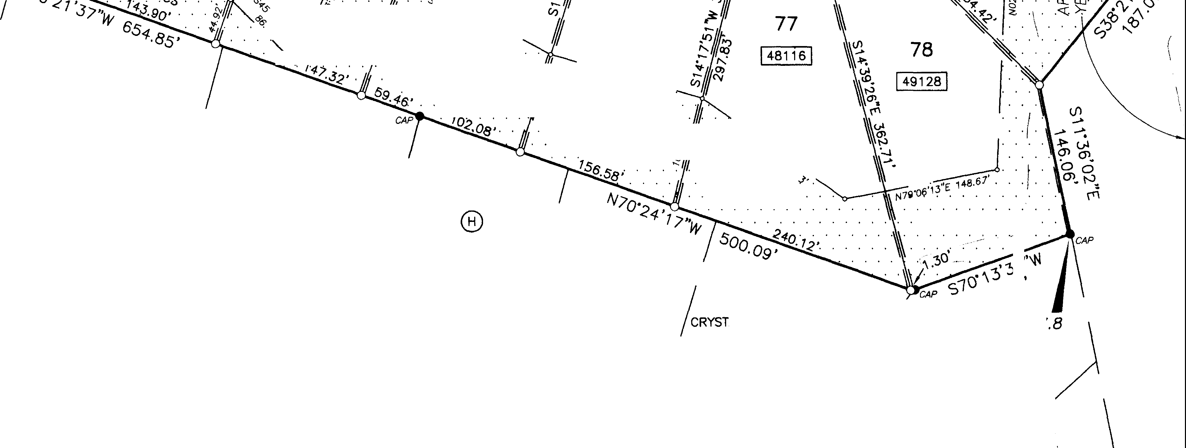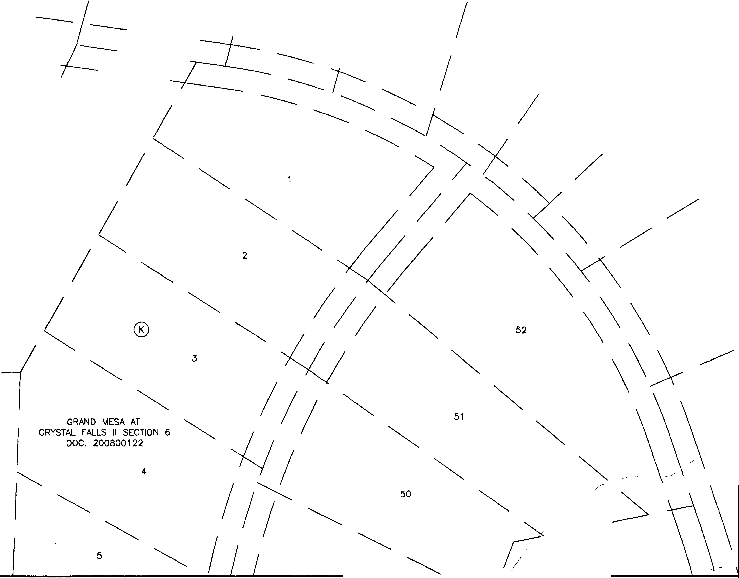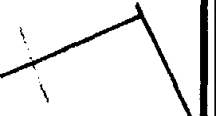

**GRAND**

**FINAL MESA AT SECTION**

**PLAT OF CRYSTAL 8, PHASE**

**FALLS**

**1**

**11,**

|  |  |  |
| --- | --- | --- |
| LINE TABLE | | |
| NUMBER | DIRECTION | DISTANCE |
| L1 | S76'01'52"E | 15.37' |
| L2 | S37'41'25"W | 17.19' |
| L3 | N25'41'26"W | 83.98' |
| L4 | N76'01'52"W | 69.51' |
| L5 | S15'18' 49"E | 60.00' |
| L6 | S59'05'04 "E | 60.00' |
| L7 | N40'37'04"E | 95.88' |
| LB | N25'41'26"W | 10.23' |

**&;:t**

***SURVEYING, LLC***

*1805 OUIDA DR*

*AUSTIN, TEXAS 78728*

*PHONE: (512) 267-7430*

*FAX- (512) 836-8385*

SHEET 6 OF 7

|  |  |  |  |  |  |  |
| --- | --- | --- | --- | --- | --- | --- |
| CURVE TABLE | | | | | | |
| NO. | DELTA | RADIUS | ARC | CHORD BEARING | CHORD | TANGENT |
| C1 | 1'00'46" | 430.00' | 7.60' | S26'11'50"E | 7.60' | 3.80' |
| C2 | 90'00'00" | 20.00· | 31.42' | N31'01'52''W | 28.28' | 20.00' |
| C3 | 90'00'00" | 20.00' | 31.42' | S58'58'08"W | 28.28' | 20.00· |
| C4 | 0·12·22· | 500.00' | 1.80' | S13'51'57"W | 1.80' | 0.90' |
| C5 | 0'13'09" | 470.00' | 1.80' | S13'51'34"W | 1.80' | 0.90' |
| C6 | 23'12'23" | 500.00' | 202.51' | s02•09•35•w | 201.13' | 102.66' |
| C7 | 23'24'07" | 470.00' | 191.97' | S02'02'55"W | 190.64' | 97.34' |
| ca | 19'30'58" | 500.00' | 170.31' | S19'12'06"E | 169.49' | 85.99' |
| C9 | 19'18'27" | 470.00' | 158.38' | S19'18'21 "E | 157.63' | 79.95' |
| C10 | 5'12'48" | 500.00' | 45.49' | S26'21'11 "E | 45.48' | 22.76' |
| C11 | 5·11·02· | 530.00' | 47.95' | S26'22'04"E | 47.93' | 23.99' |
| C12 | 14'18'10" | 500.00' | 124.82' | S16'35'42"E | 124.49' | 62.73' |
| C13 | 14'19'02" | 530.00' | 132.44' | S16'37'02"E | 132.09' | 66.57' |
| C14 | 9'18' 49" | 500.00' | 81.28' | S04'47'12"E | 81.19' | 40.73' |
| C15 | 10'08'22" | 530.00' | 93.79' | S04'23'20"E | 93.67' | 47.02' |
| C16 | 14'05'56" | 500.00' | 123.04' | S06"55'10"W | 122.73' | 61.83' |
| C17 | 13'17'17" | 530.00' | 122.92' | S07'19'30"W | 122.64' | 61.74' |
| C18 | 0"17'41" | 2000.00' | 10.28' | N28'48'45"W | 10.28' | 5.14' |
| C19 | o·17'37" | 2030.00' | 10.40' | N28"48'47"W | 10.40' | 5.20' |
| C20 | 3'34'28" | 2000.00' | 124.77' | N26'52' 40"W | 124.75' | 62.40' |
| C21 | 3'33'21" | 2030.00' | 125.99' | N26'53'18"W | 125.97' | 63.01' |
| C22 | 0"08'38" | 2000.00' | 5.02' | N25'01 '08"W | 5.02' | 2.51' |
| C23 | 0'09' 48" | 2030.00' | 5.79' | N25'01 '43"W | 5.79' | 2.89' |
| C24 | 2'33'43" | 2000.00· | 89.42' | N26'13'40"W | 89.42' | 44.72' |
| C25 | 2'36'39" | 1970.00' | 89.77' | N26'15'08"W | 89.76' | 44.89' |
| C26 | 1'27'03" | 2000.00' | 50.65' | N28' 14'03"W | 50.65' | 25.33' |
| C27 | 1"24'07" | 1970.00' | 48.21' | N28'15'31 "W | 48.20' | 24.10' |
| C28 | 10'16'18" | 470.00' | 84.26' | S30'04'58"E | 84.15' | 42.24' |
| C29 | 10'30'47" | 500.00' | 91.74' | S30'12' 13"E | 91.62' | 46.00' |
| C30 | 10'29'40" | 530.00' | 97.08' | S30'11'39"E | 96.94' | 48.67' |
| C31 | 12'29'19" | 530.00' | 115.52' | S41'41'09"E | 115.29' | 57.99' |
| C32 | 15'04'32" | 530.00' | 139.45' | S55'28'05"E | 139.05' | 70.13' |
| C.33 | 1'45'06" | 5.30.00' | 16.20' | S63'52'54 "E | 16.20' | 8.10' |
| C34 | 1·10'44" | 500.00' | 10.29' | S64'10'05"E | 10.29' | 5.14' |
| C.35 | 15'24'15" | 500.00' | 134.43' | S55'52'36"E | 134.02' | 67.62' |
| C36 | 12'42'52" | 500.00' | 110.95' | S41'49 '02"E | 110.73' | 55.71' |
| C37 | 29'17'51" | 500.00' | 255.67' | S50'06' 32"E | 252.89' | 130.69' |
| C38 | 29'32'20" | 470.00' | 242.31' | S49'59' 17"E | 239.63' | 123.91' |
| C39 | 82'07'21" | 20.00' | 28.67' | N74'10'53"E | 26.27' | 17.42' |
| C40 | 97'52'39" | 20.00' | 34.17' | S15'49'07"E | 30.16' | 22.96' |
| C41 | 4'34'13" | 270.00' | 21.54' | S35'24'18'W | 21.53' | 10.77' |
| C42 | 4'34'13" | 300.00' | 23.93' | S35'24' 18"W | 23.92' | 11.97' |
| C43 | 4'.34' 13" | 3.30.00' | 26..32' | S35'24'18"W | 26.32' | 13.17' |
| C44 | 27'35'01" | 500.00' | 240.71' | S78"32'57"E | 238..39' | 122.74' |
| G4S | 27'31'17" | 470.00' | 225.76' | S78'31'05"E | 223.59' | 11s.1 o· |
| C46 | 23'20'59" | 500.00' | 203.76' | N75"59'03"E | 202.36' | 103.32' |
| C47 | 23'24'43" | 470.00' | 192.05' | N76'00'55"E | 190.72' | 97.38' |
| C48 | 10"18'50" | 500.00' | 90.01' | N69'27'59"E | 89.88' | 45.13' |
| C49 | 9'52'00" | 530.00' | 91.27' | N69'14'34"E | 91.16' | 45.75' |
| C50 | 11·16'54" | 500.00' | 98.45' | N80'15'51"E | 98.29' | 49.39' |
| C51 | 11'54'09" | 530.00' | 110.10· | N80'07'38"E | 109.90' | 55.25' |
| C52 | 14'04'00" | 500.00' | 122.75' | S87'03' 42"E | 122.45' | 61.69' |
| C53 | 13'50'27" | 530.00' | 128.03' | s81·00•03"E | 127.72' | 64.33' |
| C54 | 13'06'15" | 500.00' | 114.36' | S73'28'35"E | 114.11' | 57.43' |
| C55 | 13'04'12" | 530.00' | 120.90' | S73'32'44"E | 120.64' | 60.71' |
| C56 | 2·10·01" | 500.00' | 18.91' | S65'50'27"E | 18.91' | 9.46' |
| C57 | 2•15•11" | 530.00· | 20.84' | S65'53'02"E | 20.84' | 10.42' |
| C58 | 90·00·00" | 20.00' | 31.42' | N70'41'26"W | 28.28' | 20.00' |
| C59 | 83'28'29" | 20.00' | 29.14' | N22'34'19"E | 26.63' | 17.84' |
| C60 | 34'25'21" | 330.00' | 198.26' | S01'57'15"E | 195.29' | 102.22' |
| C61 | 38'33'40" | 300.00' | 201.91' | S06'24'36"E | 198.12' | 104.94' |
| C62 | 55·52•43• | 300.00' | 292.58' | S02'14'55"W | 281.12' | 159.11' |
| C63 | 55'39'06" | 270.00' | 262.25' | S02'08'07''W | 252.06' | 142.51' |
| C64 | 7'30'08" | 300.00' | 39.28' | S.33'56'21 "W | .39.25' | 19.67' |
| C65 | 7·43'45• | 270.00' | 36.42' | S33'49'32"W | 36.40" | 18.24' |
| C66 | 24'49'11" | 300.00' | 129.96' | S25'16'49"W | 128.94' | 66.01' |
| C67 | 22·25'59" | 3.30.00' | 129.20' | S26'28'25"W | 128.38' | 65.44' |
| C68 | 2·25•45• | 500.00' | 21.20' | S53'31'28"E | 21.20' | 10.60' |
| C69 | 2'46'20" | 470.00' | 22.74' | S53'41'45"E | 22.74' | 11.37' |
| C70 | 33'20'21" | 500.00' | 290.94' | S71'24'31 "E | 286.85' | 149.72' |
| C71 | 34'29'04" | 470.00' | 282.88' | S72'19'27"E | 278.63' | 145.87' |
| C72 | 3'13'38" | 500.00' | 28.16' | S89'41'31 "E | 28.16' | 14.09' |
| C73 | 1'44'21" | 470.00' | 14.27' | N89'33'50"E | 14.27' | 7.13' |
| C74 | 0'28'32" | 530.00' | 4.40' | N88'55'56"E | 4.40' | 2.20' |
| C75 | 13'32'30" | 5.30.00' | 125.26' | S84'03'33"E | 124.97' | 62.92' |
| C76 | 14'01'02" | 500.00' | 122.32' | S84'17'49"E | 122.02' | 61.47' |
| C77 | 22·01 •43• | 5.30.00' | 203.77' | S66'16'27"E | 202.52' | 103.16' |
| C78 | 22'32'58" | 500.00' | 196.78' | S66'00'50"E | 195.51' | 99.68' |
| C79 | 2'57'00" | 530.00' | 27.29' | S53'47'06"E | 27.29' | 13.65' |
| C80 | 13'11'21" | 800.00' | 184.16' | N84'42'39"W | 183.75' | 92.49' |
| C81 | 13'22'02" | 8.30.00' | 193.64' | N84'37'19"W | 193.20' | 97.26' |
| C82 | 15'16'54" | 800.00' | 213.37' | N70'28'32"W | 212.74' | 107.32' |
| C83 | 14'47'44" | 830.00' | 214.33' | N70'32'26"W | 213.74' | 107.76' |
| C84 | 7'14'26" | 800.00' | 101.10· | N59'12'52"W | 101.03' | 50.62' |
| C85 | 7'32'56" | 830.00' | 109.35' | N59'22'07"W | 109.27' | 54.76' |
| C86 | 0'42'22" | 800.00' | 9.86' | N55'56'50"W | 9.86' | 4.93' |
| C87 | 0'08'07" | 770.00' | 1.82' | N55'39'43"W | 1.82' | 0.91' |
| C88 | 10'56'30" | 800.00' | 152.77' | N61'46'16"W | 152.54' | 76.62' |
| C89 | 11·21'49" | 770.00' | 152.72' | N61'24'41"W | 152.47' | 76.61' |
| C90 | 10'52'28" | 800.00' | 151.84' | N72'40'45"W | 151.61' | 76.15' |
| C91 | 11'15'41" | 770.00' | 151.34' | N72'43'26"W | 151.1o' | 75.92' |
| C92 | 11·20•19" | 800.00' | 158.32' | N83'47'08"W | 158.06' | 79.42' |
| C93 | 11'37'38" | 770.00' | 156.26' | N84'10'05•w | 155.99' | 78.40' |
| C94 | 1·51 •03• | 800.00' | 25.84' | S89'.37'11 "W | 25.84' | 12.92' |
| C95 | 1·19'26" | 770.00' | 17.79' | S89'21'23"W | 17.79' | 8.90' |
| C96 | 51'19'04" | 20.00' | 17.91' | N29'56'07"W | 17.32' | 9.61' |
| C97 | .37'04'32" | 60.00' | 38.83' | S22'48'51 "E | 38.15' | 20.12' |
| C98 | 63'57'42" | 60.00' | 66.98' | S73'19'58"E | 63.56' | 37.46' |
| C99 | 43'46'15" | 60.00' | 45.84' | N52'48'03"E | 44.73' | 24.10' |
| C100 | 54'47'42" | 60.00' | 57.38' | N03'31'05"E | 55.22' | 31.1o· |
| C101 | 51'19'04" | 20.00' | 17.91' | S01'46'46"W | 17.32' | 9.61' |
| C102 | 4'07'18" | 270.00' | 19.42' | S29'29'57"W | 19.42' | 9.72' |
| C103 | 5'47'30" | 300.00' | 30.32' | S30'20'03"W | .30.31' | 15.18' |
| C104 | 6'19'41" | 330.00' | 36.45' | S30'36'08"W | 36.43' | 18.24' |
| C105 | 90'00'00" | 20.00' | 31.42' | S82'41 '25''W | 28.28' | 20.00' |
| C106 | 90•00'00· | 20.00' | 31.42' | S07'18'35"E | 28.28' | 20.00· |



L:\13152-GRAND MESA SECTION 8\dwg\13152-GR-PIAT-8-1.dwg 3/19/2015 8:13:22 **At.I** CDT

PLAT NOTES:

1. THIS SUBDIVISION IS WHOLLY CONTAINED WITHIN THE CURRENT CORPORATE LIMITS OF THE CllY OF LEANDER, TEXAS.
2. NO LOT IN THIS SUBDIVISION SHALL BE OCCUPIED UNTIL CONNECTED TO THE CllY OF LEANDER WATER DISTRIBUTION SYSTEM.
3. A BUILDING PERMIT IS REQUIRED FROM THE CllY OF LEANDER PRIOR TO CONSTRUCTION OF ANY BUILDING OR SITE IMPROVEMENTS ON ANY LOT IN THIS SUBDIVISION.
4. NO BUILDINGS, FENCES, LANDSCAPING OR OTHER STRUCTURES ARE PERMITTED WITHIN DRAINAGE EASEMENTS SHOWN, EXCEPT AS APPROVED BY THE CllY OF LEANDER PUBLIC WORKS DEPARTMENT.
5. PROPERTY OWNER SHALL PROVIDE FOR ACCESS TO DRAINAGE EASEMENTS AS MAY BE NECESSARY AND SHALL NOT PROHIBIT ACCESS BY THE CllY OF LEANDER.
6. ALL EASEMENTS ON PRIVATE PROPERlY SHALL BE MAINTAINED BY THE PROPERlY OWNER OR HIS OR HER ASSIGNS.
7. IN ADDITION TO THE EASEMENTS SHOWN HEREON, **A** TEN (10') FOOT WIDE PUBLIC UTILITY EASEMENT IS DEDICATED ALONG AND ADJACENT TO ALL RIGHT-OF-WAY AND A TWO AND A HALF (2.5') FOOT WIDE PUBLIC UTILllY EASEMENT IS DEDICATED ALONG ALL SIDE LOT LINES (SEE lYPICAL EASEMENT DETAIL).
8. A PORTION OF THIS TRACT IS WITHIN A FLOOD HAZARD AREA AS SHOWN ON THE FLOOD INSURANCE RATE MAPS PANEL NO. 48453C 0095H FOR TRAVIS COUNTY, EFFECTIVE SEPT. 26, 2008, AND CONTAINED WITHIN THE WATER BUFFER ZONE EASEMENT SHOWN HEREON.
9. BUILDING SETBACKS NOT SHOWN HEREON SHALL COMPLY WITH THE MOST CURRENT ZONING ORDINANCE OF THE CllY OF LEANDER. ADDITIONAL RESIDENTIAL GARAGE SETBACKS MAY BE REQUIRED AS LISTED IN THE CURRENT ZONING ORDINANCE.
10. ALL UTILllY LINES MUST BE LOCATED UNDERGROUND.
11. NO DRIVEWAY SHALL BE CONSTRUCTED CLOSER THAN 50' OR 60% OF PARCEL FRONTAGE, WHICHEVER IS LESS, TO THE ROW OF AN

STATE OF TEXAS:

COUNlY OF TRAVIS:

DEDICATION STATEMENT:

THAT LOOKOUT DEVELOPMENT GROUP, L.P., A TEXAS LIMITED PARTNERSHIP, BEING THE OWNERS OF 96.278 ACRES OF LAND SITUATED IN TRAVIS COUNlY, TEXAS, OUT OF THE PA GLOSSOM SURVEY, THE TEXAS MEXICO RAILROAD CO. SURVEY 203, THE MCKINNEY & WILLIAMS SURVEY 175, AND THE CANDELARIA YBARBO SURVEY 422, BEING A PORTION OF A 1,013.55 ACRE TRACT OF LAND DESCRIBED IN A DEED OF RECORD TO LOOKOUT PARTNERS, L.P. IN DOCUMENT NUMBER 2000162836, OFFICIAL PUBLIC RECORDS OF TRAVIS COUNlY, TEXAS, DO HEREBY PLAT SAID 96.278 ACRES OF LAND IN ACCORDANCE WITH APPLICABLE ORDINANCES OF THE CITY OF LEANDER, TEXAS AND TRAVIS, COUNTY, TEXAS, THE HEREIN DESCRIBED PLAT TO BE KNOWN AS

-GRAND MESA AT CRYSTAL FALLS II, SECTION 8, PHASE 1 ", AND DO HEREBY DEDICATE ALL ADDITIONAL ROW, STREETS, ALLEYS, EASEMENTS, PARKS, AND OTHER OPEN SPACES TO PUBLIC USE, OR, WHEN THE SUBDIVIDER HAS MADE PROVISION FOR PERPETUAL MAINTENANCE THEREOF, TO THE INHABITANTS OF TH SUBDIVISION AS SHOWN HEREON, SUBJECT TO ANY EASEMENTS

AND/OR RESTRICTIONS E OFORE GRANTED AND NOT RELEASED.

FINAL PLAT OF

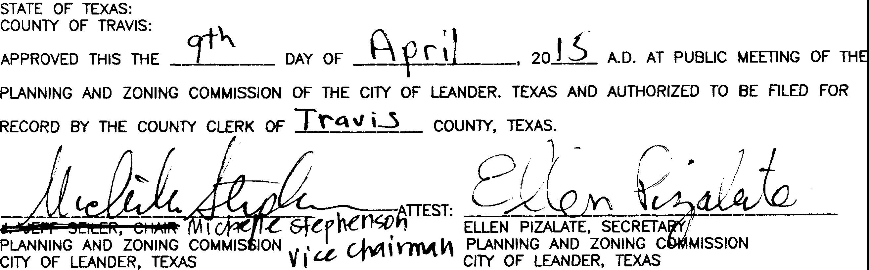GRAND MESA AT CRYSTAL SECTION 8, PHASE

STATE OF TEXAS:

FALLS

1

11,

INTERSECTING LOCAL OR COLLECTOR STREET OR 100' OR 60% OF PARCEL FRONTAGE, WHICHEVER IS LESS, TO THE ROW OF **AN** INTERSECTING

COUNlY OF TRAVIS:

ARTERIAL STREET.

1. THE HOA WILL OWN AND MAINTAIN THE FOLLOWING LOTS: LOT 53, BLOCK **M** AND LOT 15, BLOCK 0.
2. THE HOA BYLAWS ARE RECORDED IN THE OFFICIAL PUBLIC RECORDS OF TRAVIS COUNTY, TEXAS UNDER DOCUMENT NUMBER 2012206635.
3. THE HOMEOWNERS ASSOCIATION IS REQUIRED TO MOW AND MAINTAIN LANDSCAPING IN THE OPEN CHANNELS, DETENT10N AND WATER QUALITY AREAS.
4. THE CITY ACCEPTS AND MAINTAINS DRAINAGE AND WATER QUALITY IMPROVEMENTS CONTAINED IN OPEN CHANNELS, DETENTIQtq AND WATER QUALITY AREAS.
5. THE DECLARATION OF COVENANTS, CONDITIONS AND RESTRICTIONS ARE RECORDED IN THE OFFICIAL PUBLIC RECORDS OF TRAVIS COUNTY, TEXAS UNDER

DOCUMENT NUMBER WH,ICH IMPOSE THE REQUIREMENT FOR HOA MANTENANCE OBLIGATIONS ASSOCIATED WITH PRIVATE STREETS AND THE CITY'S

WILLIAM R. HINCKLEY, PRESIDENT LOOKOUT GROUP, INC.

GENERAL PARTNER LOOKOUT DEVELOPMENT GROUP, LP. WILLIAM R. HINCKLEY, OPERATING MANAGER MORNINGSIDE LAND AND CATTLE CO., L.LC.

GENERAL PARTNER KEY-DEER HOLDINGS, LP. 2370 RICE BOULEVARD, SUITE 200

HOUSTON, TEXAS 77005

STATE OF TEXAS: COUNlY OF TRAVIS:

DATE

NO STRUCTURE IN THIS SUBDIVISION SHALL BE OCCUPIED UNTIL CONNECTED TO A PUBLIC SEWER SYSTEM OR **A** PRIVATE ON-SITE WASTEWATER (SEPTIC) SYSTEM THAT HAS BEEN APPROVED AND LICENSED FOR OPERATION BY THE TRAVIS COUNlY ON-SITE WASTEWATER PROGRAM.

THIS SUBDIVISION IS SUBJECT TO ALL THE TERMS AND CONDITIONS OF CHAPTER 48, TRAVIS COUNTY CODE, RULES OF TRAVIS COUNlY, TEXAS FOR ON-SITE SEWAGE FACILITIES. THESE RULES REQUIRE, AMONG OTHER THINGS, THAT A CONSTRUCTION PERMIT BE OBTAINED FROM TRAVIS COUNTY BEFORE AN ON-SITE SEWAGE FACILllY CAN BE CONSTRUCTED, ALTERED, MODIFIED, OR REPAIRED IN THE SUBDIVISION AND THAT A LICENSE TO OPERATE BE OBTAINED FROM TRAVIS COUNTY BEFORE AN ON-SITE SEWAGE FACILllY CAN BE OPERATED IN THE SUBDIVISION.

THESE RESTRICTIONS ARE ENFORCEABLE BY THE TRAVIS COUNTY ON-SITE WASTEWATER PROGRAM.

NO CONSTRUCTION MAY BEGIN ON ANY LOT IN THIS SUBDIVISION UNTIL PLANS FOR THE PRIVATE ON-SITE SEWAGE DISPOSAL SYSTEM ARE APPROVED BY THE TRAVIS COUNTY ON-SITE WASTEWATER PROGRAM.

AUTHORITY TO RECOVER ATTORNEY'S FEES AND EXPENSES INCURRED IN JUDICIAL ENFORCEMENT.

1. IN ORDER TO PROMOTE DRAINAGE AWAY FROM A STRUCTURE, THE MINIMUM FOUNDATION SLAB ELEVATION SHOULD BE BUILT AT LEAST ONE FOOT ABOVE THE HIGHEST GROUND ELEVATION WITHIN FIVE (5) FEET OF THE SLAB PERIMETER, AND THE GROUND ADJACENT TO THE SLAB SHOULID BE SLOPED AWAY FROM THE STRUCTURE AT A SLOPE OF 1/2" PER FOOT FOR **A** DISTANCE OF AT LEAST TEN (10) FEET.
2. WASTEWATER AND WATER SYSTEMS SHALL CONFORM TO TCEQ (TEXAS COMMISSION ON ENVIRONMENTAL QUALITY) AND STATE BOARD OF INSURANCE REQUIREMENTS. THE OWNER UNDERSTANDS AND ACKNOWLEDGES THAT PLAT VACATION OR RE-PLATTING MAY BE REQUIRED, AT THE OWNER'S SOLE EXPENSE, IF PLANS TO DEVELOP THIS SUBDIVISION DO NOT COMPLY WITH SUCH CODES AND REQUIREMENTS.
3. TEMPORARY AND PERMANENT EASEMENTS TO BE PROVIDED AS REQUIRED FOR OFF-SITE WATER, WASTEWATER AND DRAINAGE IMPROVEMENTS.
4. FINISHED SLOPES WHICH ARE GREATER THAN 15% CANNOT USE SURFACE IRRIGATION SYSTEMS.
5. TWENlY-FIVE FOOT OSSF SETBACKS ARE REQUIRED FROM ALL DRAINAGE WAYS.

BEFORE ME, THE UNDERSIGNED AUTHORITY, ON THIS DAY PERSONALLY APPEARED WILLIAM R.

HINCKLEY, KNOWN TO ME TO BE THE PERSON WHOSE NAME IS SUBSCRIBED TO THE FOREGOING INSTRUMENT AND ACKNOWLEDGED TO ME THAT HE EXECUTED SAME FOR THE PURPOSE AND CONSIDERATION THEREIN EXPRESSED, IN THE CAPACITY THEREIN STATED.

GIVEN UNDER MY HAND AND SEAL OF OFFICE, THIS THE *(£,+* DAY OF _Aprjj , 20J5_ A.O.

_.ls.e_L\/_ _A_±_ _lV\ -

PRINT NAME

NOTARY PUBLIC IN AND FOR THE COUNTY OFWi.lli.A:. _.

MY COMMISSION EXPIRES **j_°1--=-.2.-=:J.i. .**

DEVELOPMENT ON EACH LOT IN THIS SUBDIVISION SHALL BE IN COMPLIANCE WITH THE MINIMUM REQUIREMENTS OF THE TITLE 30 OF THE TEXAS ADMINISTRATIVE CODE CHAPTER 285 AND TRAVIS COUNlY CODE CHAPTER 48 THAT ARE IN EFFECT AT THE TIME OF CONSTRUCTION.

ALL LOTS IN THIS SUBDIVISION ARE RESTRICTED TO ONE SINGLE FAMILY DWELLING AND APPURTENANT STRUCTURES PER ACRE.

NO STRUCTURE IN THIS SUBDIVISION SHALL BE OCCUPIED UNTIL CONNECTIED TO **A** POTABLE WATER SUPPLY FROM AN APPROVED WATER SYSTEM OR A PRIVATE WELL.

NO WATER WELL IN THIS SUBDIVISION MAY BE LOCATED **WITHIN** 150 FEET OF THE SUBDIVISION BOUNDARY WITHOUT THE CONSENT OF THE ADJOINING LAND OWNER(S).

A ...:-- .o..c" s 9J\.,\..._Q,_-¥- 4l7

1. TWENTY-FIVE FOOT OSSF SETBACKS ARE REQUIRED FROM ALL FINISHED SLOPES WHICH ARE GREATER THAN JO%
2. ALL PRIVATE STREETS SHOWN HEREON AND ANY SECURllY GATES OR DEVICES CONTROLLING ACCESS TO THE SAME PRIVATE STREETS SHALL BE OWNED AND MAINTAINED BY THE ESTABLISHED HOMEOWNER'S ASSOCIATION OF THIS SUBDIVISION.
3. THE FOLLOWING VARIANCES WERE GRANTED PER A DEVELOPMENT AGREEMENT WITH THE CITY OF LEANDER AND APPROVAL OF THE CRYSTAL FALLS II CONCEPT PLAN ON MAY 1, 2003.
   1. PRIVATE STREETS WITH ROADSIDE DRAINAGE.
   2. NO SIDEWALKS.

STATE OF TEXAS:

COUNlY OF TRAVIS:

I, PHILLIP L. McLAUGHLIN, AM AUTHORIZED UNDER THE LAWS OF THE STATE OF TEXAS TO PRACTICE THE PROFESSION OF LAND SURVEYING, AND HEREBY STATE THAT THIS PLAT CONFORMS WITH APPLICABLE ORDINANCES OF THE CllY OF LEANDER, TEXAS AND TRAVIS COUNTY, TEXAS

pot-STACEY SCHtFFEL D. R. #OS001114J PROGRAM MANAGER,

ON-SITE WASTEWATER, TRAVIS COUNlY TNR

STATE OF TEXAS: COUNlY OF TRAVIS:

DATE

* 1. NO STREET LIGHTS.

1. FRONT BUILDING LINES ARE MEASURED FROM THE EDGE OF THE STREET EASEMENT.
2. A PUBLIC SAFETY EASEMENT IS HEREBY GRANTED FOR ALL PRIVATE STREETS, DRAINAGE AND PUBLIC UTILITY EASEMENTS WITHIN THIS SUBDIVISION.
3. ALL PROPERlY HEREIN IS SUBJECT TO THE LOWER COLORADO RIVER AUTHORITYS HIGHLAND LAKES WATERSHED ORDINANCE. WRITTEN NOTIFICAT10N AND/OR PERMITS ARE REQUIRED PRIOR TO COMMENCING ANY DEVELOPMENT ACTIVITIES. CONTACT LCRA WATERSHED MANAGEMENT AT 1-800-776-5272, EXTENSION 2324 FOR MORE INFORMATION.
4. THE WATER BUFFER ZONE SHALL REMAIN FREE OF CONSTRUCTION, DEVELOPMENT, OR OTHER ALTERATIONS EXCEPT FOR UTILllY AND ROADWAY CROSSINGS.
5. A PERPETUAL PUBLIC SAFETY EASEMENT FOR THE PURPOSE OF PROVIDING PUBLIC SAFETY SERVICES, POLICE, FIRE AND MEDICAL SERVICES, ENFORCING THE PENAL CODE AND CITY ORDINANCES, AND GIVING THE CllY AND ITS AUTHORIZED OFFICERS AND DESIGNEES UNINHIBITED INGRESS AND EGRESS OVER, ACROSS AND THROUGH SUCH STREETS, ROADWAYS, AND RIGHTS-OF-WAY FOR THE PURPOSE OF PROVIDING PUBLIC SAFETY SERVICES, POLICE, FIRE AND MEDICAL SERVICES, AND ENFORCING THE PENAL CODE AND CllY ORDINANCES. THE HOA SHALL MAINTAIN AT ALL TIMES WITH THE CllY SECRETARY THE CURRENT GATE CODE OR KEY FOR ALL GATES REGULATING ACCESS TO AND FROM THE SUBDIVISION.



***SURVEYING, LLC***

-&

*1805 OUIDA DR*

*AUSTIN, TEXAS 78728*

*PHONE: (512) 267-7430*

*FAX· (512) 836-8385* SHEET 7 OF 7

AND THAT ALL EXISTING EASEMENTS OF RECORD AS FOUND ON THE TITLE POLICY PROVIDED BY INDEPENDENCE TITLE COMPANY, GF NO. 1431182-TOH, ISSUED DECEMBER 29, 2014, HAVE BEEN SHOWN OR NOTED HEREON.

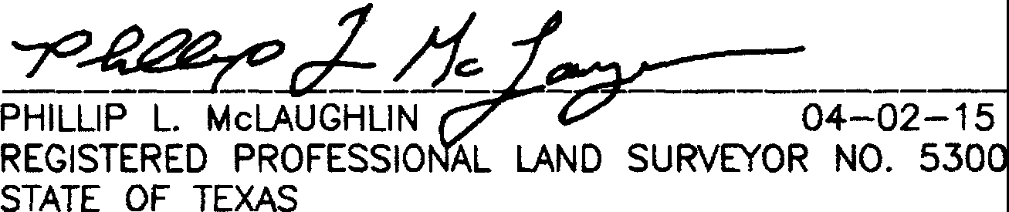

STATE OF TEXAS:



.......................

* **Q:-v**

••;_ **G** * ;._•,

***,-c·***

....P.L......M...C.L..A.U....

.1-i 5300

***·.p* \O.•'**

COUNTY OF TRAVIS:

I, SAMUEL D. KIGER, **AM** AUTHORIZED UNDER THE LAWS OF THE STATE OF TEXAS TO PRACTICE THE PROFESSION OF ENGINEERING, AND DO HEREBY STATE THAT THIS PLAT CONFORMS WITH THE APPLICABLE ORDINANCES OF THE CITY OF LEANDER, TEXAS THAT THIS TRACT IS NOT LOCATED WITHIN THE EDWARDS AQUIFER RECHARGE ZONE AND THAT **A** PORTION OF THIS SUBDIVISION IS

WITHIN THE LIMITS OF A 100 YEAR FLOOD PLAIN RECOGNIZED BY THE FEDERAL EMERGENCY MANAGEME GENCY (FEMA) PER FLOOD INSURANCE RATE MAP (FIRM) PANEL NO. 48453C 0095H D E SEPTJ 2q;/2008, AND CONTAINED WITHIN THE WATER BUFFER ZONE EASEMENT

SHOWN ON. - ***C*** .



--.. **-t OF** -,. \\

SAMU L D. KIGER, P.E. ***•-••••••l:,t-_}L***

STATE OF TEXAS NO. 89353 ••.-* **•••••151·ra.**

P.O. BOX 1220 ***•1.***

\ *

LEANDER, TEXAS 78646-1220

512-259-3882 --··"···..-·

UNY. h.Q; !L

*<* **89363** *!$*""

**••/.C**..**E**..**N**..**S**..**'**.**:••0•*.*.*f*.*'*,,**

**10NAL** ,

**4-.. -IS**

THE WATERWAY BUFFER ZONE EASEMENT IS FOR THE PROTECTION OF THE ENVIRONMENT BY IMPROVING THE QUALllY OF STORMWATER RUNOFF FROM DEVELOPED LANDS. THE NATIVE LAND OR MANAGEMENT PRACTICES WITHIN THE EASEMENT ARE TO HELP MAINTAIN CLEAN WATER IN CREEKS, RIVERS AND LAKES. NO STRUCTURE OR IMPROVEMENTS, OTHER THAN NATIVE PLANT ENHANCEMENT OR MAINTENANCE OF THE AREA IN ACCORDANCE WITH LCRA RULES, MAY BE PLACED OR PERFORMED WITHIN THE EASEMENT WITHOUT SPECIFIC PRIOR AUTHORIZATION AND APPROVAL IN WRITING FROM THE LCRA, ITS SUCCESSORS OR ASSIGNS, OR OTHER GOVERNMENTAL ENTITY WITH AUTHORllY TO PERMIT SUCH IMPROVEMENT FOR THE PROTECTION OF THE ENVIRONMENT. THE EASEMENT SHALL BE MAINTAINED BY EACH LOT OWNER BY PRESERVING AND RESTORING NATIVE VEGETATION. THE EASEMENT MAY NOT BE AMENDED EXCEPT BY EXPRESS WRITTEN AGREEMENT OF THE LCRA, ITS SUCCESSORS OR ASSIGNS, OR OTHER GOVERNMENTAL ENTllY WITH PROPER AUTHORITY.



STATE OF TEXAS:

COUNTY OF TRAVIS:

I, DANA DEBEAUVOIR, CLERK OF TRAVIS, TEXAS, DO HEREBY CERTIFY THAT THE FOREGOING INSTRUMENT OF WRITING, WITH ITS CERTIFICATE OF AUTHENTICATION WAS FILED FOR RECORD IN MY OFFICE ON THE **jJ_** DAY OF **_ftt, *r•*** \ , 20J5A.D., AT t.l7Po'CLOCK **.i...M.,** AND DULY RECORDED ON THE jQ_ DAY OF

**&9ri** \ , 20 A.D., AT l'l'Jioo'CLOCK, **_l.M.,** IN THE OFFICIAL RECORDS OF SAID COUNlY AND STATE, UNDER DOCUMENT NUMBER 'l,,0\5 *0* oo<( **1**

WITNESS MY HAND AND SEAL OF OFFICE OF THE COUNTY CLERK THE **J6._** DAY OF **_fi.p_._0-=-•..,., _**

20.l.5i,.o.

DANA DEBEAUBOVOIR, COUNlY CLERK OF TRAVIS COUNlY, TEXAS



BY: **- -----'CIID-- -** DEPUTY

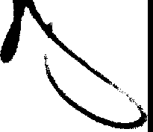

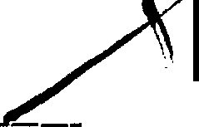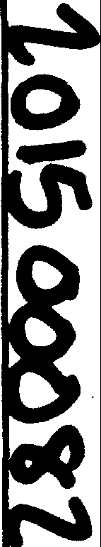

L:\13152-GRANO MESA SECTION 8\d•g\13152_GR-PlAT-8-Ldwg 4/2/2015 3c52c35 **PM** COT

I

I

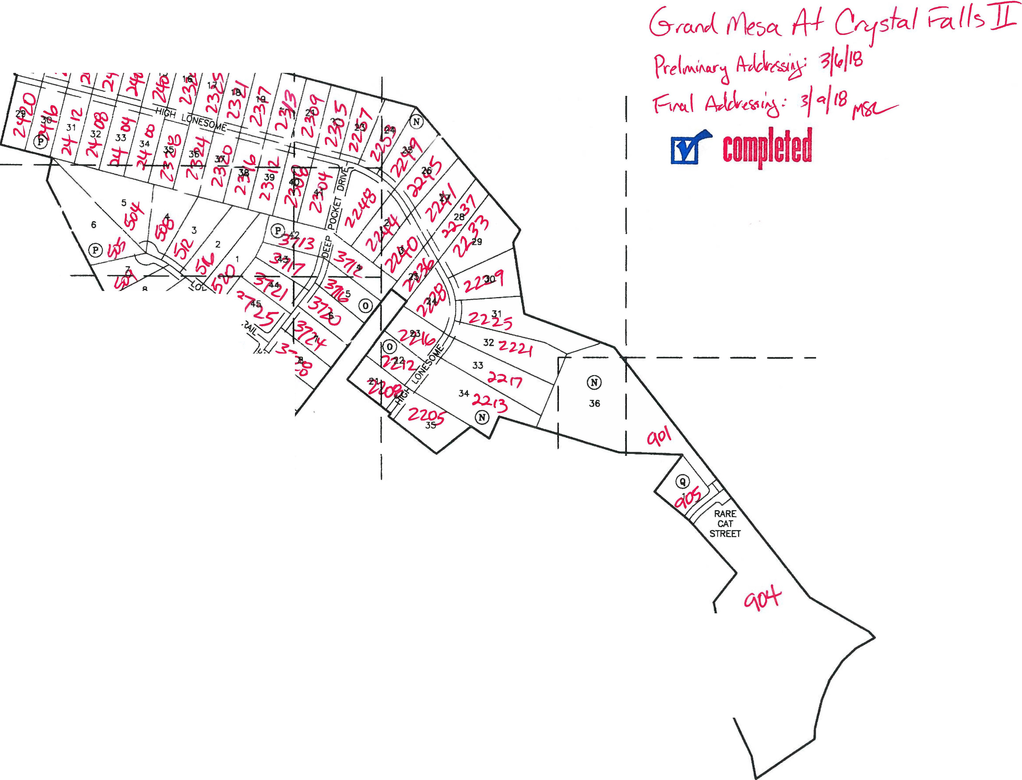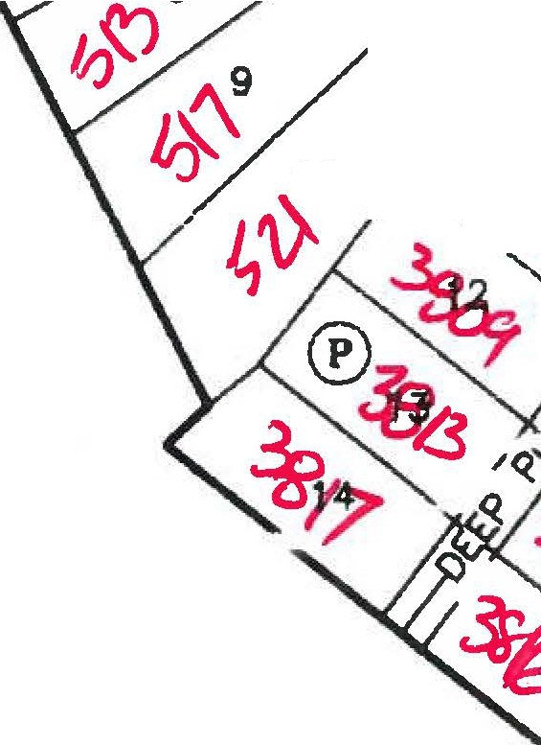

I _I_

SHEET 57

-

I

I

r--­

"'

**10**

HEET 4 LI

_ _J I

SHEET 57

I I I

-----

l _

I I I I I I I

_IJ

I I I

® I

**80** I

I I I

r-------------------------------------------..:.....----------------- '-"' " -'"-------,;_.. --.

FINAL PLAT OF

GRAND

MESA AT CRYSTAl SECTION 8, PHASE

N

FALLS 2

11,

127 .030 AC. (TRACT 2) DOUGLAS D. HOOD

VOL 12189, PG. 1339

_,..

0 SC ·10

**W*E**

s

1"=100'

20 • -DO

BEARING BASIS:TEXAS CENTRAL ZONE, STATE PLANE COORDINATES (NA□ 83)

33

34

36

5

I 91571I

38

***t*** *-*.:*'<*,*,* I,.,.

*SURVEYING, LLC*

*1805 OUIDA DR*

*AUSTIN, TEXAS 78728*

VJ

.,

23 ® •

*"--*

*PHONE: (512) 267-7430*

*FAX: (512} 836-8385* SHEET 3 OF 7

L\17242-CRAND MESA SECTlON 9\dw9\tn42-GR-EIASE.dW9 11/21/2017 8:46;06 ,_.. CST

ul:. ..,

453

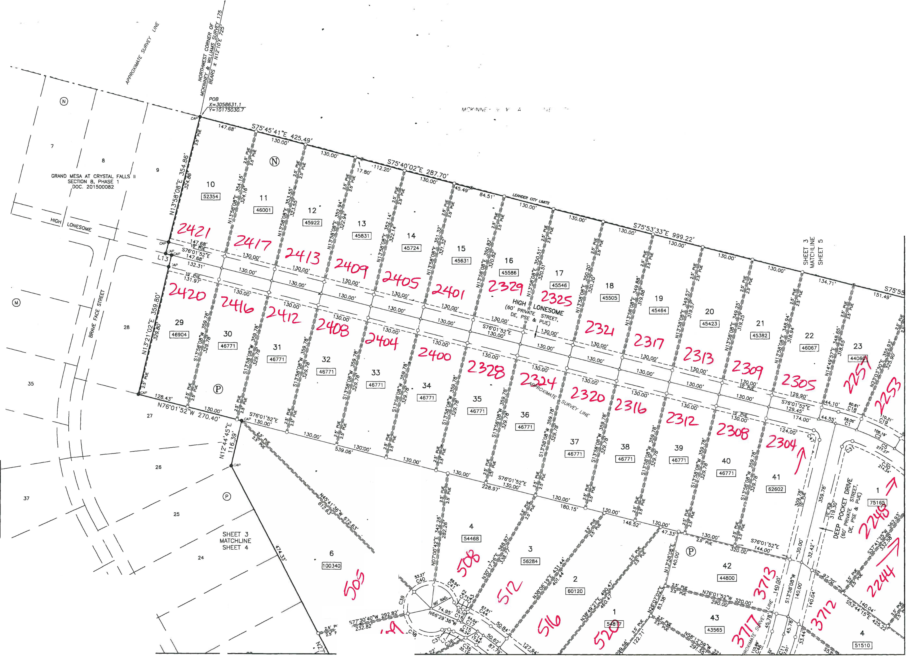

s

1"=100'

2( •

BEARING BASIS:TEXAS CENTRAL ZONE STATE PLANE COORDINATES (NAO 83)

/SHEET 3

MATCHUNE SHEET 4

!4

22

21

21

*I*

A

19

GRAND MESA AT CRYSTAL FALLS 117

SECTION 6, PHASE 1

"" DOC. 201 500062

16 16

·sw

/4/""

t lllf / •

w

*si I* "'

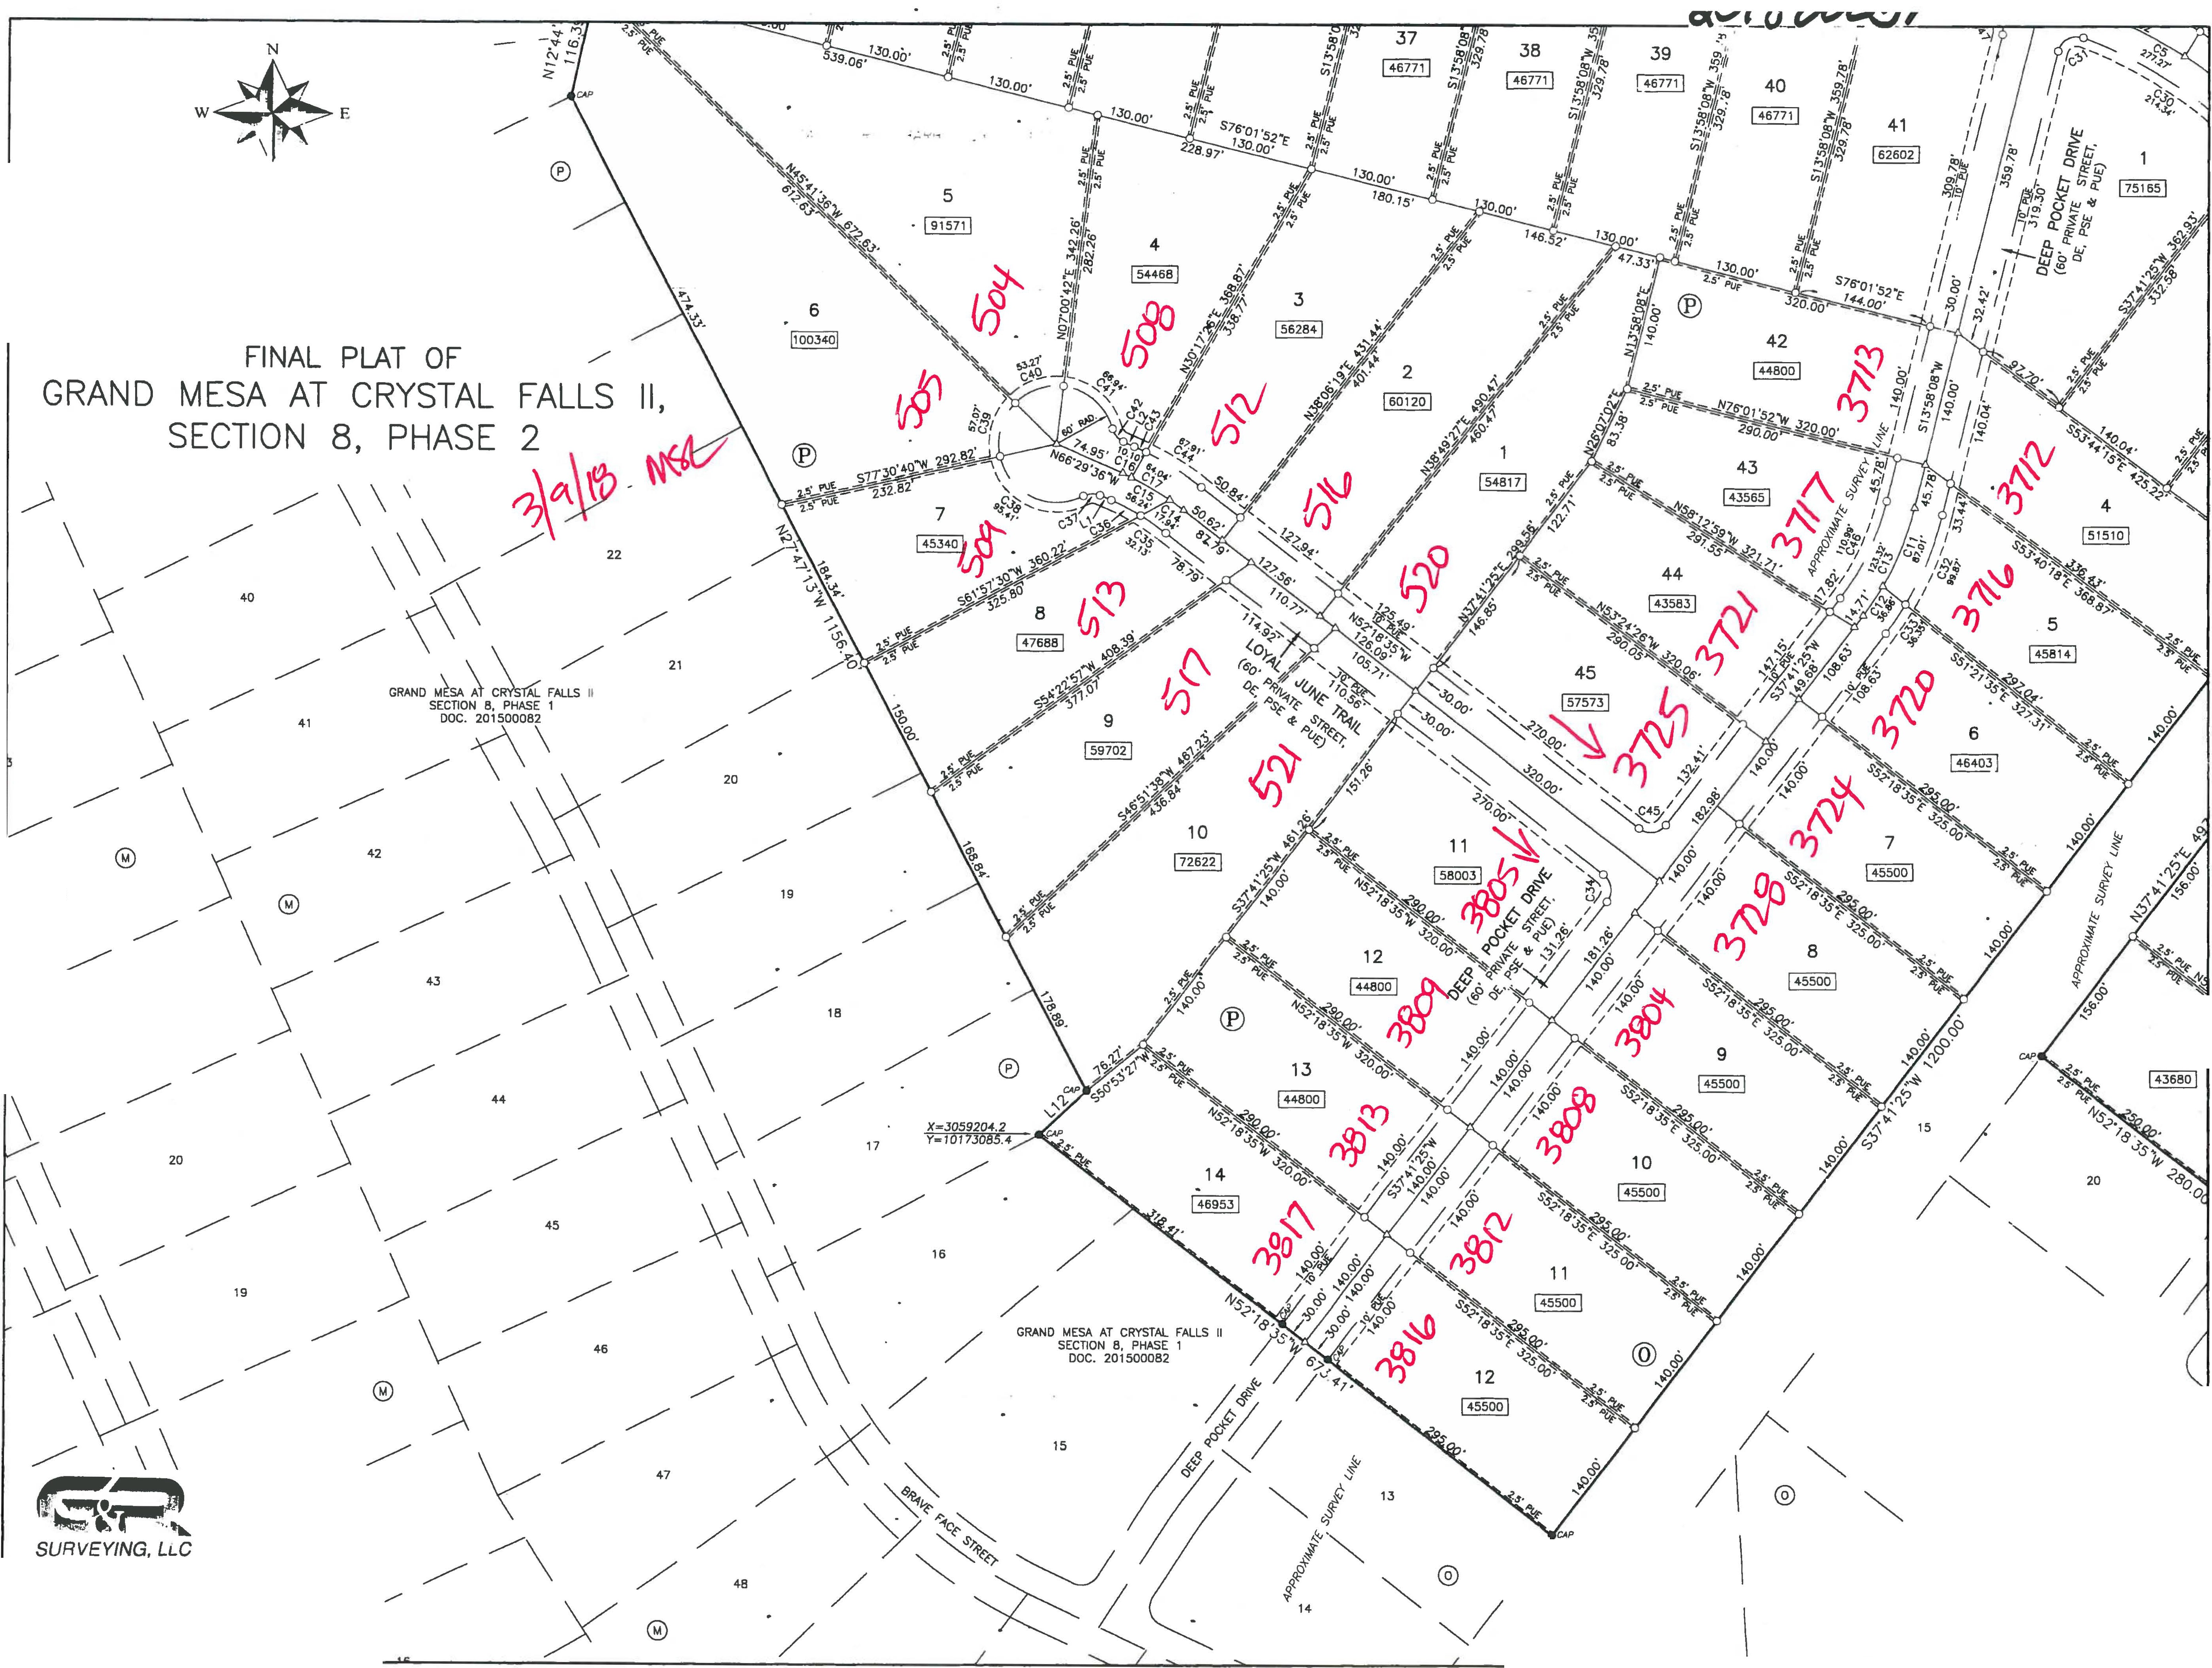

*1805 OUIDA DR*

*AUSTIN, TEXAS 78728*

*PHONE: (512) 267-7430*

*FAX: (512) 836-8385* SHEET 4 OF 7

**L \17242-GRAN0 MESA SECOON 9\d•9\1724LCA-BASE.dw9 11/2 /2017 9:46.06 AM CST**

Vl :::i!: Ul

*I I I;* "" ,

*I f'1 I* ""

**GRAND**

**FINAL**

**MESA AT**

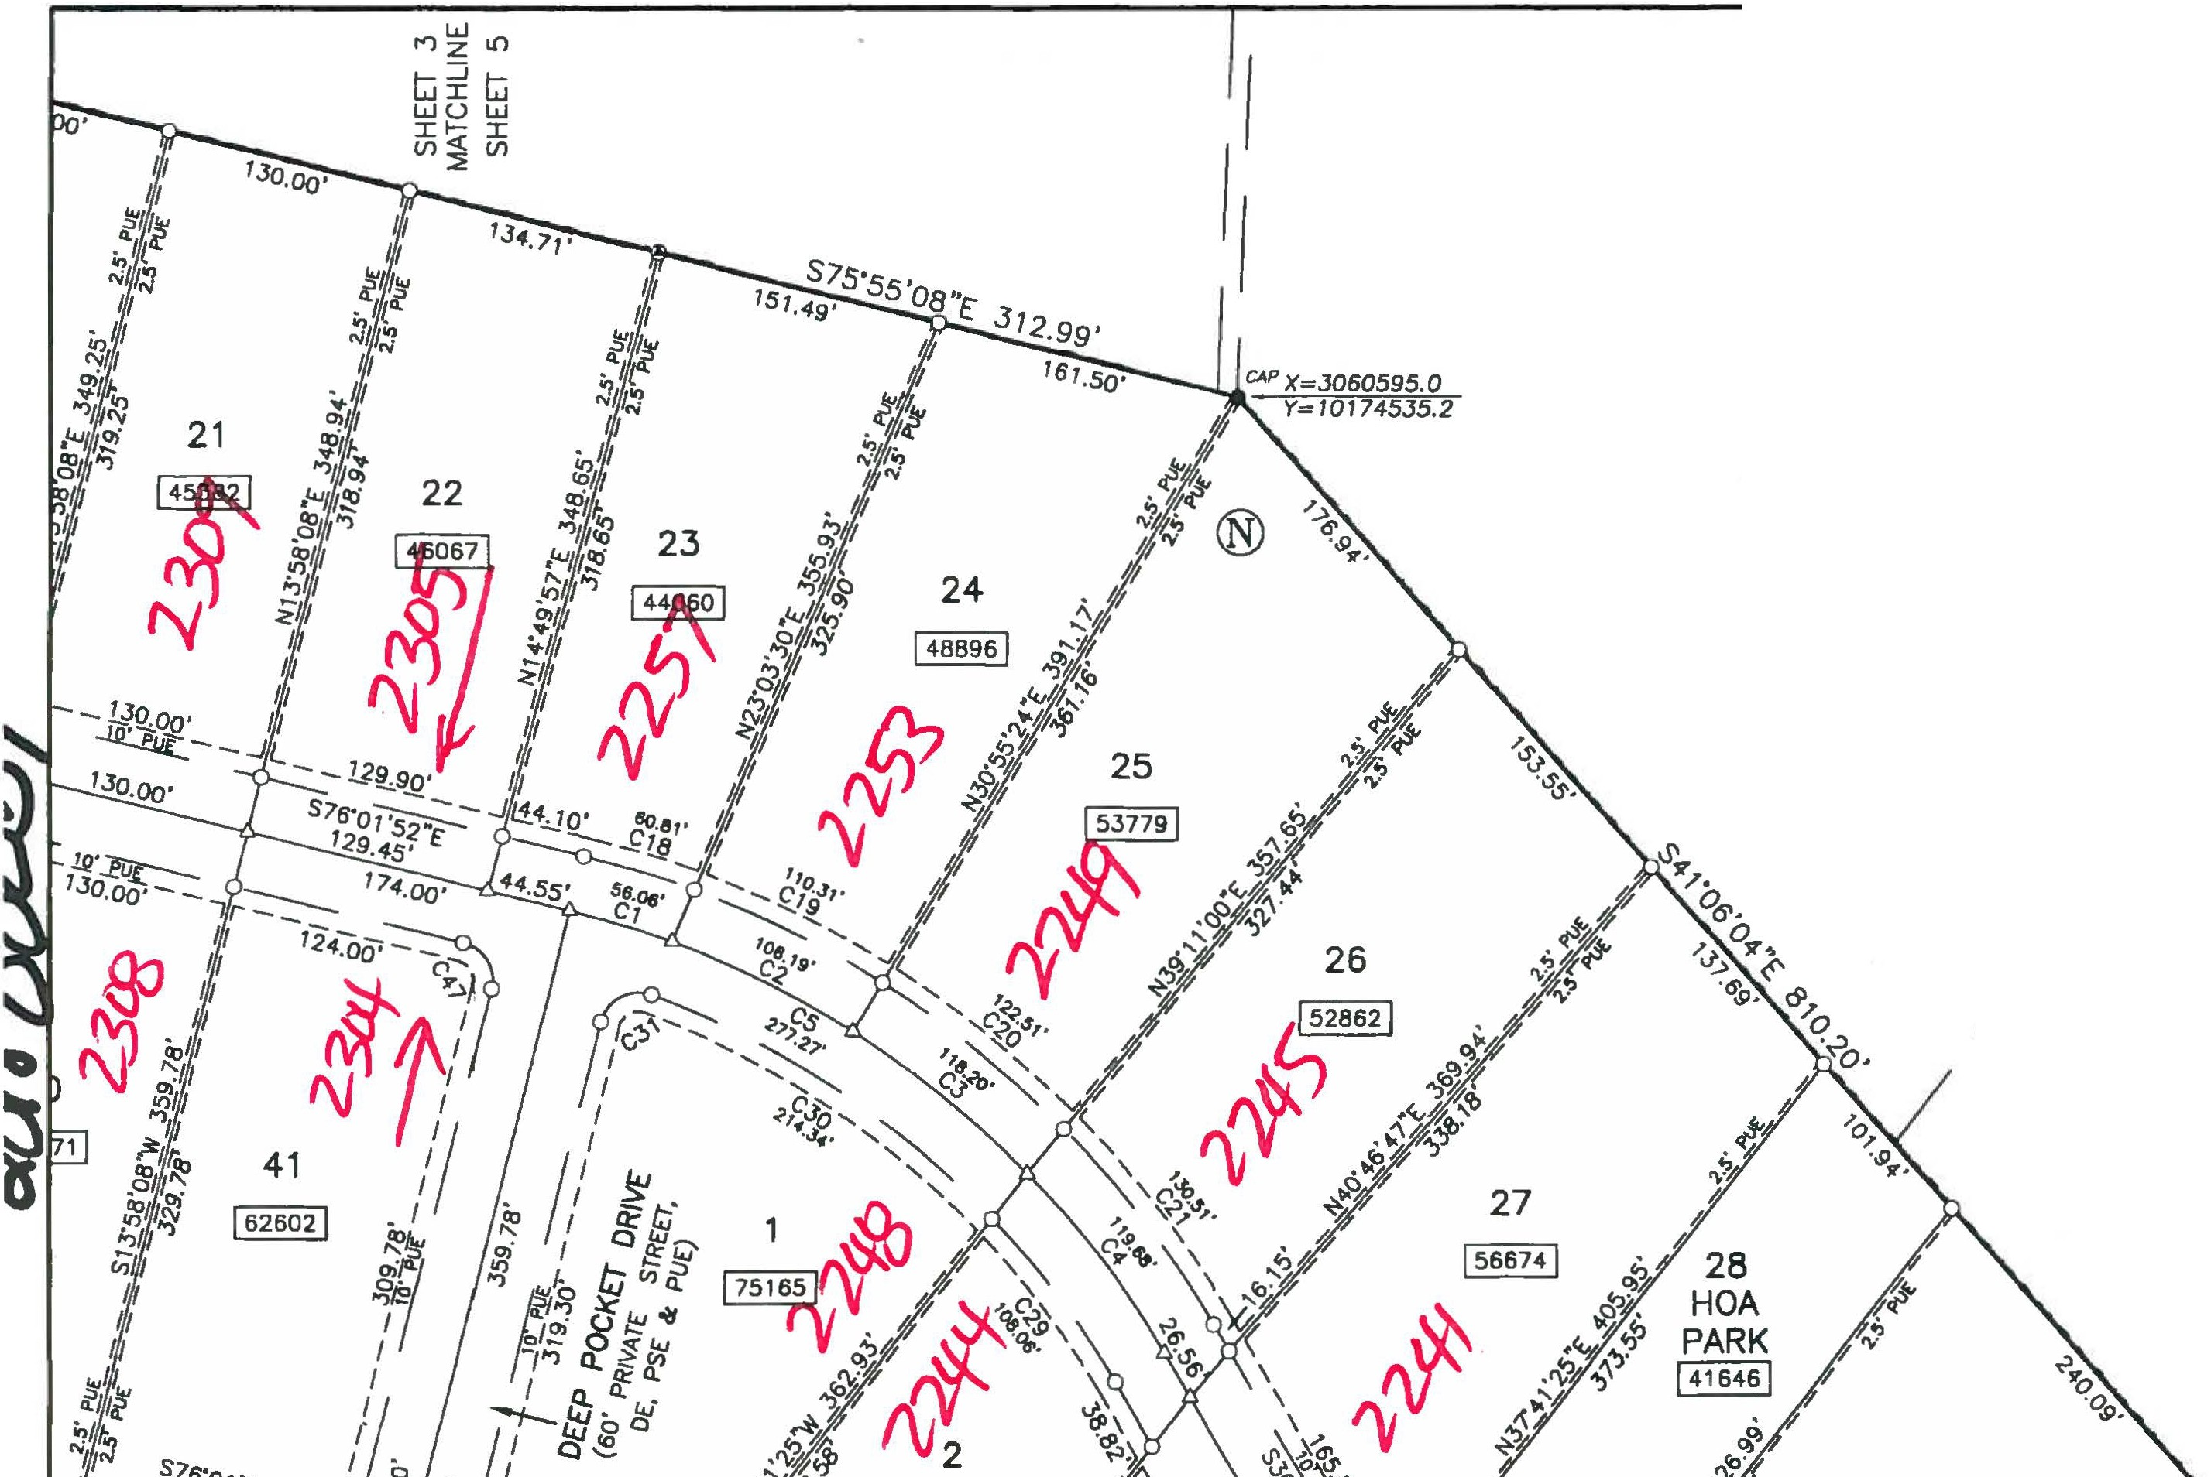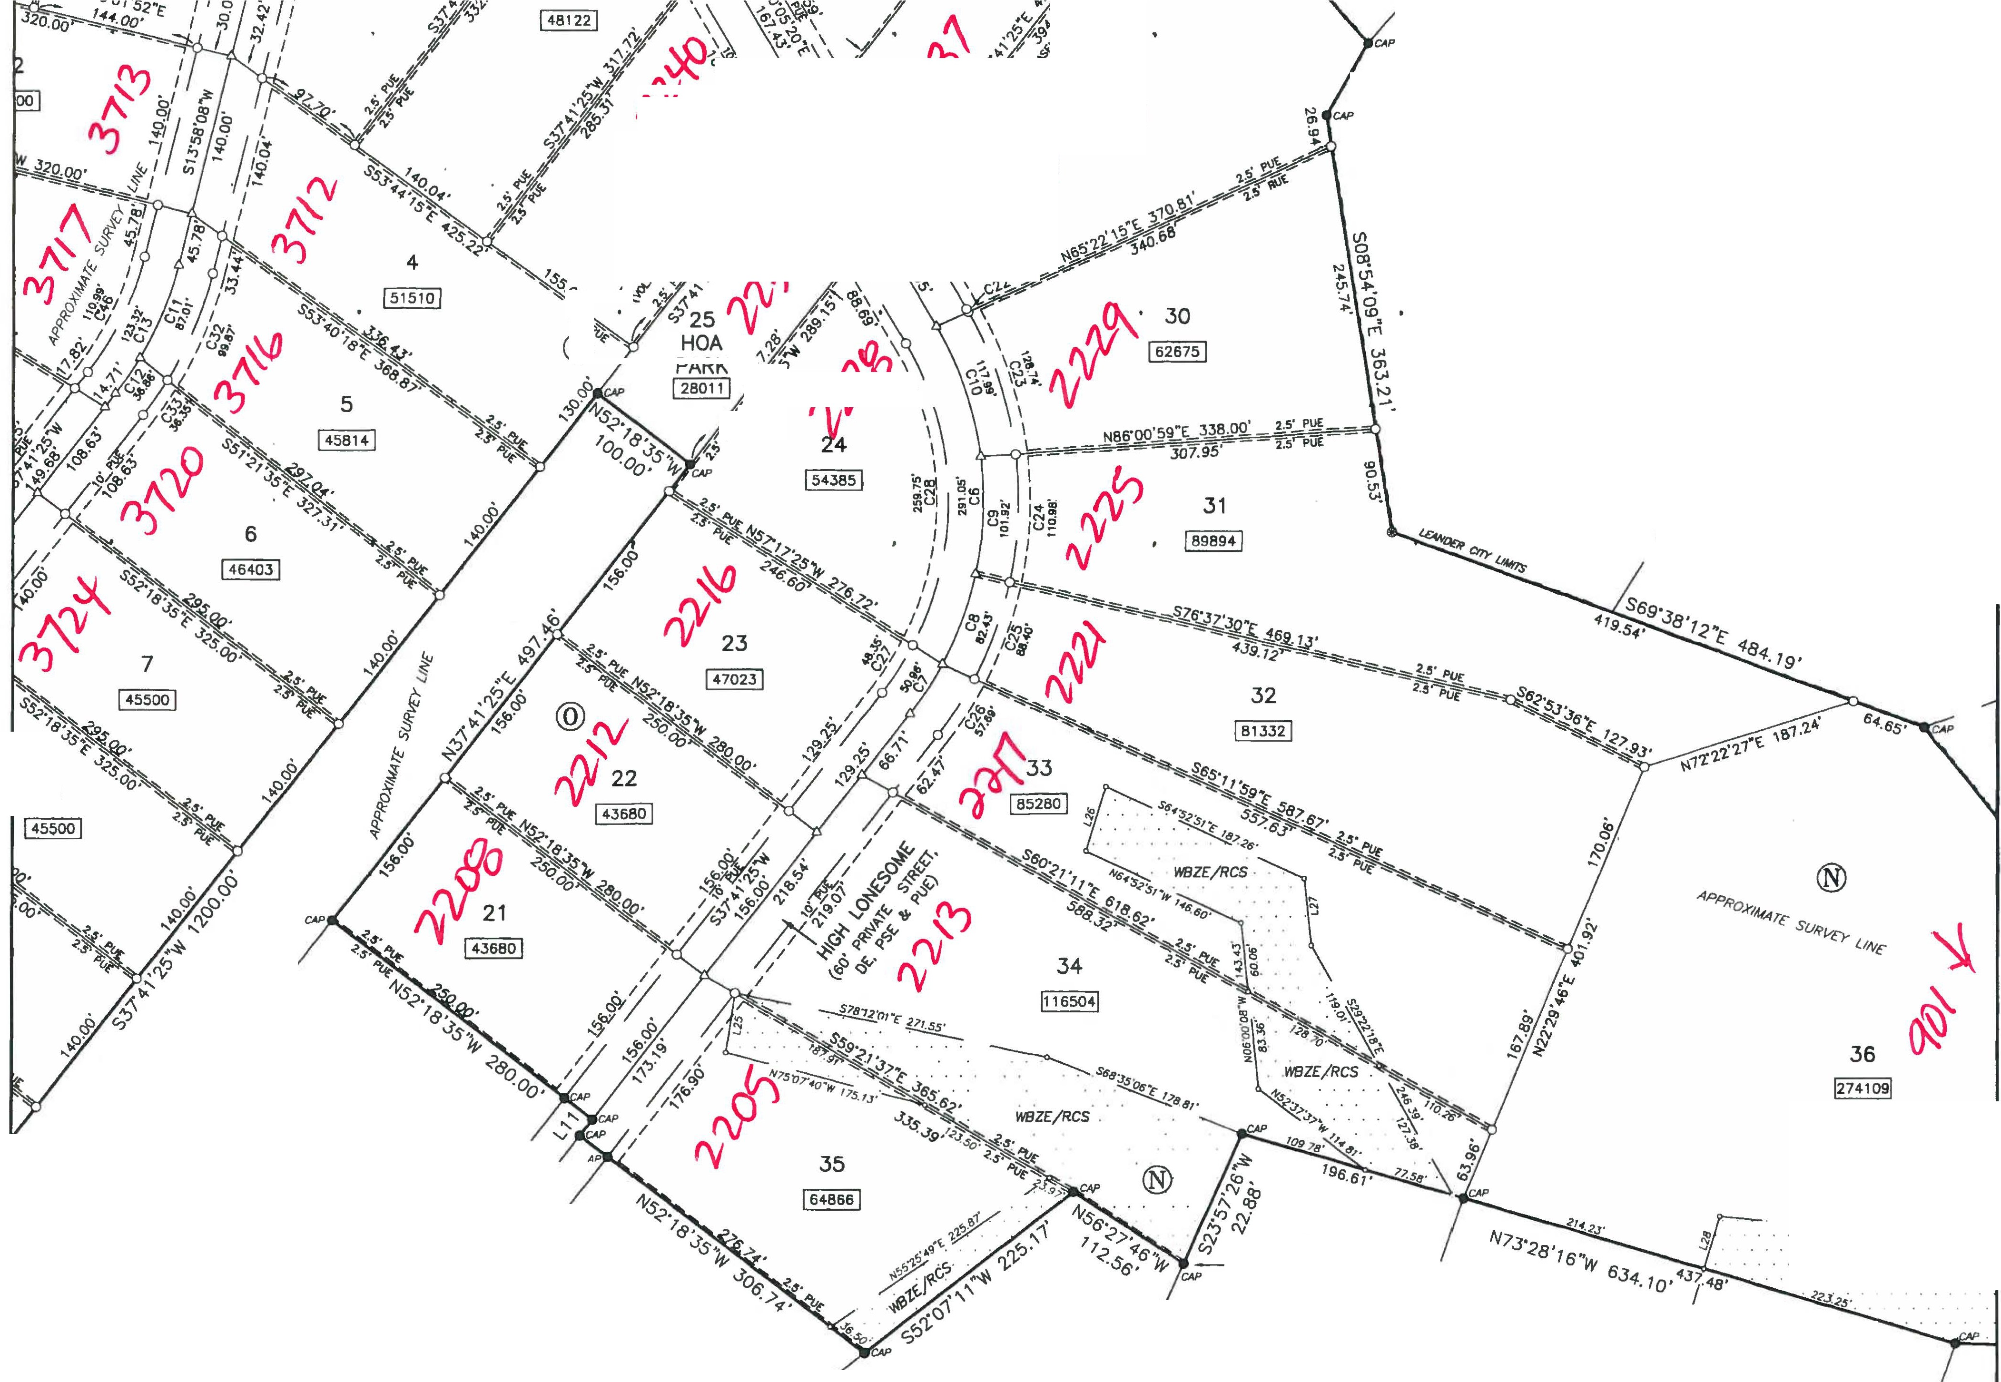

**PLAT OF**

**CRYSTAL**

**FALLS**

**11,**

**SECTION**

**8, PHASE 2**

**N**

.>:&..._ **-9.**

18 **W E**

s **0**

1"=100'



0 50 100

200

400

BEARING BASIS:TEXAS CENTRAL ZONE, STATE PLANE COORDINATES (NAO 83)

*I* /

*I* 19 /

/

/

/

/

ij,

*':t,* 'J

*I*

144 401 •

C,

*J'*

**29**

! 84666 !

-S29'14'52"W

72.40'

APPLE SPRINGS BK. 83, PG. 51A-558

*I*

*I*

20 *I*

·/

,..fl>

**0**

>;.:.."'; \

*,§* \

*t"' I*

*I* 21

**8**

15 /

/ 20

/ ,, *I;*

A ..... -

GRAND MESA AT CRYSTAL FALLS II ')( ( SECTION 8, PHASE 1 / "

*y*

*I*

"-. DOC. 201500082 (

8

/4 /

18 ; fif/

: /

X=J060971.1

*Y=I0/72872.J*

*I* 6 *I I* ®

1. 5

0

" *I*

GRAND MESA AT CRLAL FALLS 11 / / SECTION 8, PHASE 1

DOC. 2/500082

'---..

= *I*

4

*I*

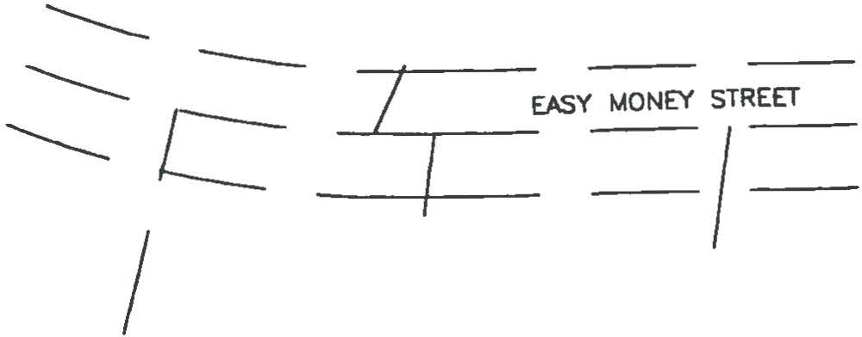

*I* '--._ *61*

**G,rt** " *I*

##### ;z

*I*

***SURVEYING, LLC***

*1805 OUIDA DR*

*AUSnN, TEXAS 78728*

*PHONE: (512) 267-7430*

*FAX: (512) 835-8385*

SHEET 5 OF 7

68

*I-- I ! I*

*3::: :!*

*I I* --- *::t ::t::*

**L\17242-GRAND M[SA SCCTlON 9\d,.9\17242_CR-BA5£.dw9 12/7/2017 5 JJ 42 Plrl CST**

**FINAL PLAT OF**

**GRAND MESA AT CRYSTAL**

♦·

**SECTION 8, PHASE**

N

**FALLS**

2

**11,**

36

!274109!

w • --- E

s

*I* @)

*I* 4

*I*

*VrfJZE/RCS* ..•.

100 200

BEARING BAStS:TEXAS CENTRAL ZONE, STATE PLANE COORDINATES (NAO 83)

400

53

. .*W8Z£/RCS* .

' ..... ' ... *I*

*I*

*I*

*I*

**54**

59 80

!577774!

I I

24

GRANO MESA II AT CRYSTAL F'ALLS DOC. 200100236

2

23

,

• .•.•.

22

52

*I* 51

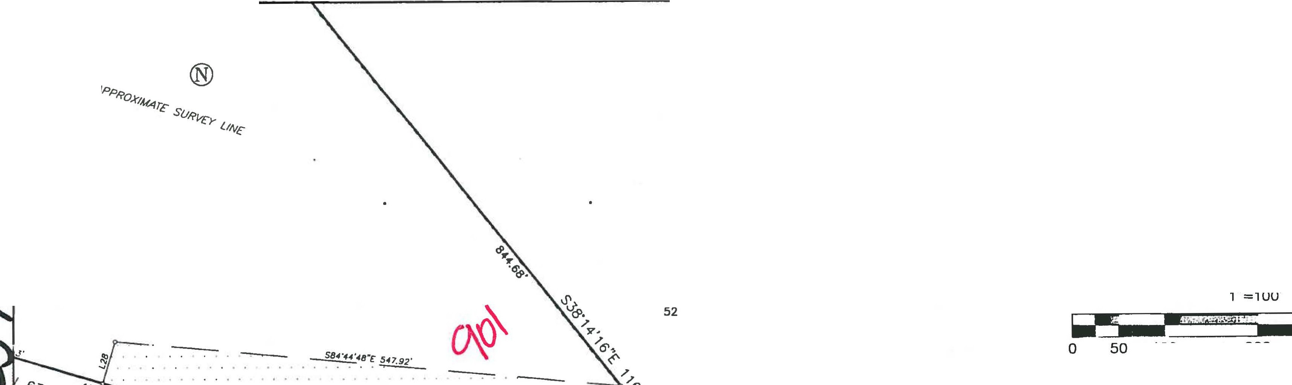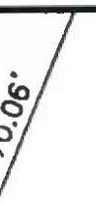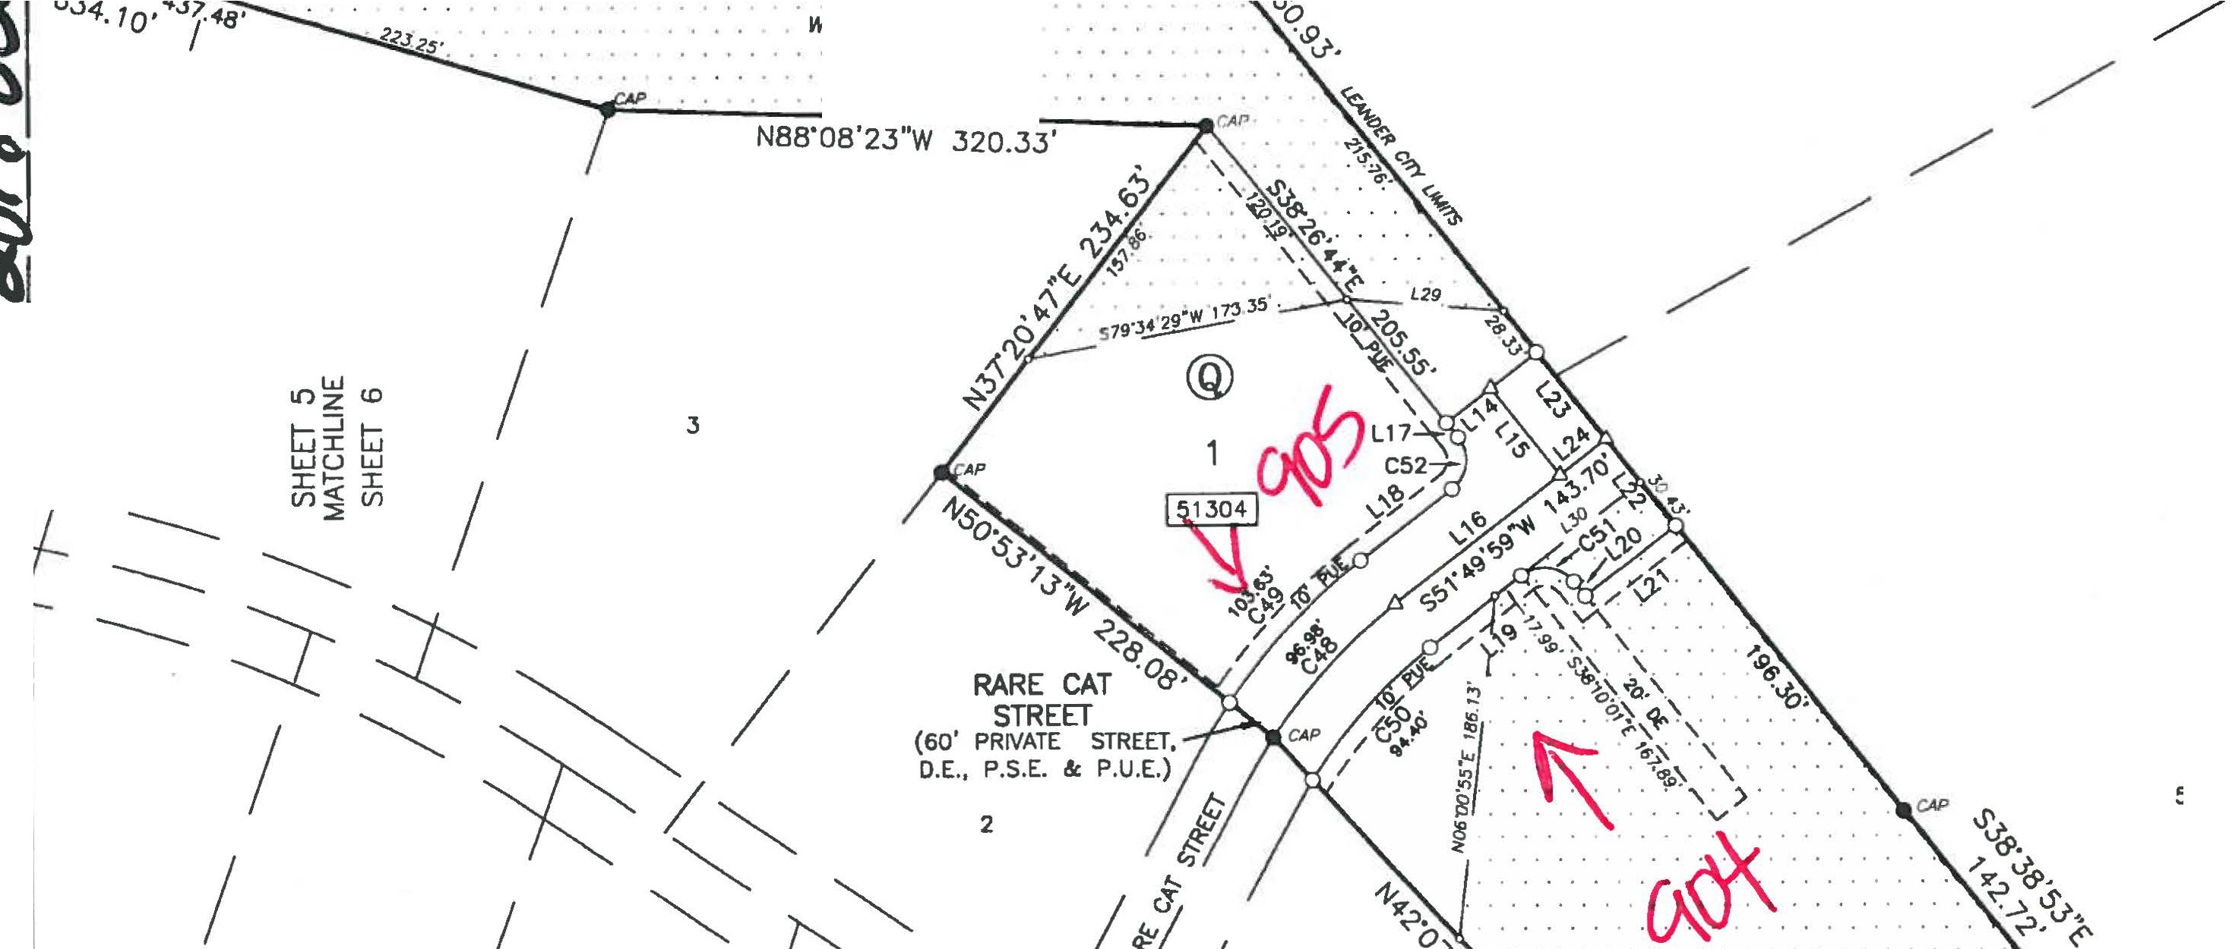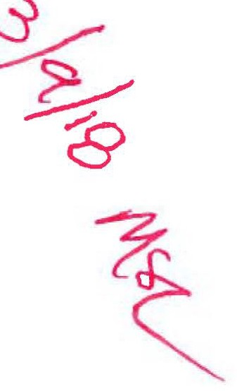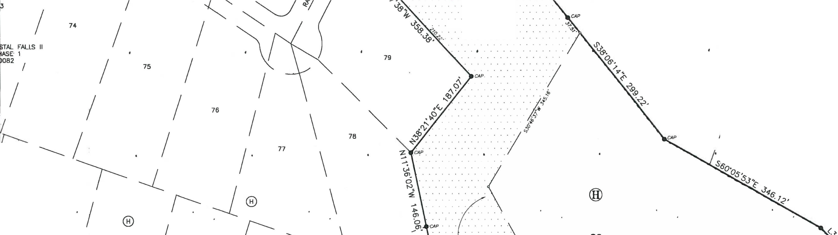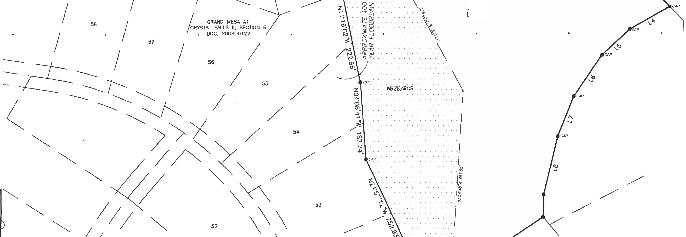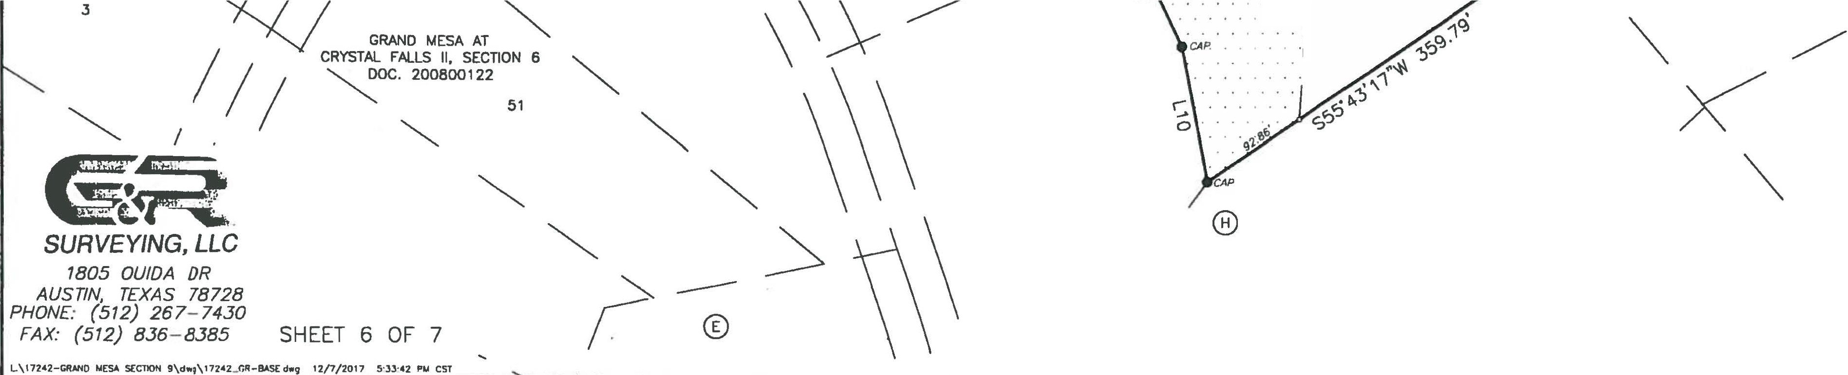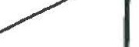

*I*

GRAND MESA AT / CRYSTAL FALLS II, SECTION 6

DOC. 200800122

/ V

/ 50 21

*S.S. [VANS SURVEY* 501

*r*

*I*

12.346 AC.

*I*

**GRAND**

**FINAL**

**MESA AT**

**PLAT OF**

**CRYSTAL FALLS II,**

, PHILIP R. HAMILTON DOC. 2001060263

**..Po-+;.;**

***'¥...q***

**su-1>t--e)..**

***(/1),-e,***

*I I*

*I TEXAS MEXICO RAILROAD* co. *SURVEY 203*

*I*

*I* **SECTION 8, PHASE 1**

*I*

*I* (+ ,

W E ***lf/13/l5 M8l_***

s

1. *I*

*I*

2

1"=100'

0 50 100 200

BEARING BASIS:TEXAS CENTRAL ZONE, STATE PLANE COORDINATES (NAD 83)

)

1

400

**of 4**

127.030 AC. (TRACT 2)

DOUGLAS D. HOOD

-- VOL. 12189, PG. 1339

*•-.......... • 'Cwa*

***- !'Rem,,***

-,

---,-..........

--.-.

*MCKINNEY* & *WILL/AMS SURV[Y* 175

--

--

--

32

31 --

REMAINDER OF 1013.55 AC. (TRACT 1) LOOKOUT PARTNERS, L.P.

DOC. 2000162836

--

-- *CANDELARIA YBARBO SURVEY 422*

30

29

GRAND MESA AT CRYSTAL FALLS II SECTION 7

DOC. 201300054

76

75

23

***SURVEYING, LLC***

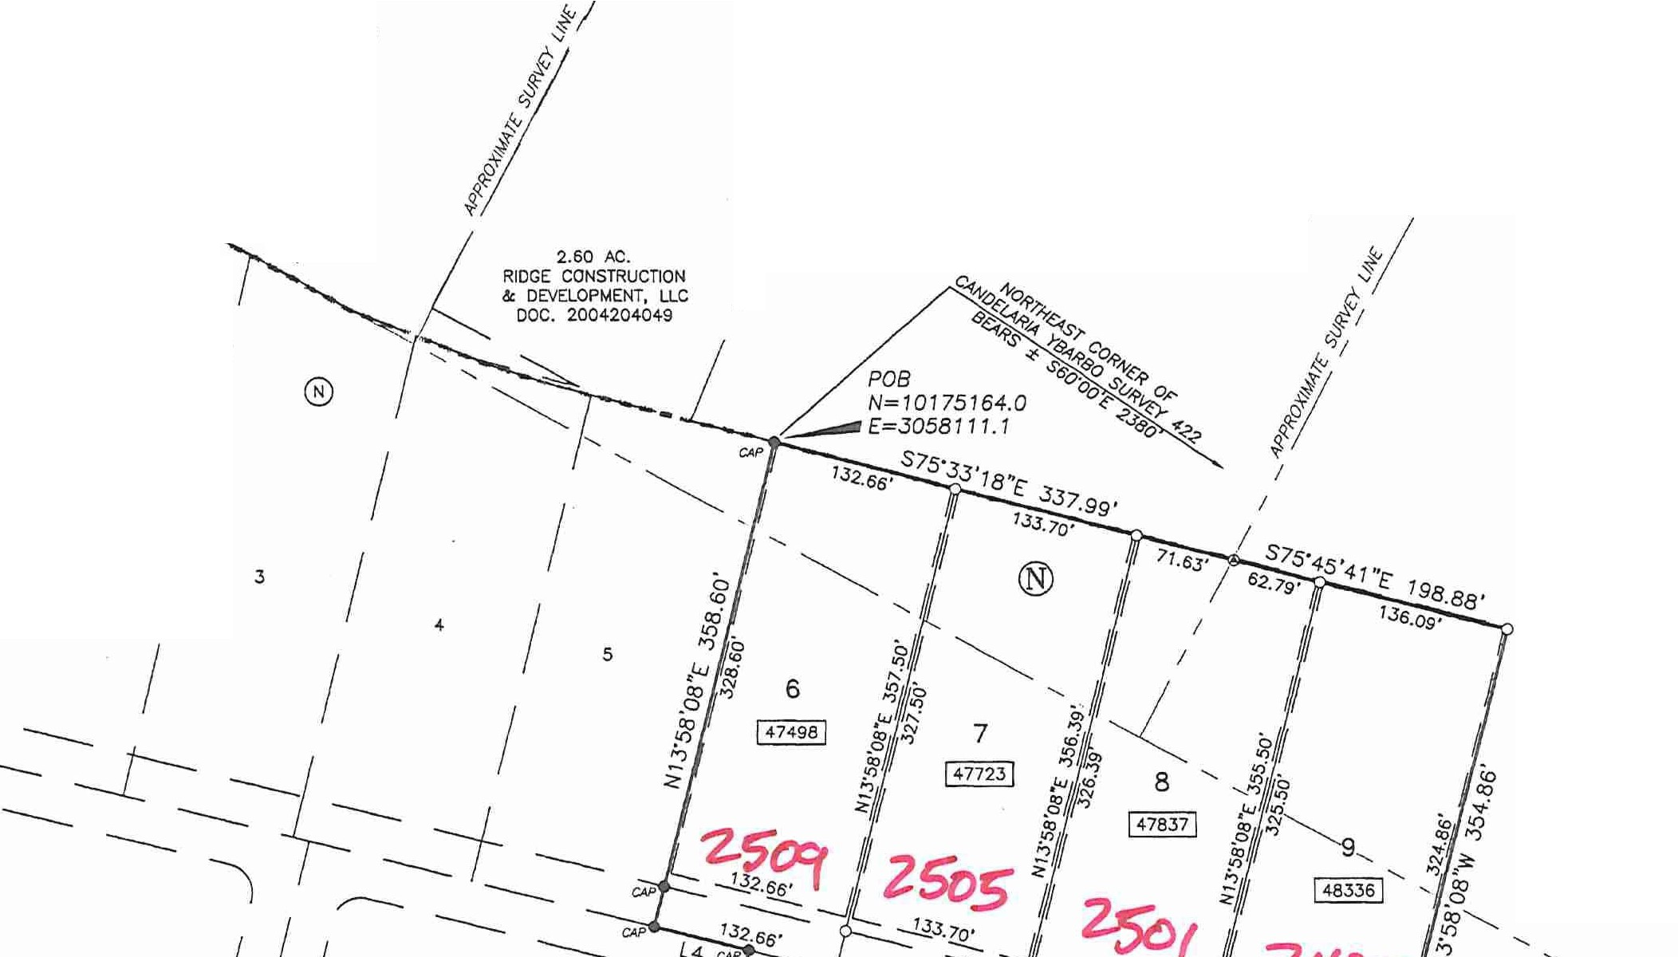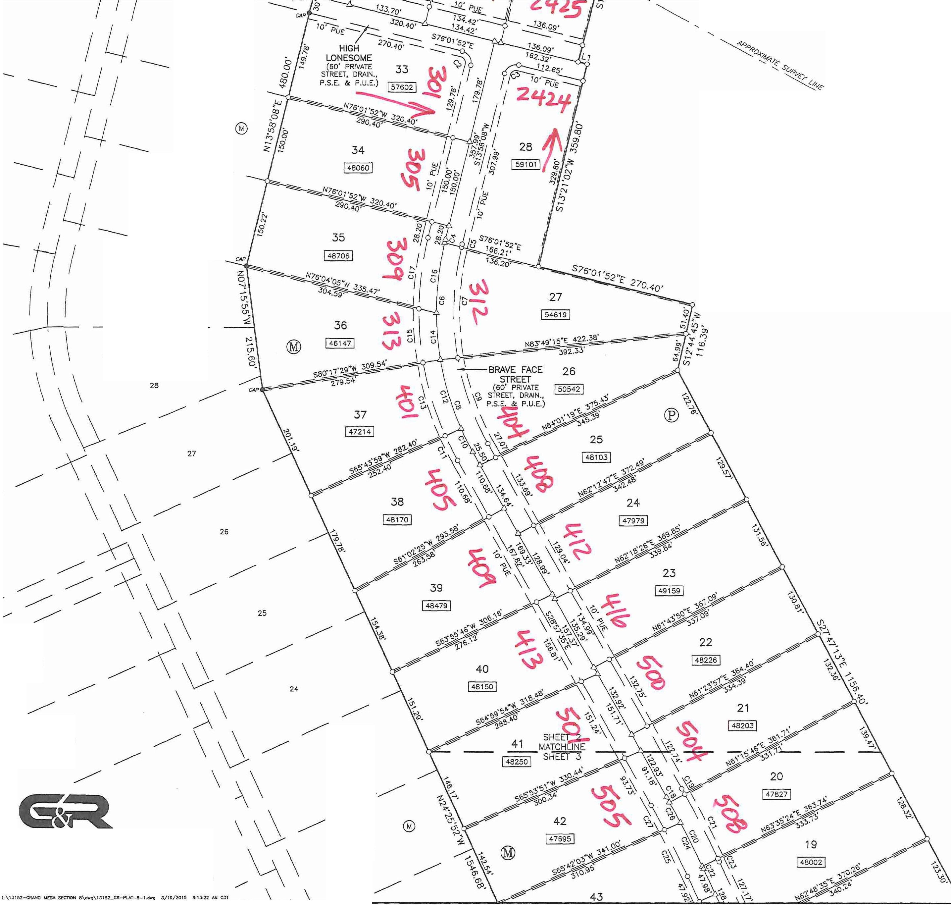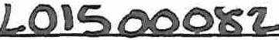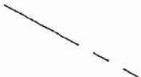

*1805 OUIDA DR*

*AUSTIN, TEXAS 78728*

*PHONE: (512) 267-7430*

*FAX: (512) 836-8385*

SHEET 2 OF 7

------------

22

I 46147 I

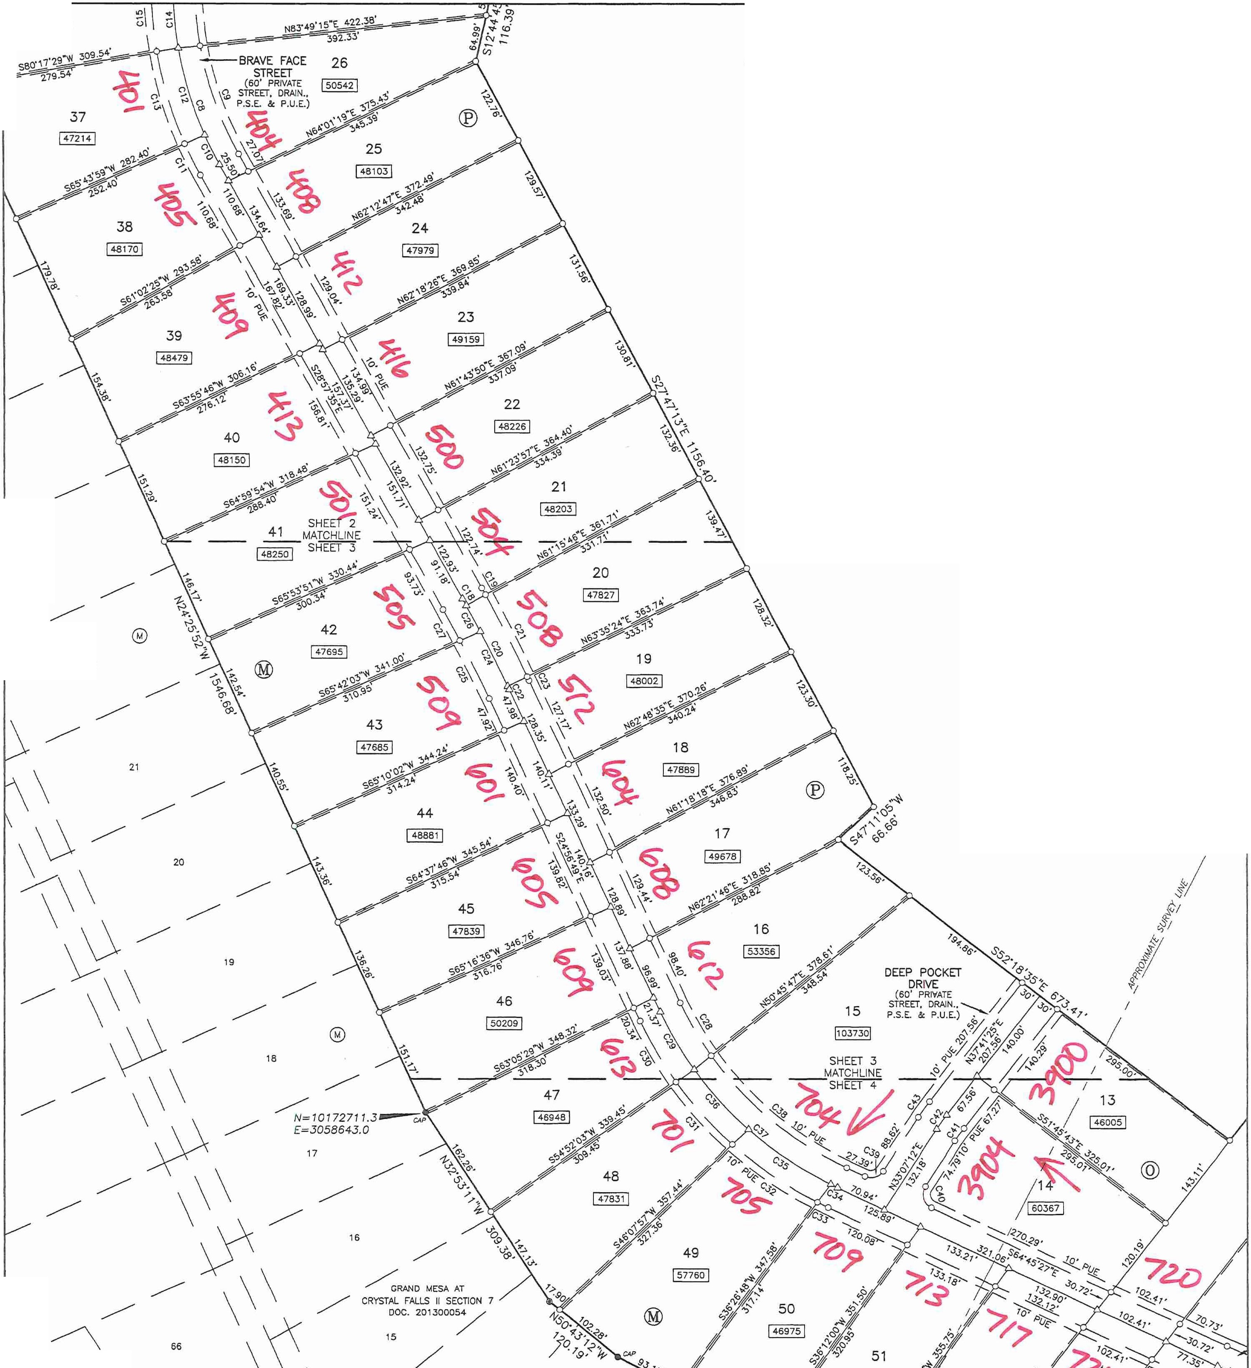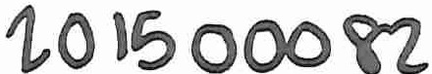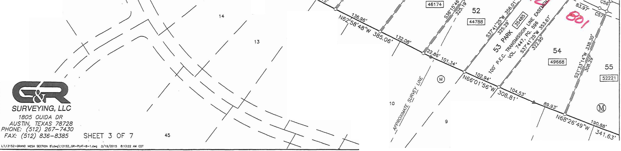

**GRAND**

**FINAL**

**MESA AT**

**PLAT OF**

**CRYSTAL FALLS 11,**

**SECTION 8, PHASE 1**

N ***AJ. /***

w* E ***l.f /t J,s M9(..,***

.- 1"=100'

s

***'2-o{,f***

0 50

100 200 400

BEARING BASIS:TEXAS CENTRAL ZONE. STATE PLANE COORDINATES (NAO 83)

23

22 REMAINDER OF

1013.55 AC. (TRACT 1)

LOOKOUT PARTNERS, LP. DOC. 2000162836

*CAND[LARIA YBARBO SURV[Y 422*

*I*

\ /

65 *I*

12

"-

*I*

*I*

11 *I*

*I*

*I*

*I*

*I*

/ 8

*MCK/NN[Y* & *WILLIAMS SURV[Y* 7 75

**GRAND**

**FINAL PLAT OF** *I*

**MESA AT CRYSTAL FALLS 11,**

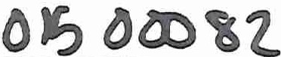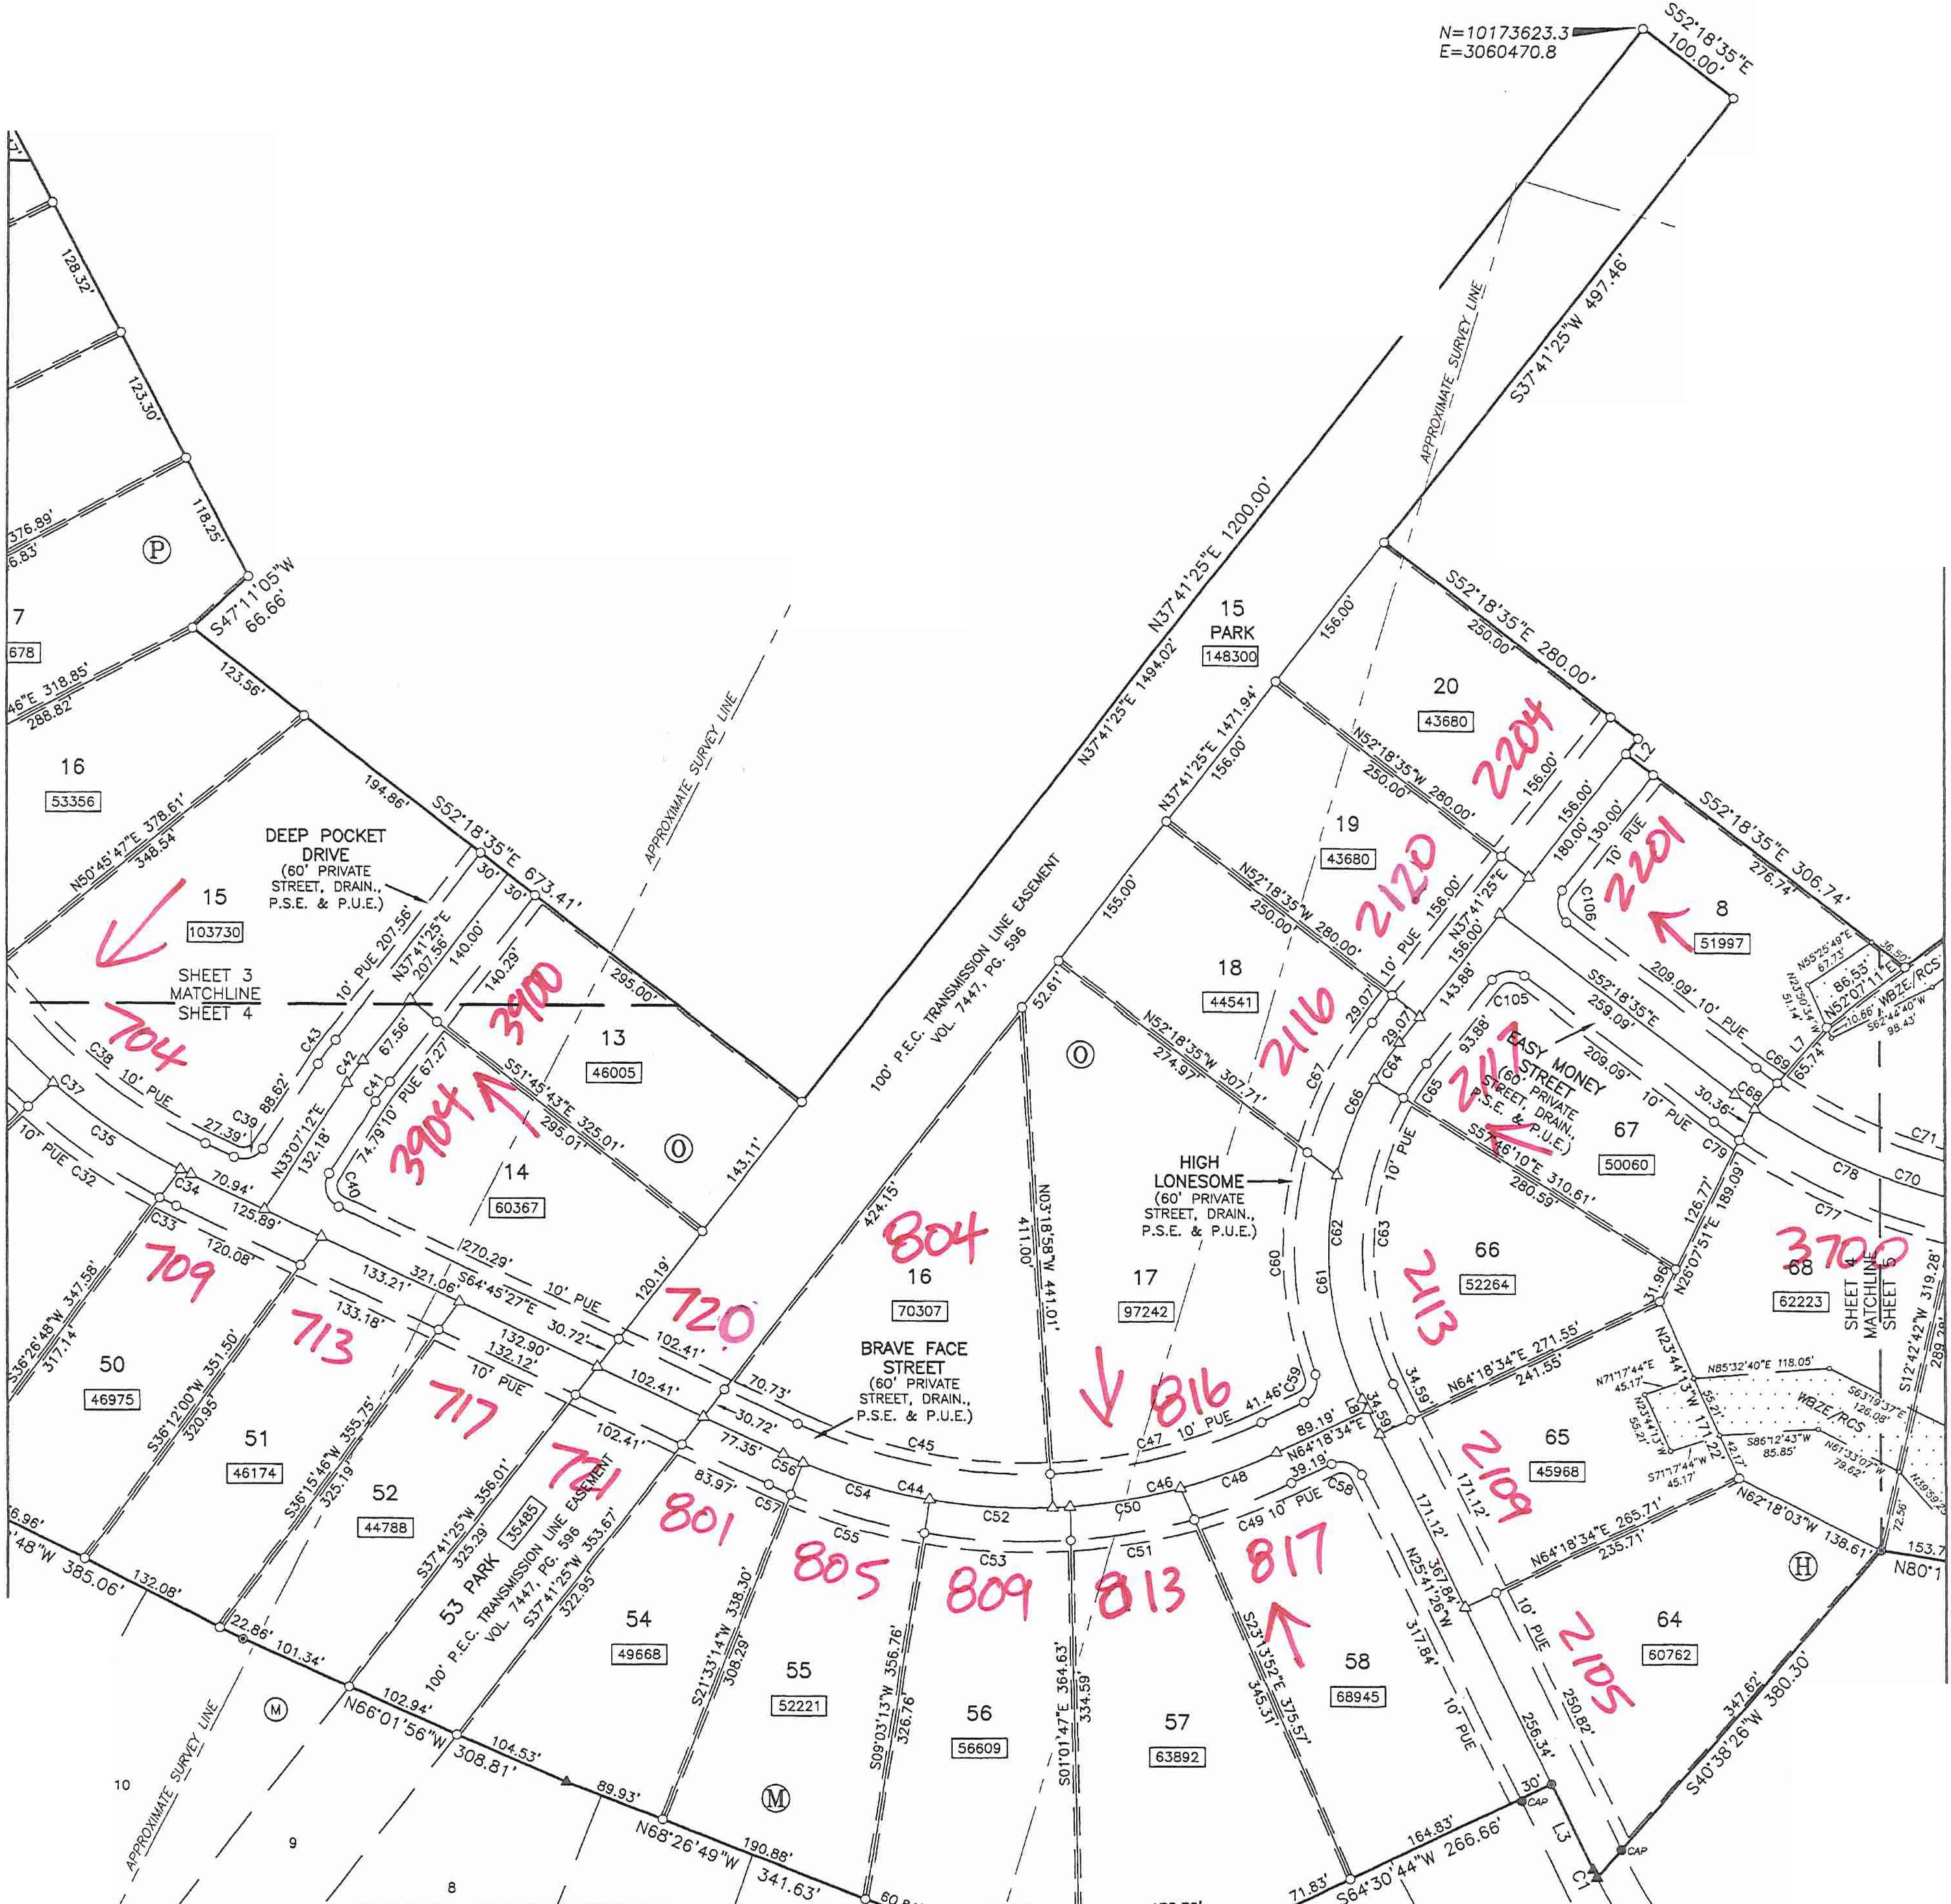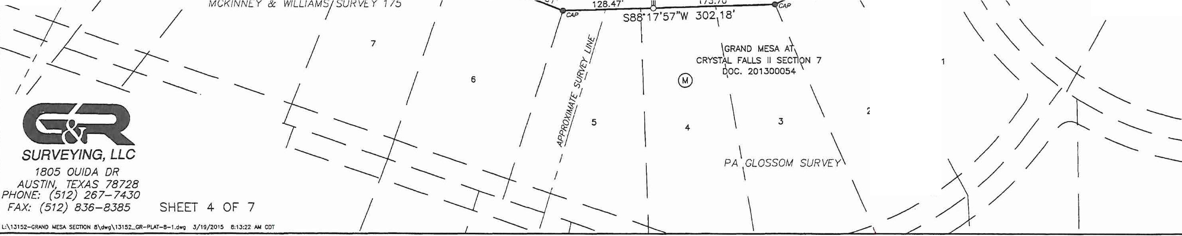

*I*

*I*

**SECTION 8, PHASE 1**

**,(J, $1**

**W E *ti}1/1s***

1"= 00' **3 'f**

!

0 50 100 200 400

BEARING BASIS:TEXAS CENTRAL ZONE, STATE PLANE COORDINATES (NAO 83)

REMAINDER OF 1D13.55 AC. (TRACT 1) LOOKOUT PARTNERS, LP.

DOC. 2000162836

*I MCK/NN[Y* & *WILLIAMS SURVEY 175*

*I*

*I*

*I*

*I*

*I*

REMAINDER OF *I*

1013.55 AC. (TRACT 1) *I*

LOOKOUT PARTNERS, L.P. DOC. 2000162836

*I*

*CANDELARIA YBARBO SURVEY 422*

*I*

------------

*I PA* CLOSSOM *SURVEY*

*I*

*I*

*I* 63 *I*

*I*

*I*

\

\

\

**GRAND**

**FINAL PLAT OF**

**MESA AT CRYSTAL**

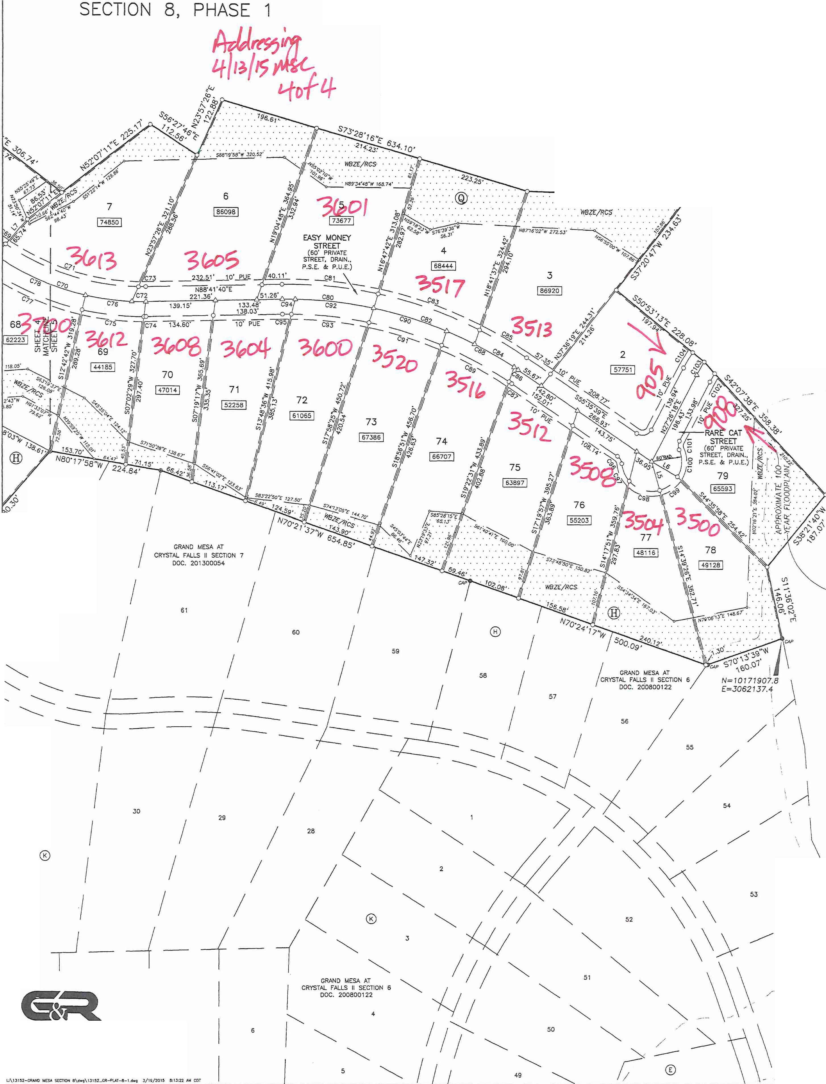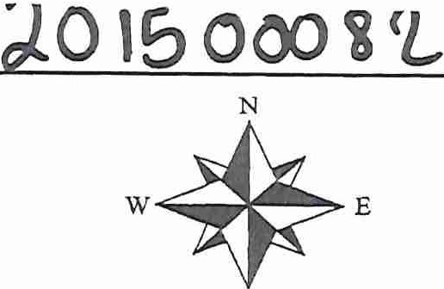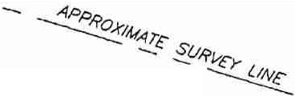

**F**-**A**----**L**---**L**-­ **S**

-;--.._

*MCKINNEY* & *WILLIAMS SURVEY* 175 ..

\

"'

\

--

**1**,**1**

- - ----------

REMAINDER OF 1013.55 AC. (TRACT 1) LOOKOUT PARTNERS, LP.

DOC. 2000162836

PA *GLOSSOM SURVEY*

'

.. 1"=100'

s

- ----------- , 0 50 100 200

- BEARING BASIS:TEXAS CENTRAL ZONE, STATE PLANE COORDINATES (NAD 83)

400

' \

S88"08'23"E 320.33'

------------

'

%

- ...._

'\

- ----------

'

\, /

V

' \

..

\

REMAINDER OF 1013.55 AC. (TRACT 1)

LOOKOUT PARTNERS, L.P. DOC. 2D00162836

*I*

*I*

63

*I*

62

*I*

*I*

31

\ ,\

\

,,.,.-------

\_ \

*I*

/

52

***SURVEYING, LLC***

*1805 OUIDA DR*

*AUSTIN, TEXAS 78728*

*PHONE: (512) 267-7430*

*FAX: {512) 836-8385* SHEET 5 OF 7

---*I*

*I*

*I I* **14**

*I*

*I*

*I*

*I*

~ *I*

**35f>...,(**

7" t'.?R;:--;;:f\-24:::_4_-1.- ::::a1

*I*

*I I I).,* 45

/*I* 6 *1*

*I*

**48**

*I*

*I*

*I*

*I*

9 // j

*I*

CK *c)//*

*I I*

**SPYGtASS HILL**

*I*

(.

' ' ' '

*I*

\ \

\ \

\ I

*I*

I \

**7 *,:i*** \ \

I \

**76** I I

I I

14

I I

13

*I* I

*I I*

*I I*

1 2 \

------------

\

I

\-------

\

.,

I I

I

---\

'

\ *I* I

\ *I I*

\ ' *I i*

\

\ ' \ *Ii II*

\ \ *I I*

\ \ *I I*

\ \ *I I*

\ \ *I I*

\ \ *I I*

*\/*

\ //

\ I I

\

\

*I*

*I*

*I*

\ *I I*

I *I I*

\ / **V**

\, *I*

*I*

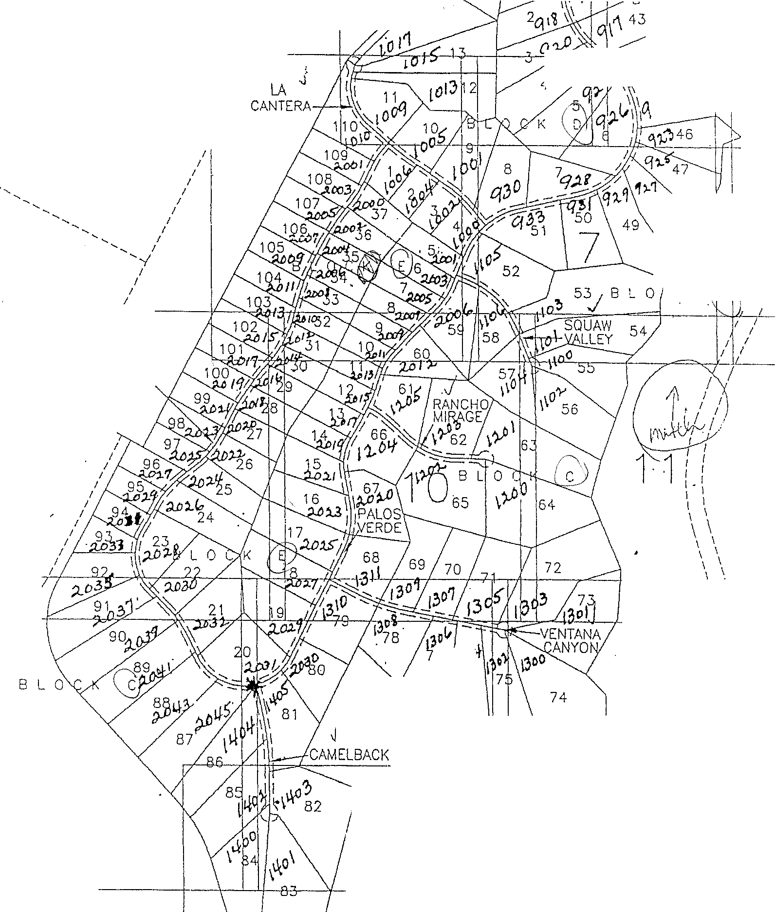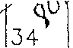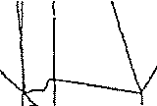

*I*

*I* I I

I.

*I*

I

*I*

\ SHEET 2 T

I

I

I

I SHEET 3

I

2+

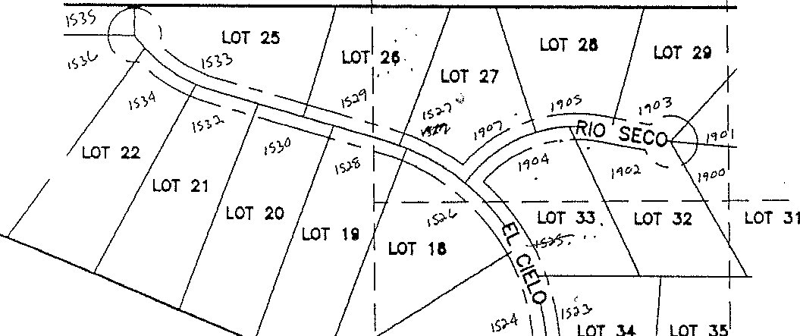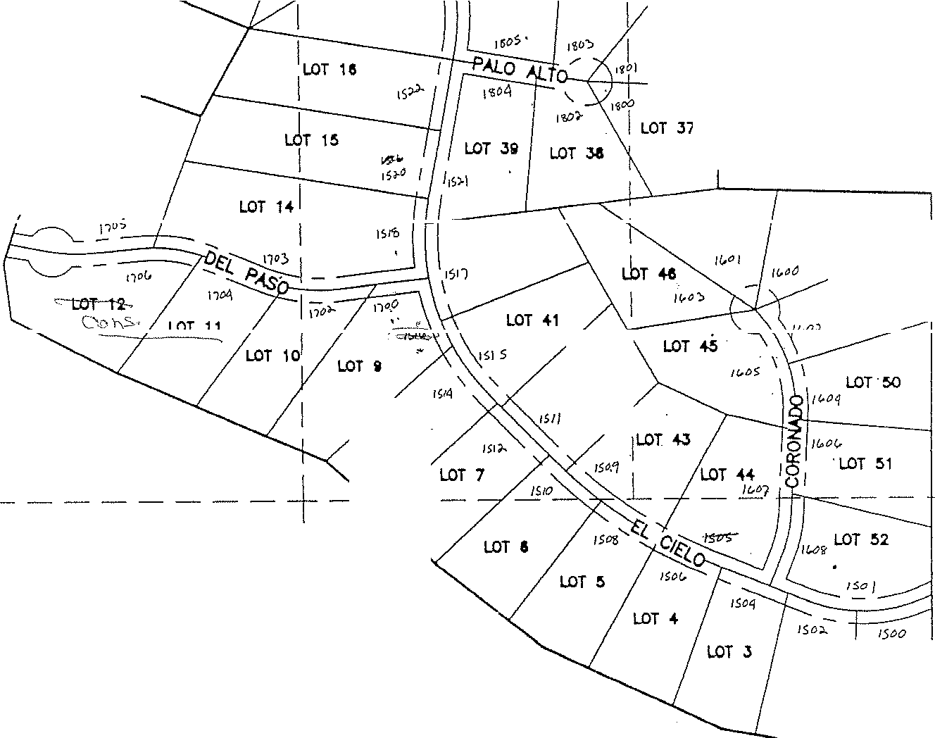

LOT 30

LOT 23

LOT 17

LOT 3a

LOT 1J

LOT 40

LOT +7 LOT -ia

LOT +9

LOT -421

LOT a

I I I I

I

I

I SHEET 4

L _

LOT 2 LOT 1

**LOT l**

**a.or 4**

**LDT 10**

n,) 1)11 I

**11 LDT 15 LDT**

*.J*

**IIIIIOCK "II"**

**LDT 12**

**1J**

*±¥1*

**LOT 14**

130,;i..

NOT TO SCALE

**LDT 7**

*t41"l*

141,

**LOT 10**

**LOT J**

**LOT 11\ .J.OT 15**

1.3,06

j/ ' ··- •••*·-t4-&,q..*

*1410*

**LDT *2* LOT 1**

**LOT 5**

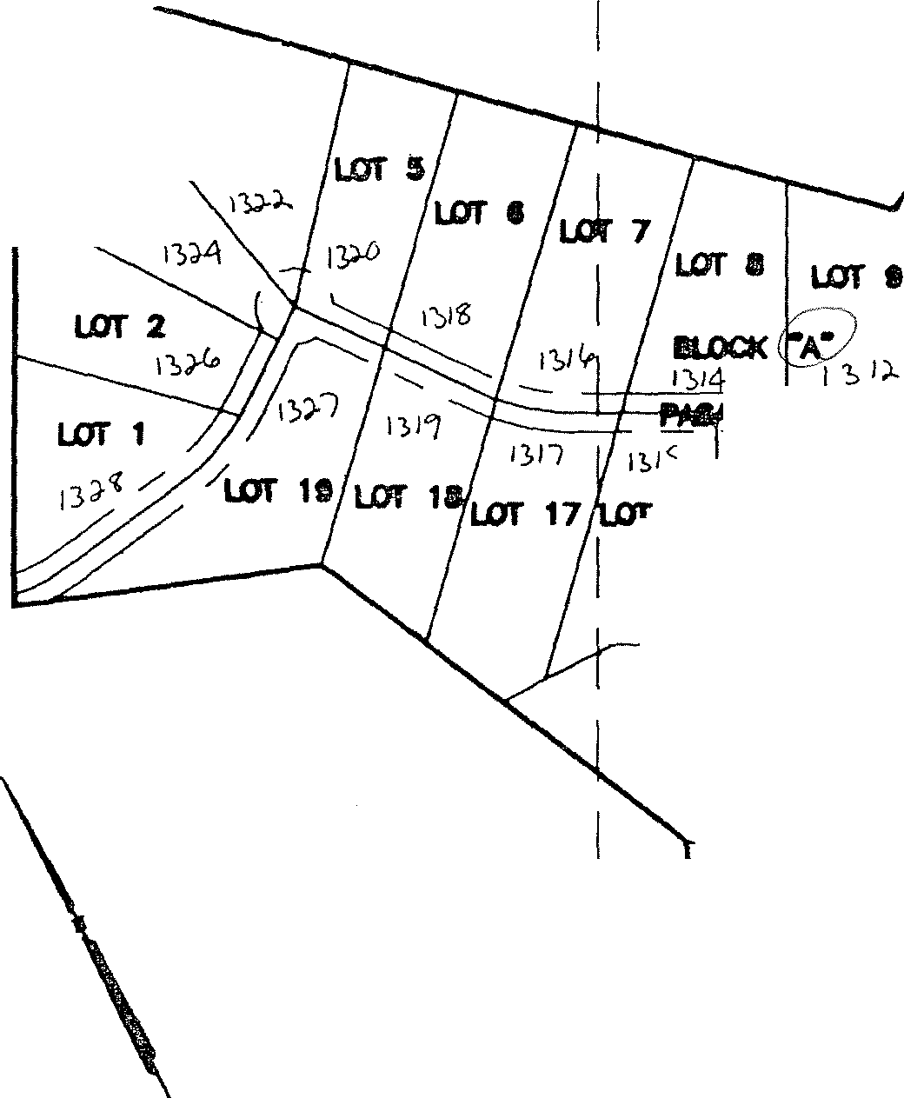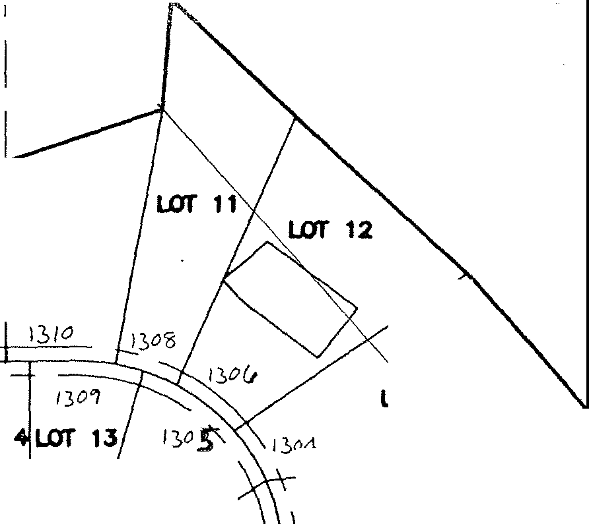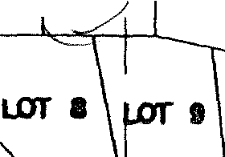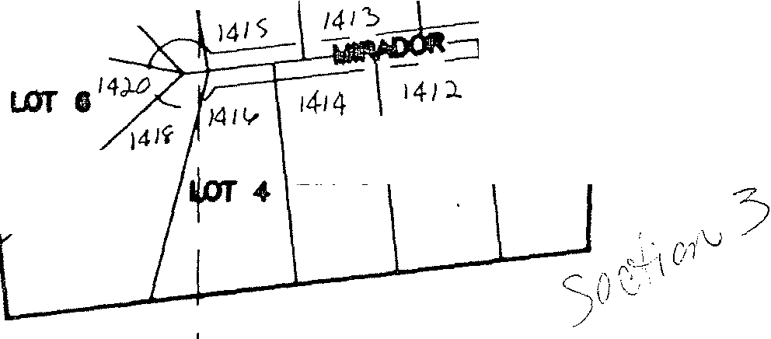

_L SI

SCALE IN FEET

1 500 300 o·

600

*<*

\

\

\

\

\

2 \ \

B L 0

4.

L O ( K

A 5

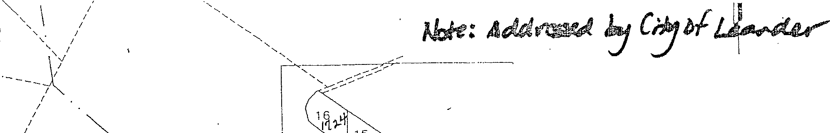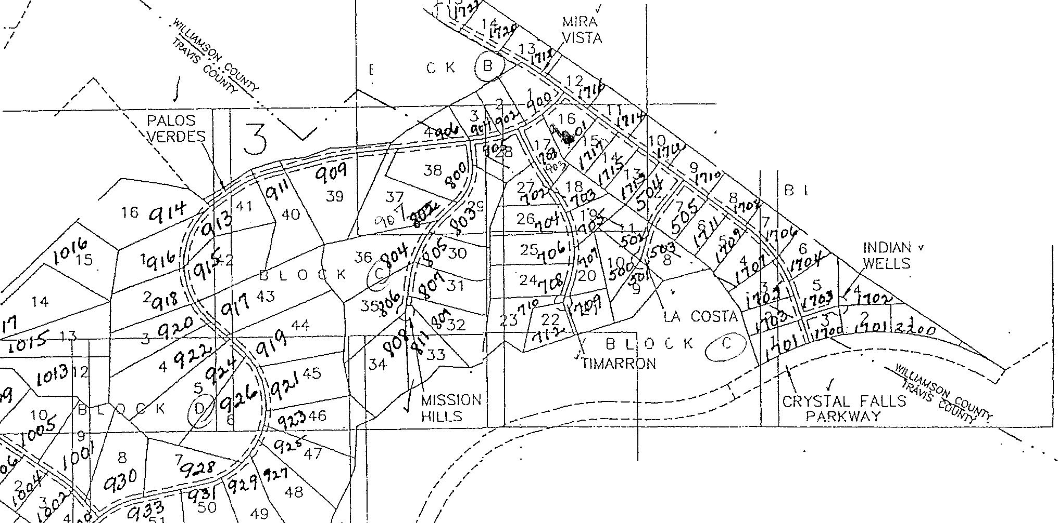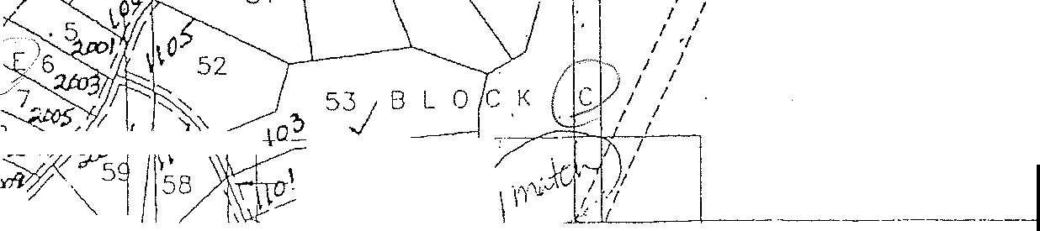

0.

0)

(i)

r-i

0

r-i

0

;j

r-i

I

Ol·..,.,.., ;.,..;,o/P-it-s- ,IS,\\:,-,

:,

*"11/* r;n ,

8

7

SQUAW 54

- ,LLEY

. 1/\0

"'-

\i;,'

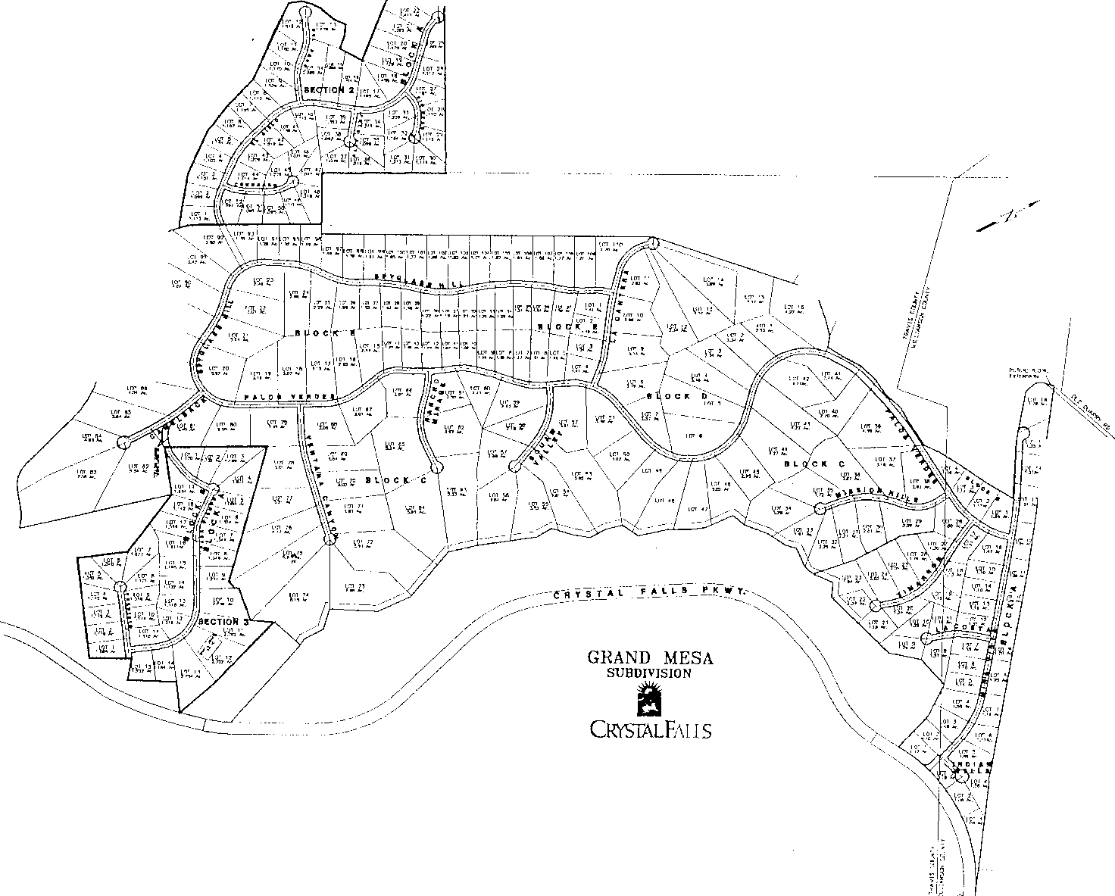

·-*'-:*'"*-*'*=*.\,*"*._-,

*/ l*

*I*

I",., *I*

·-----

'fl.l!

,, --,,

,*,-*,*•*,*,*.*rc*,*p*,*c*

I

I

I I

I I I I

I L _L _J

1- 7 I

I I I

-1 _J

I

**LBGBND**

-· 1 **/2" IRON ROO 1M1H •CHAPARRAi.**

SHEET 4

I • **1 */-Z-* ·IRON ROD FOUND**

***v•* 1/2" IRON ROD IM1H "CUNNWGMA**

I

**Lor·21**

<Y)

\()

3=:> I

0 **1/2" IRON ROD OR MAG NAil IIIITI**

* **HllTl NAIL FOUND**

-·

**MAG NAIL WITH "CHAPARRAL" SMlt**

l::L

**LOT 28**

<c::J

I

**(XXX) RECORD INFORMATlON AS PER**

**DOCUMENT NUMBER 200000019**

LOT c,

**LOT JO**

**LOT Ji1**

**[XXX] RECORD INFORMATION AS PER**

**'vO..UME 13085, PAGE 1974**

7

I I

**LOT 32**

**LOT 33**

I_J I

I

I

I I

LOT **J5**

,r **LOT,lSe**

\

\

**LOT J4**

\,

I

*'Q,*

,;;- ' /"

'

f,frw *m*

-

;'!J

*m* I

I

"

**LOT Ji7**

*0'*

<J/

*t'r*

*1 I.* **'i(** FALLS

f.? */ -,/:*

*S;'/*

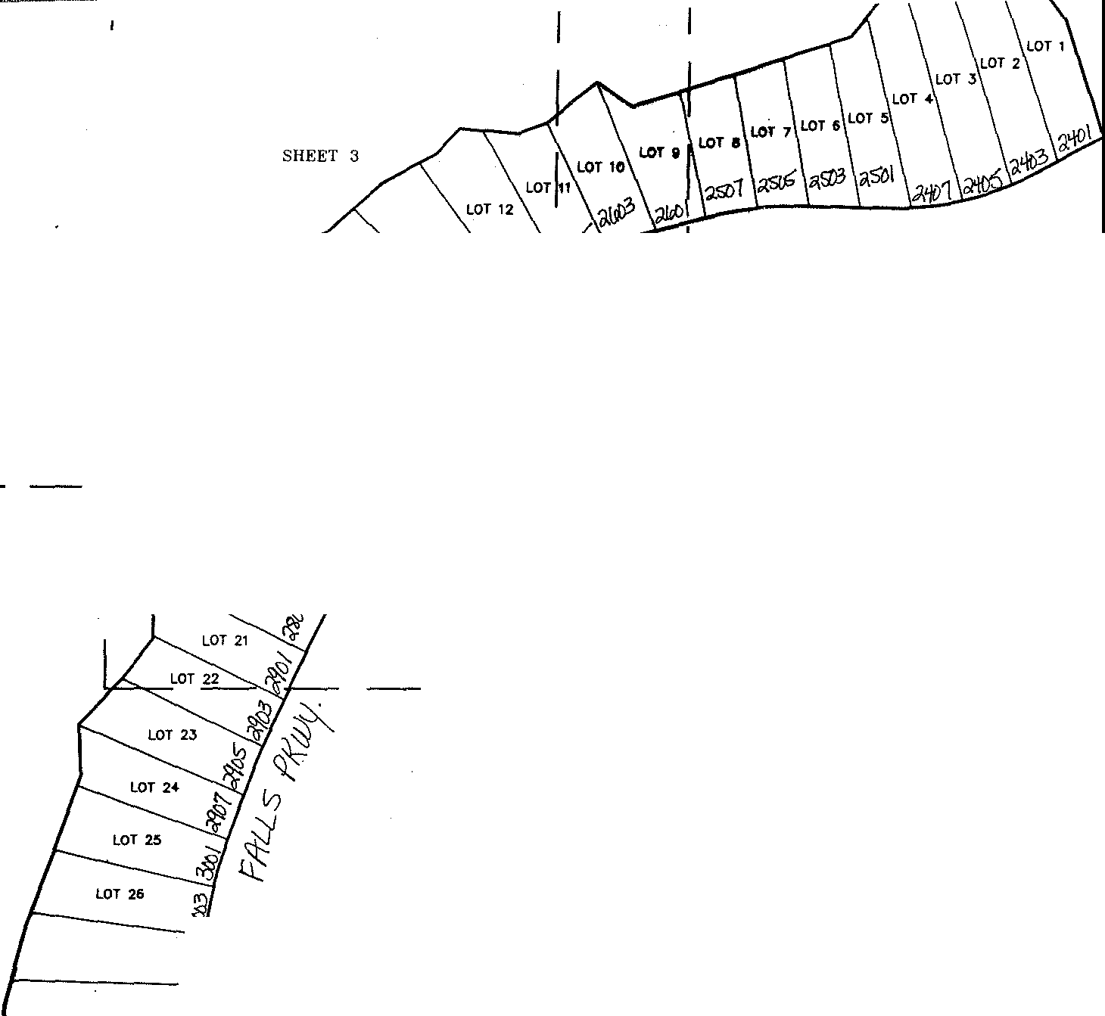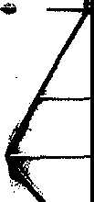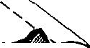

J\?

LOT **J8**

**LOT Jg** */J*

*(*

I

'

I

**SllftTl!fflEX**

**(HOT TO ""'-E)**

I

I I

I I I

I

*(*

I

i

I.,.,

I

i 1-

I I

I I I I I

r-1

7

I

-1

I

I

SHEET 4

I

I

71

LJ_

I I

_J

_J

**LEGl!ND**

e 1/2" IRON ROD FOUND

a,fil,11• 1/2" !RON ROD WITH •0-1APARRAL" CAP rOUHD CU'l/tl!IW• 1/2"' 1RON ROD WITH "CUHNINGHAM-CRA'v£s" CAP F'OUND

O 1 /2" 1R0N ROO OR MAG NAIL \IWTH • orno· CAP SET

A HILTI NAIL F'OOND

Clfilol'.6, MAG NAIL WITH "otAPARRAL" SHINER FOlJND

(XXX) = F=: OH g

[XXX] RECORO INFORMATION AS PER

VOLUME 13085, PAGE 1974

\. I I I I

'

*/"*

'--.

" I L

''- LOT 33

I LOT 34.

LOT 35

I

I

I

SHEET 5

I

I

L

I_J

I I

I

I

I I

_J

LOCATION **!IAP**

(NOT TO SCALE)

**GRAND MESA**

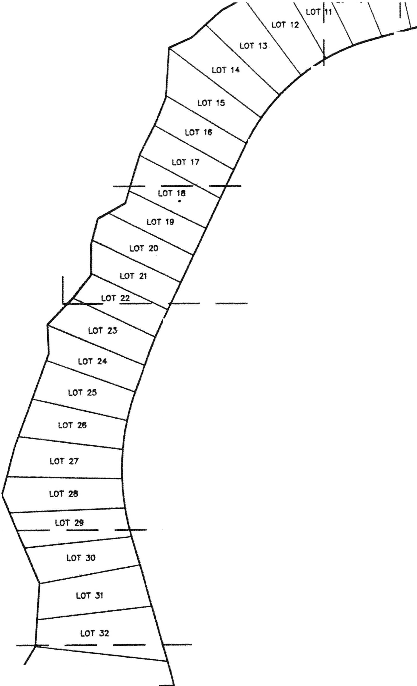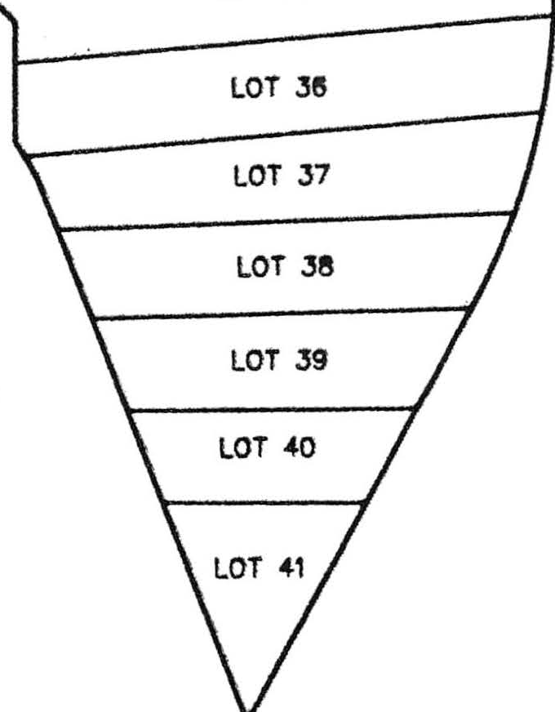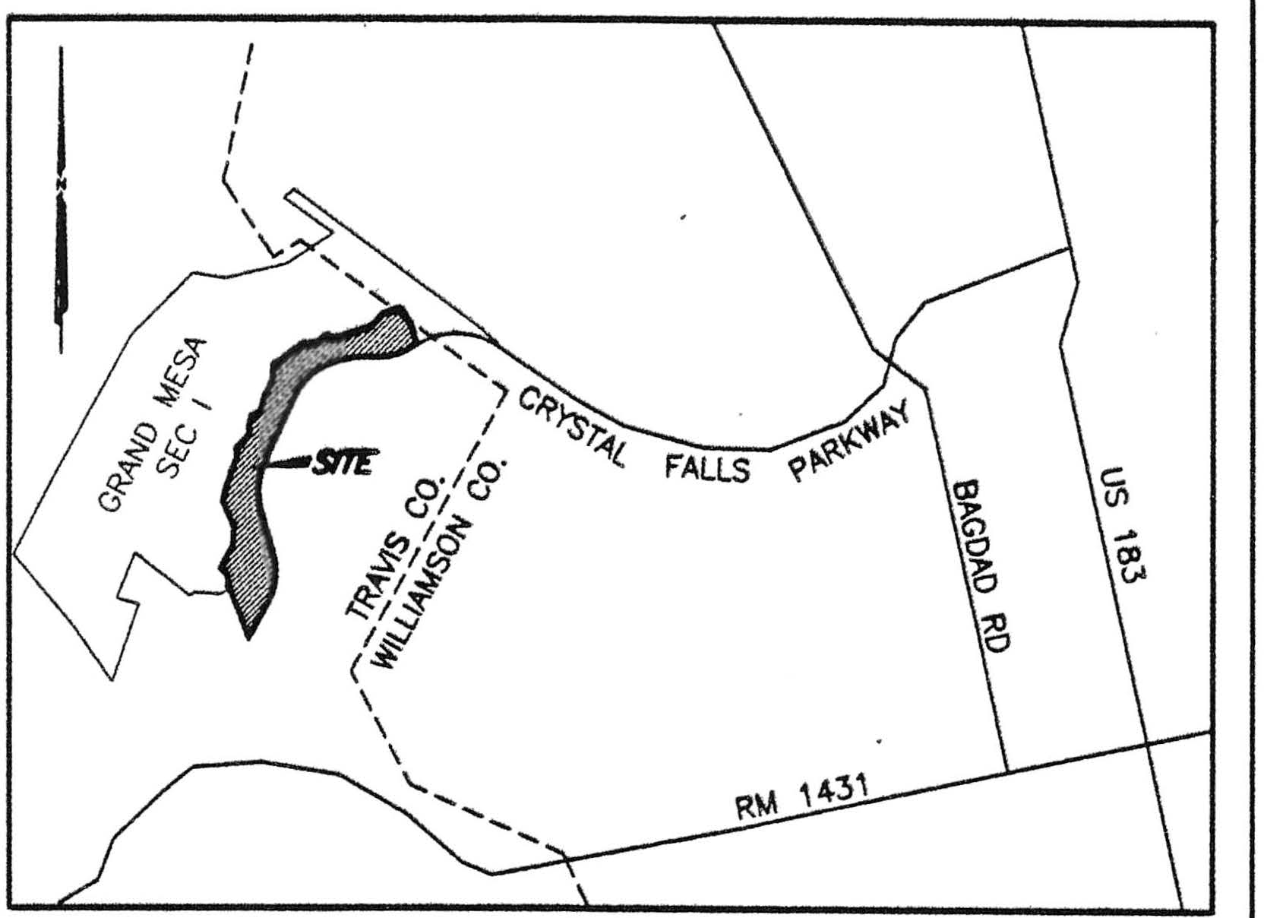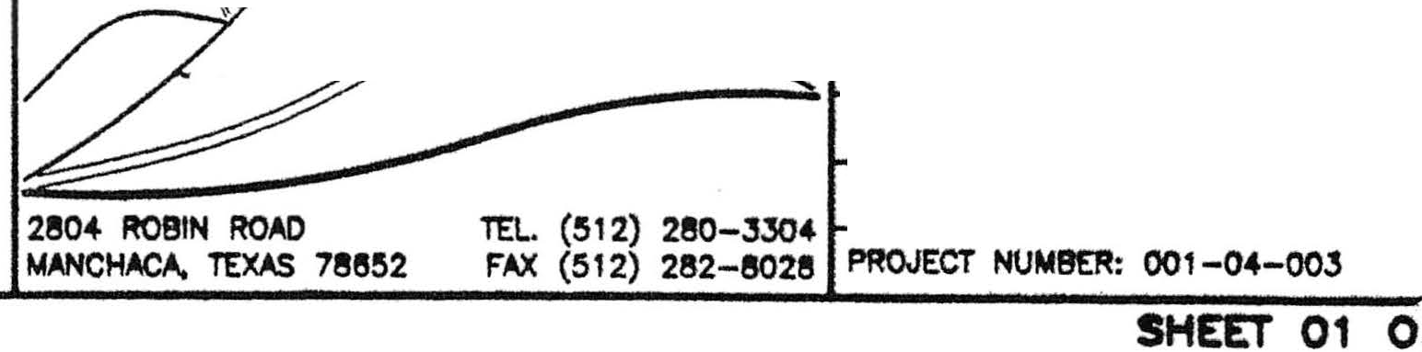

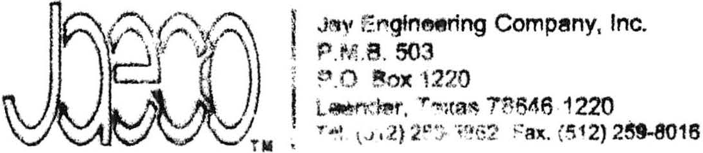**SUBiSION**

**CRYSTALFALI.S**

*\V*,

*st: ri:wc*

*/T7*

PLOT DATE: OJ/11/04 SCAL.£: 1"•100'

"- DATE OF SURVEY: February, 2004 9EARING 9AS1S: Doe. No. 200000019

DRAWN B't': PMC APPRtM:0 Err: •PMC

FlELDNOTE FlLE; NA

DRAWING FILE: 001-04-00JPL

**1..M 8 1.1"2..tS**

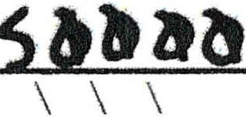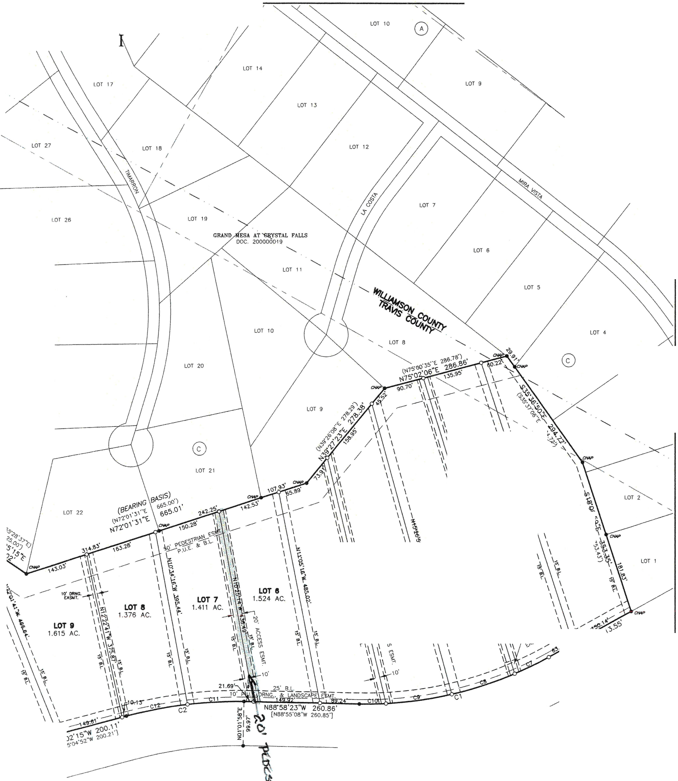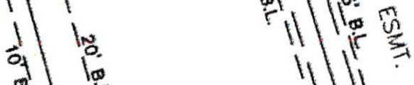

\ *I*

-GRA---N D

MESA IV AT

*I*

LOT 15

CRYSTAL FALLS I

'--

LOT 28 '-..,

192.46 AC.

MASON FAMILY' PARTNERSHIP, LTD.

VOL 2653, PG. 412

LOT 8

LOT 7

LOf 25

LOT 24

LOT J

Lor 2J

I

' '

\ti

**LOT 1**

* 1.922 AC.

I 0\

\ I \

*rs* \:i1 I 1t-

\ 2. !c \

\Iii \ ,1, **LOT3** I

\\ ';i_i \

I 2.236 A

i;,,_ **LOT 4** •

**LOT S** 1\ 2.000 AC. la.

i

1.606 AC. I\ l',

\I

'0,

_.),'\1 r,_ *o.*

-.

IJ..

""

'

',.:\\\ \,:*(* r, '.,o 'l,

J- -

"

**1** \ **r..'**

,C *y * .

\ *i* \1c,

\ \¼.u'\J'

*(* \ 'S

,s,

CRYSTAL FALLS PARKWAY

(VOL, 10833. PG. 1446)

(100' R.Q.W.) (ASPHALT)

'\s<il'

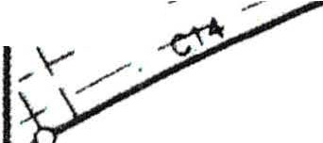

' //

. I

**s**

**RAND MESA IV AT CRYSTAL FALLS** II

*I*

LOT 36

LOT 30

LOT 4J

*I*

*I*

*I* LOT 44

LOT 35

C YARBO

LOT 33

SURVEY 420

LOT 31

LOT 32

LOT 23

*rs*

LOT 24

LOT 22

LOT 34

GRAND MESA AT CRYSTAL FAUS DOC. 2000000 19

LOT 10

\ 'f.

\ ­

1\

\ \

LOT **t**

1.615 AC.

**LOT 12**

\

\ \,

\ "\'

\ ,:..

\ \

\ \

\

\ 1.627 AC.

LOT 11 \ ;,

1.543 AC. "

I \

\ ., I

1.971 AC. \

\

LOT 46

LOT 47

LOT 48

tsi5

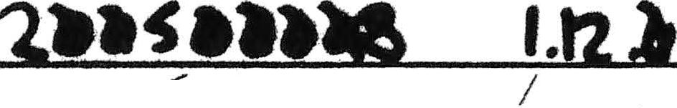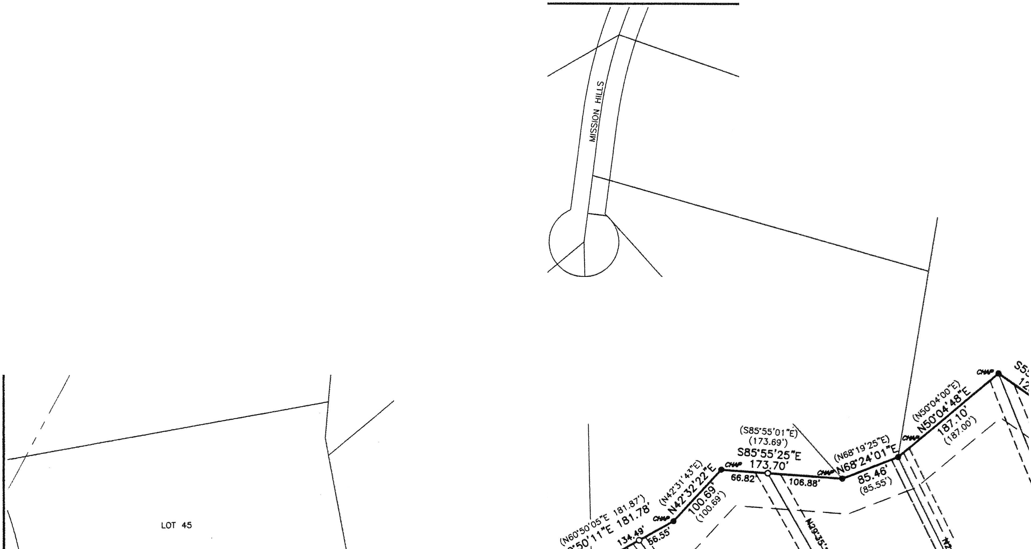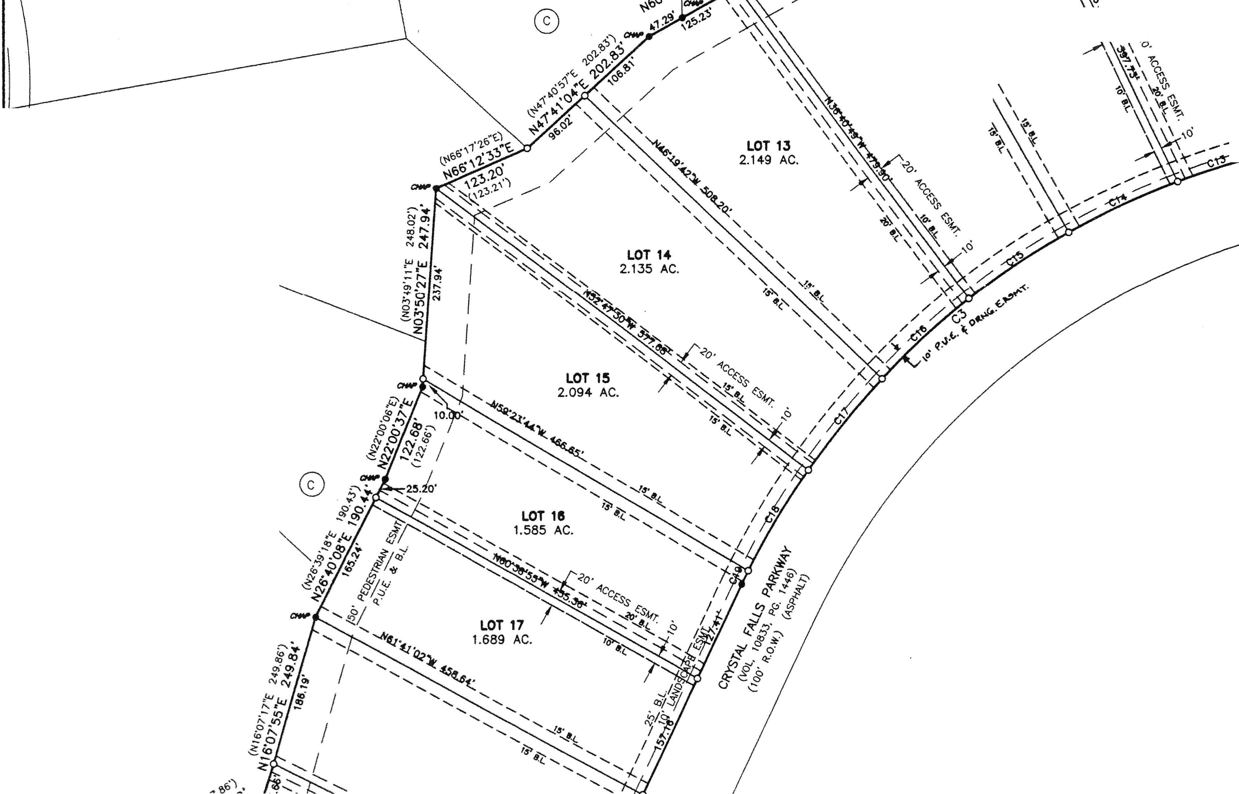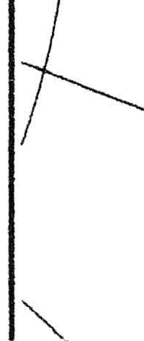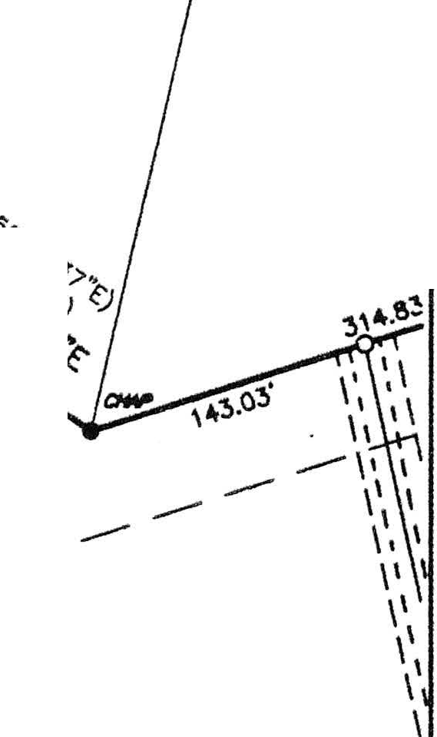

LOT49

LOT **18**

1.770AC.

PORTION OF

1142. 166 AC. (TRACT 1) LOOKOUT PARTNERS. L.P. VOL. 13065, PG. 1927

'2.

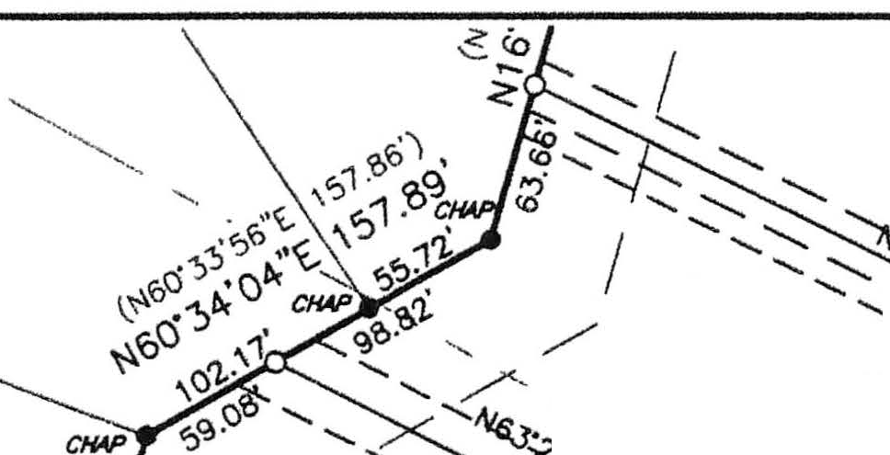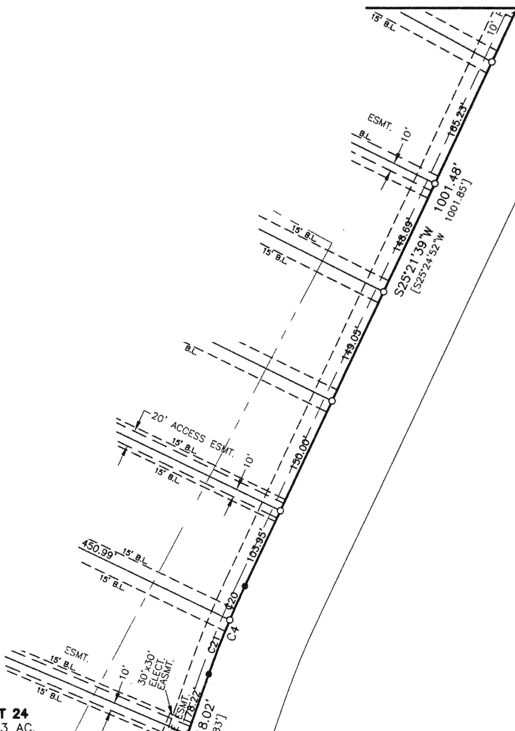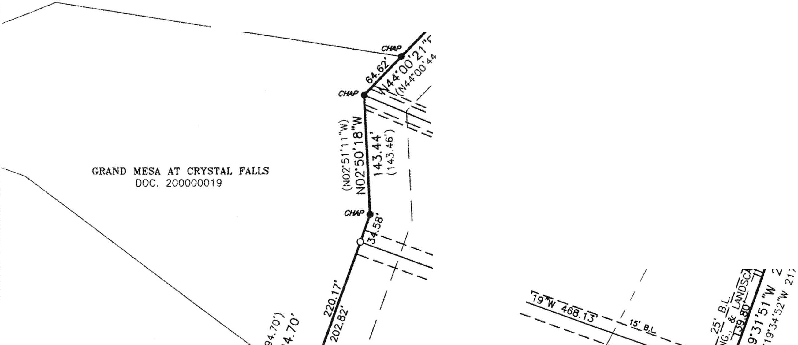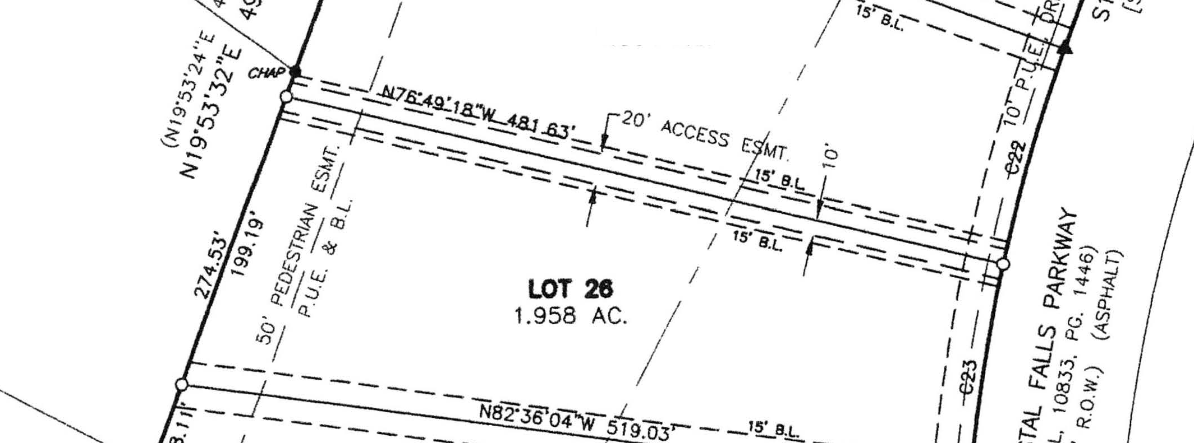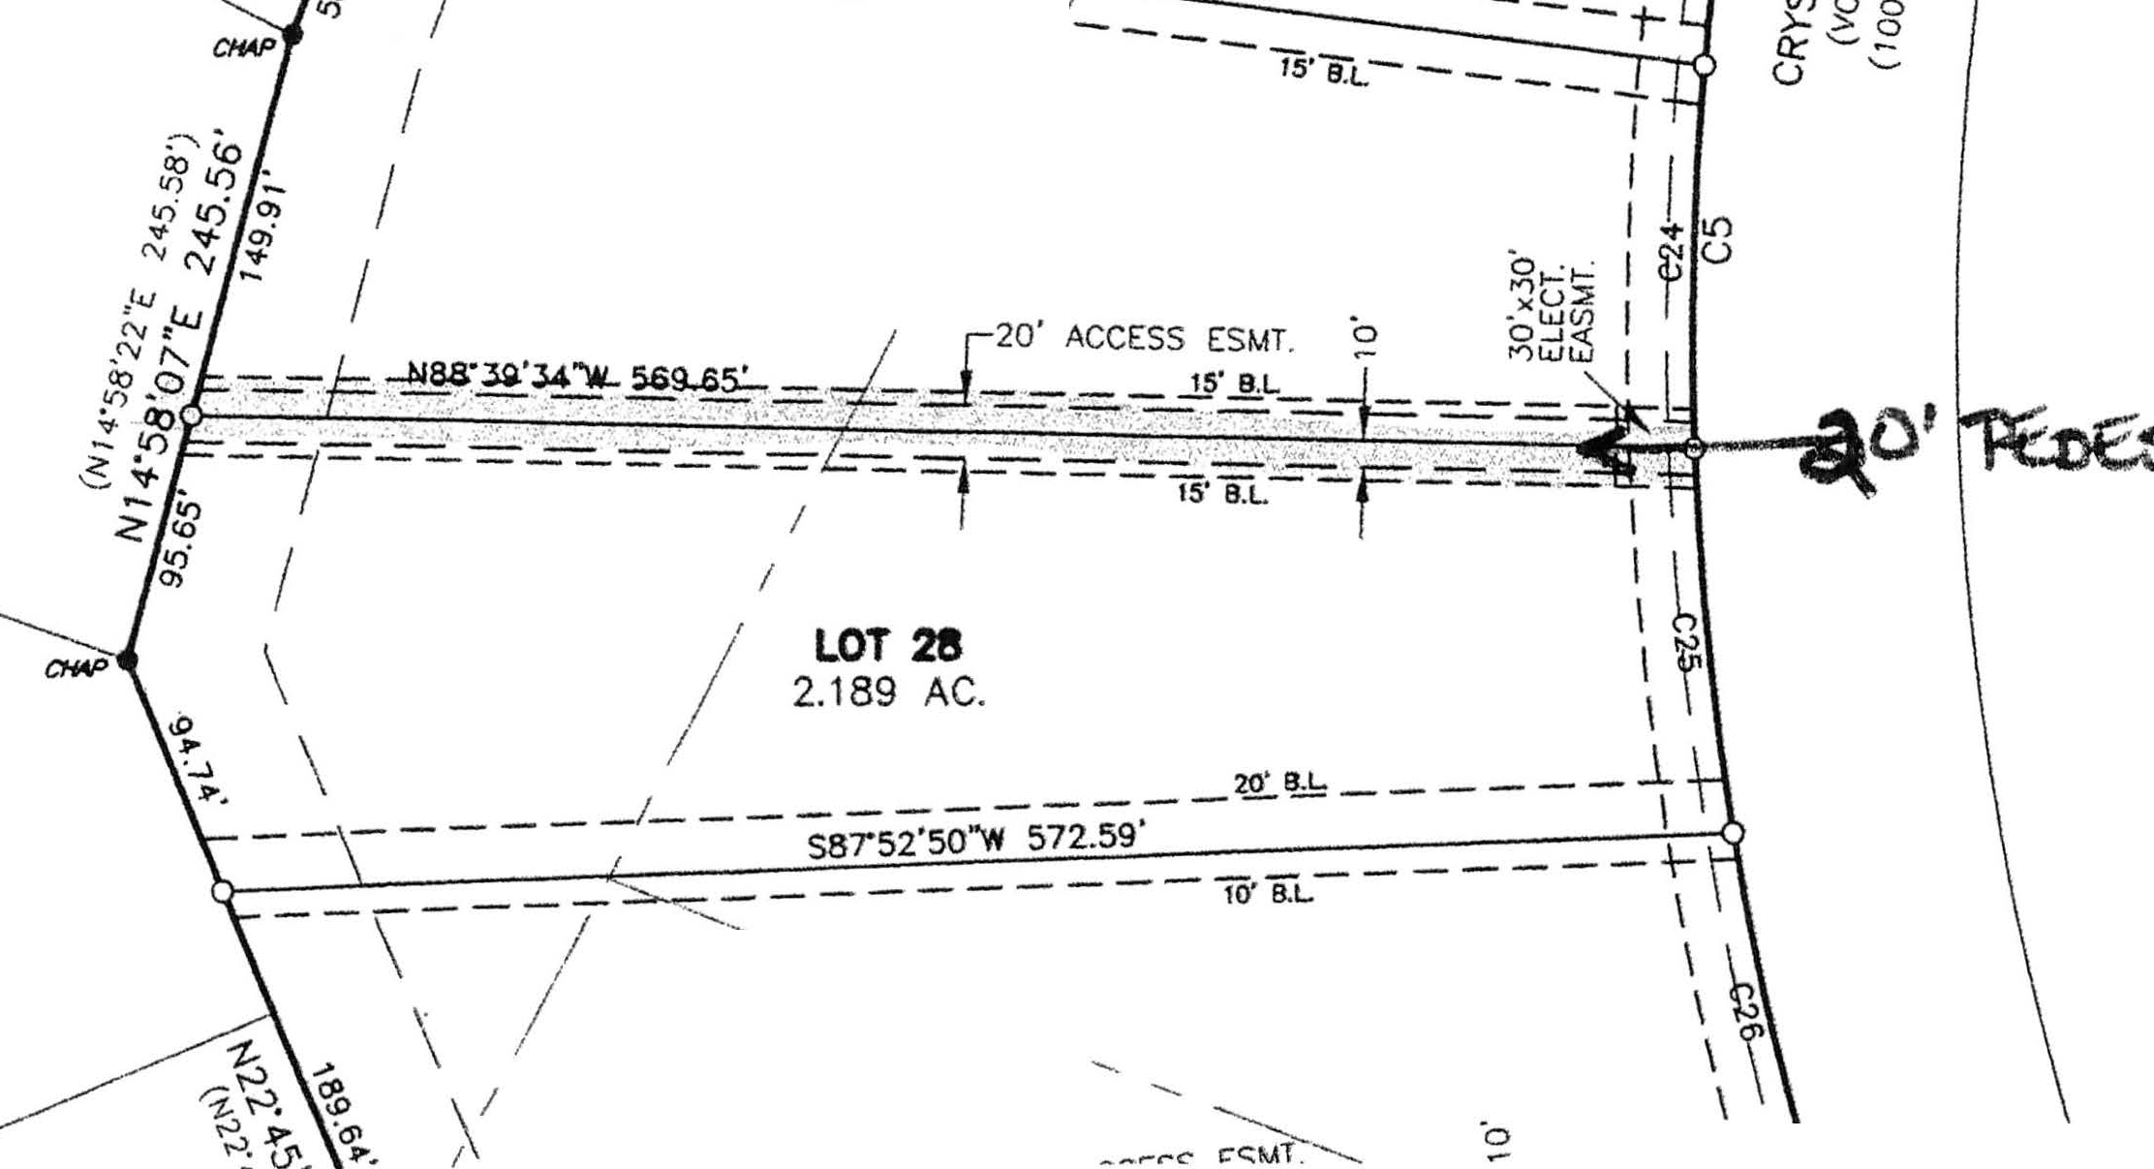

I \

GRAND MESA IV AT

LOT 49

**LOT 18**

1.770AC.

YSTAL

FALLS

'<--.;.;..,,,.::---.._

........

*{;' "«>¾:,*

- */'<o <cc*

, , *Css*

LOT 1;y fk. *'o•*

1468AC ' ,.,,

I

N

*(){'?;_* .............. ......

LOT 53

* 1. HEART SURVEY 704

*::t -cr, I* .................................::---

*.!:.* -.......*:!* .............

..-.in LOT 20 ',

j;:"!""" ', 1.740 AC.

20.11>'.j, ................................... .......

,, *R* ',,

*aw>* ....... ......, *<s6_"'1t,*

... *......, ...'..!.8 ,?J-. $ ,*

g zob '

LOT 54

-z **LOT 21**

588 AC.

'

SCALE IN FEET

100 50 100

LOT 55

' *I*

* + - .-.., '9".,?,..,

/ .....................

**LOT 23**

,,_., 1.803 AC.

- ::

--::--... -. ::

*J-lo·*

....._"" .._¼

*- ...'....:::..;:...... -1cccss*

*'I'*

**LO**

---- 1.71 •

--

-- ..........._ *NJ"o.o:,*

**LOT 25**

1.894 AC.

LOT 56

----

PORTION OF 1142.168 AC. (TRACT 1) LOOKOUT PARTNERS, L.P.

VOL. 13085, PG. 1927

LOT 63

**LOT 27** /

2.181 AC./

C. YARBO SURVEY 420

**n.iP\'JJ 6' 0-t*r***

99.1236 AC. C1TY OF LEANDER

VOL. 10833, PG. 1355

LOT 64

**LOT 29**

2.051 AC. _,\ \

,'

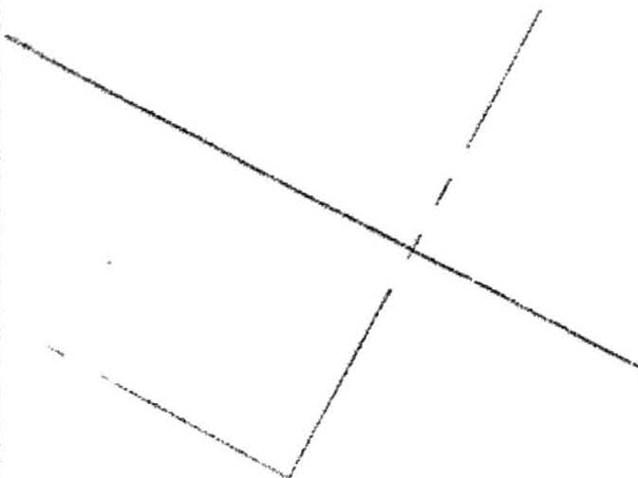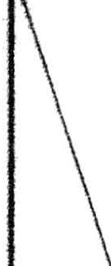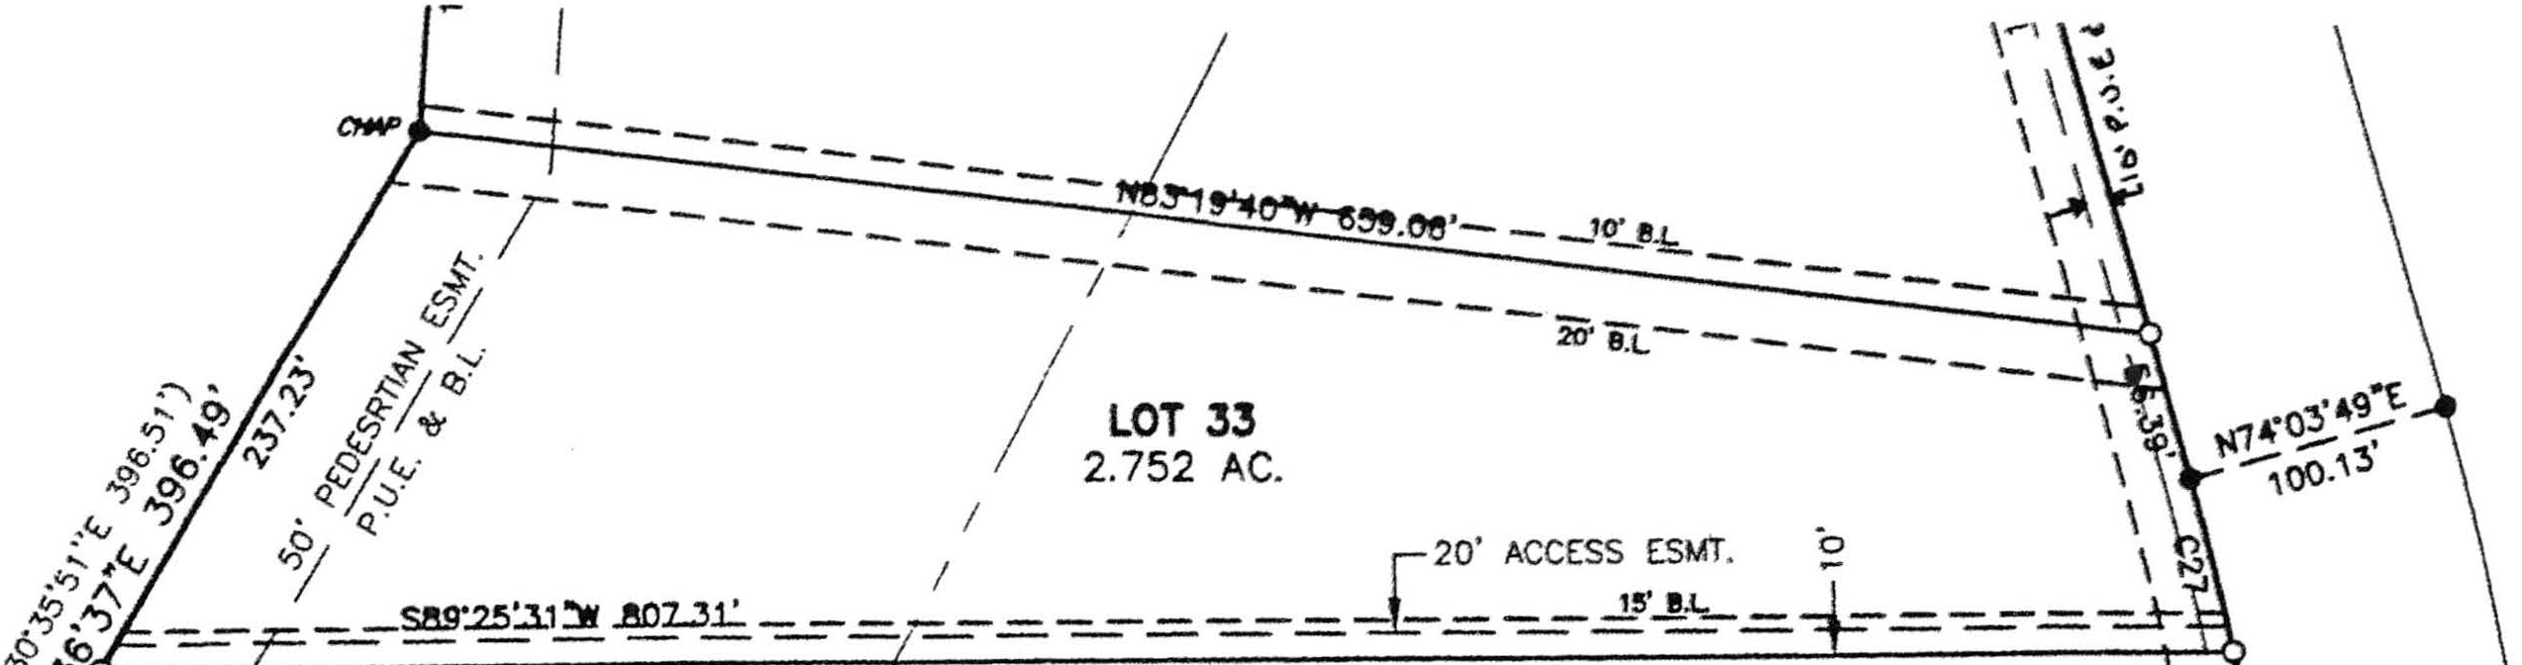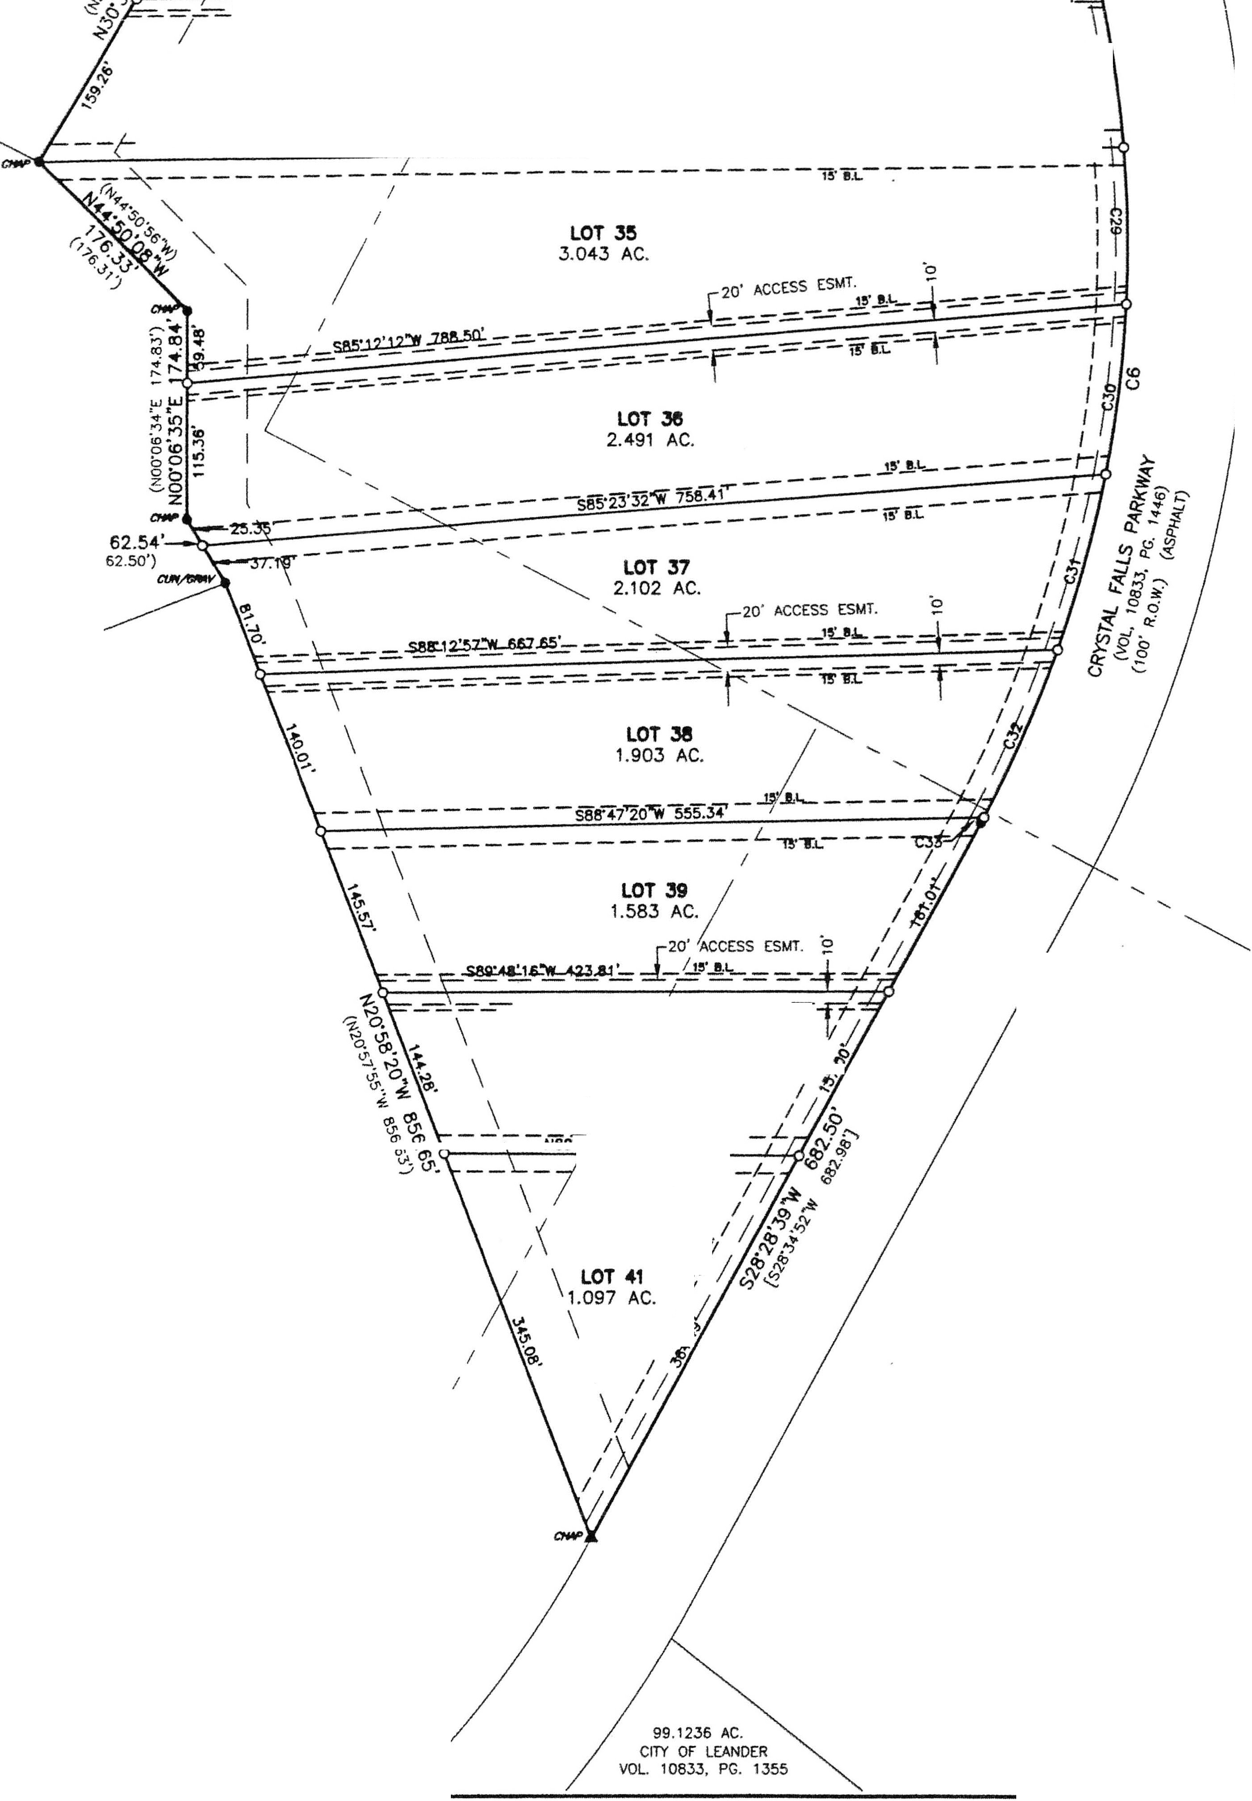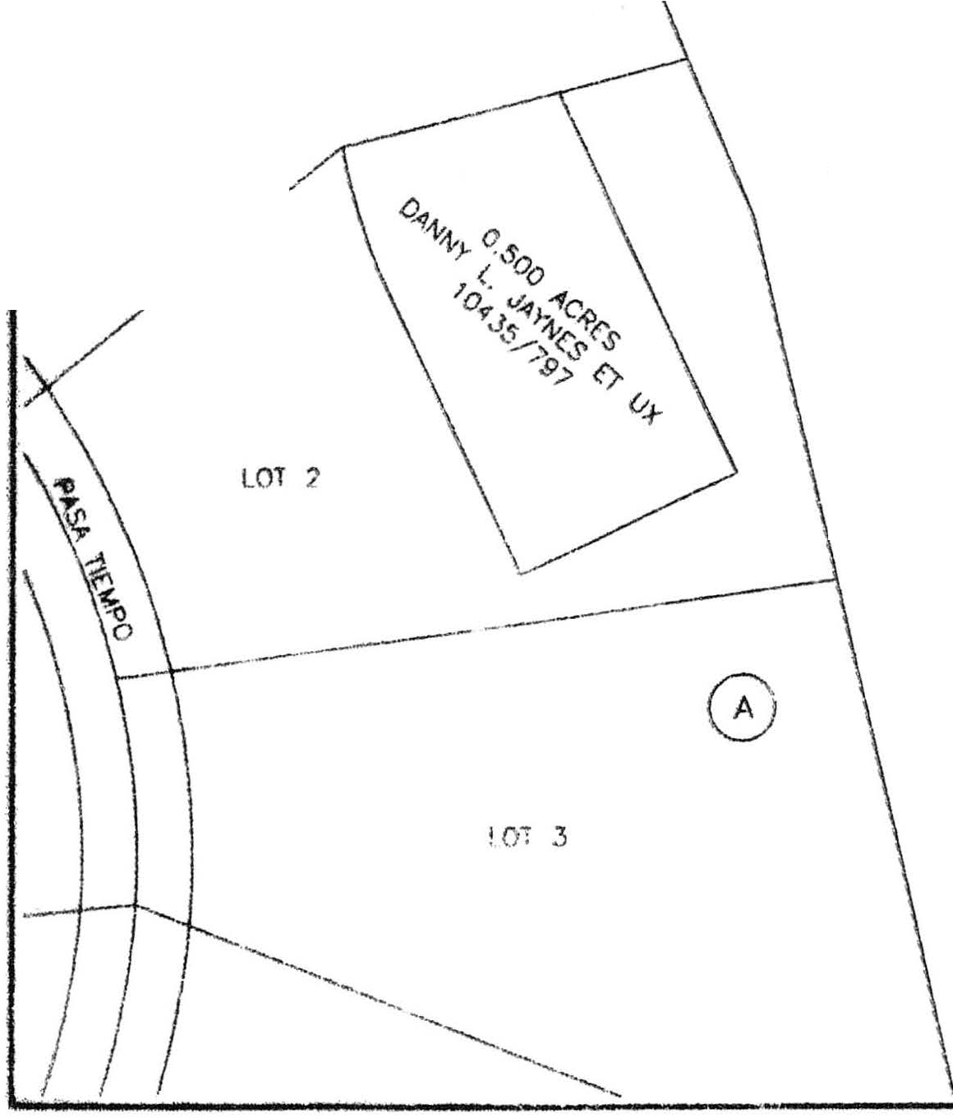

*/*

-

=- =- =- =- - - - - - - ,-----,,...-,.--, T

/ **LOT34** I

**t**

/ **2.653 AC.** \

-- - - -- --- - -- - - - **sav,,.,.-.-,lil!.oo** - - -_- **.J>'..,** --- -- - --- _lI

GRAND 1111:'SA AT CRYSTAL FALLS

DOC. 2000000 19

LOT 74

**N30"34'06"W**

{N.:XrJ5'44"W

LOT 75

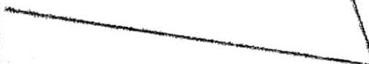TOM

CATER SURVEY 206

LOT 10

*I··*

**CltAND Jtt!A m AT** CRYSTAL J'ALLS

ooc. 700100237

LOT 4

PROPOSED C:RAND MESA Ill-A AT CRYSTAL FAUS

DOC.

-=- =--7,..u=- -

**Lor 40** /

1.1?9 AC. / •

*I*

. 38... i 297. IU.-

----1"5',:c,-

*I*" *I*

\ *I* •

PORTION OF 1142.168 AC. (TRACT 1) LOOKOUT PARTNERS, LP.

VOL 1.3085, PG. 1927

*I*

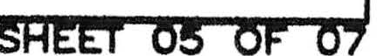

*I*

*I*

0. 1'110 IUl llt "' ,,,,,_. _... ..,.,.,.,_,,..,., """" ...... -----.-•-- ......... .

distribution system of the City of Leander, Texos.

9 Restrictive covenants in the form of a "DECLARATION OF COVENANTS, CONDITIONS

ANO RESTRICTIONS FOR THE GRANO MESA AT CRYSTAL FALLS II, SECTION 4 SUBOMSION"

ore recorded in the deed records of both Trovis and Williamson Counties.

1. In order to promote drainage away from o structure, the minimum foundation slab elevation should be built at least one foot above the highest ground elevation within five (5) feet of the slob perimeter, and the ground adjacent to the slob should be sloped owoy from the structure at o slope of 1/2" per foot for o distance of at least ten (10) feet.
2. Water will be provided by the City of Leander.
3. Finished slopes which ore greater than 15,.; cannot use surface irrigation systems.
4. Twenty-five foot OSSF setbacks ore required from all drainage ways.
5. Twenty-five foot OSSF setbacks ore required from all finished slopes which ore greater than 30,.;.
6. A 10 foot P.U.E. from the front lot lines is hereby dedicated.
7. A 5 foot P.U.E. from all side lot lines is hereby dedicated.
8. Building setbacks not shown hereon shalt conform to the current Zoning Ordinance of the City of Leander, Texas.
9. The following variances were granted per o Development Agreement with the City of Leander and approval of the Crystal FoUs 11 Concept Pion on Moy 1, 2003.
   1. Private Streets with roadside drainoge (Austin Transportation Criteria Waived).

8. No sidewalks, due to private streets and terrain.

C. No street lights, light pollution free deed restrictions.

0. No tree survey, due to private streets.

1. All lots will be served by onsite sewage facilities permitted thru Wwilliomson County.

|  |  |  |  |  |  |  |  |  |  |  |
| --- | --- | --- | --- | --- | --- | --- | --- | --- | --- | --- |
| CURVE **TABIE** | | | | | | | | |  | |
| f--:NcOc,."+-c,D""E.".,LoT=A••n"'•··,-+B""sR,oA•D.=IU""S'"··-+-,, .,;,cA_RsCo=-•-+-",",,C,'Hc,O.cR-D+--""'s1=C,Hs=O,•R·Ds,-CBE:5A.R"I"N2G,,'=-w  f--'=cc,c-+ ,"s··"'s,"'·.,"'··,-+-',"'eo"'u"',-xr·-+-',"",.'".oo""""·*-+-","',1"'.*,"',·-,I--s"a:","'··0""2·"1s"'·-w'- | | | | | | | | -+-  --+- | | -.• |
| CJ 4<r39•05• 998.1>_,. 865.39' 838.57' S'i0'11'?.,"W | | | | | | | |  | |  |
| C4 o:;·49•32• 1160.nn' 117.94' 117.89" S22'26'29"W | | | | | | | |  | |  |
| C5 35"28'06" 1160.nn• "718.08' 706.67' so1·47'??"W | | | | | | | |  | |  |
| C6 44"J0'26" 101 •.nn' 788.45' 768 7a• S06'17'12"W | | | | | | | |  | |  |
| C7 s-4 roo· 5so.oo· a5_2g' 86.2 ' s53·44•s3-w | | | | | | | |  | |  |
| C9  C10 C11 |  | 1""""'1n•  4·05•11•  738'0?" | R..n.nn· 850.00'  960.00' | 1",n 7'  "-n "-?'  1 7.<W' | ISO.I 60.61'  127.81' | <:R.t•o:;1'1J"W  S88"57'54"W S8T1 '05-W | |  | | |
| Ct2 CtJ  C14 |  | 8"?1'41"  019'?1"  8"35'29" | 960.00'  996.63'  998.63' | 140.09'  110.20·  149.74' | 139.97'  11n 14'  1-49.60' | S79'13'14"W s11·51'15"W  S64"23'49"W | |  | | |
| C15 |  | ,r.34•00• | 996.63' | 149.36' | l-49.2 ' | S'i'i'49'00"'W | |  | | |
| C16 |  | ...,,..•1,::• | 998.63' | 146.19' | 146.06' | S47"?0'17"'W | |  | | |
| C17 | . | 8"1 '4 • | 99 | 14"'.16' | 14 04' | <:38"S:.R'47"W | |
| C18 |  | 8"23'06" | 99863' | 146.15' | 146.0' | SJ0"37'23"W | |
| C19 |  | 1·04•nn• | 998 ,::,• | 1R. 'i9' | 1R.'i9' | <:;?<;•,::;_,•o;n"W |  |  | | |
| C20 |  | ,,.16'?7" | 11 | 4"-.04' | 45n4• | S24'1 l'n?"W |
| c21 |  | 3"33'05• | 11 | 11.90• | 71.89' | s21·18'16"W |
|  |  | | |
| C29 C30  c3t  c.32 |  | 7"?4'n,:;" R"Q '29"  8'4t'39"  8'38'?5" | 1n1 ,nn• 1n1 •.nn' 10,s.oo·  101."i.OO' | 1 1,1?'  143.34'  t54.02' 153.06' | 13t.ni.• 143,??'  1s3.67'  l'i?.92' | '14"1'"  <=06'51'34"W  s1s·1 ·oa"W  <:;23'55'10"W | |  | | |
| C33 |  | 0-1 '03" | tnt •.nn' | 5.33' | 5.33' | S?8"?3'?4"W | |  | | |



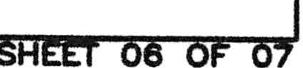

***Jflf* Eng;neering** Compaoy, Inc.

I

P.M.B. 503

P.O. Box 1220

Leander, Texas 76646-1220

TN Tel. (512) 259-3882 Fax. (512) 259-8016

GRAND MESA

SUBDIVISION

8

CRYSTALFALI.5

PLOT DATE: 03/11/04 SCALE: 1"•100'

DATE Of SURVEY: February. 2004

*(7*

*SENDERO* BEARING BASIS; Doc. No. 200000019

*SURVEYING* DRAWN BY: PMC APPROVED BY: PMC

/ / F'IELDNOTE FlLE: NA

t-ORA-Wl-.-.-Fl-LE-,-oo -,-_-o,---00-JP-l 1

2604 ROBIN ROAD TEL (512) 260-3304 t 1

MAHCHACA., TEX4S 78652 fAX (512) 282-8028 PROJECT NUMBER; 001-04-003

STATE OF TEXAS COUNTY OF WILLIAMSON

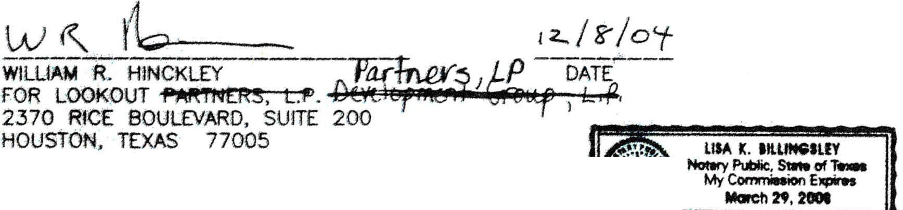

6 rtw !lllb_

BEFORE **ME,** THE UNDERSIGNED AUTHORllY, ON THIS DAY PERSONALLY APPEARED wtLUAM R. HINCKLEY. KNOWN TO ME TO BE THE PERSON WHOSE NAME 1S SUBSCRIBED TO THE FOREGOING INSTRUMENT ANO ACKNOWLEDGED TO ME THAT HE EXECUTED SAME FOR THE PURPOSE AND CONSIDERATION THEREIN EXPRESSED, IN THE CAPACITY THEREIN STATED.

GIVE f UNDER MY HANO AND SEAL OF OFFICE, THIS THE r:_ DAY OF btt.!:::2._l?if

20.J.l..'t **A.O.**

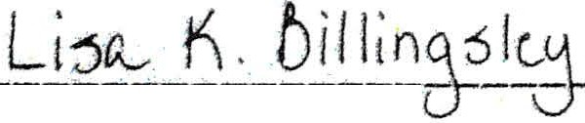

PRINT NAME

I, NANCY RISTER, CLERK OF THE COUNTY COURT OF SAID COUNTY, DO HEREBY CERTIFY T FitloF ;:G i S RU tiF; Ew INT Ew s D; R;;irc,x.._ HENTICATION

20 A.O.. AT ***.3_;p_*** O'CLOCK *f..* .M., ANO DULY RECORDED THis THE DAY OF

***..:::,e,i,1_,. --*** 201).i° A.O., AT ***.3J.i1*** O'CLOCK, £!..M,. IN THE PLAT RECORDS OF1 -'/

S/IJO COUNl'\' IN CABINET- -• SLIDE ***3,S;S'.'.&S-1,, Mh 3S.,* 3S'1, *3r,o,..,a.s¥***

TO CERTIFY WHICH, WlTNESS MY HANO ANO SEAL AT THE COUNTY COURT OF SAID COUNTY AT MY OFFICE IN GEORGETOWN, TEXAS, THE DATE LAST SHOWN ABOVE WRITTEN. '

,.,t(•;"'-''''''

NANCY !R, CLERK COUNTY COURT 3"-- !J.fou \11,

OF WILLIA SON(COUN_!Y EXAS /., ........ <.. \

BY: Ocb..L DEPUTYf *!* \;

\:{s :: /;)

NOTARY PUBLIC IN ANO FOR THE COUNTY OF *f_mj_ _,* TEXAS.

STATE OF TEXAS COUNTY OF TRAVIS

1\, •v,.Ji1N C()\J· --­

\\,,,,"'(°'..._...,-. -

MY COMMISSION EXPIRES *{)* -J'-jQj'i

STATE OF TEXAS COUNTY OF TRAVIS

APPROVED THIS THE DAY OF - -• 2*(;/!*0*t.* A.O. AT A PUBLIC

I, PHILLIP L. MCLAUGHLIN **AM** AUTHORIZED UNDER THET LAWS OF THE STATE OF TEXAS TO PRACTICE THE PROFESSION OF LAND SURVEYING, AND HEREBY STATE THAT THIS PLAT CONFORMS WITH APPLICABLE ORDINANCES OF THE CITY OF LEANDER, TEXAS AND WILLIAMSON AND TRAVIS COUNTY, TEXAS, AND THAT ALL EXISTING EASEMENTS OF RECORD OF WHICH I AM AWARE HAVE BEEN SHOWN OR NOTED HEREON.

*t #itt:-*

MEETING Of' THE PLANNING ANO ZONING COMMISSION TEXAS **ANO** AUTHORIZED TO BE FILED FOR RECORD B TRAVIS COUNTY, TEXAS.

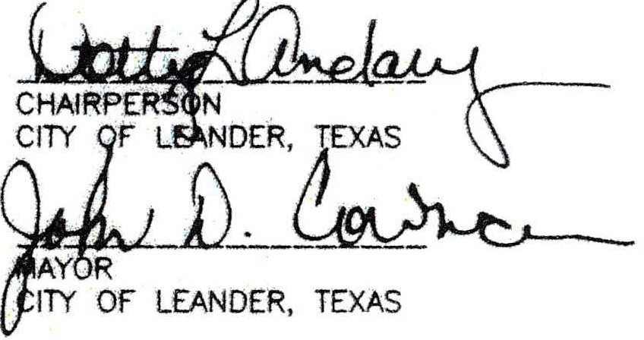

ATTEST,



:,.,r.

* - :,·*' =-·* ·· .,., '.,'

- i:7.-, *di-*

REGISTERED PROFESSIONAL LAND SURVEYOR STATE OF TEXAS NO. 5300

SENDERO SURVEYING 2804 ROBIN ROAD

MANCHACA, TEXAS 78652

512-280-3304

STATE OF TEXAS COUNTY OF TRAVIS

I, SAMUEL 0. KIGER, AM AUTHORIZED UNDER. THE LAWS OF THE STATE OF TEXAS TO PRACTICE THE PROFESSION OF ENGINEERING, ANO DO HEREBY STATE THAT THIS PLAT CONFORMS WITH THE APPLICABLE ORDINANCES OF THE CITY OF LEANDER, TEXAS ANO TRAVIS COUNTY, TEXAS, THAT THIS TRACT IS NOT LOCATED WITHIN THE EDWARDS AQUIFER RECHARGE ZONE ANO THAT NO PORTION OF THIS SUBDIVISION IS CONTAINED WITHIN THE LIMITS OF A 100 YEAR FLOOD PL/IJN RECOGNIZED BY THE FEDERAL EMERGENCY

MANAGEMENT AGENCY (FEMA) PER FLOOD INSURANCE RATE MAP (FIRM) NO. 8453C0275E

TRAVIS C TY) CTED 6/16/93, UNLESS OTHE.RWISE CONT/IJNED WlTHIN DR/IJNAGE EASEME SH HEREON.

, . ,.•;. ···-• :-:;

SAM U,!,ELLDc-'.'--Kcc'IGt,:ER:::., _,:P.C,,E.-­ STATE OF TEXAS NO. 89353

JAY ENGINEERING COMPANY, INC.

P.O. BOX 1220

LEANDER, TEXAS 78646-1 220

512-259-3882

BASED UPON THE ABOVE REPRESENTATIONS OF THE ENGINEER OR SURVEYOR WHOSE SEAL IS AFFIXED HERETO, AND AFTER A REVIEW OF THE BLUELINE AS REPRESENTED BY THE SAID ENGINEER OR SURVEYOR, I FIND THAT THIS BLUELINE (SURVEY) COMPLIES WITH THE REQUIREMENTS OF EDWARDS AQUIFER REGULATIONS FOR WILLIAMSON COUNTY, WILLIAMSON COUNTY fl:000 PLAN REGULATIONS ANO WILLIAMSON COUNTY ON-SITE SEWERAGE FACILITY

ALL PROPERTY HEREIN IS SUBJECT TO THE LOWER COLORADO RIVER AUTHORITY'S LAKE TRAVIS OR UPPER HIGHLAND LAKES NONPOINT SOURCE POLLUTION CONTROL ORDINANCE.

REGULATIONS. THIS CERTIFICATION IS MADE SOLELY UPON SUCH [PRESENTATIONS AND

SHOULD IOOT BE RELIED UPON FOR VERIFICATIONS OF THE FACTS ALLEGED. THE

SHOULD

**ANY**

LOT BE PROPOSED FOR **A**

USE OTHER THAN SINGLE-FAMILY RESIDENTIAL **AN**

WILL- COUNTY " cmES HEALTH DISTRICT ANO WILLIAMSON COUNTY OISCL/IJMS ANY RESPOIISIIIIUTY TO ANY MEMBER OF THE PUBLIC FOR INDEPENDENT VERIFICATlON OF THE REPR£SENTATIONS, FACTUAL OR OTHERWISE CONTAINED IN THIS BLUELINE (SURVEY) ANO THE OOCUMENTS ASSOCIATED WlTH IT.

**PAULO PINTO**

DIRECTOR OF ENVIRONMENTAL SERVICES

c s t_;'Erlt E "01R 6RMIT, OR OTHER PERMIT BY THE SUCCESSORS OR ASSIGNS

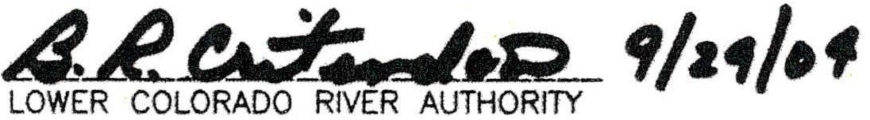

**Joy -ng Company, Inc.**

I

P.M.B. 503

P.O. Box 1220

Leander, Texas 78646-1220

HI let. (512) 259-3882 Fax. (512) 259-8016

GRAND MESA

**SUBDIVISION**

**8**

**CRYSfALFALlS**

PLOT DATE: 03/11/0◄ SCALE: 1"•100' DATE Of SURVEY: FebNory, 2004

*SENDERO* BEARING BA.SIS: Doc. No. 200000019

*(7*

*SURVEYING* DRAWN BY: PMC APPROVED 8Y: PMC

,_n_n_DN_orr_n_"'_._.. ,

DRAWING fl1..E; 001- -00JPL

2804 ROBIN ROAD TEL (512) 280-33041 1

MANCHACA., TEXAS 78552 FAX (512) 282-8028 PROJECT NUMBER: 001-04-003

SHEET 07 0 07

I I

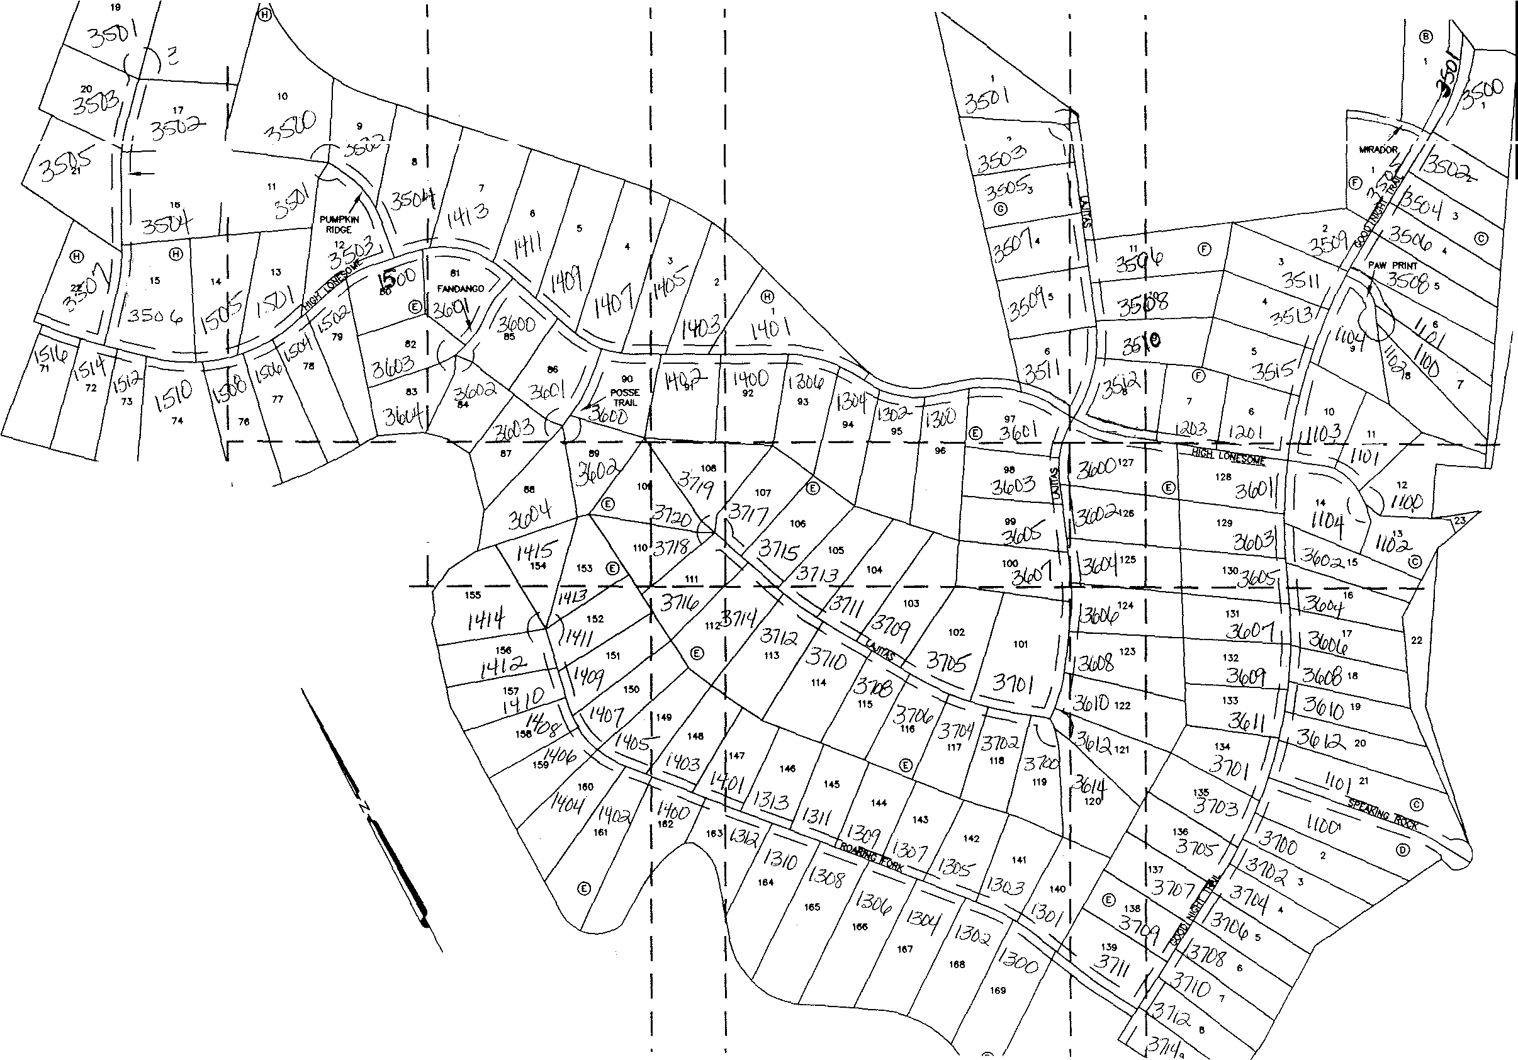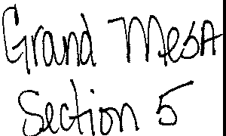

I 6t"D I I

I I

I I

I

I

I

**8'CHELOR**

I

GULCH I

I " I

I I

I I

I I

I I

I I

I i -7

I © I I

I I I I

L l_ ---- J

1 I

I I I I I I I I I

I **SHEET INDEX**

(NOT TO SCALE)

I

LOTS **16 AND** 17, **BLOCK** H, **GRAND MESA AT CRYSTAL FALLS** II **SECTION 5, AMENDED**

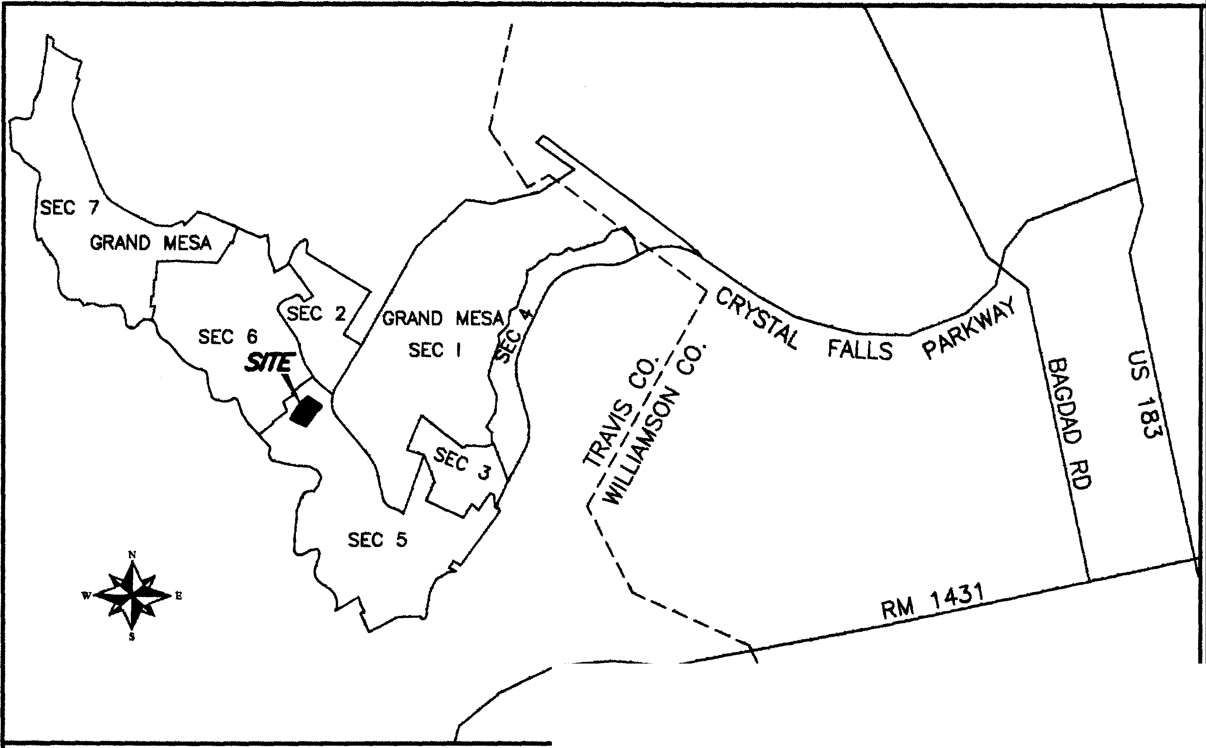

\

N



s

LEGEND:

•

0

®

PUE

PSE

(173742!

**(XXX)**

••

= IRON ROD WITH CAP FOUND

= COTTON SPINDLE FOUNO

= MAG NAIL FOUND

= COTTON SPINDLE SET

= BLOCK NAME

= PUBLIC UTILllY EASEMENT

= PUBLIC SAFETY EASEMENT

= LOT AREA IN SQUARE FEET "" RECORD INFORMATION

w E

1"=100'

0 50

200

**BEARING BASIS: TEXAS CENTRAL** ZONE,

**STATE PLANE COORDINATES {NAO BJ)**

400

LOCATION MAP

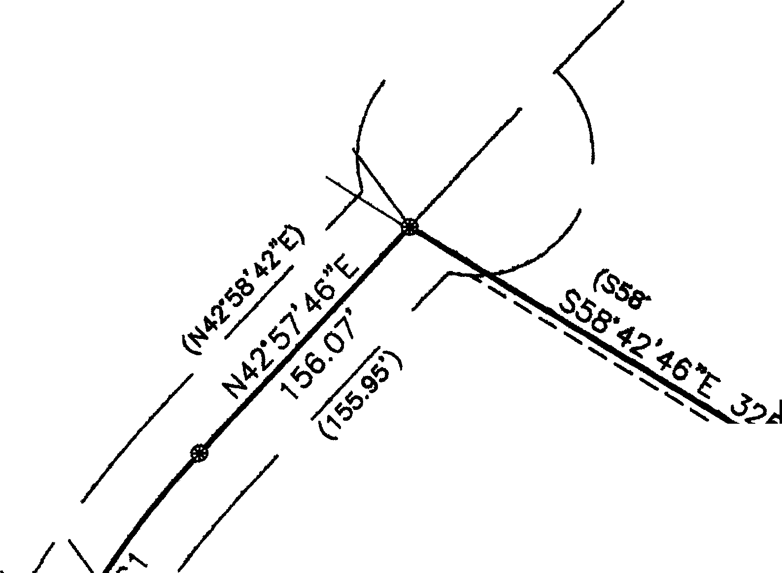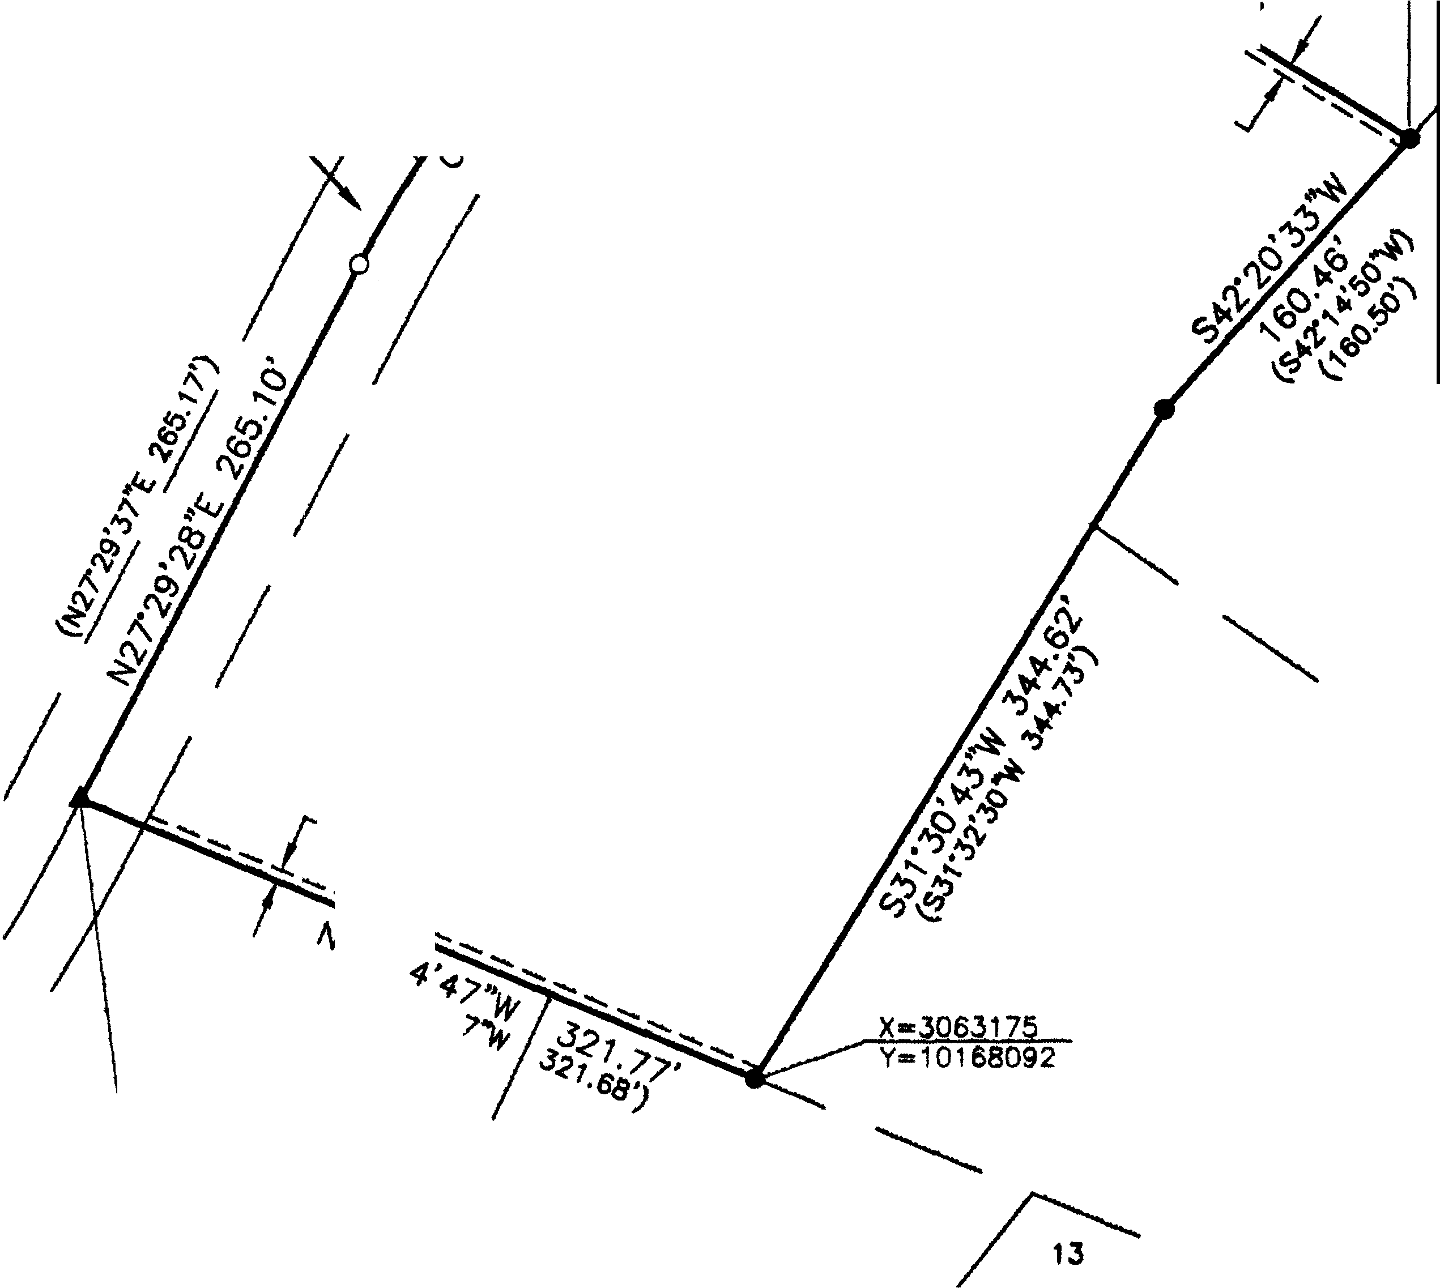

/

'

(

\

--19--

\

20

X=3063184

Y=10168674

**18**

21

\

BACHELOR\_ GULCH \_

..,_,.

*0*

Xm306346

y...10158504

*'1<6'*

*·SeJ·*

(60' PRIVATE STREET, DRAIN. & P.U.E.)

***S•***

**.0**

-

®

CRYSTAL FALLS II, SECTION 5

16A

11737421

GRAND MESA AT

10

ooc. 200600041

*s· /:,*

* *U.t,*

11

*(lv6:,,*

*I*

15

X=3062878

Y=t0168215

J..,i>

*I*

14

'-.....

N.T.S.

STATE OF TEXAS: COUNlY OF TRAVIS:

DEDICATION STATEMENT:

THAT MARVIN L. WOLVERTON AND MARYANN H. WOLVERTON, BEING THE OWNERS OF LOTS 16 AND 17, BLOCK H, GRAND MESA AT CRYSTAL FALLS II, SECTION 5, A SUBDIVISION OF RECORD IN DOCUMENT NO. 200600041, OFFICIAL PUBLIC RECORDS, TRAVIS COUNlY, TEXAS, SAID LOT 16, HAVING BEEN CONVEYED TO US BY GENERAL **WARRANlY** DEED IN DOCUMENT NO. 2013081248 AND SAID LOT 17, HAVING BEEN CONVEYED TO US BY GENERAL WARRANTY DEfiD IN DOCUMENT NO. 2006231098, BOTH RECORDED IN THE OFFICIAL PUBLIC RECORDS, TRAVIS COUNlY, TEXAS, DO HEREBY AMEND SAID LOTS IN ACCORDANCE'. WITH APPLICABLE ORDINANCES OF THE CITY OF LEANDER, AND TRAVIS, COUNlY, TEXAS, THE HEREIN DESCRIBED PLAT TO BE KNOWN

AS •LOTS 16 AND 17, BLOCK H, GRAND MESA AT CRYSTAL. FALLS II SECTION 5, AMENDED", AND DO HEREBY DEDICATE TO THE PUBUC THE USE OF ALL RIGHT-OF-WAYS, STREETS, ALLEYS, EASEMENTS, PARKS AND OTHER OPEN SPACES AS SHOWN HEREON, OR WHEN THE SUBDIVIDER HAS MADE PROVISION FOR PERPETUAL MAINTENANCE THEREOF, TO THE INHABITANTS OF THE SUBDIVISION, SUBJECT TO ANY EASEMENTS ANO/OR RESTRICTIONS HERETOFORE GRANTED AND NOT RELEASED.

WITNESS MY HAND THIS THE JC,tk DAY OF Alovew-.lo(,. , 20\4 A.O.

M O T  **Mo941ncJ**

3502 BACHELOR GULCH 3502 BACHELOR GULCH

LEANDER, TEXAS 7B641 LEANDER, TEXAS **7B641**

STATE OF TEXAS:

COUNlY OF TRAVIS:

BEFORE ME, THE UNDERSIGNED AUTHORITY, ON THIS DAY PERSONALLY APPEARED MARVIN L. WOLVERTON, KNOWN TO ME TO BE THE PERSON WHOSE NAME IS SUBSCRIBED TO THE FOREGOING INSTRUMENT AND ACKNOWLEDGED TO ME THAT HE EXECUTED THE SAME IN THE CAPACllY THEREIN STATED FOR THE PURPOSES ANO CONSIDERATION THEREIN EXPRESSED,

GIVEN uw MY HAND, AND s *oy* OFFICE, THIS THE 1:1_ DAY OF _,Jo 111tktr 20fl. A.O.

*(?I/* /.,

*L --- --*

NOTARY PUBLIC, STATE- -

*.-jff'.'f ,* EUENPIZALATE

/*0* :/j/1

°'.;';;-... *-·i'l*

MY COMMISSION EXPIRES

STATE OF TEXAS: COUNlY OF TRAVIS:

'••tir.;,"'•' .**"**.,**-**..**'**,**-**..**'**,**-**_**20**' **2018**

BEFORE ME, THE UNDERSIGNED AUTHORITY, ON THIS DAY PERSONAL.LY APPEARED **MARYANN** H. WOLVERTON, KNOWN TO **ME** TO BE THE PERSON WHOSE NAME IS SUBSCRIBED TO THE FOREGOING INSTRUMENT AND ACKNOWLEDGED TO ME THAT HE EXECUTED THE SAME IN THE CAPACllY THEREIN STATED FOR THE PURPOSES AND CONSIDERATION THEREIN EXPRESSED,

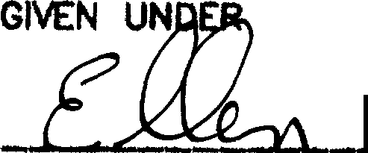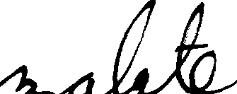**MY** HPc **AND SEAL** DF=E• THIS THE *it'.:* DAY OF ..,,,.,!,,,, **20ft A.O.**

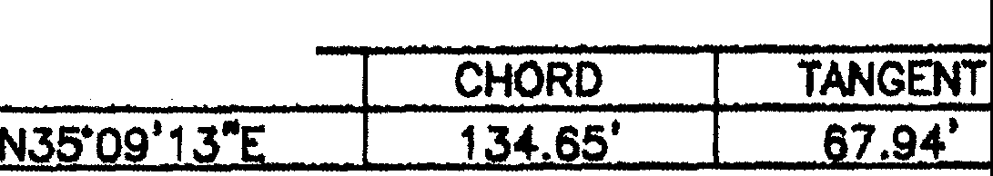NOTARY PUBLIC, STATE



|  |  |  |  |  |  |  |  |
| --- | --- | --- | --- | --- | --- | --- | --- |
| CURVE TABLE | | | | | | |  |
| NO. | DELTA | RADIUS | ARC |  | CHORD BEARING | | |
| C1 | 00.00' | | 135. | 6' | |  | |

PLAT NOTES:

1. THIS AMENDED PLAT DOES NOT REMOVE ANY RESTRICTIONS. THIS SUBDIVISION IS SUBJECT TO ALL GENERAL NOTES AND RESTRICTIONS APPEARING ON THE PLAT OF GRAND MESA AT CRYSTAL FALLS II, SECTION 5, RECORDED IN DOCUMENT NO. 200600041, OFFICIAL PUBLIC RECORDS, TRAVIS COUNlY, TEXAS.
2. BUILDING SETBACKS NOT SHOWN HEREON SHALL COMPLY WITH THE MOST CURRENT ZONING ORDINANCE OF THE CITY OF LEANDER.
3. NO DRIVEWAY SHALL BE CONSTRUCTED CLOSER THAN 50' OR 60% OF PARCEL FRONTAGE, WHICHEVER IS LESS, TO THE ROW OF AN INTERSECTING LOCAL OR COLLECTOR STREET OR 100' OR 60,C OF PARCEL FRONTAGE, WHICHEVER IS LESS, TO THE ROW OF AN INTERSECTING ARTERIAL STREET.
4. THIS SUBDIVISION IS WHOLLY CONTAINED WITHIN THE CURRENT CORPORATE LIMITS OF THE CITY OF LEANDER, TEXAS
5. A 10-FOOT PUBLIC UTILllY EASEMENT ADJACENT TO ALL RIGHTS-OF-WAY IS HEREBY DEDICATED WITH THIS PLAT.
6. THE FOLLOWING VARIANCES WERE GRANTED PER A DEVELOPMENT AGREEMENT WITH THE CITY OF LEANDER AND APPROVAL OF THE CRYSTAL FALLS II CONCEPT PLAN ON MAY 1, 2003.
   1. PRIVATE STREETS WITH ROADSIDE DRAINAGE.
   2. NO SIDEWALKS.
   3. NO STREET LIGHTS.
7. THIS SUBDIVISION IS SUBJECT TO A BLANKET TYPE ELECTRIC UTILllY EASEMENT TO PEDERNALES ELECTRIC COOPERATIVE, INC. AS DESCRIBED IN DOCUMENT NO. 2007087297.

STATE OF TEXAS:

COUNlY OF TRAVIS:

NO STRUCTURE IN THIS SUBDIVISION SHALL BE OCCUPIED UNTIL CONNECTED TO A PUBLIC SEWER SYSTEM OR A PRIVATE ON-SITE WASTEWATER (SEPTIC) SYSTEM THAT HAS BEEN APPROVED AND LICENSED FOR OPERATION BY TI-IE TRAVIS COUNTY ON-SITE WASTEWATER PROGRAM.

NO CONSTRUCTION MAY BEGIN ON ANY LOT IN THIS SUBDIVISION UNTIL PLANS FOR THE PRIVATE ON-SITE SEWAGE DISPOSAL SYSTEM ARE APPROVED BY THE TRAVIS COUNlY ON-SITE **WASTEWATER** PROGRAM.

DEVELOPMENT ON EACH LOT IN THIS SUBDMSION SHALL BE IN COMPLIANCE WITH THE MINIMUM REQUIREMENTS OF THE TITLE 30 OF THE TEXAS ADMINISTRATIVE CODE CHAPTER 285 AND TRAVIS COUNlY CODE CHAPTER 48 THAT ARE IN EFFECT AT THE TIME OF CONSTRUCTION.

THESE RES'mlCTIONS ARE ENFORCEABLE BY THE TRAVIS COUNTY ON-SITE **WASTEWATER** PROGRAM.

ALL LOTS IN THIS SUBDIVISION ARE RESTRICTED TO ONE SINGLE FAMILY DWELLING ANO APPURTENANT STRUCTURES PER ACRE.

NO STRUCTURE IN THIS SUBDIVISION SHALL BE OCCUPIED UNTIL CONNECTED TO A POTABLE WATER SUPPLY FROM AN APPROVED WATER SYSTEM OR A PRIVATE WELL.

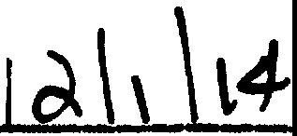NO WATER WEU. IN THIS SUBDIVISION MAY BE LOCATED WITHIN WITHOUT THE CONSENT OF THE ADJOINING LAND OWNER(S).

150 FEET OF THE SUBDIVISION BOUNDARY

STATE OF' TEXAS:

l'\ **((df\104 *5+-pg,I..½*** *P.C.* Qt.If *o o4(111*

COUNTY OF" TRAVIS:

I, PHILLIP L. McLAUGHLIN, AM AUTHORIZED UNDER THE LAWS OF THE STATE OF TEXAS TO PRACTICE TI-IE PROFESSION OF LAND SURVEYING, AND HEREBY STATE THAT THIS PLAT CONFORMS WITH APPLICABLE ORDINANCES OF THE CITY OF LEANDER, TEXAS AND TRAVIS COUNlY, TEXAS AND THAT ALL EXISTING EASEMENTS OF RECORD AS FOUND ON THE TIRE POLICY PROVIDED BY GRACY l1TLE COMPANY, GF NO. 01247-30749, ISSUED SEPTEMBER 23, 2014, HAvt BEEN SHOWN OR NOTED HEREON.

STACEY SC EFFEL D. R., PROGRAM MANAilR, ON-SITE WASTEWATER, TRAVIS COUNlY TNR

THE STATE OF TEXAS: COUNlY OF TRAVIS:

DATE

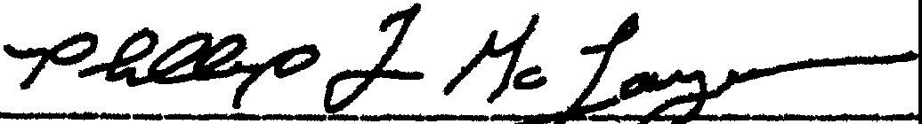PHILLIP L. McLAUGHLIN NOVEMBER 19, 2014 I, DANA DEBEAUVOIR, CLERK OF' TRAVIS COUNTY, TEXAS DO HEREBY CERTIFY THAT THE FOREGOING INSTRUMENT

L

REGISTERED PROFESSIONAL LAND SURVEYOR NO. 5300 STATE OF TEXAS

STATE OF TEXAS:

**OF**

ITING AND ITS CERTIFICATE OF AUTHEN11CATION WAS FILED F'OR RECORD IN MY OF'F'lCE ON THE

*/ ..C,Q·'l"\-be..n..,* 2o_l!.:f. AD. AT_il!l)l.p O'CLOCKf!°t.4., AND DULY RECORDED ON THIS THE /

*.* - - *LA*

DAY OF

**DAY**

COUNlY OF TRAVIS: s+

APPROVED THIS THE \ DAY oF

*N**o****I.le* Mo ls,er** . 20.l<:L A.D. AND AUTH RIZED TO BE FILED

_ ------20J.d. A.O. AT 11•.*vc:e,*o'cLocK M., OFF'ICIAL PU8UC RECORDS OF SND COUNTY AND STATE

IN DOCUMENT *N VIL-f@0 1*

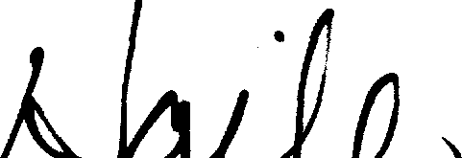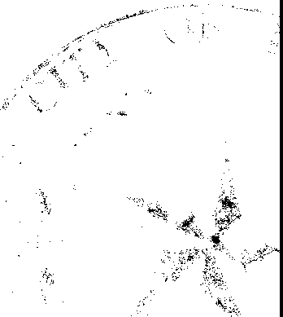FOR RECORD BY THE COUNlY CLERK OF TRAVIS COUNTY, **TEXAS ·,**

*a/*

I

ATTEST: --'-'l.--t'.- - :=:..=.=::

wr MY HAND AND sEAL oF omcE oF THE couNlY cLERK, THE_!_ DAY orD<..e. *u*

20 , A.O.

WAYN A , PE DEBBI HAILE

CITY NGINEER CITY SECRETARY

CITY OF LEANDER, TEXAS CllY OF LEANDER, TEXAS

DANA ffl'-<COUNTY CLERK, TRAVIS COUNTY, TEXAS

BY_ *_JJ_1JJ_rr1 vfzttM.v,d«Ls*

* DEPUlY

SUBMITTAL DATE: SEPTEMBER 26, 2014 TOTAL AREA OF THIS PLAT: 3.989 ACRES TOTAL NUMBER OF LOTS: 1

RESIDENTIAL: 1

**NEW** STREETS: NONE

OWNERS:

MARVIN L. WOLVERTON AND MARYANN H. WOLVERTON 3502 BACHELOR GULCH

LEANDER, TEXAS 78641

SURVEYOR:

G&R SURVEYING, LLC

**1805** OUIDA DRIVE

**AUSTIN,** TEXAS **78728**

S-URVEYING, LLC

*180§ OtJIDA DR.*

*AUSnN, TEXAS 78728*

*PHONE: (512) 267-7430*

*FAX· (512} 836-8385*

***FIRM*** *NO. 10032000* SHEET 1 OF 1

L: 14317-3502 AND 3504 BACHELOR GULCH\dwg\14317_GR-BASE.dwg 11 19 2014 8:12:41 AM CST



|  |  |
| --- | --- |
|  | GRAND MESA  Sec. 5 |
| RESIOENTIAL LOTS | '" |
| AMENITY FACILITIES | ' |
| MAILBOX CENTER | ' |
| ACREAGE | 240,989 Ac. |

SCALE: 1"=400'

5 FOOT CONTOURS

CRYSTAL FAL LS II,..

OWNER:

Lookout Partners. Inc. 2370 Rice Blvd., Suite 200

Houston. Texas 77005

Phone: (713) 524-5263

Fax: (713) 524-2807

DEVELOPER:

The Lookout Group

2370 Rice Blvd.. Suite 200

Houston, Texas 77005

Phone: (71J) 524-5263

Fax: (713) 524-2807

NOTE:

SURVEYOR:

Chapparal Professional """['"''""'•

510 S. Congress Ave

Suite 8-100

Austm, Texas 78704

Phone: (512) 476·7103

;:'*..- /!Ji -:*

*;x..:n."1'..,,,./atr .....r...,,* ;,;;*s;,u.,,,;,.:,,,,.,.*

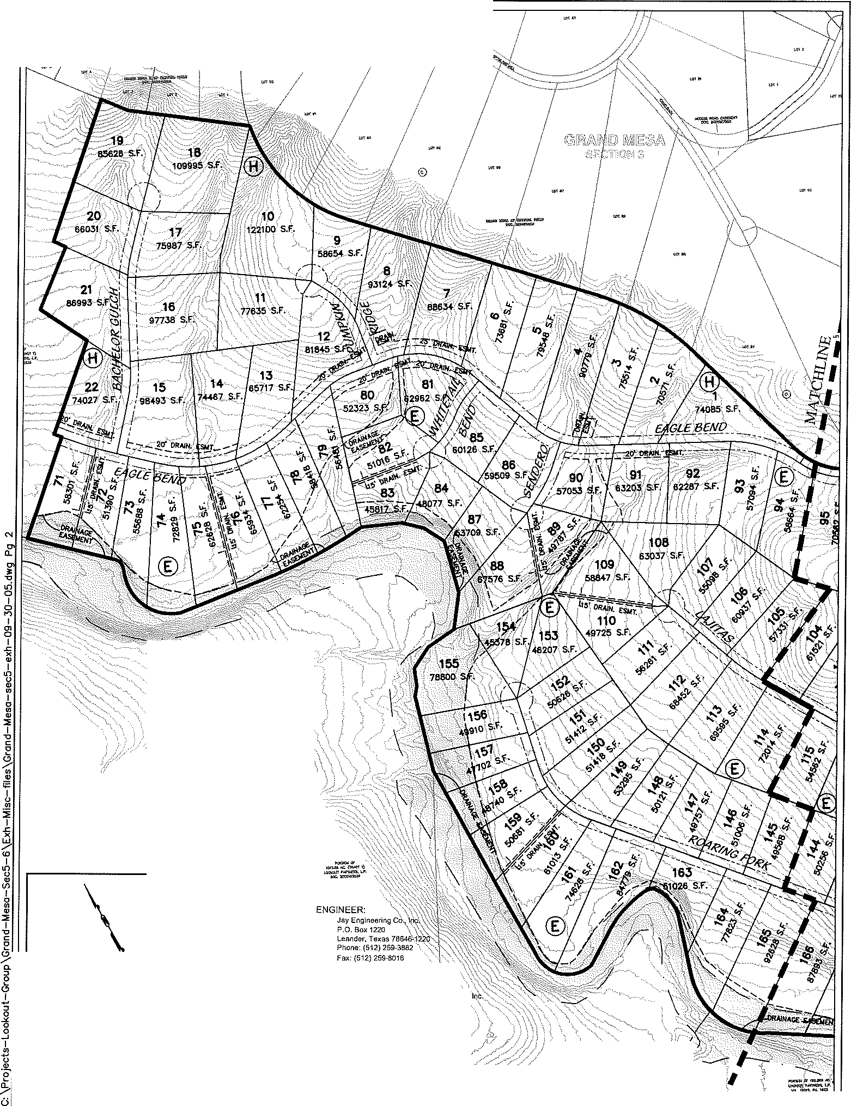

ALL STREETS TO BE 60' PRIVATE STREETS AND P.U.E.,UNLESS OTHERWISE NOTED.

**;jPAG;;** of2I·.:·

GRAND MESA@ CRYSTAL FALLS II

SECTION 5 LAYOUT

**99**

**·53593** _s.F.

SCALE: 1"=:400'

5 FOOT CONTOURS

*CRYSTilLFALLS*

*GOLF COURSE*

*/////*

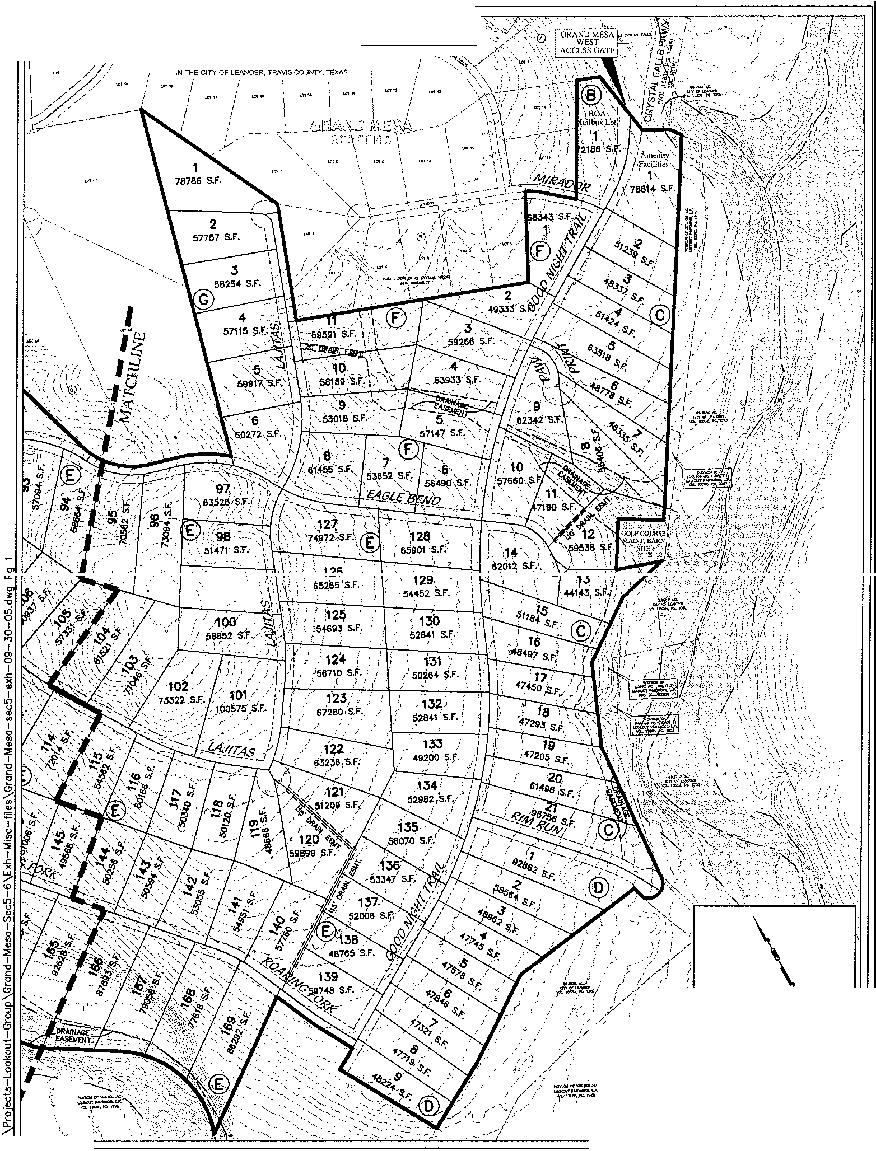

IPAGE I of21

u

CRYSTAL FALLS II,.

*lk* n.,,--...,../&-..,.,. ,-_ *T. >,M..,,_,_,*

***'2boU{t)()L.J I***

GRAND MESA AT CRYSTAL FALLS II, SECTION 5

LEGEND

**e** 1/2" !RON ROD FOVNO

**C<Oe** 1/2"' IRON ROD \\\TI, CAP FOUND

$ COTTON SPINDLE FOUND

D T/2" IRON ROD *OR* I.IAG NAtL W,n, "S8<DERO" C P SET

6 CALCULATED POINT

SCNCHMARK (BRASS DISC SET IN CONCRS-:0:) @fil Ml'lllkJIJ >INSHED FLOOR ELEVATION

LOCATION MAP

(NOT TO SCALE)

**SHEET INDEX**

I snEET s I j SHEET **4 T T** ·sHEET 3 T I slfEEr2- - 7

I

I /@\

I

I I;;//I;

I I I I I I I I I I I I

L L _

I

I I I I I I I I I

L/ I I

I SHEET IJ\'llEX

(NOT TO SOU}

I

I ®

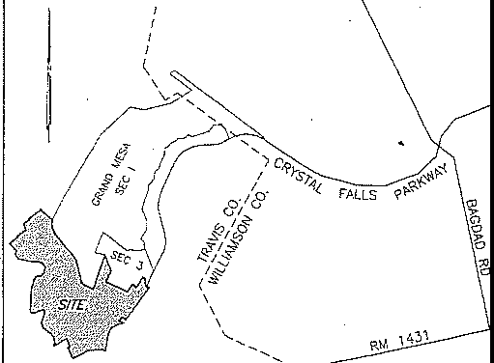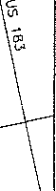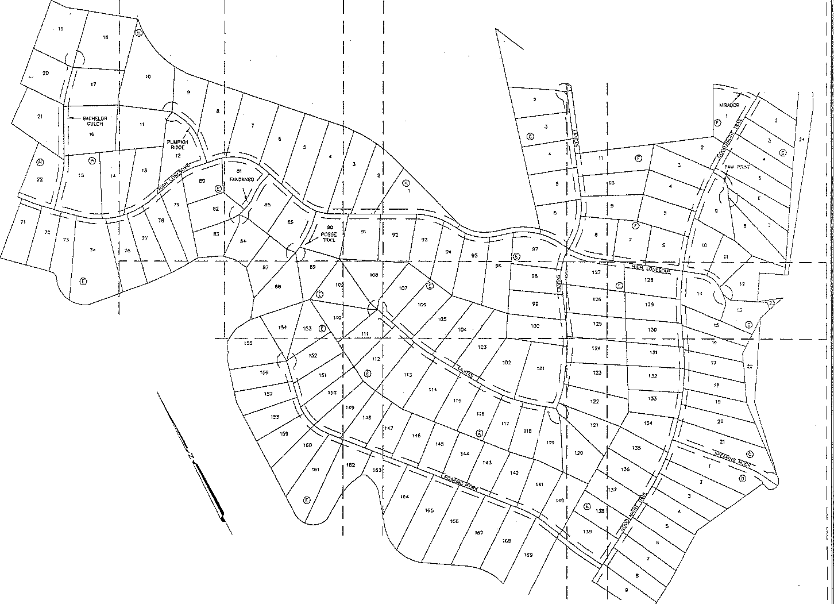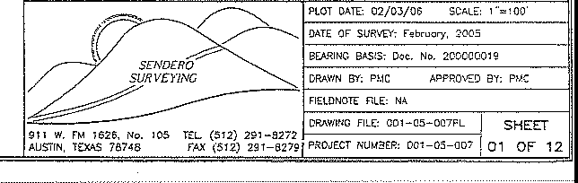

**L**  SHEET 6 J J_ SHEET 7 J J_ _@

**ff,**

**Pl**

CRYSTAL FALLS II"-'

*The Natural .Alternative lo Subdivis/ons*

_SHEET O J

LOT B 01 \GRAND MESA

I

AT CRYSTAL FALLS II, SECTION 5

GRhNlJ MESA III-A A'l' CRYSTAL PAld.8

0

DOC. ?.00400050

LOT 4

L07 3

LOT IJ

*WT* 12

P9.1235 AC CITY OF LEANOrn

VOL 10331. PG 1;155

LOT 7

LOTB

LOT 9

LOT 10

LOT 11

LOT 15

·-

(50" PRIVATE STRCIST

DRAIN & PUE)

'5·

"

\

1

\

·a1. LOT \

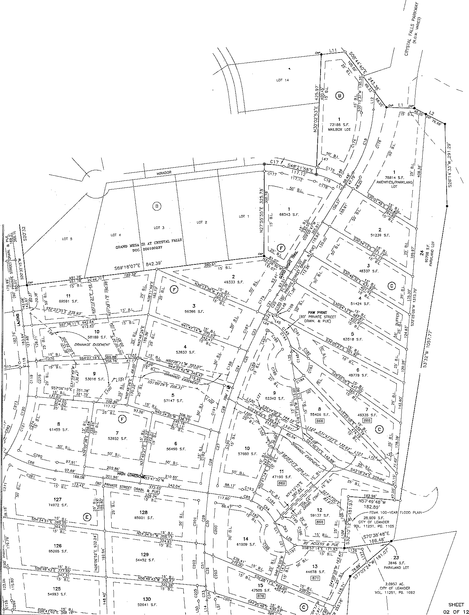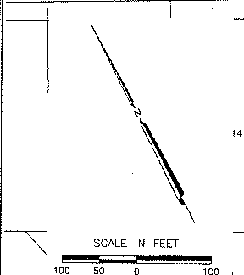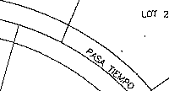

*iJ*

gg,1236 AC.

cnY or ,r.m□F.R

VOL TOS33, PG 1355

*I*

GRAND

LOT 81

MESA

AT

LOT I

CRYSTAL FALLS II, SECTION

*1//II*"- °'";;*m*;*l* '""c's"ss'm '""

,,,,, *I* ,,,,,

5 LOT 8 LOT *9*

ACCESS ROAD 8-SH!ENT DOC. 2001027990

LOT 17 LOT 1S

LCT 15

SCALE !N FEET

*WO* SC

LOT 82

LOT 7

LOT B

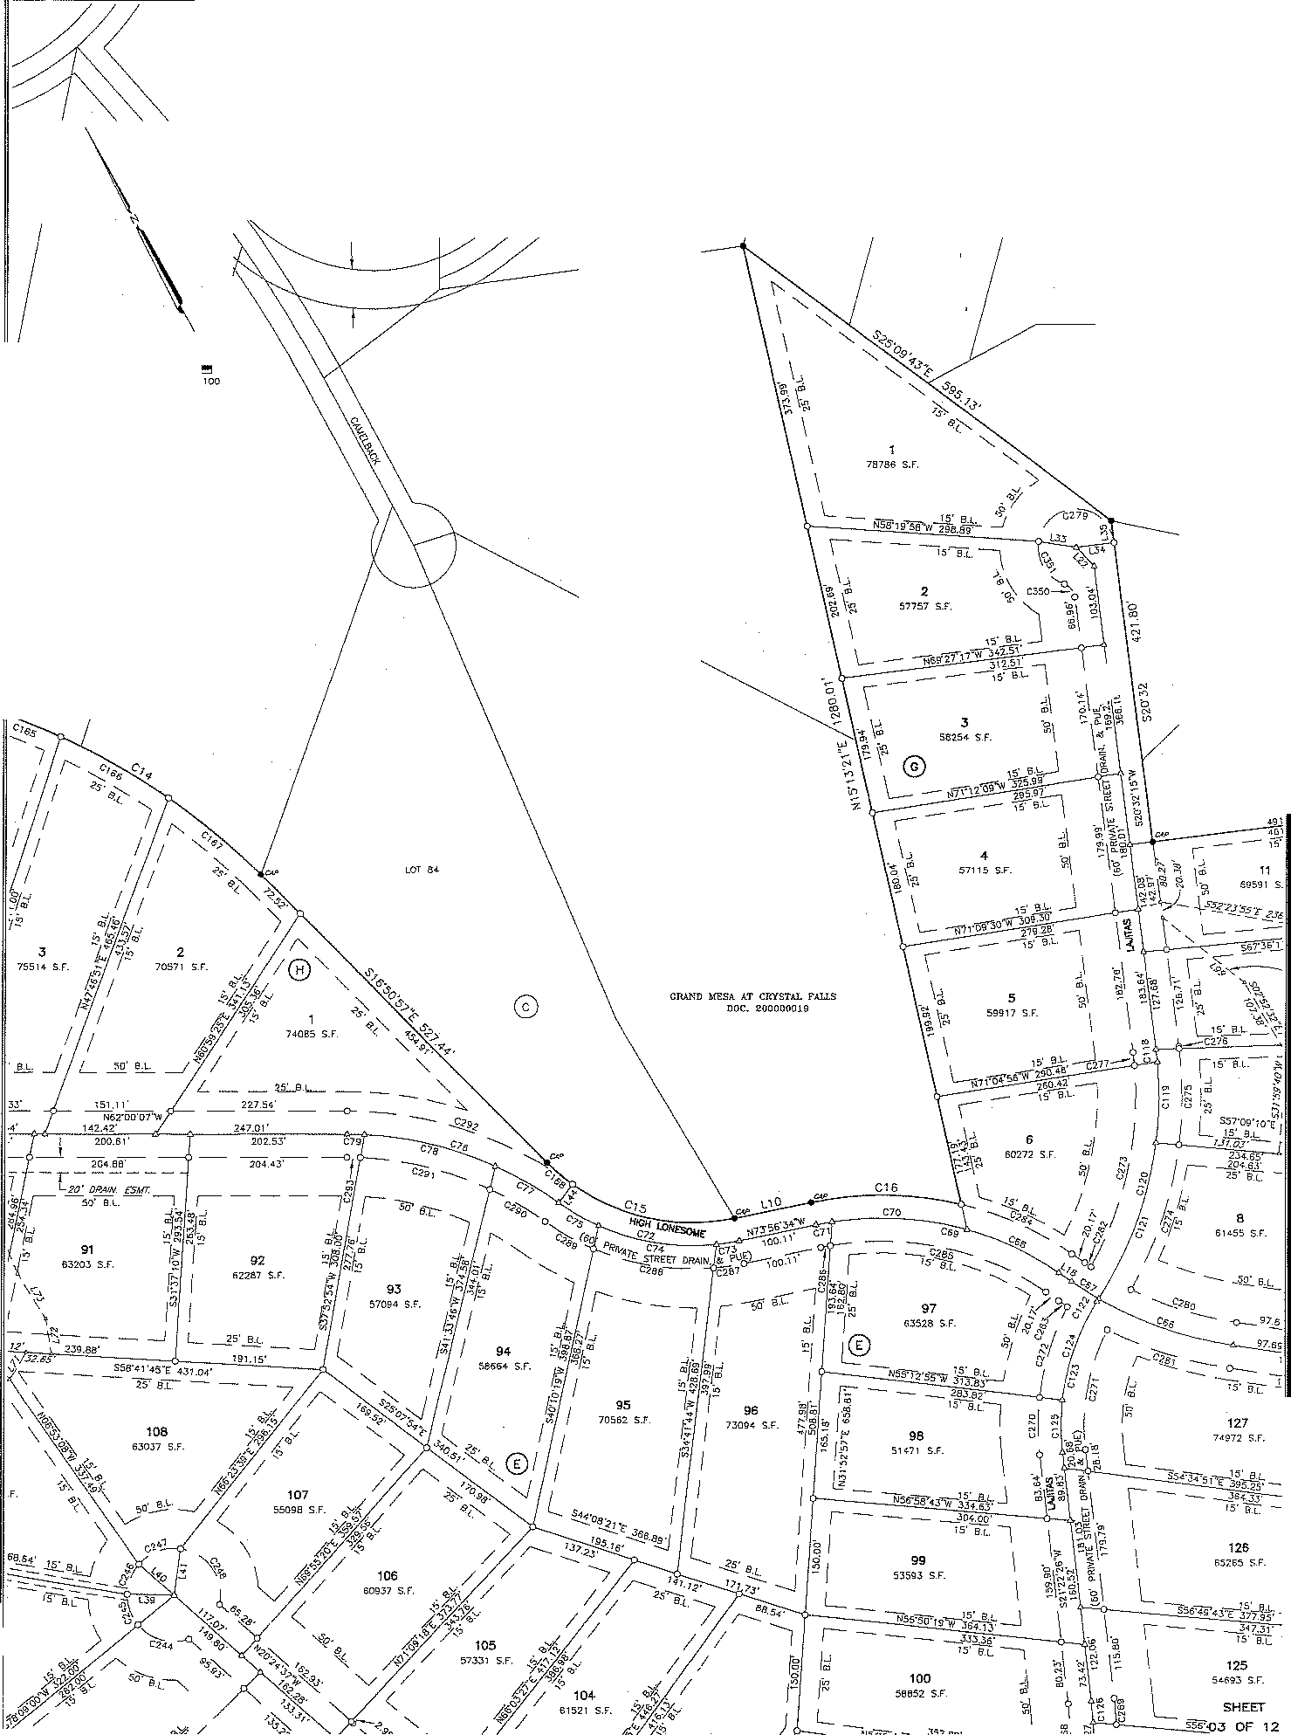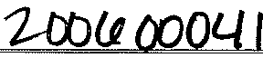

LOT as

LOT 85 LOT 6

LGT 5

LOT 8J

0

i S.F.

>

m A

MESA AT CRYSTAL

**lO OXJ4** *(*

FALLS

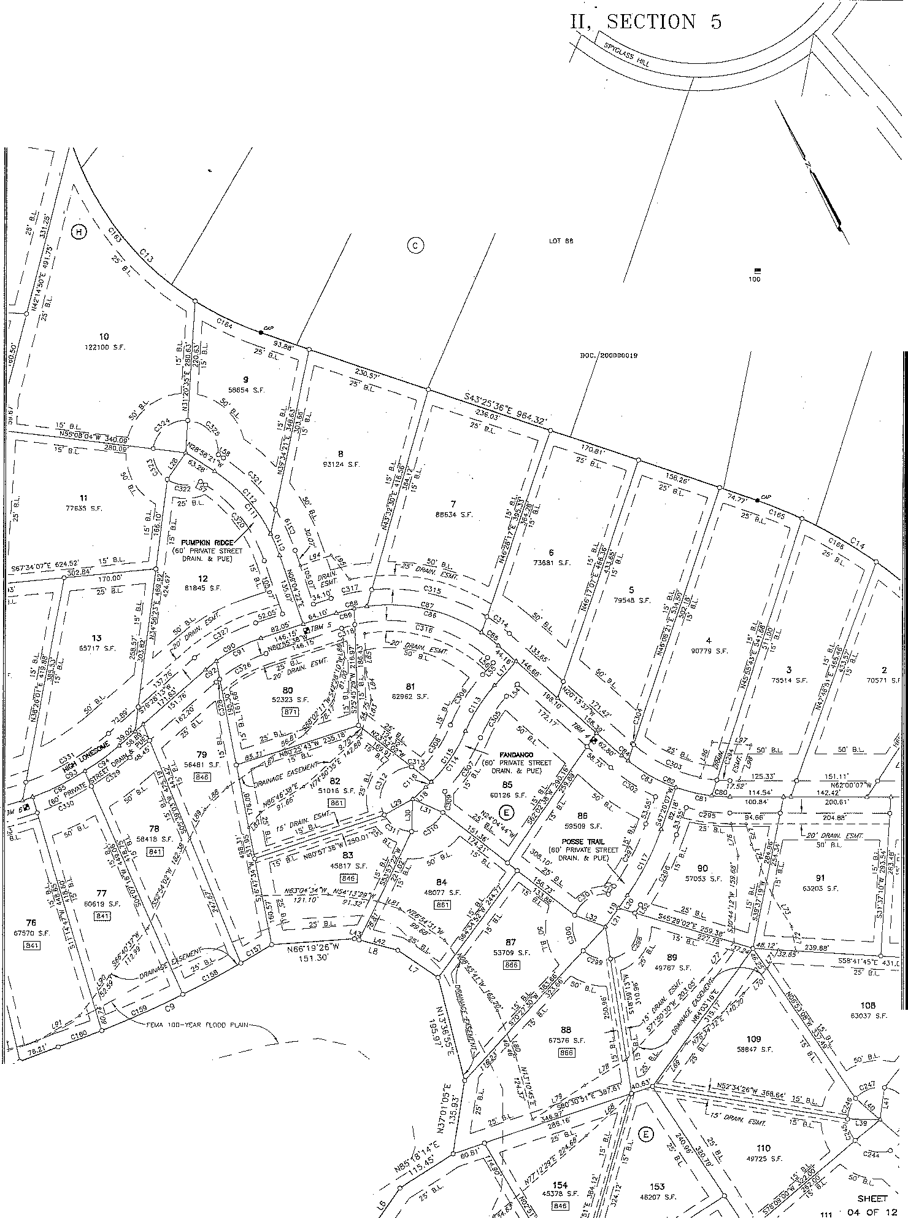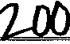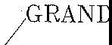

LOT 92

LOT 1

LOT 91

LOT 90

LOT 8

SCALE IN FECT

LDT 87

GRANJJ ME5A *AT* CRYSTAL *FAUS* L.0186

1.6'6

\

***1-0D<Jl O[X'}ll***

GRAND MESA AT CRYSTAL FALLS II, SECTION 5

GP.AND MESA !) AT CRYSTAL FAl,J,5

DOC. 200100 36

\ *II*

\

LOT 2 LOT l

LOT 2

SCALE IN FEIT

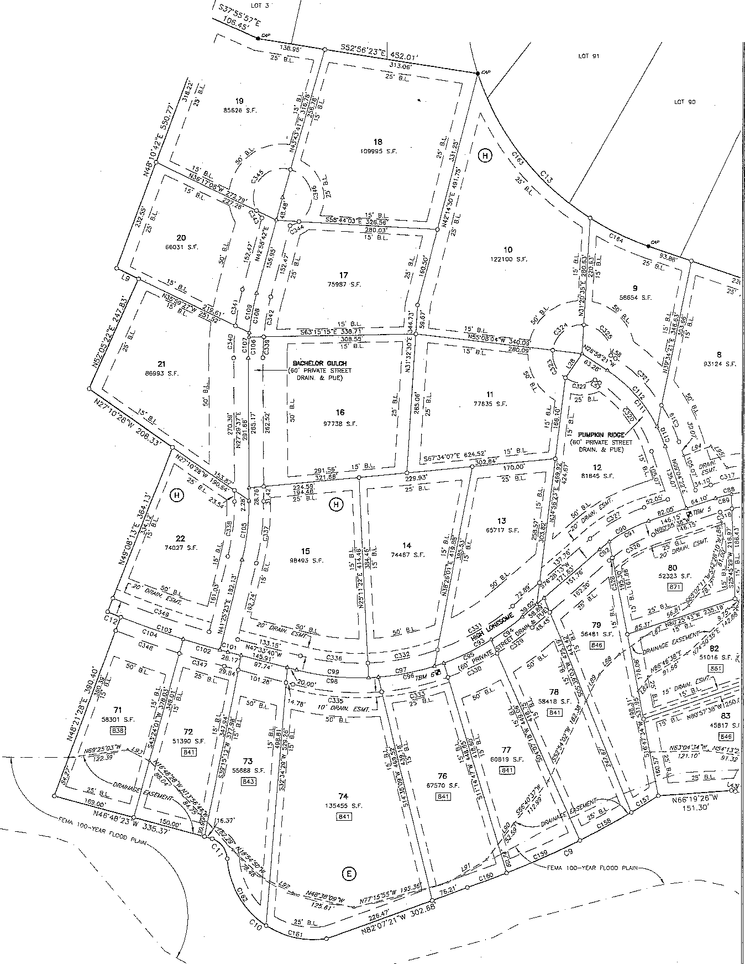

mo ,oo

PORno o, 1013.55 AC. (' ACT 1) LOOKDl.ff PARTNERS, LP

Doc. WOa162635

**SHEET/**

05 OF ;12

MESA

'----Fl:HA 100-Y-e.AP nooD Pl.Al

' \

/ \

\

\

"

\

***D I.J OWl/***

108

63037 s.r.

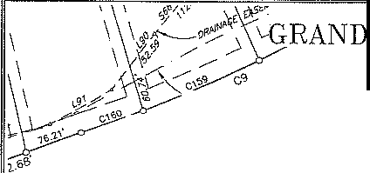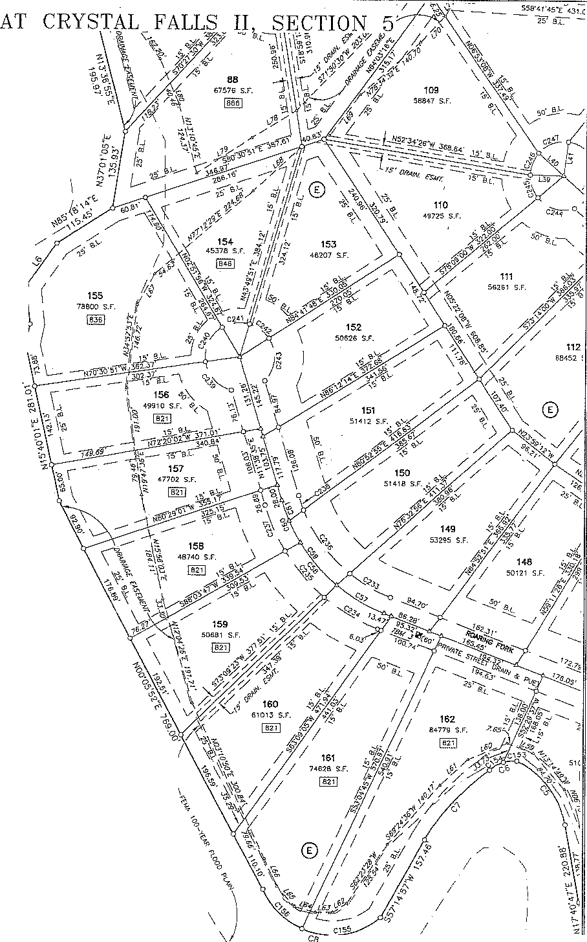

*I*

*I*

SCALE !N FEET *3*

100 so ''" I

I

\

*I*

*I*

I

\

\

\

\

\

\

PORTJON OF \

7013.55 /.C, (HA.CT 1)

\

LOOKOUT PARTNERS, L..P

DOG. 2DD0'828J6

\

\

\

\

\

\

\

\

*I*

\ /

\

\

**SHEIT**

**06 OF 12**

**0004**

I I

\

*(*

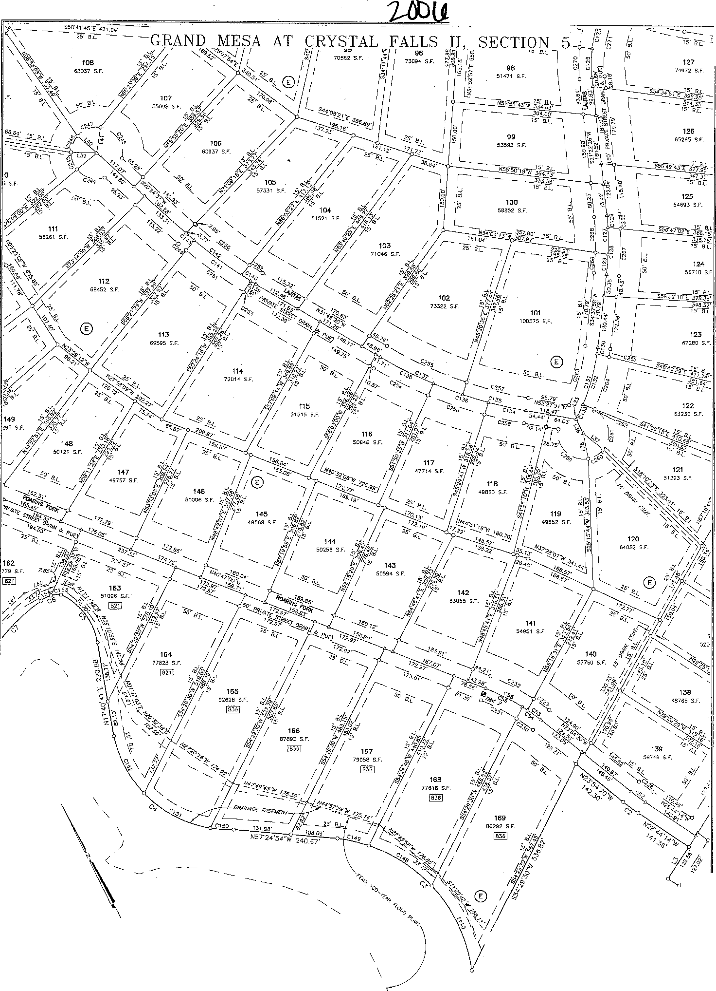

SCALE IN FEET

mo ,oo

PQITTlON Of' ! 0.29 AC

LOOKO 'f PARTNE;RS, l.P

\

VO!.. 1J122. *PG* 193} \

I

**SHEET**

07 OF **12**

'J *(*

I"

•e L

I

*I*

*I*

*I*

*I I*

*I*

*I*

I

99.1236 *N:.*

\

I

Cm' OF LEANDER VOL. 1083:J. PG, 1.'155

120

6<082 SF

20.5626 AC.

CfTY or LEANDER

VOL. 10833, PG. 1355

PORTION OF 1B6.299 *N:..*

LOOKOUT PARTNEllS. L.P

VOL 13122, PG, 1933

*I*

*I*

*I*

*I*

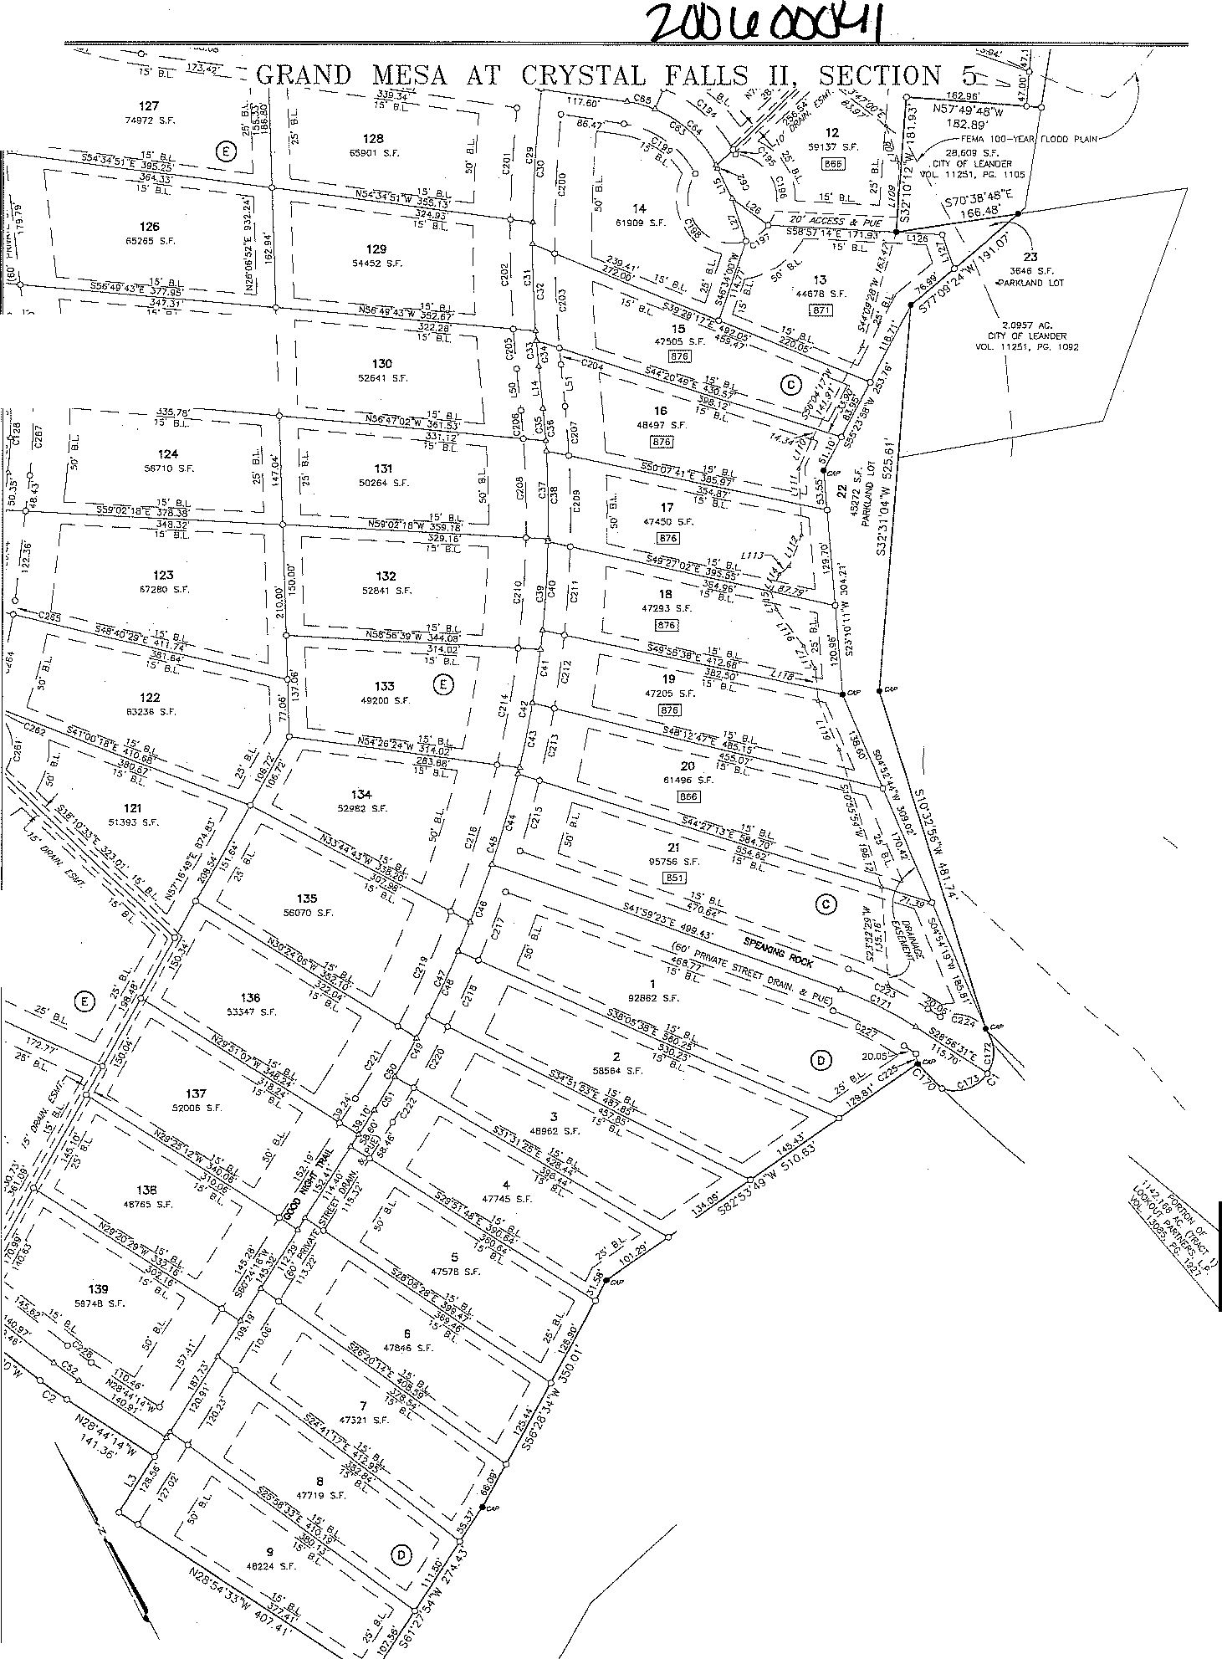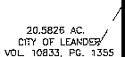

SCALE IN FEET *I*

'" *I*

**SHEET**

**0$ OF 12**

***ZD{)l.JOCiJ-11***

GRAND MESA AT CRYSTAL FALLS II, SECTION 5

UNE TA.SU:

NUMBER--,- 01RECTION DISTANCE

L1 550·3g·1□"E 100.02

" DELTA RADIUS ' MC

CHORD

CURVE TABLE CHORD BEARING

! D8.TA

RADIUS

·MC

CHORD

CHORD BEARING

L2 S35"04'200: 123.0:J' N60-24"1B'<' 09.38"

"C,

4•49·55· '

75·15•43•

C, 14T34'37'

52.53' 135.30"

'

525.oo·

357.70'

44. 7'

469,97'

44.26"

436.69'

N63"40'18"E

S2Er19'17"E Nl735'4

nlss·

'**c**°**aa** 10"56'16"

cas

cs,

6"29"44"

22"36"09"

300.00"

300.00"

300.00'

57.?7"

'4.01'

118.3 '

5718'

33_99'

i\7,58"

N75"27"JO"W

N7T4G'46"W 5ll7'46'1B"W

N3i,57'59-, i._37.30'

c< ' B0'16';5· 272_g4•

382 ·9·

351.B!l'

s24·,3•04'""

**cs,**

17"41'13"

300.00'

g2_61'

0 _24•

!<89"4°"14"W

N2T27''9''E' N6T56'?0"E N2T42"22"w M6"51"37"W N35"59'27"W

S73"56"34"E

67 4 '

91 15' B6.9 ' B2 52'

5D □□'

9 _Q7_'. .

,c,s

c;

**ca**

cs

54•54·55•

4<r31"4B"

2s2e·24·

10717'50"

1S48"28" g4•43'42"

153.!4'

6009'

414.96'

**,**1**e**3**,**0.45'

"

176.18'

146.7°'

51.95'

17□01'

44.JO'

43680"

91,28"

Hl,22"

50,35"

168.82"

210.,

435.80"

259.22'

N0'733'31'w N80"32'3l"W S71'05'38"W

**e**9"58"

S87'39'49"E

S23'09'45"

**cs,**

C93

**cs,**

cs,

cs,

co;

4·54·ss·

23"4ll'33"

!,06"48"

12"24·og·

15"29'37"

15"27"44"

JOO.DO' 500.00'

soo.oo·

500.00'

500.00'

500.00'

5.74'

207.77'

79.53'

1082,3·'

**m**

134.93'

25.73"

206 ne•

79.44'

1oa.02·

' '

4.M"

134.5°'

'

576"55'41"" NE8"2Z'JO"E N81"01"3TE S86"12"55"£ 574"16"02

571"59"22"E

S58"48'3S"E

S31"44"37"W

63 59'

62.78'

"c,',

m

68"41'02·

0"57"54"

4496'

1750.0D"

s _eo·

9 47'

0.73

oe4T

N□8•40'23"W

5.:,9"32"31"[

cee

**css**

18'57"33"

15·41·so·

S00.00'

soo.oo·

'65 45' '

14 _71·

164.7D'

145.rn'

S 7"0 "26"E

S55"54"35"(

N30"54'1TW

15.77"

cu 53"31'48"

55344'

Sl'/.07'

····;- s.. a·

516"39"48"£

C100 7'53'18"

son.oo·

68.M'

68 78'

**s** 1·3o'rn"E

S22"15"50"W

57.3T

m ,5·34·25·

876 95'

40A.J1'.

40309'

N30"D7"58"W

C101 0"32'50"

nso.oo·

1S 71'

!6.71"

S47"17"15"£

N02"20"2YE 4 69'

c,s

5T07'11"

26355"

251.99

S45"24"

C102 3"05'40"

1750.00·

94.51"

g4_50'

s,, o'oo"E

N27'43'45'W I 20.17'

"m'

25·25•01·

438.33'

n4.5Y

192.94'

N6n3'45'W

C103 7'57'16"

1750.0Q'

242.95'

242.76'

S4:Y02"12"E ,,

S59"46"23"W S75"00'11"W

59.56"

32. e·

14"16'40"

**cm** 27·21·10·

'1s.oo· so□.oo·

SB.53" 7..JB.70'

68.35"

236.44'

N55'30'18"W N4""25"12lc

Cio• 4"26'32"

Cl05! 13'55'46"

1750.00'

500.00'

135,68"

121.ss·

,.,5.65

121. 6

542"14'44"E N34"27"30"E

S63"01"52"W

70.36'

m 17'27'<.?"

.>00.00·

Sl.43'

91.□3'

N39"38"06'w

C106 4"56'5g"

soo.oo· 43.20"

43.18" S29'5B'07'W '

S63"01"52'W

'

28.44'

*cw* T13"43'

1750.00"

68.07'

68.07" S5T58"55'w

C,07 5"59'05"

500.0Q" ' 52.23'

52-20' I s3o·n·1o'W '

553·01'5""'\\' 41 91'

,..

s1s·,g·oo·c

33.74"

C109 9'30'00"

82.B1' S3Er13"42"\'/

c,, :,43·1r

1750.00'

----;::3_12·

63.12"

S57'4?'0B"W

C!08 10'32'06"

500.00'

1.9"'

,.s1· ' S37"42"3R'\'/

ss3·5g'o3"w S3703'34"E

,..

7_20·

.03 65'

m 4·39·51·

c;, 4"37'36"

'

1750.00·

1750.00'

rn 0-SQ'O

1750.00'

142.46'

141.31'

3D.05'

142.4 s 4'02'34"W

141.27" S49'23'5D"W

30.05'

SEr22'33"W

Cl 10 c111

a·13'os" 2·+3·

300.00"

300.00"

500.00'

43.03'

199.20'

82.90"

42 99' N:::t:;: ;

s2s·og•o,'w

* □.+1'

c,; 10'07'33"

1750.00' ""

JDS.BB"

s50·49•1s·w

Cl 12

29·49'37"

JOG.OD'

155.17"

154.42." ' N'4"03'32"W

&2s· g·,a· 6□oo'

s· 1'31"

1750.00'

161.67'

163.51"

s4,r"4•1rw

Ct13 19"07"52"

30□.oa·

100.17'

99.71' ' 560"12'27"W

sog·ss•34•w

60 □□'

"m'

11"0B'54"

175000'

340.5:'

.,39.97"

540'l1'01"W

Cl 14

1'40·

.:,00.00'

127.55"

126.60" N6°"49'0l"

N6T15'44"E 60,0 '

7'06'5T

1750.00'

·--·;;,7_34•

·-:;-17.20"

538'10'03"W

C115 21·42·11·

300.00'

113.64'

1!2.9£'

N61"29'"T'

SBB"5B':;1 "w 6□.oo'

"' 5'52'5T

,7sooo·

179 67'

179,59"

S31'40'0£'W

Cl 16 2"39"28'

300.00"

13 92'

13.92'

N73'40'26"E

s2g·4n'a"w

B□.oo

"c:;'o

6'50"<1!"

l7 aD□'

209.12"

209.00"

s31·11'!0"w

c1n

15"41"46"

soo.oo·

136.97'

136.55'

N55"10" 9"E

N37'53'49'W

60.00"

rn 4'52'30"

ooo'

148.8S'

146.B5

s Sl7'<3"W

C118 1"57'09"

460_00'

16.36'

16.JO'

N21"J0"50"E

I L.J? N41'27'59"W

L.."l3 N53"15·29·w

60.00"

50.00'

soao·

4·20· -

1·3s·1a·

"'

1"09'23"

'1750.00'

1750.00'

1750.GD'

132.63'

48.51'

35 32'

132.60'

48 51'

3532'

S25"35'29'W S2J'03'29'w

52Z50'o2"W

c11 C1W

C121

14'35'10"

3a-33'30•

5·55•2g•

480.00'

480.0□'

42□oo·

,.:;,_w·

323.02·

217 \g'

17.1.67"

'16,96

215,.34"

N27"49'50"'" 47·45•09'[ N41l'05'10"E

I ;-69:17:45"£

I W7 '

'-"'--

26.3 '

:,7.45·

o.oo·

60,00"

"rn'

c,e

C37

rn

1"4l'P"

2·12·34·

5"04"1J'"

4·41•20·

150000

1500.00'

,

1500.0D'

1500.0G'

4416'

57.84"

132.74'

"

44 16'

57 84'

132.70'

122.72'

N2C"06'06"E N2.l"22'0TE N26"29"D9"E N26"49'04"E

C122 0"□3'1"" C12J 39·4 '47"

C124 26'4 ·.,;i·

c, •5a•24•

•"" o□• JOO.OD' 300.00'

300.00'

0.46'

208,0

140.10"

67.93'

0.46'

203.B8' t3B.83" 67.78"

N61-04'34'E

s41·14·1g•w

S47'43'3i'W S2751'JB"W

L.39 N\SO" ,·os-w

1....L40 N20"46"30"W

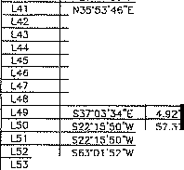

60.00"

N<6"51'3TW 73.87"

60.00"

6000"

C39

C<O

S'M-"02"

4"35"58"

1soo.oo· I ,so.11·

150 !0.41'

150.D5"

120.38

N31"53"T7"E N31"27"4.l"E

C126 Cl27

' 40·1r

·43·15·

WO.OD 600.00

27.97'

91.32'

27.97'

91.24"

N2T42'34"E

:;;: : : -

rn 3"47"02"

m '' '16"

150000'

1500.ao'

e9os·

' 2.4Y

99.0"-'

162.35"

N35'39'13"E N37'51'25•-

C128 10"35"16"

C129 •·32·,r

600.0D'

6Do.ao

110.87'

47.52'

110.72'

47.51'

N3721"49"E

m :)"44·41"

|  |  |  |
| --- | --- | --- |
| N•6"51"3TW  S63"46'2B"\ | | ' B.65'  30.00' |
|  | N *T* " 4"W |  |
|  | S5S"05'47"W |  |
|  | N48"21'5B"W | 5.13' |
|  | S3T03"34"E | 1.78' |
|  |  | 57,.:,7 |
|  |  | 1B.40 |
|  | I 5o;i·o1·s2"W | 1B.4D' |
| _L54 | 569"46"23-W | 29.6B' |
| 569"46'23"'W  N20"13'3TW | |  |
| N28"58'21"W  528"58"7.1"[ | |  |
| L126 | 558"57"14"E | 62.34" |
| 127 | 508"52'55-W | 48.97' |

1 00.00·

98.04"

98.02"

N39'25'□5-

C13D 1"43'2.:,"

500.00

15.04"

15.04'

N:J5'29';J;,2

m 4·5••11·

1soo.oa·

128.36"

128",lL_ N43"44':J,.E

C1,l1

rn·21·05·

5_00.00'

16 _87'

168.07'

N44"18'3D"E

*C*c*4*s,

S-28'46"

1500.QQ'

2"- 9'

221.79"

N45·11'57e".

c,021 14•m•3 •

500.00

12;>,55'

!22.24'

N43"22'37"

*w* 6"J5'3Q"

'

1500.0G

172.57'

1'72.4B'

C1.l4 5"05'32"

1000.00'

BBB ' ' 68.B'"

54""55"05'"E

c's",

"'

4·51·:io

3'42"<9

3'34'49

1500.00·

15DO.OO'

1500.00'

127.rn'

97.22'

93.73'

7.15"

97.20"

93.72"

N48" 7"21"E

N5Z"44"GS"E

N02"5t,"J{)"E

N56"33'19"E

C13JI 3°35'09"

Cl 5 8'40'04"

C1.l61 7'44'06"

'

5..!J0.00'

1000.00·

100 _00·

ai.:rn

151.28'

135.□□'

31_7.9·

151.13'

134.90

N52"11"29"E

548"07"49"£

S43"30"16"£

'

4·22·2a·

rn Z-03'35"

150.(l.OO'

1500.0Q'

114.5

53.92'

114.49

53.92'

N58"13"04lc

N5g"22'31"E

C137

C138

·m '27"

757·53·

1□00.00·

1000.00·

209.86"

137.26

2□9.•a·

137.16'

S3T47'04"E

53042'16"[

m '

CS3

4•49•55"

6'.lO"

4950□"

co.a□•

41.7•"

38.76

41,73'

38.75'

526"'9'17"

N2Er07'35'w

c,3g

Gl40

□·so·15"

2"17'02"

""'

1000.00·

1000.00·

14.61

39.BD"

14.61'

39.86

S31"21'13'E

S30"37'49"E

cs, ' '5'59'53"

'

...2L17"58"

500.00'

co, 5'46'33"

793.55'

*w* 52.34

52.32

N2Er54'ts"w

Gl41

·15·55·

1000.00·

161.71'

161.53'

S2Er1B'OB"E

rn ' '26'11"

"5000□' 108.5.Y

108.31"

N34'33'55'W

C142

9·04'40'

100□.oo·

158.44" 158.27' '

524"56'58"E

cse ' 1D"52'47"

ca,

7'37'31"

soooa' ' 94,94'

94.60

N35'20'36"W

' Cl43

,-,5•·3"

100□.oo·

1.ea· ,a

,21·02·24·E

c,;

cse

cse

coo

cs,

cs,

18'35"19"

tB'36'59"

038'38"

,s·10·,r

*r,,· a·*

1·25·2r

JOO.DO'

3CO DO

,93 55'

09.55'

jQ0.00' 39_93·

39.90" N24'02'23"w G172

300.00'

300.00'

300.00"

160.00'

97 3 •

974B"

'

1J9.51'

79.70'

37.67"

3.96

96.90'

97.05'

'

138.25"

79.46'

37.64"

3.98'

S31"29"21"E

s12·53·12T

SQB"52"22"£

S04"01"57"W

sos-cz•+s·w

N0t'37'39"

C144

C14

C15J

22"56'08" 60.09'

crno

C146

C147

Cl4B

C149

'35"

52·23•33·

g•4s•o7"

35·,g•n·

28°03'37"

11"5J'44·

l"D.00'

12D.OO'

1°0.0<l·

357,70'

357.70'

357.70'

130 a·

109.73"

2".56'

2.20.52'

17 .1B"

74,26"

1°3.99' '

105.95'

158.06'

S02"27"03"E

65,25' 6\ , ••

N25"Z8"14•e

0o,0Y

217,05'

173.44·

7•-13'

N00"57"16''w

N!O" 1'45',i

N2rc14'37.''E NOZ" ,·5s·E N29"18"54"W N49"17"14"\\'

C63

56"07'55"

160.00"

156.75" 150.55'

N'5"43'35-W

C150

11"23"12" ' 272.94"

54.24"

54.15"

558"39'56"'E

cs,

CEi5

40"44'54· 160.GO"

13'57'34" 160.0D'

113.79' 111.41"

38.sB' 38.69'

165.B7'

184.80'

Nl9' 7'31"\'1

N46c.,;• s"W

54:Y08'33"E

C151

c102

C!62

36"47'22" 272.94"

32"05'41" 272.94'

2"43'00"

53"18'18"

71"10'29•

1h.2s·

152.89"

24.06'

172.26"

150.90'

23.90'

s 4·34·39"'E

SQO"0B'C7"E

N67'14'41"W

cs;

4·45'49" o□o: ·

41.57'

41,5&"

530"06"40"E

Cl54 26'35'40" ' so_og•

27.B9'

27.64'

SB7'5>'z5'w

**cee**

m

18"41'22" <-08- Y

43·15•03· 4-08.33'

133.19

308.24'

132.60

300.97'

N3T04'26'w

N49'21'l7"'N

S71"03'17"C

S32"02'14"E

: t1-: :; :;:::

130.45'

130.•

1812.74"

176,18"

5253

146.lB'

96.11'

B5.95'

!63.91'

1:l8.£5'

95.82"

85.94'

S70"□2'45"E

S16"23'50"E

SB2"07'04"E

m 2T31"28" 4-0B33'

196.16'

19,4_.,,6,'

Nso·1o·s1·w

Cl57

2·05·14·

1812.74

66.03

66.03

86"28'34"E

i....£!_ 408.33' 11..J

J

□

?9.59'

29.5B'

59.45·

N72"27"42'w

C158

3·•9•55•

1B12.74'

121.24'

121.22'

NB9"26'0B"E

*en* - i-...,.n3.55' ,

244.48'

37.47"

55D"DS'OYE

c,s

5·10·19•

1812.74

163.63"

1£3.58'

586"03"44"E

-HH-ff2 : ;:

293.55' 33'

153.52'

S53"00"Z8"E

c1s1

41"25"24"

176.15"

127.37'

124.61'

S49"48"54"£

**rn** 35"46'J6"

<70□0' 293,48'

288.73'

N44"D6"49"W

C103

39"35'13"

553.44'

:J8 _ss·

374.98' ,

rn 11·30·02"

00 9 .34"

94.18"

N31"58'33"W

C164

!3"55'35"

553.44'

13452'

134.!S' ' ; i1r _

**c,a** 21"3t'DIJ"

"470.00' !76.50"

175..4,7."

N48"29'03"W

C165

5·53·43·

87f.95"

90.2J

90.19' N40"2B'rn"\s

c,e

·45'34•

470 oo· n.64"

N60"37' ' C166

10"27' 6"

B7S.95"

160.18'

159.96' N32"17"30"W

cao

6'26'05"

Joo oo· - _59'

:J3.67'

S$W47"0°5"'£ C167

10·12'45·

876.95'

156.31

156.10" N21"57'09"W

ca, 19·20'14"

:io□.oo· ' 101.?5'

100.77"

552·20·00·£ C168

9"22'15"

263.55"

43.10' 43.06' 521"32'24"£

ce, 32·22·54·

30DQO" 159.55"

1S7.30"

S39"22"J5"E C169

2"58'07"

150.00'

7.77' ' 7.77" NJ5"34'30"\

ca; 22"26'10"

300.00' 117.48'

116.74' S31"26"h"E C170

1·53'?7"

1436.22'

47.4-0' ' 47.40' S!5"43'21"E

CM 2·57"31·

300.00 15.49 15.49' s21·•2•23'"E C171

,

13"02'5°"

500,00'

113.BB' 113.62' N35"27'57''1'1

**ces** s,·12'1s·

30000' 283.81' ' 273.35' N47'19'45"w C17J

76"24"08"

52.53"

70.05 64,97' S80"H'27'"(

'"' 42°08'14" 300.00· 220.6 215.69" N48"55"15'W C174 28"53"10" 450,QD' 225.87' 224.48' NH

\CAf,\P\o I"P".M'.eBa.a5>0o3eecac ecm,,,,. "'·

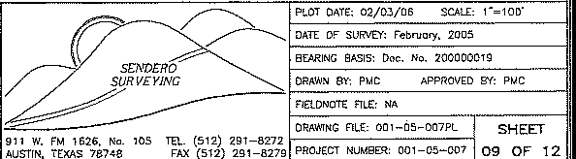

195.56"

P.O. Ba< 1220

Leander, Texas 78846-1220

*01:::!J* '" T•I(512)25 832 Fa,. (512)25NI016

CRYSTAL FALLS Il'M

*The Natural .IJ,lfemot1ve To Subdivisions*

***OD<LCJ1)l/*** *I*

GRAND MESA AT CRYSTAL FALLS II, SECTION 5

OR.sl AGE £ASEMENT LINE TA3LE

CURVE TAai.£

"'

NUMBER DIRECTION DISTA CE

"° DElTA RADIUS

CHORD

CHO D al':AAING

'°·

DELTA

RAfl<US

CHORD

CHORO BEARING

L5 N41-0t'29'W 4g_ 8"

L60 NB4"2 '29'\e 75.%"

cs, s1s·17'5J"w ss.aa·

L62 S84"48"3i"W 28.58"

L63 N62"21'55"W , 30.66' N<6"24'4g"W : 37.5.Q.'

LS5 N72"52'50"'W < 46. 2'

I L66 ND4"11"08"E 53.15' L67··· N$6"53"25"E 61.70'

LSB N74"51"44"E 11466"

C175 C176 C177 C178 C179

ciao

c,a,

C182 C18J C184

14"57"09"

?]"00'12"

14•7o•or 14"29'<-<"

z43·as·

2"09"36"

57"41'32'

'"

8"4<

02·57'54•

34·· ·31'

325.0D

coo·

'

'

250.0o'

27500'

1780.00"

1120.00·

150.00"

60,DO

60.00

6□.oo·

8'4".8'1

66.14'

C ss·

69.57'

87.49"

64,84" t.',1.04" 49 20·

65.S4"

36.35"

84.57'

264.65'

62.39"

69 39·

87 41,·

64.84"

144.74"

4763'

62 67"

35,n·

·24-w N4T55"43"E N5S32'02''W N41"07'06"w 7"4l'1B"w

···,:.B"00"59"w

NC8"1 ·•o'"w N11'S"•2 N43"D '58'"[

?Jl·03'5o'E

CZ63 C264 C265 C266 C267 C.l66 C25 C270 C271

C272

17"30'39'

13"<-0'53"

·oo·rn·

4•50'47"

moa·51· 1r24·45· J"Q6"41"

13"00"47"

34·0,•59•·

21·24•3g•

470.0

530.00

530.00'

570.00'

63000'

570.0□'

oao.oo· J3 .00'

?70.00'

330.00'

1'4"3,'64"

126.56'

18.55"

48."!'

tl1 58' 83.6,C·' "74.!1_ ,: _

\60.38'

3.32'

143.08

\26.25' 1B.54'

48.20"

111.4;3"

83.62"

"74.7'9'

158.03"

122.sa·

N43"23"17"E

N43 N$5"38"07"E N32"12"34"E N29"33"33"E N25"34"48"E N22"55'<6"E S27"52"49"W S33"23"25'W

S45"05"33"'W

L69 N64"03"1 6"E 89.04'

C185 155"05"37"

60.00

162.41'

117.18'

sos· .,.-w

C273

34•37'08"

o.oo'

'71.90"

267,73"

N.i0'02'1TE

L?O N71"55"12"E 63.63"

L71 N59"J2"49"E 4!.26'

L72 N'WJG"JJ"E 45.JS"

C186 C187 C188

55·05•5 •

4'37"43"

4"35"42"

90.00"

1780.00"

1780.00"

86.55"

143,79'

142.75"

BJ 25'

143.76'

142.72"

Ncg··o•37·w

553"57"57"\II S49" ,·, 5"\11

C274 C275 C276

22·21'49"

14'08"14"

a·rn·54·

'510.00'

510.0o'

510.00'

mg.as·

,2s. 1:

so·

1 7.80"

P5,52"

2.80

N46"10"17T N27"55'16"E N20"41"42"E

,-- i:=± : ::i;;t: ; ::±:f; ,· ;, .:::J

C189

o· 2·04·

1720.0D"

w1.22· ' 280.90'

sso·, "O:J"w

C277

2"11'2B"

450.00'

17.21"

17.21"

N21"37"59"E

L75 N12"-<8"Jg· 39 01'

C190 C191

9·59·10·

·1ros·

1720.00"

11ao.oo·

299.78

164.21·

299.40'

164.15'

S40"34-;::;-7"w

O¼· 4'49'"\'/

cna

cng

60"49'39"

163"47'44"

50.00·

50.00'

70.54'

142,94'

04.83

S9.oo·

so3·40·1s·E N£1"21"37"'11

L76 s15•49•39'W 60.39"

C192

6"!0'07'"

1780.00"

rna.a4·

191.55"

..... 3s·41•,2·w c2eo

17"31"41"

470,00'

143,78"

143.22·

s4s·o1•4o·E

L17

S6T45'42"w ga_or

C!93

1.,·59·20·

190.00"

6.39'

46.27"

N46"47'52'W C2B1

16"06'07"

530,00'

167.45"

166.75"

s44·44•,,j""c

L7B

S8554'35"W

9.Q.<.L.......

Cl94

as·o1·25·

190.00"

126.09

123.79' r47·3o·w C282

1·12•57•·

470,00'

9.97"

9.97"

s21r20·1.n;

Ll?.L_ LSS4"4B'3D"w

!1J.8g"

Cl95

2·,2•35•

190.00·

7 33'

-· NOD"40"30"'W

C283

1"2B"03' 530.0D"

13.SB'

!3 5B' -,

5.Zru.:.±2:l_

lBO



ND5"07'12"E

CS96 122·15"47"

60.00'

,2a oe··

,o's.10· N03"21"48"E

' C284

n-41'09•

438.33

159.02"

158.15'

N38"07"20'W

C197

35"25"23"

BD.00"

J7,09"

36.51" N82"12"53"E

' C285

44"17'26"' '

37B.3 '

"23.55"

2S2.4B'

285.25" N49"52"2B"W

N6 "2J''6"E 36.,3"

N45"00'51"E 65.60'

C198 142"15"04"

60.00·

148.97'

113.5,5.' ' sos·55•54"E .

1·55·24"

JJ'

12,70"

12.70"

39.43'

N72"58" :i'.)'!.._

'

N1T06'45" *7•*

C!99

C200

53'24"17"

6"14'20"

130.00"

172000'

121.\7'

187 29'

1'8"7 1g·

N2, os·24·w

"'"

SJ0"2T•3"W s2 .s5·

'

3S45'

158.02"

156.<5' '

S70-26'59"E

S5Z-57'55"E

N?SJ4'l1"0 71 79"

C201

4"49'47"

7780D0'

15004'

150.00"

S3n5'19"W

12"44"55" 323.55"

71. g·

' 531."35"59"E

s,.2·10'. *,"w* ,5.65'

s1'2·s••3g"w t75.7T

C202

4·49'47"

4·,s•53"

1780.00'

1no.oo'

15004'

13003'

150.0D"

130.0D'

526'25"32"\\'

s2s'1"'37"w i

10·,5·33·

22"44'42"

440.00·

440.00'

82.B4"

174.67"

"82.5'7'

17.>,52"

'

S'.>1"36"21"\I/

' N48"21"31"W

C204

0"44'50"

1720.0

22.43"

22.43"

S2T38'15"w

C292

35"46'36" 5□o.oo·

3'2

307,16 . N44.06"4S"W

S55"J7'59"W 59.11·

C205

1·44'43'"

1700.00

54.26'

54.26'

·-- 0·3·oa·1•-v1

C293

2·1o•,5·

44000'

S7,H''

17.44' N60"52'00"VI

S<i5"0ff51"vl 97.BJ"

C206

1·29'45·

1470.00

38. 8"

38 3E'

N23"00"43"E

C294

5'08'13"

27000"

24.21" 24.20" I S59"26'D1S:

S8B"G4"75'1'1 I 92.05"

N34"2B'07"W 74.46° N35"04'21"W I 4g_g1•

C207 2·01'0T

C208 5"13"18"

czog 4"36'21·

15JO.OD"

1.i70.00

1530.00"

67.26"

133.97"

122.99"

57.25'

133n'

296'

N°J"31'24"E N26"22"14"E

·;j:;:7"05"0B"E

CW5 C296 C297

14"07'17"

15'4!'46"

15"4\'46"

330.00'

0 C.C

470 oo·

81.3J' 81.13"

1<5,!9" 144,74'

6,75 126.3

S54"5G'29"£ N55'10'5S"C

; :;; "---i

5J.90"

71.29"

78.01·

99.19"

770.13'

2.53

'

0211·

67.17"

63'

98.!JZ'

167.33'

2.53"

S45"16'38"f Sl<'29"46'W SB5"4E'57"w 5>3"50"17"£

s:;a·4.s."s1· s20· 9•4o"c

SB0"55"33"E sii:"'o·

'

S09'3:?"C3T I

N45"55"43•E ' 70.00"

ssrY·44"E *n.oo·* S45"55 4J"W ! 70.00" S2J"J9"JO'"E 1J6.46" Nf,4"0B"56"E I 102.9B"

1530.00"

1530.00'

ssoco·

1470.00"

1530.00"

I 1470.oO'

00.00·

so.oo· so.oo· 330.00"

270.00"

270.00"

' . '

SS9'-'7'40"E I £9.58"

c210: 5"50"57"

II

c211 4·2g·51·

C212 3·44•35•

1470.00

I ,sai;:;o.

150.0T

120.10· e9.95' 100.0D'

160.08'

es.s,2,',

'15000'

---;:9,60"

170.74"

95.47'

'20 07'

99 g3·

99.99"

' \60.00"

' 2rn.es·

N 1"54'21"E

N31" B't4"E N35"45'27"E N39"30'00 N37"57'01"E N43"!4'2!"E N45"1l '04"E

N4g·1 '38'

C29B 1Q.5'57'21"

C299 C300 C301 C302 C303 C304

51'?8'17"

·o,·31· 74·,s·51"

,r,:i·rn·

Joos·or 0·32·10·

C3D5

19"07'52"

19"07'52"

EOOO"

'110,96 ' 95.B1"

'

7

C221 4'26'50"

S06"G7'05"E

SOB"55'11"W

L107

'lOB

95.77'

74,71'

S33" 6' e"E

SOO"D□'GO"E

I UOS

L106

70"36'58"W

frs-54·52"E

L104

I

270.0D'

90.15'

89.73'

025- z·w·E g1_55•

,,,, ""'

330.JO'

110.19'

1□9.Jl.a.:....· ::;: ;

4 .. 73"

58.80'

No1·os•3o"E '

cm "03'25"

13"02"52"

7y59'53•

1470.00'

*. JfilQ:.@'-*

1470.00'

1530 OD"

s.,o.oo·

52.5.,

02.5:,'

1530.00"

114.10'

9"9.22" 99.20"

S8.91" 98.89"

170 B4"

95,46'

120.69" 120.43'

54,9:l'

114.07'

20"53"57"

20"17'12"

oo·

270.00'

1;10,37

95.60'

119.70'

95.10'

67.6<

13.88"

63.23'

13.84'

5 _g3·

. 37" 5"<!"

0

67"J4"03"

so.oo·

"'

,'

59"18"17"

6□.oa·

116"53"45"

1s·22·35·

60.00'

OD.DO"

60.0Q"

39.54'

B2.70'

70.76'

38.63'

59.37'

122.41'

19.24'

B5.73'

! : : l_1

,w

S30"<,a.'37"

!02.0E' 19.1B"

'N"54'56'26"W

NB5'53'!2'°E

L109

LllO

5J0"03'12"'W

ss1·21·os·w

LL114

107.0J"

106.BO'

9·04·55·

330.00"

52.31"

5?.;_5.:,...._. + !:ll£46'05'W

L111

S25" 5"08"'W

39.21"

39.20'

1s16"19 17r C31'5

38"25'52"

330.00"

221.35'

217.22'

N<8'J1'S. .Yf-

L112 L113

S50"2J"13"w S7ff<5"30"W

530.0D'

470.00

43.97"

4£.26"

43.90'

46.24'

C230

c2:i,

s12·os·s1'"w 50ff2o"49"E

50_7'2}"47"\'I

S53'35"10"w 25.34'

46.11"

6.21·

as. _,,:

11·14•20·

,-

c44·49· s·3s'21·

47□.oo·

Ho.a□'

4·49'55•

455.oo'

92.19' 2.04"

260.B4'

75.95'

'

No5"09"50"'1/

N26"16"44''W

N>6"4Y o·w

C318

CJ18 C317

5"20'57"

55"21'03"

13"11·,,-

210.00·

210.00· JO.DO'

25.21"

25.,o· ' N73"15'□9"VI

C232 C233

L115

L116 L1'7

1""07'5?"

1T36'

530.00"

70.0

11 :,.2·

s2. e·

112.01'

82.65"

N34"43"04"VI SJT"5B'45"E

C319 C320

14'19'19"

,e;-ci?.'43"

3.;;;·00· 82.4

210.00· 179.28'

'

a2.2r No1·54'43"£

* 1. " N09"55'59"w

135.66" '

250.6;'

75.79'

;;: : ;

4J.)\'

s22·34•2:i·w

S0-'"54"0:i''w

'82.20·

C234

C2J5

19·04'35•

18"16'47·

330.00·

330.00"

109.87'

105.27"

109.36"

10<.B:S'

531'14'43•

Sl2"34"05'"E

C321

C322

23·43'24·

61"14"05"

330.00" 136.64"

60.00' 64.12'

fil.!2' '

N17"06'39"W S58'21"18"E

*n.zo·*

89.00"

C236

29"Q9'57"

270.00'

137.44'

135.96'

SOB"35"32"E

C323

62"36'12"

60.00' GS.56'

; ' SO'""J' o·w

7.50"

s40·;,",,1"E

533"26"29"E

N56"33"3;'"[

541"?6'18",:

573·os'1s·w

C238 C239

1-.-' 04'20"

5·3g•o9•

01'"5□'34"

7.70.00'

60 00

'

2664'

7\,04"

33QJ1Q..:..... .) 8B.8!'

86.56"

26.6J'

65.97"

S04"06"25"W

SOB"49'D1"w S14"26"08"E

C324

C325 C326

86"28"39'

89"41'04"

20·•5'04"

ED.OD' 93.9

270.00" 97.79'

60.00' 90.56'

84.62' ' N13"48'53"11

97.25" SBW.i1'50"W

>53"DB'J7"E 58,T 6'5<"E

'

C240

C2<2 0243 C24',

"

'

i G245 C2<6 C247

r

67"38'55" 50.00

4£"41"47'" ' 60.0D"

76"56'47 ' so.on·

'

40"51'57" ' 60.GD

68'33'38' 6000"

40"59'54" *wm*

40·04'J6" 6D,DO'

55·4o'ts" 6D.oo·

70.84

.iB,90

42,79'

80.58"

71.80'

4293

41.S7'

59.35'

6£.ao· 47.56'

41.89'

74,£6'

67.59'

42.02"

4;_72·

5;;:;;s•

S53"16'3B"\II N69"31'0J"w

ms·«·, 1"w

N33"10"11"c

s41;-0T4s•c S06"38"57"W

s,.9·1n2"w

NB2"26"22''W

□,;

C}28 C329 030 C33\ C332 C3J3 C335

22·35·09·

\"(S1"Q5"

g·as·oo· 12·as·or 2'"50"00"

17"26'24'

74·41,•,o•

19"27'55"

330.00"

270.0G"

530.00"

530.00"

470.0D'

470.00"

530.00'

530.00'

130.18

6.72

88.80"

111.93'

179.10'

14.3.33'

136.93'

1800B'

129,J•"

3.72·

88.70'

117.73'

* 1. '

147.78'

136.55'

,n.,s'

S87"46'78"w

' S77"Z3':,_"i:!J.......

NB1"16'1J" SBT5:1"46"< NBT23"13"F 572·57•35•,

574·25·40"£

1---,2?7"17"3!!'.L. j

C248

93·41·,7 so.oo·

98 1

67.50"

NOT15"26"'11

C336; 16"39'4.3"

470.00'

136.6B'

.L...J.3620'

S55"5J'31"

C249

l"l!!'So'·

1030.D□'

23.62'

ZS.62"

s21·o•·orE

C3371 13"55"46"

530.00'

128 85'

128.53"

N34" 7"30' !

C250

C251

9·1s·oo·

9·10·1a·

970.00'

10 0.oo'

l56.SO' 164.88"

]56.43'

164,70

s2s·o2·orE 526"1B"36"E

C33a 13"55'46"

5·rn'53"

470.00'

470.00'

'14.?6'

4.3.50'

113.98'

4:l. .a·

W4· rao"c

530·□0'04'\V

C2 2

2"DS'43"

970.00

35.75"

JS.75

S30-42'59"£

"CJ"<O rn'41"

30.00'

6655'

ss.s,·

s>1·os·n·w

C25J

0"5'.l"a5" 1030.GD'

15.75'

\5.75"

S 1"20"03"E

C3<1 8"17'24"

530.00'

76.69'

76.B''

S38"50"00"\II '

C254 C255 C25G

"

T•s·1e· 11·59·51·

7"47"49" ff<1"39"

103D.OD

970.00'

1030.DO

970.00'

!40.61"

20,.,2

138. T

147.19"

C

202.7

"

138.26

147.05'

'

535"40'59"E

5.>7"46"16"E S43"26'32"E S48"07'D1"E

C342 10"10"12"

C343 18"10'56" C344 4"33• G345 13:,-34'0;('

,..

470.QO'

6000'

6D.00'

so o·

83.42'

19.04"

G.33'

,:,aa2·

3 ;i,r

,n_g,s·• 1"09.87

;::! ' ''

ses·43'37"E S£72s· s·w

C258 C259 C260

5·,0•24•

110·37•04'

4D"50·2a·

\030.QD'

so.oo· so.oo·

93.00' 9?97'

115.84' 9867'

42.77" 41.87"

S4S"52'3s"E S17"46"2.>"E NB£"29"51"E

C346 12S"$0"24"

C3<71 .1"03"30" C3<8 4"27'D4"

so.oo· 178.Q.(!D

1780.00'

135.97"

95.02·

138.26'

106.09"

95.oo· 138.24'

N18"3B'53"'E

s•a·o,·ss·E S42"16'3B"E

C261 102"55'18"' '

SD.DO"

107.78" 93.66'

N14"36'5g"E

c34g1 57'31"

1720.00'

208.90'

20B.71

42'30'26"C

c_C2 2 _ ·23•,o• I 530.Dj)'

357' 3..5.L... N50-30'43".E C350[ 64"37'23•

2G.00'

22- 6'

:/1.:lB'

N11"46"26"W

Jay Enginee ng Company, Inc.

P.M.S. 503

P.O. Bo, 1220

Leander, Tmcas 78606-1220

Toi, [512) 2SS-lS82 Fa,.10121 20 -aorn

CRYSTAL FALLS II•M

*The Natural Alternative To Subdivisions*

PlDT DATL 02/03/06 SCA!..[: ,· ,oo·

DATE Or SllRVt'fc Feb;oo,y, 2005

*r?*

*lV* ,

BEARING SASISc Doe Na. 200000019

*SEND£RO*

*SURVEYING* .. PRAWN *BY:* PMC APPROVED BY, PMC

/ / -------- !1ElDN0ff FlL£c *W.*

71

,-AA-,,-'"-,-,-,-""-,-_,-,_-,-m-ec_i_s_H_E_Er_

911W Fla 1626. No 105 TEL. (512) 291-6272

AUSTIN. TE>'.AS 76N8 FAX (512) 291-6279 P,:OJ[CT UMB<il· □01-05-007 10 OF" 12

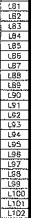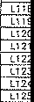

GRAND MESA AT CRYSTAL FALLS II, SECTION 5

1 fotol Acres 244.112

1. Numbe, *oi* Lobs; 166 Residential Lots; 4 Porklond Loi; 1 Moilbo Lot
2. Number oi Blocks: 7
3. Proposed Use, Residential
4. Owner Lookout. Development Group, LP.
5. This subdivision is wholly contoined within the current cocpom\e limits of the City of Leonder, Texas
6. Construction of improvements within this subdivision shall not commence until 'all opplicolion permits ond/or Construction Plans hove been approved by the City of Leander, Texas. All pubk impcovemenls shol! conform to \he current Zoning Ordinance *of* the City ol Leonder, Texas.
7. No lot in in this subdivision shall be occupied until connected to the waler dis/ribution system of the City of Leander, TexM.
8. Restrictive covencnts in the form of a "DECLARATION OF COVENANTS, CONDITIONS ANO RESTRICTIONS FOR THE GRANO MESA AT CRYSTAL FALLS SUBDIVISION" ore recorded in the deed records of both Travis and Williomson Counties
9. In order to promote drainage owoy from o structure, the minimum foundation slob elevation should be buil•l ot least one foot above the highest g,ound elevation within live (5) feet *ot* the Slab perimeter, end the ground odjacent to \he slob should be sloped owoy from the structure at o slope of 1/2" per foot for a distance of at least ten {10) feel
10. Waler will be provided by the City of Leander
11. Finished slopes which are greeter than 15% cannot use surface i•rigation systems
12. Twenty-/iv foot OSSF setbacks ore required from oil droinoge way>

14. Twenty-five fool OSSF se\bods ore roquired from all finished slopes which ore greater than 30%

1. All private streets shown hereon and any security gates or _devices controll,ng access to the some private streets shall be owned and maintained by 1he established homeowner's association of this subdivision
2. A 5 foo1 P.U.E from all side lot lines is hereby dedicated
3. Building setbacks ore os shown on plot. In ony event, building setbacks shall conform to the current Zoning Ordinance ol the C,ty of Leander, Texas
4. The following variances were gronted per o Development Agreement with 1he City of Leander and opproval of the Crystal Falls I! Concept Plan on Moy 1, 2003.
   1. Private Streets with re>odside droinoge (Austin Transportation Criteria Waived). B No sidewalks, *due* to private streets or.d terrain.
5. No street iights, light pollution free deed restrictions
6. No tree survey, due to private streets

79. No development shall begin on Lo\s 7-8, 11-13. 15-21, Block "'C" ond Lots 71-80, 82-84, 87-88,

754-169, Block "E", prior to issuance ol o Flood Ploin Development Permit by the Williamson County Flood Plain Admin;strotor for eoch lot spec;/ied.

1. The developer, builder, seller, or ogent shall inform, in writing, eoch buyer of subdivision lots or property located within flood ho:tord oreos tho\ such property is ,n on identified flood hazard oreo ond tho! o Flood Ploin Development Permit will be required before a structure con be ploced on 1he prnperty The written notice shall be filed for record in the Deed Records of Williamson County. A copy of this written notice shoil *b* provided when applications ore mode for Flood Plain Development Permits
2. Prior to any channel ollerotions, bridge construction, fill, dredging, grading, channel improvement. or storage of moteriols or ony other change within the 100 yeor flood plain located within this blue l<ne

{survey), on opplicotion for Flood Plain Development Permit with a description of 1he project and extent

of changes, if any, to the watercourse or natural drninoge os a result of the prnpased development must be submitted lo and approved by the Williamson Coun1y Flood Plain Adminis!ro(or. All specifications and details necessary For complete review must be provided

1. Prior to ony channel alteration or bridge construction which will change existing flood pollerns or elevations, o letter of mop omendm nt must be submitted to ond approved by the Federal Emergency Management Agency.
2. No driveway shall be cons\rucled closer than 50' or 60% of poccel frontage. whichever is less, to the

ROW of on intersecl;ng local or collector s\reet.

1. Front building lines ore measured from the edge of the street easement
2. Garages facing o side slreel on o corner lot ore required lo be set bock 2.0'.
3. There is no floodwoy contained within this subdivision according tc, the Federal Emergency Mor,ogment Agency os shown on the Federal Flood insurance Role Mop No. 48453C0275 E, Travis County, Texas dated JUM 16, 199}
4. No .slruclure or lond on !his blue line (su.-,,ey) shail hereafter be located or altered without first submitting o CERTIFICATE OF COMPLIANCE Application Form to the Williamson Co nty F!ood Plain Administrator.

BFNr.HMARKS

BM '' SRASS OISC SET IN CONCRETE AT TllE BACK OF CURB OPPDSlT£ FRONT LOT CORNER OF LOT 4 AND 5, BLOCK T' ELEVATION - 876_g4

BM 2, BRASS QJSC SIT IN CONCRETE AT mE BACK or CURB BD'± SOUTF-!EAST Of" T E COMMON FRONT LOT CORNER Of 1.0T 1S7 AND 168, BLOCK "E"

ELEVATION - 6 7.04

9M 3: BRASS D•SC SET IN G0NCRE7E AT THE BACK OF CURB 35'± NOR1H\'E5T OF THE COMMON FRO T LOT CORNER Of LOT 161 Af/D 162. BLOCK "E"

Ct.EVA110N 83£.27

BM , BRASS D!SC SET IN CONCRETE AT THE EAGK OF CURB OP?OSITI:: FRONT LOT CORNER OF LOT 85 AND 66. BLOC "E" ELEVATION - 922.23

BM Sc BRASS DISC SET IN CDNCRCTE AT THC SAC DF CURB lN LOT BO. BLOCK "E", OP?OSITI:: 1HE CENTI::RUNE OF PUMPKfN RFDGE

ELEVATFON - Mt.<3

BM 6, BRASS DISC SET IN CONCRETE AT THE E<AC OF CUR8 15'± WEST *OF* THE COMMON FRONT LOT CORNER or LOT 75 ANO 77.

BLOCK "E". ELEVATION 852.36

\/ERTICA( OATUM, NAVD-88. SllSEO ON CITY OF LEANDER GPS COITTllOt.

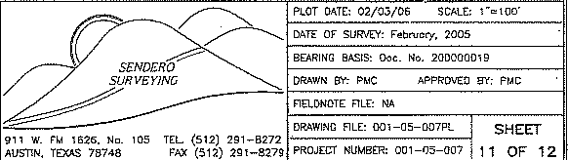

D*'f*-0\l JD@010

I P'" .M.'B"."5'0"3'"""' Oom,aa, '"' P.O.Box1220

Leander, Tsiras 78646-1220

TM Tol.(512)259,-3S82 Fa<.l512)25Q-fl016



**CRYSTAL FALLS** II"

*The Natural Alternative To Subdwisions*

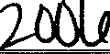**(JX)l/**

|  |  |
| --- | --- |
| **GRAND MESA AT CRYSTAL FALLS** II, **SECTION 5**  DEDICATION STATT:MENT: STATE OF TEXAS  COUNTY OF TRAVIS  THAT LOOKOUT DEVELOPMENT GROUP, L.P., A TEXAS LJMITED PARTNERSHIP, BEING  THE OWNERS OF 244.112 ACRES OF LAND SITUATED IN TRAVIS COUNTY, TEXAS OUT I, DANA DESSAUVOIR, CLE'.RK OF TRAVIS, TEXAS, DO HEREBY CERTIFY THAT THE FOREGOING OF THE C.W. OWENS SURVEY NO. 71, THE C.S. MASON SURVEY NO. 204, THE TOM INSTRUMENT OF WRITING, WITH lj:/ £.E.VlllFICATE O (IJT ;;,IILED FOR 1&:I·  CATER SU VEY NO. 206. THE C.C. CHAFIN SURVEY NO. 76, THE J.H. HARRIS SURVEY RECORD IN Y OFF1CE ON THE **_ct;_•' *b***AY OF---' ·,UrJ,1:.c.&_ , dJU'A.D., AT •  NO. S6 AND THE J.M. FRAME SURVEY NO. 656, BEING ALL OF A 240 989 ACRE O'CLOCK iff.!5r ANO DULY J1ECOROED ON- THE J _ Y OF • ::1[" 1---, 20_-  TRACT OF LAND CONVEYED TO LOOKOUT DEVELOPMENT GROUP, LP. BY DEED OF tiD[:1ooC MEN c ·d'j'> *..cJ.Q'B"m*IRECORDS OF SAID COUNTY A 'D STATE, RECORD IN DOCUMENT NUMBER 200507:?.609 OF THE OFFICIAL PUBLIC RECORDS OF  TRAVIS COUNTY. TEXAS. AND PORTIONS OF THOSE PROPERTIES CONVEYED TO  LOOKOUT PARTNERS, L.P. BY DEEDS OF RECORD IN VOLUME 13085, PAGE 7927. wI1®t>'tJKt11 D WAo; orncE OF THE o,uNTY CLERK THdl!.- D11Y oF VOLUME 13085, PAGE 1974 OF THE REAL PROPERTY RECORDS OF TRAVIS COUNTY, 20  TEXAS AND DOCUMENT NUMBER 2000762836 OF THE OFFICIAL PUBLIC RECOROS OF - ,,,,'",;.ouiii-;,,,,,, mAVIS COUNTY, TEXAS, 00 HEREBY PLAT SAID 244.112 ACRES OF LAND IN DANA BEA BOVOIR, COUNTY CLERK / t§,;:;}f" ACCORDANCE WITH APPLICABLE OROINANCES OF THE CITY OF LEANDER. TEXAS AND  TRAVIS, COUNTY, TEXAS, THE HEREIN DESCRIBED PLAT TO BE KNOWN AS GRAND *i1, JJ*  MESA AT CRYSTAL FALLS II, SECDON 5 AND 00 HEREBY DEDICATE TO THE'. PUBLIC ::. - -: ;t' -- ,e,u;y(:  THE USE OF OF ALL EASEMENTS AND PARKLAND AS SHOWN HEREON, SUBJECT *TO*  ANY EASEMENTS AND/OR RESTRICTIONS HERETOFORE GRANTED AND NOT RELEASED  **\.,,IL i l-= e,t..- e,8,-c(:,** STATE OF TEXAS  COUNTY OF TRAVIS  WILLIA\< R. HINCKLEY DATE I, PHILLIP L. MCLAUGHLIN AM AUTHORIZED UNOER THE LJ\WS OF THE STATE OF TEX/IS  BY LOOKOUT GROUP, INC., GENERAL PARTNE'.R TO PRACTICE'. THE PROFESSION OF LAND SURVEY1NG, ANO HERESY STATE THAT THIS PLJ\T  2370 RICE BOULEVARD, SUITE 200 CONFORMS WITH APPLICABLE ORDINANCES OF THE CITY OF LEANDER, TEXAS ANV TRAVIS  HOUSTON, TEXAS 77005 COUNTY. TEXAS, AND THAT ALL EXISTING EASEMENTS OF RECORD OF WHICH I AM  AWARE HAVE BEEN SHOWN OR NOTED HEREON  STATE OF TEXAS  COUNTY OF TRAVIS - iLA1t t -  BEFORE ME, THE UNDERSIGNED AUTHORITY, ON THIS DAY PERSONALLY APPEARED REGISTERE'.O PROFESSIONAL LAND SURVEYOR  WILLIAM R. HINCKLEY. KNOWN TO ME TO BE THE PERSON WHOSE NAME IS STATE OF TEXAS NO. 530D SUBSCRIBED TO THE FOREGOING INSTRUM(NT AND ACKNOWLEDGED TO ME THAT HE SENOERO SURVEY1NG EXECUTED SAME FOR THE PURPOSE AND CONSIDERATION THEREIN EXPRESSED, IN 911 W. FM 1626, NO. 105 THE CAPACITY THEREIN STATED. AUSTIN, TEXAS 78748  GIVEN UNDER MY HANO AND SEAL OF OFFICE, THIS THE 2=:' DAY OF *s1.2..!!_?* 512-291-8272  20J;L4. A.O.  STATE OF TEXAS COUNTY OF TRAVIS  **°&A'i\"-Fl. l\ ..f.:I._,_ S. 1"1'!:\ ­**  PRINT NAM[ I HEREBY CERTIFY THAT THE PROPERTt HEREIN IS PARTIALLY WITHIN A SPECIAL FLOOO  NOTARY PUBLIC IN AND FOR THE COUNl'f OF 1RruJ.1.!:, , TEXAS HAZARD AREA AS IDENTIFIED BY THE FEDERAL EMERGENCY s'ANAGEMENT AGENCY AS SHOWN ON THE FEDERAL FLOOD INSURANCE RATE MAP NO. 48453C027S E. TRAVIS  MY COMMISSION EXPIRES ....!_1.:: 'Z_:_ . COUNTY, TEXAS, DATED JU E 16, 1993  I, THE UNDERSIGNED PROFESSIONAL ENGINEER IN THE STATE OF TEXAS. *DO* CERTIFY Ti1AT THE PROVI NS CONTAINED ON THIS PLAT COMPLY WITH Tl-lE SUBDIVISION ORDINANCES  STATE OF TEXAS AND ;:: LICIES ADOPTEO BY THE CrTY OF LEANDER, TEXAS.  COUNTY OF TRAVIS  APPROVED THIS THE DAY OF EclJ..cl.LJ)...!'.!,!, 20 *(){j,_* A.O. AT A PUBLIC MEETING OF THE PLANNING ANO ZONING COMM1$SION OF Tri£ CITY OF LEANDER,  TEXAS ANO AUTHORIZED TO BE FILED FOR RECORD BY THE COUNTY CLERK OF SAI.IUEL O KIGER, P.E TRAVIS COUNTY, TEXAS STATE OF TEX/IS NO. 89353  JAY ENGINEERING COMPANY, INC.  P.O. BOX 1220  *'1-* LEANDER, TEXAS 78646-122D  512-259-3882  CHAIRP  mo  ALL PROPERTY OF THE HEREIN-DESCRIBED SUBDIVISION IS SUBJECT TO THE LOWER  'oe COLORAOO RIVER AUTHORITY'S NONPOINT-SOURCE (NPS) POLLUTION CONTROL ORDINANCE.  ITY OF LEANDER, TEXAS ANY DEVELOPMENT OTHER THAN CONSTRUCTION ON A SINGLE-FAMILY RESIDENTIAL LOT MAY REQUIRE AN NPS DEVEWPMENT PERMIT FROM THE LOWER COLORADO RIVER  AUTHORiTY.  ATTEST:  THE WATER QUAUTY PROlECTION AREA IN THE FORM OF BUILDING SETBACKS IS USED TO IMPROVE THE QUAUTY OF STORM WATER RUNOFF FROM DEVELOPED LANDS. NO  cf:R(/4 STRUCTURES OR OTHER IMPROVEMENTS MAY BE CONSTRUCTED Wm-!IN THE BUILDING  CITY OF LEANDER. TEXAS SETBACKS OTHER THAN THOSE ALLOWED BY THE CITY OF LEANDER. THE'. WATER QUALITY  PROTECTION AREA MAY BE ENFORCED BY THE LOWER COLORADO RIVER AUTHORITY OR ANY OTfiER GOVERNMENTAL ENTITY  BASED UPON THE ABOVE REPRESENTATIONS OF Ti'IE ENGINEER OR SURVEYOR WHOSE SEAL IS AFFIXED HERETO, AND AFTER A REVIEW OF THE BLUELJNE AS REPRESENTED BY THE SAID ENGINEER OR SURVEYOR, I FIND THAT THI$ BLU[LINE (SURVEY) COMPLIES WITH THE REOUIREMENTS OF EDWARDS AQUIFER REGULATIONS FOR WILLIAMSON C0UNT1', WILLIAMSON COUNTY FLOOD PLAIN REGULATIONS ANO WILLIAMSON COUNTY ON-SITE SEWAGE FACILllY REGULATIONS. THIS CERTIFICATION IS MADE SOLELY UPON SUCH REPRESENTATIONS AND SHOULD NOT BE RELIED UPON FOR VERIFICATIONS OF THE FACTS ALLEGED. THE  WILLIAMSON COUNTY & CITIES HEALTH DISTRICT AND WILLIAMSON COUNTY DISCLAIMS ANY  RESPONSIBllrTY TO ANY MEMBER OF TI-IE PUBLIC FOR INDEPENOENT \IE:RIFICATION OF THE REPRESENTATIONS, FACTUAL OR OTHERWISE CONTAINED IN THIS BLUELINE (SURVEY) AND THE DOCUMENTS ASSOClATED WITH IT.  PAULO PINTO  DIRECTOR OF ENVIRONMENTAL SERVICES | |
| Ja@I/ \) IO,.,ea, ,,, eom,,,,, '"  P.M.S. 503  P.O. Box 1220 **CRYSTAL FALLS** II""  Leander, Texas 78646-1220  *t'.'.J* '" T•I.101212so-saa2 Fa,. 1s1<\ 2 0-3016 *The Nolural Altemotwe To Subdivisions* | PLOT DATE. 02/03/06 SCAl.Ec 1·~100'  DJ1TE OF SURVEY; Februmy, 2005  *\V*, B!:AR!NG E!"51S; Doc. No. 200000019  *SE:NDERO*  *SURV£nNC* DRAWN BY, PMC AJ>PROVED BY, PMC  / / -------CcCeCeC"==c•ILE=-•C ' ll  DRAWING Fl<.£; 001-05-007PL SHEE.T  911 W. FM 1625, No 105 TEL. (5• ) 291-8272  AUSTIN, TEXAS 7874B FAY (512) 291-8279 PROJECT NUMffER; 001-05-007 j 12 OF 12 |

GRAND MESA SECTION 6 ADDRESSES

---- ---- --,-------,---------

'I

I I

I I I I I

I- _

r-

I I I I I I I I

I

N

®

12 11 10 **SI 8** 7

11ID\ *'l* l .3f',tS *-Vo* t \

**10**

"

20

I I

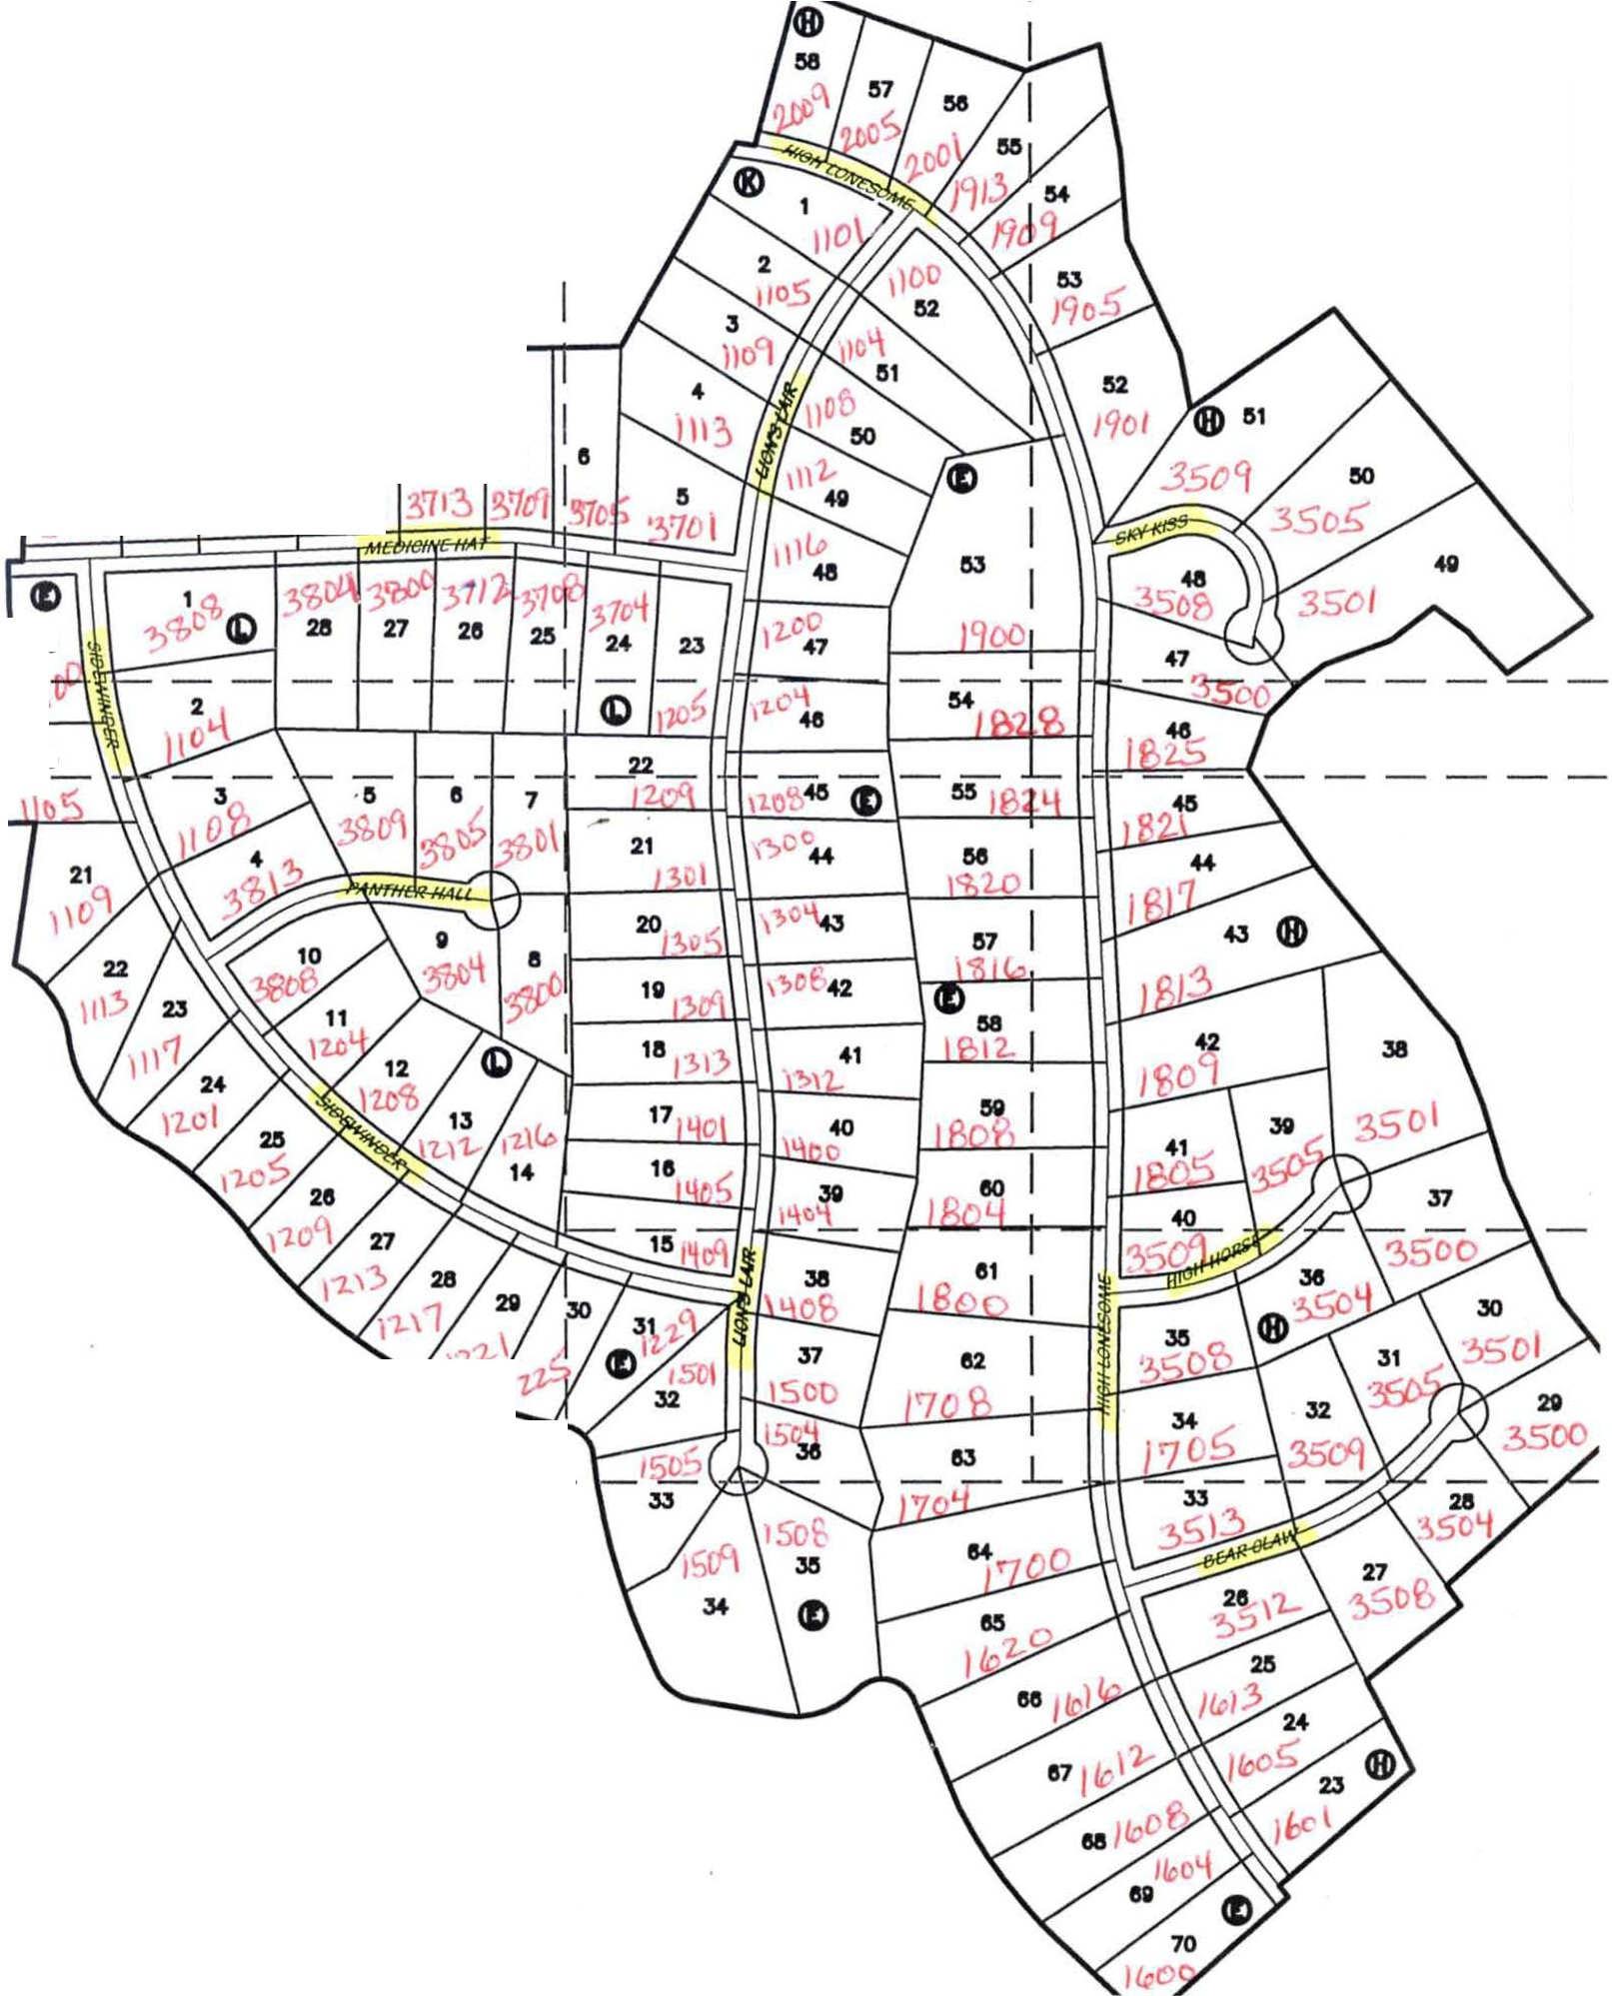

L I

I I I I I I I I

**GRAND MESA AT CRYSTAL FALLS** II, **SECTION 6**

**FINAL PLAT**

LEGEND

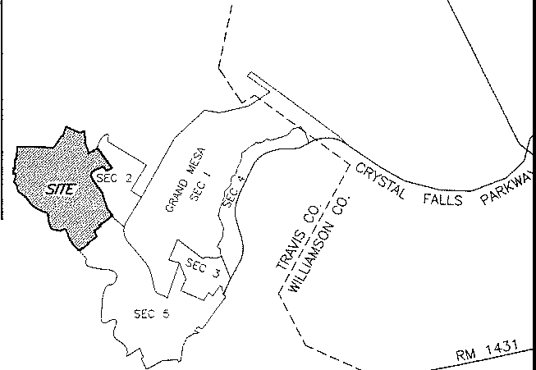

I

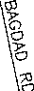

LOCATION MAP

{NOT TO SCALE)

**SHEET INDEX**

i

I I

I I

I I

I I

SHEET

I I I I

I

I I

I ®

I " " *w*

I I

L

I

I

7 1'

"I

_j

1. "

SHEET INDEX

(NOT TO SCALE) N

I I

50 I

I I J

I (9

"

*J.2_*

i

7

54

'5 ©

"

SHEET 3I

1

I 21 55 I

"

20 .,

I

I

57

I 1' -t\+--"---1 **E** I

58

I 18 " I

I " "° 59 I

I

I

I _J

I I

I I

I I

*_l* J

I I

I I

I I

I I

I I

I I

I I

I I

L

,f'"'c>---. 0,_c_o,_o,_,_,_o_,_f2_,_10_, sc,_cc_,_1·_·-_rn_o_·_

**Pl**

/ --.. DAT£ OF SURVEY: 08/2007-02/2008

_,,

Jay Engineenng Company, Inc.

P.M.B. 503

P.O. Box 1220

Leander, Texas 78646-1220

Tel. (512) 259-3882 Fax. (512) 259-8016

**CRYSTAL FALLS** II™

*lZ::- -...Jan-- _,,, ro -*

*SE,VDERO;;::::: SURVEYING*

*_-;::::-::::-1/* ----

911 W. FM 1625, No. 105 TEL. (512) 291-8272

BEARING BASIS: TEXAS CENTRAL ZONE

DRAWN 8Y: PMC APPROVED BY: PMC FIElDNOTt FIL£: NA

DRAWING FILE: 001-07-013Pl **SHEET**

AUSTIN, TEXAS 78748 FAX (512) W1-8279 PROJECT NUMBER: 001-07-013

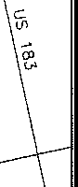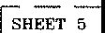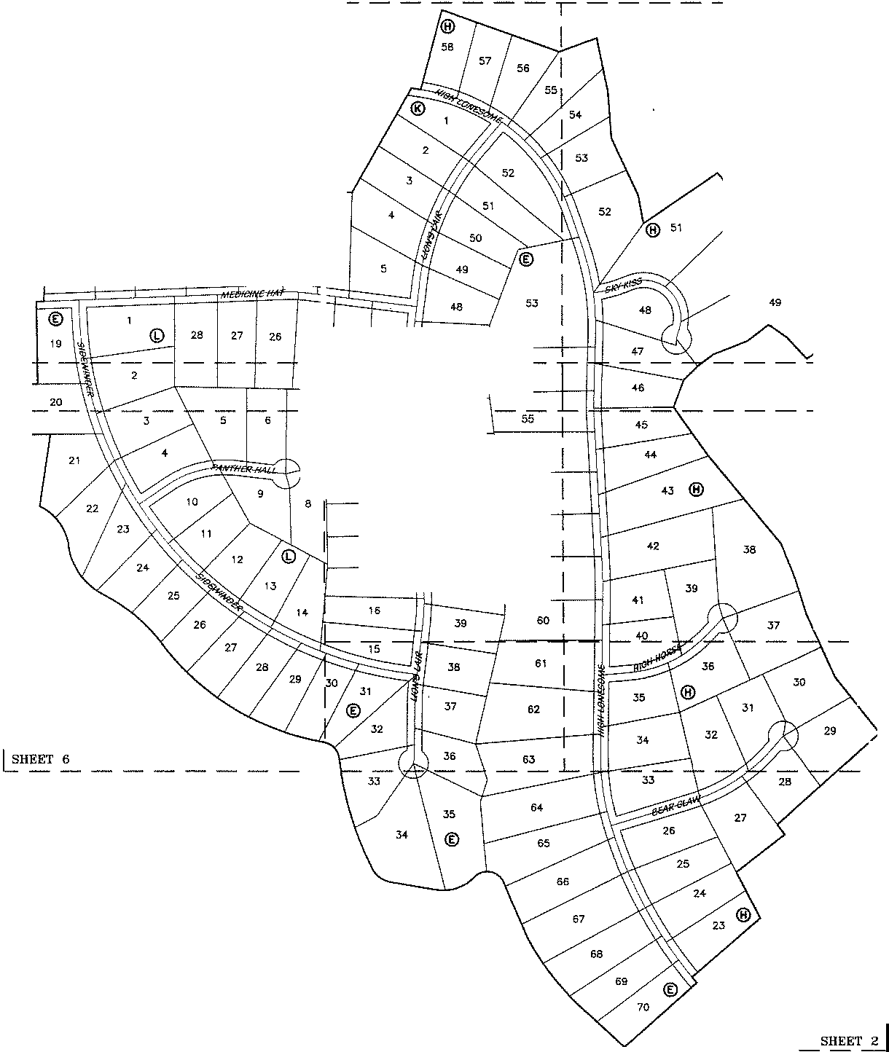

**Cl.Pe**

1/2" IRON ROD WlTH CAP FOUND

0 1/2'° IRON ROD WlTH "SENDERO" CAP SET

*C:,.* MAG NAIL WITH "S£NOERO" SHINER TO BE SET

.._

@El

O.E.

CALCULATED POINT

MINIMUM FiNSHED FLOOR ELEVATION

DRAINAGE EASEMENT

W.8.Z.E. WATERWAY BUFFER ZONE EASEMENT



1 OF 9

61162 Sf :f/ 1 S89.4T11'W 4\1.38

61

80%7 SF

(60' PRIVATE STREET

DRAIN.

LOT 5

S7g,43,

38

51174 SF

[]:ill

* 219_81'

[]nJ

101_ 16' 35

36

65257 SF

30

46*E 2aa.27•*

LION'S I.AIR

(60' PRIVATE STREET

DRAIN. & PUE)

37

50385 SF

[]:ill

*I* 62

98174 SF

[ill}

*;>Gs.*

58728 SF

31

6122" SF

64900 SF

5J01S SF

{M[]

2%.15'

S85'2J'47''W 5o3.1B'

63

67760 SF

34

63445 SF

32

68748 SF

29

68517 SF

28

55421 sr

64

86248 SF

[]§QJ

65

\

/61% Sf'

26

69216 SF

27

68107 SF S36"00'07"E

/ 50.00'

JO 3,•

66

75291 SF

[]ill

25

s5oJ7 sr

\:,\

',&,_\"'..,

.,

.

\'.'

\

67

80807 s•

[@]

68

&834 1 sr

CM[]

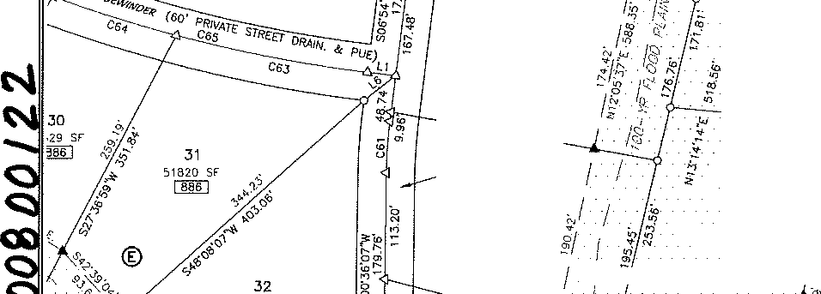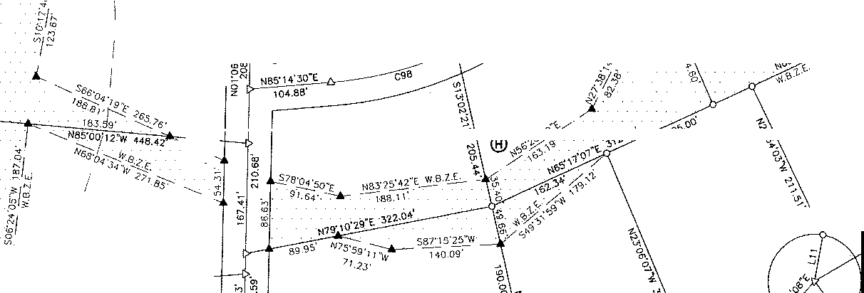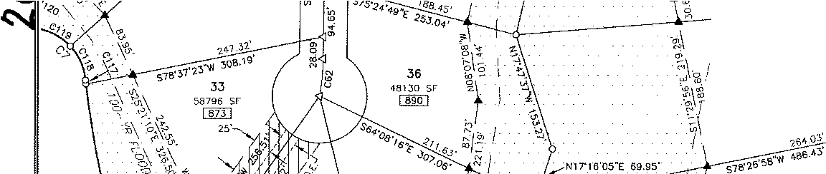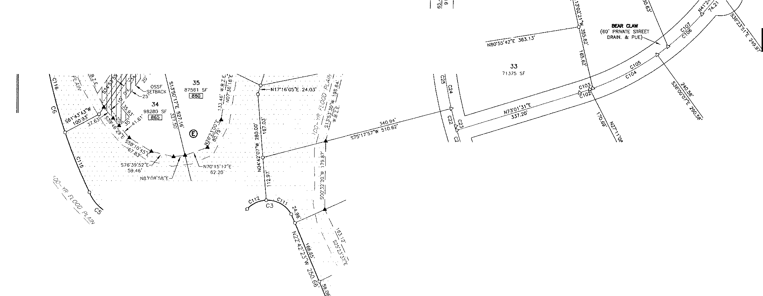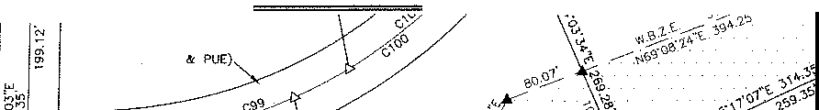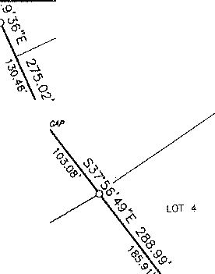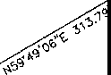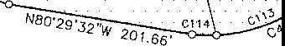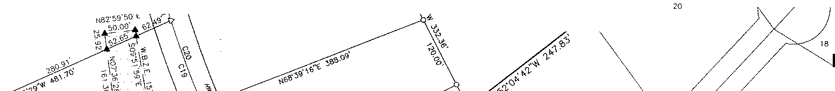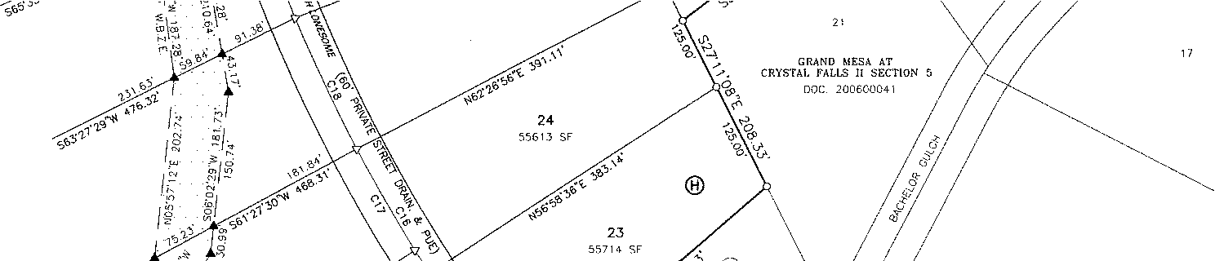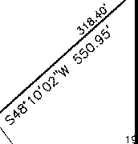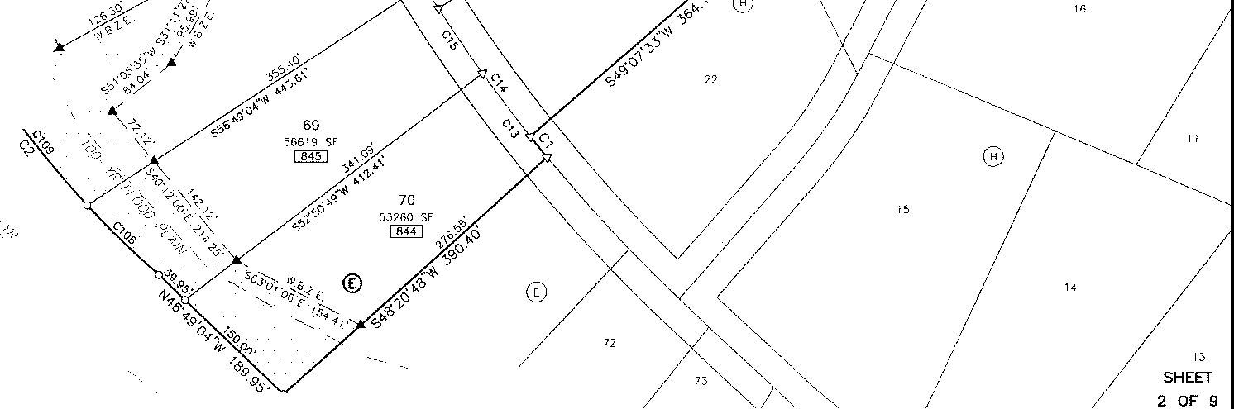

1013.55 AC. (TRACT 1) LOOkOUT i'ARTNrRS, 1..P DOC 2000\628JG

"

**GRAND MESA AT CRYSTAL FALLS** II, **SECTION** 6

**FINAL** PLAT /

**\\I** J

*"'*

'

/'":r!

*1m·*

I

<J

- ,.-

1 , GRAND MESA

**PLAT**

46

,tf\_V,2 sr

**AT CRYSTAL**

d

150.06' 159.35' Vcs1

331.43'

[]ID]

I>

**FINAL**

**FALLS**

46

II,

**SECTION** 6

LLH 13

LOT I'.",

**C'-&**

;; 22

•19260

,,

N89"18'20"W 327.55'

N8<;t30'05"E 336.04'

45

47647 SF

[filfil

272.H'

saa·2a'32"E Js2.e2'

55

66943 SF

[fil]J

228.D'

Ns9·s1·37"w 404.21·

••>

r

zo

45

LOT 16

4%75 SF

LOT 12

r 21

C,',901 SC

44

5fi2.)2 ':,F

!MI]

--- ....-3!.8.l[

r!B7'5\'t,7"E 190 Ol

56

ns1so sr

[fil]J

S88'38'46"W 341.61'

43

99:,1 1 sr

19

47585 SF

S88'31'71''W 366.88'

1B

7508 SF

N87'51'52"E 357.53'

41

4B7 30 SF

[]ill

42

87929 SF

LOT 8

17

47490 SF

N88'27'14"W 398.86'

253.67'

S86'45'57"E 3,36.65'

40

8109 SF

rnIJ

------------------------

LOT 7

16

47508 SF

N/34"38'32"W 400_87'

15

39

49521 Sf

255 26'

40

Cl9109 SF

37

80862 SI

LOT 6

61762 SF

307,40•

3B

I S89'43'11"W 411.J8'

61

80967 SF

cmJ

N **HKll< HORSE**

(60' PRIVATE STREET DRAIN. & PUE)

36

LOT 5

30

,29 SF

©

ib

51174 SF

[]ll)

S79·43•46' 219_37•

f *288.27·*

**LION'S I.AIR**

_..--(60' PRfVATE STREET DRAIN. & PUE)

37

5038!:i ;iF

mm

62

98174 sr

[0J

35

58728 SF

65257 SF

31

61224 SF

30

64900 SF

*60.* ">·

*r,*

32

53019 sr

*SlS',24•49• 11313 15'*

*E: 25J.04·*

"

·m

,.\

296.15'

ses•23'47''W 503.18'

''

%,

g_?; 29

*C'>* S, () \'&.

- ..

t\.;.

*t* "

c'

' - *i* 63

34

63445 SF

32

"· 66748 SF

0

68517 SF

36 • C -

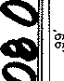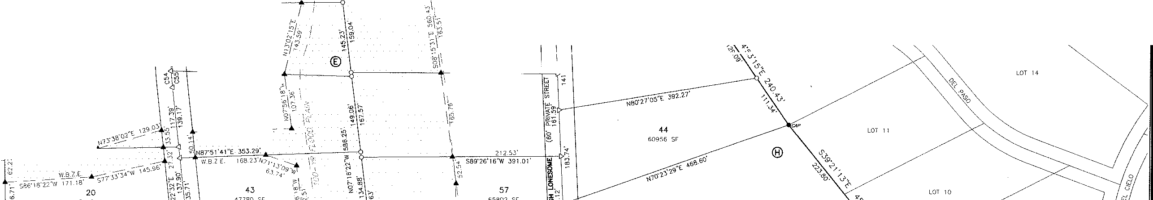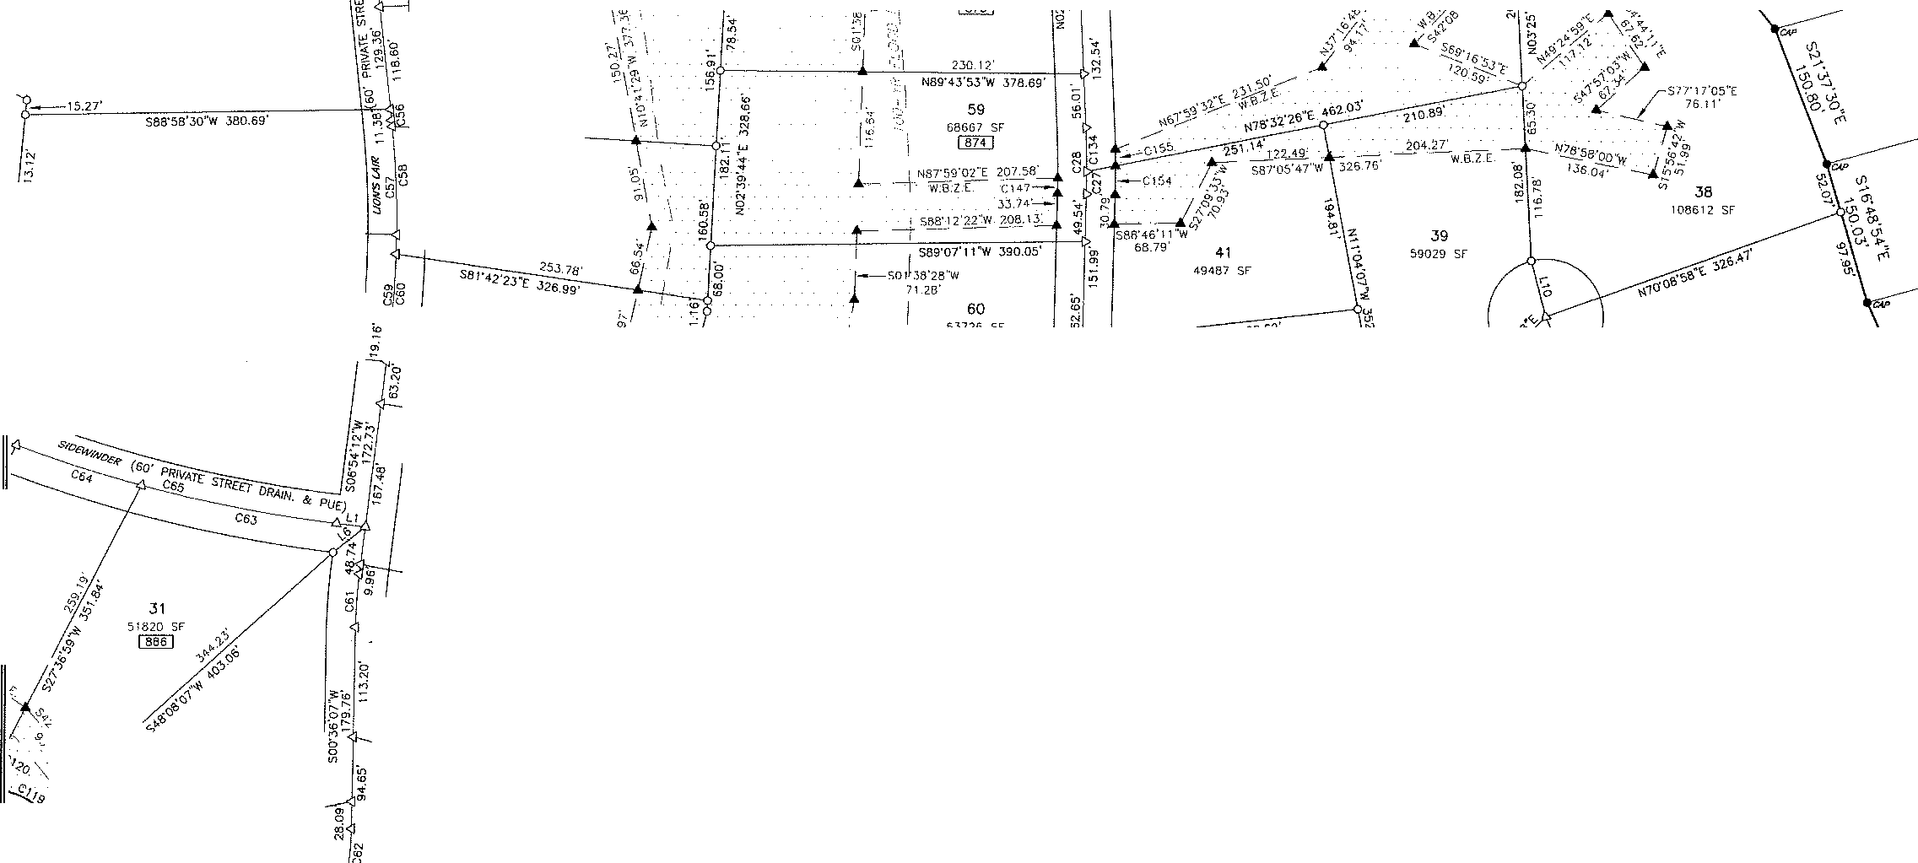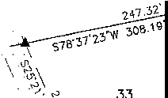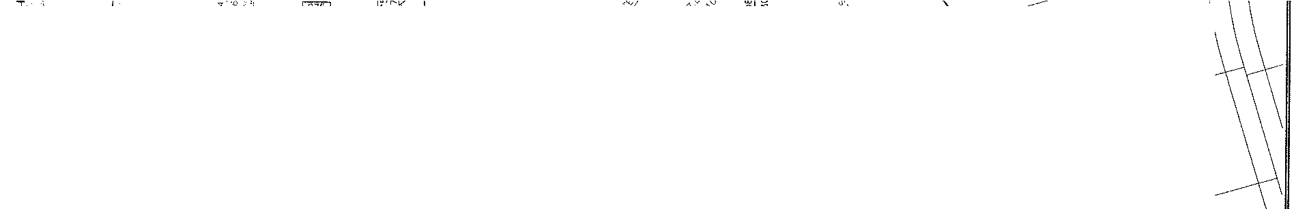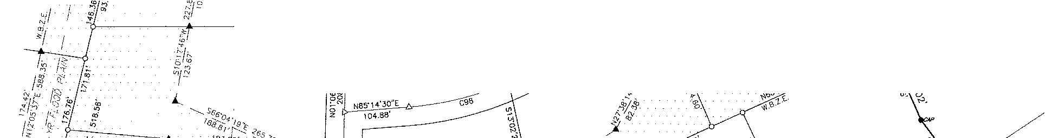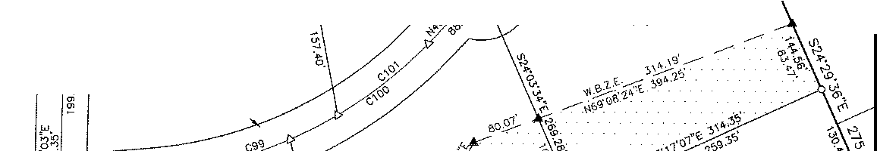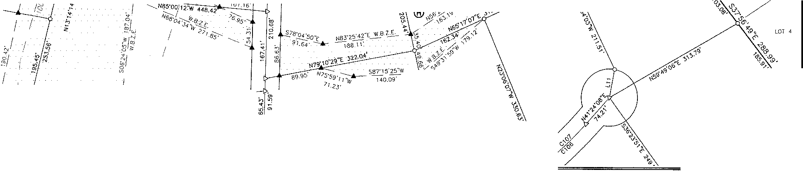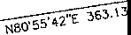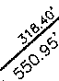

48130 **SC**

[]][] ¾

c.r:

,o!\,"o

*'.:/*

sn6o s 0

rn[] 0

N

"- ***CU,.***

(60' PRIVATE STREET

t. DRAIN. & PUE)

**SHEET**

***.3* OF 9**

GRAND

MESA AT

CRYSTAL FALLS

II, **SECTION** 6

**FINAL PLA'E**

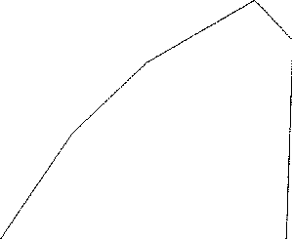57

H,?46 SF

so2c:,9 sr

56

55

62417 SF

[@TI

101.3 S':i AC (lflACT 1)

1.00KOUf Pr.RTNERS. LP DOC. 2000162tl36

57Sl4 St

3

50725 SF

fl6066 sr

83762 SF

51

120791 SF

[ill]

®

*121.:w*

9'

rn

C 5

65146 SF

**MEDICINE H.4.T**

(SO' PRIVATE STREIT

DRAIN. & PUE)

SKY IOSS

(so' PRIVATE STREET

DRAIN. & PUE)

LOT 19

*149.98'*

274.49'

48

S2850 Sf'

[]Q[]

.

*}'*  240,98'

·" S87'08'18"E 301.01'

48

63095 SF

49

l 43389 SF

LOT 18

*ie h 2*

J

;";

" 24 "

·"""

'0

1/]8 47

55291 SC .< 23 *§i ';!*

59 32 SC

8 *h*

rn 0

©

rn

••

150.06' 159.35" 2cs1

331.43'

g;

48228 SF

[]Q[]

46

48352 SF

256.18"

N89"30'05"E 336.04'

54

74832 SF

[]fil]

248,94'

S88'47' 43''W 421.50' lq

47

58037 SF

46

50104

LOT 13

LOT 15

LOT 16

**SHEET**

;; 22 55

**4 OF 9**

~~'"~~

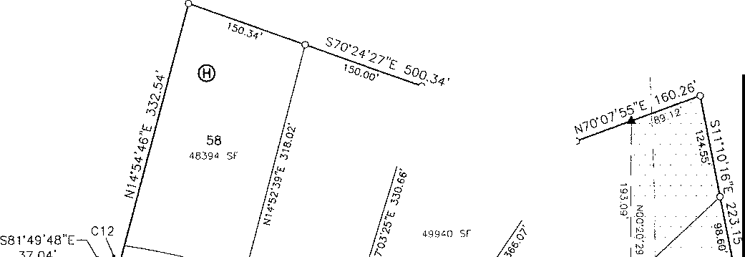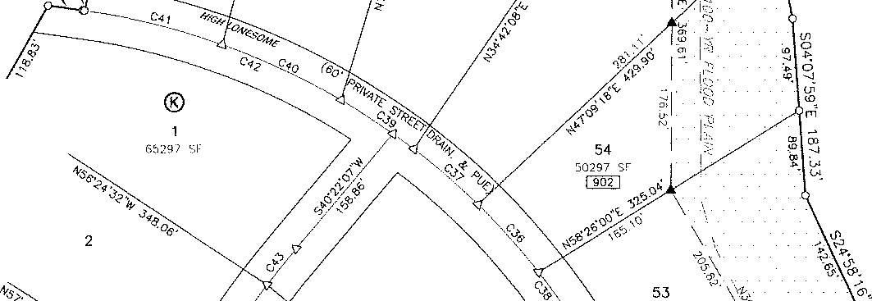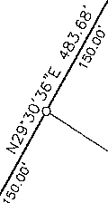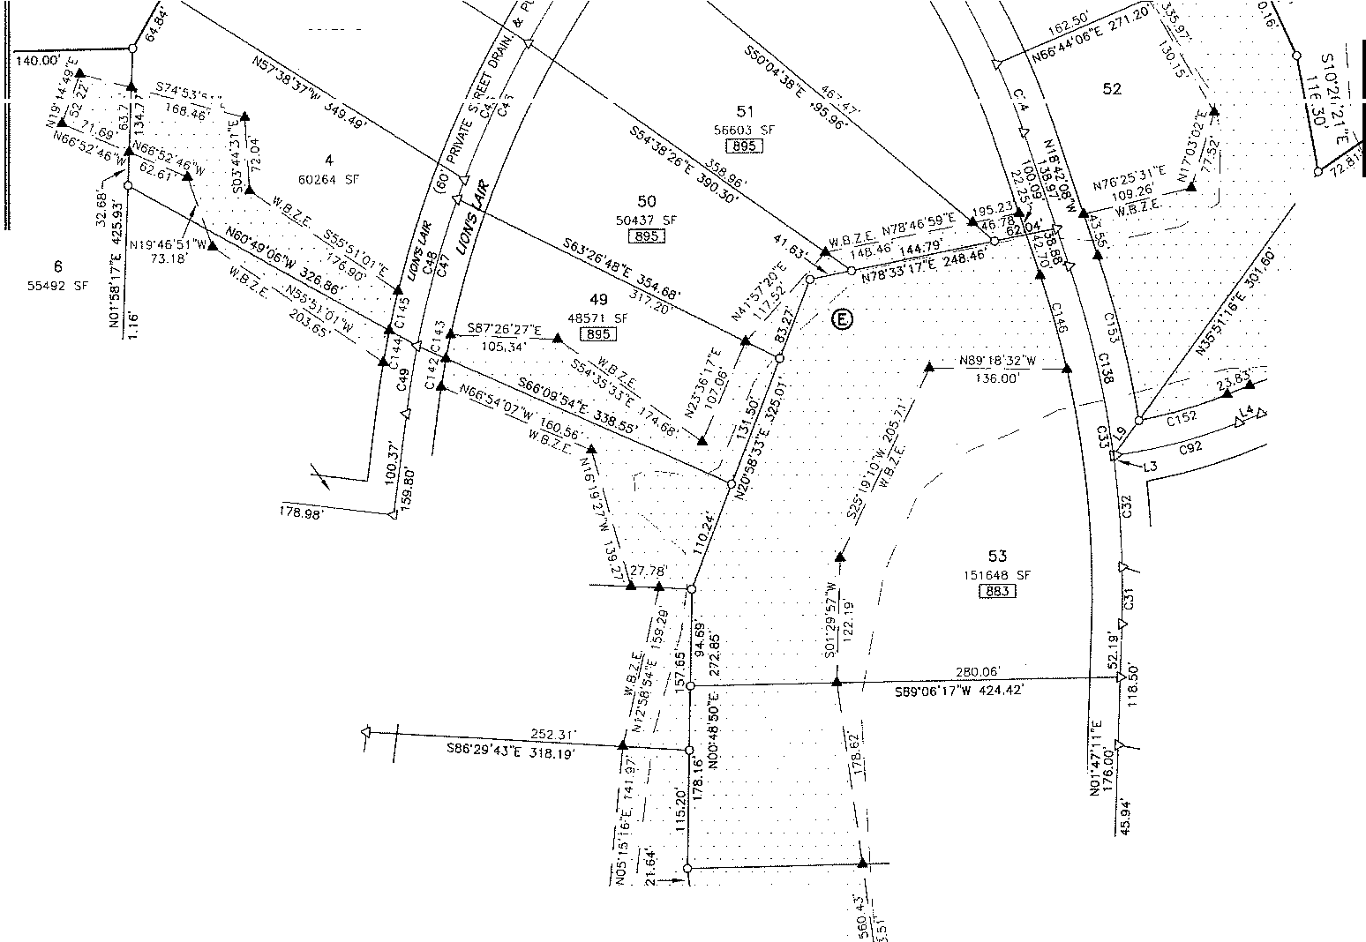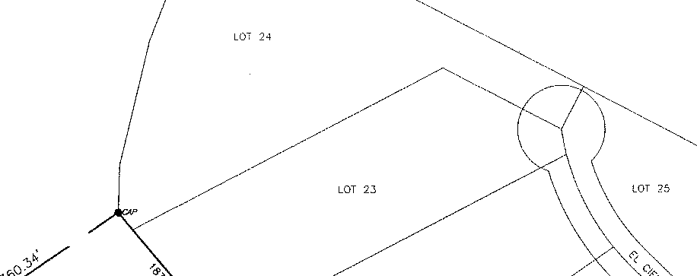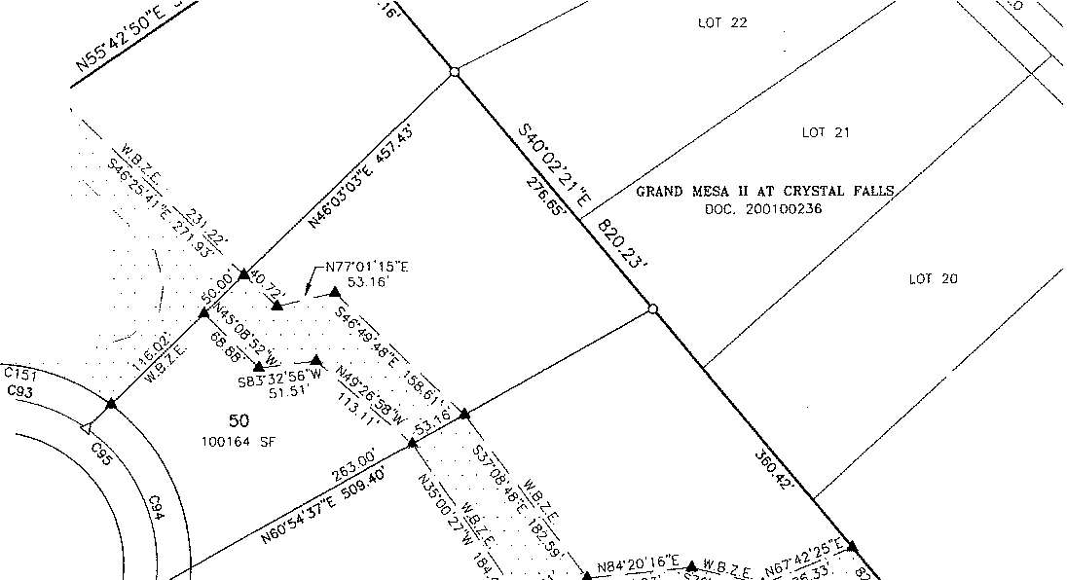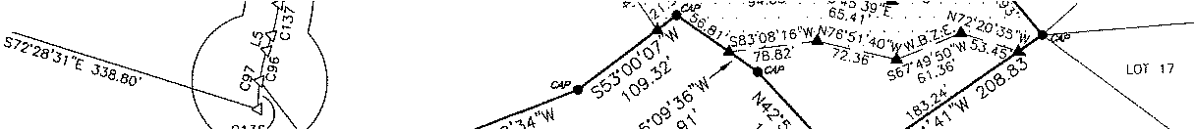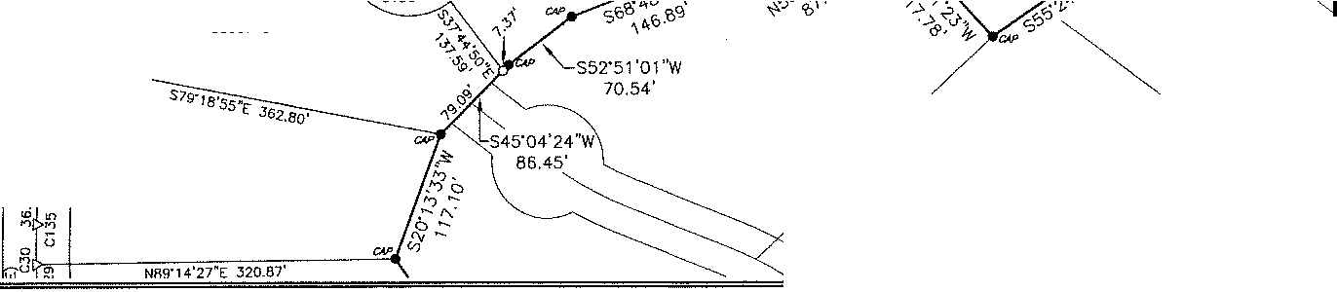

**GRAND MESA AT CRYSTAL FALLS**

**FINAL PLAT**

II, **SECTION 6**

®

57

46246 SF

56

IOU t,C 1)

101JH)L;' I I

DOC ,,;crnc,,,s•;,;

55

62417 SF

[][[]

52

BG066 SF

ITT

"

ro

n

'io"

0

io

*:'*

0z

12

75006 SF

14.86' C87

5

65146 SF

**MEOICINE HAT**

(60' PRIVATE STREET ORAIN. & PUE)

159.75'- 116.73'

© 26

CB6

c139 4J a· 127.Jg'

116.8,9.-.

*k*

sa2·s1•24.E.

14s.s8.----

526S0 SF

[gQ.Q]

"'[

28

628138 St

27

61162 SF

25

57&09 sr

,< 24

- 552S1 Sf"

e

§'

©

\ I

*1-* 23

J;' 59432 SF

47

48228 SF

[]QI]

252.JJ'

S86'29'4J"E 318.JS' 5

1c\ 7483

[fil

\ I

588'45"42"[ 930.22'

46

48352 SF

[@]

' ,,,

256.18'

S88"47'4J"W,

cl

;11,

**SHEET**

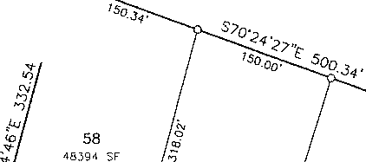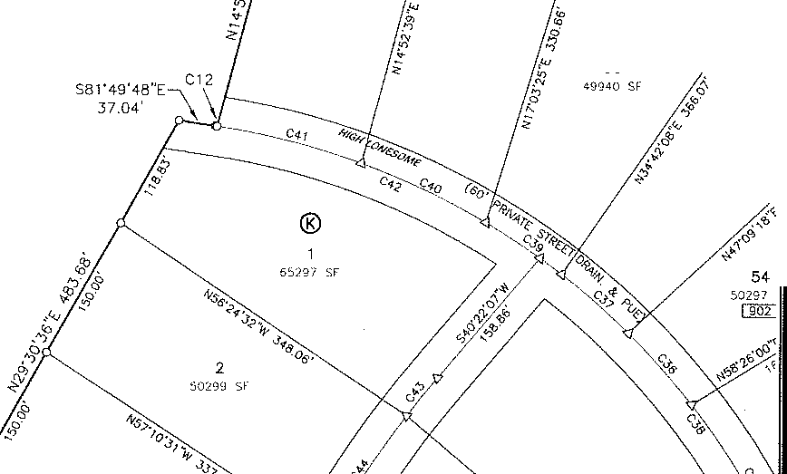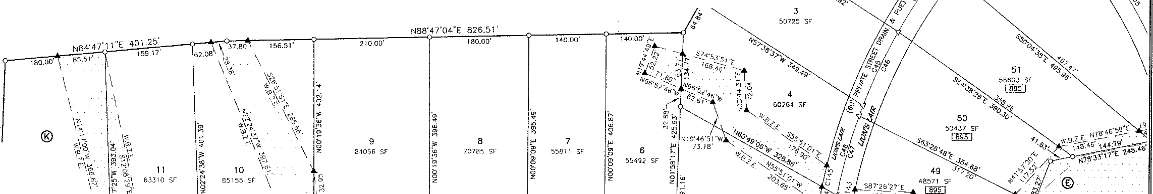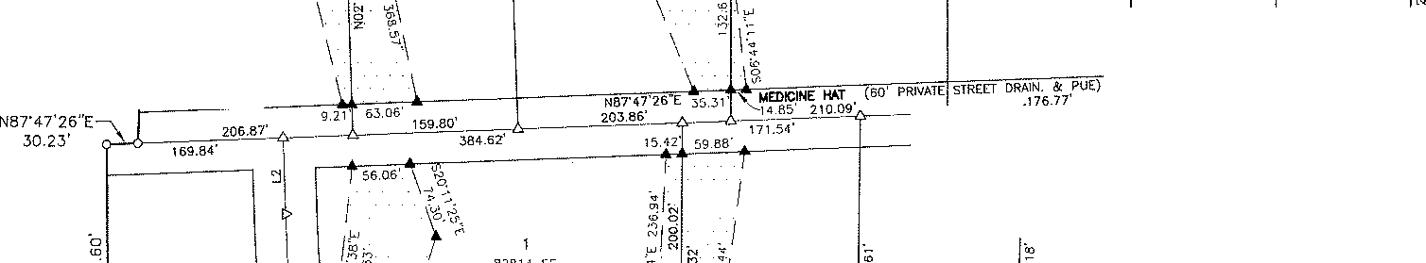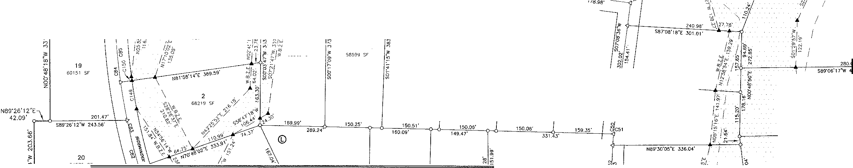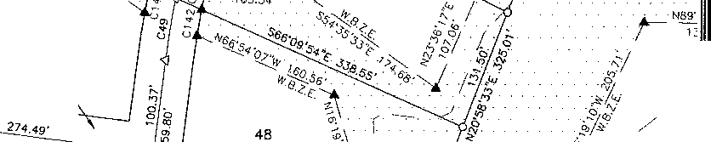

22 "'" 5 OF.. </''

:>titi"29'4J"E 318. 19·

'"**r,** 5

, : 74.'Jj

**I**

[fil

N89'26'12"E

42.09' o-1.L-b------''°"'"'"'-'---\

S89'26'12"W 243.56'

*<O*

w

n

0

N

46

48351 ':,t

[]QI]

256 78'

N89"J0'05"E 336.04'

\ I

24f S88"47'4J''W •

<::)

**c::::)**

S89'26'12"W

90.29'

20

S4870 Sf

S89"26'12"W 300.46'

210.16'

**PANTHER 1-W.L**

(60' PRIVATE STREET

7

51104 SF

45

4/647 SF

t:mJ

DRAIN. & PUE) **S5**

[

21

C:3161 Sf

[ND

N89'45'19"E

102.44'

9

536.34 Sf

'\J42 ! s,-

S88'31'1 l''W 366.88'

18

47508 SF

46695 SF

=

S88'58'.30"W 380.69'

14

4-! 58

50122 SF

=

61162 SF *sa1·2a'o* " 2Js.Jo·

I

*'3/ I*

*:::! I*

*1* S8

*H*

•

*i,:*

38 '

"

Io·, 3.5 , AC. (TRACT 1_) LOOi<OUT PARTNERS. LP

ooc 20()01628.36

29

47524 SF

[§[]

48629 SF

[]ID

51 !74 se

S79"43'45• 219.ai,

=

£ *2BB.27·*

.<,o

"'

.

,0

.••

51820 SF

EM§]

**LION'S I.AIR** ;;;

(60' PRIVATE STREET

"

DRAIN, & PUE)

37 *I*

50385 SF

32

53019 SF

,,;

a<o

*I*

*I*

·$_

*I*

0 2%

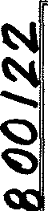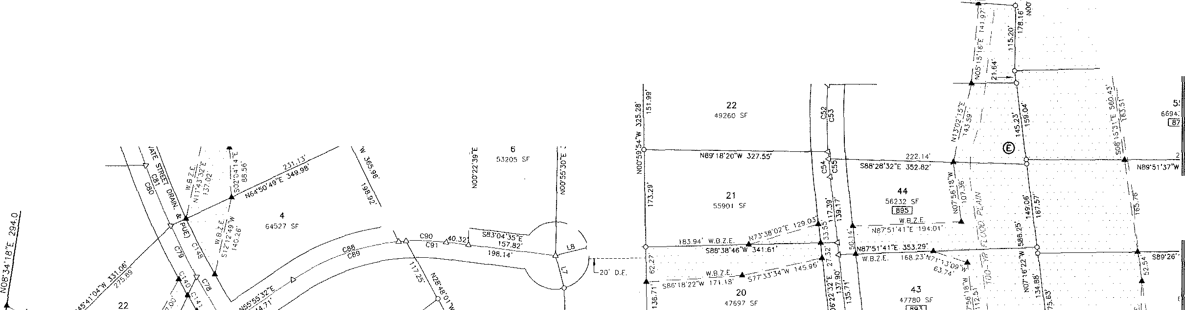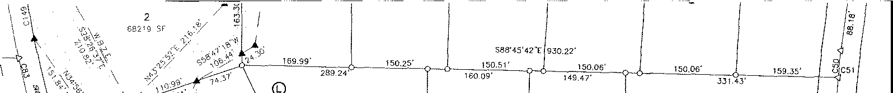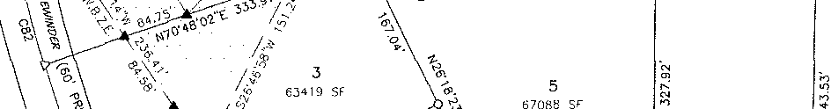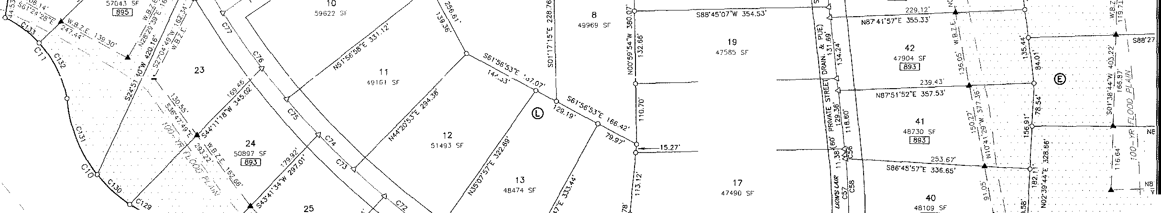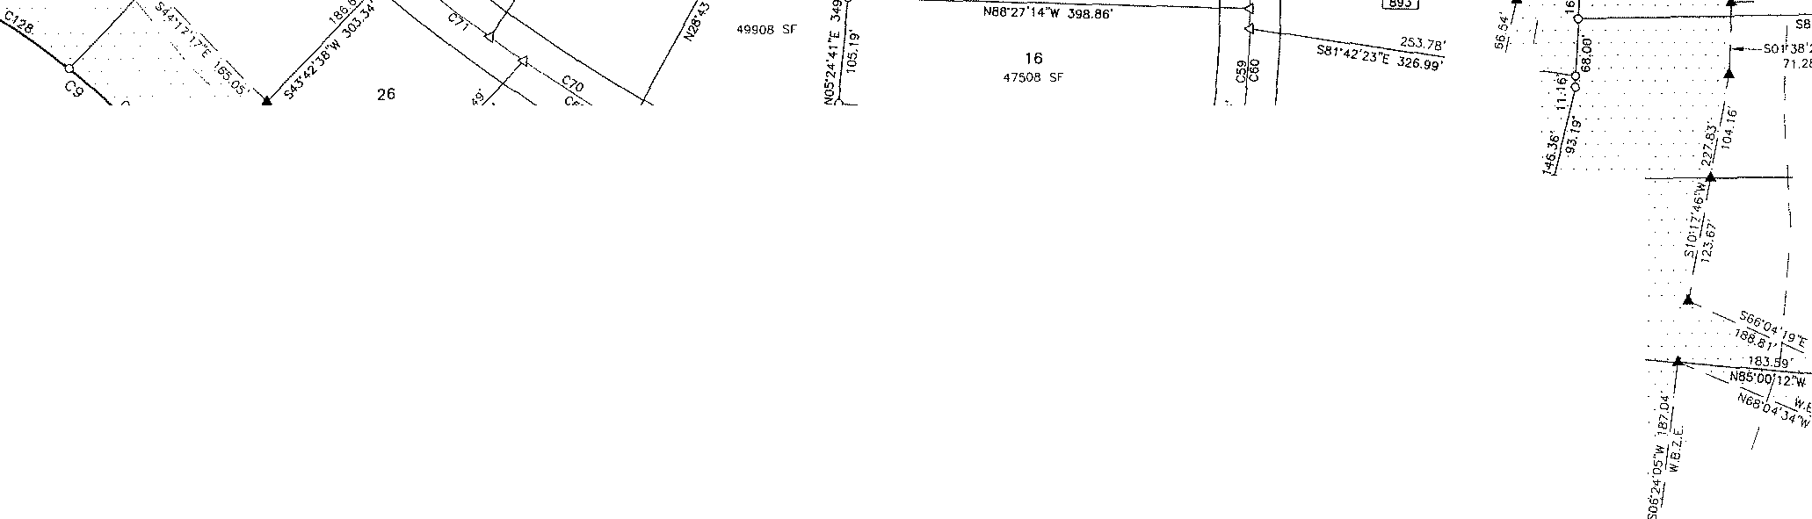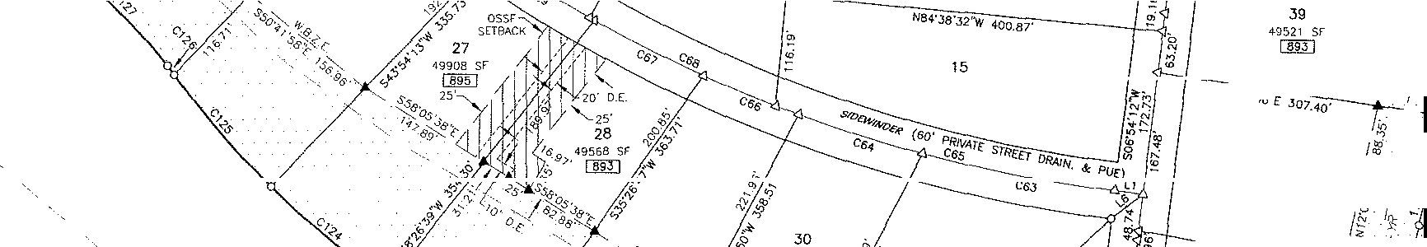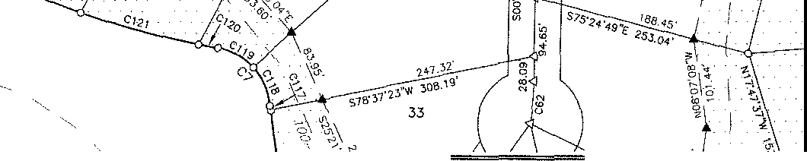

**GRAND MESA AT CRYSTAL** FALLS II,

FINAL PLAT

SECTION 6

I]§]

58796 SF

@lJ

36

48130 SF

[§]QJ

,o S85·23'4i

1 *I*

lg/

e,

- \% **SHEET** [

*r*

m

*=:.1* 6 OF 9

***2nn9. nn I* zz.**

**GRAND MESA AT CRYSTAL FALLS** II, **SECTION** 6

**FINAL PLAT**

|  |  |  |
| --- | --- | --- |
| LINE TABLE | | |
| NUMBER I DIRECnoN | | DISTANCE |
| L1 N83'05"48"W | | 30.00' |
| L2 | N□2·12':.H''W | 73.28" |
| C3 | N82'27' 19"E | 3.36' |
| " | N68'10'22"1' | 23.83' |
| LS | S1S-25'55"W | 13.90' |
| Le | ssrs4'12·w | 42.43' |
| " | S14'43'40"E | 60.00' |
| LB | N75'56'06"E | 60.00' |
| LS | N36"15'19"E | 42.57' |
| Lrn | N1S"03'56"W | 60.00' |
| u, | N10"08'47"E 60.00' | |

: : ::6 -

|  |  |  |  |  |  |  |  |  |  |  |  |  |  |  |
| --- | --- | --- | --- | --- | --- | --- | --- | --- | --- | --- | --- | --- | --- | --- |
| CURVE TABLE | | | | | | | | | | | | | | |
| so | DELTA | RADIUS | AAC | CHORD | CHORD BEARING | so | DELTA | RADIUS | | Af<C |  | | CHORD | CHORD BEARING |
|  | 0·57'54" | 1750.00' | 29.47' | 29.47' | s39·33•11 "E | C78 | 7'44'50" | 1500.00' | | 202.82' | I | | 202.67' | S28"46'31"£ |
| C2 | 21"41'48" | 1055.22' | 399.59' | 397.21' | N38'27'34"W | rn | 3'5!'35" | 1500.00' | | 101.os· |  | | 101.03' | S26"49'SJ"E |
| C3 | 107"58'26" | 71.76' | 135.23' | 116.09' | N83'16'34"W | CBO | 4"27'44" | 1500.00' | | 116.82' | ' | | 116.79' | S22"40'14"E |
|  | 52·12•19" | 172,72' | 157.38' | 151.99' | S69'55'50"W | CBL | 7'43'40" | 1500.00' | | 202.32' |  | | 202.16' | S21'0"'15"E |
| cs | 55•10'34• | 102.57' | 98.77' | 95.00' | N49'18'55"W | C82 | 8'05'34" | 1500.00' | | 211.87' | | 211.69' | | s15·23'35"E |
| Co | 19·05•44" | 1368.45' | 456.47' | 454.36' | N16'12'14"W | C83 | 3·47 '06" | 1500 00' | | 227.37' | | 227.16" | | S12'•!-9'52"E |
| C, | 74·29'49" | 73,07' | 95.oo' | 88.45' | N42.27'15"W | cs, | 10'08'13" | 1500.00' | | 265.39' | | 265.04' | | S07'16'47"E |
| C8 | 44'17'25" | 1032.63' | 798.23' | 778.51' | N58'07'28''W | C85 | 5·75'45" | 1500.00' | | 164.39' | | )64.31' | | s05·2o'S7"E |
| C9 | 23·20'00·• | 697.75' | 284.!5' | 282.19' | N50"25'00"w | C86 | s·33·2r | 500.00' | | 48.50' | | 48.48' | | N89'25'57 ''W |
| 10 | 58"21'39" | 261.59' | 266.45' | 255.08' | N34'19'47''W | cs, | 9·21'10· | 500.00' | | 81.62 | | 81,53' | | N87"31'59"W |
| CL L | 53'37'06" | 206.10' | 192.87' | 185.91' | N37'20'44"W | C88 | 28'49'47" | 400 oo· | | 201.26' | | 199.i4' | | S70'20'23"W |
| CL2 | o·oe·22" | 750.00' | 1.82' | 1.82' | ss1·4s'37"E | C89 | 30-43•,o· | 400 00' | | 214.46' | | 2: 1.90' | | S7!'17'07"W |
| CL3 | 3'50'23" | 1750.00' | 117.28' | 117.26' | S38'06'56"E | coo | 12·10·12·• | 400.00' | | 84,96: | | 84 80' | | N89"09'47"W |
| C14 | 5"42'40" | 1750,00' | 174,43' | 174.36' | S36'12'54"E | C91 | 10'16'43" | 400,00' | | 71.76' | | 71,66' | | N88"12"57"W |
| CL5 | 3"50'47" | 1750.00· | 117.48' | 117.46' | S34'16'21"E | CS2 | 14'76'57" | 500.00' | | 124.64' | | 124.32' | | N75"18'50"E |
| CL6 | 5·77'55" | 1150.00· | 16Ul4' | 161.78' | S30'42'37"E | C'3 | 57·04'44" | 1so.00· | | 1"'9.43' | | 143,33' | | N83'77'17"W |
| *w* | 4"17'19" | 1750.00' | 130.99' | 130.96' | s30·12·18"E | CS< | 62' 13'09" | 150.00' | | 162.89' | | 155.00' | | N23"38'20"W |
| CL8 | 5"78'28" | 1750.00' | 162.12' | 762.06' | S25"24'25"E | C95 | 130'75'33" | | 150.00' | 347.02' | | 272.18' | | N46"41'52"W |
| c,g | 4"53'14" | 1750.00' | 149.27' | 149.22' | S20·1a•34"E | C96 | 10·37'75" | 150.00· | | 27,81' | | 27,77' | | S1J'07'17"W |
| C20 | 6'27'34" | 1750.00' | 197.29' | 197.19' | S19'Jl'24"E | C97 | 20·1 !'19" ! | | 150.00' | 52.85' | | 52.58' | | s08·20·1s·w |
| co, | 1"56'13" | 1750.00' | 59.76' | 59.16' | S16"53'51"E | C9' | 19"10'43" | 500.00' | | 167.37' | | 166.59' | | N75"39'08"E |
| C22 | 2'4]'50" | 1000.00· | 47.66' | 47.65' | S14"33'49"E | css | 26'15'22" | 500.00' | | 229. T 3' | | 227.13' | | N72"06'49"E |
| C23 | 0'21'53" | 1750.CO' | 11.14' | 11.14' | S16"06'41"E | CtOO | 22"28'09" | 500.00' | | 196.08' | | 194.83' | | N54'49'42"E |
| CN | 11"51'09" | 1000.00' | 206.87' | 206.50' | s10·00'10"E | Cl01 | 15·23·30" | 500.00 | | 134.32' | I | | 133.91' | N51"17'23"i' |
| C2S | 9'07'19" | 1000.00' | 159.21' | 159.04' | S08"38'15"E | C102 | 2'18'52" | 700.00· | | 28.28' | ' | | 28.28' | N71"52'05"E |
| C26 | 5"10'38" | 1000.00' | 90.36' | 90.33' | s01·29·16"E | C103 | 2"58'36" | 700.00' | | 36.37' | | 36.36' | | N71'32'13"E |
| C27 | 1•19'39" | 1000.00' | 23.17' | 23.17' | N00'26'74"E | C104 | 16"20'26" | 700.00' | | 199,64' | | 198.96' | | N62'3?'25"E |
| C28 | 3'56'10" | 1000.00' | 68.70' | 68.68' | N00'52'02"W | C105 | 18"33'19" | 700.00' | | 226.70' | -- | | 225.71' |  |
| C29 | 1'54'26" | 750.00' | 24.97' | 24.96' | S01'52'54"E | C106 | 12"58'04" | 700 00' | | 158.43' |  | | 158.09' |  |
| C30 | 4"37'18" | 750.00' | 60,50' | 60.48' | S00'31'28"E | C107 | 10"05'27" | 700.00' | | 123.28' | | 123.12· | | N46"26'52"E |
| 03, | 3"12'29" | 1000.00' | 55.99' | 55.98' | N00'10'57"E | C108 | 5·53•41" | 7055.22' | | 110.10' | | 110.os· | | S46' 19·os"E |
| C3' | 6"16'15" | 1000,00' | 109.45' | 109.39' | N04'33'24"W | C109 | 9·12•40" | 1055.22' | | 169.64' | | 169,46' | | S38"43'27"E |
| C33 | 20·29•20" | 1000.00' | 357.60' | 355.70' | N08"27'29"W | C110 | 6'30'27" | 1055.22' | | 1 \9.85' | | 119 78' | | s30·51'54"E |
| C3' | 5"32'23" | 750,00' | 72.52' | 72.49' | N21'28'20"W | C111 | 63"03'55" | 71,76' | | 78.99' | | 75.06' | | N60'49'19"W |
| C3' | 13'57'37" | 750.00' | 182.74' | 182.29' | N31"13'21"W | Cl 12 | 44•54'31" | 71.76' | | 56.25' | | 54.82' | | ss5·11·23·w |
| C36 | 7"22'19"' | 750.00' | 96.50' | 96.43' | N41"53'19"W | C113 | 43"24'32" | 172.72' | | 130.86' | | 127.75' | | N65'37 '5s"E |
| C37 | 6'53'26" | 750.00' | 90.20' | 90.14' | N49"01'11"W | Cl 14 | 8'47'48" | 172.72' | | 26.52' | | 26.49' | | s33·21'54"E |
| C38 | 35"50'14" | 750.00' | 469.11· | 461.50' | N36'37'15"w | Cl15 | 7'08'05" | 1368.45' | | 170.41' | | 170.30' | | S22'11'33"E |
| C39 | 7"05'56" | 750.00' | 92.92' | 92.86' | N56'00'52"W | C116 | 11'45'17" | 1368.45' | | 280.75' | | 280.26' | | S12'44'52"E |
| C<-0 | 10"38'39" | 750.00' | 139.33' | 139.13' | N64"53'70"W | Cl 17 | 0'13'21" | 1.368.45' | | 5.31' | | 5.3!' | | S06'45'33"E |
|  | 11'28'56" | 750.00' | 750.30' | 150.05' | N75'56'58"W | C118 | 37"56'13" | 73.07' | | 48.38' | | 47.50' | | N24'10'27"W |
|  | 27"!7'25" | 750.00' | 357.23' | 353.86' | N68"11'05"W | C119 | 35-33·35" | 73.07' | | 46.62' | | 45.84' | | N61'25'27"'W |
| C<3 | 2'48'52" | 1000.00' | 49.12' | 49.12' | S38'57'41 "W | C120 | 1"15'29" | 1032.6.3' | | 22.67' | | 22.57' | | S79'38'26"E |
| m | 3·19·15•· | 1000.00· | 145.23' | Hs.10· | S33'23'38"W | C121 | 7'49'54" | 1032.63' | | 141.15' | | 141.04' | | s75·0 •45"E |
| m | 8'30'13" | 1000.00' | 148.41' | 148.28' | S24"58'54"W | C122 | 3·42•2r | 1032.63' | | 156.93' | | 156.78' | | S66'4<l'.34"E |
| C<6 | 9'39'30" | 1000.00' | 168.57' | 168.37' | S24'24'75"W | C123 | 8"12'18" | 1032.63' | | 147.88' | | 147.75' | | S58"2?'12"E |
| *w* | 8'35'33" | 1000.00· | 149.97' | 149.83" | s15·15•44"w | C124 | S-55'19" | 1032.63' | | 160,80' | | 160.63' | | S49'48'24"E |
| C<8 | 9"44'50" | 1000.00' | 170.12' | 169.92' | S15•51·22''W | C125 | 8'42'07" | 1032.63' | | 156 83' | | 156.68' | | s40·59'41"E |
| c,g | 3'50'21" | 1000.00' | 67.01' | 66.99' | S09"03'47''W | C126 | 0'39'52" | 1032.63' | | 11.97' | | 11.97' | | S36'18'41"E |
| C50 | Z-25'24" | 1000.00' | 42.30' | 42.29' | s05·55•54•w | C127 | 12·35·os" | 697,75' | | 153.46' | | 153.15' | | N45'0- '03"W |
| cs, | 4'06'55" | 1000.00· | 71.83' | 71.81' | s05·05·09·w | C128 | 10'43'54" | 697.75' | | 130.69' | | 130.50' | | N56'4,·03·w |
| C52 | 8"31'56" | 1000.00· | 148.92' | 148.78' | S00'27'14"W | C129 | 7"34'14" | 261.59' | | 34.56' | | 34.54' | | S59"43'30"E |
| C53 | 7"33'17" | 1000.00' | 131.85' | 131.76' | S00'44'57"E | C130 | 17'39'49" | 261.59' | | 80.64' | | 80.32' | | S47'06'28"E |
| CS< | 2'33'48" | 1000.00' | 44.74' | 44.74' | S05'05'38"E | C137 | 33'07'35" | 261.59' | | 151.24' | | 149.14' | | s21·4:,'46"E |
| css | rso'56" | 1000.00' | 32.27' | 32.27' | S05'27'04"E | C132 | .31'57'28" | 206.10' | | 114.95' | | :73.47' | | N26'30'54''W |
| C56 | 0·22•47" | 1000.00' | 6,60' | 6.60' | N06'11'11"W | C133 | 21"39'38" | 206,10' | | 77.91' | | 77.45' | | N53'19'28''W |
| CS7 | 6'49'27" | 1000.00' | 119.10' | 119.03' | N02"57'49''W | C134 | 2"36'31" | !000.00' | | 45.53' | | 45.52' | | N01'31'57 ''W |
| csa | 7·35'15" | 1000.00' | 132.43' | 132.33' | N02"12'13''W | C135 | 2'42'52'' | 750.00' | | 35.53' | | 35.53' | | s00·25·45"w |
| C59 | 6'27'17" | 1000.00' | 112.65' | 112.60' | N03.40'33"E | C136 | 9'34'04" |  | 150.00' | 25.05' |  | 25.02' | | S03"01'38"W |
| C60 | 5'18'48" | 1000.00· | 92.73' | 92.70' | N04'14'48"E | C137 | 10"57'41" | 150.00' | | 28.70' | | 28.65' | | N12"57'04"E |
| C6' | 5·15•05" | 500.00' | 54.99' | 54.96' | S03"45't0"W | C138 | 11'00'37" | 1000.00' | | 192.16' | | 191.87' | | N13'11'50''W |
| C62 | 9·11'28" | 300.00' | 48.12' | 48.07' | No5·11·51"E | C139 | 3"47'44" | 500.00' | | 33.12' | | 33.12' | | N84'45'16''W |
| C63 | 7·54'39· | 1500.00' | 207.11' | 206.94' | S79"08'"8"E | C140 | 1·13'45" | 1530.00' | | 32.83' | | 32.83' | | s23•5c·12·E |
|  | 5·15·35" | 1500.00' | 138.14' | 138.09' | S72"32'51 "E | C141 | 1'10'56" | 1530.00' | | 31.57' | | 31.57' | | 530'10'3:l"E |
| C6S | 14'11'23" | 1500.00' | 371.49' | 370.54' | s1s·oo'o7"E | C142 | 1'39'27" | 970.00' | | 26.06' | | 28.06' | | S09'44'57"W |
| C66 | 4"09'39" | 1500.00' | 108.93' | 108.90' | S67'49'44"E | C143 | r23'04" | 970.00' | | 23.44' | | 23.4-4' | | s1n5·12"w |
| C67 | 4"58'56" | 1500.00' | 130.44' | 130.40' | S63"15'76"E | C144 | 1'45'38" | 1030.00' | | 31.65' | | 31.65' | | s10·39·oo·w |
|  | s·21·5r | 1500.00· | 219.02' | 218.82' | S64"43'27"E | C145 | 2·12·55· | 1030.00' | | 39.84' | | 39.84' | | S12'3"-'18•w |
| C69 | 4"56'55" | 1500.00' | 129.55' | 129.51' | S58"1T31"E | C146 | 5·40'12" | 970.oo· | | 95.99' | | 95.95' | | N15"52'0J"W |
| c;o | 6'19'36" | 1500.00· | 165.63' | 165.55' | S57'22'40"E | C147 | 0'56'07" | 970.00' | | 15.83' | | 15.83' | | N00"37'59"E |
| C7L | 6'02'39" | 7500.00' | 158.24' | 158.16' | s52•47'44"E | C148 | 4·20•54" | 1470.00' | | 111.56' | I | | 111.54' | S27'04'14"E |
| en | 7'17"50" | 1500.00' | 191.04' | 190.91' | S50'33'57"E | CT49 | 2'54'52" | 1470.00' | | 74.78' | | 74.77' | | $09'57' 19"E |
| C73 | 6'18'22" | 1500.00' | 165.09' | 165.01' | S46'37'13"E | C150 | 0'23'23" | 1470.00' | | 10.00' | | 10.00' | | S08"18'11"E |
| m | 6'46'34" | 1500.00' | 177.40' | 177.30' | S43"31'45"E | C151 | 58'53'43" | 180.00' | | 185.02' | | 176.99' | | N82'27'47''W |
| C75 | 6"06'25" | 1500.00· | 159.88' | 159.81' | S40'24'50"E | C152 | 71°05'54" | 470.00' | | 91.04' | | 90,90' | | N7J"43'19"E |
|  | 7'29'32" | 1500.00' | 196.15' | 196.01' | S36'23'42"E | C153 | 9"\8'18" | 1030.00' | | 157.27' | | 157.09' | | N14'03'00"W |
| C77 | 8'35'56" | 1500.00' | 225.12' | 224.91' | S33'03'39"E | C154 | 1·39'37" | 1030.00' | | 29.82' | | 29.82' | | Noo·16'1rE |
|  | | | | | | C155 | 0"57'39" | | 1030.00' | 17.27' | |  | 17.27' | N01"0?'18"W |

JJ ll Jay Engineering Company, Inc

P.M.B. 503 P.O.Box1220

Leander, Texas 78546-1220

Tel. (512) 259"3882 Fax. (512) 259•8016

BEARING BASIS: Grid azimuth foe Texas Centro! Zone state plane coordinates, based oa GPS solutions from The National Geodetic Survey (NGS) On-line Positioning User Service (OPUS).

*SENDER()-*

K

**CRYSTAL FALLS** II™

*Jk -n.,.r-4dA" 7,-; -*

PLOT DATE: 03/24/08 SCALE: 1"=100' DATE OF SURVEY: 08/2007-02/2008 BEARING BASIS: TEXAS CENTRAL ZONE

DRAWN BY: PMC APPROVED BY: eMC

-- *RVEYING*

FIELONOTE FILE: NA

DRAWING FILE: 001-07-013PL I **SHEET**

AUSTIN, TEXAS 78748 FAX (512) 291-8279 PROJECT NUMBER: 001-07-013I 7 OF 9

**Pl**

9L' *w.* CM 1626, No. '°' TEL. (512) 291-8272

GRAND MESA AT CRYSTAL FALLS

FINAL PLAT

II, SECTION

***200P. IJ0/22-***

6

e!..6Ll!filES

1. Total Acres: 185.380
2. Number of lots: 128 Residentiol lots

.3. Number of Blocks: 4

4_ Proposed Use: Residential

5. Owner: Lookout Development Group. LP.

6 This subdivision ,s wholly contained within the current corporate limits of the City of Leander, Texas

1. Construction of improvements within this subdivision shall not commence until all application permits

ond/or Construction Plans hove been approved by the City of Leander, Texas. All public improvements shall conform to the current Zoning Ordinance of the City of Leander, Texas.

1. No lot in in this subdivision shol! be occupied until connected to the water distribution system of the City of Leander, Texas.

9 Restrictive covenants in the form of o "DECLARATION OF COVENANTS, CONDITIONS AND RESTRICTIONS >QR

THE GRAND MESA AT CRYSTAL FALLS SUBDIVISION" ore recorded in the deed records of both Trevis ono Williamson Counties.

1. In order to promote dro;noge owoy from o structure, the minimum foundation slob elevotion should be built at le<Jst one fool obove the highest ground elevation wilhin five (5) feet of the slob perimeter, crnd the ground adjacent to the slob should be sloped owoy from the structure ot o slope of 1/2" per foot for o distance of ot leost ten (10) feet.
2. Waler will be provided by the City of Leander
3. Property owners shall provide for access to droinoge easements os moy be necessary ond sholl not prohibit occess by \he City of Leander.
4. All easements on private property sholl be maintained by the property owner or his or her ossigns.
5. All subdivision construction sholl conform to the City of Leander Code of Ordinom:es, construction stondords, ond generally accepted engineering practices
6. No buildings, fences, londscoping or other structures ore permit.led .. ithin droinoge eosements sho,,.n, except os opproved by the City ol Leander Public Works Deportment.
7. Wostewoler and Woter systems shall conform to TCEO (Texos Commission on Environmental Quality) and State Boord of Insurance requirements. The owner understands and acknowledges thot plot vocation or re-plotting may be required, ot the

owner's sole expense, if plons to develop this subdivision do not comply with such codes end requirements

1. Developer shall be responsible lor oll relocation and modifications to existing utilities.
2. The owner of this subdivision, ond his or her successors and assigns, assumes responsibility for plans for construction of subdivision improvements which comply with opplicoble codes and requirements of the City of Leander. The owner understands and acknowledges thot plot vocation or replatting moy be required, ot the owner's sole expense, if plans to construct this subdivision do not comply .. ith such codes and requirements

1g Community impact fees for individual lots to be pold prior to issuance of any building permits.

20. Site development construction plans sholl be reviewed and approved by the City of Leander prior to any construction.

21 Temporary ond permonent easements to be provided as required for off-site water, wastewater ,:,nd droinoge improvements

22, Finjshed slopes which ore greater than 15% cannot use surface irrigation systems.

23 Twenty-five foot OSSF setbacks ore required from all droinoge ways.

1. Twenty-live foot OSSF setbacks ore required lrom oil finished slopes which ore greater thon 3D%
2. All private streets shown hereon and any security gates or devices controlling access to the some private streets shall be owned and m<Jintoined by the established homeowner's ossociotion af this subdivision
3. A 5 foot P.U.E. from oil side lot lines is hereby dedicated

27, Building setbacks ore os shown on plot. In any event, building setbacks sholl conform to the current Zoning Ordinance of the City of Leander, Te os.

28. The following vorionces were granted per o Development Agreement with the City of Leander and approval of the Crystal Falls I! C<Jncept Pion on M<Jy 1, 2003.

A Private Streets with roadside droinoge (Austin Tronsportotion Criteria Waived)

8. No sidewalks, due to privote streets and terr<Jin.

C No street lights, light pollution free deed restrictions

0. No tree survey, due to private streets.

29. No development sholl begin on Lots 51 - 55, Block "H" or Lots 21 - 70, Block "E", orior lo ,ssuonce of o Flood P/oin Development Permit by the City of Leander Flood Pioin Administrator for eoch lot specified

30 No structure or land on this blue line (survey) shall hereafter be located or oltered without first submitting a CERTIFICATE OF COMPLIANCE application to the City of Leander Flood Ploln Administrator.

31. The developer, builder, seller, or ogent shall inform, in writing, each buyer ol subd;vision lots or property localed within flood hozord oreos that such property is in on identified flood hozord area and th<Jt a Flood Ploin Development Permit will be required before o structure con be placed on the property. The written notice sholl be filed for record in the Deed Records of Travis County. A copy of this written notice shall be provided when opplicotions ore mode for Flood Ploin Development Permits.

.32. Prior to any channel <Jlter<Jtions, bridge construction, fill, dredging, grading, channel ;mprovement, or storage of materials or ony other chonge within \he 100 year flood plain located within this blue line (survey), on application for Flood Ploin Oevelopment Permit with a description of the project ond extent

of changes, if ony, lo the w<Jtercourse or natural droinoge os o result of the proposed development must be submitted to ond opproved by the City of Leander Flood Ploin Administrator. All specilicotions and detoils necessary for complete revie"' must be provided.

33. Prior to any channel olterolion or bridge construction which will chonge existing flood patterns or elevations, a letter of mop amendment must be submitted to ond approved by the Federal Emergency Management Agency,

34. No driveway shall be constructed closer than 50' or 60% of p,:,rcel frontage, "'hichever is less, to the

ROW of on intersecting local or collector street.

.35. Front building lines ore measured from the edge of the street easement.

1. Goroges toeing a side street on o comer lot ore required to be set bock 20'.
2. A public safety easement is hereby gronled for oil private streets within this subdivision

BENCHMARKS

8M **1:** ALUMINUM DISC SET IN CONCRETE AT IBE BACK OF CURB, WEST SIDE OF HIGH LONESOME AT THE P/!0./ECITD CENTERUNE OF BEAR CLAW. EI.EVATJON 877.9\

BM 2' ALUMINUM DISC SCT IN COrfCRCTE AT THE BACK OF" CURB, WEST SIOE OF H!GH LONE;'.,m,IE AT THE PROJECT!:0 CENTERUNE Of SKY KISS. EI.EVATlON 865.95

BM J: AWMINlJM DISC SCT IN CONCRETE AT THE BACK OF CURB, EAST SIOE OF LOINS LAIR AT THE PROJECTED CENITRUNE OF MEOICINE HAT EI.EVATlON 5 922.32

BM 4, ALUMlrfUM DISC SEr IN CONCRETE AT IBE BACK OF CURS, EAST SIOE Of LOINS LAIR AT THE PROJECTED CENTERLINE *or* SIDEWINDER EI.EVATlON n 9H.45

SM 5: ALUMINUM DISC SEr IN CONCRETE AT THE BACK OF CURB, WEST SIDE OF SIDEWINDER AT THE P O./ECTED CENTERlJNE Of PANTHER HIU­ EI.EVATlON ,. 909-02

1/ERTlCAL DATUM: NA\ID-88, BASED ON cm- Of Ll'ANOER GP$ Cotffi!Ol.

**Pl** ;'''''',,,

**A**

PLOT DATE: D3/24/08 SCALE: 1",.100' DATE OF SURVEY: 08/2007-02/2008

,,--;;::: BEARING BASIS: TEXAS CENTRAL ZONE

Jay Engineering Company, Inc.



// *V*

*SENDERO* f==cc:c=-= ='-'-'"-" ji

P.M.B. 503

P.O, Box 1220

Leander, Texas 78646-1220

CRYSTAL FALLS II™

/ / *_,f:fRVEHNG* DRAWN BY: PMC APPROVED BY: PMC

l"/4_;-::::::;;:"-: >---- FlELDNOT£ FILE: NA

Tel (512) 259-3882 Fax. (512) 259-8016

*1k 71,,d'_,./ d,,:,u,u,;;('-,,ye, To ,_,*

911 W. FM 1626, No 105

TEL. (512) 291-8272

DRAWING FILE: 001-07-013PL I

**SHEET**

AUSTIN, TEXAS 78748

FAX (512) 291-8279 PROJECT NUMBER: 001-07-013 I

1. **OF 9**

PHOTOGRAPHIC MYLAR ***200,***

GRAND MESA AT CRYSTAL FALLS II, SECTION 6

FINAL

DEDICATION STATEMENT:

THAT LOOKOUT DEVELOPMENT GROUP, LP., A TEXAS LIMITED PARTNERSHIP, BEING THE OWNERS OF 185.380 ACRES OF LANO SITUATED IN TRAVIS COUNTY, TEXAS OUT OF THE C.W. OWENS SURVEY NO. 71, THE C.S. MASON SURVEY NO. 204, THE MCKINNEY & WILLiAMS SURVEY NO. 175, AND THE PA GLOSSOM SURVEY, BE!NG ALL OF A 185.380 ACRE TRACT OF LAND CONVEYED TO LOOKOUT DEVELOPMENT GROUP, LP. BY DEED OF RECORD IN DOCUMENT NUMBER 2008041128, OF THE OFFICIAL PUBLIC RECORDS OF TRAVIS COUNTY, TEXAS, DO HEREBY PLAT SAID 185,380 ACRES OF LAND IN ACCORDANCE WITH APPLICABLE ORDINANCES OF THE CITY OF LEANDER, TEXAS AND TRAVIS, COUNTY, TEXAS, THE HEREIN DESCRIBED PLAT

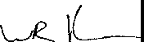TO BE KNOWN AS "GRAND MESA AT CRYSTAL FALLS II, SECTION 6", ANO 00 HEREBY DEDICATE TO THE PUBLIC THE USE OF OF ALL EASEMENTS AS SHOWN HEREON, SUBJECT TO ANY EASEMENTS ANO/OR RESTRICTIONS HERETOFORE GRANTED AND NOT RELEASED.

V!.S-08

PLAT

STATE OF TEXAS COUNTY OF TRAVIS

I, DANA DEBEAUVOIR, CLERK OF TRAVIS, TEXAS, DO HEREBY CERTIFY THAT THE FOREGOING INSTRUMENT OF WRITING, WITH IT iRTIFICATE OF HENATION WAS FJIJ=D FOR RECORD lf::hMY OFFICE ON THE ,.;... DAY OF 2 AO ... A.T .:.

*.28*

*1*

O

O'CLOCK *L.* .M., AND DUL)'.,,RECO-RD ON THE -- DAY OF , 20 -=s AD., AT **[_:J.j)** O'CLOCK, f_Jjj., IN THE 9[fir_lAL RECORDS OF S D COUNTY AND STATE. UNDER DOCUMENT NUMBER ***- _D/)$_(20J-2,.';t.-***

: N - D20J1:i/t OFFICE OF THE COUNTY CLERK THE **7--** DAY OF

DANA DEBEAUBOVOIR. COUNTY CLERK

OF TRAV_IS COUNTY. TEXAS *{;,:if,* <\_\

*BY:1:J1::!Ltfc/*7*J -.l*Y*.* -*[t*.*;*8*[ ':1*

WILLIAM R. HINCKLEY

BY LOOKOUT GROUP, INC. GENERAL PARTNER 2370 RICE BOULEVARD. SUITE 200

HOUSTON, TEXAS 77005

STATE OF TEXAS COUNTY OF TRAVIS

DATE

*z':'"'('* ***V*** *,,_;,,.,.* ,,*/*

STATE OF TEXA . ''"NHL,.,;,.;"'

COUNTY OF TRA

I. PHILLIP L. MCLAUGHLIN AM AUTHORIZED UNDER THE LAWS OF THE STATE OF TEXAS

TO PRACTICE THE PROFESSION OF LAND SURVEYING, AND HEREBY STATE THAT THIS PLAT CONFORMS WITH APPLICABLE ORDINANCES OF THE CITY OF LEANDER, TEXAS ANO TRAVIS COUNTY, TEXAS, AND THAT ALL EXISTING EASEMENTS OF RECORD OF WHICH I AM

AWARE HAVE BEEN SHOWN OR NOTED HEREON.

BEFORE ME, THE UNOER:'.;IGNED AUTHORITY, ON THIS DAY PERSONALLY APPEARED WILLIAM R. HINCKLEY, KNOWN TO ME TO BE THE PERSON WHOSE NAME IS SUBSCRIBED TO THE FOREGOING INSTRUMENT AND ACKNOWLEDGED TO ME THAT HE EXECUTED SAME FOR THE PURPOSE ANO CONSIDERATION THEREIN EXPRESSED, IN THE CAPACITY THEREIN STATED

GIVQ;j/ UNDE.R MY HAND AND SEAL OF OFFICE, THIS THE *.;1.5_* DAY OF ***tf/l1l,J1!/..***

*201/l._* A.D

JEl(NlfE ANN STIPP

Notary Public, State :>f Texas

M'/ Com<n1os""1Exp«es

Octobel 10. 2009

*JJiJ.1Jfa_ll.3f'JA 'fJ*

PRINT NAME

NOTARY PUBLIC IN AND FOR THE COUNTY OF *-ff./lJ(/g ,* TEXAS. MY COMMISSION EXPIRES ***_./.1{Li,2 t2_'L***

STATE OF TEXAS COUNTY OF TRAVIS

APPROVED THIS THE **lQ._** DAY OF **_Bf.r.i} , 20 Q_i_** A.O. AT A PUBLIC MEETING OF THE PLANNING AND ZONING COMMISSION OF THE CITY OF LEANDER, TEXAS ANO AUTHORIZED TO BE FILED FOR RECORD BY THE COUNTY CLERK OF TRAVIS COUNTY, TEXAS.

*t2*

*f! /i. ,L*

l i oN

CITY O LEANDER, TEXAS

*eL P.;.._0_1"*

ELLEN P!ZALATt:

PLANNING AND ZONING COMMISSION CITY OF LEANDER, TEXAS

BASED UPON THE ABOVE REPRESENTATIONS OF THE ENGINEER OR SURVEYOR WHOSE SEAL IS AFFIXED HERETO, AND AFTER A REVIEW OF THE BLUELINE AS REPRESENTED BY THE SAID ENGINEER OR SURVEYOR, I FIND THAT THIS BLUELINE (SURVEY) COMPLIES WITH THE REQUIREMENTS OF EDWARDS AQUIFER REGULATIONS FOR WILLIAMSON COUNTY, WILLIAMSON COUNTY FLOOD PLAIN REGULATIONS ANO WILLIAMSON COUNTY ON SITE SEWAGE FACILITY REGULATIONS. THIS CERTIFICATION IS MADE SOLELY UPON SUCH REPRESENTATIONS ANO SHOULD NOT BE RELIED UPON FOR VERIFICATIONS OF THE FACTS ALLEGED. THE

WILLIAMSON COUNTY & CITIES HEALTH DISTRICT ANO WILLIAMSON COUNTY DISCLAIMS ANY RESPONSIBILITY TO ANY MEMBER OF THE PUBLIC FOR INDEPENDENT VERIFICATION OF THE

REPRESENTATIONS, FACTUAL OR OTHERWISE CONTAINED IN THIS BLUELINE (SURVEY) AND THE DOCUMENTS ASSOCIATED WITH IT.

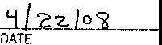&-

PAULO PINTO

DIRECTOR OF ENVIRONMENTAL SERVICES

c·

REGISTERED PROFESSIONAL LAND SURVEYOR STATE OF TEXAS NO. 5300

SENOERO SURVEYING

911 W. FM 1626, NO. 105

AUSTIN, TEXAS 78748

512-291-8272

STATE OF TEXAS COUNTY OF TRAVIS

I HEREBY CERTIFY THAT THE PROPERTY HEREIN IS PARTIALLY WITHIN A SPECIAL FLOOD HAZARD AREA AS IDENTIFIED BY THE FEDERAL EMERGENCY MANAGEMENT AGENCY AS SHOWN ON THE FEDERAL FLOOD INSURANCE RATE MAP NO. 48453C0275 E, TRAVIS COUNTY, TEXAS, DATED JUNE 16, 1993. THIS TRACT IS NOT LOCATED IN THE EDWARDS AQUIFER RECHARGE ZONE.

I, THE UNDERSIGNED PROFESSIONAL ENGINEER IN THE STATE OF TEXAS, DO CERTIFY THAT TH%VPISIONS CONTAINED ON THIS PLAT COMPLY WITH THE SUBDIVISION ORDINANCES AND INAG P LICIES ADOPTED BY THE CITY OF LEANDER TEXAS



**1\.,.1:e. 0,**

*

"'

•

- ,.c-- L_ --

SAMU L D KIGER, PE

STATE OF TEXAS NO. 89353

JAY ENGINEERING COMPANY, INC.

P.O. BOX 1220

LEANDER, TEXAS 78646-1220

512-259-3882

ALL PROPERTY OF THE HEREIN-DESCRIBED SUBDIVISION IS SUBJECT TO THE LOWER COLORADO RIVER AUTHORITY'S HIGHLAND LAKES WATERSHED ORDINANCE. WRITTEN NOTIFICATION AND/OR PERMITS ARE REEQUIREO PRIOR TO COMMENCING ANY DEVELOPMENT ACTIVITIES. CONTACT LCRA WATERSHED MANAGEMENT AT 1-800-776-5272, EXTENSION

2324 FOR MORE INFORMATION.

The Waterway Buffer Zone Easement is for the protection of the environment by improving the quality of stormwoter runoff from developed lands. The native land or management practices within the Easement are to help maintain clean water in creeks, rivers and lakes.

No structure or improvements, other than native plant enhancement or maintenance *cf*

the area in accordance with LCRA rules, may be placed or performed within the Easement without specific prior authorization and approval in writing from the LCRA, its successors

or assigns, or other governmental entity with authority to permit such improvement for the protection of the environment. The Easement shall be maintained by each lot owner by preserving and restarjng native vegetation. The Easement may not be amended except

by express written agreement of the LCRA, its successors or assigns, or other governmental entity with proper authority.

Lots 53-63, Block "E'' and Lots 52 and 53, Block "H" ore subject to Buffer Zone

Enhancement requirements as described in a ResW io Co;,11o t,q111'z),.in the Real Property Records of Travis County, Document # ***:,!f fl f.R_.:;+f2***

DATE



RIVER AUTHORITY

, = -P_c_o_r_o_>r_E_,_o_,;_,_,_;o_, s_c,_c_E_•_,·_·-_,_oo_·

0

71

Jay Engineering Company, Inc.

P.M.B. 503

P.O. Box 1220

Leander, Texas 78646-1220

Tel (512) 259-3882 Fax (512) 259-8015

CRYSTAL FALLS II™

*?'k- ?'k:r-./tl# - To" s; (4·* . .;,.-

*SENDERO SURVEr"/NG*

/ - DATE OF SURVEY: 08/2007-02/2008 BEARING BASIS: TEXAS CENTRAL ZONE DRAWN BY: PMC APPROVED 8Y: PMC FIELDNOTE FILE: NA

DRAWING FILE: 001-07-0tJPL **SHEET**

911 W FM 1626, No 105 TEL (512) 291-8272

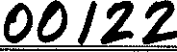

AUSTIN, TEXAS 78748 FAX {512) 291-8279 PROJECT NUMBER: 001-07-013

1. **OF 9**

IIIIIIIIIIIIIIIIIIIIIIIIIIIIIIIIIIIIIIIIIIIIIIIIIIIIIII PLATS 200900128

2 peg

AT DOCUMENT# _

**PLAT**

**PLA DS INDEX SHEET:**

**SUBDIVI** : Grand Mesa at Crystal Falls II, Section 6 Amending Lots 65, 6 , 7 ck E A Subdivision in Travis County, Texas

**OWNERS NA**

**RESUBDIVISION** .

**ADDITIONAL RESTRI**

ment Group, L.P.

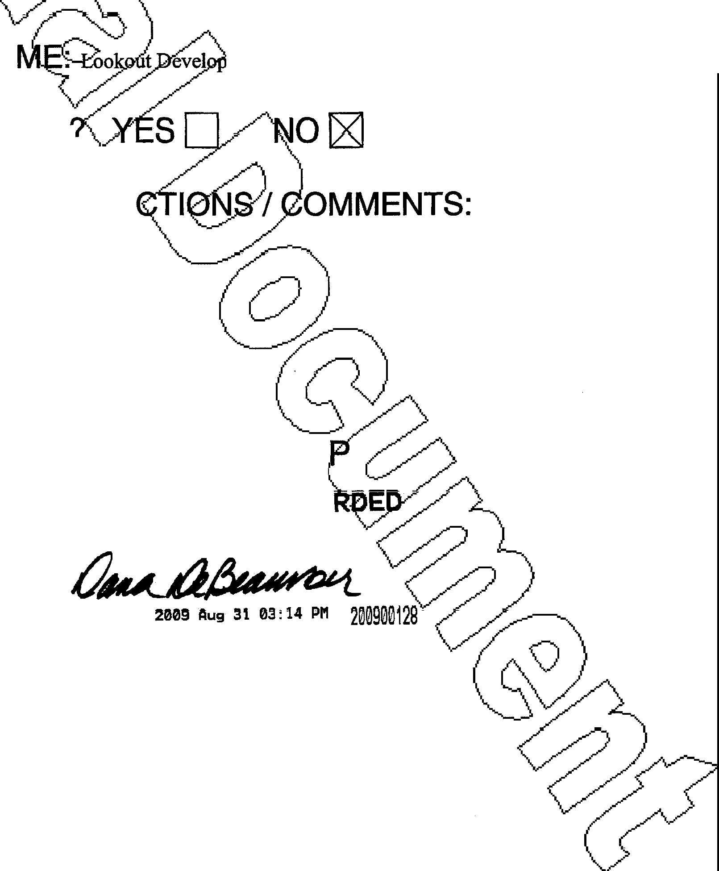



PL

0

None

**RETURN:**

Cail Barbara Smith at 913-5590

**PLAT FILE STAM**

**FILED AND RECO**

OFFICIAL PUBLIC RECORDS

'

GONZALESM $65.00

DANA OEBEAUVOIR COUNTY CLERK TRAVIS COUNTY TEXAS

GRAPHIC SCALE

GRAND MESA AT CRYSTAL FALLS II, SECTION 6

i T i T

( IN FEET )

11 inch = 100 ft.

.AMENDING LIOTS 65, 66, 67 AND 68

A SUBDIVISON IN TRAVIS COUNTY,

I I

BLOCK E TEXAS

I

\

64 \

35

I 33 ,,.,,,.,,.,,,.-.,,.._.,.,,..,,.-

\ ----c\}- ---- -; .,,....,,.. ...

------- -o J>. JliS\ ­

, ).

,,-

26

,/ ,

**MAP N.T.S.**

\J

5

24

**23**

1013.55 AC. (TRA1CT 1) LOOKOUT PARTNERIS, LP. DOC. 20000162556

69

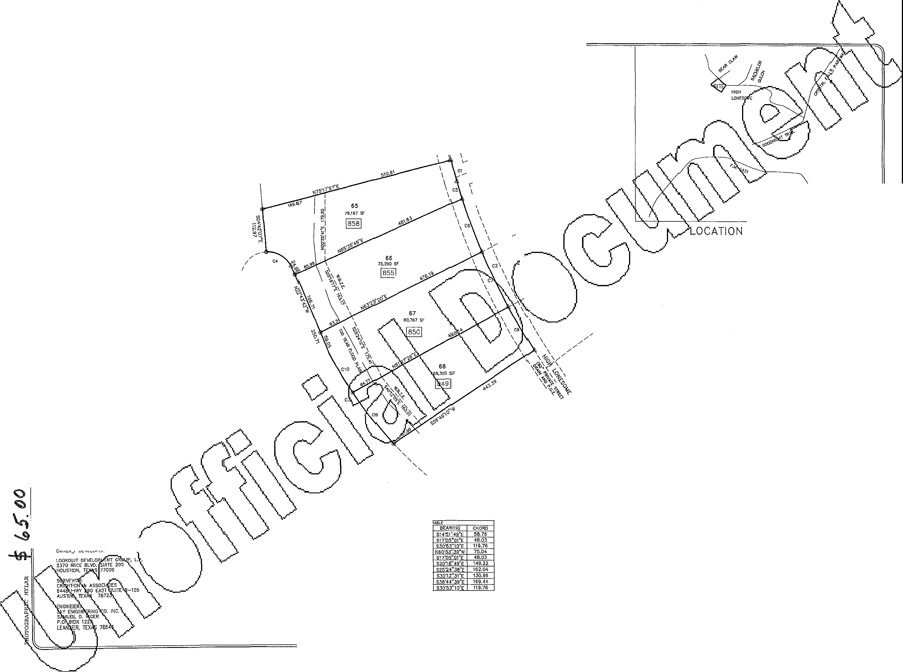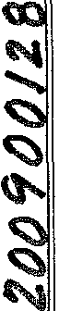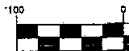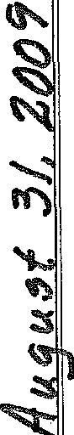

SUBMITTAL DATE:

LOT AN/D STREET SUMMARY

NUMBEfR Of BLOCKS: 1 TOTAL ACREAG : 6.8992 AC

NUMBEIR OF LOTS: RESfDEINT!Al: 4

SMALLEST LOT: 68,305 S.F,

TOTAL R0.W. : 0

TOTAL LIMEAR FE T .OF STREEJS1

|  |  |  |
| --- | --- | --- |
| CtJJRvt Ct | LENGTH  58.77 | RADIUS  1000.00 |
| C2 | 48.03 | 1750,00 |
| C3 | 119.83 | 1055.22 |
| C4  cs | 7K97  48.03 | 71.76  1750.00 |
| c, | 149,27 | 1750.00 |
| C7 | 162.10 | 1750.00 |
| *CB* | 130,99 | 1750.00 |
| C9 | 169.62 | 1055.22 |
| <Cto | 119.83 | 1055.22 |

BENCH MARK NOTE:

ALUMINUM DISC SET IN CONCRETE AT THE BACK OF CURB, WEST SIDE OF HIGH LONESOME Alf THE PROJECTED CENTER:LINE OF BEAR CLAW, ELEVATION 877.91

LEGEMD

@V2"liRON PIN FOUND

0 1 /2 !!RON PIN SET

A NAIL WOUND

W.B.Z.E. WATERWAY BUITTR ZONE EASEMENT

MIN!MIJJM FlN\SHEO FLOOR ELEVATION

PAGE 1 OF 2

09-225

THAT LOOKOUIT DEVELOPMENT GROUP, LP., *f,,,.* TEXAS Ulll!TEO PARTNERSHIP, !BEING lHE OWNER OF THIAT 6.8992 ACRE BEING LOTS 65, 66, 67 AND 68 BLOCK E OF GRAND l,lESA AT CRYSTAL fFALLS 11, SECTION 6, A SUBDIVISION RECOROEO IN DOCUMENT NIUMBER 20080041126 OF THE TRA\IIS COUNTY, TEXAS. OFFlC1AL RECORDS 00 HEREBY' AMEND SAID LOTS 65, 66, 67 ANO 6B, BLOCK B IN ACCOIROANCE WITH APPLICABLE OROJMANCES OF THE QTY OF LEANIOER, TEXAS AND TRAVIS COUNTT'r', TEXAS, TO BE KNOWN AS

**OOAHO IIIESA AT 'YSTAL FAU.S. AM8<0tNO** ILOTS **15&,. 815, 157 ANO Bl.Oat( 8**

AND 00 HEREBY DEDICATE TO THE PUBLIC n+IE USE OF All STTlE.ETS AND E:ASEMENTS AS

SHOWN HEREON, SUBJECT TO AN'!' EASEMOH!S AND/OR RESTR!CTIONS HEREFOFORE GRANTED ANO) NOT RELEASED.

GRAND MESA AT CRYSTAJL FALLS II, SECTION 6 AMENDING L,OTS 65, 66, 67 AND 68 BLOCK E A SUBDIVJISON IN TRAVIS COUNTY, TEXAS

wmEss MY HM(o/'"1s m AY o, ***Av,u.s:r***

VL I'--•----

W.LUA-.! R. H!JNCl<LE'I', PRESIDENT LOOKOUT GROJUP, INC.

GENERAL PAR!TNER, LOOKOUT DEVELOPhlENT GROUP, LP. 2370 RICE BOULEVARD, SVITE 200

HOUSTON, TE))(AS 77005

STATE OF lD(AS:

COUNTY OF llRAVIS:

BEFORE ME. m-JE UNDERSIC-NEO AUTHORITY, OiN THIS DAY PERSONfilY APPEARED WIWAM R.

tRi ·o l ui ¥ g ng:vir T eiE WHt l0sm IN 1HE CAPACITY 1HER£1N STATED FOR lHE PURPOSiES ANO CONSIO ilON THERElNI EXPRESSED,

**A:i:** :**HAa_: A x·** ntlS THE y OF ***2otJ!l*** *t-o.*

NOTARY PUBUC FOR THE STAlE OF lEXAS A. flll

**_&g 'l,!l_./"J.,L.0..,lllC<L ---lliJ!'IW-c** ll OI

VJ0:1: :1r:l if s:_ **11-,,-2.0iu.._**

FLAT NOTES

1. TOTAL ACR!ES: 6.8992
2. TEIIPORAR'I' AND PERMANE!NT EASEMENTS TO BE PROVIDED AS REQUIRED FOR OFF-SITE WATEIR, WASTEWATER ANO DRAINAGE l'.IPROVEMENTS,
3. m,IsHEO SLOPE WHICH ARIE GREATER THAN 10,: CANNOT us;E SURFACE IRRIGATION SYSTEMS.
4. 1Vi£N1Y-F!VE FOOT OSSF SETBACKS ARE REQUIRED FROM AlLl DRNNAGE WAYS.

,2,,4,),.TWENTY-FIVE FOOT OSSF SETBACKS ARE REQUIRED FROM AU.L FlNtSHEO SLOPES 'hHICH ARE G>REATER THAH

1. All. PRIVATE STREETS SliCDWN HEREON ANO Atl'/ SECURITY GATES OR DEVICES CONTROLLING ACCESS TO THE SAME PRIVATE smms SHALL BE OW,"IEO AND MAINTAINED B'I' ,n;r,: ESTAflUSHEO HOME0½1'1ER'S A:SSOOATION OF TiilS S1.1BOIVISlON.
2. A 5 FOOT P U.E. FROM AUL SlDE LOT LINES IS HEREBY OEDl•CATED.
3. ALL BU!LDING SETBACK UN!ES NOT SHOWN HEREON SHALL B!E IN ACCOROAflCE 'MTH THE CITY CF LEANDER'S CURRENT ZONING ORDINANCE.
4. THE FOLLOW!NG VARIANCES WERE GRANTID PER A OEVELOPft ENT AGREEMENT WITH TH£ *C!T'(* <OF LEANDER

ANO APPROVAL OF THE CR'l'ST;AL FALLS II CONCEPT PLAN ON M,AY 1. 2003

A) PRIVATE SlREETS 'r'tlTH ROA\OSlOE ORAfNAGE (AUSTIN TRANSP10RTAT10N CRITERIA WAJVEO).

8) NO SIDEWALKS, DUE TO PRllVATE smEETS AND TERRAi,'!

1. NO STREET UG!-HS, LIGHT P'OLLUTION FREE DEED RESTRICTI S.
2. NO lREE SURVEY, DUE TO !PRIVATE S1REETS.
3. NO DEVELOPMENT SHALL EBEING ON LOTS 65 1HROUGH 68 EllLOCK E, PRIOR TO ISSUANCE OF OEVaO;:>M T PERMIT BY THE CITY OF LEANDER FLOOD PLAIN AlOM!HJSTRATOR FOR EACH LOT
4. NO smvcruRE OR LANO OClN THIS BLUE UNE (SUR\/EY) SHALLL HEREAFTER BE LOCA TEO FlRST SUB\llTTlNG A CERTIFICATE Of COMPLIANCE APPLICATION lTO _ LE,,1,NDER ADMINISTRATOR.

JI) THE DEVELOPER, BUILDER, saLER OR AGENT SHALi OR PROPERTY LOCATED WITH FLOOD HAZARD AR

AREA AND THAT A FLOOD PL.AllN DEVELOPMENT P ON THE PROPERlY. THE WRITTEN NOTICE SH

STATE OF TEXAS: COUNTY OF TRAVIS

NAL ENGINEER 1N THE STATE OIF TEXAS, DO HEREBY CERTIFY lTHAT TI-IE

IIS PLAT COMPLY YllTH TiiE SUBDIVISION ORDINANCE AND ORNNAGE POLICIES EAlNDER.

P'ROPERTY HEREIN IS PARTIALLY 'WITHIN A SPECIAL FLOOD HAZA/'11D AREA AS RG!ENCY MANAGEMENT AGENCY AS SHOWN *ON* TiiE FEDERAL FLOOD !NSURN CE

* 4t81453C0275 E, DATED SEPT. 263", 2008. THIS TRACT IS NOT LO>CATED lN 'THE E20NE. "•·,';•.

1. NUMBER 01F LOTS: 4
2. NUMBER 0/F BLOCKS: 1
3. PROPOSED USE: RESIDENTIAL
4. Oi'tNER: L(l)()KOUT OEVELOF ENT GROUP, LP
5. THIS SUBOIIV!SION IS lr',HOLl.'I' CONTAINED WllltHN THE CURRENT CORPORATE UMOTS OF lHE CIT'I' OF LEANDER, TEX:AS.
6. CONsmucmoN OF JMPROVEMENTS WITHIN THUS SUBDMSlON SHALL NOT COMMENCE UNTIL ALL APPLICATION !PERMITS ANO/OR CONSTRUCilON PLANS HAVE BEEN APPROVED BY THE C1TY OF LEANDER, lEX:AS. ALL PUSUC IYPRO't'EMENTS SHALL CONFORM TO TifE C\JRRENr ZONING ORDINANCE OF THE CITY tOF LEANDER, TEXAS.

WA i:ism: Nsu , IVISl NESH = F gn LE NNECTEO TO THE (I.:ITY OF LEANDER

9) RESTRlClME COVENANT IN TifE FORM OF A "l>EClARATION OF Cot" oc.NANTS, C:ONOlilONS AND RESTRICTIONS FOR 1HE G::!.AND MESA AT CRYST;t,..l FALLS SVBO!V1SION ARE RECOl.'lOEO IN THE DEED RECORDS OF [BOTH lRAVIS AND WiLUA.',!SON COtU TI', TEXAS.

COUNTY; TEXAS. A COPY OF 'THIS WRITTEN NOTICE SHAU:

FLOOD PLAIN DEVELOPMENT PERMITS.

1. PRIOR TO ANY CHA IMPRO ENTS OR STO WlTH,N TH!S BLUE LINE

OF THE PROJECT AND E SULT OF

THE PROPOSED DEVELO O PLAIN

AOMrNlSTRATOR, ALL S \/lOEO.

1. PRIOR TO ANY CH FLOOD

PATTERNS OR El.EV BY TI-IE

SAMU . KIGER, **p7_E, -------;=.i<=-.,ll,,,--">,.'0"1.,.------**

JAY ENGINEERING COMPANY, INIC.

TEXAS REGISTERED ENGINEERIN!G FlRM F-4780 1500 CR 269

LEANDER TEXAS 78641

PH (512) 259-3882 EXT 310

FAX (512) 259-8016

ALL PROPERTY OF TI-IE HERE!NI-DESCRIBED SUBDIVISION IS OWE:R COLORAOCD RIVER AUTHORITY'S HIGHLAND LAKES WATERSHED ORDINANCE. WRITTEN NOTIFICATION AND/OR PERMrTS ARE REQUIRED PRIOR TO COMMENCllNG ANY DEVELOPMENT AC1)VITE!S. CONTACT LCRA WATERSHED MANAGEMENT AT 1-800-776-5272, EXTENSIION 2324 FOR MORE INFORl.tATICJN.

THE WATERWAY BUFFER ZOtlE EASEMENT IS FOR THE PROlEC7TON OF THE EN\llRONIJENT B'I' UMPROVING 11-lE QUAUTl' OF STORMWATER RUNJOFF FROM DEVELOPED LANDS. THE NAil\/E LAND OR MANAGEM!ENT PRACilCES WITHIN THE EASEMENT ARE TOl HELP MAINTAIN CLEAN WATER IN CREEKS, RIVERS AND LAKES.. NO STRUCn.JRE OR IMPROVEVEf/TS, OTHER THAN NAilVE PLANT EMHANCEME!ff OR MAINTENANCE <OF THE AREA IN ACCORDANCE WITH LCRA RULES, MAY BE PLACED OR PERFORl!JED 1',1THIN THE EASEMENT WITHOUT SPECIFJC PRIOR AUTHORIZATION AND APPROVAL !N \liRlilNG FROM THE ILCRA, ITS SUCCESSORS OR AS5nGNS, OR OTHER GOVERNMENTAL ENTITY WITH #.UTHORIT'i TO PERMIT SUCH IMPrROVEMENT FOR THE PROTECTION-I OF lliE

,,i 1o ufRa g0tf N t \ Jo f JU \

E DAt

0 iH

ENVIROMENT, THE EASEMENT SHALL BE MAJNTAINED 8'1' EAC!-H LOT OWNER BY PRESERVING AlND RESTORING NATIVE VEGETATION. THE EASEMENT MA'!' NOT BE AM8'lDEO IEXCEPT BY O:PRESS WRITTEN A1GREEMENT OF lHE LCRA, ITS SUCCESSORS OJR ASSIGNS, OR OTHER GOVERNYENTAL ENilTY WITI--l PROPER AUTHORITY.

FJVE (5) FEET' OF THE SLAB PERIMETER, ANO Tl!;£ GROUND ADJACENT TO THE SLAB O BE

SLOPED AWAY' FROM THE STRUCTIJRE AT A SLQlPE OF ¼" PER FOOT FOR A DIS E OF LEAST 1EN (10) FEElf.

11) WATER W.lLL BE PROY\OUl BY THE CITY OF LEANDER

cf:S0:R %g·n:H m :t EA SiHJ°cM

NS OF THE ENG!NEIER OR SURVEYOR \\HOSE SEAL US AFFlXED PLAT AS REPRESENTED BY THE SAID ENGINEER OR SUJRVEYOR, I FIND

E REQUIREMENTS OF ED\WAROS AQUlFER REGULATIONS AIND W,LUAMSON REGULAilONS. THIS CER11F1CAT10N IS MADE SOLELY LIPON SUCH

T BE RELIED UPON FOR 'VERIFlCATIONS Of THE FACTS A!LlEGEO. lHE ALlH DISTRICT AND WILUIAMSON COUNTY OISCLAlMS ANY' RESPOHSIBIUTY OR INDEPENDENT 'vrn!FlCAilON OF THE REPRESENTATIONS, FACTIJAL OR

LOWER bTY •

STATE OF TEXAS: COUNT'i OF TRAVIS;

!;ivt-of

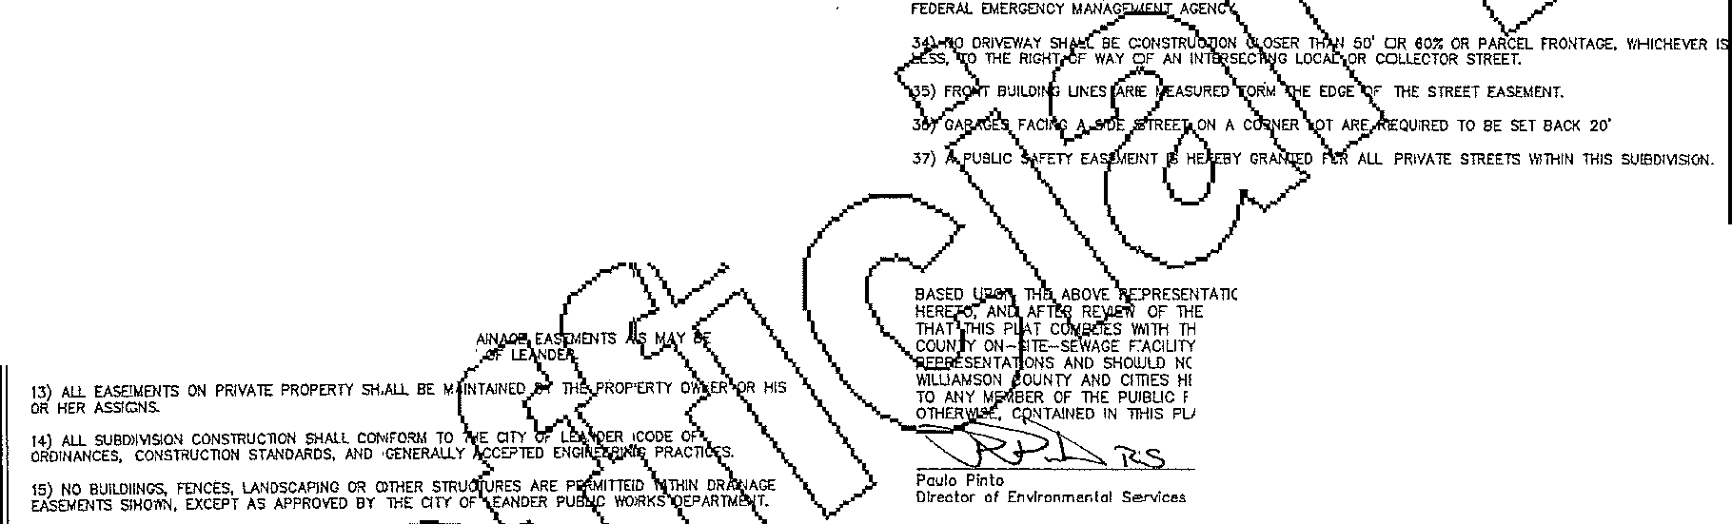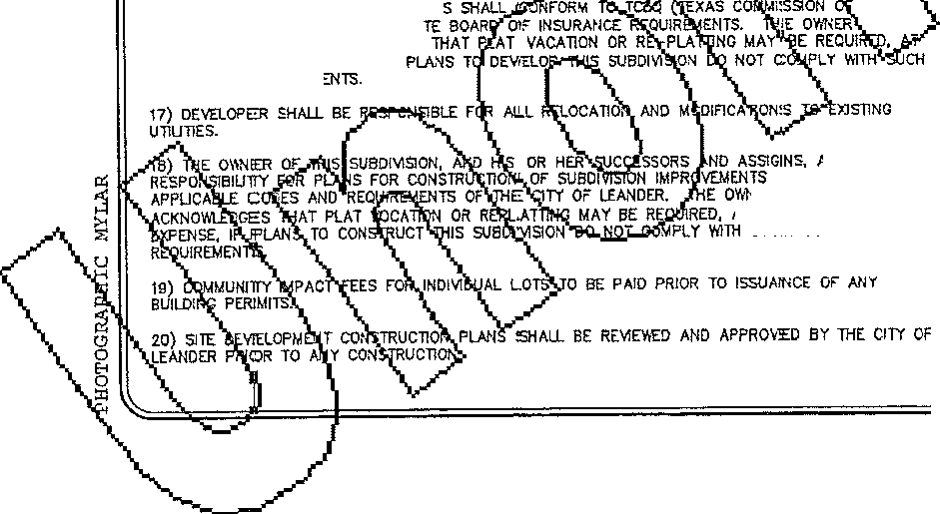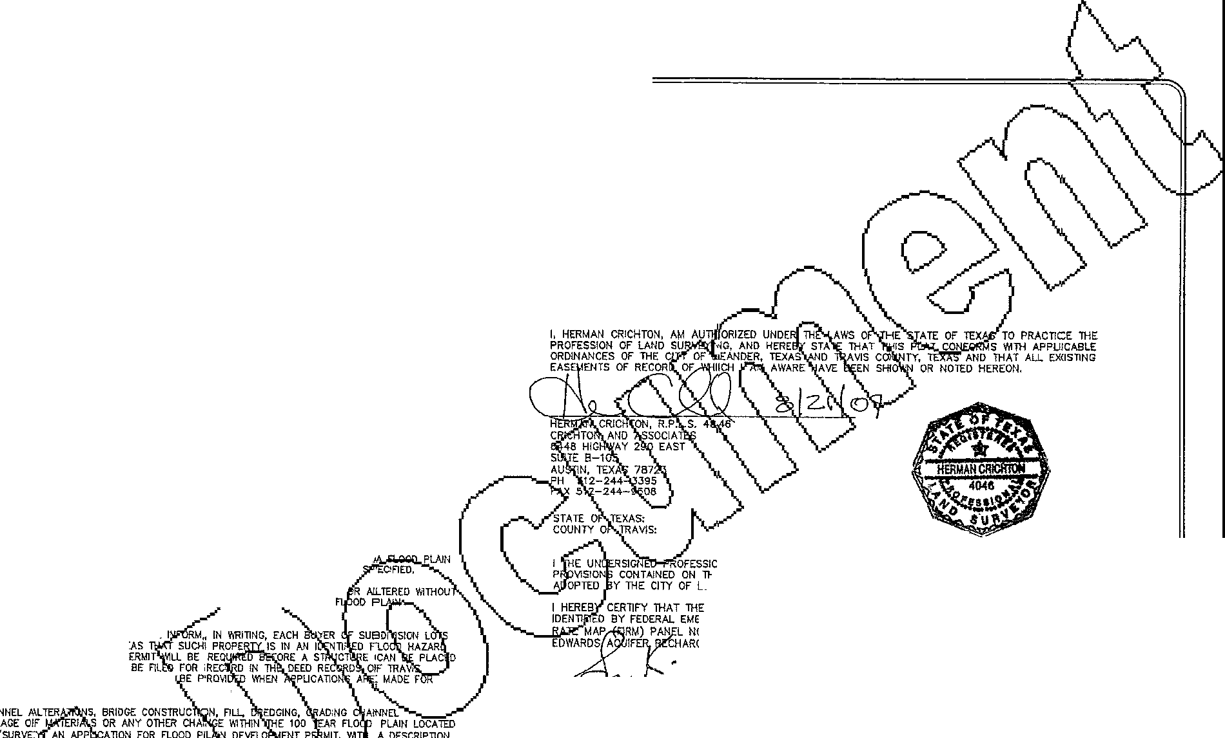

16) WASTEWA7ER AND WATER S'l'STEM EHV1RON"MENTIAL QUALITY) ANO STA UNDERSTANDS ANO ACl<NO\'itEDGES lHE OWNER'S SOLE EXf>ENS:'., tF CODES ANO Rl:EQUJRBJ

SSUMES

YM--IICH COMPL'I' \',lTH ER UNDERSTANDS AND

T THEE OWER'S SO:£ SVC!H CODES AND

T ANO lHE DOCUMENTS ASSOCIATED ¼lTHIN IT.

'6 2'i 'fl

Dote:

APPROVED TH!S THE '2../  *f* DAY OF 2of2..'l_ A.O. ANO AUTHOJRIZED TO BE

**:E2Y** lHE,c UNTY CLERK OF A S COUMTY, TEXAS

**z;::G;l**

CITY OF LEANDER, TEXAS , WAYN

ATTEST: '

DEBBIE HAIi.'...., CITY SECRETAI.RY C!T'l' OF LEANDER, TEXAS

I, DANA DEBEAUVOIR, CLERK OF lHE TRAVIS COUNT)' COURT,. 00 HEREBY CERTIFY THAT TI-IE FOREGo,NG INSTRUMENT OF \\R!llNG, '111TH ITS CERTIFICATE CF AUTHENTiiCAilON, WAS FlLED FOR RECORD)

!N MY omcE ON THE *_11* DAY *OF ':2.of!-.?A.o.,* AT

*A.M...f-*

***?)'./4*** O'CLOCK :r.M., ANJD DULY RECORDED THIS THE DAY OF

**11.jL** 20P1, A.O.. AT ***1-:l!f:_*** O'CLOCK, ***L.*** IN THE PLAT RECORDS OF S>JO COUNTY INl DOC. No._ ';***t)0Jf2fl***

V11TNESS MY HANO AHO SEAL OF THE COUNTY COL!RT OF SAJD COUNTY, AT MY OFFICE !N Gf£0RGETO\',N, TEXAS, THE LAST DATE Y1RIT1TEN ABO\IE.

NANCY DANA DEBEAUVOiR CLERK, COUNTY COURT,

*::.!Ec u; rJ t!!l k*

PAGE.2 OF 2

09-225

**U\**

***CJ***

*tnD* "'"'''

**0**

u::scm:"lXlt rs :x&..lCM #Oll£S *CF* \MD SlUA'l(i) tit UA'CS aucn:. JDAS. our or I!£ c.. WWBO SIANO' 421. M s.s. EV"1CS $;.lf'tO' SOI'.. 'M 1EXAS .vac:o- tut. en

'S.llf'liCY r,c *It* -.U.WS. SUR\£'f ( NCI a-tE" *P.A.* Q.DSSQI SU!r'£Y, BOv.. A PQlfflCI( *CF* A 71.i..70 AOIE IRACT *CF* INCi CXM£'YED lO I.Cl0KOJT

*er rs*

0EW...Cl'IE(f Q(UI, "· .., DEil) flCOCAO IN -oa::.a.ocT tC.l&R 2Dl201M""- *OF* 1'£ 0AlCW. Pta,;C: JUXJIDS nt,1,\15 COMn; 10:AS; $JliD 201,.11)4. ADii:E *1iW:'T*

rSHEET2

I

SHEET INDEX

(NOT TO SCALE)

---;;-7

**FINAL** PLAT OF

GRAND MESA AT CRYSTAL FALLS II, SECTION 7

I *I I*

**0** l!IEI«; IIIOIIE:. P=NtllOJlJILY 0ESCIEEl): 8'1' WIES AMO !ICUC5" AS f'CUJ)WS:

=. t

=..

W EI *I*

J :1

':.°'..!::,ti,::;:-,V-;:;.oR. :

of a=-' 2H.10 '°°"" Ir.at Md • brwi 4inicl'tMd: Kt

.i:.*-::tt;.-t* I I \

"IECC.at\ ..._DOl'1twf1Snadth. 211.l'Oocn tract. .._t,--aapat .. ,Uw'W'.,_ cl..,12.346oa, INct.iitp:r. oi. *.,.d•* 1.AO«- ollorN! dncd:ied \o,• dNI! CII rw:ard *to* lbbert l. Cdc8'1. .t-.h Mo.2Dll118Qq, OfScicl Pallk. lra<it: h-a end. 9'I ,-1 ._ ,. r• 1V.Jll0

::=tor 1aa(lr-oe1 2) • o dMd d r.::ord u. Doug11ot, o. flr:iod n 121m.. Ull. tta:i1 ,,,..._.,R:ca:r 1ro,,a a,,;., . r-. u.. ei¢t (I)

1. S»"'ZZ'57t... a, of 15a t..t ta, a 1/r ne r.d ._
2. . a ot 1!51.D f1id bao 1/rhll"" bn,:t

l. Slt"U7"U"'L • u.cnc. *cl* 173 ..,_. tD • l0ci n:il ,._,... " •

4 Sl0"3t"z2"'E. 0 of &IIQ fMt \o O .t .... S..C. PN.l;

sa1,"'1'1»'"£.ediriDwAdlfQ.Dl.fNI: t:.oeat.11 fencia,ott.

5,. SS&'Zfs.&-r_ *a* ol 105.&J 1wt h • ao:ftt .._.

1. S1.J"3S'm'"£, a Oil 60.38 fMt b o _. t.aa. po•t:

a. sr.1"3>'22t. o Dt 1-t&:1!, .... tocahs\rod .. t.hG'Mcq,-Ht.b tt-mmt -c11b.121UDo:nlr=d..cl tbehll"Mdua.ud lr:od,;

»ea: (;1;111 ..- .. Gr. ol tte. 1'9..70' o;r-. tnK-t. h ('t2J----.

L S1.J"5&"Q!l'"ll o CIIJSIUDf..t. t.• ..-.ro11.-C&:Rap.-it 2. $1S1)1"!r[. a dWmcl *d* u.51 INt Ut en., rod , Cldl a:ip 9llt;:

J. S1 etS.1o1ica.ttal.0Dt'Nli=o Oftnm ra.=;..-.-GAdlmpNII:

4,, S011S!i5'l:, a *cl* 215.IO ....... to - Aft rod 'llft1I CMI c:mp ,at:

S. st♦"'2S"52"'E.o d J.5,4S.A, ._. t.o•ft!O fW_,..gfl cap.-t:

II. Sl2"!Sl:1'"£. o 6taaao Cid Jm..31!. l'nt lo o,c;ct\on Ml;:

*1* ,o diri.onol of UD.11 WI b:I ca i:m ffld 'W'i'.UI Col!I: cap ut.;

L Sll2':58'"48'"'E.. o &l-.c:e *ol tftl'I* to o cutblrl Nit:

L SiM'Ct Cl *ds* ol .DllJ f'.Mt. t.o a tbi IICil .. t;- 1Q.S58"215"fi"'E. o or 3f1Ai3 fut. ho en hn .roe.._ GMo:ip Mt ILKtlr\7'.sT'E. o *d* 302.U kid '1o, en tvl nd Gl:R cq, td:

,2. NM'J0'44,"[, .. Utaxc of 2l'ilLN fffl ,.. on ron roct ... CM CQ Mt;"

-

aoc:E 0.- G'.'ld CCRID tt. 215L"10 OCF'II 'lnx't. U. f:9ow.fli lQ (l) CCIGCWS

L $25"41':zr'E. o *ot* llllS8 Mn en irm rod ..,_. cast • ct illle p...t *ol* cur,,,.... *.t* o cur.. lo o,,. 111ft;

1. Aicnt -'d cunt1 to CM*Ml\.* • 1lnftb *ol 1..EO.* a1lh Cl rodmi *cl* CO.CO i..t. end■ct.o,-d 5211"1f"!ii0"'[. • ., 7..60 JMt to lai ....*t.cl* ._.. Ctil

....

1111El'CCN40"Jl!l c:. o6tax.d4..0Dt■.t olfog1fail -- 1at-,o-lll *d* iN219.1D-1Nc.1. enc ain *t'ot•lo:td d.Jl!ll.» ....*

b oCOU.:. Mt Ill ltltl ecr!br.f:, .. II.I tbt: 2!9.10 OICN trcl:

nGa con'wull,g .ru, itt. liM -clbf 219..70 ocr. ln(.C. .._ ...... a.a Cl)_._

1. S8C'1TV'E., o lllistonca of Z24.M 1ut '- O CDtb:n Mt;

I I

I

I

I

t-

HEIT 3

I I I I I

I

* I

.. *ptr,,.C..-,;s,*

- I

I I I

-I

-I I I I I I

I

LOCATIOM MAP

(NOT TO 9CAl.E)

*[),,-4;1!,.,s/3/131>1*

2S1.C:T'21i"l7"£. o ....,._ of iNIi.m -a 1/r roe! b-,:b:IN_,

noa: ..tu. lb ._ cift'.J.U.JO..._ tn:d. .._ t-. (tlJ L SM"S4'W'4' o '■1:D,ca *of* JJiU.3 fee to a •.._. 11d *bnd.*

1. Mal '52""- a ds:m *at·*.JB..!18 r..a to CM k'.- .,.. capf'CUld:

l. ur.st'lr.t o *ril* "'83.10 t'Nl lo a *•1'1""*rn.n *nd* 1icuri¢

oft. 518' 15' c&i.nc. of *8211,.36* loll 12 o 1/r hilt f'OC tr:llnl;

s. ser,1"'5o"'lt o ....._ *e1* 40UD r..t a a 1/r nn rod touMt.

A. SO!l".s'O:Z"'lt -a c&bnu *cl* 354.43 fHl te o W=,; nol Ht;

*1.* SST'-1"2ir'lt o of 31.Z! le■t Lo • n. rK ..- mp found; &. SOD"'4-7"...-S"E. o lbt.-.of331.sJ fut Ito o l!"r hwfNd b.lilict

i:,. SU,l"D5"W.. o Ula- *el*tt.lJ& 1111111 to •· ootlon ,ciibl• tau■d;

10.$C0"+.7°2!"\:. Q d":ll.Gncl er $ell \=io D 1/r i'an rod bmd:;

11... M'2T o diilt.Cftu. 0, 90..ll rut too 1/2"' ln,,n rod boait'

..---a CIC ._ 2).9.11) c:x:n lr:ct . DelMra:I bad:

I

I

I

L

I;

-I -r--7-

1 I

I I

I I

I If( complete

12.o.A.eelS.of' aJ ..'nl ,_,I ID en i"clll *ttld* w'lh cap NI b h ,t.wt, cf 11,c 2:tt.10 C1N trod os.d 9'!c benin da,ctbed lnlc1; 1lOC:C -& tu -c:i-r,,h *d* 1MZll..10 ocrc traet. IN ..,_ (l)i::io..nmc

l. • ane to bleft. .z«clln;OII ol 34:1.10 (Mt,,.,. ondn-el20&.M>killit.Clldo -=-:nSl,l"3C"'Dlnl o *d.>..U.3S* r-i to OIi t-m r■d lli1b

G.att cq,.sctctb poiil:ltd,_...,anobft cf a caw ta h t

z. AbJs 91:id cw-... *to* U.. rS$tf\. cn c,ctetti;tili ot.JD0:.75 r..t.,.- a oruc..ae '-l. .,,.o CMt1:1 lllbiich SM"3.7'5.s"'",t a 111.-lllncll*d* iu.:m r.. t to an hin rod

_.G4dl.cap..t-.91dd-..d

1. M:'KT'02' o cd 19S..25 ilMt an._fflel .it!CM mp •Gt ._paid: er .,aa.nr1 'lo._Wt;
2. Al:n9 *91:M* CU"'\111 lo 6■ left. Gil in. lmtltl: .r 3».42. t.t....., a s:6a. ,c,I 2Dl,'2 ..._ MCa! Cftllrd --1ctl K5J"'57"...-., c datai!ce ot:n.:ns f..t 1o en\oQI ,ad

a9'C6:Ra.,-C.at 9MNdol-=idcur-.c

1. . S77"51'U"'W. D .S.UlflC:1! ., 241.S mt to ca ntl l"Cld wiltl Qft CClp Mt;

I. tl7.J'l'l'oTll, G disb:rica *d* 1ti.07 to - hn Gaff. cap .at

*1..* S1nf"l1r'w, o diltmcc *d* 1e.%1 INL t. an h,t ftJd .a,. C,lllt cap Mt;

noCI: -- ., OICl"Cfl lhs :lft.10 00,11 lrxf. l'tc dgllt- (18) _.,.

I ..4.J"2:9"o5"'o --=--a1 U&.-0 tMt.'9miran.rod ..USCM INC

1. . o ctatmaca of 22.4..CI r..t. tA enlr0!5 rod ..ah Ctil cq:, Mt

l. N55"CK°I.,..._ o of 1&.21' t.1 to Cl■ ba Nd ... QA c:qi, Mt

.._ 'W'I.S-.. o al I t4I O't i'on rod Ql:8 cap Mt

S. N21"'1 odr.r,c:,. of U'l.1.5 r..t too, ftlll ,od .W. GM CC1F ..C:­

&. fli1 ""- ocl.ten:» *ct* 14..UH feet I• en hn *rad* GaR ap

1. o CIII 171.18 fut to ca, I-an rod 1111ft G,ti? ca, at" a KDF11"3:t"11; o •&a1r.t.1.o m ftlllrad .ai o:p lilt;"

..._ h1r41• o al -46.U Ifft \JII .. ,.. .-ext _.

CH a::p ..._

It

11

I 'rrr 4_1

I

I

L£GEND:

•

I *3fi2-/*

I I I

I

_J

lll. ..u'U""lt, o d-1 o-f83.2◄I-'! to• ha f'Olf _.. Gadl Mt;

1. NJD"37"l;n,. o dist.cftu *ol* J2.!6 1-t lo a'I hn n:id ...,. c:MCQp ,ct:.
2. .N2S'25•3!5".. o -. CII 27..29 1-t. • • t:cn Rid .ah CM o:ip ..t:
   1. flo43'21'.3J"W,, • ct. *dS,l,.11,* 1rNt to a ln:ft Rd -" C,111 cap Mt; 1-t..tf.W.15"3$.._, • dii■t.-xc cl »..D '"1 to- lh:n nd 11Ai1 CM cap Mt

15. lfiT.qJJ-W. • dil1- *el*229.ft rMt lo Cl"I \-on Rid .m-. Qi:lt cqi,

'II.M32"D1'1'4«rw.. • clia1.oriol *el* 1$5..tJ fNt UI CM.,. ,.,..-, Cldl cqi, -11;

17.N21i$'iD:Z"'lt o of .JIU,S (NC 1• en l'a; rod.ei CHo::p

sa.se .., 6.uina *=1* tt.» ,_ t.o • •t:u:I r-- peat .. llfl& .,.*o*•t2*l*fil.1'S «N: bod.,. 1c11Nt tt • OM111 ot *l"KIClt'd* to u. Ud.

II ,...._ 1292,. Pc9, 1958. Rd Pniprty trowh c-t). 1- .., -tait ._ *cl*.. 211..10 o:r. tro:t. W 1ic: -,a,. ca... oth bra

'"""

ne1X -- ibe corrD1GG .. of .;,.12A.l'5 acN b"Od. GIid '1l.e 219..70 ocrs 1,-cxt,, Itta w ,,. --- (.M} CClllnat

I. NM"l$•zr._o cd mz.22:'--1 too •t::. hncapolll;'

Z. ,HD0"21J"22"E. e c&tonce CIII IOl.Q:Z *t-.t* l.o o st• (MQ: peet

-1 .wu"38'29'""£. a *at* 155..M r.. 1 e. ..., peat;

1. . Mt◄·¢ .... 11 dilUll'IIC'.6d 13!..45 Mt to ,a ate. ,-- posi:-
2. . N51"'5d"15-._.., dittanca.,d .J5&L7 l'Mt. U o .at.. iMca- poet:

L ,OS, ◄fi o *d* 117.12, fielll to D .tut fexia poar.

I I I

I

I

ITT 5_

***CAPe***

0

0

•

•

_J

1/2" IROO ROD 'Mlll CAP FOUND

1/2" IRCt-l PIPE FOOP«l

1/2• IRO.'I ROO FOOHD

1 /2" IRON ROO **1MlH** G&R CN' SET

= SJEEL FWCE POST

= COTTON SPIHIX.£ SET (U>ll.ESS NOTED) CALCUtATED POINT

60d ttAIL FOlft,ID (UNLESS i'IOIID) MAG IY!JL SIT

BLOCK NAME

7. MU'31""1♦'"11,• cr..o.c.. cl 157.-0 hat ta• It.- tmc. ,,..a::

1. M:18'11!1'"\0"lf. Cl clbt:ox.. *d* S5JD.315 r..tl l.o Cl -- bat¢,

PU£ = PUBLlC Uffl..JTY El&MENT

1..NS4-"06"+1"E." d'alcectt o, 1 re to ., siltd f.-c. PNt

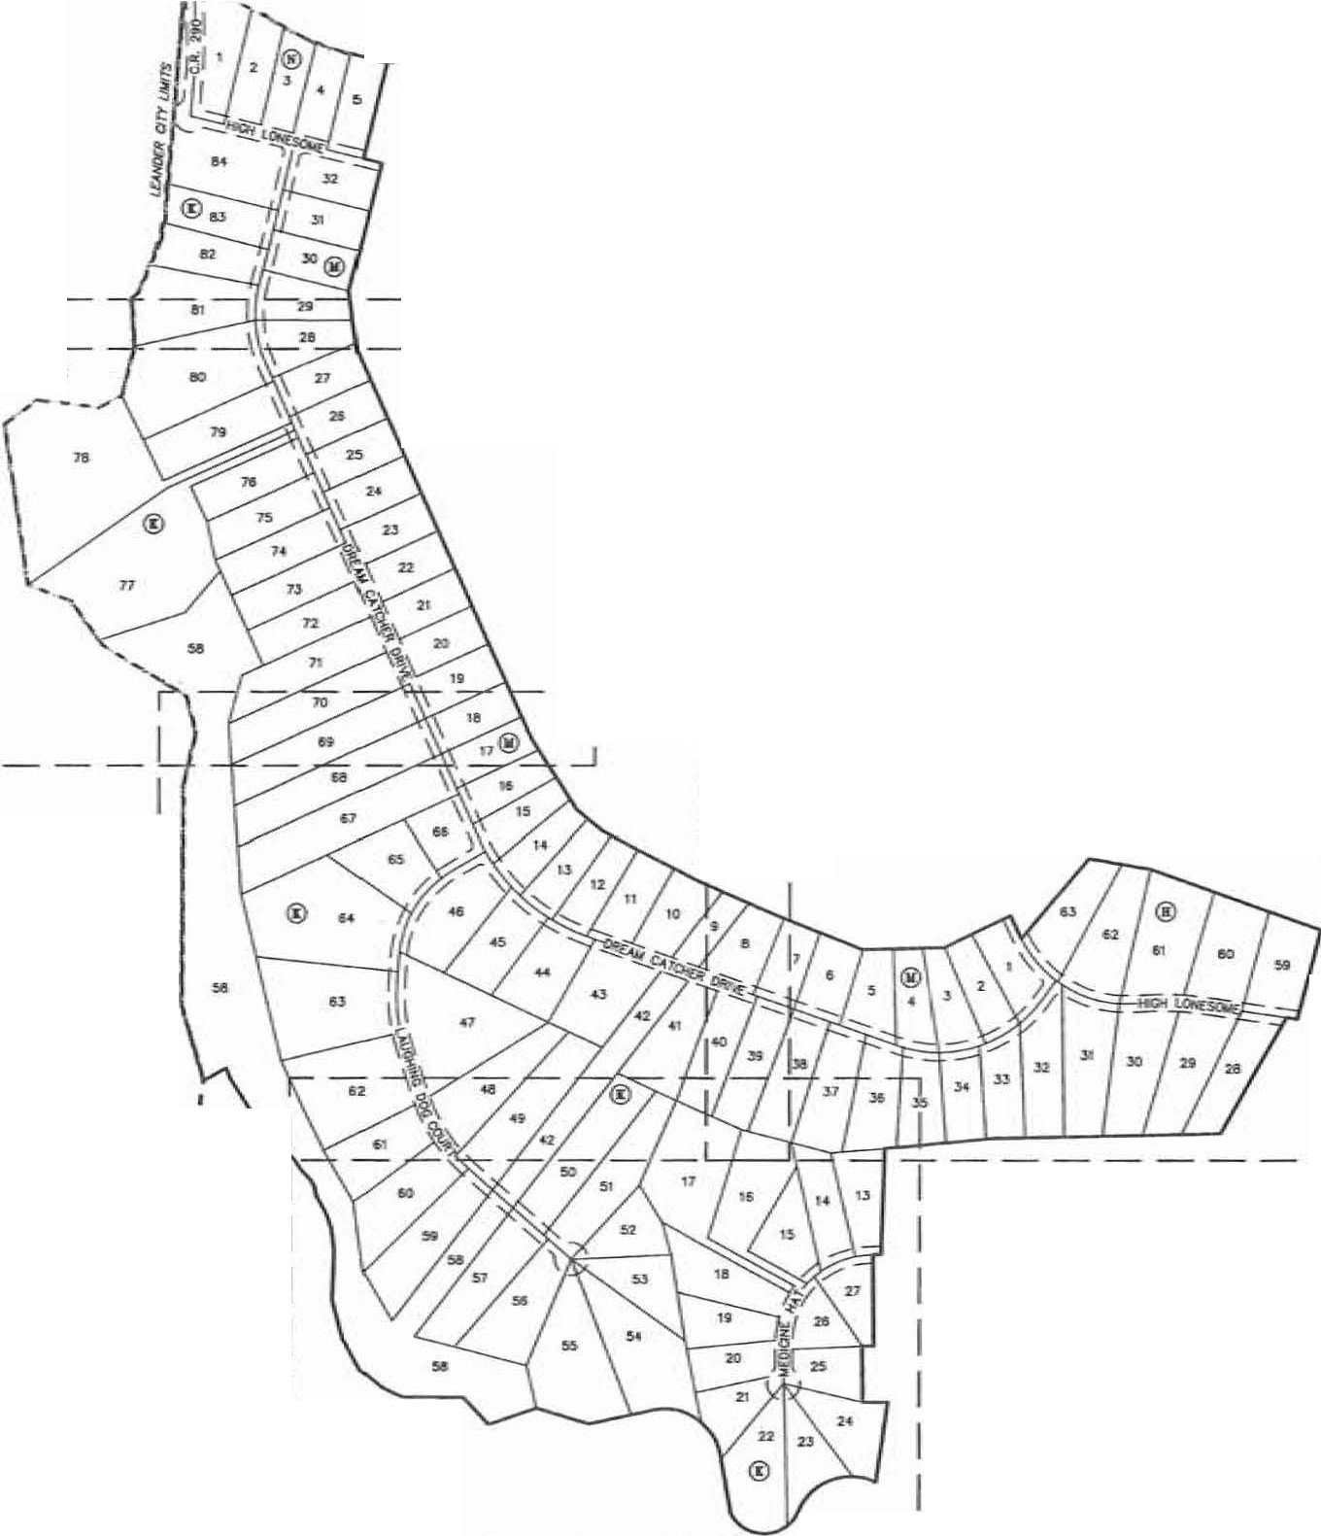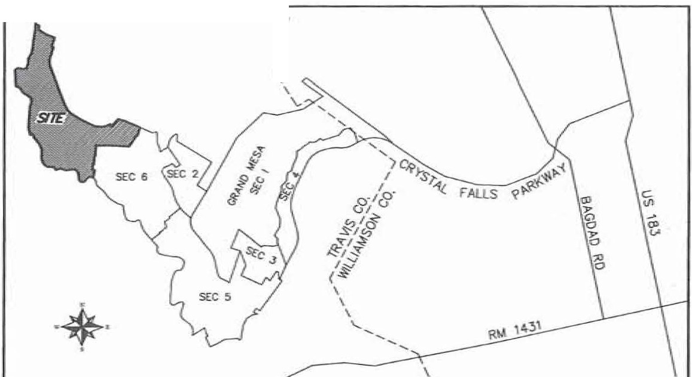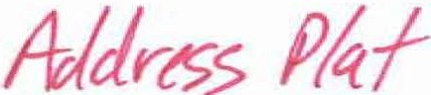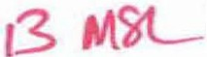

10S.ISJ"l:nu"r.. o 4111.mca *ct* 225.al fMt. II:. o _.._._ aX9I ,-1,:

•LN&:J'la'.lt.4£. o *ol* ,ll5J, fNlID a •leaf lalK9 pMt::

U.lftn:s'll"E. o l6Unc9*d* 1115.&D e..: to c &ld _. iocat ul03'53"5i'-.. a or t7UO $Ht • o .s!.t !Mee. poat; 14..N41'01""5T'E. • diiltcmc4I cf 34..21 W t4 ca hn nd _. CAR cop *NI:*

t5.M22"'25"2:6"E o of 21u1 r..t to • no roe: .- e.st ap NI:

ILN11"'211'0T£. ,a; *r*s*,*a.l*I*4 ilealb o stul '-- ,-1;

1. .M.>4·(1'48'"[. a ._..:nor of asl.35 -.I toc, , , po■t;
2. K04-»"0r'E,. o *.S.* cf5&.51, ,_. to c, 1./Y hn .-od t.ed cl 1M e.ty c:ianw" *.t* h 1251.115 caw trodt:

11.h.51'35'Je"'II. o oil 1.s.JJ, (Mt to c S/2"' hr! eod ilOlilald et. b .-bCCl"l.1« of mid Lot 40.. w.m;;:

TJE>tCE Hl:2'tl6"'U"'E. .,. 1t.c -1q ._ oilMidLot +a. IGdCIM "- O"IC h ..ut■rt:, ._ er lb& 211..10 ocre: tro:t,, c caca *cl* 150.4' Ju!! tD 1M PQNl <F

CIOU."...... - c:rc,c1 of *201.V'.A* ., ... ear. G" Ian.

O'o\l<IER ANO DE\a.Of'ffi:

LOOKOUT DE\'EI.OPMENJ G'!OUP, LP.

2370 RlCE BOU...EVAAO, SU1E 200

HOUSTON. 1DrAS 77005

SUR\00!!:

GaR SIJR>,£'1ltlG, U.C 1805 OUIOA DfflVE AUSTIN, 10tAS 7&728

DICINffR:

JAY ENGll,EERING <Xl.. INC.

P. 0. BOX 1220

l.EANllER, UXAS 786'6

SUBUITTAL OAT(: JA.W/olf'f 17, 2013 TOTM. AA£A Of IHIS PU.T:209.104 ACRES lOTM. **NlJWSER Of** LOlS:11!>

RESlllOIlllll.:111

PARK/HOA:

UN£AR FUT Of NEW S (?RIYAlE):

HIGH LOIIESOME: 1,900

- CATCHER CIRll,£:5_138

LI.UGHING DOG OOURT:1,ll58

WEDICJKE HAT:68J

C.R. 291:t 7 TOTAL:10,236

PSE

DE

**y,** Y,13.l.£ MMFE

!115697)

*Z.53*

= PUBLIC SAFETY EASO.IDff

= ORAltfAGE EASEl.lENT

= WAlER LIME EASEMDff

**Y.1A**lER 81JfF'ffi Z E EASEMENT MINi'll.llJM flt..'JSll FLOOR ELEVA11011 LOl AREA IN SQUARE FEET

Ul.lJTS Of "'13.Zf

SHEET 1 Of 8

SURVEYING, LLC

*1805 OUIDA OR*

&

*AUSllN, JFXAS 78728*

*PHONE: (512) 267-74.30*

*FAX: (512) 836-8385*

f MATa-tUNE

*I*

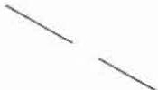I -rsEE INSET-

L6o FT. ACCESS **AHO** uiu1Y ESUt.

I

7

YOL.. 12902. PG. l!MB

l

/ FINAL PLAT OF

GRAND MESA AT CRYSTAL FALLS 11,

,- f

I

*POB N=l0175647.2*

*I* / SECTION 7

- ' ....._*,I*

/ *I*

*I ¥ I*

*;: J-(*

I

*§ I* I

HllOE1f lolESA

BK. 66, PG. 27

7

40

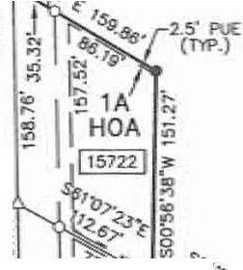

!;

*I* •

I'

0

i'Ji

0z

3.o;r £=J057376A

*I I*

*I I*

*I I*

s

;

0 l ....._*8*

I

r*I* I

I

(,J

**PHUP** R. HAMI.TON

0

**L.-.c;**

*I*

*I*

100·

I

2«f

I

SCALE: 1· = 100·

300'

400'

I

I'-! I

I I

I l I I

i1:;10· • • ,

1. J46 AC.

DOC. 2001060263

BEM!l!IC BASIS:TEXAS roo'IAI. ZO£. S!Alr PLAKE COOfflJN liS (N,IO 83)

I I !:.:

II lI 11gji_l

.. (m>.) • *I I*

I I I I

I l

*I* 11 t

I C.R. 290

(60' PRIVATE

I

STREET, ORIIIN...

I I I I

:

I

*I* ::,iO

rS.E. "' P.U.E.) --

I

I l

I :

I

I I

I I

I

r---I -----

/

I I -----

I I I

I

j

I

I I

- I

*I*

**450.00 *w:..***

I

**M.** IOJTSICHER UfE ESTAJ'E

12.592, PC. 1901

lr It ,

al *f1* 1?4n11

*: /;!*

*//1l*

*i* ! **IYN**

-----

g Q!}.

!lo.

127.030 AC. (TRACT 2)

D<>\lCl"5 O. HOOD

**VOL** 12189, PC. 1.339

----- ----- -----

----- -----

----- ----- -----

I *:*

I

I J

I I

I

I I 12.MS AC.

IH294<lf

Addass P(a.+ Dfll.t

I J J

l

I

I I I

l *I*

I

l'tlllP R. HAMII.JCl!f

DOC. 1001060263 *)*

I *I*

I

com-e1ed;,/zt

I I

f I MATCHLINE

j --rsEE INSET-

83

156'959!

[ Lm n. ACCBS ai urulY ESMT.,

I

7 VCL 12902. PG. 19'4-9

I I *'!011s641.2*

I I

E=3057J76.4

·<%· J

RDI.AINOCR **CF** 1013.55 AC. (IRACT 1) LOOKOUT PAATllERS. LP.

DOC. 2000l628J6

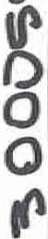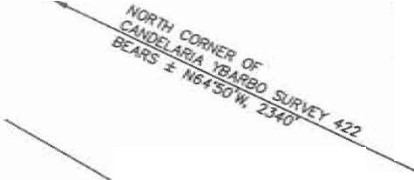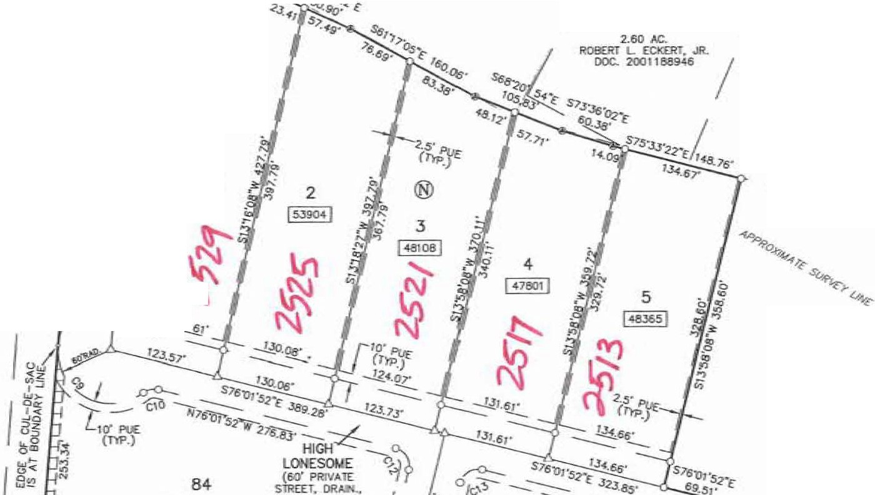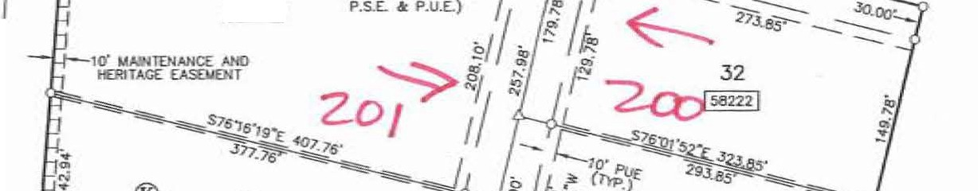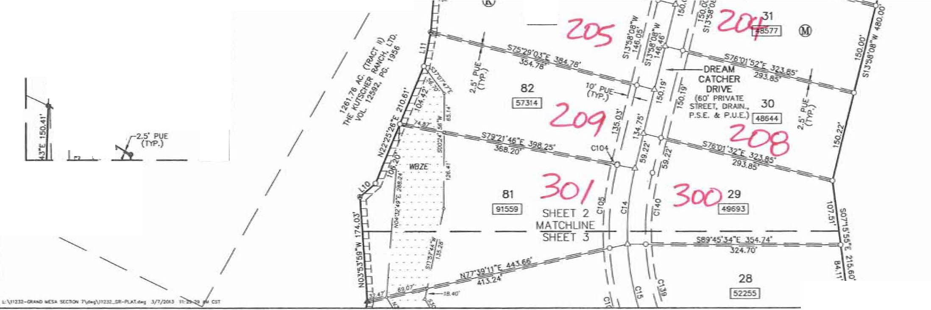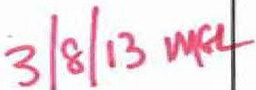

-----------

I I ..-*>-*

• 1 • e,.i-,g,

.. *es*

r'> 11*·I9*

INSET

SHEET 2 OF 8

SURVEYING, LLC

*1805 OUIDA OR*

&

*AUSTIN TEXAS 78728*

*PHONE: (512) 267-7430*

*FAX: (512) 836-8385*

-• - ***·t;***.***J***.

* r. -

**4**

**IS..4:Y**

SHEET 2 °1

MATCHUNE l

SHEET 3 **FINAL PLAT OF**

**GRAND MESA AT CRYSTAL FALLS 11, SECTION 7**

80

*if* ir·::::--:\

ij . . \;

tr··:------

0

**Lr.£-**

100·

I

SCALE:

s

2<Xf

I

•1

= 100·

300'

I

400"

I

**- j**

llAINlOfMC£ A.'-'> n:JllTACE E:ASOl£Hl (DIAGONAL HATCHED AREA)

*di*

78

76

1511905!

®

74

I s41o;J

24

43l52

- • ,,'I,

*0 s* 23

**Uc:.o'\- o**

22 @

- TEXAS camt.11.. ZOlE.

STATE **PW£** COCl!lllHATES (MAD 113)

AJdttsS f/tJ

H '3Mr., Y'\9L-

**m-- compl***/***et***i***ed***2./1* ,..s<---

**REMNNDER CF**

1013.55 *At:..* (!RACT I) LOOl(OUT PAAINEl!S., LP. DOC. 2000162&36

60\ . **4**

_i;Jl

*.·:.·::::*- **.5.8** .

- •• :---:-: _-::-:-: :-: _.::!::::.1.-••. •. _.

lf!!Zc ... -... .- . -

21

**50** 79

**60q** 0

- -- .• -- - • -• . •

**..:i:** ...

.

.

- . - . - . - .

SURVEYING, LLC

&

*1805 OUIDA OR*

*AUSRN TEXAS 78728*

*PHOIJE: (512) 267-7430*

1261.76 *N;.* (fRJ,CT II)

THE KIJISCHER RAHCI\ LTD.

**1/0L** 12592. PG. 1956

... _._._ -·-·- . •

69

j1029-41j

SHEH 3 **o\**

MATCHUNE

--SHEET 4 --#""---

*1!P*

*¢P"*

*eP'*

*FAX: (512) 836-8385* SHEET 3 Of 8 68

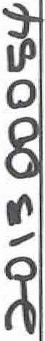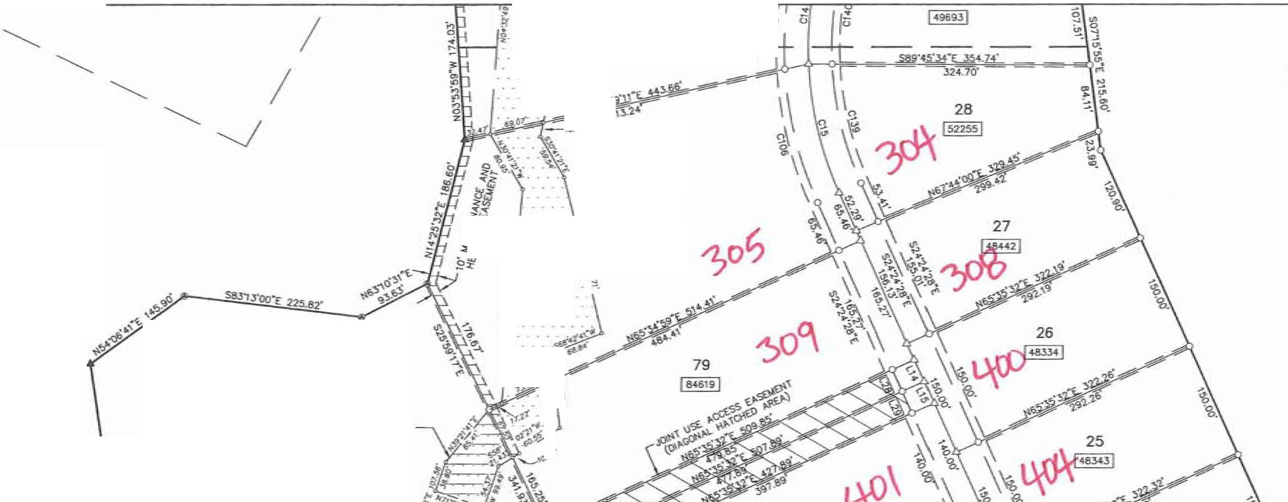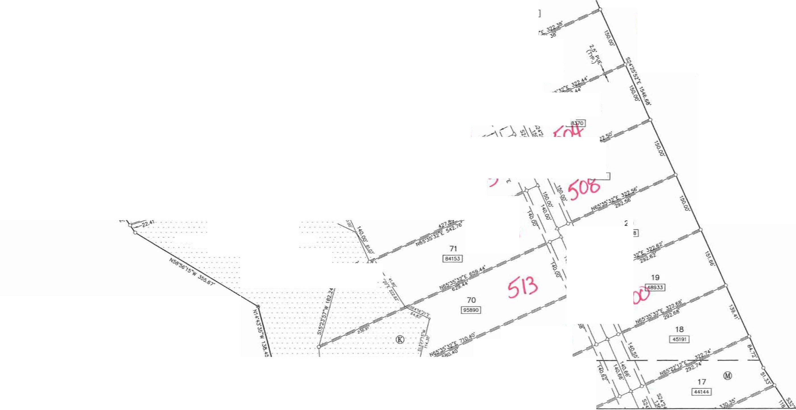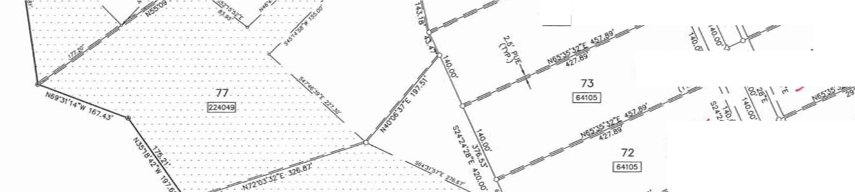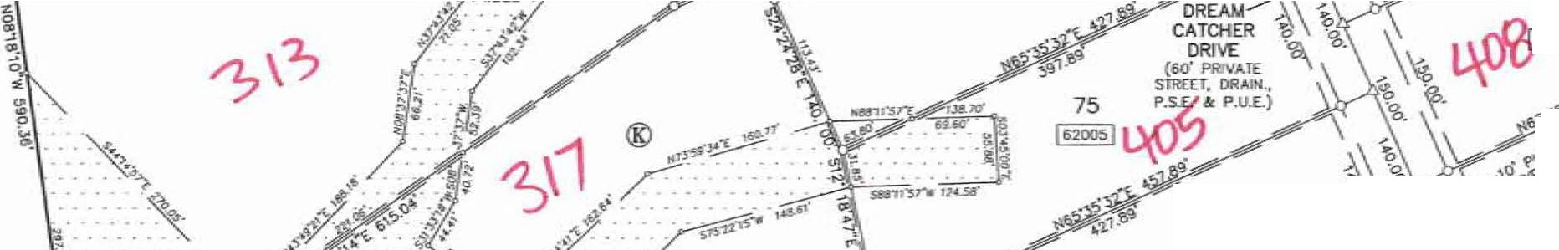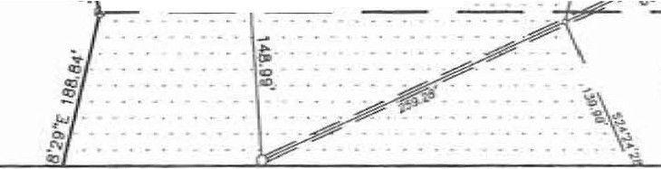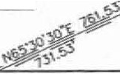

SHEET 3 MATCHUNE

--SHEET 4

18

45191

FlNAL PLAT OF

GRAND MESA AT CRYSTAL FALLS II,

f

SECTION 7 Adc*I*tttS5 *I*

N Pr((

';;

* . ... *9*

$.,. '?fl·

*!>..:* ,

-

17

**144**

w* • **f),c,.f+ 3MI?**

::- =±-,.,ii}(;compl

rl

. 0

.. . . . . . .. ii:

* *·.·:*...._.. ·_-_· - _2i; -

. - . . - .

67

113,4054!

lgO , ;. ••

\

*a*

C,07\

c, 4

. ... */1*

S1AIT IUIIE COORIJNAT£S (NAO 83)

ROIAJN!l£R OF 101l.55 AC. (lRIICT 1) **LOOK(JJJ** PARlNERS, LP.

OOC. 2000162&36

,;,·. =

65 •Y -

*4?.;.*

0

s- :;

e : :-:::-i --:-:··.•. • {:/ \ ;:: 'Ftw 5 r

t 4! 0"'

0

iHGO

0

..

..

._. . _. _.

_.. . *k >; S* .,, *1/* / *;..j'J'*

cifiN

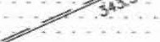

.

<::i:

.-,"::, .

*-*N *w>*0-'

.:.,:.

• • • *·:_·:.*· · · <i / **ct"'** *1/* <_,o·PUE **C"\**\

5" • • • • • • • • • - (T'l'P.}

*I\\,*

8

z _:_::::::::::::t :: : ® */* ) ,.! ., *7o /#";;;:,,* ,,:., - ,.

* • • • • • • • o. · · · L.AUGflNG "' (

*ti* •*:*

:-:-:-:-:-:-: :-:-:-:--: • • • *l>9ZE* .-: : • : • : *I{* T 45

.·.··_ . -.- *1;*

(60' Pli!VATE / -. • - I 66781I

* + 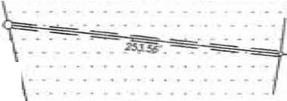• • • • • • *.8* S1Jl£IT. - • • • • ;;

" P.s.£. & P.UL

*'<"* DREAM CATOIER DRIVE

(60' PlaVktE

11

!536:is I

. . - . . . . . . .. 1!!

. - . .

- ■ ..... - • • • • • • -Lo! -

.. - - ... -

. . . - . - . - . . .. . t;i

<:-.<·:··;--:::.::::-::.-:\.::::-:::-::::\ _:*<);*

'51r.l5llf7.4r' :

-ilV" 0

=- J

- "1tHill/:

,Ap,,i_

STREIT. DRAIN_

P.S.E. & P.U

44 ()

1 1'. _·.-.· *_._: :*

.• •.

*I* /3 I jl \' : It *>Q.st<*

11415991 :'.ll .... \t :-:-.-1

63 J\ [ l·

\ ••• 47

. \ \

\ \ --

"7.2"fTT j709J8 I

-.--.::'.i

*-_-_·':*

**Qj** 43

1- 1

41

J75232!

*1'1=10171476.1*-

*£"=3057455.2*

'1\1i '·1 \;:- "

62 ......

SURVEYING, LLC

REMAINDER *CF*

219..10 AC.

. --

•• - - ),

*viezi*

- -

SYEET

MATQ-ILJ

--SHEET

t· *qyo*

61

*1805 OUIDA DR* LOOl< 9fT

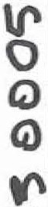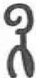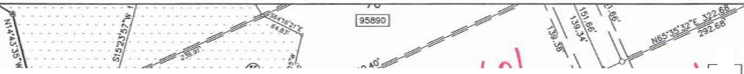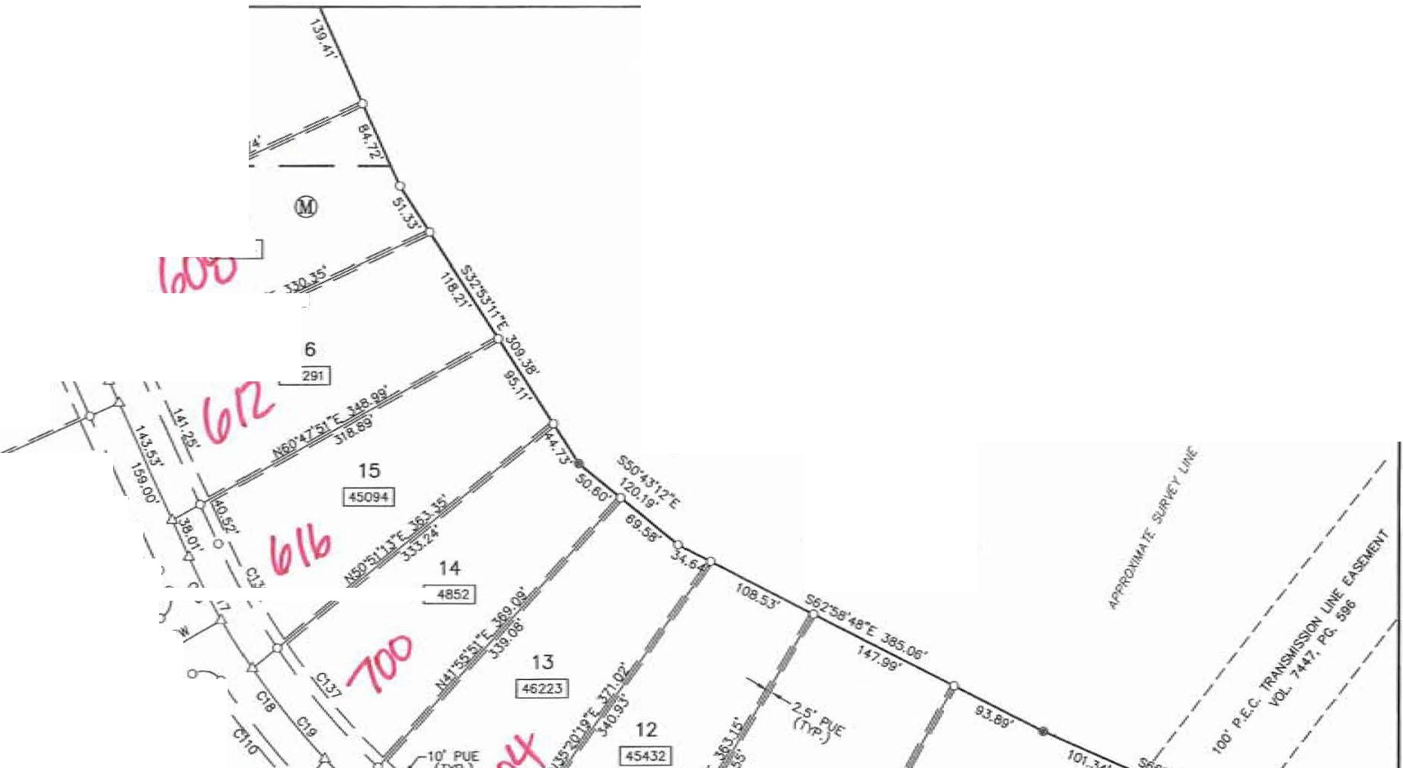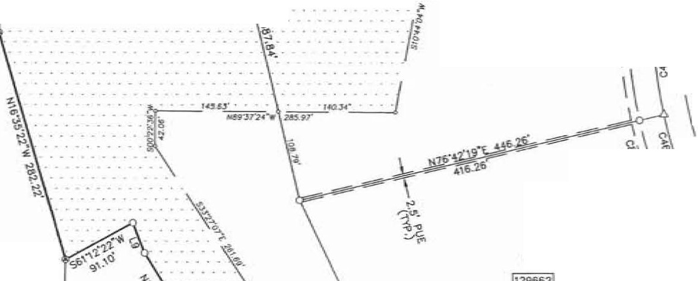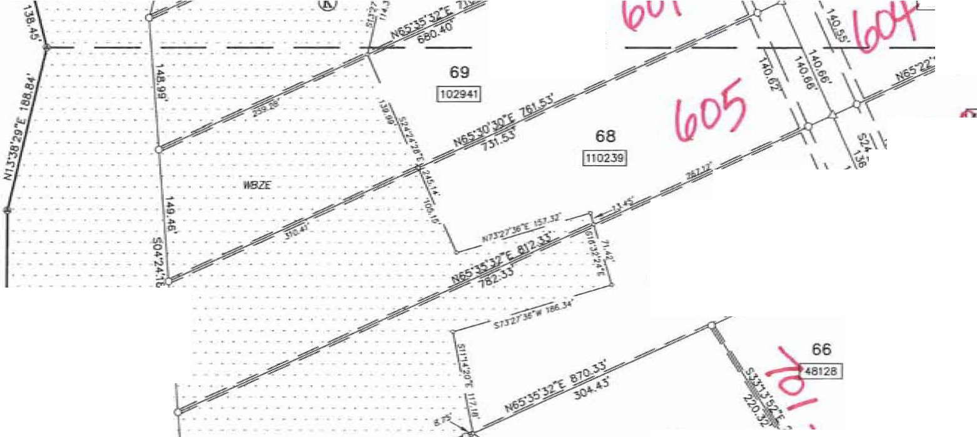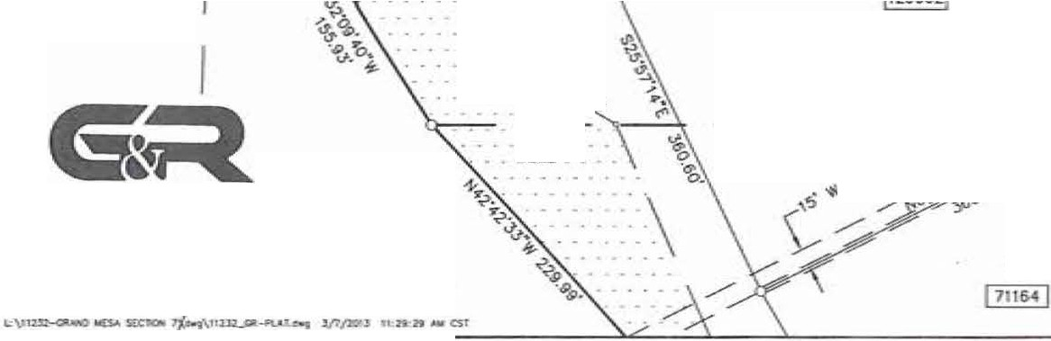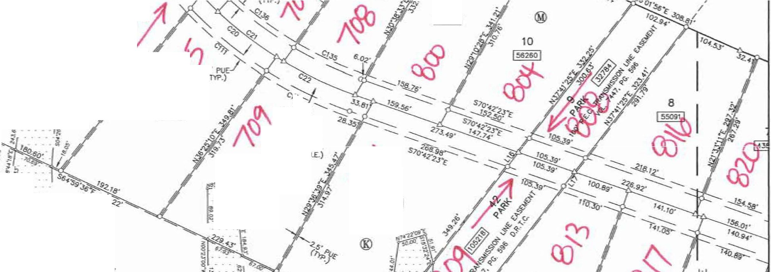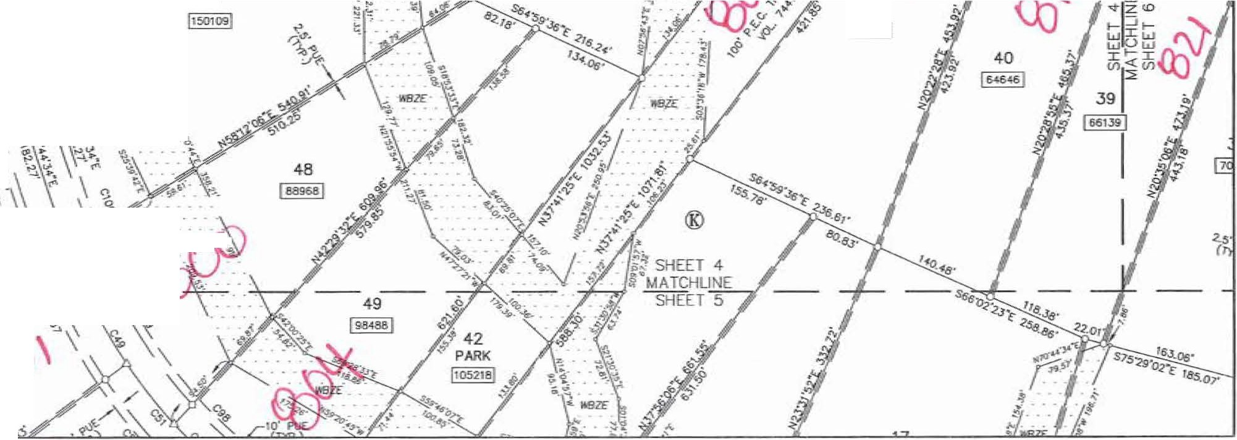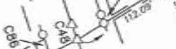

/.*USll!I, TEXAS 78728* DOC. 2012:G54164

*PHONE: (512) 267-7430*

*FAX: (512) 836-8385* SHEET 4 OF 8

62 L...i.

"\

"'

**U'**

**0**

**0** •.. \

**G)** ' ..

SHEET 4 MATCHLJNE

--SHEETS

(129662(

**,1\1** \

*(ho\'*

61

·.•:

-

*J*,*.·*·

43.07"

584

12

**0** .

(\

...

-\.

. -

.;.

,...

{,.

...

-

,'\_I\)

**<o"**

60

17

;

.

.,.

*25'* PUE­ (TYP.)

13

(5566!!!

-"!_

..

**co**

59

188886 I

cou

(60' PillV

STRfET.,

P.S.E. **a:** P.

. .

•. s2·-·

:'4,;_ t =f

-.

.,'!,

D.E.

3

,;

_.,. 0 ...,,

*:li*

sz

18

/,/

-=

*)*

;,,

"'!

7

,;.;.;,

\

bJ

I

;.. 19

.b,

0

55

(121916!

llffE=914

54

!1156971

MffE•909

***btbcz*** \

e. - ·-

.. ." *5,!}t·u=-y-* C .l!L,g1 ·=--= !t, --

*711*

20

. . .

..

.

- .... -

-.\ *'"£f.b ':£:-* 1

• .• _._. - _._.

- - . - . . - - .

* - *PPROXJMA'TE ·1*
* _... n: ·*fWODPI.AI*

®

. .. ---.--.

* • • "FFE=!lG4 le l 46756 j */9' w* CRA!.'D l.tES4 AT

**M** *18,1* CllYST"1. FAllS I SO:tlON 6

**OOC.. 200800122**

8

.

tll!S'29'lll"W 224.01"

"' ©

NS9'V"57"E 911..31•

PORTICN ()f

219.70 AC.. LOOKOOT DE\0.0fMOff

GROUP. LP.

-

-

"\_ OOC. 2012064164

-------

24

ROIJJNOER Of 1013.55 AC. (lRAcT I)

LOCl(OIJT PAAlNERS, LP. 21

DOC. 2000162836

**m-- come1ed** *:;,/1-ij,3*

FINAL PLAT OF

GRAND MESA AT CRYSTAL FALLS II,

SECTION 7 \

0

**L.----**

/

SCALE: 1• = 100'

**BEAR11iC** BASIS:TEXAS CDmlM. ZONE.

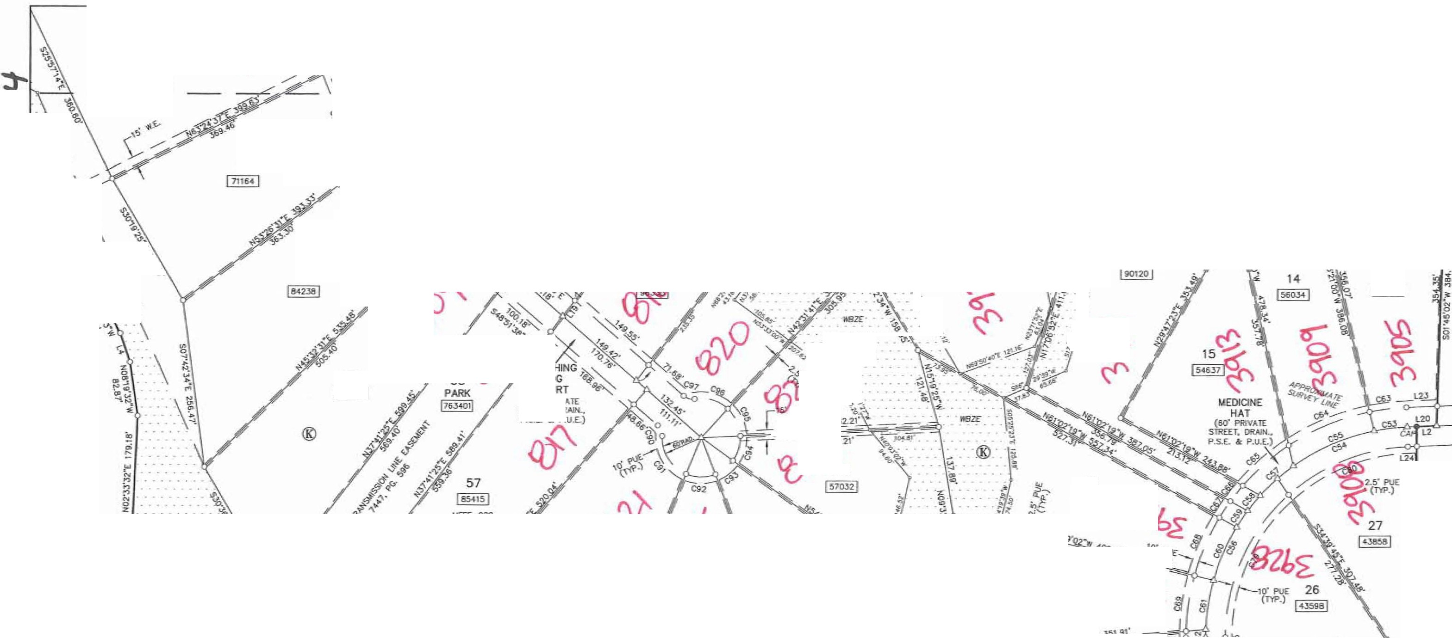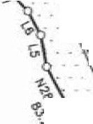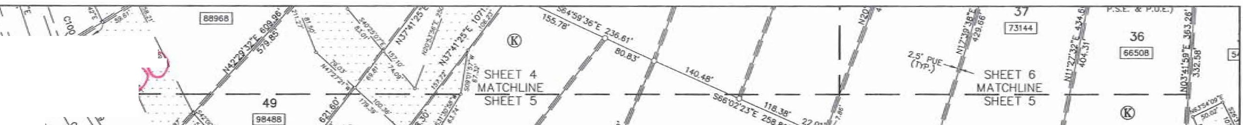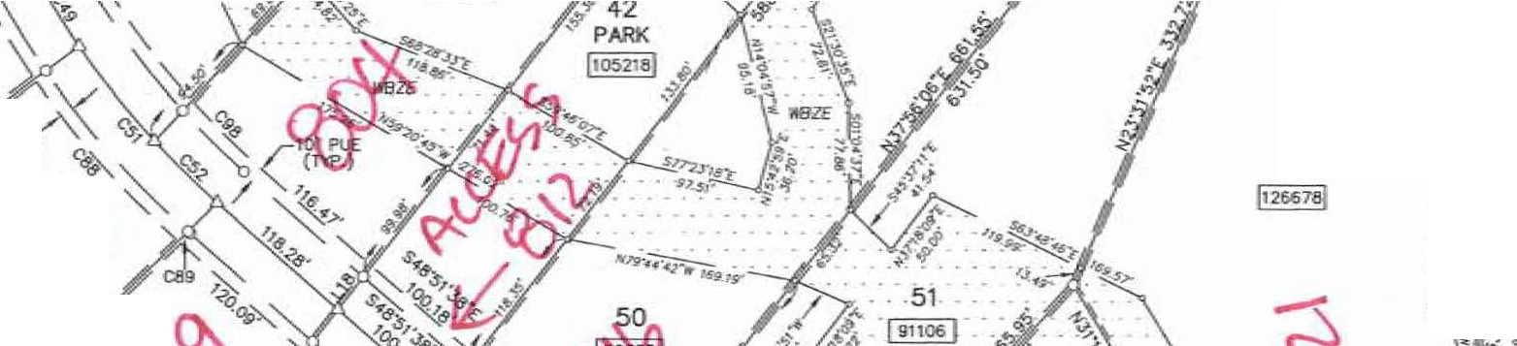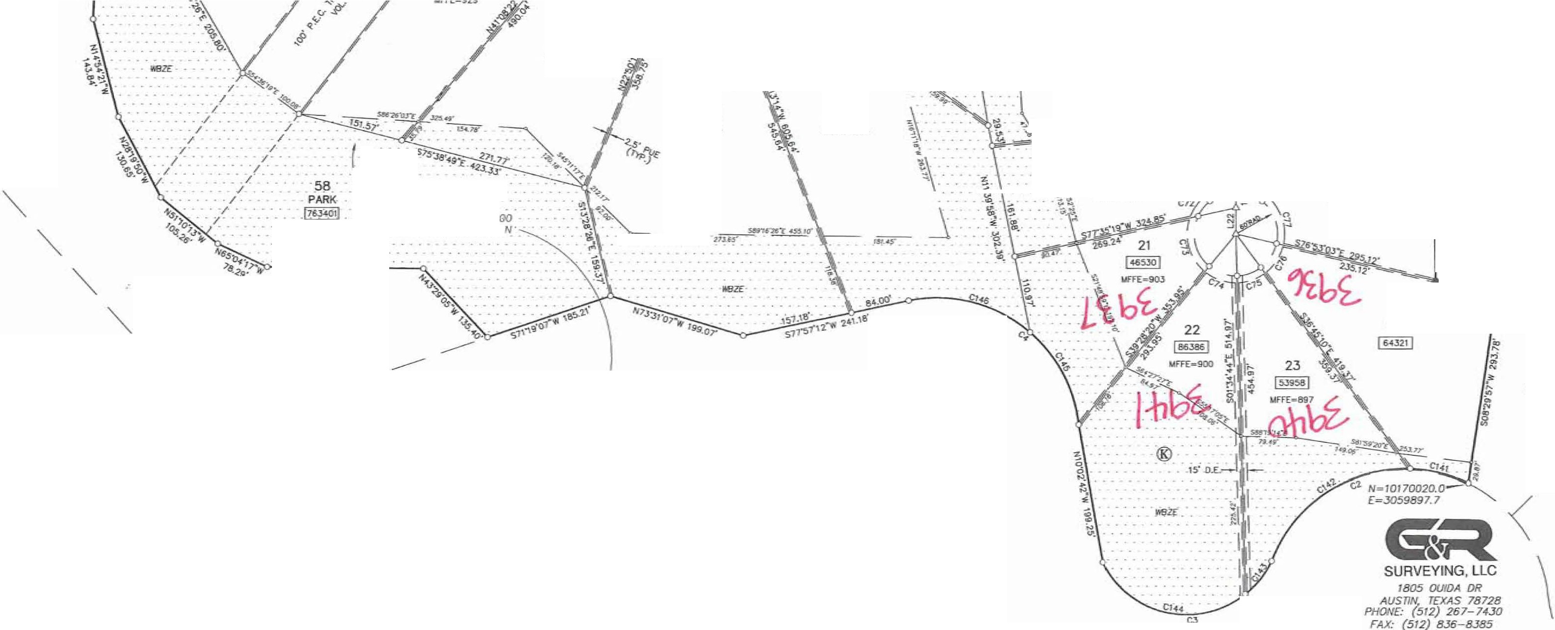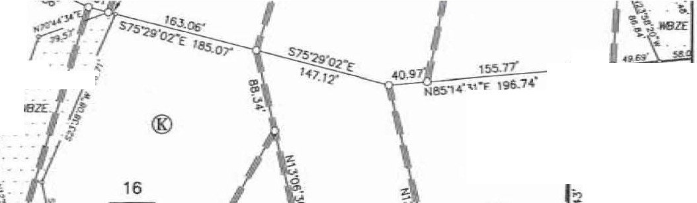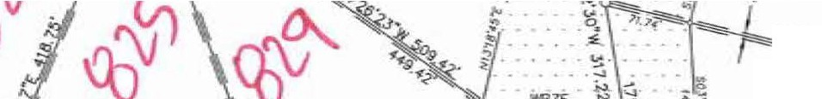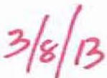

ST1LTE PlANE AJES. (IIMI 83)

FINAL PLAT or

GRAND MESA AT CRYSTAL FALLS II

.:,-­

**ll'**

/)

**0**

**0**

"-'

**0**

*(*

0

**t.y_**

100·

I

SECTION 7

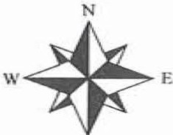s

200'

I

SCAl£: 1. = 100·

300"

I

'

400'

'

BEARNC BASIS:lEXI.S OOIUIM.. ZONE.

SJA!E RAllE COORDNATES (N.ID &)

,4-ddras ***f/4f***

REMA.K>ER

IOlJ.55 *M:..* (TRACT 1)

LOO<OUJ PARTNERS. LP.

ooc. 2000162836

l'alllON OF

219.70 AC.

L<Ja<OUT ll£\IELDPUOH

<iR:OUP, LP.

DOC. 2012064164

. ,; N=l0l72021.4

•'"' *1515.6*

60

1-21 59

K

1,05431

**58**

*r'f :!f*

**-'q.**

***e***

- s.1 (\Jo

*(}_ir\t'*

*<O* o 0 -­

§

**0.£.**

-----

40

16-4646!

SHEET 6 MATCHLJNE EET

(rtP.)

*.?o*

(60' l'RIVAIE ST'lED, ORAi P.S.£. & PJJ.£.

32

1144511

C)

*f'*

0z

*?*

*t*

0*z*

z 2. -

(TYP.)

i::,

0*z*

HIGH

&

"-, STREET, DRAH.,

'=•'·"'·'

31

1-,

®

c121-60.80-'

(\.J

30

leso11I

cID.

10'PUJTI

(TYP.)

29

GRAND MESA AT

CRYSTAL FALLS I SECJlON 6

Doc. 200&IOl2Z

© &"'

3

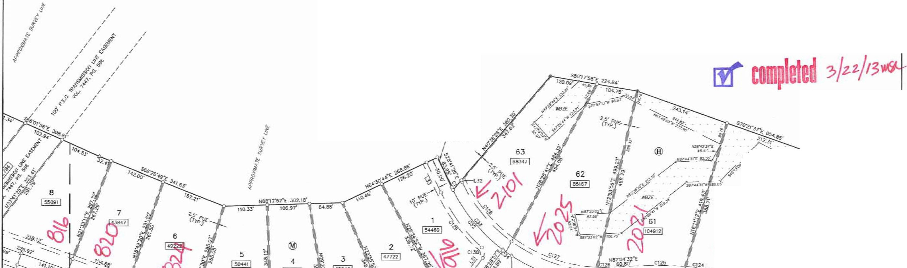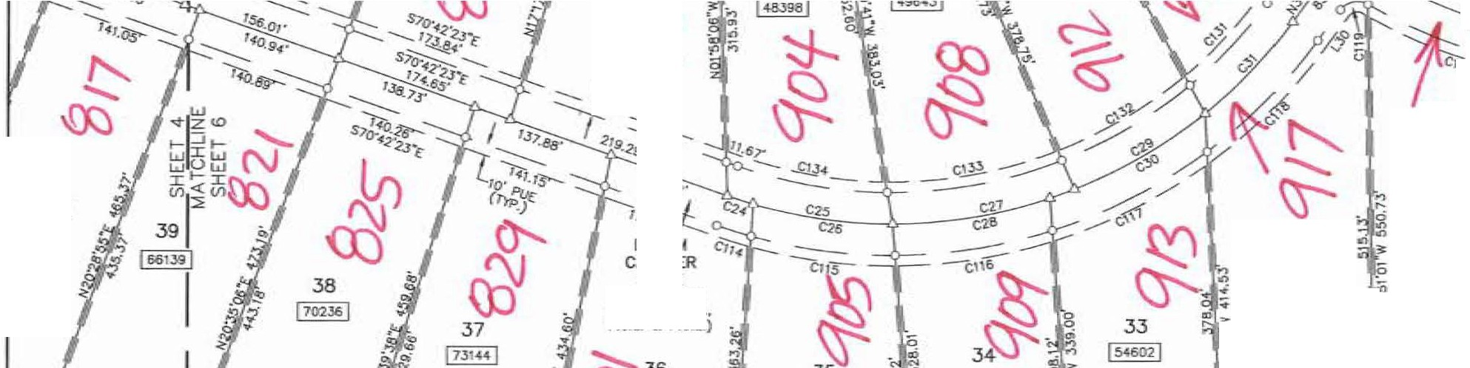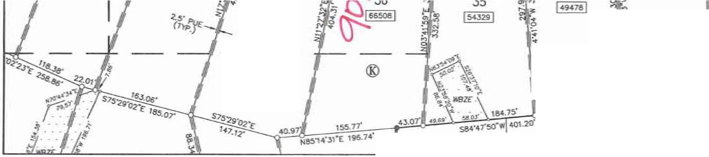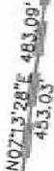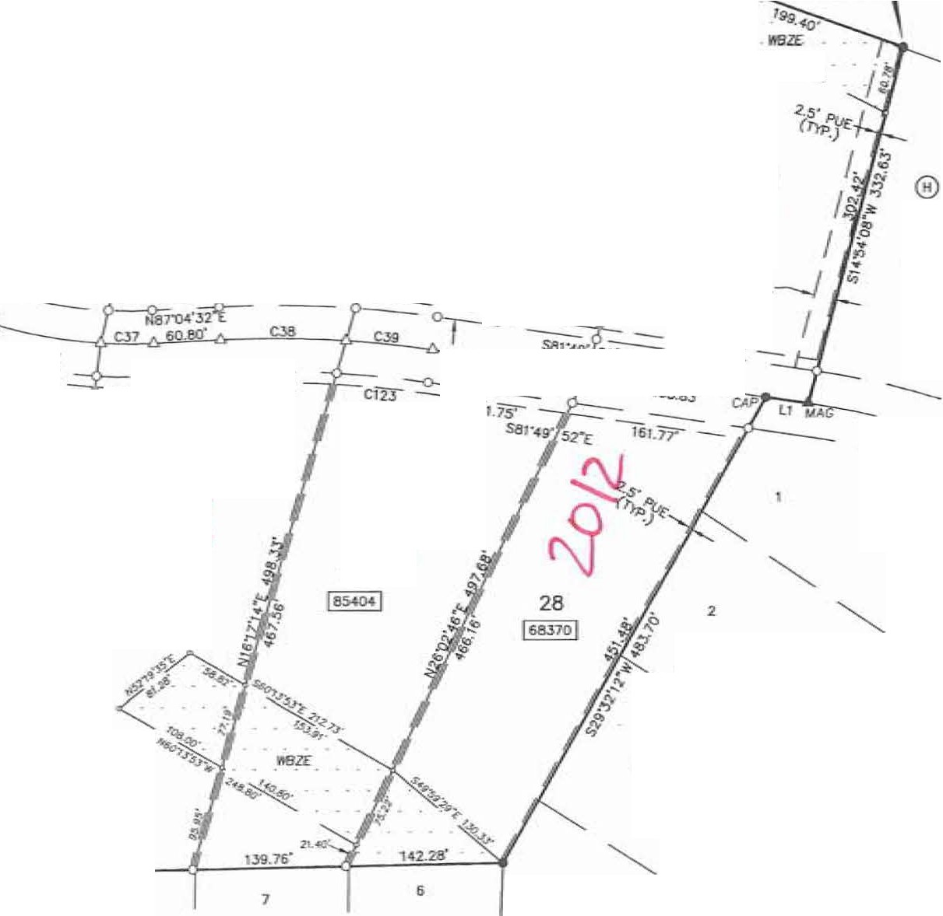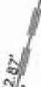

11&.82'

10

11

12

142.os' \.!,&91!"

® 9

CRAJID MESA Ar

CRYSTAL l'AI..I..S N S£CTICW 6

**DOC.** 200800122

144.42'

S88"46'57"W 82.6.36'

8

-4

SHEET 6 **OF** 8

SURVEYING, LLC

*1805 OUIDA DR*

'--.._ *ALJSrlN, TEXAS 78728*

*PHOM£- (512) 267-743()*

*FAX: (512) 836-8385*

<Ut\'£ T"81£

**FINAL PLAT OF**

**GRAND MESA AT CRYSTAL FALLS 11, SECTION 7**

**AJJ.rt> *p 1***

NO.

-

Cl C2 CJ C4 C5 C6 C7

**0**

*(*

**CS,**

C9 C10

Ctl C12 C13 C14 C15

Cl6 Cl7 **CIB** C19

DELTA

1'00"46'"

94•-4o•11·

12T45'3S"

95"08'00"

6°03'31"

,6"0J'll•

6°03'31"

5119'04-"

IB.J'29':J1•

51"19'04"

so-51•22·

**90"00'o0"**

**90"00'00"**

16'3l'58"

21'50"38"

5"31'40"

9'57".34"

13'28"23" IT35'30"

**RADalS**

430.oo"

206.IO'

134..88' **Z<M.42" 600.oo"**

570.00'

**6JQ.OO'**

20.00·

110.nn-

ffl.00"

**20.00·**

20.00·

20.00'

**440.oo"**

**4-40.00'**

690.00"

690.00'

690.00'

690.00'

ARC 7.60'

J.40.90'

300.75•

.339.42'

63.45'

60.27

66.6:2'

17.91'

192.15'

17.91"

2&22'

31.42'

31.42'

126.96'

167-75'

66.57'

119.94"

162.25"

151.64'

CHCIIID BO.RING

S25o1"50"'E

S68":>4'otrw N89"32'55"E 1<5S57"41-..

N01"47'45'"E NOl"4T45"E N01"47"45"E N:l0'29"02"E

s.55"36'11"E

S78"18"36'"W

535"36"11'1'.

N31"01'52.,..

**SS!r.i8'08'w**

**S0!>"42'09"W**

S13"'29'09"E S2n0'1f'IT S29'23'15"E 536"40'20•

540"39'41"E

CHORO 7;50•

JOl-JS' 242.211' JOl.76" 63.42"

60.25'

66.59'

17.32'

119.94'

17.32'

25-94'

28.28'

2&28'

126-52'

166.74'

66.54'

119.79'

161.81!'

151.33'

TANGENT

3.BO'

224.01'

21s.or 223.61'

31.75'

30.16'

33.3<'

9.61'

1966.43'

9.61'

17.04'

20.00'

**20.00"**

63.93"

84.91'

33.Jl"

60.12"

**61..50'**

76.13"

00.

**C74** C75 C76 C77 C78 C79

C80

cs,

C32 C'8J C34 **C85 C86**

C87

csa

C89

coo

C91 C92

DELTA 41m'O-I"

3570"26"

40'07'54"

64"26'01·

5n9•04•

4815"18"

39'J2'08"

709•45•

23"58'08"

zs,s·oo·

11518'38"'

5--ss•01·

1·46'19•

13'5,4'()()'"

1412'09"

0"12'36"

5119"04"

69"JT09"

44"03'31•

**RJJllllS**

60.00'

60.00'

60.00'

60.00'

20.00'

290.00'

290..00'

**4,J0..00'**

**4Jo.00'**

**431U)(l'**

**1530.oo'**

630.oo'

**630.oo"**

630.oo"

630.00"

630.00'

20.00·

6D..OO'

**60.00'**

k'lC 42..99'

**42.03'**

=·

67.47'

17.Sl'

244--24"

200.11'

53,_75•

179.l!a"

189.50'

**179.34°**

65.79'

19.85'

152.84'

156.16'

2.31"

17.91'

72.91•

**45.14•**

CHORO SEARING s:Tl"03'12"E N70"50'03"E

Nl3'10'5J"E N19ll6'()L**"W**

S25"39'32'"E S24"0739-W S68"01"2Z"W 556--:!1"00-W **S40'47"09"W** SIIS'IO'JS"W S0Cl6'14'"E

$'l.S•45'0.,E

S19'36'43"E S2T29'53"E S41'32"5rE

s ·•S20"E **HZ3'12'06"W** S32--:!1"08"E

"'"'11'2!1'E

**CJlORll 42.08'**

35.25•

41.17"

153..97"

17.32'

237.0!t

196.16'

il72' 178.58'

187.1ff

178.74'

65.76'

19.85"

152.46"

155-77"

2.31'

17.32'

68.50"

45.01'

T

22.46"

19.02'

21.92'

37.81'

9.61"

129.89'

104.22'

26..91"

**91.28"**

96.3r

90.28'

32.9.3'

9.93"

76..RIT

**78.48"**

1.16'

9 1·

41.n·

24.28'

p,o.ff **3/i(/?,**

**comlee**

**M**

*3/4ih* "'

C20 C21 C22 C2J **C24** CZ5 C26 C27 C28 C29 C30 01 c:,.2 CJ3 C34- C35 C36 C37 C3!I C39

C40

C4I C42 C4J C44 C45 C46 C47 C4B C49 C50 CSI C52 C53 CS4

css

C5l5 C57 C58 CS!I C60 C61 C62 C63 C64 C65 C66 C67 **C68** 069 C70 C71 C72 C73

14'27'25"

12'."09'2•·

12'!i0'2T

11'35"26"

J"06"12" 19'27'1l8"

16'20'56"

21"23'30"

18'22"45"

lnd5Cf" 20--:!1"3,4"

14"37'12· V"49'36" *2T5TOJ"* S30"3B" 31'51"36'"

""'29'12·

""'4'37"

6'34'11"

4'3l'25" *nT46"'* ST38'3T 24"05'05"

24"49'02"

3'4◄'15•

16,ro1·

6'00"3T

?217'39"

1·.30•07•

22'28"55"

14'0S'52"

14"31"05"

6"08"01"

9'tl7'25"

38'52'07"

2411'57"

48'55"19"

12'09'44"

5"28'01·

5--:!3"44"

15'41'53"

13°32'59"

211"◄3"

917"47"

22'0d5'i"

15"20'13"

4'59'01·

•'55'4-6"

IS'Jg"O- 14-0?"4:/!"

1'31'23"

51'19'04"

:zs10·01·

75•4-0'43"

690.00'

690..00'

090..00'

**690.oo'**

475.00"

**475.00'**

475.00"

475.00'

**-HS.Oil"**

475.00'

475.00'

**475.00'**

430.00'

**4Jo.OO'**

**4.30.00'**

**4.30..00·**

**430.oo'**

**4Jo.OO'**

1000.00"

1000.00'

**-OD'**

**400.oo'**

◄**00.00·**

**400.oo'**

**,,,,,_oo·**

6,00.00'

**600.00'**

**•oa.oo·**

**600.00'**

**600.00'**

600..00"

**600.00'**

**""".00"** J,20.oo" 320.00"

320.00'

.,20.00'

320.00'

320.00'

320.00'

**320.00'**

320.oo'

320..00'

350.00"

"'" oo'

'""00'

350.00"

350.00'

350.oo'

**350.00'**

350.00'

**20.00·**

**60.00'**

**60.00'**

174.10'

146.40"

1 .64·

139.58"

Z5.7Y

161.26'

135.54'

177.34'

152.37"

1◄J.81·

158.79'

121.21·

208.84'

209.77'

26.35"

2.39.11'

221.29'

l.'1.11"

114.66'

78.95'

52.10'

367.52"

168.26'

173..26'

26.09'

170.52"

6'-'-94'

23.l.46'

15.73'

2354.3'

147.63'

152.03'

&4.23'

50.96'

217.06'

135.15"

273.23'

67.!>l'

Jo.SJ'

30.13'

87.67'

75.68"

12.2!6'

56.79"

134.48'

!>l.69'

J0.44'

30.11'

95.67'

85.l!O'

9-VT

17.91'

27.4-0'

7!1, s·

S50'38"13"E 533-02"14"" S6-41TOfl

S64'54'40"E

S7T15'29"E 580'25"5TE

581'59'03'1'.

N7!1'0!l"«"E NBIY.59"0TE N5!1"46'3'4"E N6116"5TF t;43·,r3-1-•.- 539'36'15"[ S40'40'-4A• S5516'21"E S70'35'04"E S71"46'16"E

=43•1o"E t[.!l!,38'23"" Na4"05'35°'11' 55612'05-W S33'36"39"W 540'25'09-W SI 5"57'36._ 505--:!5'13-W

504"35'26'"(

SI 5·4-4'1S"E

**so ...•«**

519'29"3TJC

531'29"08"£

*S2nT37'"E*

541·35•os"E S4-5"47'3TE **SIIJ"ll"-43"\I•** S66'2l'22"W S66"34'02"W S24'2r39"W 546'23"11-W

539 •19;,r

534'08'26...

523'35'38... S08'5B't2"W SIJ1'05'51"W SBSOB'32'W S67'29"13"W

-S46"0'42"W

S38"39'05"W S33"41'41-W

523'25'\IS"W SO!l"J2'« ·w 500·45•4,..

N25'39"3Z"£

**S31n4'04"W**

s12·41•19•r

17364"

146.13"

15•.32'

139.35"

25.72'

160.49'

135.08'

176.32'

151.72'

143.26'

157.90'

121Ul8'

206.79'

207.69'

26.34"

2.36.04'

2l8.86'

44.08"

114.60'

76.93'

52.06'

354.73"

167.02'

171.91'

26.09'

169-95'

62.91'

231-99"

15.73'

2.33.92•

147.26'

151.6.3'

64.20'

50.90'

212.94'

134.15"

2!65.01'

67.6/t

30.52'

30.12"

87.40'

75..50"

12.2!6"

56.73"

133.65"

93.41'

30.43• JD..10· '95 38'

**-58'**

9.JO'

17.32'

27.16"

73.61'

57_52•

73..48'

77.64"

70..113'

12.87"

81.4-2'

6&23"

69.72"

76.85'

72.46'

85.29'

60.!>l'

106.52'

107.0l"

13.18'

122.73'

ltl..16" 24.08'

57.39"

39..50'

26.09"

197.88'

85.39'

88.01'

13.05'

85.84'

31.50•

118.23'

*7.&:*

119.25'

**7 .19,**

76.4$

32.15"

25-53"

112.91"

68.6o'

145.57'

34.09'

1 211'

15.08"

**«.11'**

38.02'

6.U'

28.46'

68.0EI'

47.13'

15.23'

15.07'

41!.a'

43.11"

4.65'

9.61'

1. .94-'

46.61'

C!IJ C94 C95 C96 C97 CSB C99 C100 C!Ol CI02 C,03 C104 C105 C106 CIOJ CI06 CI09

CllO

cm

Cl12

CllJ CIH

Cll5 C1l6 C117 C118 C119 C120 Cl21 C122

=

C124 Cl25 Cl26 C127 C,28 C129 Cl.JO C,31

C132 C,33 C1J4 C135 C136 C137

CllB C139 C140 Cl41 Cl42 C,43 Cl44 C145 C14-6

J313"t0'" 3811"00"

**44'50"56"**

5T42'23"

5119'04"

6'23'10'"

22."50'49•

0'53'0<5"

2T17'39"

**r,4•50• 54,ia'o.3"** 012•4-5•

16"57'00"

2112'5Cf"

1"39'44'

86'1Xl'10"

8614'55"

9-s5'33•

13'56'32"

111:ll'll" 11" 9"19"

3'51'22"

15-Sl'SS"

1ns0♦• 18"47'11" ITOJ'OT B4'01"15• 26'46'25"

6'39'16"

61o'19"

4-SS'lT

4'09"10"

6'56'26"

5·41"53"

33°05'33"

211"26'36"

21'50'51"

84'01'15•

>S54'58"

18'11'21"

21'53'25"

18"43'55.

ll-'23'16" 12--:!4'37"

12"45'.J,2."'

**!,4**◄**'30•**

21•33'19'"

16"44'17"

24°03'26"

70-42'4-5"

25°54'44"

101-so•51·

42-s3'7T

5214'33"

S0.00"

**60\00"**

6!0,00"

6!0.00"

20.00"

5'10.00'

570.00"

570.oo"

570.00"

370.00"

370.oo'

470.00'

470.00'

470.00'

720.00'

20.00"

20.00"

**720.00"**

720.oo'

720.00"

720.00"

505.00"

505.00"

505.00" SOtS.00' 505.00'

20.00'

4-60.00'

-460.00'

970.00'

970.00'

1030JX1

1030.00"

400.oo'

**400.00"**

**400.00"**

460.00'

20.00'

445.00'

445.00'

◄-•5.00'

4-45.00'

660.00'

660.00'

660..00'

660..00'

410.00'

410.00'

206..10'

206.10'

134..1!8'

134..Ba'

204-.42'

204_42'

34.7'.l'

39.99"

46.9T

55.19'

17.91"

53.53•

227.'19'

8..80"

221.79'

1451"

349.58'

1.75'

139.04'

17◄.02·

20.89'

30.02'

:l0.11· 124-73"

175.20"

163.61'

146..56'

:ll.99"

13!U!4'

152.05'

165.58'

150.29'

29.JJ"

2l.C.95"

53.42"

104.49"

833.2"

74.65"

124.7T

39.78"

2.31.03"

198.57'

175.40'

29..33"

108.06'

141.27"

170.02'

1<6.13'

131.18"

142.95"

1-46.97"

112.22'

15<_84"

119.78"

66.54'

254.36'

**61.00"**

239.75"

153..03"

186.39"

N5210"l1"E N16'2B"Or£ H25"02'51"W **N73'49'30"W** 574·31"10-E

545"40'03"£

531'03'0.:S"E S1911'06"[ &lT35'44"E 50-4·40'30"ll• S32'51' Sll'Sl"-<5-W SG516'52-W

SIS48"03"£ S2514"20T M6"55'53"E **N76'56'34"W**

SJ8',e6"53"[

S5CT<r,2'56"£ S6411'4T£ 5154·-47" £ S72'38'04"£ S82--:!9'43'"E

'-l!O'S6"

N'62"55"40"t

N45'll0'.l,1"E

S78"29"35 ..... S72'53'00"E 589"35"51"£ N8!1'50'19-W N841T3!"W N83-S4'27"'lr

Nll9--:!Tl5"W Nll9'SS'28'E

s10·-w·49"£

539'54-"44"£ "'"'"36"52"'£ N05"31"40"W P«3'26'26"E

N59--:!9"36"£ N79'31'59"E S80"06"51"'E S65°00'45'"E 533ll6'49"E S40"31"44"E S29'16"43"£ S13"35"19"E SOS'.35'59-W H76'04"31"W

5515·32•2.:s·w H38'37",30"E S77'29"+3"E

.N27'SO':l.5'W N75'24'25°W

3•.30" "9.25'

45.78' S.l2T 17.32'

63,50'

225.79"

**8..80'**

220.39'

1451'

336.73'

1.75'

13!1.5.>

173.03"

20.89"

27.2ft 27.34'

124.58'

174.77'

163.26'

148.,30'

33.SB'

139.39'

**151.4W'**

164..84°

149.74"

26.7-r

213.oo"

53.39•

104.44'

83.29"

7♦.64°

124.69'

39.76'

227.83"

196.54'

174,34'

26.7T

107..112'

14-0.68'

168.98"

145.48' IJQ.96" 142.68"

1-46.67"

112.08'

153,92'

119.35"

85.90'

238..52"

ro.48' 209.41'

**149.48'**

**180..00'**

17.90'

2D..77'

24.76'

29.7''

9.61°

3UIO"

115.IT

**4.40'**

112.32'

7.26"

189.0T

0•.87

70.03" B!l.02' 10.44'

18.6S'

18.73'

62.52'

**8.04'**

B2.16"

74.54'

17.oo"

70.37"

76.60'

83.54"

75.71'

1e.01·

109.4-B"

2!6.74"

52.29"

41.69'

37_3,;

62.-46'

19.91'

118.84"

101.38"

88.76'

tB.Ot'

54.31'

71.23'

**86..00**

73-73"

**65.BI'**

71.76'

73.79"

56.24"

1a.35•

60.3'.t

4.3.92'

146.23'

31..03'

166.11'

80.30'

100.24•

IU!30!

LI

l2

Ll

*'u*

LS

l6 L7 L8 l.!I

LlO Ul LIZ L13

Ll4 LIS

ll6

L17 LIB U9 1.20

l21 l22 1.23

l24 l25 L26

l27 L28 L29 L30

Lll LJ2 t.JJ

iR,E TABI.E DRECl\ON N81'49'52-W SB7'47'2'6""' 589118"05"W NIB'-49'29"W

"10'31'11"\Y N28"26'35"W N43'29'33-W **N34'35"35"W** "''1'15'02"'\Y N49'01'57"E N11'28"0TE N04-"39'01"E

N59"38"38"W

S24'24'2B'"E

S24'24'2B"'E

N37'-41'25"E IOT41'25"E NlT41'25",E H.3T41"2S',E SB7'4T2.6"W SOO'IIO"oo"E SOO'IIO"OO"'E "'"'4-r26'"W

ssnr26'"w

**SOO"OO'oo"E** SOS3S05"W SOS33"05"W

S24'24'28'"E

S24'24'2B"'E

1'136--:!8'57"£

N36--:!8'5-r£

N2'5"41'2!6"W S2S-41'26"E

DCSTA.'la' J.!!,86' J0.2.3' 42.06'

46.49'

32.56'

27.29'

53.76'

35.2.3'

38.6.3'

34 29•

**58..J,4"**

58..56"

1:uJ'

**30.00"**

**30.00"**

31.62'

3i.62'

J0.05'

30.05'

**44.66'**

24.65'

37.45'

'6.74'

13.69'

2328'

**44.27**

52.15"

VVVT

**30.oo"**

36.M

36.50"

5.52'

**84.09'**

SURVEYING, LLC

&

*1805 OUIDA* O,'?

*AI.ISTTM TEXAS 78728*

*PHON£· (512) 267-7430*

SHEET 7 OF 8 *FAX: (512) 835-8385*

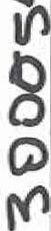

PLAT HO!ES

I. llilS SUB01>1S!ON IS 'IIHOU.Y CXNTAIMED **llllltN** llE CURRENT OO!l!'ORAl! lMiS *OF* lHE OlY *OF* l.£NEER, TEXAS.

1. OllffSlRUCIION *OF* IWPRO\O,IENlS .,-_ THIS SUB!ll'ilSIO!l SHAl.l. NOT <XIWIIEl'lct: UNlI. /II.I. N'PUCAllOH PERMITS MIO/OR CXlNSTRUCllClf Pl.AMS HAVL BED< APPl!O'ofi> BY 1HE alY OF L£Mtl£R. TEXAS. All. **Pl8JC** M"l!O\=TS 5'fAU. C0,..,.7)RM TO THE QJRRO.'T ZOIING ORlllNAIICE Of Tl£ OIY **OF** LEANDER. TEXAS.
2. t,'O LOT **ff** THIS SUBOMSICIN SHAU. BE OOCI.J!'IED lllHL 00...'tECIED TO THE W.,.TER lllsmBUllON SYSrEII *OF* Tl£ CllY OF LEANOCI!. TEXAS.

- PlAT All£ RECCl!IJED IN 1l!E OFf1CIAL PU1UC REOORDS ***OF*** RAYIS COUNlY. 1EXAS UHIJER OOaJMDfT

1. *1H* al!lER TO PROMOTE O'WH.MlE AWAY FROM A STJ!UCTURE. lHE IIIN:IIIAI fOUNDAnotJ £l£1/A110N SHOOll> BE BIA.T AT I.DST CINE rnoT AB<M: IHE HIGHEST CROUND El£V"OON 'IITTHN All( (5)FEET *OF* Tl£ 51>9 PlRIWET[R. ANO 1l£ CROOII0 AOJM:DIT TO 1HE SU,8 5HOUU) BE S\.OPED A-.AY FROM lHE SiJIUCTURE AT " SI.a>£ **OF** 1/T PER FOOT fal A INSTANCE *OF* AT LEAST :rElf (10) FEET.
2. . WATER IIU. !lE PRmtllEll BY lHE OIY ***OF*** I..EJJUR.
3. ERlY OIMEIS SHAU. PROYOE FOR ACCESS TO llRAINACE EASEWENlS AS MAY BE NECESSARY AHO SHALL h'Ot PIIOHlillT ADCESS BY tHi:

alY OF l£ANOER.

& Al.I. EASOIOHS ON PRIVATE PROPERTY SHAU EE WJKTAINED BY THE l'RO!'£RTY 0-/iNUl OR KS OR HER ASSICNS.

1. AlL SIJBON90N CONSlRVCllON SHAU. CONFORM TO TH£ CITY *OF* LEANIJER COOE *OF* ORDIHANCE:5. CONSIJ1UCOOH STAN!IARDS, ANO aNERAIJ..Y

ACCO'lED ENCtllURl!C PRACTICES..

1. NO EM1.D1NGS. f£NCES, LA.'ESCAPING OR omER S1ll1JCTtlRIES /\R£ Pflil.UiED YtllilN DRAINAGE EA5EMENTS SHOIIII, EXCO'T AS AP!'RO..ul SY THE QlY OF LEAND:R PUBUC YltJRKS DEPARlUEHT.
2. WASTE:tlATER · WATER sYSTEMS SHAl.l. ClllNFc.iW 10 TCEO (lEXAS (l(M_IIJSSlON OH EHW\ONWBH"'- CUN.ITV) **AND** STATE BOARD ***OF*** INSURANCE REOURO!ENIS. II£ C1IM-l£R UNIE!SJANDS ANO lli,\l Pl.AT VACATIOII OR RE-Pl.ATQIG MAY BE RECIURED, AT Tl£ O'IINEl!'S SOlE EXP£HSE. **F** PLANS TO MS 9J£flf"1SlON 00 NOT OOMF\.Y 'liltti SUOi CXlDES AND REOOl!lEMENTS.
3. OEV!l.Of'ER SHAU EE RESPOHSllll.E FOR *M.L* RELOCAUOH AN!l MOINflCAl,0NS TO EXISTIHG UllUTIES.
4. !HE O"IINER *OF* llflS SUllOMSIOlt. NID MS al 1£11 9roCESS0RS A>O ASSIGNS. ASSUllES RESPONSIBUTY FOR f'lAAS FOR CXlNSlRVCllON *OF* SIJ30111190N IWPIIO',£M£NTS **'i'HOt** COMPLY WiTH APl'UCASl.E <XlOES AN1l REQUREMD<TS Of THE *art OF* t.0..'41Y.R. **THE OlltEI** IJNDERST.AHDS AND ACKNO'M£DGES THAI PLJ.T VACA**TlON OR** REF1..ATTIHG MAY 8£ RECMRED. **AT** 1HE 0-MER'S SCI£ EXPENSE.F PlN«S TO CONSTRVCr lHIS

**SISOMSION DO** NOT **COMPLY 'MTlf** SUOH CODES *Nm* ilEOUIREMrnTS-

1. flSCAL SURETY FOR SU30MSICtf COliSTlWCTlOlt. IN FOR» AOa?T..a.E TO 1HE 0lY OF u:AHD£R.. SHM.L BE l'RO\UD PRHR TO Pl.AT

APPftO'l'Al BY 11£ ftAN, lG *MD lONll,lG* **COIIMISSICN.**

IS. **COl,IIAJH!lY** -ACT fEES fOR **N)MIXJ,t,l.** *WTS* TO 11E PAil Pl!IOR TO ISSUANQ: ***OF*** /WY **llllll.lllNG** PERt.lTS

6. sm: *DE\n.OPll£HT* CONSlRl.l..'"TIClf P1.NtS SH.Ill BE Rf:w:v,a) ANO APPRO-.ol ·BY THE aTY Of LEANDER l'RIOi1 TO A.'fY CONSTRUCTION.

1. tEWPCIRARY N;o F'ERMNIEHI EASEMENTS TO 8E PROWJED AS REWIRED fOi! OIT-SHE WA= WASJOIIAtER M1l OR,QIAGE JMPa«Y,Ol[NTS.
2. FNSHED SUffS 'WHIOt ARE GREATEli THAii t:'>% CANNOT USE SURFACE IIIRlGAnctf SYSTIMS.
3. TWENTY-fl\€ fOOT 0SSf SElBl,QCS AR£ RE0UREl> FROM *M.L* MAJHACE WAYS
4. TIOflY-Fl' FOOT OSSF SET!!ACl<S A.'!E REQUlllfD FROM ALL flNl&fBI SLOPES v.ttlOf ARE C'IEATER THAN .-
5. /II.I. AWATE STI!EETS 9!0' HEREO< ANO ANY SEQJRllY CA1!S OR OEV!CES CONT'!QJJ<G M:a:SS TO lHE SAIJE PRl'VATE STREEiS SHAU. EE

IJEDICA.TIOOf STAIDlEHT:

IHAT LOOKWT OE\8..0PMENT GRCU', LP .• ,\ TEX,l,S UMITED PAR'TNEliSHP, -C lJ£ 0-.RS or 209.104 ACl<ES *OF* LN,l) SITUAlID IN lRAYIS COlllllY. TEXAS WT OF lH£ C. lBAASO SUR\'EY 422. lHE S.S. EV.-;."5 SU 5()1, THE TEXAS WDOCO R.R. CO.. SURVEY 2B5. TlE WC!ONHEY *.!t* WU1AIIS SURVEY 175, A.'<D THE P.A. QOSSOM Slfi\€Y, !IONG A POR110II *OF* A

219.70 *N::11£.* lRACT OF I.AHO CON\'EY!D TO l.OCf<OUT llE'\IEI.G'WENT GROJP. LR. SY DEB) Cf ll(COR!I IN DOCIAIDIT MUMEER 2!31206◄164, *OF* l'HE 0FAaJ.L l'UBUC RE<Xllll!S OF TRAVIS COUNTY. lEXAS, 00 t-:Ell£BY P\.U SAID 209..104 ACRES *OF* I.J.ND IN AlXXJR!)J,NCE WITH N'PUCl&.E Oi!OOWICES *OF* T1£ OlY OF lU'«lER. TEXAS NfO TRA111S, COUN'tl'. lEXAS, lHE HEl!EJN OESCiU&D Pl.Ai TO BE lCNOv.tl AS "GRANO lol£SA AT C'lYSTAL fMJ.S n, SECTIQf

*r.*

AND DO HO!EBY DEDICATE AU. M>OITIONAl.. RO'N. StR££TS. ALlEYS, EASEMENTS, PAAICS, I.NO OTHER OPEN SPACES TO PIIBUC US£, **OR, 'Ma** r-£ SUBOl"1DER HAS MAil£ PRO'lt90N FOR PERl"ET\/AL W....._TENAHCE THEllECF. TO tHE L'fiA.BITANlS *OF* lHE SUIIOMSll»f AS SHOWN

'-''- u*L*

HERE°"- SUMCT TO AAY EASEMENTS l'HO/fR RESTRICIIO!f:5 .H:11£TOf'ORE GlAHTID AND NOT

=

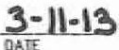- It HIIO<l.EY, f'RE5IDEH'J

UXl!out -- l,C,

PNrna LDCl<OUT OE\QJFlj()ff G!tl.f', LP. **'1tilAW R.** . IHRA111"-l.lUollAGcR **WIJiNNGSlllE UN!l** AHO CATIU: CO., LLC.

G8£RAL PARTNER l<Ff-llEii! HO.DIKGS LP.

2J70 acuLVl<!D, SllrE

HOUSTCtf, TEXAS 770".15

ST.ATE **OF** TEXAS;

OOlmTY *OF* TRA"1S:

BEF<:IIE ME. THE UhDERSIQIED AlflHORITY, **ON** l1ilS DAY PEIISONAU.Y A"PEARED I\IUJAM R. Hetaa.EY, IQ,'OY,fl IO .WE TO IE 1J£ PEJISO!I V11iOSE NAME IS SU3SCREED TO THE fOOEGaNG INSTI1UMDff ANO ACK><O!f,L[DGED TO IE: lHAf HE OEQJTED SAi.iE FOR IH£ PIJRPOSE ,ro COHSIDu!ATlCN lHERI»i EXPRESSED. IN 1llZ CAPAQIY lHEROf STATEO.

GMH UNllEJI *Wf* HANO **Aia>** SEAL Of OFFICE. THIS THE ll._ DAY or *'ZD* A.O.

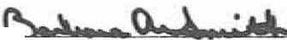

PRiI'NAME

FINAL PLAT OF

GRAND MESA AT CRYSTAL FALLS II, SECTION 7

SJAlE ***OF*** TDCAS:

COU>llY **Of** Tli4\IS:

h

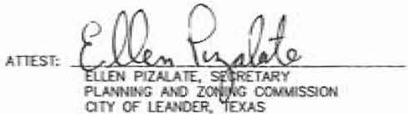N'Pl!Q.\IED **TltlS** Tl-£ _\L'i...1¥- **DAY *OF*** N\g,rt, 20 \3 A.O. AT PUBUC MEElNG OF lHE l'tA'INl!IC ANO ZOh1NG COWMISSKlH OF Tl£ OlY *OF* l..£AHOEli. TEXAS AND AlffiltRlZED TO BE FLED Fill! RECCR> BY THE **COON1Y** CWU< Of 1 0," i':> COUliTY, TEXAS.

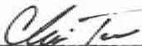

CHRIS 1CVAR. CHAIR

PUN AAD ZONINC ClCMWISSlON aTY **OF** L£ANJJER. TEXAS

ST.ATE ***OF*** TEXAS:

COIMIY OF tRA'<IS:

NO SJRUC IN SUBIN'ilSIOI SHAU BE IIIXU'll'D UH11t. CONNECJDl TO ... **PU3UC** SD\Eli SYS'T!M OR A PRIVAIE OH-SITE 'IIASlDIIATcR (SEPllC) SYSTEM lHAT HAS l3EDi APPRD..m ANO lJCDlSEll Hi! OP£11AIION *8Y* Tl£ 1RA"1S COl.HTY ON-SITE WASTEW,\TER PROGRAW..

!fO CQ;STRUCllON MAY BEGIN Qf ANY LOT IN TltlS SUBIN'ilSlON I/NTL PLJ.HS fOR THE l'RIYATE OH-Sffi: SEWAGE

DISPOSAL SYSTEM ARE N'f'RO\m BY THE TRA"1S **CCUflY** O1-SITE WAStEWATEli **!'llOCRAM.**

oc,.acFWOl'l ON EAOI LOT IN 1HJS **SlJBOMSION,** SHAU eE IN cat?UANCE "MIH THE MINU.IUW REWREWOflS *CE*

l}!E TIM **JO *OF*** Tl£ TDCAS AOMIHISTRA TI\IE DCllE QU.PlER 265 **MO** lliA\IS **cruftY** COO£ Q!AP1D! 48 THAT

- IN EFFECT ...r THE llME Of OOHSTRIJCTKIN.

1l£SE RESmlCT'iGNS *AH£.* **ENFCfiCEA8l£** BY tHE TRA"'5 COUNlY ON-sm: WASTE1r"lER Pl!OQ!AW.

AU t01S IN D-IS **Sl.JBIIMSlON** ARE RESJRlC1ED TD ONE S-.Q.E f".wt.Y O'IEUJHC ANO ,l'l'URT[NA.'fT SlRUCTUfil:S

PERAOlE.

NO SIRIJC INTH SUBDMSlCfl SHALi. BE OCWPIED tl!ffil CONNECTED TO **A** POT..a.E WATeJI SIMi'PlY FROM

*I'll* APl'RD..m WATEli SYSTOI OR A PRIVATE WEU.

NO WATER v.£1.1. **N** lHIS SUBDl"1SIOH **WA'I'** BE LOCATED l'IITlffl 150 FEET OF **Tl£** SIJIDMSION IIOUNl>AR'I' 'IIIITHOUT

lHE CQlf.SENT CF THE **AD.Ol,1NG** I.AHO 01!NER(S).

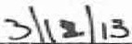*I\.* Kol>u.C, .:S.U,t.A-

OW<ED *"'llJ* IIAIHTAINED BY 1HE EST"8USHED HOMEOi,,,,vrs ASSOCIATIOlf *CE* IHlS -

1. LOTS 42. 511. llLOO< ,C- ANO WT 9, !llOCK "M" All£ PARI< LOTS AND WT lil, lll.OCI< Y IS AN HO" lOT Alll SHALL BE **OMIED** ANO

MAlNTAIHED BY THE EST"'8l.lSHED ttO!lfOll';ER's ASSOCV.IIOPI Of lHIS SIU8lll\!SiOH.

2.l. ,A 10 FOOT l'UE ADJACDlT TO All PfllV,\TE liOADW"'YS mD All. RlGHT-Of-V.'AYS AND ,\ 2.5 fOOT PUE AlCNG M.L SlllE LOT LINES JS HEREBY

DEDICATED.

24. Ail. **lllJlm«:** SEJBAQ( NOT SIIO'l,N HEREON Sli1U BE IN ACCO!!llANOE 'MTH 1'iE al'/ *OF* 1..£AHOE1i'S CUl!ifNT ZCN NG OR!lt<ANCE..

i,OJARY PIS.JC IN AHO FIR TIE CXlUHTY OF **'1'""'85,**

MY COMWJSSIION Ell1'lilf5 **\1,-\ •2011.**

TEXAS.

**ft,J** STACEY SCHEffn. **D.** R., **PROCR.i.>I** IWIAGE!f, ON-SITE WASTEV.TEii, TRAVIS COUNTY TNR

SlAtE *OF* TElCAS:

COUNTY Of Il!A\\S:

DATE

2S. IHE FOUO""'ll& VARIANCES **'flEliE** GRNITED PER A OE',a..oPUENT AGREEWENT 'MTli 1l€: OIY CF LEANDER A.. >J'PROVAL Of lHE CRYSTAL ,>US I CONCEPT Pl.AH ON .WAY I. 200J.

A. PRIVATE STRETIS \tlltli ROADSIDE

B, HO SlllE1l'AUCS.

C. NO srREET lJGlfTS.

26- t, SHALi. BEQH a; LOTS 20-2•, £LOCI< "I<" OR LOTS s+-56, 81.0Q( Y. PR1Clt TO ISSUANCE OF A flOOO Pl.AN llOUCJ>MENt P£JIMlT BY lHE OlY OF LE.AtroER R.000 PL>JN TRATCfi FOR EA.CH LOT SPEQflED.

27. lHE OE'wEUJPEII, **BUILllEli.** SEU.ER, OR MDIT SHALL INFORM, **a,** \tlllfTIHG, CAOi BU'°1*OF* SUilCI\ISl0H LOTS al f'RtFERlY LOCl,l!l) •THIN

R.000 HAZARD N1£.AS DiAT Sl>Oi P?.OPERIY IS IN AN IDD,ITlflED R.000 HAZARD AREA AHD lHAT ,\ Ft.000 PlAIH llE'IEl.CPMBff PERIIIT W1L

ST,\TE orTDCAS:

COUITTY Of TilA"1S:

I, PHUJP L 11'.dAUGHUN, AM AUTHORIZED UNDER lHE LAVIS Of lH£ STAIE *OF* 1EXAS TO P'IACTICE IHE PilOf!SSKlN OF I.ANO SURVEfflG. A.'l!l HEREBY sr...rr JHAT TKS PLAT OONRlllMS '11111H Al'P\JCA3lE Gill!NAHCES or lHE OlY OF LEAN0ER. TEXAS. lRA\IS CCUftY. TEXAS MID IliAT /II.I. ElOSllHG EASOEHlS *OF* REOORD AS f OIi THE PRO!'£RTY RlPORT

RECEl\'ED FRCU elllEPEl<D£NCE 1111£ COMPANY 00 .W.'l/ARY 111. 2013.,HA\o'EBEEN S>IOI\N **Cll**

KOlEll HEREOf. '. °'!,-¾

'\ *9 . rr)•:-*

't "i''"•·•.._':"'"

Tl!E WATERWAY BUfn:R ZCliE EASEWENT IS FOR Tl£ l'ROTECTIO!I *OF* tH£ ENW!ON.UENT BY IWf'liOW«l THE OU/olllY *OF* SroRlol'NAtEI! RUNCff' FROW OE\ofillPED LJ.NOS. THE lS4TlVE I.NIil OR w.HAGDlENT PRACTICES Yt1THIN ti£ EASEMENT Al1E TO HElP WANTAJN 12..EAN WAID! IN CR£ElC5. Rl',ERS AHO LAAES.. HO STRUCTURE OR IWPRO'.osrrs,. OTHER tH,_'f HA.Tl',£ PLANT ENHA.'ICOIENT Olt llAJNlD<ANCE **Of**

IHE Afl£A IN AilCORD.A!ICE 'MTii I..CRA RUt£S. IIAY BE Pl.AUD **OR** PERFORW£D WllHIH ll£ EASOIDfT 'MlJia1T SPECl'lC l'RICR AUTHIJRfZA110N A.','O APPROV IN ••RmNG FRCU 1lE LORA. I TS SUCCE5Sl(J;IS Oil ASSlCHS,. OR ono GO\IERtOIE!rl:AL DITTIY YtllH AUIHORllY 10 l'OlMJt SlKJI llolPROVEJJENT Hl!! THE PROTECllON *OF* JHE E!I\VlOIIME!ft. Tl£ EASEMBfi SHAll 8E MAlNTNNED 8'Y EAa-1 lOT - BY

iir

ING AND «ESRHfG NAJI',£ lo'EGEJAOOH. lHE EASEMENT MAY NOT BE AWENDED EXCO'T

OJ/,.,,.,,

BY ElCl'l£SS 'I\RITTEH A.CREE)l,0;, **OF** THE l.CRA. llS SUCCESSORS OR ASSIGNS,. OR Oll£R CO\o'E&,"l&ENTAL

*-r n:i. ,*

T PERWITS

BE REQIJREO BEFORE **,A** STRIICTIJP.E CNf BE PU.CED OM Tl!E PROPERTY. IHE 'IIRITTrn .:OTICE SHAU. BE fUD FOR REaJRO IN lHE OfrlOAI.

PUl!UC i!£OOROS OF TR,."'5 COUlfTY. A COPY OF THIS 'liRfTTDt NOTICE SttAlL BE !'ROWE) **'Mef** Aff'l!CATIONS All£ MADE R:R FLOO:> F'I..AJN

2B. - TO *N.rt* OIAK.'E.. ALTERATia«s. B'!lllGE CONSTRIICTION, F1U. OREDGING, GRADi.llG, QW;Nll IWl'RO'l9IOIT, OR STCRAGE **Of** IIATERIALS

OR MY 01HER Oi-'»CE **'llTHIW** TME 100 YEAR FLOOD l'UJ.li l.OCATED - THIS Pl.AT. *NI* APPIJCATIQ,I FOR FlOOlJ PUIH llE\IELDPME),IT

'9'ESSIDHAI. l»EJ S.JR'ot"roR•;o. 991'ti;

\.•. 5300 . ,,;_f1

••.::..ti.

PHU.JPL: •

*< 1,.,..1.•* r1-.. "' \

*:•* ,·,

·, ., -'cs,,i,#offl cJ

LOM:R ca.c . lll\EJ!

DATE

Pfllt,fl 'lillH A OESCll:PTIOM *OF* 1HE Pfl'O..ECT ,\IE EXIENT OF CHANGES. IF *mY,* TO IHE WAtER!XlURSE OR N"' llJRAt Dl!AJHACE AS A IIESIA.T Of Tl£ l'RCPOSED DEVEl.(P\IOfl MUST BE 9JBt.l1TTEll TO ANO Al'PRO\OI BY THE CITY OF I.DJi:>ER fUJOD PI.AIH AOMlNlSlRATOR. ALL SP£CIFICAllOHS AND DETAILS NECESSARY fOR ca.l'l£TE REw:W VI/ST BE PRO\tllED.

29. Pli!OR TO *AHY* ();ANNE!. ,t,l.JERA110N OR 8!!l>GE OONS'lRUCTION W«H V.U. OlANGE ElllSTIHG R.000 PATTEIINS OR El.E.VATIOtlS,. A l£T1ER OF

STATE or tEX."5:

CD.INlY or lR>,1/IS:

o. -"

*01-08-/.3*

STATE OF TEXAS:

COUNTY *OF* TRA\15:

w.P AWENOMDIT MUST IE SUEUTTED TO A.'ID APf'RO\'£O 8Y Tl£ fEDERAL ElolER(;OICY MAHAG!JAENT .M.£HCY.

I. SAWUEL D. KIGER. AM AIJlHCRfZED Ul,1lEli THE LAWS Of lHE. STATE CF TEXAS TO PRACDCE

I, 0RiA DEBEAJJIDR. CliRJf *OF* TRA111S. TEXAS. 00 HER[BY CERTlfY lHAT THE fOR£GOING INStRIJMDIT Of

:lCl. *HO* lllll\EWAY SHAlJ. BE CCffSr.llCTED Cl.OISER THAN 5()' Oil 60% OF PARCEL FRONTAGE. *VHOiE\£R* IS l£S5,. 10 11£ ROW OF AN IN1!1iSECIIOII LOCAL OR au.ECTOR STR£Et OR 100" OR 6ml; Of PA..'<CEJ.. flKlHTAGE. IS U:$. TO lHE RO'# Or *N<* INtERSECTION

THE !'llCffSSJOH **Of** DIGll<HlilliC, AND DO HEREBY STATE THAT lHS l'I..AT CONfORIOS \IIITH lHE

,IPl'UCABL[ ORtWfANCES Of T'1[ aTY OF LEAlftR, TEXAS rMT fHIS lRACT IS NOT LOCATED

r:J:':!7.

**'lllHIN** TliE EDllARDS l4JlffR REotARGE ZONE AND lHAT " PalTIOtl *OF* **n«S** SIJEIJl'IISIQY IS

Vl!lfTIHG, WlH ITS TE OAfUThOjllC,\llON **w**

*lJ*

f(fi

RECaID *WY* cmCE *OH* Tl£? , DAY

AR!ElilAL SlREET.

1. FRONT BuaDl>l!G LINES ARE IIEASU'rul fRO>I 1HE EDG£ *OF* THE SlREIT EASEM!HT.
2. GAA.AGES FACING "' SlOE S1REIT ON A CORNER LOT All£ l!E.cuaEI> TO 8c SET BACK *'ZD•.*

ll A PUBLIC SA1UY EASEMENT IS HEJIEBY GRANTtll FOR ALL l'fflVA TE STREETS. llRAINAGE PUilOl: UTUTY EASEMDf1S •TtflH 1HIS

SU!!MISIOk

1. AL Cl.AIISQI lltSPOSAL. INC. SHAU. BE Tl£ SOlE P!WW>ER *CE* -..STE HAUU.-.G fOil THIS SITE BDIH lltlRIIIC ....m AFTER OOHSTJIUC OOH.
2. ALL PRCFERIY HERflH IS Sll!I.ECJ TO 1HE U)'llfR OOLO!!ADO Rl'l£R AUTIIOl!ITYS HIQilANO l.AJ<£S WATEliSl£D ORIJIWiCE. Vl!ilTTEH HOTIFlCATION 1,HO/Of! PERWITS ARE REOUF!ED **l'1llOR** TO COWWENDIIC ,.,.., CC'lfl.CJ>WEJ.'T ACTMTIES. CONTACT LCRA DTERSHED llAHAGEMENT AT 1-l!00-77&-5272. EXIENSICH 232-t fCR Mm£ INFORMATION.
3. LOT ACCESS TO HIGH LOIESt'ME IS P?.OHBTEI> Fat LOT 8+. llt.OCI< *"I('* NID LOT 32. BLOCK "M". tor ACCESS 10 O!!EAW CATOiEli Oill\'E IS PROIIBltED fO! LOT 66, Bl.OCI< "K". LOT ACCESS TO I.Al.lQilNG DOG COURT IS PIIOHIEl'IED FOR LOT "6.. BLOCK -.
4. THE lic:.EC'UIER ASSOO.l\llON lm.JIV.S AR£. RECORDED IN tHE Of'f'ICIAl. PLf.11.JC REOORDS **Of** TRA\\S COUNTY. TEXAS Uh:>ER DOCUWDfi NUMBER

2012206635.

1. BUFTER ZCl4E - Sfl.'.U. ROIAIN fl!ff *CF* OOilSTRVCllCIII. OOfi.CJ>.MENl, OR OTHER AI.TERATlllNS EXOO'T FCR uruTY AJ,ll) RONYIIAY

'MlHIN Tl£ UWll'S *OF* 100 '!UR R.000 PLAIN Rl\'.COQOllD> BY 1HE FEDERAL EllERGOOCY i,ANAGEMENT ACENCY (FnlA) PER AJlOO INSIJRNICE RATE w.P (flRM) PNIEL NO. **4845.lC**

2 2008. OOfTAINED **'M lllAlER** oom:, E EASEME).'T **SHO'llel**

,;_··,· ..... i-:1...

*i*

SA..\IIVR D. IC)GER. P.E. ...... *r··* '•.........

STATE **Of** TEXAS NO. 119.35.3 *.: ,'* .•.;

P.O. BOX 1220 ; '· 'l

g:_= 786 6-122D ;,; *.irt:.:..*

.· ***,,?J***

.... • *,I'·* .. --

,I,.:;•.;. ..-1.,:f••

•**•-,..:.-···1.11-l)**

*OF :*

*AziktJ§*

*t/4f*

*_l!l* O"a.oocL1.1... ""'° EM.'I' RE= ON o,Y Of

E omaAL RECQRIJIS a' 9JD OOJN1Y A.

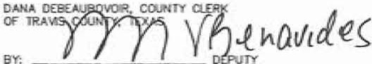

STA1E. -

*-*

201 -. 4T •

OOQJIIDH NUM

l:300

a.ocK. &uTH

'M MY H'-'ll *ND* SEAL *OF* OFllCE Of Tl£ COUNTY Q.E

*A*

RK 1lE y O*YY*f*O*'*f"'*

/. •. ..,.,_,..

*1:* ·k',...\\

i: . ,..

l '<i

..

GS.

1. AU. UTUtY UNES **'lill!-IH** 1ffE SU30MSION *ARE.* REOUR£D TO BE UN1lEl!QWLI@.
2. tliE lolAIN AND HERITAGE EASOIENT IS TO PR0\1llE REPRESE'Jffil'MS Of IHE HOME.O-l!NEli'S ASSOCJAIIO!l ACCESS FllOM KCH LONESOME TO Tl£ "a71'1BOY 8.'!IOCE" LOCATED IIIJTHIN LOT 71!, BLOCK- . TIW£MIIENANCE EASEMENT A.'«J -oo'MIOY BilIDGE" SlTE SHAU. BE ILAINTAINED AND PROTECTED BY lllE hOMEOWER's ASSOCU,.llON R. 0 POlffTUllY.•

*-I 3f'i(t?*

**om leted *,/)7-(i) M***

*B* or *8*

SURVEYING, UC

*18()5 OulDA DR*

*AUSTiN TEXAS 78728*

*PHONE- (512) 267-7430*

*FAX: (512) 836-8385*

L \11212-atMICI llllA. SECD1 Vf%J1Jlt4\Af..., 3,f't/tAJ. ,, a'ff C'Sl'

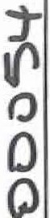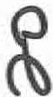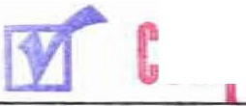

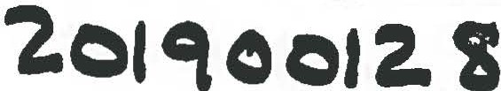**GRAND MESA AT CRYSTAL FALLS II, SECTION 7**

**LOTS 83 AND 84, BLOCK K AMENDED, LOTS 84A, 848, 84C REPLAT**

LEGEND:

•

0

.•.

®

!4J56o!

PUE PSE

HOA

1 /2" IRON ROD FOUND

1/2" IRON ROD WITH G&R CAP FOUND

= 1/2" IRON ROD WITH G&R CAP SET STEEL FENCE POST

CALCULATED POINT MAG NAIL FOUND BLOCK NAME

LOT AREA IN SQUARE FEET

PUBLIC UTILITY EASEMENT PUBLIC SAFETY EASEMENT

HOMEOWNER'S ASSOCIATION



s

1"=100'

DE DRAINAGE EASEMENT

**bF' c$1** i• **i**

.;.;.

; **iC**

PRTCT

PLAT RECORDS

TRAVIS COUNTY, TEXAS

0 - 50 100 200

BEARING **BASIS:** TEXAS CENlRAL ZONE,

400

RPRTCT = REAL PROPERTY RECORDS

TRAVIS COUNTY, TEXAS

STATE PLANE COORDINATES (NAO 8J)

OPRTCT

OFFICIAL PUBLIC RECORDS TRAVIS COUNTY, TEXAS

t- 60' ACCESS AND UTILITY EASEMENT I VOL 12902, PG. 1948, RPRTCT

I I I

I

S.S. *EVANS SURVEY 501*

12.346 *N;.*

PHILIP R. HAMILTON DOC. 2001060263, OPRTCT

*I'*

*Il I*

*I*

*I I*

*I*

*·! I*

*I*

*I I*

*II I*

*I*

2.60 AC. ROBERT L. ECKERT, JR.

DOC. 2001188 46, OPRTC/

*TEXAS M[XICO RAILROAD CO. SURVEY 20J*

lYPICAL EASEMENT DETAIL (SIDE LOT LINES)

N.T.S.

127.0JO AC. (TRACT 2)

DOUGLAS D. HOOD

VOL. 12189, PG. 1JJ9, RPRTCT

450.00 AC.

M. KUTSCHER LIFE ESTATE VOL 12592, PG. 1901, RPRTCT

LOT 83

LOTS BJ AND **84,** BLOCK K, GRAND MESA AT CRYSTAL FALLS II

SECTION 7, AMENDED

OOC. 201500089, OPRTCT

32

--- *·---1*

;/

*I* ---

*I*

*I*

*CANDELARIA YBARBO SURVEY 422, A-839*

REMAINDER OF 1013.55 /IC. (TRACT 1) LOOKOUT PARTNERS, L.P. DOC. 2000162836, OPRTCT

*I* 82

----

i *!;/* /

*- 1*

JO

*I*

*I* -- --

*I*

/_/1---

--- --- *I*

**SURVEYING, LLC**

*1805 OUIDA DR.*

*AUSTIN, TEXAS 78728*

*PHONE: (512) 267-7430*

*FAX: (512) 836-8385*

*FIRM NO. 10032000*

L:\18289-GRAND MESA 7 LOT **84** BLOCK K RE-PLAT\dwg\18289_GR-PLAT-LOT **84** K-REPLAT.dwg J/25/2019 7:14:05 AM CDT

SHEET 2 or 3

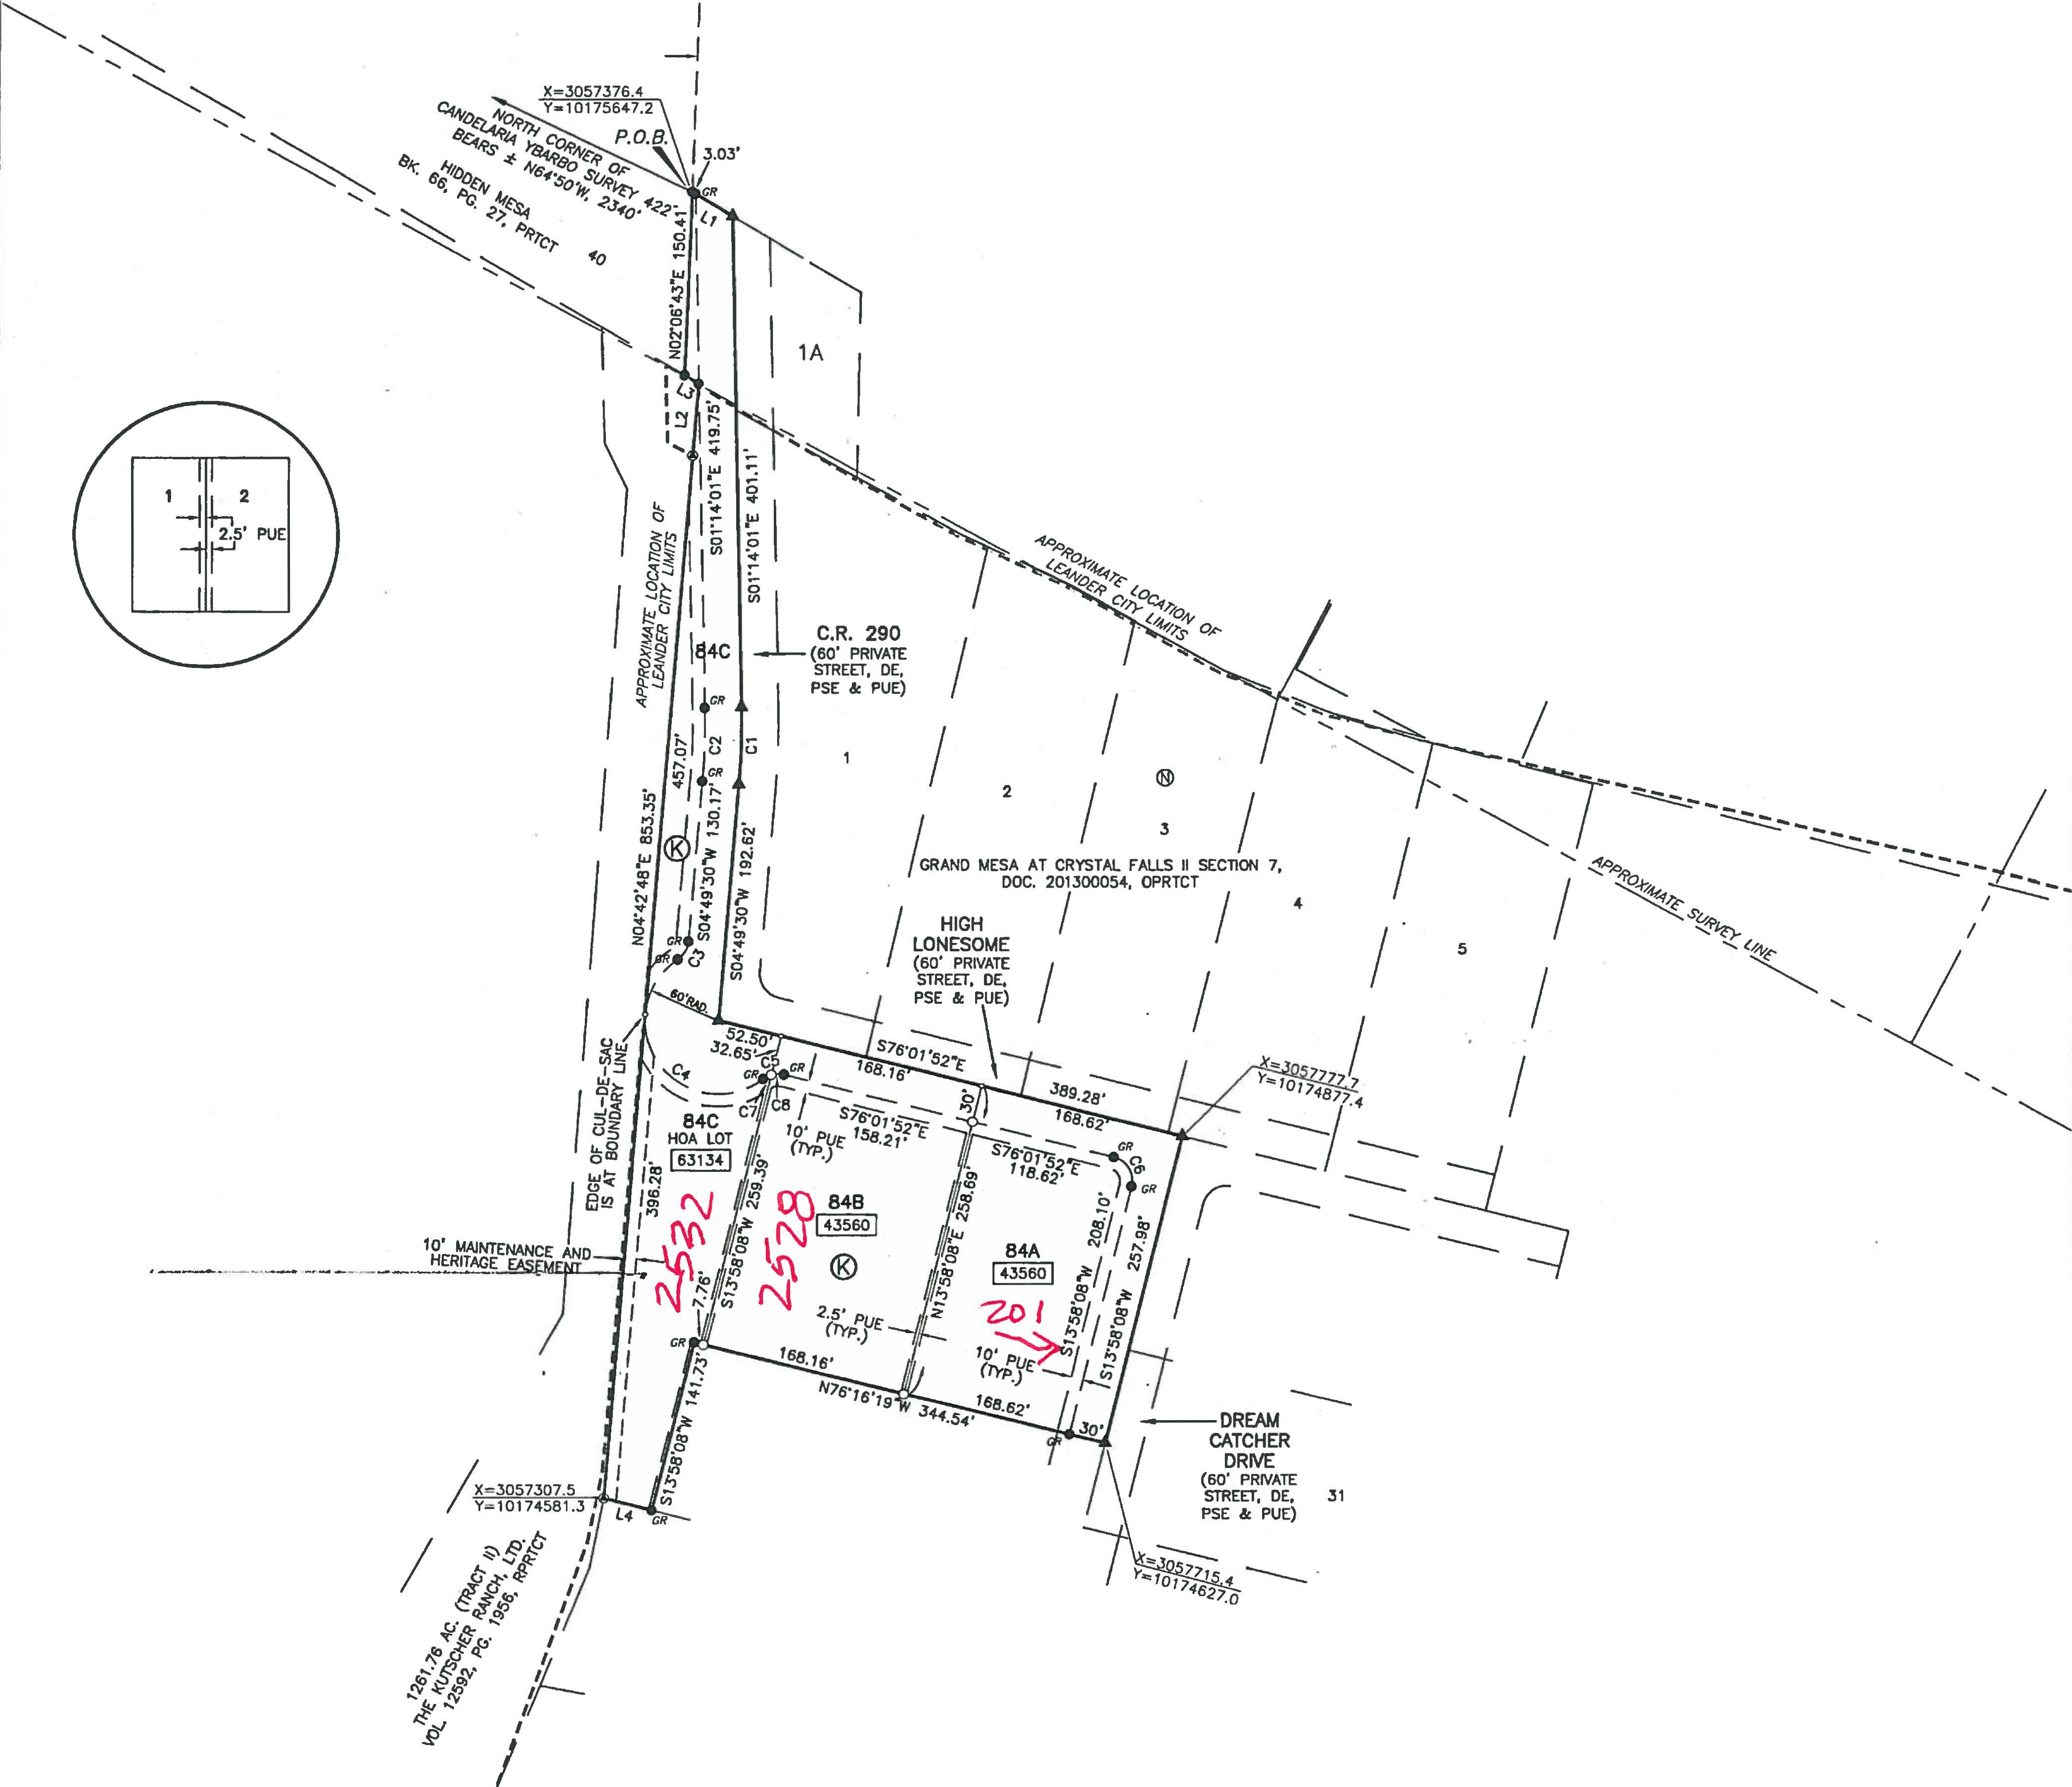

FINAL PLAT OF

GRAND MESA AT CRYSTAL FALLS II, SECTION 7

DESCRf' Of 209.104 AtRES Of lAhO SllUAtm IN lRAIAS COUHlY, r6As. OUT Of 1lf£ 0. 'raARBO SlJR',U 422. 1llE S.S. ANS SUR 501, lHE TEXAS MEXICO RJI, CO.

fE.000 I

= : :EJ:, w mr

= :\;J(t!c:' t':fd 't:-

TRACT

9R. f:i*::*=!t J:&1M7'ot1=l='R::!f., J:!t"y,ti!!: ',';thth!'t

o°'.':J :f' oM

oQrth-l c;,ornw of fO)d 21t.70 wt ttoct O'ld tht b'l:Kt;

*a::*

=ed :i- I •cu:;. em°!1t1 l1 : 1 ;i.i:w:-.. ·c!in . *:: .rt,thi:·.: •g.,.* :-:r1. lond

:;.::-1o lo'ld (Trcct 2) d k\ o 6t«I r;,f ,-4 to D. Hood ., Vol\ll'nf 12.109, P• 1339, Real Pn:,pwty T Counly, TPot, th• •tvhl (e)

I. '22'$7"£. o dllt.:m. of 169..86 fHt to 11 1/r ml rQ<S fwrld;

1. SO()'M' olist- of 151.27 fHl lo O 1/r hn PP' found;
2. S8t'O't2J"t;. o dlllla\C41 of 07.20 !NI to o 60d n(!I foiJl'ld h o tree; "- 2'll"E, o of eo.to fHt too irt"1 ,-_ post:
3. S8ti7'06"E. o dial of 180.00 ftel loo ,t..i pm:
4. $&$'20' "E, • dlttonct of 105.aJ 1"l to o tlt4l fwlot post;; 7, S73"30'02"£,.o 411lOIIQt of6Q.30 r.tt too .tffl r-.

ll. S75'3J'U"r. o dl!lton1;41 of 144.78 fMI tow, hill n,d -.Ith 04,;K cop •t for" moet norlllerly, norttieo,t • of lhl 219.70 CIC>'f ttwt Cl<ld tho hw-eln dNC:tib' d tra,;t;

lHENCE thu.,g -.Ith Ult northerly In• of th• :llt.70 oo:re '"'°"t. II t.-tlv, (12) I, SIJ"M'OS"W, O dldonct1 of MUO '"t to QII .. on r with 0-'R CXlp "t;

2. 571'01'52'£. o 4'11W1¢1 of l'UI, .. t to on Iron rod with '1til e,op fft;

J. $13W08"W. o cl!llonta or 480.00 f..t to a, R>4 wUh CAR ,;qi ..t.

1. 50710'1$$-r_ G dlttanc. of 21&.60 r..t to GIi hn rod -.Jlh Gift t,op Nt;
2. $2◄'26'52°£. G cllll<lllot of 1$46.68 1"t to en Iron rod with G.IA cop Ml;

S. ·u-r. O dlltcno. of JOI.M fMl to Q coltion .,.,, Mt;

7, SW43'I od.tanc.of120.191"tlomlrol)tod Gtftc:oput;

8,. Cl o&lmte of JM,.01 fMl to O cot\Ol'I tpbdlt Mt;

a. G dllllll'lot ofJO&OI fMttooMQfnlll Mt;

IG. c,dttcmeolJ.41.6JfMttoon.-onrod.tttiOafteapaet;

1. Qdif; ofJ01.1!ftitltoonhnrodwrutOIRcapNt; 12.Nt4°30'44 o •tone- of 248.&8 fM.l to on rod wflh Gtit cap ut;

m

TtE«:E ow- Ol'lcl QQ"gq the 219.70 IIQ'f troct., thl kfotm9 WO (2) p;

.....

1. S25"◄1'21i"E. o cn.t of 83.H fMt to on IRirl rod with OM e,op Nt ot tilt poilt of CVl'Wb.ltt of o cun. lo lh• 1,ft;
2. Along told c,.ir.,s to lhe left, m Olll l,riglh of 7.60, wilt! o rodkl• of 430.00 f11t. and o chord -.him bt<n S26'11'50"'£, o dlatmoe of 7.60 IHI to GI'! Iron rQd wllh O&R

t :E,:t:"&, onn: : *ti:*t'f:\oo:: t kuld oton htri:if Ill *com.,-* of tho 2111,70 OQ"d trod, GIid C<rnliwln9 for c, total dl1 of J00.3(1 fttt 1lSICE COl'lllnuhg with tho ll<lrth-1y 1\-\t of U.. 219,70 oge t,ocl, tho Moffl9 I.a (2) «aU11e.;

I. seoi/M"E, o ,;!qt of 224.84 fNt too tuwt aphilt .,.1,:

2. S70"21'37"E. o dsl of 654.85 fNt too tP 1fm rod fol.lntJ lor th• m t totl-1t, northecst of lht 2111.70 QQ'1I troQt ond the 11«.lrl de.c.-blMI ttoct;

nv«:E 111th th• tcnt.-iylk'lt of the 2111.70 oat the foi<mlll t (12) QCWMt:

1, S14 'oe"W, ci dlllton,a of 332..03 r.tt to ci l,l:09 nol foun4

=

*=-* :::::::*::::.:* = *:::*

2. N81'◄9'62"W. o dlatgnoe of 38.8& 1"1 to on ....,,, rod 111th i:,qp f<Mld;

J. 529'32'12"W. o cilitonoe of -483.70 ffft to Cl 1/1:'. ha,, rod fotwid;

*=::::i*

1. SOl'46'02")if, o dlttonc, of 384.4J fMt to a M09 ncd Mt

*1, SOT*◄*12* o dialCOQt of J0.2:) feet to Cl\ rqd '!l(lh fwrni.

a.

S00'47' 9£.odletQOct.of3'1,5Jf..ttoatp:'. ,,,rodfciund;

O.SW,8'05"W,adhilQnQtof42..04fHttooC11tton found;

t::g;eri:: :::

,!':'t.!0/1Wt!nort:

1. S'OOW67"W, o dlelortct of 2".78 fNI to on Iron rod wM <UrR ;qi "t fw tht 10Uthtotl-1y comer of the 219.70 o"" lrO¢l i:ind the h•elri d•tq-lbod troct;

n£HCE with th• tQUthwly lln• of tilt 219.70 ocn tr«t,. Int follO'n\11 - (7)

1, Nong o to the left, m, CR 1.-igth of 340.90 f"t, with a r(ldli;, of 20$.10 lttl. aod o chard llh!d-1 l>tanl 618'3+'06-W. ci dlelmiceo of JOl. fHItollll lfol\ rod -.Ith

2. QtfCltq,N:lc:rtlthtpol,rlofr.YWM ofO(;l,lfW\Olhori;lfll;

*viii* of ;,Q0.75 fffl. wftll II I of 13-U.8 Ifft. QM Cl d!onl 'lohldi b«n S&n2'66 Q llitlOl'lct. of a♦2,20 feet to Oil Iron rod

J. N10'02'42"W, o dbllll'IQI oftff.25 r..ttoon m rod with 06Rcq, 11tat thtpokil of ein,itur,ofo to lh,1,ri.

.:ftn •:, 1:,,;:,:J.t'::!.

4• of 339,◄2 ffft. irllh o rodtJ• of 204.◄2 '"'- Olld c, cflord which been H53''7'◄1"W,a dlalQnof of 301,76 ft.et to on tr rod

5. sn"57'12-W. a dblmi,a of 2◄1,HI f.. t to on Iran rod with Gift ,;op Mt; H1n1•orw. o dlttonoe of 19:9.07 feot to on Iran rod -.tth OfrR .. t;

e..

7, s11,rorw. o .ii.tonoe of 1aa.21 fNt to on n,n rod -.fth 04:ft et'fl Nti

lt£NCt ow ond-. the 219.70 ocr• lro;t. tht IM!I (111) OMW$:

I, N43'2t'... a dlotcnce C'/f 13'-.-W fHt to on lrwi rod '!!(th ONI t,op ••t.

2. »ant'tirW", a .ii.lm>ol of224.0t ffft toon hwlrod-.,llh C&R Mt;

= =====:::

J. H65'04'17"llf. a dlriatlCt of 7&.29 f•l to on Iron rod wllh cq> "t;

*m*

-4. Nl5110'13"W. o dbtlll'K't of 105.U net to on m rod wtth Mt;

a. N28"19'so"W. o ca.tcin¢tot1 6G r..-tto on hnroct-.Hh OM c:op "t;

.= :':.\:::f

LOCATION MAP

(NOT TO SCALE)

, --_]

8. HOe19'Jrw, odltlOl'IQfof82.17 ffft to onh>n.rocfMth o&Roop Ht.

t. Nla'◄i1'211"W.adl1Jt-of-41.4t r.. t toon hlrt ""wltii OMOQfl; Mt; 1G.N28",P'13-W. o dltlonot of 8).2◄fMl lo on Iron; rod .till GM: C<lp NI; 11.N10"J7'U-W. c, dtitonet: of 32.50 fNt to on Iron rocl with G.tlll cop Ht; 12.N28'2b'J5-W. a clllOr\Clt of 27.ti feet to on )"1;111 rocl with OM c,:ip -.t. ll.lUJ"WJJ-W. a dalcnc,t of f>J.70 Ifft to en m rocl wf\11 Gaff cop•'-

.-"°'

14-.HJ.f'M'JO... a dltlon of 35..23 fNt to on tun rocl ..W, <MiR CGP ..t.

15.t«r◄tJJ'"W.a dl!Jt"'" ol 2 119 r.tt to on *tw* .,,nti i;Aff cop Hq 18.NJrot'-40"W. o dlirlonee of1&5.t3 fttt ta on hn r()d •th C4:R oap Mti 17.H21, 'Ql"#, Cl o&\moe of 34.83 fffl toM kon. rocl wtth 0M cop Mt;

1e.sa1,t22--.. a dblOIIOII of 11.10 fMt too •1•4' flnct th'°' ta4l«lt lht of o 12111.711 OQ""f trqet of lond duc,t>td In o dfOd of ,,_d to \ti• ICulltd!...- Ronch. Lid.

12.5t2. 111$1., Rta1 PrapttlyR Trinfii COunlt, r ... ,;,nd , . of th• i111.10 Oln ttoct,, for th1 IOl.rlhff1ititriy Q(lffl,r of lh• hv.ln ducrbt,I

ll£HCE with I.ti. COIM!onh of Kid 1211,76 lroet end 1h• 21J.70 °'" trQcl, lh• fof0lm9 nkl,teen (Ill) tour"8I:

1, Nll"J5'2rw. o dhltanc. of 282.22 fttt to o 11M1 t.loe P"'t;

2. N00'2e'22"E. o dtlonw of l!I00.02 ft.tt to o tleel fonce PQtll

J. N13-;,e' o llfttOl'IC. of 1&8.M ffft ta •tNI , p0tl;

4-. Hl4'4J'... o dbtan.et of 138.-4,5 ,.. to a ., .. po,t;

a. N581i1'15-W, a dltlmcit of 3'5.67 fffl too •I"' f-.

t. HMi8'42"W. o dlstorlQt of 1117.62 t..t to a to.i *t* poet

*1.* H6VJ1'1-+"W, o dt.tonct of 117.43 fNt to a tlNl ftnc, p,pat_

1. H08"18'10-W. *a* dliitor.oe of5$(1..JO -..1 to• llo.tllol

I, H$4'06'◄1-r. o dstonc. of 14$.IO fMl to • tlNI tone. po1t;

1a.miJ'OO"£. a c&.tllFlt't of nu2 fMt to a IJtNl f«\Cll poet;;

I I I I I I

HEET 5 _J

LEGEND:

•

*CAPe*

©

0

•

PUE PSE

= 1/2' IRON ROD FOUND

= 1/2" IRON ROD \\HH CAP FOUND

= 1 /2" IRON PIPE FOUND

= 1/2" IRON ROD \\1lH O&R CAP SET

= SlEEL FENCE POST

= COTTON SPINDLE SET (UNLESS NOTED)

= CALCULATEO POINT

= 60d NAIL FOUND (UNLESS NOTED)

= MAO NAIL SET

= BLOCK NAME

= PUBLIC UTILITY EASEMENT

= PUBLIC SAFETY EASEMENT

lt.Hl,J,0'31"E, o clltlllr!Qf of 03.63 fttt too tt.. f.-ict t: 12.Hlof.'15' o die l'lf 15UO fNI too 00d 1-d. IJ.HOnl'&a"W,. o of 174.0J r..t to a .._., foil poet; 14.N41'0f'6r£. a dliJtonet of 34.29 fNl to 91'1 Iron; rod 1!IUI Cl:ft cop "t;;

Hl,lt2:2'25'2$ a clittmlot of 210.el rf.tel to on ton rod lritll C&fl !qi *HI;*

OV.-N.ER ANO DEVELOPER:

LOOl<OUT OEVELOPMENT GROUP, LP.

2370 RIC. 80U ARO, SUITE 200

HOUSTON, TEXAS 77005

SUBMITTAL DATE: JANUARY 17, 2013 TOT,11. AR£.A OF lHIS PLAT:209.104 ACRES TOT& NUMBER OF LOTS:115

RES<DENTIAL: 111

PE WE WBZJ;:

= DRAINAGE EASEMENT

= WAlER LINE EASEMENT

= WATER BUFFER ZONE EASEMENT

1S.NU"l8'07"E, Q chtanc. of 58,34

to Cl 111111! f.nct pott;

MMFE

= MINNIMUM FINISH flOOR ELEVATION

1. N04"42'-48"E.odlatonet:of85J.J5fNttoot1•f.-f!O'll:

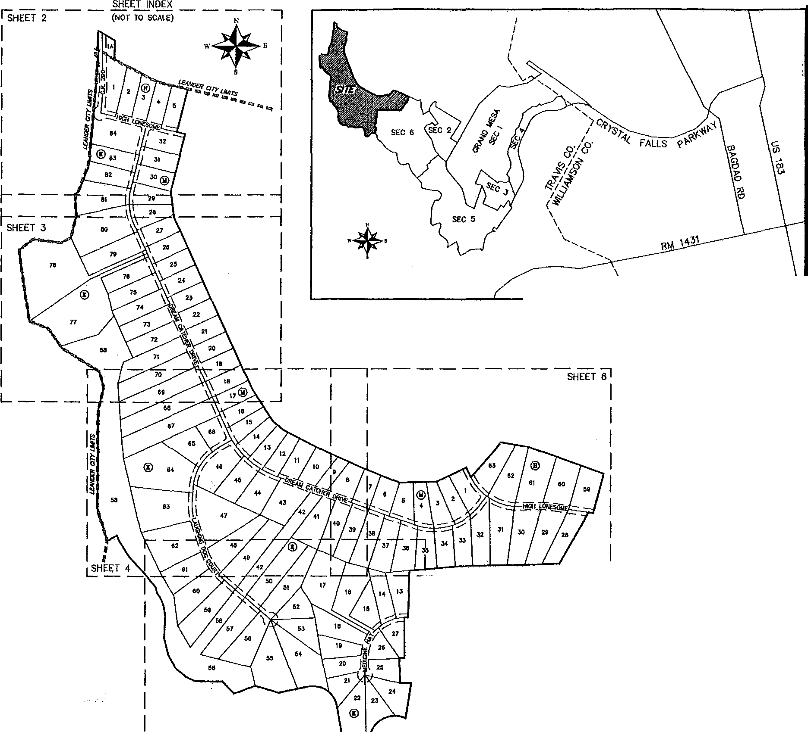

1. .H04"Jt'Ot"E. o dlfll)'!Qf of 15&54 ftet tQ o f/1! lr,;in rod kutd at tho northtctt-1y com...- of tht 1281,78 cer. lrQ¢1,:

IU$"J8'38"'W. odlt of1J.JJ fttttoo1/",t'lrfltl rod f'llund ot U.. IIOUth •bdy«rntroftOldlot 40. Hldd«t 1.1.-a;

lHEHCE N02'00'43"£. -1th the -tlfly One of tOld ).J)t ,4(1. Hlddtn MftCI and tht ... 1.i, lk'lf of I"- 219.70 oc:r, trocl, Cl dlltwlot or 1!,q..4t fttl to the POINT Of BEQNHINO, contolnhf an cno of 209.104 QQ'"M of kl1d. mer. *tJt* 1._.,

ll\llUl--awD t.1EM S(ClX:t< '1\.i.-t\11UL -fV.T........ 3/1/lCll lUt:29 N' CST

SUR'ltYOR,

G&R SUR'lt\1NG, U.C 1605 OUIDA DRl'lt

AUSTIN, TEXAS 78728

ENGINEER

JAY ENGINEERING CO., INC.

r. o. aox 1220

LEANDER, lEXAS 78846

PARK/HOA:4

LINEAR FEET OF NEW STREElS (PRIVATE): HIGH LONESOME:1,900

DREAM CATCHER ORlvt,5,138 LAUGHING DOG COURT:1,856 MEDICINE HAT:683

C.R. 280: 657 TOTAL:10,236

!116697!

t:.Z.d

= LOT AREA IN SQUARE FEET

= LIMITS Of WBZE

SHEET 1 OF 8

**SURVEYING, LLC**

*1805 OUIDA OR*

&

*PH3¼N%/ff1%i¾1i*

*FAX: (512) 836-8385*

_j ---t-MATCHLINE_ *I*

*I*

*I!*

I I SEE INSET

-r;;

1

7

*I f:J I*

*I ¥ I*

l

L6o FT. ACCESS AND UTILITY ESMT,

VOL 12802, PO. **1946**

I

7

I *POB*

, / *N=10175647.2*

*E:=3057376.4*

5' PUE

(m>.)

**FINAL PLAT OF**

**GRAND MESA AT CRYSTAL FALLS** II,;""

♦**•**

*I*

**SECTION 7** *1*

*I*

*I* **N**

*I*

*I*

*I*

**w** *I*

0--

'------,1/•? *{*

I

*, /*

S.S. *EVANS SURVEY 501*

*II I I* **s** *I*

'-- I I

I

l'--1 I I I

I

I I

I I

I I

e, *S.-,b>,*

E *-;:.!/;, <a'"*

;1 %J..)

I

V)

4

*I*

12,346 Af:..

PHILIP R, HAMILTON

ooc. 2001060263

*I*

0 100' 200' 300' 400'

SCALE: 1" = 100'

*II*

*I*

BEARING BASIS: TEXAS CENTRAL ZONE, /

STATE PL\NE COORDINATES (WJJ 63)

I I I

III

;,!; 1

*I* 2.60 *NJ. I I*

I I

I I I

I II

C.R. 29

(60' PRIVA STREET, DR

Rogoo; '/'f.W4s"R•

*I*

TEXAS *MEXICO*

I I

I I

I I

I I I

I I

I I

!,lo flP.s.t.&P.u

I J!, *r/'*,,.:,.,

; /} *N* 11

*RAILROAD CO. SURVEY 203*

I I I

g- *,11*

"'- /"

r I

I

I

I I ----

I I ----

I

I I

I I

I I

450.00 AC.

M. KUTSCHER LIFE ESTATE

VOL 12592, PG. 1901

*2:* d>'.d

*I*

*:x* C}

----

- *l<PiJI,;*

I

10' PUE S2''jf-2

I I (TYP.) • • fttGH

I I LONESOME

I I

I

12.346 AC. PHILIP R. HAMILTON DOC. 2001060263

I I

I I

I

I I

I I

I I

I I

**84**

10' MAINTENANCE AND

HERITAGE EASEMENT

(60' PRIVATE STREET, DRAIN,,

P.S.E. & P.U.E.)

*!?*

_j I MATCHLINE I

I -i-sEE INSET- -

h 60 FT. ACCESS AND UTILITY ESMT.1

I WL

7

12902, PG. **1946**

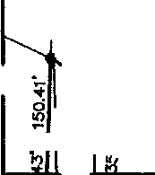I / *POB*

I

I *N=10175647.2*

=

*(*

*I*

***t::A***E:=3057376.4

¾• .,[

82 10•

=

60' PRIVATE

STREET, DRAJN., 30

REMAINDER Of 1013.55 AC. (TRACT 1) LOOKOUT PARlNERS, LP.

DOC, 20001628J6

t ! *>•*

*,s 8Q.* J *I*

P.S.E. & P.U.E.) I 48644 I

*CANDELARIA YBARBO SURVEY 422*

-

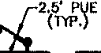*w* '1 *{(•l!J*

INSET *I*

S ,3 3

ss ·

**81** 29

*I*

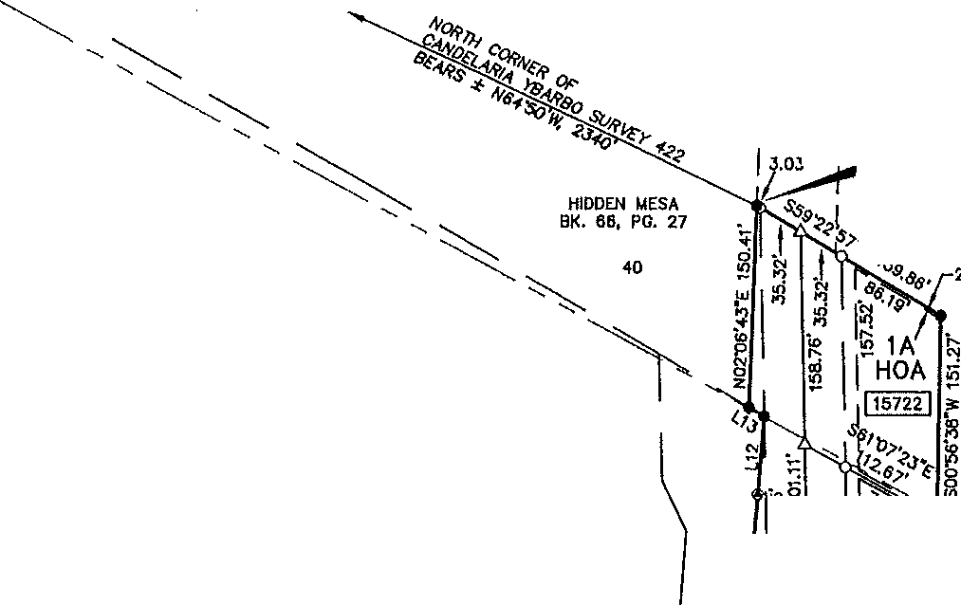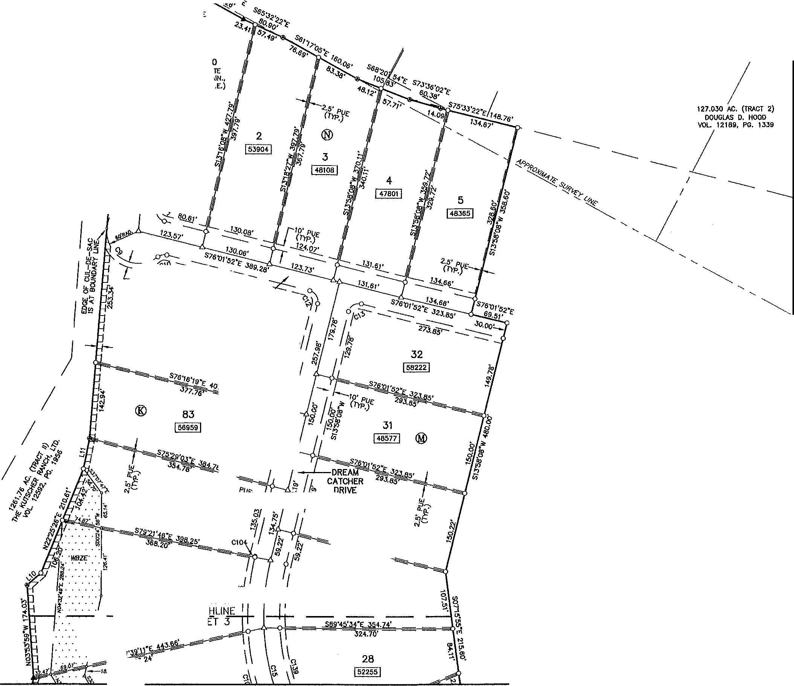

*I*

ll\112.ll-lJW,iDUESA!;CCl!W 7\ \ll?J2_G!I-PI.AT,<lo,g J/7/'M) AT

I 91559 I SHE I 49693 I

MATC

••• ,*f*· SHE

* I;

• *$ •.*

.,,,.

SHEET 2 OF B

**SURVEYING,** LLC

*1805 OUIDA DR*

*PH WP%/Jl :l¾2Jo*

*FAX: (512) 836-8385*

\ \1

'.ll '\l\

i

- 24.70•-

**FINAL PLAT OF**

GRAND MESA AT CRYSTAL FALLS II, SECTION 7

N

•*'

s

0 100' 200' 300' 400'

S8J"fJ'OO"E 225,62'

SCA!£: 1' = 100'

BEARING BASIS: TEXAS cytHRAL ZONE,

STATE PLANE COORDINATES (NAO BJ)

MAINTENANCE ANO HERITAGE EASEMENT

(DIAGONAL HATCHED AREA)

78

!263278! *CANDELARIA YBARBO SURVEY 422*

REMAINDER Of 1013.55 AC, (TRACT 1) LOOKOUT PARTNERS, LP.

:I

DOC. 2000162636

•.•• *11.*

•••• ·.,2240491.. •.•

:<-:-:-: > *>Q.q>,*

... ' .. ' '

.sa.·:.· ......

······PARK···

....... :-.,7 3401! ,•• •

1261.76 AC, (TRACT ll) THE KUTSCHER RANCH, LTI>.

-

VOL 12582, PG. 1956

.. , l\1lZE,

SURVEYING, LLC

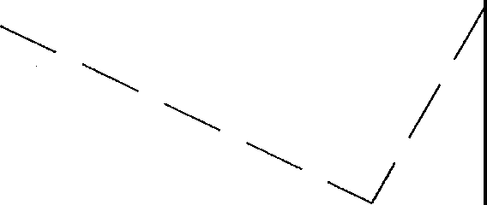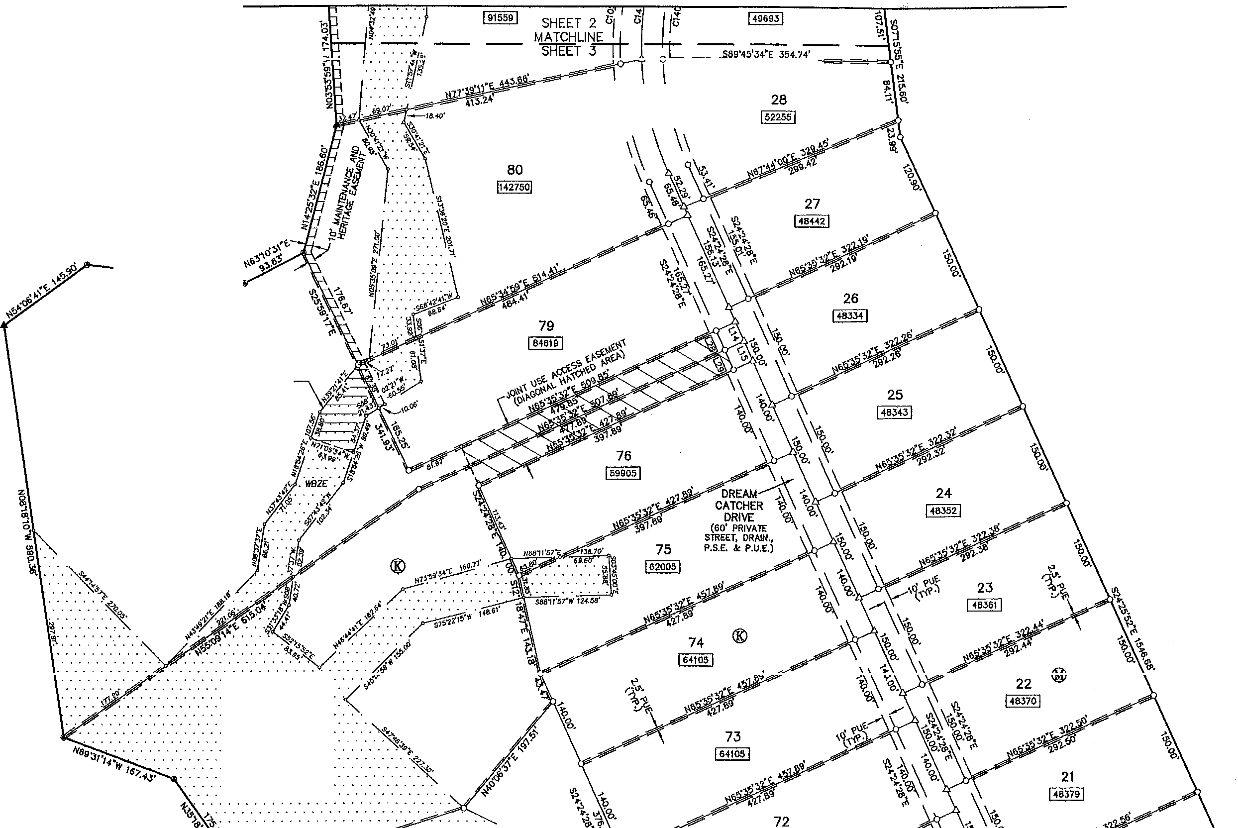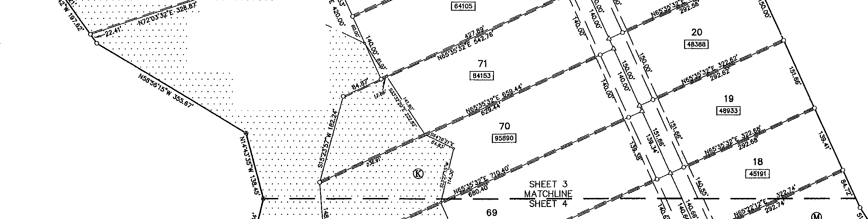

*1805 OUIDA OR*

*PH ¼N%,ix1ll.3/'fii*

*FAX: (512) 836-8385* SHEET 3 OF 8

L:\11"2...(JIWO WUA Sl;Cb(N J\n1\1!2l2....Ql-fUT-"99 3/1/2013 ll;2i:2t *hi.* CST

17

l 44144 I

68

V'

**0**

***Q***

**Cc)**

**FINAL PLAT OF**

**GRAND MESA AT CRYSTAL FALLS II, SECTION 7**

.• , *I*

s *I*

"-'

**16**

I44291 j

0

**i.-**-**.**

I

1i' *2n* 300'

SCALE: 1" = 100'

**BEARING BASlS: TEXAS CENTRAL ZONE,**

STAlE PLINE COORDINAlES (NAO **BJ)**

*CANDELARIA YBARBO* SURVf.Y 422

**REMAINDER Of** 1013.55 AC. (lRACT 1) **LOOKOUT PARlNERS, LP.**

**DOC. 2000162836**

***gg:g***

I

ut;l,

* ***iffiZE·***

!**s**i §

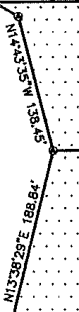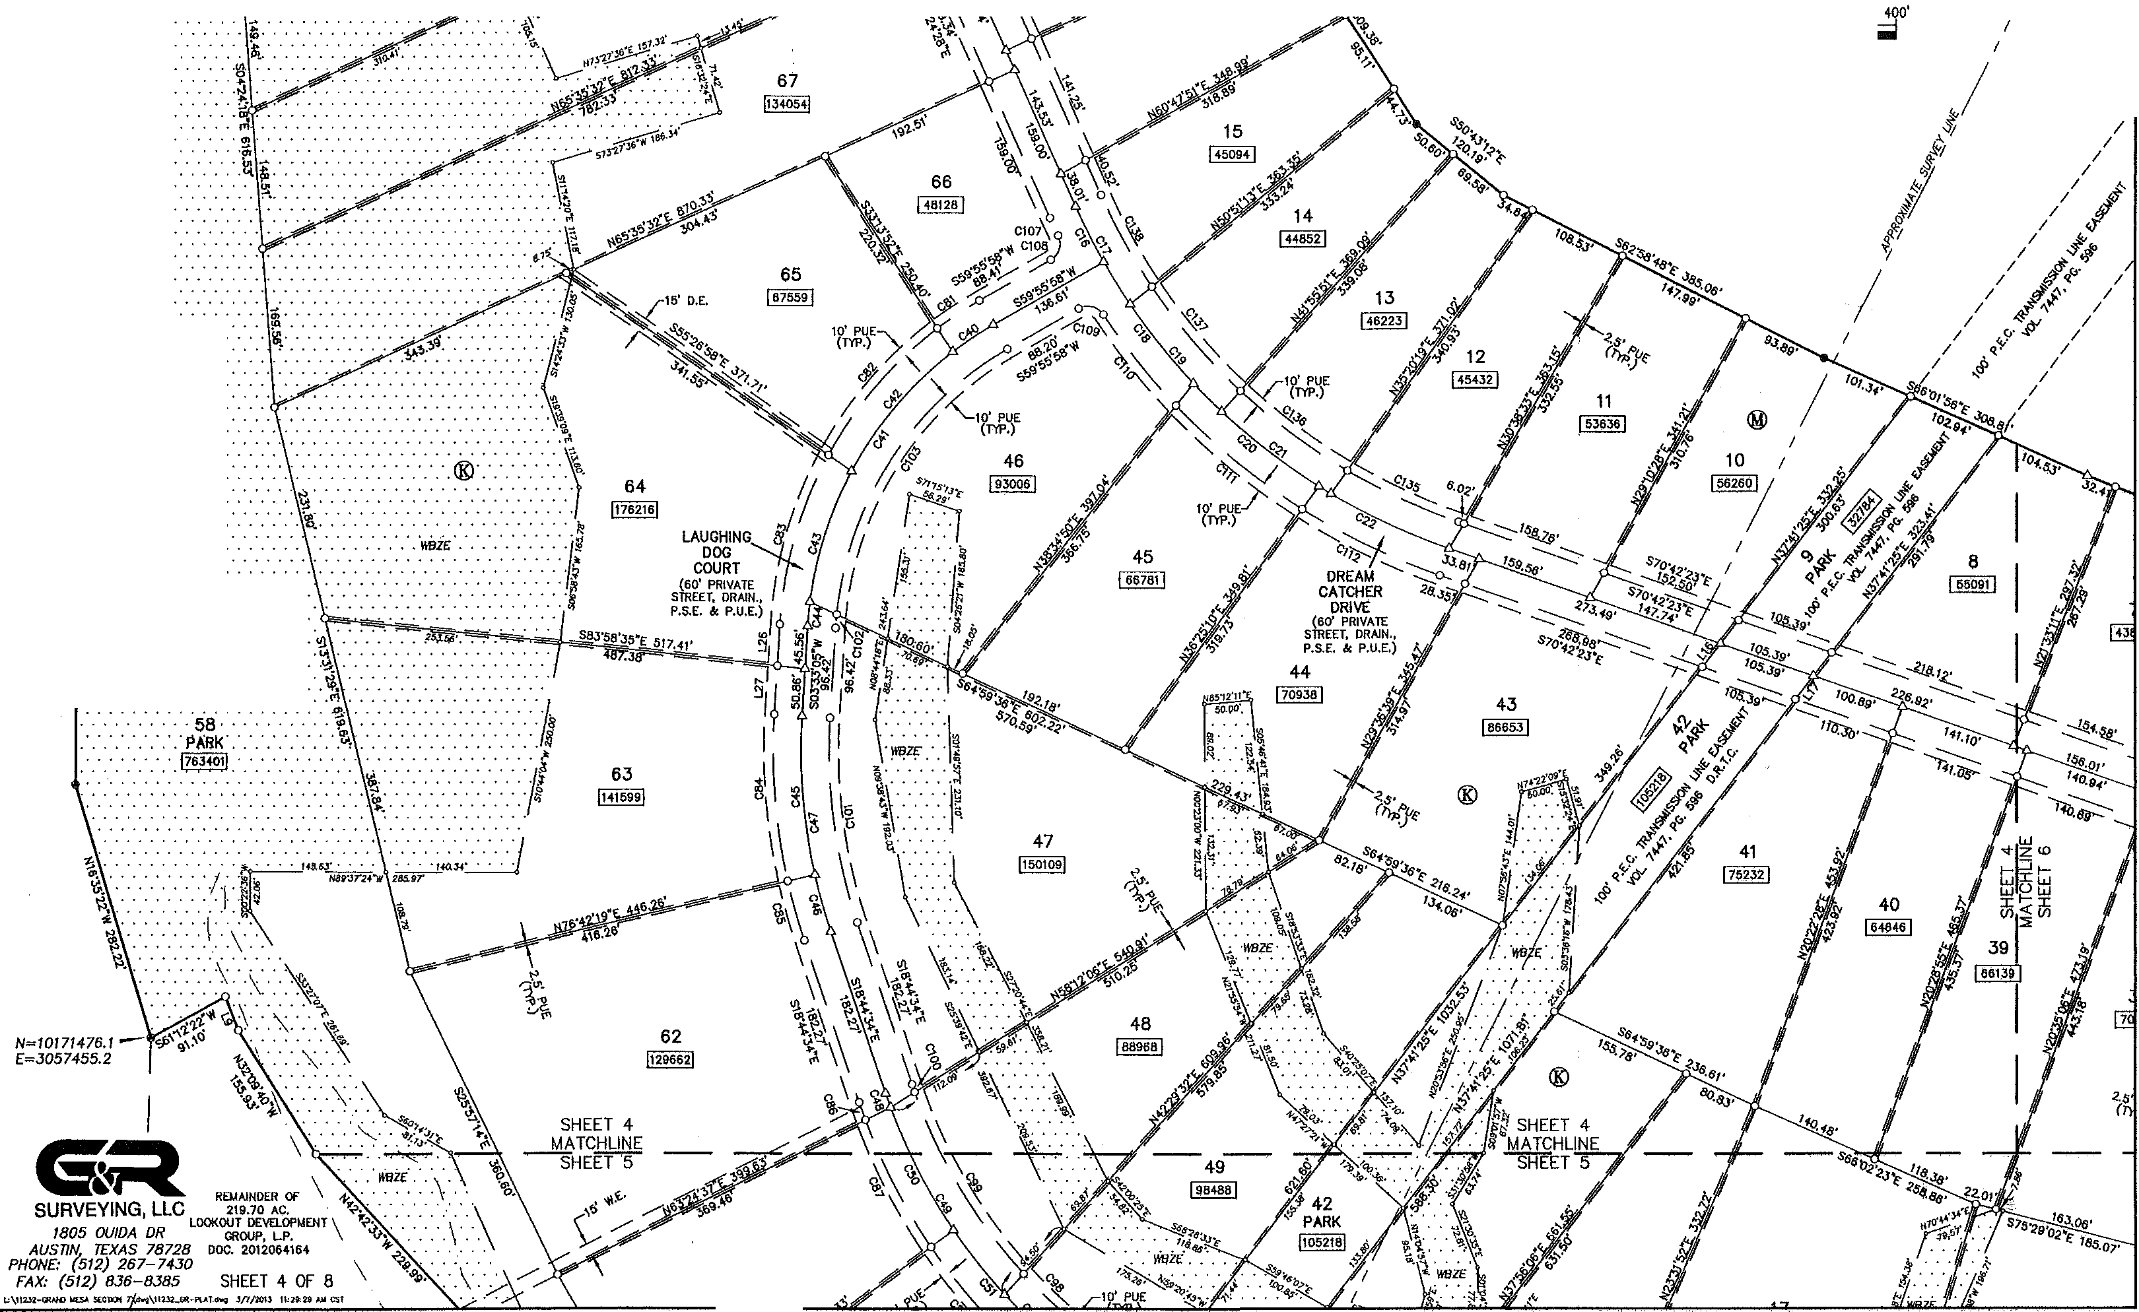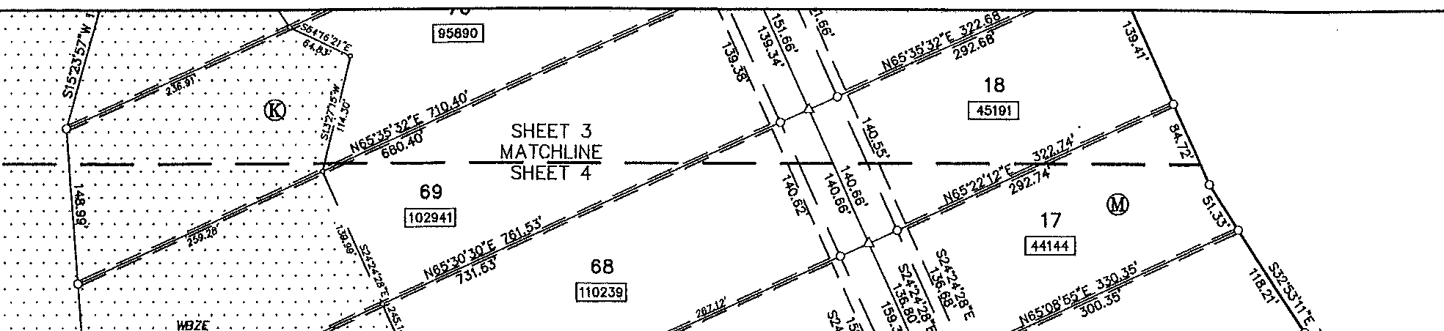

**ui}r!_J** ·

**w z.**

iE

............

........ . . . . .

61

I111•• I

. .

%

"'ii,.-.

61

/71164 I

***<6'·***

**'/JQ•**

,**q**-·**\A 1 • pt ·** ••

"'

*}­*

*.i*

17 !I:.

*$*

60

1•423•1

*)* ·.-.\.

_. ·_-\.

·\_.

* • • • ***WBZ£·*** •

\.

•••• •... /

56

l•s110I

**MffE=929**

55 54

C,

1f PUE 26

n'P,) !43598!

27

/ flll58!

\ :-:-:-/..::

... . . /·

. /..

·/- ..

\

*·'11./."..*

I ./. ..

. .

. . .

. . .

5B •

. PARK • . *1.· l\lll•*

/121916/

**MFFE=914**

)115697!

**MFFE=909**

-C7

-:-. tC78

""\

\;

'

\_'\_ *CANDELARIA*

· • *APPROX/MATE: 1*

•••• '·::/:: *.Yf.'-'lll"!'i,0.0P!'sA* :-::

224.01'

j··<

©

, '\_ **P**2**O**1**R**9,**T**7**I**0**ON**A**O**C**f**. (

'. '\_ **LOOKOUT DEVELOPMENT**

GROUP, t..P.

', "" ooc. 2012064164 ---------

*i--y"-* ', " \

**REMAINDER Of** 1013.65 AC. (TRACT 1) **LOOKOUT PARlNERS, LP.**

**DOC. 2000162836**

23

I539sa1

**MFFE=897**

24

! 64321 !

21

\ ·♦- ,, 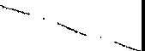 *<*

N'--

I

oi *N=/0170020.0* '----

/

**S..:l** \

**FINAL PLAT OF**

s

0 200'

300'

400'

*MCKINNEY* & *WILLIAMS* SURVEY *175*

*/ E*--..*:=3059B97.7* •

**GRAND MESA AT CRYSTAL FALLS 11, SECTION 7** \

**t.**-**-.**

I I I

SCALE: 1" = 100'

SURVl::YING;--LLC \ \

*1805 OVIOA OR*

°"'

*PHj¼f%/!f1f /._8//Jo*

**L:.\1123:t--<fWIO l,l(U** !£CIU>I **7\kt\112lL"'.-PlAtdw9 3/7/21JIJ 11:29: *}Jl* C$T**

**BEARING BASIS: TEXAS CENTRAL ZONE.**

STATE PU.NE COORillNATES (NAO 83)

SHEET 5 OF 8

*FAX: (512) 836-8385*

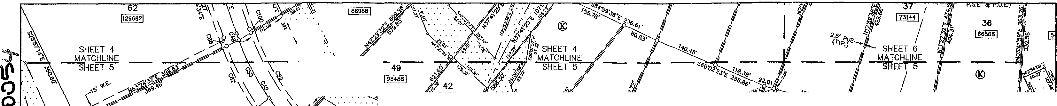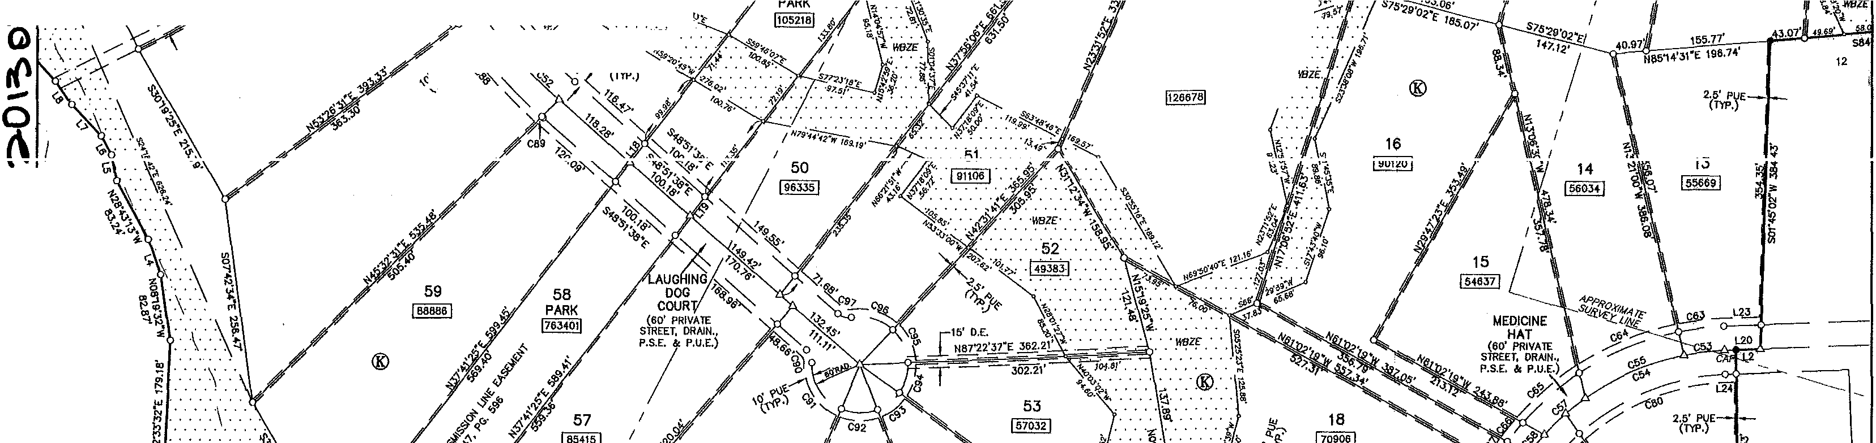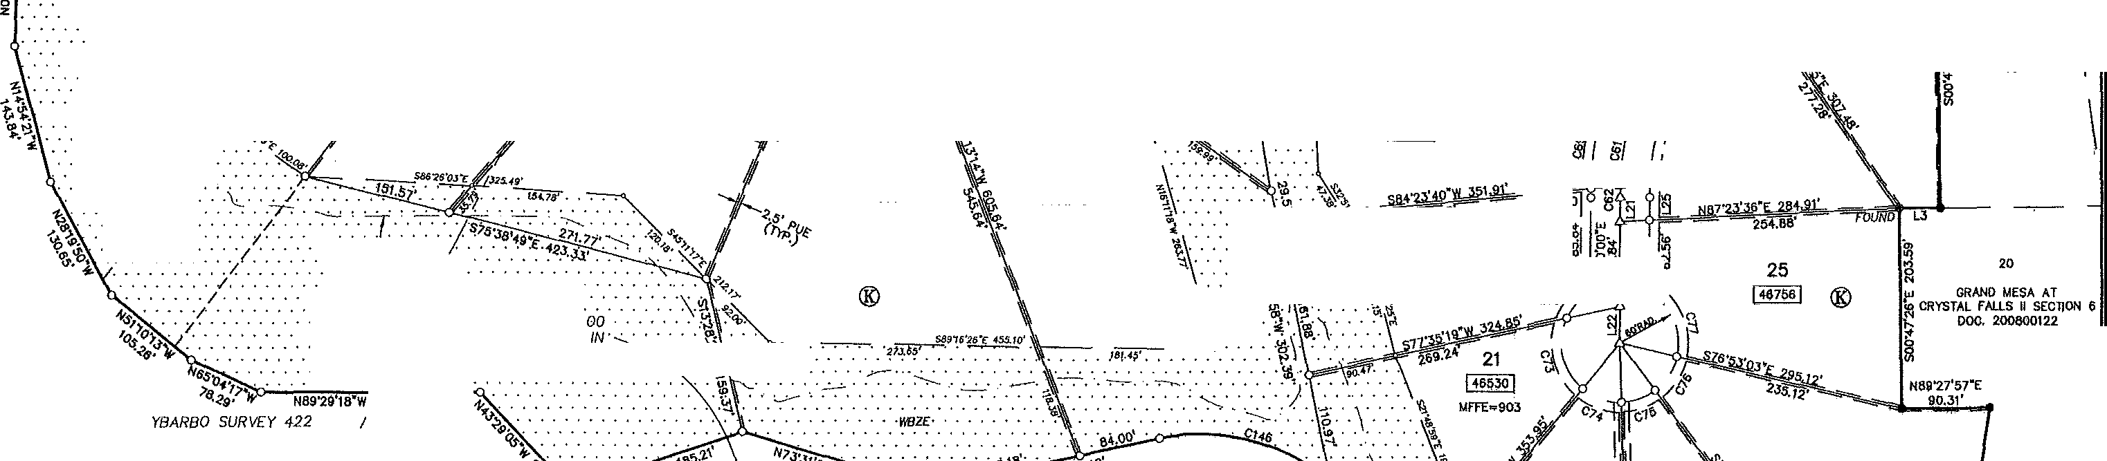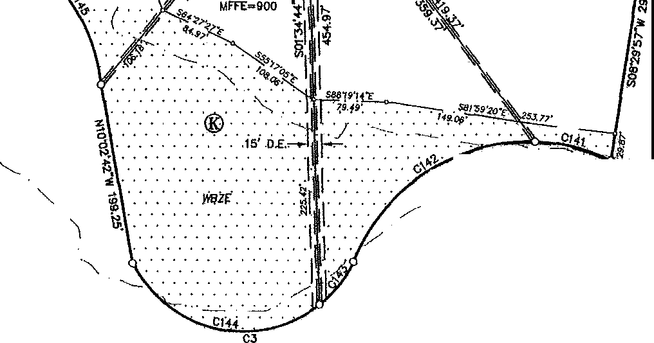



'":)--

**11'**

()

**0**

**0**

I('\

*I*

*I I*

*I*

*I*

*I*

*I I*

*I*

*I*

*I I*

*I*

*I*

*MCKINNEY* & *WILLIAMS SURVEY 175*

*I*

*I*

*I I*

*PA GLOSSOM SURVEY*

**FINAL PLAT OF**

**GRAND MESA AT CRYSTAL FALLS 11, SECTION 7**

♦**,**

**N**

**w**

**s**

100' 200' 300' 400'

SCALE: 1" = 100' BEARIHG BASIS: TEXAS CENTRAL ZONE,

STATE PlAAE COORDINATES (NAO OJ)

*I*

*I*

/

/

/ REMAINDER Of

/

1013,55 AC. (TRACT 1)

*I*

/ LOOKOUT PARTNERS, LP,

/ DOC. 2000162836

/

/

/

/

/

/

/

PORTION Of

219.70 AC.

LOOKOUT DEVELOPM T

GROUP, LP.

DOC. 2012064164

®

*N87'-H*

,,, . . .

..n ••••

*V·*

*.IWZE. ·.j,*

. -,,._,,.,o-

60

I e48e2I

®

58

40

36

(66508!

**34**

I◄9478 I

24,14'

118.62'

"*p*

32

j 74451 j z

2.5' PUE

(TYP.)

142.08'

**31**

I 8808s I

® "

138.98'

144.42'

**30**

j 8eo111

"'

GRAND MESA AT '-.._

CRYSTAL FAU.S II SECTION 6 "-, DOC. 200800122

®

&

**SURVEYING,** LLC

184.75'

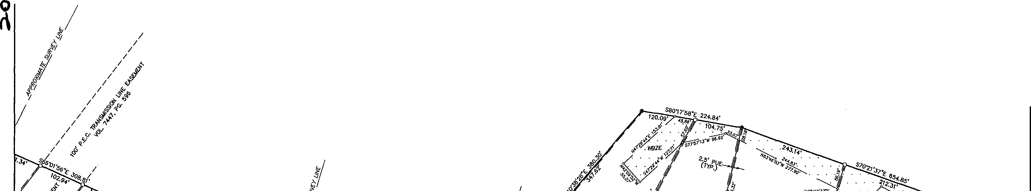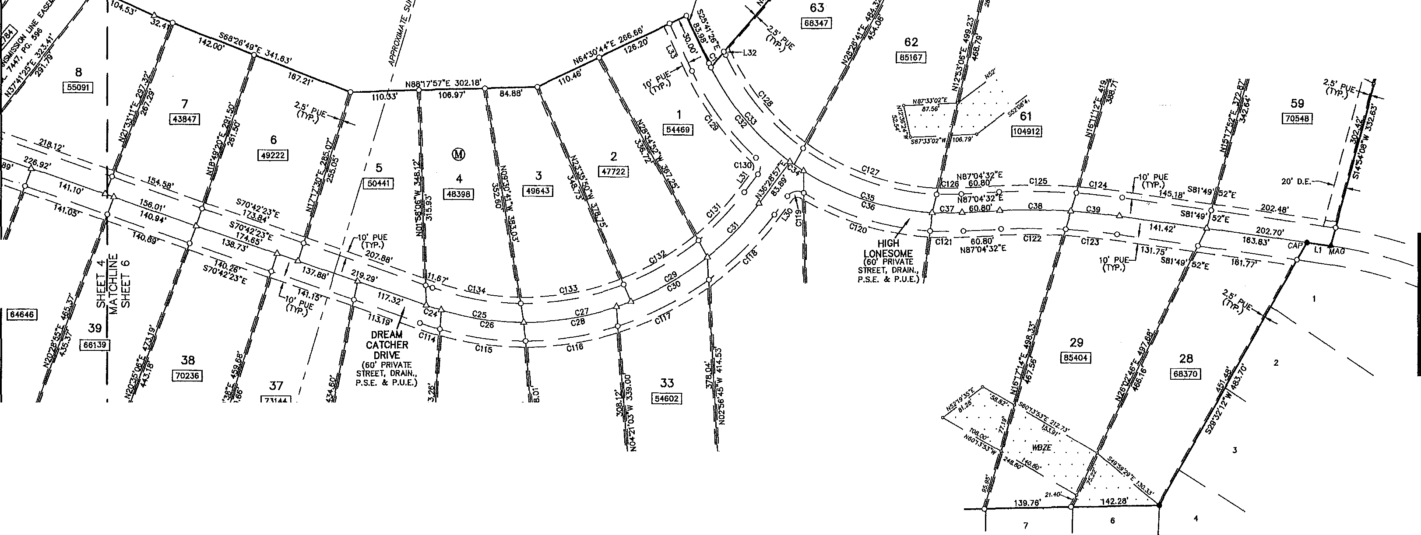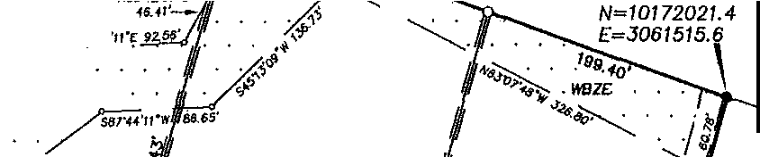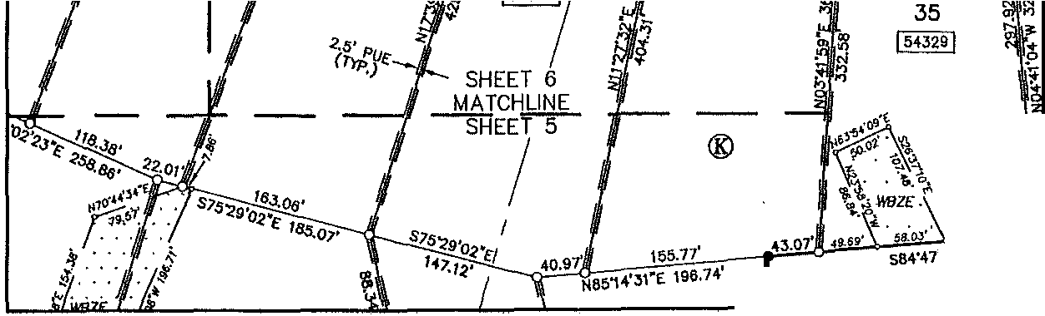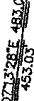

**50•w**401.20'

12

149,25'

11

10 ®

GRAND MESA AT CRYSTAL FALLS U SECTION 6

DOC, 200600122

S88'46'57"W 826,J6'

*1805 OUIDA DR*

'--. *AUSTIN TEXAS 78728 PHONE: (512) 267-7430*

SHEET 6 OF 8 *FAX: (512) 836-8385*

L:\1UJ2-Ql.\ljQ MESA s.:enON 7\d•11\tl2).LOR- T,t,,11 l/1/2fll3 11:211:19 Ml CST

**FINAL PLAT OF**

**GRAND MESA AT CRYSTAL FALLS** II,

**SECTION 7**

**an**

**b**

|  |  |  |  |
| --- | --- | --- | --- |
|  |  |  |  |
| CHORD | **CURVE**  **TANGENT** | | **TABLE**  NO. |
| **7.BO'** | **3.80'** | | C74 |
| **303.35'** | **224.01'** | | C75 |
| **242.20'** | **275.0** ' | | C76 |
| **30 76'** | **223.61'** | | C77 |
| **63.42'** | **31.75'** | | C78 |
| **60.25'**  **66.59'** | **30.16'**  **33.34'** | | C79  cao |
| **7.32'**  **1 9.94'** | **9.61'**  **1968.43'** | | **ca**  ca |
| **17.32'**  **25.94'** | **9.81'**  **17.04'** | | ca |
|  |  | |  |
|  |  | |  |

|  |  |  |  |  |
| --- | --- | --- | --- | --- |
|  | | | | |
| DIUS | ARC | **CHORD BEARING S71'03'12.E 70'50'03.E N33'10'53"E N19'06'04"W S25'39' 2•E S24'07'39"W S68'01'22"**  **sss'2 'as·** | **CHORD**  **42..08'** |  |
|  |  | **S40'4 '09"W** |  |  |
|  |  |  |  |  |
|  |  |  |  |  |
|  |  |  |  |  |
|  |  |
|  |  |
|  |  |
|  |  |
|  |  |
|  |  |
|  |  |
|  |  |
|  |  |
|  |  |
|  |  |
|  |  |
|  |  |  |  |
|  |  |
|  |  |  |  |
|  |  |
|  |  |
|  |  |  |  |
|  |  |
|  |  |  |  |
|  |  |

**0**

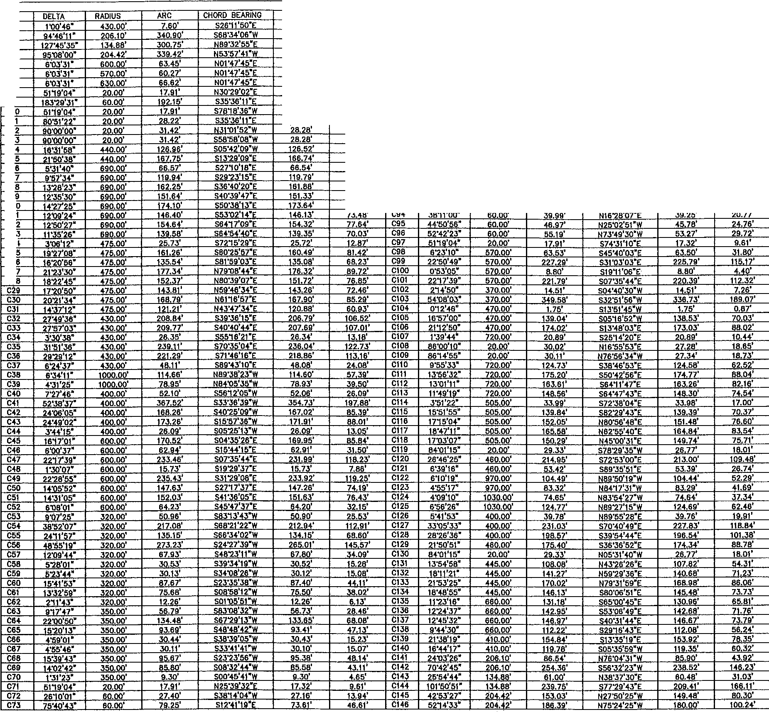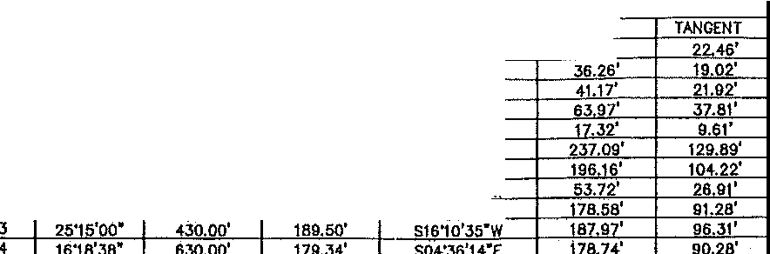

NO.

Cl C2 CJ C4 C5 C6 C7 C8 C9

Ct

Cl Ct Cl C1

Cl C1

Cl Cl C1 C2 C2 C2 C2 C2

C2 C2 C2 C2

**G)**

-

i

'i'

**"'1**

**0**

***(b***

NUM L1 1.2 **L3 L4** L5 **L6**

L

**LB**

L

**LJ\** L32 LJ;)

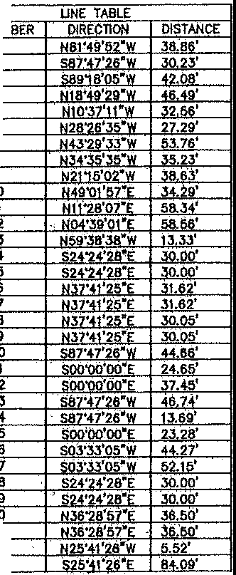

SHEET 7 OF 8

**SURVEYING,** LLC

*1805 OUIDA DR*

**&.:l**

*AUSTIN, Tf:XAS 78728*

*PHONE: (512) 267-7430*

*FAX: (512) 836-8J85*

PLAT NOTES

i

1. THIS SUBDIVISION IS VtttOU.Y CONTAINED WITHIN THE CURRENT CORPORATE UMJTS OF 1HE CITY Of I.EANDER, TEXAS.

2, CONSTRUCTION OF IMPROVEMENTS Wllli!N lHlS SUBDIVISION SHALL NOT COMMENCE UNTIL ALL APPLICATION PERMITS AND/OR CONSTRUCTION PLAHS HAVE BEEN APPROW 8Y THE CITY Of U:ANOER, TEXAS. ALL PUBLIC U.!PROYEMENTS SHALL CONFORM TO THE CURRENT ZONING ORDINANCE OF THE CHY OF LEANDER, TEXAS.

J. NO LOT IN THIS SUBOIVISIOH SHALL BE OCCUPIED UNTIL CONNECTED TO lHE WAlER DISTRIBUTION SYSTEM Of THE CITY OF LEANDER, TEXAS.

0

1. EJJ:E O\o1VPlAT ARE RECORDED 1H THE OFFICIAL PUBLIC RECORDS Of TRAVIS COUNTY, TEXAS UNDER DOCUMENT

0

1. lN ORDER TO PROMOTE DRAINAGE AWAY FROM A STRUCl\JRE, THE MINIMUM FOUNDATION SLAB filVATION SHOUlD BE BUILT AT LEAST ONE FOOT ABOVE THE HIGHEST GROUND ElEVATION WITHIN fl.VE (5) FUT Of THE stAB PERIMETER, ANO THE GROUND ADJACENT TO THE SLAB SHOULD BE 51,.0PED AWAY FROM TiiE SlRUCTURE AT A Sl.OPE Of 1/2• PER FOOT FOR A DISTANCE OF AT LEAST TEN (10) FEET.

0

6, WATER 'MLL BE PROVIDED BY THE CITY Of l,.EANO€R.

7, PROPERTY OYmERS SHN..i PR0\10E FOR ACCESS TO DRAINAGE EASEMENTS AS MAY BE NECESSARY ANO SHALL NOT PROHIBtT ACCESS BY THE CITY Of l.EANOER,

B. AU. EASEMENTS ON PRIVATE PROPERTY SHALL BE MAINTAINED BY THE PROPERTY OYINER OR HIS OR HER ASSIGNS.

1. AU. SUBOtVISION CONSTRUCTION SHALL CONFORM TO THE CITY Of LEANDER CODE Of ORDINANCES, CONSTRUCTION STANDARDS, ANQ GENEltAU.Y ACCEPTED ENGINEERING PRACTICES.
2. NO BUILOINGS. FENCES, LANOSGAPING OR OTHER STRUCTURES ARE PERMITTED YdlHIN DRAINAGE EASEM TS SHOWN, EXCEPT AS APPR0\<£0 BY lHE ctTY OF LEANDER PUBLIC WORKS DEPARTMENT.
3. WASTEWATER AND WAlER SYSTEMS SHAL,l CQNFORM TO TCEQ (TEXAS COMMISSION ON ENVIRONMENTAL QUALITY) ANO STATE BOARD Of INSURANCE REQUIREMENTS. lHE OWNER UNDERSTANDS AND ACKNOWLEOGES lHAT PLAT VACATION OR RE-PLATTING MAY BE REQUIRED, AT THE O ER'S SOLE EXPENSE, IF PLANS TO DEVELOP lHlS SVBOIVlstON 00 HOT COMPLY 'MlH SUCH CODES ANO REQUIREMENTS.
4. DEVELOPER SHAU. BE RESPONSIBLE FOR AU. RELOCATION ANO MOOlflCATIONS TO EXISTING UTILITIES.
5. THE O'M-IER Of' THIS SUBDIVISION, ANO HIS OR HER SUCCESSORS ANO ASSIGNS, ASSUMES RESPONSIBILITY FOR PLANS FOR CONSTRUCTION Of SUBDl\1SION IMPROVEMENTS Yd-ltCH COMPLY 'MTH APPLICABLE CODES AND REQUIREMENTS OF me: CHY Of LEANDER. mE OWNER UNDERSTANDS ANO ACKNOYUDGES THAT PLAT VACATION OR REPlATTINO MAY BE REQUIRED, AT THE OWNER'S SOLE EXPENSE, If PLANS TO CONSTRUCT lHIS SUBDIVISlON DO NOT COMPLY YdTH SUCH COOES ANO REQUIREMENTS.
6. ASCAL SURETY FOR SUBO\VISION CONSTRUC110N, IN FORM ACCEPTABLE TO THE CHY Of U:ANOER, SHALL BE PRO'vlDED PRIOR TO PLAT APPROVAL BY THE PLANNING AND ZONINO COMMISSION,
7. COMMUNITY IMPACT FEES FOR INDIVIDUAL LOTS TO BE PAID PRIOR TO ISSUANCE Of ANY BUILDING PERMITS.
8. SITE DEVaOPMEHT CONSTRUCTION PlANS SHALL BE REVIEWED ANO APPROVED BY THE CITY OF LEANDER PRIOR TO ANY CONSTRUCTION,
9. TEMPORARY AND PERMANENT EASEMENTS TO BE PROVIDED AS REQUIRED FOR Off-SHE WATER, WASTEWATER AND DRAINAGE IMPROVEMENTS.
10. ANISHED SloPES \\t\lCH ARE GREATER THAN 15% CANNOT USE SURFACE IRRIOATION SYSTEMS.
11. tv.£NTY-F1VE FOOT OSSf 5El8ACKS ARE REQUIRED FROM ALL DRAINAGE WAYS.
12. TWENTY-FlVE FOOT OSSf SEl8ACKS ARE REQUIRED FROM ALL ANISHEO SLOPES WHICH ARE GREATER THAN 30,C
13. ALL PRIVATE STREETS SHO\litt HEREON ANO ANY SECURITY OATES OR DEVICES CONTROWNG ACCESS TO THE SAME PRIVATE STREETS SHALL BE O't'MEO AND MAINTAlNED BY THE ESTABLISHED HOMEOVINER'S ASSOOATION Of THIS SUBDIVISION.
14. LOTS 42, AND 58, BLOCK •K• ANO LOT 9, BLOCK *•u•* ARE PARK LOTS AND LOT 1A, BLOCK N• IS AH HOA LOT AND SHALL BE OWNED AND MAINTAINED BY mE ESTABLISHED HOMEO\lmER'S ASSOCIATION Of THIS SUBOl\1510N,

23, A 10 FOOT PUE ADJACENT TO ALL PR1VATE ROADWAYS ANO AU. RIGHT-OF-WAYS AND A 2,5 FOOT PUE ALONG All SIDE LOT LINES IS HEREBY DEDICATED.

24. AU. BUILDING SETBACK LINES NOT SHOi\t-1 HEREON SHALL BE IN ACCORDANCE WITH THE CITY Of LEANDER'S CURRENT ZONING ORDINANCE,

26. TI-IE fOUOWING VARIANCES VifRE GRANTID PER A DEVELOPMENT AGREEMENT WllH TI-IE CITY OF l-EANOER ANO APPROVAL Of THE CRYSTAL FALLS II CONCEPT PLAN ON MAY 1, 2003.

A. PRIVATE STREETS \\int ROADSIDE DRAINAGE.

8. NO SIDEWALKS.

C. NO STREET LIGHTS.

1. NO DEVELOPMENT SHALL BEGIN ON LOTS 20-24, BLOCK •K OR LOTS 54-56, BLOCK "K", PRIOR TO ISSUANCE Of A fLOOO PLAIN DEVELOPMENT PERMIT BY THE CITY Of LEANDER FLOOD PLAIN AOMINlSTRATOR FOR EACH LOT SPEOFlEO,
2. TI-IE DEVELOPER, BUILDER, SEUER, OR AGENT SHALL INFORM, IN YrRITING, EACH BUYER OF SUBOl'vlSION LOTS OR PROPERTY LOCATEO WITHIN FLOOD HAZARD AREAS THAT SUCH PRQPERTY IS IN AN JOENllflEO FlOOO HAZARD AREA AND THAT A FLOOD PLAIN DEVELOPMENT PERMIT 'MLL BE REQUIRED BEFORE A SlRUCTURr CAN BE PlAC£D ON THE PROPERTY. ll-lE YMITTEN NOTICE SHALL BE fllED FOR RECORD IN 1HE OFFICfAL PUBLIC RECORDS OF TRAVIS COUNTY. A coPY OF THIS YIRITTEH NOTICE SHALL BE PROVIDED 'M-IEN APPLICATIONS ARE MADE FOR FLOOD PLAIN

DEva.OPMENT PERMITS.

2a PRIOR TO ANY CHANNa ALTERATIONS. BRIDGE CONSTRUCTION, FlU.. DREDGING, GRADING, CHANNEL IMPROVEMENT, OR STORAGE Of MATERIALS OR ANY OTHER CHANGE 'nllHlN THE 100 YEAR FLOOD PLAIN 1-.0CATEO 'MTHIN THIS PLAT, AN APPLICATION FOR FLOOD PLAIN DEVELOPMENT PERMIT 'MlH A DESCRIPTION OF THE PR; CT ANO EXIDlT Of a-lANGES, If ANY, TO mE WATERCOURSE OR NAlURAL DRAINAGE AS A RESULT Of lHE PROPOSED VELOPM T MUST BE SU8MITTE() TO AHO APPROVED BY THE CHY Of LEANDER FLOOD PLAIN ADMINISTRATOR. All SPEQflCATIONS AND DETAILS NECESSARY FOR COMPLETE REV1EW MUST BE PROVIDED,

1. PRIOR TO ANY CHANNa ALltR,'.llON OR BRIDGE CONSTRUCTION 'MilCH WILL CHANGE EXISTING FLOOD PATTERNS OR El£VATIONS, A LETTER Of MAP AMENDMENT MUST BE SUBMITTED TO ANO APPROVED BY mE FEDERAL EMERGENCY MANAGEMENT AGENCY.

OEOJCATION STATEMENT;

THAT LOOKOUT DEVEloPMENT GROUP, L-P., A TEXAS LIMITED PARlliERSHIP, BEING THE OWNERS OF 209,104 ACRES Of LANO SHUATEO IN lRAVIS COUNTY, TEXAS OUT OF THE C. YBARBO SURVEY 422, THE S.S. EVANS SURVEY 501, THE TEXAS MEXICO R.R. CO. SURVEY 203, lli

f:, s Ycl?J PciEL Jr° :i f·J:1otl.t Of;E&f RECORD IN DOCUMENT NUMBER 2012084164, Of THE OFFlctAL PUBLIC RECORDS Of TRA'vlS COUNTY, TEXAS, 00 HEREBY PLAT SAID 209,104 ACRES *at* LAND IN ACCORDANCE VdTH APPLICABLE ORDINANCES OF THE CITY Of LEANDER, TEXAS ANO TRAVIS, COUNTY, TEXAS, lHE

H BE KNOY.N AS "GRANO MESA AT CRYSTAL FALl.S II, SECTION 7•, All ADDITIONAL ROW, STREETS. ALLEYS, EASEMENTS, PARKS, ANO

euc USE, OR, WHEN lHE SUBDIVIDER HAS MAOE PROVISION FOR

MAINTENANCE lHEREOf, TO TiiE INHABlTANTS OF THE SUBDJ\ilstON AS SHO'wN

% BJECT iTQANY EASEMENTS AND/OR RESTRICTIONS HERETOFORE GRANTED AND NOT

'-"'-

'MWAM R. HiNCl(lEY SIOOtT DATE LOOKOUT GROUP, INC.

GENERAL PARTNER LQOKOUT OEvaOPMENT GROUP, LP. YttWAM R, HINCKI..EY, OPERATING MANAGER YORN!NGSIOE l.At;D AND CATILE CO., L.LC.

*r:-Jt iit=*

GS. LP.

HOUSTON, TEXAS 77005

STAlE Of TEXAS:

COUNTY Of TRAVIS;

BEFORE ME, lHE UNDERSIGNED AUTHORITY, ON THIS DAY PERSONALLY APPEARED ViilWAM R. HINCl<LEY, l<NOY!tt TO ME TO BE Tl-IE PERSON ¼HOSE NAME IS SUBSCRIBED TO THE FOREGOING INSTRUMENT ANO ACK O'M..EOG£0 TO ME THAT HE EXECUTED SAME FOR THE PURPOSE ANO CONSIDERATION lHEREIN EXPRESSED, IN lHE CAPACITY THER0N STAlED,

CI\W UNDER MY HAND AND SEAL Of OfFlCt, llilS lliE **1l**DAY OF **20.t)_** A.D,

... **o,.,** ....

P NAMk' - --=-

NOTARY PUBLIC IN AND FOR lliE COUNTY OF TEXAS. MY COMMISSION EXPIRES **lo}..**

1. 9Ml1H

State of Texas

klnExplrel

rl9, 2016

STAlE Of TEXAS:

COUNTY Of TRA S:

I, PHJWP L McLAUGHLIN, AM AUTHORIZED UNDER THE LAWS OF 1HE STATE Of TEXAS TO PRACTICE TrtE PRQFf:SSlON OF LAND SURVEYING, AND HEREBY STATE THAT THIS PLAT CONFORMS 'MTH APPLICABLE ORDINANCES OF TiiE CITY OF LEANDER, TEXAS, TRAVIS COUNTY, TEXAS AND THM ALL EXISTING EASEMENTS Of RECORD AS FOUND ON lHE PROPERTY REPORT RECElVEO FROM INDEPENDENCE TITLE COMPANY ON JANUARY SHO'M-4 OR NOTED HEREON,

*¼==*

REGISTERED PROfESStONAL LANO SURVEYOR NO. oJOO STATE OF TEXAS

STATE Of TEXAS:

COUNTY OF lRA\1&

I, SAMUEL o. KIGER, AM AUTHORlZEO UNDER TI-IE LAWS OF me: STATE Of TEXAS TO PRACTICE

FINAL PLAT OF

GRAND MESA AT CRYSTAL FALLS II, SECTION 7

STATE OF TEXAS:

COUNTY OF TRA'1& ),,

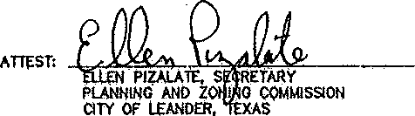APPROVED llilS lliE - DAY OF t-[\ci.f'(,b 20 A.O. AT PUBLIC MEETING Of lliE PLANNING ANO ZONING COMMISSION Of THE cnv OF LEANDER, TEXAS AND AUTI-tORtZEO TO BE FlLED FOR RECORD BY lliE COUNTY CLERK Of ..J..!J,_Yl2._ COUNTY, TEXAS.

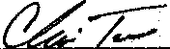

CHRIS TOVAR, a-fAIR

PLANNING AND ZONING COMMISSION CITY Of LEANDER, TEXAS

STATE OF TEXAS:

COUNTY Of lRAVIS:

NO STRUCTURE IN THIS SUBDIVISION SHALL 8E OCCUPIED UNTIL CONNECTED TO A PUBLIC SEVi£R SYSTEM OR A PRIVATE ON-SITE WASlEWATER (SEPTIC) SYSTEM THAT HAS BEEN APPR0'1tD AND LICENSED FOR OPERATION BY THE TRA'vlS COUNTY• ON-SITE WASIDVATER PROGRAM.

-r

p J i i yrt. TTR ,s VIJW Sl A !Jrp a:!: ATE OH-SITE SEWAGE

EYJ:MECH i 1 mi s :i Sl AP tt2 Vl; M MCHRfp N Ar ARE IN EFFECT AT 111E TIME Of' CONSTRUCTION,

lHESE RESTRICTIONS ARE ENfORCEABl£ BY THE 1RA'¥1S COUNTY ON-$1TE WASTEWATER PROGRAM.

ALL LOTS IN lHIS SVBDIVISION ARE RESTRICTED TO ONE SINGLE FAMILY OWELUNG AHO APPURTENANT STRUCTURES PER ACRE. '

NO STRUCTURE IN Tl-OS SUBDl\1SION SHALL BE OCCUPIED UNTI CONNECTED TO A POTABLE WATER SUPPLY FROM AN APPROVED WAlEf{ SYS OR A PRIVATE VrRL,

NO WATER \\£LL IN THIS SU8DIVISION MAY BE LOCATED WITHIN 150 FEET Of THE SUBDIVISION BOUNDARY WITHOUT THE CONSENT Of THE ADJOINING LANO OWNER(S),

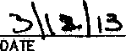/\. ---.'..- I?- .,.,..... ***."'xi.:-....,......***

***foi*** STACEY ii°cf ,

ON-SITE WASTEWA1 R. TRA'v1S COUNTY TNR

STATE OF TEXAS:

COUNTY Of lRAVIS:

w AciFB W W'r s Ffil lHE O r En;: J R M :XJ PRO\i1NG

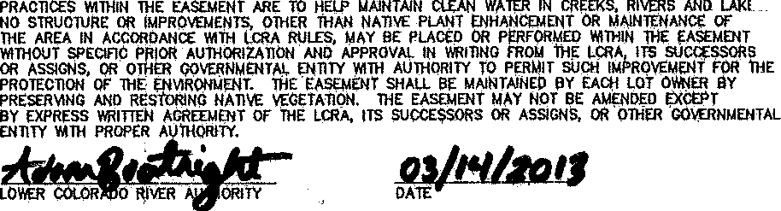

s.

STATE OF TEXAS:

COUNTY Of TRAVIS:

I, DANA D AUVO!R, CLERK Of TRAVIS, TEXAS, 00 HEREBY CERTIFY lHAT THE FOREGOING INSTRl,IMENT OF

1. NO DRlvEWAY SHAll BE CONSTRUCTED CloSfR THAN 50' OR 60:C: Of PARC€L FRONTAGE, \IMICHEVER IS LESS. TO THE ROW OF AN

THE PROFESSION OF ENGINEERING, ANO DO HEREBY STATE THAT THIS PLAT CONFORMS 'MTH TH.E APPLICABLE ORDINANCES OF tHE CtTY Of LEANDER, TEXAS THAT THIS TRACT IS NOT LOCATED

VrRITING, Yl1TH ITS A lE OF AUTHµjTICATION WA D FOR RECORD IN MY QFFlCE ON TH ,._) DAY

INTERSECTION LOCAL OR COLLECTOR SlREET OR 100' OR 60,C Of PARCEL FRONTAGE, WHICH IS L£SS, TO THE ROW Of AN INTERSECTION

ARTERIAL STREET.

'MlH!N THE EOWARQS AQUIFER RECHARGE ZONE AND THAT A PORTION OF lHIS SUBOt\1SION IS Yttlll!N ll{E Ul.llTS Of A 100 YEAR FLOOD PLAIN RECOGNIZED ijY THE FEDERAL EMERGENCY

MANAGEM NT AG£NQY (FEMA) PER FLOOD INSURANCE RAlE MAP (FJRM) PANEL NO. 4B4oJC

Of -

oJ:?..o. **A**

**JJi.**

O'ClOCI(**1-,M..** AND DULY RECORDED ON **lli DAY** OF

Jt. FRONT 8Ull.DfNG LINES ARE MEASURED FROM THE EDGE Of TiiE STREET EASEMENT,

0095H DATE SEP7. 26, 2008, AND CONTAINED 'MIBIN .WATER auFFER ZONE EA.·SE..UENT SHO'M-1

- 20l D.. •• 'Cl); -• IN THE OFFlCIAL RECORDS OF SAID COUNTY ANO

32, GARAGES FACING A SIDE STREET ON-A CORN LOT ARE REQUIRED TO BE SET BACK 20'.

3J. A PUBLIC SAFETY EASEMENT IS HEREBY GRANTED FOR All PRIVATE srng:TS, DRAINAGE AND PUBLIC UTIUTY EASEMENTS WITHIN 1HIS SUBDIVISION.

1. Al. CLAYISON DISPOSAL, INC. SHAU,. BE THE SOLE PROVIDER OF WASTE HAl,JUNG FOR THIS SITE BOTH DURING AHO AFTER CONSTRUCTION.

HEREON. • .. .

L-,. "*I*

SAMUEL . KlGtR P.[. STATE Of TEXAS NO. 69:353

P.o. aox 1i20

LEANDER, S 78646-1220

.. .

STATE, UNDER OOCUMENT NUM - *"-X..) ,-"Jr) A*

'M1)¥S MY HAND AND sEAL Of omo. OF lliE COUNTY Cl.ERK lliE A y OF ***fY\O.*YC,f\**



'

2,t?A.o. •

v"I

1. ALL PROPERTY HEREIN IS SUBJECT TO THE LOYIER COLORADO RlvER AUTHORITYS HIGHLAND LAKES WATERSHED ORDINANCE. Y!RITTEN NOTIFlCATION ANO/OR PERMITS ARE REQUIRED PRIOR TO COMM CING ANY DEVELOPMENT ACTIVITIES. CONTACT LCRA WATERSHED MAHA.GEMENT AT 1-800-776-0272, EXTENSION 2324 FOR MORE INFORMATION.
2. LOT ACCESS TO HIGH LONESOME JS PROHIBITED FOR LOT 64, BLOCK "K" AND LOT 32, BLOCK •1,r'. LOT ACCESS TO DREAM CATCHER DRIVE IS PROHIBITED FOR LOT 66, BLOCK "K•. LOT ACCESS TO LAUGHING DOG COURT IS PROHIBITED FOR LOT 46, BLOCK •K".
3. THE HOMEO'fflER ASSOCIATION BYLAWS ARE RECORDED IN THE OFFICIAL PUBLIC RECORDS Of TRAVIS COUNTY, TEXAS UNDER DOCUMENT NUMBER

2012206635,

36. BUFFER ZONE - SHALL REMAIN FREE Of CONSTRUCTION, OE'IELOPMENT, OR OlHER ALTERATIONS EXCEPT FOR UTILITY AND ROAOWAY CROSSINGS.

39. AU. UTILITY LINES WlmlN THE SVBrn\1SION ARE REQUIRED TO BE UNDERGROUND.

40. THE MAINTrnANCE ANO HERITAGE EASEMENT IS TO PROVIDE REPRESENTJTIVES OF THE HOMEOWNER'$ ASSOCIATION ACCESS FROM HIGH LONESOME TO THE "CO'MJOY BRIDGE., LOCATEO WITHIN LOT 78, BLOQ( •K". THE MAINTENANCE EAS04ENT ANO "CO'MlOY BRIDGE" SITE SHALL BE MAINTAINEO ANO PROTECTED BY THE HOMEO'M-IER'S ASSOCIATION INTO PERPITUtTY.•

512-2 9-3882

"o,AN f TY

BY: ;..._/--/'-_- , /--'/--

***'AO.iii(!***

JuTY

SHEET 8 OF 8

Sl,JRVE;YING, LLC

*1805 OUIDA DR*

••

*PH ¼f%/f/ lififo*

*FAX: (512) 836-8385*

L:\1!2 ....(lR/,,NOl,i£!lASEOl)Ot;7\<:wg\1123LGR-PV.T.<MJ l/1/20!3 11;2i:tt,1,>!CST

I

I



I _I_

SHEET 57

-

I

I

r--­

"'

**10**

HEET 4 LI

_ _J I

SHEET 57

I I I

-----

l _

I I I I I I I

_IJ

I I I

® I

**80** I

I I I

r-------------------------------------------..:.....----------------- '-"' " -'"-------,;_.. --.

FINAL PLAT OF

GRAND

MESA AT CRYSTAl SECTION 8, PHASE

N

FALLS 2

11,

127 .030 AC. (TRACT 2) DOUGLAS D. HOOD

VOL 12189, PG. 1339

_,..

0 SC ·10

**W*E**

s

1"=100'

20 • -DO

BEARING BASIS:TEXAS CENTRAL ZONE, STATE PLANE COORDINATES (NA□ 83)

33

34

36

5

I 91571I

38

***t*** *-*.:*'<*,*,* I,.,.

*SURVEYING, LLC*

*1805 OUIDA DR*

*AUSTIN, TEXAS 78728*

VJ

.,

23 ® •

*"--*

*PHONE: (512) 267-7430*

*FAX: (512} 836-8385* SHEET 3 OF 7

L\17242-CRAND MESA SECTlON 9\dw9\tn42-GR-EIASE.dW9 11/21/2017 8:46;06 ,_.. CST

ul:. ..,

453



s

1"=100'

2( •

BEARING BASIS:TEXAS CENTRAL ZONE STATE PLANE COORDINATES (NAO 83)

/SHEET 3

MATCHUNE SHEET 4

!4

22

21

21

*I*

A

19

GRAND MESA AT CRYSTAL FALLS 117

SECTION 6, PHASE 1

"" DOC. 201 500062

16 16

·sw

/4/""

t lllf / •

w

*si I* "'



*1805 OUIDA DR*

*AUSTIN, TEXAS 78728*

*PHONE: (512) 267-7430*

*FAX: (512) 836-8385* SHEET 4 OF 7

**L \17242-GRAN0 MESA SECOON 9\d•9\1724LCA-BASE.dw9 11/2 /2017 9:46.06 AM CST**

Vl :::i!: Ul

*I I I;* "" ,

*I f'1 I* ""

**GRAND**

**FINAL**

**MESA AT**



**PLAT OF**

**CRYSTAL**

**FALLS**

**11,**

**SECTION**

**8, PHASE 2**

**N**

.>:&..._ **-9.**

18 **W E**

s **0**

1"=100'



0 50 100

200

400

BEARING BASIS:TEXAS CENTRAL ZONE, STATE PLANE COORDINATES (NAO 83)

*I* /

*I* 19 /

/

/

/

/

ij,

*':t,* 'J

*I*

144 401 •

C,

*J'*

**29**

! 84666 !

-S29'14'52"W

72.40'

APPLE SPRINGS BK. 83, PG. 51A-558

*I*

*I*

20 *I*

·/

,..fl>

**0**

>;.:.."'; \

*,§* \

*t"' I*

*I* 21

**8**

15 /

/ 20

/ ,, *I;*

A ..... -

GRAND MESA AT CRYSTAL FALLS II ')( ( SECTION 8, PHASE 1 / "

*y*

*I*

"-. DOC. 201500082 (

8

/4 /

18 ; fif/

: /

X=J060971.1

*Y=I0/72872.J*

*I* 6 *I I* ®

*I* 5

0

" *I*

GRAND MESA AT CRLAL FALLS 11 / / SECTION 8, PHASE 1

DOC. 2/500082

'---..

= *I*

4

*I*



*I* '--._ *61*

**G,rt** " *I*

##### ;z

*I*

***SURVEYING, LLC***

*1805 OUIDA DR*

*AUSnN, TEXAS 78728*

*PHONE: (512) 267-7430*

*FAX: (512) 835-8385*

SHEET 5 OF 7

68

*I-- I ! I*

*3::: :!*

*I I* --- *::t ::t::*

**L\17242-GRAND M[SA SCCTlON 9\d,.9\17242_CR-BA5£.dw9 12/7/2017 5 JJ 42 Plrl CST**

**GRAND**

**FINAL MESA AT SECTION**

**PLAT OF**

**CRYSTAL**

**8, PHASE**

**FALLS**

2

**11,**

36

1274109!

52 --

s

1"=100'



*I* Naa·oa•23"w 320..33'

*I*

4

*I*

0 50

100 200

BEARING BASIS:TEXAS CENTRAL ZONE, STATE PLANE COORDINATES (NAO 83)

400

53

*I*

*I*

*I*

*I*

**54**

59 80

j577774!

I

*I*

24

GRAND MESA II AT CRYSTAL FALLS DOC. 200100236

23

22

52

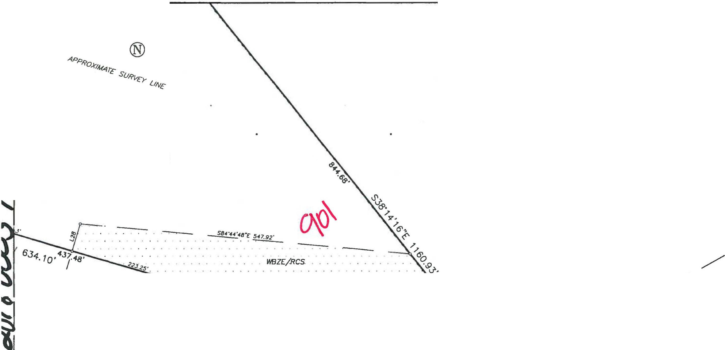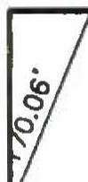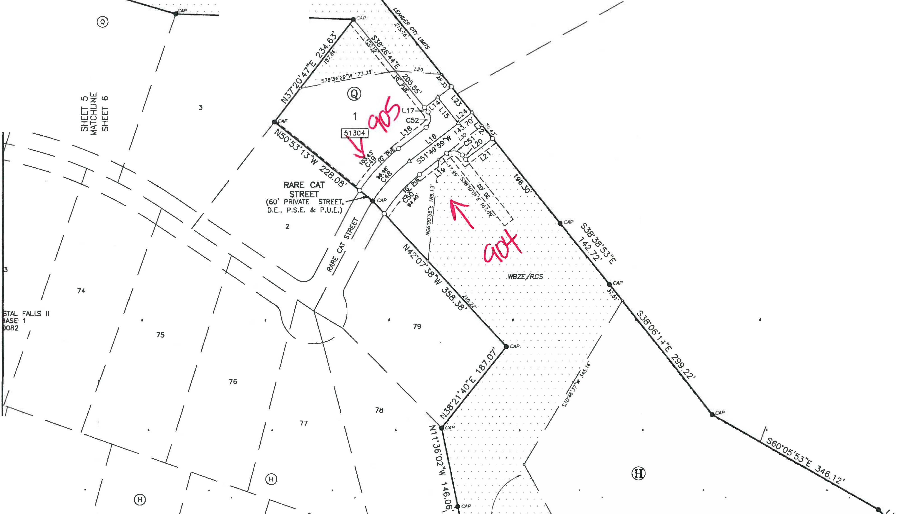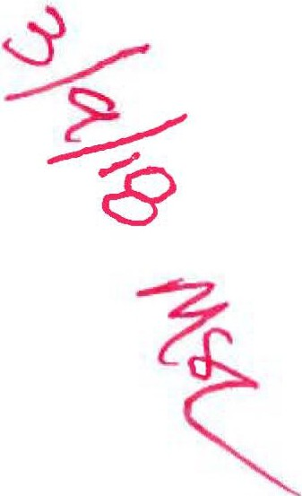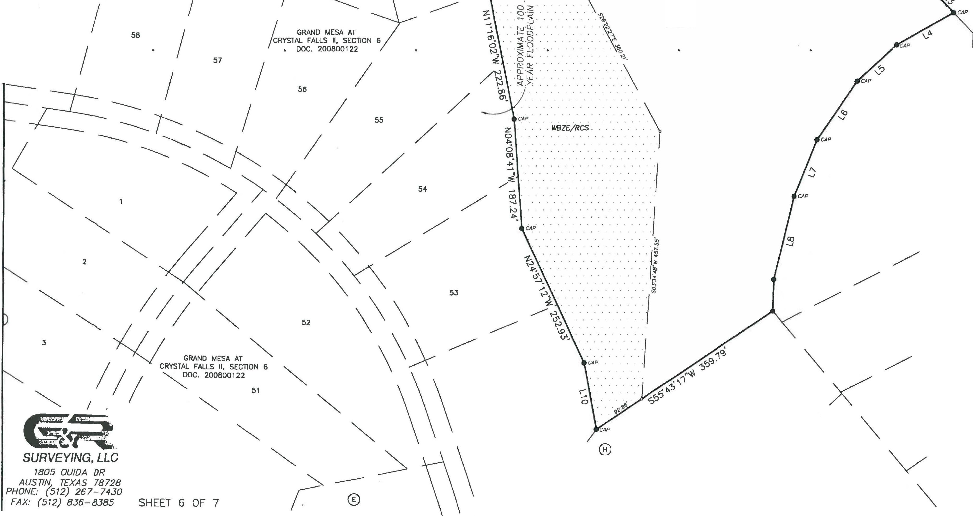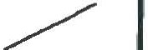

**L\17242-GRAN0 MESA S£CTION 9\dt1f\172-"2_GR-9AS£dw9 12/7/2017 5·J3·•2 PM CST**

*I* 51

*I*

GRANO MESA AT / CRYSTAL FALLS II, SECTION 6

DOC. 200800122

/

/ 50 21

     

      

IN THE CITY OF LEANDER, TRAVIS COUNTY, TEXAS

Grand Mesa Sec. 8 Ph. 1

Ph. 2

**Ph. 1**

**Apple Springs**

Jay Engineering Company, Inc.

P.O. Box 1220

Leander, Texas 78646-1220

Tel. (512) 259-3882 Fax. (512) 259-8016



LOCATION MAP

SCALE: 1"=2000'

**Grand Mesa**

**Sec. 7**

 

   

   

     

      

    

BLK H BLK M BLK N BLK O BLK P BLK Q

**TOTAL LOTS**

**TOTAL AC.**

RESIDENTIAL

LOTS 16 25 4

PARK/GB

DRAINAGE AREA 0 1 0

7 14 7 **73**

1 0 0 **2**

**92.07**

**4.22**

 **75 96.29**

GRAND MESA at CRYSTAL FALLS II - SEC. 8 - PH 1 STREET, DRAINAGE, WATER & WASTEWATER IMPROVEMENTS

    

BLK H BLK M BLK N BLK O BLK P BLK Q

**TOTAL LOTS**

**TOTAL AC.**

RESIDENTIAL

LOTS 7

PARK/GB DRAINAGE AREA 0

0 19 16 29 9 **80**

0 1 1 0 0 **2**

**109.51**

**1.59**

**OVERALL LAYOUT**

**Apple Springs**

**82 111.11**

**157 207.40**

    

  



**Grand Mesa**

**Sec. 7**

50'

Buffer Zone

50'

Buffer Zone

150'

Buffer Zone

OWNER:

Lookout Partners, L.P. 2370 Rice Blvd., Suite 200

Houston, Texas 77005

Phone: (713) 524-5263

Fax: (713) 524-2807

DEVELOPER:

The Lookout Group

2370 Rice Blvd., Suite 200

Houston, Texas 77005

Phone: (713) 524-5263

Fax: (713) 524-2807

ENGINEER:

Jay Engineering Co., Inc.

P.O Box 1220

Leander, Texas 78764.1220

Phone: (512) 259-3882

Fax: (512) 259-8016

SURVEYOR:

Philip McLaughlin, RPLS G & R Surveying, LLC 1805 Ouida Drive

Austin, Texas 78728

Phone: (512) 267-7430

**LOOKOUT GROUP**

Fax: (512) 836-8385

  

   

   

   

       

  

**STREET INFORMATION**

1. A thirty-five (35) foot Building Setback from the Crystal Falls Golf Course shall be dedicated with final plat.
2. All 100-Year Floodplain within the subdivision shall be contained within drainage easement.
3. All Water Quality/Detention Basins within the subdivision shall be maintained by the Crystal Falls Homeowners Association.

**Grand Mesa**

**Sec. 7**

STREET NAME

LENGTH PH. 1

LENGTH PH. 2

ROW WIDTH ROAD WIDTH DESIGN SPD. BASE HMAC

1. Obstruction of drainage easement is prohibited.
2. This Plat represents the maximum density and may be adjusted to a lower denslity based on topography,

**Grand Mesa**

**Grand Mesa**

HIGH LONESOME

1501 L.F.

3367 L.F.

60' 28' B-B

25 MPH

8" 1-1/2"

greenbelts, ingress, regress and market conditions.

**Sec. 6**

**Sec. 2**

BRAVE FACE STREET 3493 L.F. HANGING BOULDER COURT 0

0

839 L.F.

60' 28' B-B

60' 28' B-B

25 MPH

25 MPH

8" 1-1/2"

8" 1-1/2"

1. All streets are private, unless amended.
2. Parkland dedication satisfied through Development Agreement dated Nov. 17, 2003.
3. Property Zoned SFR-2-B.

FLAT IRON STREET

352 L.F.

1606 L.F.

60' 28' B-B

25 MPH

8" 1-1/2"

1. The Following Variances Were Granted With The Concept Plan:
   1. Private Streets With Roadside Drainage

OVER YONDER STREET

0 2714 L.F.

60' 28' B-B 25 MPH

8" 1-1/2"

* 1. No Sidewalks

1 FOOT CONTOURS

EASY MONEY STREET

1681 L.F. 0

60' 28' B-B 25 MPH 8" 1-1/2"

a. No Streetlights

a. No Tree Survey

   

Date: 04-25-14

Sheet

RARE CAT STREET 227 L.F.

198 L.F.

60' 28' B-B 25 MPH 8" 1-1/2"

1. All Easements Of Record Are Shown Or Noted On The Plat Per A Title Search Prepared For The Most Recent Purchase Of The Property.

   

**G.2.0**

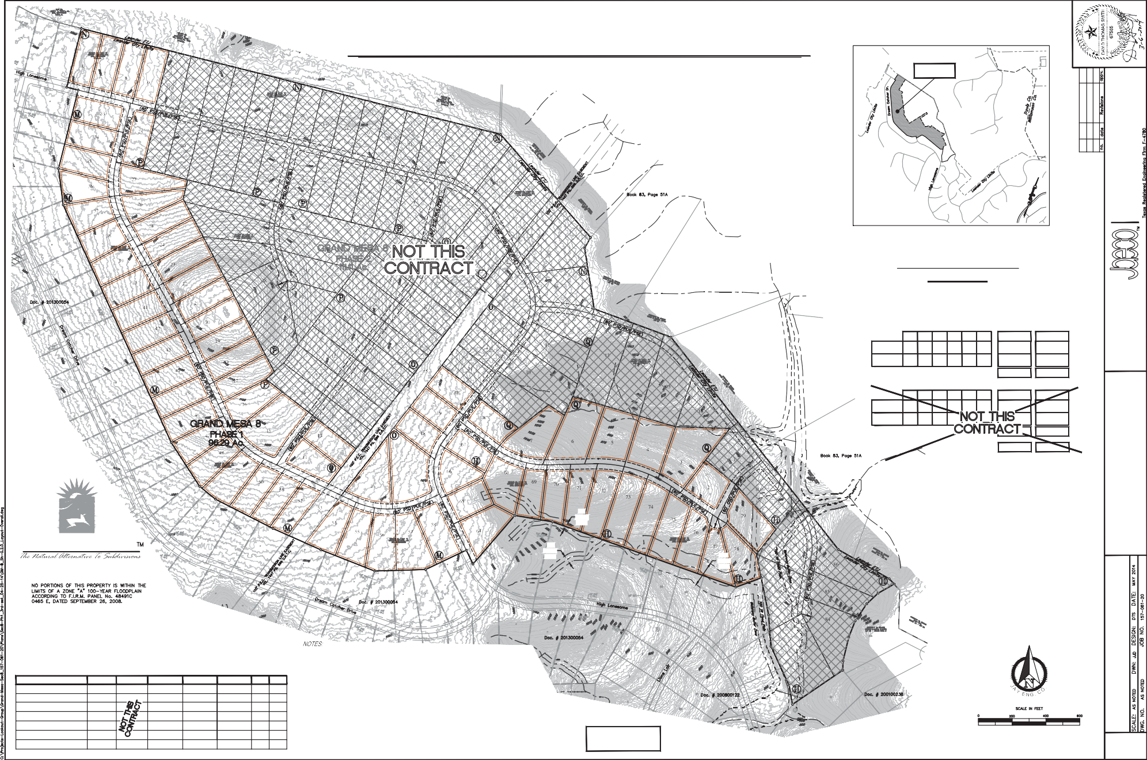

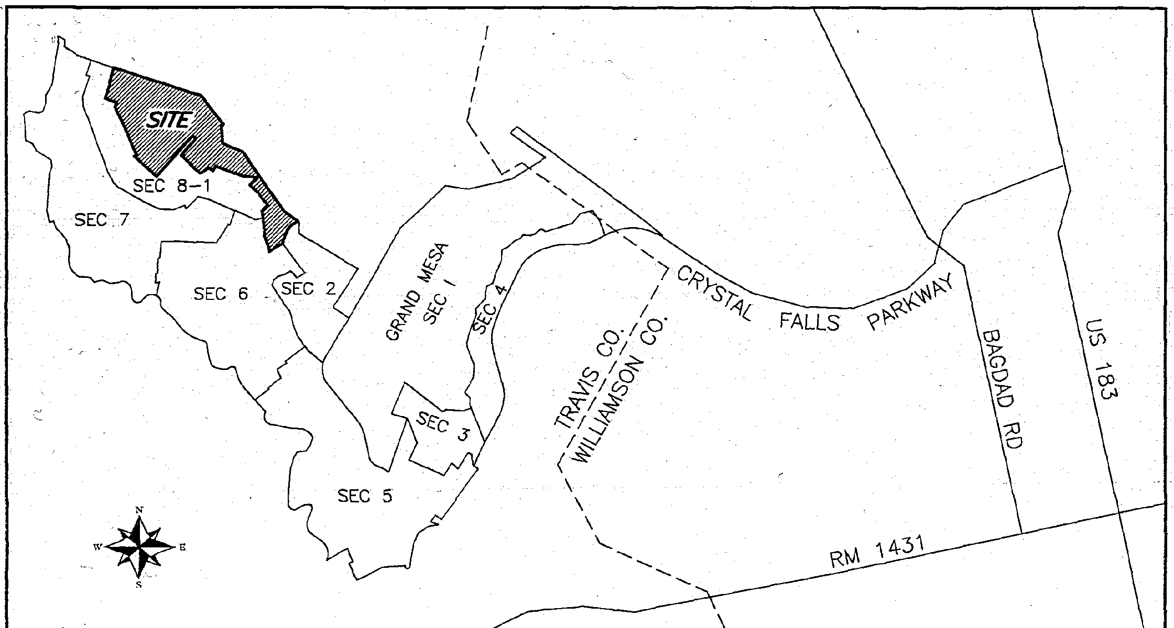LEGEND:

*CAP•* = IRON ROD WITH CAP FOUND

* - 1/2" IRON ROD FOUND

o = IRON ROD WITH G&R CAP SET

= STEEL FENCE POST

GRAND

FINAL MESA AT SECTION

PLAT OF

CRYSTAL 8, PHASE

FALLS 2

11,

LOCilTION MAP

(NOT TO SCALE)

@ PUE PSE DE WBZE

RCS HOA

11155971

05.71

= COTTON SPINDLE FOUND

= MAG NAIL FOUND

= MAG NAIL SET

= CALCULATED PO/NT

* BLOCK NAME
* PUBLIC U"ilLITY EASEMENT

= PUBLIC SAFETY EASEMENT

= DRAINAGE EASEMENT

= WATERWAY BUFFER ZONE EASEMENT

* RIPARIAN CORRIDOR SETBACK

= HOMEOWNERS ASSOCIATION

* LOT AREA IN SQUA,SE FEET
* LIMITS OF WBZE/RCS

OWNER AND -DEVELOPER: SUBMlTTAL DATE: SEPTEMBER 13, 2017 LOOKOUT DEVELOPMENT GROUP, LP. TOTAL AREA OF THIS **PLAT:** 111.080 ACRES 2370 RICE BOULEVARD, SUITE 200 • TOTAL NUMBER OF LOTS: 77

. HOUSTON, TEXAS 77005 RESIDENTIAL: 75

NON-RESIDENT!AL; 2

SURVEYOR:

G&R SURVEYING, LLC UNEAR FEET OF NEW STREETS (PRIVATE):

18D5 OUIDA DRIVE HIGH LONESOME: 3,369

AUSTIN, TEXAS 78728 DEE:P ·POCKCT DRIVE: 1,618 LOYAL JUNE TRAIL: 773

:C:NGINEER: RARE CAT STREET· 210

JAY ENGINEERING CO., INC TOTAL; '5,970 P, 0. BOX 1220

LEANDER, TEXAS 78646

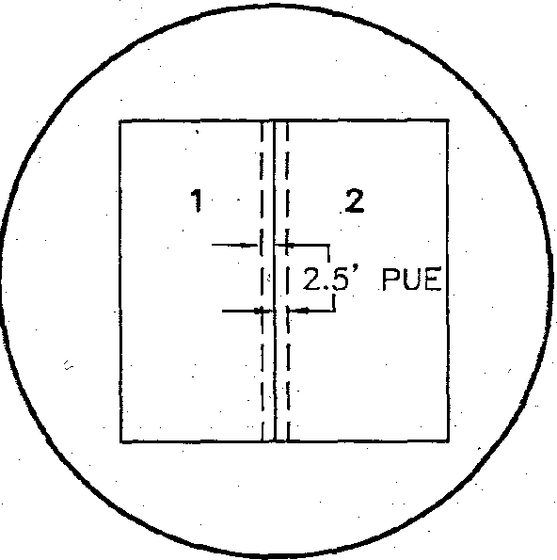

TYPICAL EASEMENT DETA\l

(STDE LOT LINES) N.T.S.

SHEET INDEX _

lsH::::ET 3 (NOT TO SCALE) **7**

I w.,I

I , I

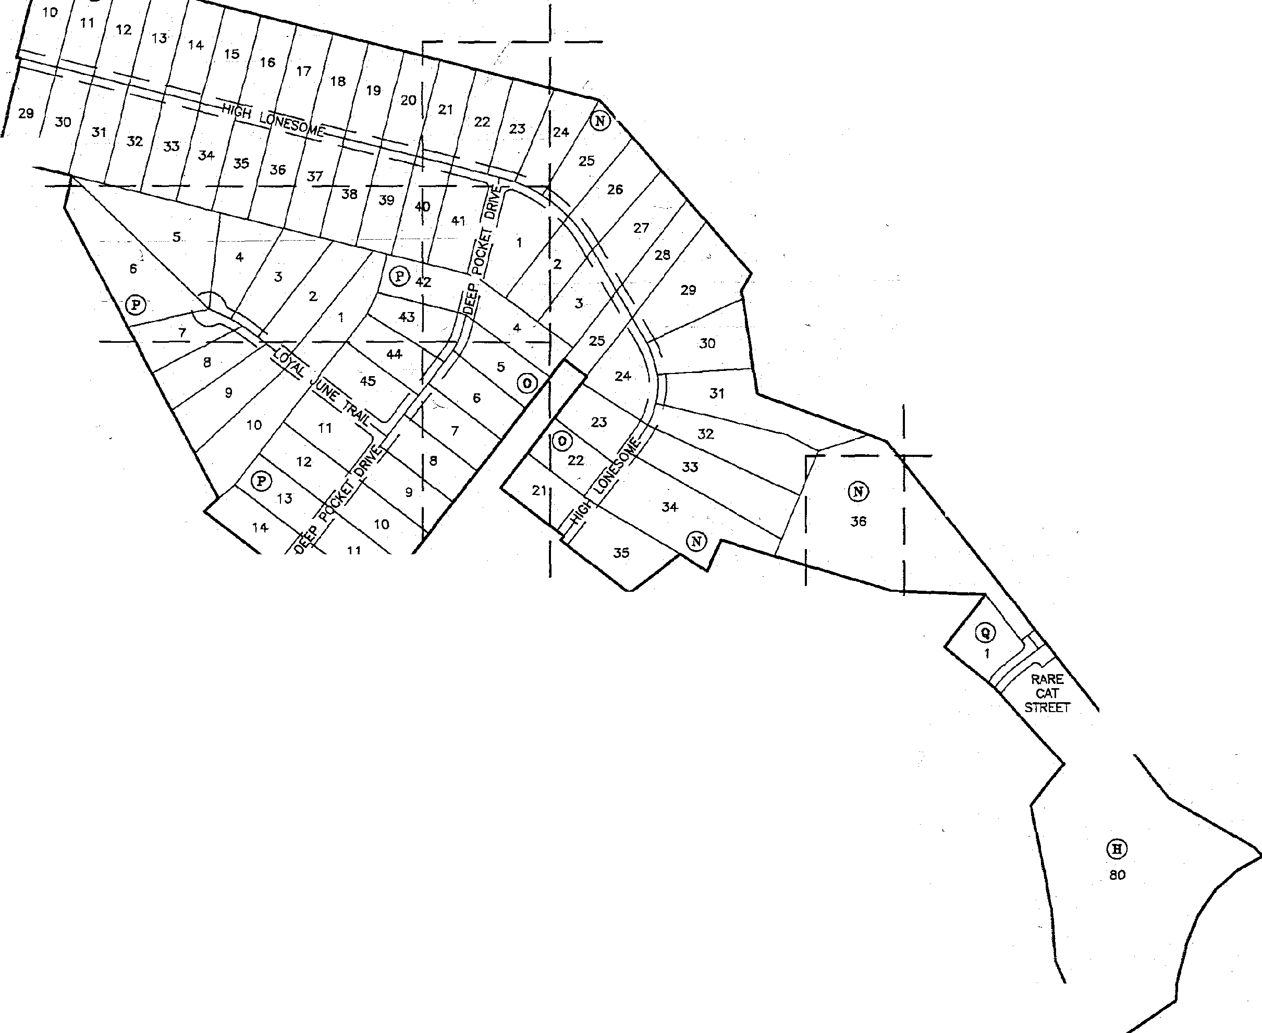I I

I ®

f---

1

I

f----

1

I I

: I I

- - -SHEET s7

I I I I I

I

- - - - SHEET s7

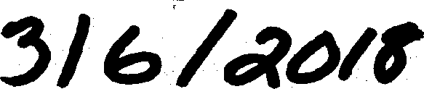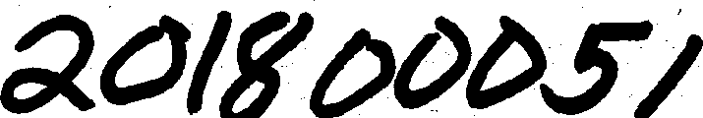

***SURVEYING, LLC***

&

*1805 OUIDA DR*

*PH tfT%17:z5x1 /-¾*

*FAX: (512) 836-8385* SHEET 1 OF 7

SHEET 4 I I I

L: c =:

_l_J

I I I I I I I

L J

GRAND

|  |  |  |  |  |  |  |
| --- | --- | --- | --- | --- | --- | --- |
| CURVE TABLE | | | | | | |
| NO. | DELTA | RADIUS | ARC | CHORD BEARING | CHORD | TANGENT |
| C1 | 6"25'37" | 500.00' | 56.09' | N72'49'03"w | 56.06' | 28.07' |
| C2 | 12'11'29N | 500.00' | 106.39' | N63'30'31"W | 106.19' | 53.40' |
| c., | 13'34'36" | 500.00' | 118.48' | N5a37'29"W | 118.20' | 59.52' |
| C4 | 1.3"44'50" | 500.00' | 119.97' | N36'57'46"W | 119.68' | 60.27' |
| cs | 32"11'41" | 500.00' | 280.95' | N59"56'01"W | 277.27' | 144.29' |
| C6 | 58"02'08" | 300.00' | 303.87' | N01"04'17"W | 291.05" | 166.41' |
| C7 | s·44•3r | 300.00' | 51.02' | N32"49'06"E | 50.96' | 25.57' |
| CB | 15"47'33" | 3no.oo' | 82,69' | N20"o.3'01"E | 82.43' | 41.61' |
| C9 | 19"33'40" | 300.00' | 102.42' | N02"22'24"E | 101.92' | 51.71' |
| C10 | 22·40'55" | 300.00' | 11B.76' | N18"44°53"W | 117.99' | 60.17' |
| C11 | 16"40'35" | 300.00' | 87.32' | .N22"-18'26"E | 87.01' | 43.97' |
| C12, | 702'41" | 300.00' | 36.89' | N34"10'04•E | 36.86' | 18.47' |
| C13 | 23"43'17" | 300.00' | 124.20' | N25"49'46•E | 123..32' | 63.00' |
|  | 6".34'40" | 300.00' | 17.94"' | N54'01'24"W | 17.94' | 8.97' |
| 300.00' | 56.32' | N61"06'54"W | 56.24' | 28.24' |
| 300.00' | 10.10' | N65' 1'43"W | 10.10· | 5.05' |
| 300.00' | 64.16' | N58'26'13"W | 64.04' | 32.20' |
| 530.00' | 60.85' | N72"44'32"W | 60.81' | 30.46' |
| C19 | 11"56'47" | 530.00' | 110.51' | N63•28'49"W | 110.31' | 55.45' |
| C20 | 13'16'26" | 530.00' | 122.79' | N50"52'13"W | 122.51' | 61.67' |
| C21 | 14'08'39" | 530.DO' | 130.84' | N3709'40"W | l30.51' | 65.75' |
| C22 | 0"29'52" | 330.00' | 2.87' | N29"50'25"W | 2.87' | 1.43' |
| C23 | 22•29'45" | 330.00' | 129.57' | N18'20'36"W | 128.74' | 65.63' |
| C24 C25 | 19'21'38"  1 •4,3• | 330.00'  ..,...a.on• | 111.51'  88.67' | N02"35'05"E N19'57'45"E | 110.98'  88.40' | 56.29'  44.60' |
| C26 | 10"01'48" | 330.00' | 57.77' | N32"40'31"E | 57.69' | 28.96' |
| C27 | 10"16'28" | 270.00' | 48.42' | N32'33'11"E | 48.35' | 24.27' |
| C28 | 57'30'17" | 270.00' | 270.99' | N01"20'12"W | 259.75' | 148.14' |
| C29 | 13'12'07" | 470.00' | 108.30' | N36'41'24"W | 108.06' | 54.39' |
| C30 | ?6"21'38" | 470.M' | 216.24' | N56'28'17"W | 214.34' | 110.07' |
| C31 | 96"22'46" | 20.00' | 33.64' | ss2·09•31"W | 29.81' | 22.36'" |
| C32 | 17'24'26" | 330cOO' | 100.26' | N22"40'21"E | 99.87' | 50.52' |
| C33 | 6"18'50" | 330.00' | 36.37' | N34.32'00"E | 36.35' | 18.20' |
| C34 | 90"00'00" | 20.00' | 31.42' | N07'18'35"\II | 28.28' | 20.00' |
| C35 | 6"49°24" | 270.00' | 32.15' | N55"43'17"W | 32.13' | 16.10' |
| C36 | 121•3r | 270.00' | 34.68' | N62"48'47"W | 34.66' | 17.37' |
| C37 | 51"19'04" | 20.00' | 17.91' | S87'50'52"W | 17.32' | 9.61' |
| C38 | 105'19'20" | 60.00' | 110.29' | S65"09'00"E | 95.41' | 78.65' |
| C39 | 56'47'44" | 60.00' | 59.48' | S15'54'32"W | 57.07' | 32.44' |
| C40 | 52"42'18" | 60.00' | 55.19' | S70'39'33"\II | 53.27' | 29.72' |
| C41 | 67'48'46" | .60.00' | *n.o,·* | N49'04'55"W | 66.94' | 40.33' |
| C42 | 51"19'04" | 20.00' | 17.91' | S40'50'04"E | 17.32' | 9.61' |
| C43 | 2"22·1r | 330.on• | 13.66' | N65"18'27"W | 13.66' | 6.83' |
| C44 | 11"48'44" | 330.00' | 68.03' | N58"12'57"W | 67.91' | 34.14' |
| C45 | 90·00'00" | 20.00' | 31.42' | N82'41'25"E | 28.28' | 20.00' |
| C46 | 23"43'17" | 270.00' | 111.78' | N25"49'46"E | 110.99' | 56.70' |
| C47 | so·oo·oo· | ?0.00' | 31 42' | N31·01'52"W | 28.28' | 20.00' |
| C48 | 18"36'12" | 300.00' | 97.41' | S42"31'53"\II | 96.98' | 49.14' |
| C49 | 18'04'01" | 330.00' | 104.06' | S42"47'59"W | 103.63' | 52.46' |
| C50 | 20·1s'24" | 270.00' | 95.54' | S41"41'47"W | 95.04' | 48.27' |
| C51 | 90"00'00" | 20.00' | 31.42' | N83"10'01"W | 28.28' | 20.00' |
| C52 | -90'00:0Q" | ?0.00' | 31.42' | N06'49'59"E | 28.28' | 20.00' |

**&a.**

FINAL MESA AT SECTION

PLAT OF

CRYSTAL 8, PHASE

FALLS

2

II,

MEJIS ANO BOUNDS DESCRIPTION:

DESCRIPDON OF 111.080 ACRES OF LAND SITUATED IN TRA\llS COUNTY. "TEXAS, OUT OF 11-iE PA GLOSSOM SURVEY, 11-iE MCKINNEY a: Will.JAMS SURVEY 175, AND 11-iE CANOEI.AAJA YBARBO .SURVEY 422, BEING A PORTION OF A 1,013.55 ACRE TRACT OF LANO DESCRIBED A DEED OF,RECORO TO. LOOKOUT PARTNERS, LP. IN DOCUMENT NUMBER 2000162836, OFFICIAL PUBLJC RECORDS *OF* TRAVIS COUNTY, lEXAS; SAID 111.080 ACRE TRACT BEING ·MORE PARTICULARLY DESCRIBED BY METES JIND BOONOS />S FOLLOWS:

BEGINNING AT A AN IRON .ROD Willi CAP FOUND IN THE SOUTHERLY LINE OF A 127.030 ACRE lRACT OF LANO OESCRIBEO IN A'DEED Of" RECORD TO DOUGLAS D. HOOO IN VOLUME 12189, PAGE 13:59, REAL PROPERTY RE'CORDS OF TRAVIS COUNn', 'JEXAS, SAME BEING ThiE NORTHERLY LINE OF SAID 1,013.55 ACRE "TRACT, AT THE fllORTiiEASTERLY CORNER *OF* GRANO MESA AT CRYSTAL FAUS JI, SECTION 8, PHASE 1, A SUBOl\llSION OF RECORD IN DOCUMENT NUMBER 201500082, OFFJCIAL PUBLIC RECORDS OF lRAVIS COUNTY. TEXAS, FOR THE NORTJiWESTERLY CORNER OF THE HERBN DESCRIBED

™"''

THENCE CONTINUING WITH THE NORTiiERLY LINE OF SAID 1,013.55 ACRE "TRACT, AND THE SOUTHERLY LINE OF SAID 127.roo ACRE TRACT, ANO GENERALLY ALONG THE LINE OF A WIRE GAME FENCE, THE FOL.LOWING FOUR ( 4) .COURSES:

1. S75'45•41•E, A DISTANCE OF 425.49 FEET TO A STEEL FENCE POST;
2. S75'40'02"E, A DISTANCE OF '2£7.70 fEET TO A STEEL FENCE POST;

J. S75'5J'JJ"E, A DISTANCE OF 999.22 FEET TO A STm. FENCE • POST;

4. S75'55'08"E, A DISTANCE OF 312.99 FEET TO AN l.RON ROD Willi CAP FOUND AT lliE SOUlliWESTERLY CORNER OF APPLE SPRINGS, A SUBOM.S\00 OF RECORD IN BOOK 83, PAGES 51A-558 , PLAT RECORDS Of" TRAVIS COUNTY. TEXAS, FOR TI-IE NORTHEASTERLY CORNER OF THE HEREIN DESCRIBED TRACT:

11-IENCE WITH 11-lE COMMON LINE OF SAID 1,01355 ACRE l"RACT. AND SAID APPLE SPRINGS, THE FOLLOWING NINE (9) COURSES:

1. S41'06'04 A DISTANCE OF B10.20 FEET TO AN !RON ROD WITH CAP FOUND;
2. S29"14'52"W, A DISTANCE OF 72.40 FEET TO AN JRON *ROD* WllJi CM' FOUND:

J. S08'54'09•E, A DISTANCE OF 363.21 FEET TO A COTTON SPINDLE FOUND:

1. S69'38'12•E, A DISTANCE OF 484.19 FEET TO AN JRON ROD WITH CAP FOUND;'
2. S38"14'16 , A DISTANCE OF 1160.93 FEET TO AN IRON ROD WI CAP FOUND;
3. S38"38'53"E, A DISTANCE OF 142.72 -FEET TQ AN JRON "ROD WITH CAP FOUND:
4. S38"06.14"E, A DISTANCE OF 299.2.2 FEET TO AN IRON ROD WITH CAP FOUND;
5. sso·o5•53•E, A DISTANCE OF 3 .12 FEET TO A 1/2" IRON ROD FOUNO:

-9. S43"57'28•E, A DISTANCE OF 4J.04 FEET TO AN IRON .ROO WITH CAP FOUND AT THE NORTHWESlIRLY CORNER OF GRANO MESA II AT CRYSTAL FAU.S, A SUBDMSJON OF RECORD IN DOCUMENT NUMBER 2001002.36, OFFICIAL PUBI.JC-RECORDS OF lRA\llS COUNTY, TEXAS, FOR 11-lE MOST EAS'JERLY

|  |  |  |
| --- | --- | --- |
| LINE TABLE | | |
| NUMBER | DIRECTION | DISTANCE |
| L1 | N66'29'36"W | 1?.50' |
| L2 | S66'29'36"E | 12.50' |
| L3 | S43"57'28"E | 43.04' |
| L4 | S60"10'32"W | 110.89' |
| LS | S46'50'44'\V | 91.50' |
| L6 | 534"17'20"W | 120.76' |
| L7 | S21'28'05"W | 104.18' |
| L8 | S13"39'12"W | 145.88' |
| L9 | S01'23'41"W | 54.15' |
| L10 | N10"32'"19"W | 116.24' |
| L11 | N37'41'25"E | 17.19' |
| L12 | N47'"11'05"E | 66.66' |
| L13 | N16·01'52"'W | 15.37' |
| L14 | N51'49'50 E | Jo.no' |
| L15 | S3B'10'01"E | 59.96' |
| L16 | S51'49'59"'W | 112.24' |
| L17 | S.38'10'D1"E | 9.96' |
| L16 | 551·49•59-W | 62.24' |
| L19 | N51'49'50"E | S?.24' |
| L20 | S38"10'01"E | 10.00' |
| l21 | N51'49'59•E | 61.53' |
| l22 | N38"14'16"W | 60.00' |
| l23 | N38'14'16"\,\I | 59.96' |
| l24 | S51'49'59"W | 31.46' |
| l25 | N08"29'38•E | 51.38' |
| l26 | N16'54'25"E | 57.97' |
| l27 | S06'00'08.E | 58.21' |
| l28 | N16'47'42"E | 46.92' |
| L29 | N85'26'46"w | 84.07' |
| l.30 | N51'31'40"E | 81.50' |

-CORNER OF lliE HEREIN DESCRIBED TRACT;

THENCE'OVER AND ACROSS SAID 1,013.55 ACRE TRACT WITH 11-iE WESTERLY LINE OF SAID G!W-11) MESA II .AT CRYSTAL FAUS, 1HE FOll.OWING SIX (fi)_ COURSES:

1. S60-10'32"w, A DiSTANCE OF 110.89 -fEE.T TO AA I.RON ROD WJTH CAP FOUND;
2. S46'50'44"W,.A DISTANCE *OF* 91.50 FEET TO JIN IRON ROD WITT-J CAP FOUND;

:3. S34"·17'20"W, A Ols:rANCE OF 120.76 FEET TO AN IRON ROD WITH CAP FOUND;

1. S21'28'05"w, A DISTANCE OF 104.16 FEET TO AN IRON ROO WITT-I CAP FOUND;
2. S1J'J9'12"W, A DISTANCE OF 145..88.FEET TO AN IRON ROD _".'fl!' CAP f_OU ;
3. S01"2.3'41"W, A DISTANCE *OF* 54.15 fEET TO AN JRON ROD WJTH CAP FOUND AT THE Mosr NORTHERLY CORNER OF LOT 51, BLOC!< H, "GRANO MESA AT CRYSTAL FAU.5 11, SECTION 6, A SUBDMSION OF RECORD IN DOCUMENT NUMBER 200800122, OFFICIAL PUBLIC RECORDS OF TRAVIS COUNTY, TEXAS, *FOR* "TI-IE MOST SOUTHERLY CORNER OF THE HEREIN DESCRIBED TRACT;

11-iENCE CONTINUING OVER AND ACROSS SAJO 1,013.55 ACRE TRACT WITH TI-IE NORTHERLY LINE OF SAID GRANO MESA AT CRYSTAL FAUS II, SECTION 6, THE fOU.OWING flVE (5) COURSES:

1. S55'43'17"\'i. A DISTANCE OF 359.79 FEET TO AN lRON ROD WITH CAP FOUND:
2. N10-32'19"W, A DISTANCE OF 116.24 FEET TO AN IRON ROD WITH CAP FOUND;

J. N24"57'12"W, A DISTANCE OF 252.93 FEET TO AN IRON ROD WITI-1 CAP FOUND;

4. N04"08'41"W, A DISTANCE OF 187.24 FEET TO AN IRON ROD WITI-1 CAP FOUND:

-5. N'11·1s·o2"W, A DISTANCE OF 222.86 FEET TO AN IRON ROD WITI-1 CAP FOUND AT THE SOUTHEASTERLY COR!-IER OF SAID GRAND MESA AT CRYSTAL FAUS II, SECTION 8. PHASE 1;

"THENCE CONTINUING OVER ANO ACROSS SAID 1,013.55 ACRE TRACT WITH 11-iE EASTERLY UNE OF SAID GRANO MESA AT CRYSTAL FAUS !I, SECTION 8, PHASE 1, lliE FOU.OWING TWENlY-FOUR (24) COURSES:

1. N11'36"02"W, A 'DISTANCE OF 148.06 FEIT TO AN IRON ROD WITH CAP FOUND;
2. N36"21'40•E, A DISTANCE OF 187.07 FEET TO AN IRON ROD WITI-1 CAP FOUND;
3. N4Z07'38"W, A DISTANCE OF 358.38 FEET TO AN tRON ROD WlTH CAP FOUND;
4. N50"53°13°'W, A DISTANCE OF 228.08 FEET TO AN IRON ROD WITH CAP FOUND;
5. N37'20'4r A DISTANCE OF 234.63 FEET TO AN IRON ROD WITI-1 CAP FOUND;
6. N88"08'2.3"W, A DISTANCE OF 320.33 FEET TO AN IRON ROD WJTH CAP FOUND:
7. N7S28'16"W, A DISTANCE OF 6.34.10 FEET TO AN IRON ROD WITH CM' FOUND;
8. S23"57'26"W, A DISTANCE OF 122.88 FEET TO AN IRON .ROO Wm-I CAP FOUND;
9. N56"27'4S"W, A DISTANCE OF 112.56 FEET TO AN IRON ROD WITH CAP FOUND;
10. S52'07'11"W, A DISTANCE OF 225.17 "FEET TO AN IRON ROD WITI-1 CAP FOUND:
11. N52'18'JS"W, A DISTANCE OF 306.74 FEET TO AN IRON ROD WITI-1 CAP FOUND;
12. N3741c"25"E, A.DISTANCE OF 17.19 FEET TO .AN IRON *ROD* Wll}j CAP FOUND;
13. N52'18'3s"W, .A DISTANCE OF 280.00 fEET TO AN 1RQN ·ROO WITH CAP FOUND;
14. NJ741'25"E. A DISTANCE .0F 497.4S FEET TO AN IRON,ROD WITH CAP FOUND;
15. -N52'18'35"W, A DISTANCE OF 100.00 FEET-TO AA ,JRON ROD WITH CM' FOUND;
16. SJ7"41'25"W, A DISTANCE OF 1200.00 FEET TO AN JRON ROD WITH CAP FOUND;
17. N52'1S'35"W, A DISTANCE OF 673.41 FEET TO AN lRON ROD WllJi CAP FOUND;
18. N47"11'os·E, A oisrANcE oF 86.66 fEET TO AN"IRON ROD WITH CAP FOUND;
19. N27"47'13".W, 'A DISTANCE OF 1_156.40 FEET TO AN IRON ROD WJTH CAP FOUND;
20. N12"44'45"E, A DISTANCE OF 116.39 FEET TO AN IRON ROD WJTI-1 CAP FOUND;

***SURVEYING,*** *LLC*

*1805 OUIDA DR*

*AUSTIN, TEXAS 78728*

*PHONE: (512} 267-7430*

*FAX: (512) 836-8385* SHEET 2 OF 7

.21. N76"01'52"W, A DISTANCE OF 270.40 FEET TO AN IRON ROI) WITH CAP FOUND;

22. N13"21'02 E, A DISTANCE OF 359.80 FEET TO AN IRON ROD WITH CAP FOUNC;

2.3. N76"01'52"W, A DISTANCE OF 15.:57 FEET TO AN IRON ROO WITH CAP FOUND;

24. N13"58'08 A DISTANCE OF 354.86 FEET TO ThiE POINT OF BEGINNING, COl'fTAINJNG AN AREA OF 111.080 ACRES OF LAND, MORE OR LESS.



J..:\172-<l!-0 MESA S\dwg\17:.4;1..GIHll\5.E.dwg 11/21./2017 ll:,fl!;!J5 CST

FINAL

*SI* I

**PLAT OF**

*TEXAS MEXICO RAILROAD CO. SURVEY 203*

MESA AT SECTION

CRYSTAL 8, PHASE

FALLS

2

II,

127.030 AC; (TRACT 2)

DOUGLAS D. HOOD

VOL 12189, ·PG. 1339

*MCKINNEY* & *WILLIAMS SURVEY* 175

s

1"=100'

0 50 100 200

BEA.RING BASIS:TEXAS CENTRAL ZONE.

*STATE* PLANE COORDINATES (NAO 83)

400

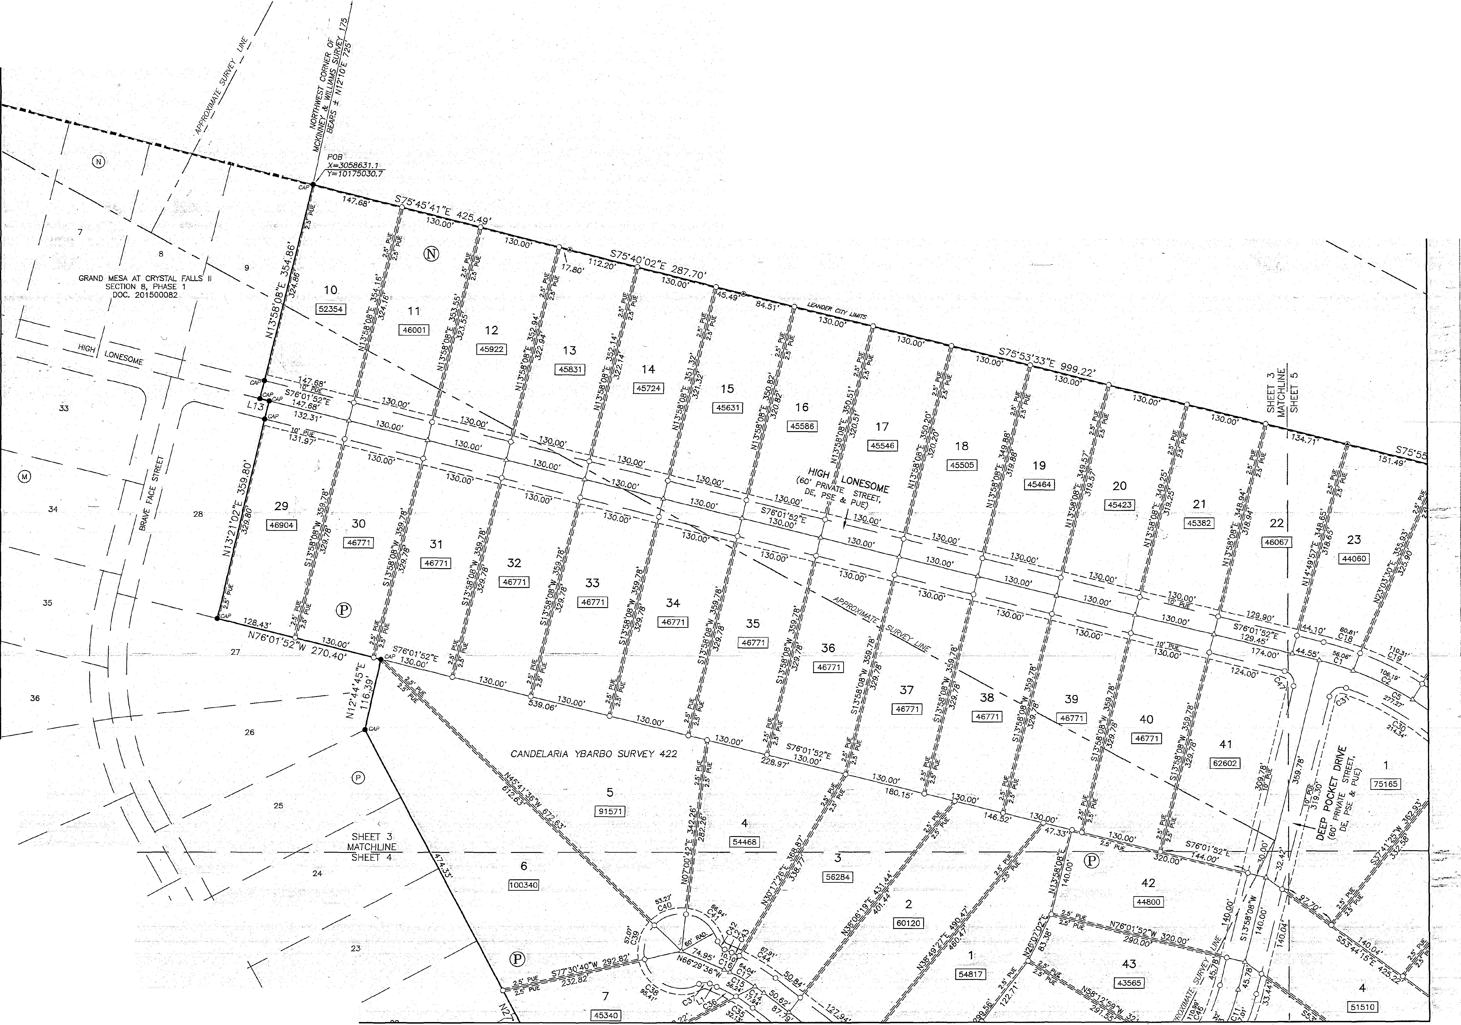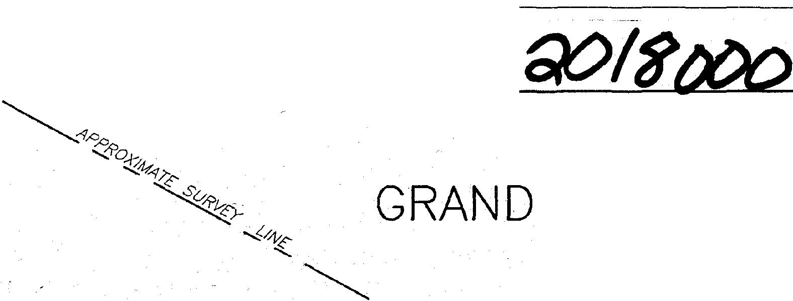

37

38

**&;:t**

***SURVEYING,*** *LLC*

*1805 OUIDA DR*

*io/Jif%l25x"Jli¾1i*

*FAX: .(512) B36-8385* SHEET 3 OF 7

L;\17242-<lRA>W *NESI* SECTION 9\cwg\:7242..._(lR-BASE.owg 11/21/2017 8;46:06 *AN*

0 50 100 200

* **BEARING BASIS;lEXAS CENTRAL ZONE/ STAlE PLANE COORDINA'JES (NAD 83)**

400

l4

GRAND

FINAL PLAT OF

MES.tt AT CRYSTAt. FALLS SECTION, 8, PHASE 2

11,

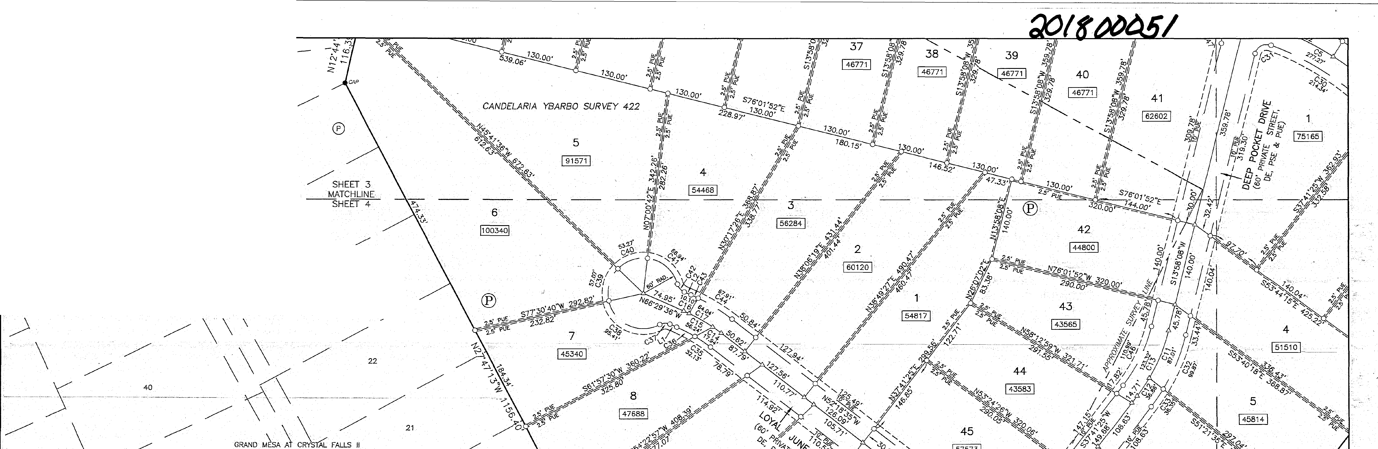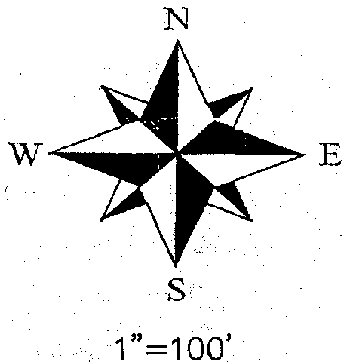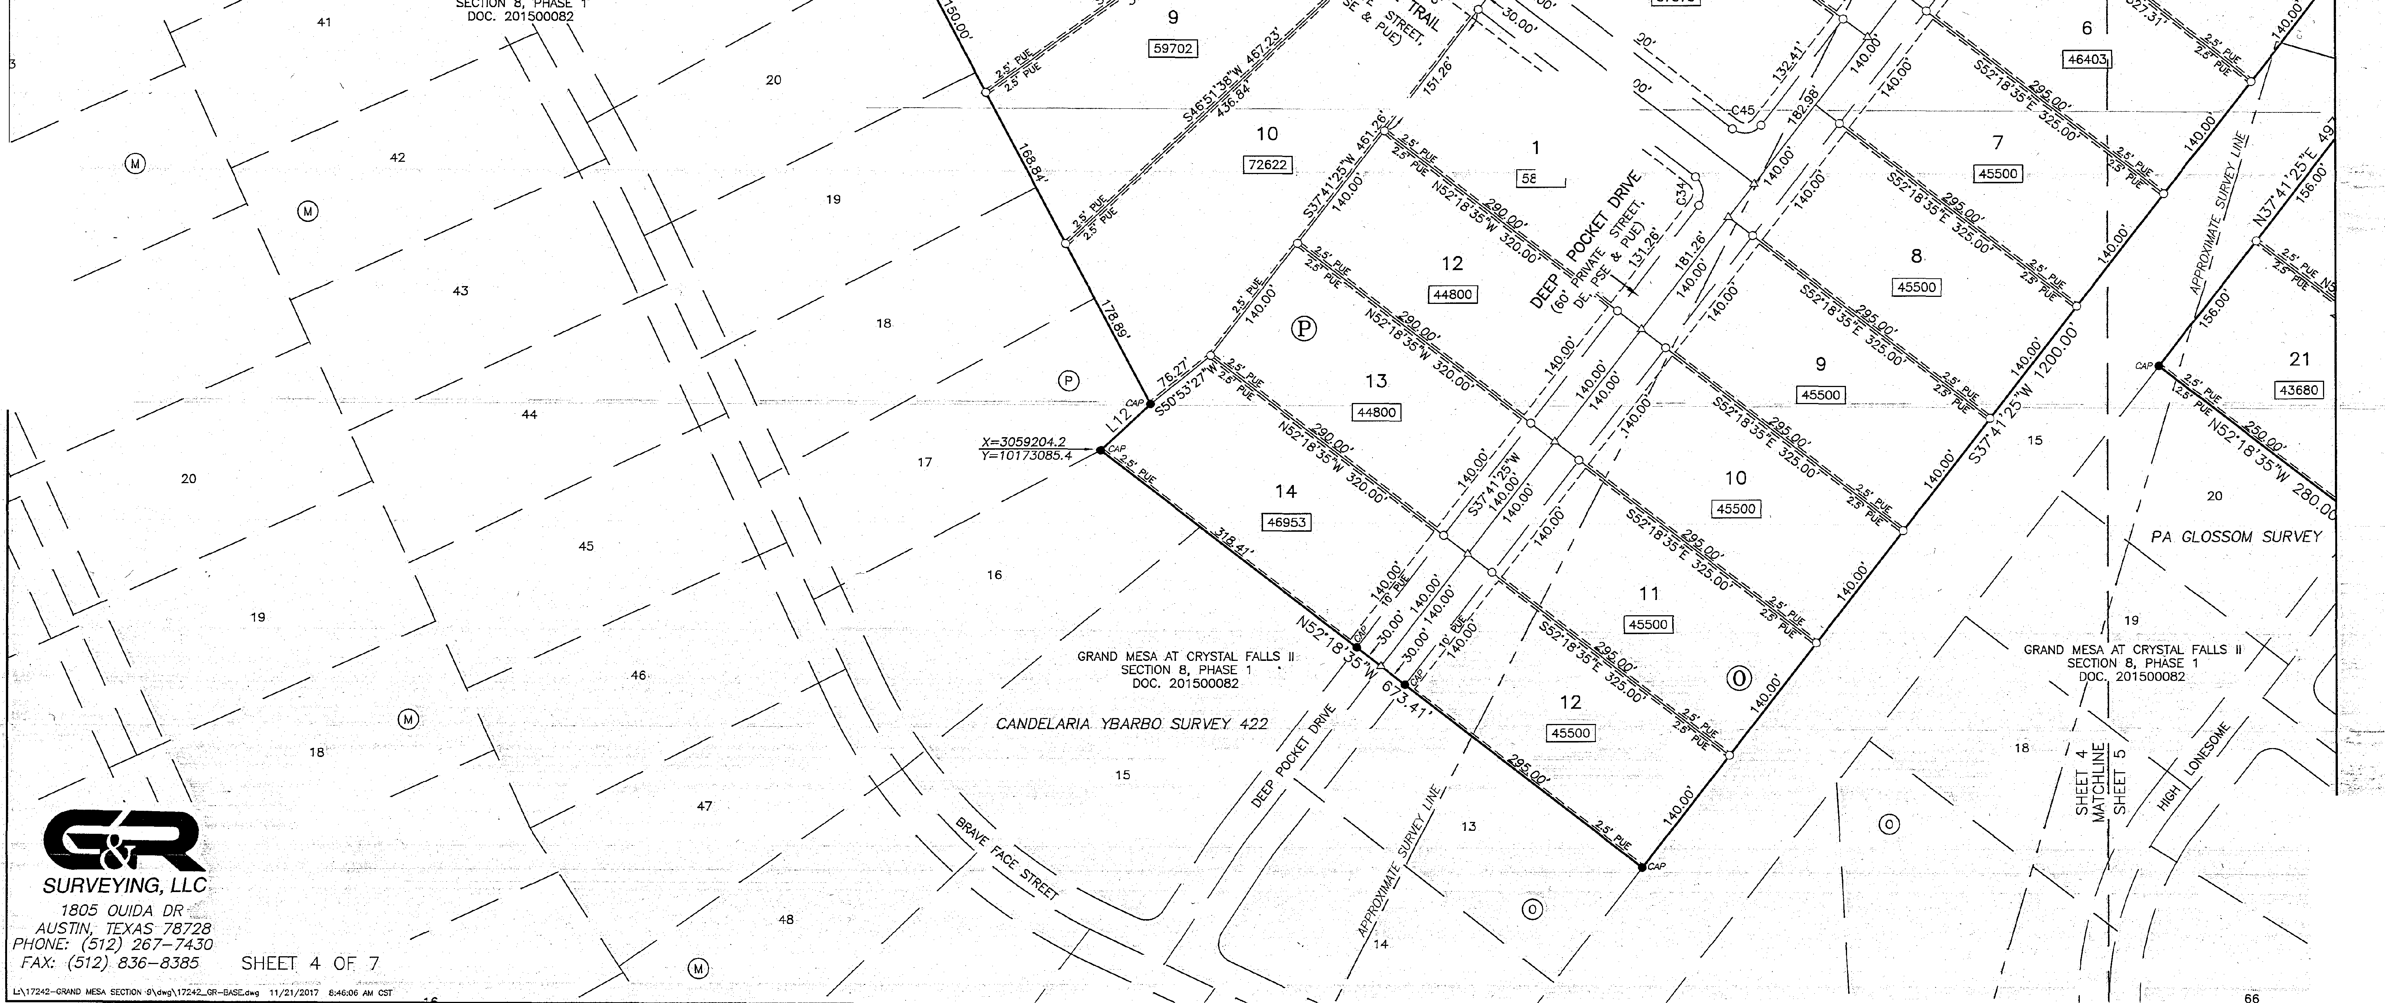

' *'--"<o*

', ***J'..?o***

*,?' C'i.D.o.?::>-.,,'-0*

1 '

**003** -

22

21

6 .

..i

GRAND

FINAL P T OF

MESA Al CRY TAL SECTION 8, PHASE

o so 100

BEARING eAStS!ID<AS 'CENTRAL'· ZONE, STATE PLANE COORDINATES (NAO 83)

I i .

FA(cs

2

II,

19 '

/

/

/

/

-S29"14'52"W 72.40"

,,APPL ·sPRiNGS

°En(. 83, Pq. 51A-q B

*/*

*I*

*l*

20

30

! 62675 ! *I*

*l*

31

I•••••I

I

- ..,,,, I*t®*

*•••{i'o tffAT!' sl'* .

I - -

*'1Nc*

- .

.tr. 36

I

!i74109!

/

/ *Y=1017 872.J I*

*PA* ldLossiiM SVRVfY.

*I* 6 i /

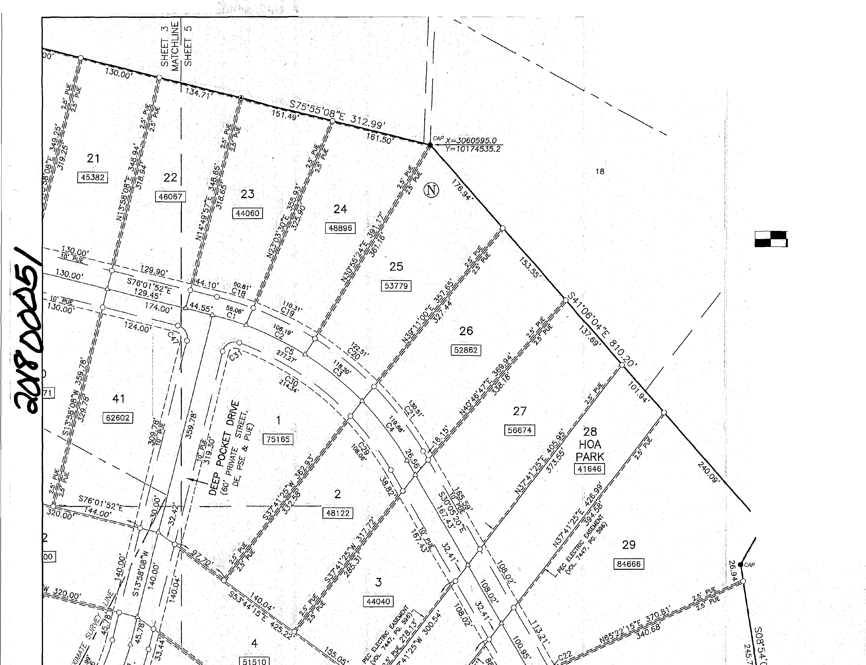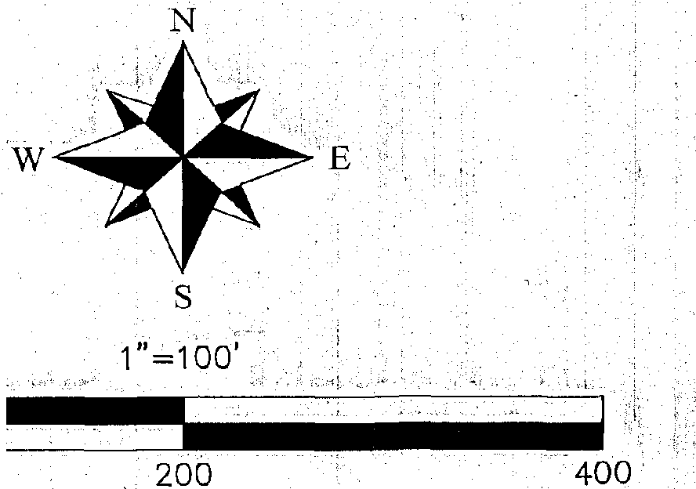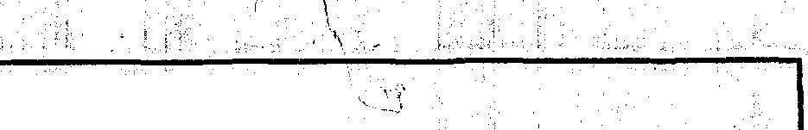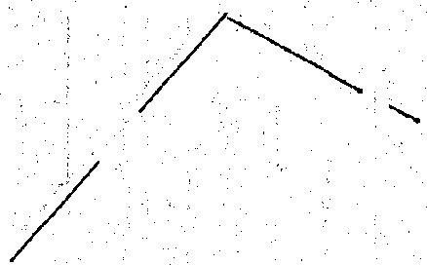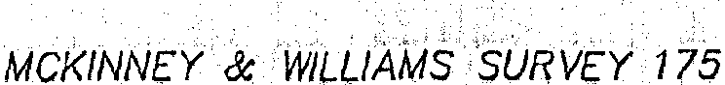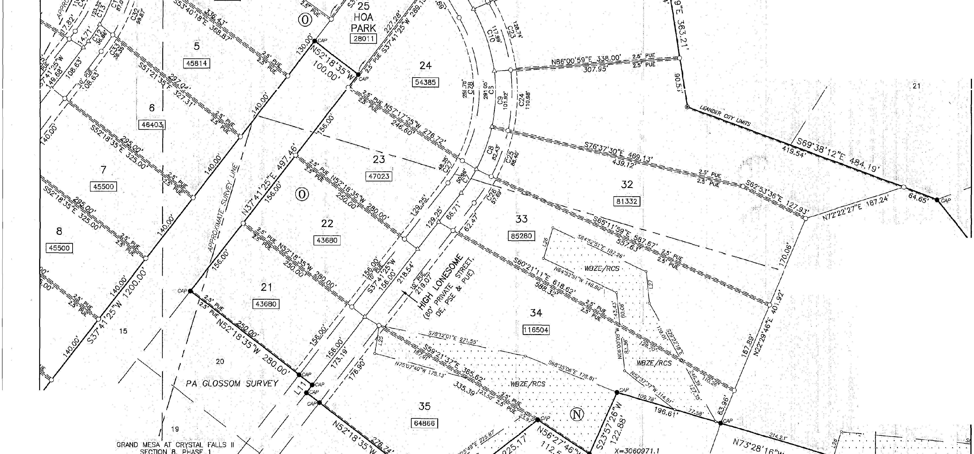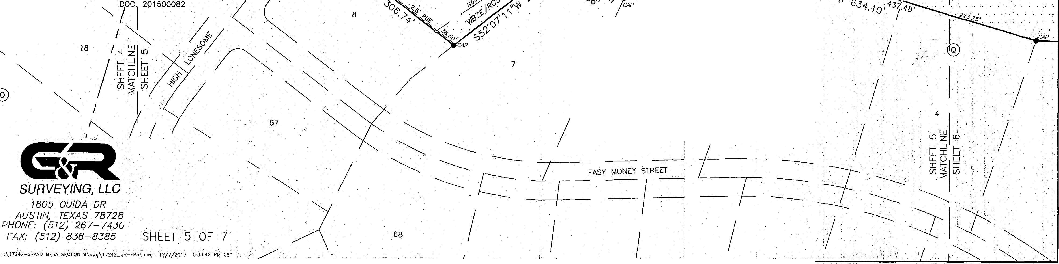

*I*

GRAND t-{ESA AT CRYSTAL FALLS II

ECTION 8, PHASE 1

;ooc. 2700082

!

I

**GRAND**

**FINAU PLAT OF** , : . .

**MESA AT CRYSTAL F'A Ls<i1;**

**SECTION *:5,* PHASE 2**

**36**

12741091 :

PA IGLOSSOM *SURV/;Y*

*MCKINNEY WILLIAMS SURV£Y 175*

52

-'-;.

. l\'BZE/RCS .

-----

0 50 100 200

--. **BE'ARING BAS1s:TEXAS CENTRAL ·i:bNE,**

**/ ST E :LANE COORDINATES (NAp 83)**

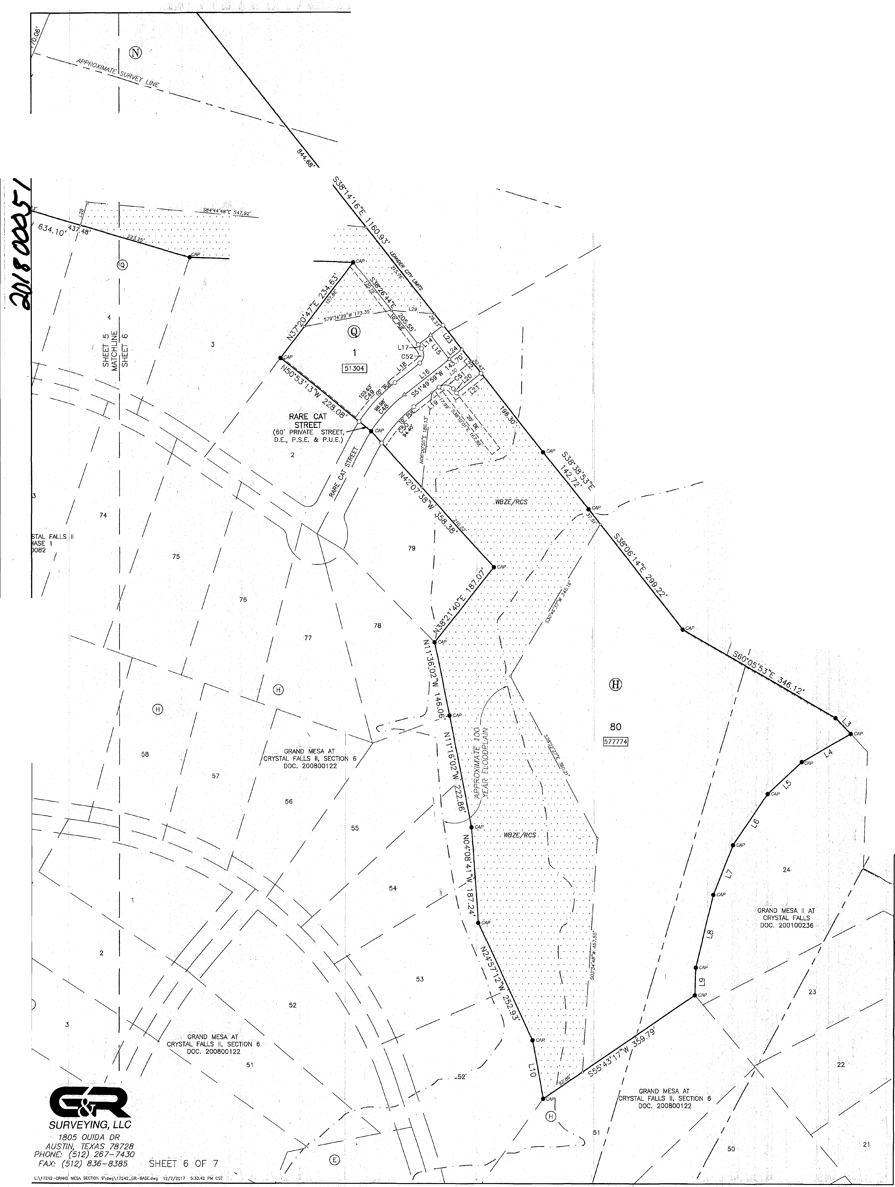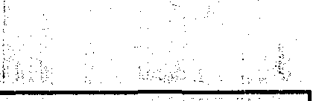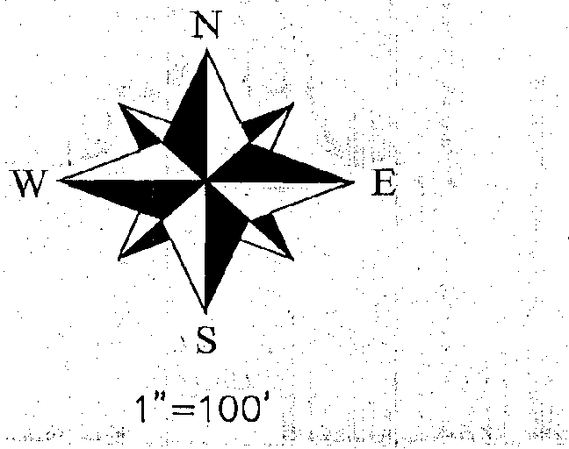

N88"08'23"W 320.33'

*l*

*l*

*I.*

53 *I*

.,*I*

*I, l*

*!l/*

*I*

*:I*

*}/*

**54**

59

*I*

*I'*

*I*

FINAL PLAT OF

GRAND MESA AT CRYSTAL. SECTION 8 , PHASE

FALLS

2

II,

1. TulS.'SuaoMs10N 1s WHDU.Y coNT NED WITHiN THE CURRENT CORPORATE.LIMITS OF'THE CITY oF· LEANDER,,TEXAS.

STATE OF TEXAS: :, COUNTY OF 1RAVIS:

STATE OF' TEXAS:',

COUNTY *OF* TRAVIS: .

,;., , ,

NO LOT JN lHIS SUBDIVISION SHALL .BE ·occUPIED ·uNTIL coNNECTED TO THE CITY o; LEANDER WATER DJSTR; unoN SYSTEM._

.3.- A BUILDING PERMIT JS REQUIRE□•FROM THE CITY OF LEANDER PRIOR TO CONSTRUCTION OF ,N,JY BUILDING OR SITE JMPROVEMENTS ON y l.OT

* IN 1HIS SUBDIVISION.

1. NO BUILDINGS, FENCES, LANDSCAPING OR OTHER S1RUCTURES ARE PERMITIED WITHIN DRAINAGE EASEMENTS SHOWN, EXCEPT AS APPROVED BY THE CITY OF LEANDER PUBUC WORKS DEPARTMENT.
2. PROPERTY •□WNfR SHAU. .PROVIDE FDR-ACCESS TO DRAINAGE EASEMENTS'AS MAY BE· NECESSARY AND SHAU. NOT PROHIBIT ACCESS BY THE

DEDICATION STATEMENT:"''

1. NO STRUCTURE IN THIS SUBDIVISION SHAU. BE OCCUPIED UNTIL CONNECTED TO A PUBUC. SEWER SYSTEM OR· A PRNATE ON-SITE WASTEWATER. (SEPTIC) SYSTEM THAT HAS BEEN APPROVED ANO LICENSED FOR OPERATION BY THE TRAVIS COUNlY•-ON-SITE WASTEWATER .PROGRAM. , '

2;\ksuoi0 1i a=.E 1u t MS ?r :m :o ·Ri Yki - % R' THINGS, THAT A CONSTRUCTION PERMIT BE 'OBTAINED FROM,• TRAVIS ,COUNTY ,BEFORE AN ON-SITE SEWAGE FACILITY CAN -BE CONSTRUCTED, ALTERED, MODIFIED, -OR REPAIRED IN 'THE SUBDMSlON AND· THAT. A LICENSE

TO OPERATE BE OBTAINED FROM 1RAVIS COUNTY BEFORE AN .ON-SllE SEWAGE FACILITY CAN BE.,OPERATED JN •

ClTY OF LEANDER. _ -- ------- -- - - -------- -

_T!:jE_SUBDMSiON,

----- -·. '----

_·c _

1. ALL: EASEMENTS ON. PRIVATE PROPERTY SHALL 'BE MAINTAINED BY THE PROPERTY OWNER OR HIS- OR HER ASSIGNS._
2. EACH RESIDENTW. LOT IN THIS susoiv1sioN Is RESTR1cTED ro NO MORE THAN ON;' SJNGL'.E FAMU owE NG PER ACRE.
   1. *_* JN AD□moN ro THE. EASEMENTS sHoviN. HEREON, A TEN (10') FOOr wIDE puauc unLllY EASEMENT 1s □E□ICA ." NG *AN*□ ADJACENT TO, Au.

RIGHT-OF-WAY 'AND A 1WO AND A ttALF (2.5') FOOT WIDE PUBLIC UTIUTY EASEMENT IS DEDICATED ALONG· All. SIDE LOT LINES ,(SEE, lYPICAl EASEMENT DEfAlL). •

9; BUILDING SETBACKS NOT SHOWN HEREON SHALL COMPLY WITH THE MOST CURRENT" ZONING ORDINANCE OF THE CITY OF LEANDER• .ADDITIONAL: RESIDENTIAL GARAGE SETBACKS MAY BE REQUIRED /JS LISTED IN THE CURRENT ZONING ORDINANCE

LOOKOUT GROUP, JNC. .. t ; DATE GENERAL PARTNER LOOKOUT DE:vELOPMENT GROUP, LP

WlWAM R. HINCKLEY,_ OPERATING-1,WIAGEIL_

•, ' ••• • a <'LI

4: THESE ,RESTRICTIONS ARE ENFORCEABLE ,BY THE TRAVIS COUNTY ·ON-SITE WASTEWATER PRQ9RAM.

10. AlL UTILITY LINES, MUST BE LOCATED UNDERGROUND;c

' --, -- MORNINGSIDE LAND AND CATTlE CO., LLC. GENERAL PARTNER KEY-DEER HOlll!NGS. LP. 2370 RICE BOULEVARD, SUITE 200

. 11. NO <'DRIVEWAY SHAU:. BE CONSTRUCTED CLOSER THAN ,So·.oR 'so,i. oF PARCEL f°RONTAG'E: WHICHEVER JS LESS, TO THE" ROW OF AN}"'-':.·» *v<* '

INTERSECTING LOCAL OR COLL£CTOR STREET OR· 100' OR· so,i; OF PARCEL FRONTAGE, WHICHEVER IS LESS, TO THE ROW OF AN INTERSECTING­ ARTERIAL STREET.,_

1. THE HOA wIu. oWN AN□ UAlNTAIN IBE FOLL.OW1NG LOTS: LOT 28, BLOCK N AND LOT 25, BLOCK a:
2. THE HOA BYLAWS ARE RECORDED IN THE OFF1CJAl PUBLIC RECORDS *·OF* TRAVIS cOuNTY, TEXAS UN.DER. oocllMENT0 NUMBER 2012206 35.

,,. '14. THE HOMEOWN[RS ASSOCIATION IS REQUIRED TO MOW AND MAINTAIN 'LANDSCAPING IN THE ·OPEN Cf-lANNEI.S, DETENTION AND WATffi· OlJALllY .

HOUSTON, TEXAS 77005

STATE OF TEXAS:

COUNTY OF TRAVIS:

EFORE ME. THE. UNDERSIGNED Al.fTHo*:*RrT*t*Y, ON THIS .DAY PERSONALLY APPEARED wiwAM R. _

STATE OF TEXAS:, .

'. COUNTY OF 1RA\II&.- *:* • • , _ •

AREAS.. .

t - : ooKN NAi G :raE

*Dfi* 1 ;1 :5s:o,:go1NG

APPROVED TH1s THE -:._ DAY oF- ***:SOJI\· +*** 201.a'. A.O. AT pusuc+

' . \_

15. THE OTY ACCEPTS AND MAINTAINS DRAINAGE AND WATER OUAUTY IMPROVEMENTS CONTAINED IN OPEN CHANNELS, 'DETENTION AND WATER

' CONSIDERATION THEREIN EXPRESSED, IN THE CAPACITY THEREIN STATED. • ,. , ·,

MEETING ·OF THE PLANNING' AND ZONING COMMISSION OF IBE CITY OF LEANDER. TEXAS-AND

QUALITY AREAS,

16, THE.DEa..ARATION OF COVB-W)ITS. CONDITIONS.AND RESTRICTIONS ARE' RECORDED JN THE OFF1CJAL *PUBUC* RECORDS OF "TRAVIS COUNTY; Tf)(AS..UNDER DOCUMENT UMBER 2015054306, WHICH IMPOSE rHE REQUIREMENT ·FOR HOA MANTENANCE OBLIGATIONS ASSOCIATED WITH PRIVATE STREETS AND THE CITY'S

.

GIVEN •UNDER .,. HAND AND sw *f* : lliE*Z I*

Kc,l\y A±k,i"' */{jjj.A#J.l!U*

oF DJJ A.D.•

No>a:: :::, ,

AUTHO T BE fl FOR RECORD BY THE COUNTY CLERK OF 1RAVlS COUNTY, 1EXAS.



AUTHORITY TO RECOVER ATTORNEY'S FEES AND EXPENSES INCURRED IN JUDICIAL. ENFORCEMENT. •

.

17. !N 0R□m TO- PROMOTE- DRAINAGE ·AWAY. FROM A STRUCTURE, THE MINIMUM FOUNDATION SLAB ELEVATION SHOULD BE BUILT AT LEAST ONE ,FOOT ABOVE TiiE HIGHEST GROUND ELEVATION WITHIN FIVE (5) FEET OF THE SLAB PERIMETER, ANO THE GROUND .ADJACENT TO THE SLAB SHOULD BE SLOPED AWAY FROM'THE STRUCTIJRE AT A SLOPE OF 1/2" PER FOOT FOR A DISTANCE OF AT LEAST TEN (10) FEEL

18. WASTEWATER AND WAT.ER S'r'S'fEMs SHAU. CONFORM TO TCEQ ( COMMISSION ON ENVIRONMENTAL OUAUlY) AND ·STATE BOARD OF INSURANCE REQUIREMENTS. THE OWNER UNDERSTANDS *AND* ACKNOWLEDGES THAT PLAT VACATION OR RE-PLAmNG MAY BE REQUIRED, AT THE

PRfI .NAME. c: ;ig;, : **g..; ,.-.,1,::2!1'!'.'!'l..;,::: _**

NOTARY PUBLIC IN AND FOR THE COUNTY. OF **'U.l.illl.,,.U1EJOIS**

MY COMMISSION EXPJ ES \2-· 2- \ '. .

OWNER'S SOLE EXPENSE, JF PLANS TO DEVELOP lHIS SUBDMSION DO NOT COMPLY WITH SUCH CODES AND REOUIRE ENTS.

19• .ALL PRJVATE STREElS SHOWN .HEREON ·AND ANY SECURITY GATES OR DEVICES ·coNTROWNG -ACCESS: TO· lHE' SAME PRJVATE··sTREETS SHAU. BE"' OWNED AND MAINTAINED BY THE ESTABLISHED HOMEOWNER'S ASSOCIATION OF TH)S SUBDIVISION,

1. THE FOLLOWING VARIANCES WERE GRANTED *PER·* A DEVELOPMENT AGREEMENT WITH, THE CITY Of LEANDER N,ID APPROVAL. OF THE CRYSTAL FALLS II CONCEPT PLAN ON MAY 1, 2003.
   1. PRIVATE STREETS WITH ROADSIDE DRAINAGE.

8. NO SIDEWALKS.

C. NO STREET LIGHTS.

1. FRONT BUJlDtNG LINES ARE MEASURED FROM THE EDG.E *OF* lHE PRIVATE STREET; DE, PSE & PUE.
2. A PUBLIC SAFETY EASEMENT IS HEREBY GRANTED FOR' ALL PRIVATE STREETS.· DRAINAGE AND PUBLIC UTILITY EASEMENTS WITHIN THIS SUBDIVISION. •
3. ALL PROPERlY HEREIN JS SUBJECT TO THE LOWER COLORADO 'R!\IER AUlHORITY'S HIGHLAND LAKES WATERSHED ORDINANCE. WRITTEN .

STATE OF TEXAS:

COUNTY OF TRAVIS:

I, PHILLIP· l:. McLAUGHLIN, AM AUTHORIZED UNDER THE- lAWS OF THE STATE OF TEXAS TO PRACTICE THE PROFESSION OF LANO SURVEYING, AND HEREBY STATE THAT TtllS PLAT CONFORMS WITH APPUCA8l£ ORDINANCES OF. THE CITY OF LEANDER, TEXAS AND 1RAVIS COUNlY, TEXAS AND THAT All. EXISTING EASEMENTS OF RECORD FOUND ON THE TITLE POLICY PROVIDED BY

INDEPENDENCE ITTLE COMPANY, GF NO: 1730258-TOH, ISSUED AUGUST 7, 2017 HAVE BEEN SHOWN OR NOTED HEREON.

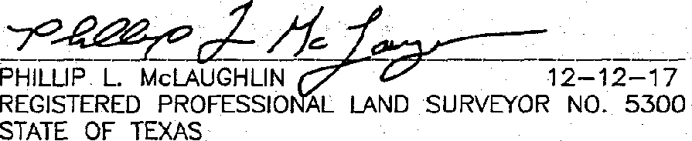

STATE OF TEXAS:

COUNTY OF TRAVIS;

THE ·wATERWAY BUFFER ioNE EASEMENT" IS FOR THE PROTECTION OF THE ENVIRONMENT BY IMPROVING THE .QLJAUlY .OF STORMWATER·. RUNOFF FROM DEVELOP£□ LANDS. THE NAT.IVE LAND OR MANAGEMENT

PRACTICES WITHIN THE EASEMENT ARE TO HELP MAINTAIN CLEAN WATER IN CREEKS, RIVERS AND LAKES. NO STRUCTURE OR IMPROVEMENTS, OTHER THAN NATIVE PLANT ENHANCEMENT OR MAINTENANCE OF

THE AREA IN ACCORDANCE WITH LCRA RULES, MAY BE PLACED OR PERFORMED WITHIN THE EASEMENT WITHOUT SPECIFIC PRIOR AUTHORIZATION AND APPROVAL. IN WRmNG FROM ltlE LCRA, JTS SUCCESSORS, OR .ASSIGNS, OR OTHER GOVERNMENTAL ENTITY WITH AUTHORllY TO PERMIT SUCH IMPROVEMENT FOR THE PROTECTION OF THE ENVIRONMENT. THE EASEMENT SHALL. BE MAINTAINED BY EACH' ).OT OWNER BY PRESERVING AND RESTORING NATIVE VEGETATION. THE EASEMENT MAY NOT BE AMENDED EXCEPT •

BY EXPRESS WRITTEN AGREEMENT OF THE LCRA, ITS SUCCESSORS OR ASSIGNS, OR OTHER GOVERNMENTAL ENTITY WITH PROPER AUTHORITY.

**t..( ,-..;f Nf1.on**

NOTIF!CA110N AND/OR PERMITS ARE REQUIRED PRIOR TO COMMENCING ANY DEVELOPMENT ACTIVITIES. CONTACJ LCRA WAlERSHED. .MANAGEMENL. -·--STATE.'-OF··TEXAS:,

LOWER_ COLO

DATE :: • *=--* _.

AT 1-800-776-5272,_ EX1ENSION 2324 FQR MO E JNFORMATI_ON.

1. THE WATER BUFFER ZONE SHALL REMAIN FREE' OF CONSTRUCTION, DEVELOPMENT, OR' OTHER ALTERATIONS EXCEPT FOR UTILITY AND ROADWAY CROSSINGS.
2. A PERPETUAL PUBLIC' SAFETY EASEMENT IS HEREBY DEDICATED FOR THE ·PURPOSE OF PROVIDING PUBLIC SAFETY SERVICES, POLICE, FIRE AND MEDICAL SERVICES, ENFORCING THE PENAL:. ·CODE AND CITY ORDINANCES, AND GJVING THE CITY AND ITS AUTHORIZED OFFICERS AND DESJGNEES UNINHIBITED INGRESS AND EGRESS OVER, ACROSS N,10 THROUGH SUCH· STREETS, ROADWAYS, AND RIGHTS-OF-WAY FOR THE PURPOSE OF PROVIDING PUBLIC SAFETY SERVICES, POLICE, F!RE AND MEDICAL SERVICES, AND ENFORCING. THE PENAL CODE AND CITY ORDINANCES. THE HOA SHAU. MAINTAIN AT AU. TIMES WITH THE CITY SECRETARY THE CURRENT GATE CODE OR KEY FOR AU. GATES •REGULATING ACCESS TO AND FROM THE SUBDIVISION.



COUNTY- OF TRAVIS:;: ; '. ,_

I, SAMUEL D. KIGER, AM· AUTHORIZED UNDER *THE* LAWS OF THE STATE oF TEXAS· TO *PRACTICE* THE PROFESSION. OF ENGINEERING, AND DO tjEREEY STATE THAT THJS PLAT CONFORMS WITH THE APPLICABLE ORDINANCES OF THE CITY OF LEANDER, 1EXAS THAT THIS TRACT JS NOT LOCATED WITHIN THE EDWARDS AQUIFER RECHARGE ZONE AND THAT A PORTION OF THIS SUBDIVISION IS WfTHJN TI--lE LIMITS OF A 100 YEAR FLOOD PLAIN RECOGNIZED BY THE FEOERAL EMERGENCY

MANAGEMENT AGENCY (FEMA) PER FLOOD INSURANCE RATE MAP (FIRM) PANEL NO. 4B45.3C

EPTV,.2:0•. AND CONTAINED WITHIN n« WATERWAY BUFFER ZONE EASEMENT

***4.-,* J'2,•l7·J'1**

SAMUEL 0. KIGER, P.E. DATE:

SfATE OF TEXAS NO. 89353

P.O. BOX 1220 . LEANDER, TEXAS 78646-1220

512-259-3882

STATE OF TEXAS:

COUNTY OF. TRAVIS:

l, DANA DEBEAUVOIR. CLERK, OF TRAVIS, 1EXAS, 00,·HEREBY CERTIFY THAT lHE FOREG01NG INSTRUMENT 0 WRITING, WITH •ITS' CERTIFICATE OF AUTHENTICATION WPS FILED FOR ,RECORD' IN ·MY'.QFFICE ON lHE_.A_ DA'l'.

F ***l(l@L/J*** , *20iJ* A.□., AT '3;.LYo·cLocK *J!.M.,* AND DULY RECORDED oN THE DAY OF

***fh C., f Lb*** *2ol..$* A.D,. AT *jlJ.1/:,* O;CUJCK, f_.M., JN TH_E CIAL RECoRDS·..oF SAID COUNTY A D STA1E UNDER DOCUMENT NUMBER ***;),01:(DW 5(·*** · .

WlTN S MY HAND AND SEAL OF OFFICE OF THE COUNTY CLERK THE£ _..,,DAY OF ***()14*** *(?/,/*

201.'iA.o:.

:.

DANA DEBEAUBOVOIR, COUNTY C

**-C.ESPtNOlA**

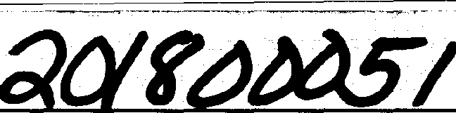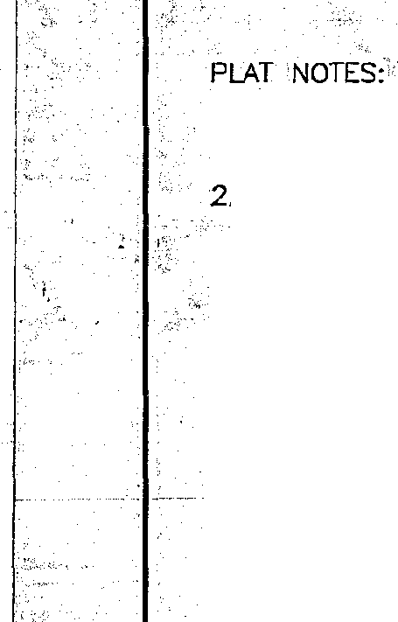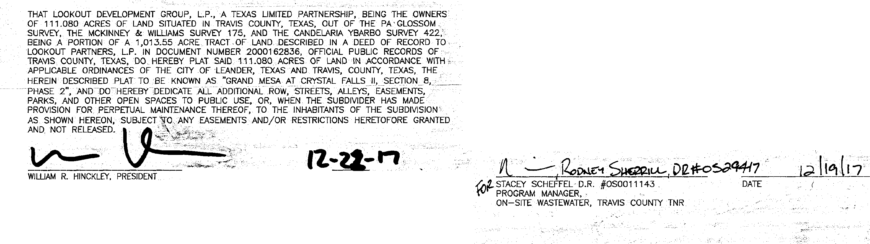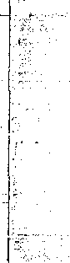

, •.•.•.-e,._,

..-, ;

***SURVEYJNG,.LLC'.***

*1805 .OUIDA. ow·,-:.,*

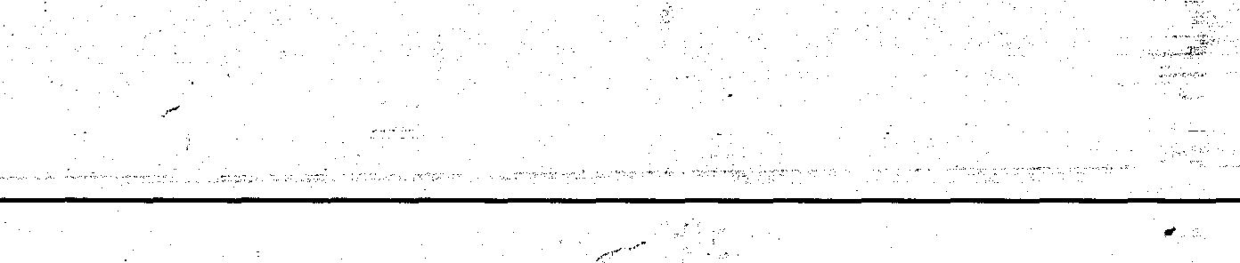

*PH kl7%1'1/jJl8!J*

*FAX: (512) 836-8385.·* SHEET *i* OF

